CHAPTER IV
RESULTS AND DISCUSSION
This chapter presents the comprehensive results and discussion of the design, development, and evaluation of A.E.G.I.S. (Academic Evaluation & Grant Integrity System), a scholarship management and AI-assisted document forensics portal built for the Office of Student Affairs (OSA) of Central Luzon State University (CLSU). It presents the system's problem context, feasibility analysis, architectural and behavioral design models, iterative development history, testing protocols, deployment verification, and quality evaluation framework.
4.1 Defining Requirements and Institutional Data Gathering
The requirements underlying A.E.G.I.S. (Academic Evaluation & Grant Integrity System) were formulated in response to a well-documented, general class of institutional problems in scholarship administration rather than to a single, formally instrumented needs-assessment study conducted at the Central Luzon State University (CLSU) Office of Student Affairs (OSA). This section presents that problem context honestly: it distinguishes between the motivating institutional problem, which is real and grounds the system's design rationale, and primary field data specific to CLSU OSA, which was not collected as part of this documentation and evaluation pass and is therefore represented below only as a clearly labeled, ready-to-fill placeholder rather than as fabricated content.
Scholarship administration at a state university such as CLSU characteristically involves a recurring institutional workflow: student-applicants submit supporting academic credentials, most centrally a Certificate of Grades (COG) or an equivalent grade-weighted-average (GWA) record, which OSA staff must inspect, cross-check against program eligibility rules, and adjudicate under a multi-tier review process before a stipend or grant can be approved and disbursed. Two problem classes are well established in the literature and practice of scholarship and admissions administration, and both directly motivated the design choices realized in the current A.E.G.I.S. codebase.
The first is administrative workload and process-integrity strain. Manual, paper- or ad hoc-digital review of grade sheets is time-intensive per applicant, difficult to route consistently across multiple reviewing tiers, and hard to render fully auditable — that is, it is generally difficult under a manual or loosely digitized process to reconstruct, after the fact, exactly who reviewed a given application, when its status changed, and on what basis. A.E.G.I.S. answers this class of problem directly and concretely: every application is tracked through an explicit status model (`Application` records progressing through `Pending`, `Under Review`, `Approved`, and related states, each transition recorded in an accompanying `StatusLog`), staff review work is distributed through a scoping mechanism (`ApplicationAssignmentService`, backed by the `scholarship_staff` pivot table) that lets a two-tier review hierarchy — OSA Staff and OSA Director — operate over a defined subset of applications rather than an undifferentiated queue, and every consequential action across the system is independently written to a dedicated family of audit-log tables (`AuthLog`, `AdminActionLog`, `ConfigChangeLog`, `ExportAccessLog`), each exportable to CSV or PDF by director-tier staff for compliance and record-keeping. Role-based route protection (`CheckRole` middleware, gating the `/admin` and `/superadmin` route groups) and custom multi-factor authentication (a six-digit one-time password delivered by email, with 30-day trusted-device tokens) further formalize who is permitted to act on an application and under what authenticated conditions, which is the system's direct response to the accountability dimension of the workload/process-integrity problem.
The second is document-integrity risk. It is a well-established, general risk in any scholarship or admissions process that a submitted grade sheet or academic credential — particularly one submitted as a scanned or photographed image rather than through an institution's own verified electronic records system — can be digitally altered to misrepresent an applicant's actual academic standing, and that such alteration can be difficult for a human reviewer to detect reliably by visual inspection alone, especially under time pressure and at volume. This is the problem the system's "Grant Integrity" function targets directly: every uploaded supporting document is routed through the `aegis-ai` forensic microservice via the queued `ScanDocumentJob`, which applies the four-pillar Explainable Forensic Decision Framework (EFDF) — OCR-based content consistency checking, compression-artifact analysis, sensor-continuity inspection, and file-metadata anomaly detection — to produce a quantified fraud-probability score and a tiered risk classification that a human reviewer can weigh as decision support, rather than an opaque, unexplained verdict the reviewer must either blindly trust or ignore. The explainability of this framework is itself a direct design response to a known weakness of black-box automated fraud-detection tooling in a high-stakes administrative context: a reviewer who must ultimately sign off on a denial needs a legible basis for that decision, not merely a score.
It is important to state plainly what the remainder of this section does and does not claim. The system's design is grounded in these well-established, general problem classes and in the project's own documented engineering history (detailed in the following chapters of this manuscript and in the accompanying technical system documentation); it is not grounded in a completed, formally administered interview or survey study of CLSU OSA staff and student-applicants, nor in a completed forensic audit of a historical corpus of CLSU OSA document submissions. Both of those activities were planned as components of a full requirements-validation exercise but had not been executed and their results had not been recorded at the time this chapter was prepared. The two placeholder subsections below identify exactly what remains to be filled in, and by whom, so that this section can be completed honestly rather than padded with invented figures.
4.1.1 Primary Stakeholder Consultation (Pending Field Data)
Formal semi-structured interviews and/or surveys with CLSU OSA administrative staff (both front-line reviewers and director-tier decision-makers) and with a sample of student-applicants were planned as part of validating the requirements baseline described above against the specific institutional reality of CLSU, rather than only against the general problem class. This primary data-collection activity had not been conducted at the time of writing this chapter. The researcher(s) completing this study should insert here, once collected: (a) the number and designation of respondents actually interviewed or surveyed, by stakeholder group; (b) direct, attributed or anonymized quotations illustrating specific pain points in the existing CLSU OSA scholarship review workflow; and (c) a thematic synthesis of the findings, organized against the problem classes identified in the preceding narrative (administrative workload/process integrity, and document-integrity risk), together with any additional themes the field data surfaces that this narrative does not currently anticipate.
4.1.2 Forensic Baseline Assessment of Historical Submissions (Pending Field Data)
A forensic baseline assessment of a sample of CLSU OSA's historical scholarship-document submissions — intended to establish, prior to A.E.G.I.S.'s deployment, an empirical estimate of the prevalence and typology of document tampering actually encountered in this specific institutional context — was likewise planned but not conducted as part of this documentation and evaluation pass. No document counts, fraud-pattern frequencies, or tampering-typology statistics are presented in this manuscript in place of that assessment, since none were actually collected. The researcher(s) completing this study should insert here, once collected: (a) the size and sampling method of the historical document corpus examined; (b) a breakdown of any tampering vectors actually identified in that corpus (for example, numerical grade alteration, institutional-seal substitution, or metadata inconsistency indicative of prior editing), each supported by the specific forensic technique used to detect it; and (c) a comparison of this baseline against the detection categories the EFDF pipeline is designed to surface (OCR inconsistency, compression artifacts, sensor-continuity anomalies, and metadata anomalies), so that the system's forensic design can be evaluated against demonstrated local risk rather than against the general risk class alone.
4.1.3 Comparative Process Analysis: Manual Review vs. A.E.G.I.S.-Automated Review
Unlike the two preceding subsections, the comparison below does not depend on empirical field measurement and is presented here as a completed, logical/design-level analysis: it compares the sequence of steps a manual reviewer must execute against the sequence of steps A.E.G.I.S. automates, grounded directly in the system's actual implemented workflow rather than in a claimed or estimated time saving.
In a conventional manual scholarship-review workflow, a reviewer receives a submitted grade sheet or supporting document, visually inspects it for internal consistency (does the document's formatting, seal, and typography look institutionally authentic), manually cross-references the applicant's claimed grades or GWA against program eligibility thresholds, and records a decision — typically in a spreadsheet, a paper log, or a general-purpose document-management tool not purpose-built for this task. Each of these steps is performed serially by a human reviewer, and each step's outcome (what was inspected, what was found, and why a decision was reached) is recorded only to the extent the reviewer or the office's manual record-keeping practice happens to capture it.
A.E.G.I.S. restructures this same sequence into a pipeline in which automated forensic pre-screening precedes, rather than replaces, human judgment. When a student submits an application through the student portal, the uploaded document is written to storage (via `CloudStorageService`, which attempts Cloudflare R2 object storage first and transparently falls back to local disk) and the `ScanDocumentJob` is dispatched onto the database-backed queue rather than being processed synchronously — meaning the applicant's submission is accepted immediately, and the forensic check proceeds in the background. The queued job submits the document to the `aegis-ai` microservice's `/analyze-document` endpoint, where it is evaluated under the four-pillar EFDF model and returns a fraud-probability score, a classification label, and the supporting per-pillar evidentiary breakdown, which is persisted as an `AIResult` row linked to the submitted `Document`. Where the system-wide auto-approval setting is enabled, `ApplicationAutoApprovalService` then evaluates the application against configurable thresholds (minimum AI confidence, maximum anomaly count, and the fraud-probability threshold itself) and will automatically approve only applications that both clear these thresholds and require no custom, scholarship-specific fields that would themselves demand human judgment; every other application — the ordinary case — surfaces directly into the OSA Staff review queue, where the reviewing officer is presented with the original document and the AI's forensic verdict side by side, and can accept, override, or request re-upload of the document as the specific case warrants.
The structural difference this comparison makes visible is not merely one of speed but of division of labor: in the manual workflow, a human reviewer performs both the routine authenticity check and the substantive eligibility judgment for every single application, regardless of whether that document shows any sign of tampering at all. In the A.E.G.I.S. workflow, the routine authenticity check is performed automatically and consistently for every document, before a human reviewer ever opens the file, so that reviewer attention is concentrated on the cases the forensic pipeline actually flags or on applications the auto-approval logic declines to resolve automatically (because they require custom fields, carry an unresolved or failed scan, or fail to clear the configured confidence and anomaly thresholds). This reallocation of reviewer effort — from uniform manual inspection of every document toward exception-based review of flagged or ambiguous cases — is the direct, code-grounded basis for describing A.E.G.I.S. as reducing administrative workload without removing human judgment from the scholarship-adjudication decision itself, consistent with the system's own settings-gated design, which explicitly declines to auto-approve any case it is not configured to resolve with sufficient confidence.
4.2 Feasibility Study and Multi-Dimensional Viability Analysis
To assess whether A.E.G.I.S. is a practical and sustainable solution for CLSU OSA, this section evaluates the system along technical, hardware, economic, and operational dimensions, grounded directly in the technology stack and implemented capabilities documented in the system's own source repository and technical documentation, rather than in aspirational specifications.
4.2.1 Technical Software Stack
A.E.G.I.S. is built as a Laravel 12 monolithic web application, running on PHP 8.2 or later at the framework's declared dependency floor and on PHP 8.4 in its actual production container image, paired with a decoupled Python microservice, `aegis-ai`, that performs the AI-based document forensics work described in Section 4.1. The stack is composed entirely of free and open-source frameworks, libraries, and free-tier developer services, which eliminates recurring commercial software-licensing costs for the institution. Table 4.1 enumerates the principal components of this stack as declared in the project's own dependency manifests (`composer.json`, `package.json`, `aegis-ai/requirements.txt`) and configuration files.
Table 4.1
Software Stack Specifications and Licensing Basis
Software Layer | Technology / Framework | Version | Licensing Basis
Backend Web Framework | Laravel Framework | ^12.0, on PHP ^8.2 (PHP 8.4 in production) | Open-source, no commercial licensing cost
Frontend Templating | Blade (bundled with Laravel) | Laravel 12 | Open-source, no commercial licensing cost
Frontend Build Tooling | Vite / laravel-vite-plugin | ^7.0.7 / ^2.0.0 | Open-source, no commercial licensing cost
CSS Frameworks | Tailwind CSS / Bootstrap 5 | ^3.1.0 (Tailwind) | Open-source, no commercial licensing cost
Icon Library | Font Awesome | Version 6 | Free tier, no commercial licensing cost
Client-side Scripting | Alpine.js / Axios / vanilla JavaScript | ^3.4.2 / ^1.11.0 | Open-source, no commercial licensing cost
Development Database | SQLite | Bundled with PHP | Open-source, no commercial licensing cost
Production/Staging Database | PostgreSQL, via Supabase | pgsql driver in config/database.php | Open-source database engine; free-tier managed hosting
AI Forensics Microservice Framework | Flask / Gunicorn | 3.0.3 / 22.0.0 | Open-source, no commercial licensing cost
AI/Deep Learning Runtime | TensorFlow / Keras | 2.16.1 / 3.3.3 | Open-source, no commercial licensing cost
Computer Vision Library | OpenCV (headless) | 4.9.0.80 | Open-source, no commercial licensing cost
OCR Engine | Tesseract OCR (via pytesseract) | pytesseract >=0.3.10 | Open-source, no commercial licensing cost
PDF Forensic Inspection | pikepdf / pdf2image / pdfminer.six | >=9.0.0 / >=1.17.0 / >=20231228 | Open-source, no commercial licensing cost
Containerization | Docker | Dockerfile (Laravel: php:8.4-fpm-alpine; aegis-ai: python:3.11-slim) | Open-source container runtime
Application Hosting | Render.com | render.yaml, free plan | Free-tier cloud hosting
AI Service Hosting | Hugging Face Spaces | aegis-ai/Dockerfile, Docker SDK | Free-tier cloud hosting

Note. All frameworks and libraries listed are open-source or offered under a free developer/hosting tier; specific license texts (e.g., MIT, BSD, Apache family) were not individually re-verified against each package's own license file for this table and are therefore described generically as open-source rather than attributed to a specific license identifier.
The frontend and backend layers are joined through Laravel's conventional Blade templating rather than a JavaScript single-page-application framework, which keeps the client-side dependency surface small and avoids the additional build and runtime complexity a framework such as React or Vue would introduce for a system of this scope. The `aegis-ai` microservice is deliberately isolated behind a plain HTTP contract rather than embedded in the PHP runtime, because its dependencies — TensorFlow/Keras, OpenCV, and Tesseract — have no mature, production-grade equivalent within the PHP ecosystem; this is a "right tool for the job" architectural boundary rather than a general microservices decomposition, and it is the single internal service boundary in the entire system.
4.2.2 Hardware Environment
Development of A.E.G.I.S. was carried out on standard personal computing hardware, of the kind ordinarily available to a student developer, meeting the minimum requirements for running a local PHP/Composer toolchain, a Node.js/npm build pipeline for frontend asset compilation, and a local Python environment for developing and testing the `aegis-ai` microservice, together with a Docker runtime for containerized local testing. No specialized computing hardware — dedicated GPU acceleration hardware, a physical on-premises server, or any purpose-acquired equipment — was required or procured for development, since the AI microservice's model inference workload is designed to run acceptably on CPU-only infrastructure, consistent with its documented free-tier, CPU-based deployment target on Hugging Face Spaces. This section deliberately does not specify particular processor models, memory capacities, or storage figures for the development machines used, since no such specification was verified as part of this documentation pass; the material point for feasibility purposes is that the system's development and testing did not require hardware beyond what is already typically available to a student researcher, and that its production deployment likewise targets commodity, free-tier cloud compute rather than specialized infrastructure.
4.2.3 Total Actual Project Outlay
Because the entire technology stack described in Section 4.2.1 is open-source or hosted on free developer tiers, and because development hardware consisted of existing personal computing equipment as described in Section 4.2.2, the project's actual, out-of-pocket financial outlay was minimal. Table 4.2 presents the two real expenditure categories recorded for this project.
Table 4.2
Total Actual Project Development Outlay
Budget Category | Description | Actual Financial Outlay (PHP)
Software, AI Tooling, and Hosting | Fully open-source software stack (Laravel, Python/TensorFlow ecosystem, PostgreSQL/Supabase) and free-tier cloud hosting (Render, Hugging Face Spaces) | P 0.00
Research Consumables | Printing, documentation, and incidental research-related consumables incurred during the capstone development lifecycle | P 1,500.00
TOTAL ACTUAL PROJECT OUTLAY |  | P 1,500.00

Note. Figures reflect the actual, out-of-pocket financial outlay incurred during development, as recorded in the project's own engineering log. No commercial software licenses, paid cloud infrastructure tiers, or hardware acquisitions were incurred.
The near-total absence of software or infrastructure cost is a direct consequence of the architectural choices described in Section 4.2.1 rather than of an unusually frugal budgeting exercise: every layer of the stack, from the Laravel framework itself through to the AI microservice's deep-learning runtime, was selected specifically because a free, open-source, or free-tier equivalent existed that could meet the project's functional requirements without a paid alternative.
4.2.4 Operational Feasibility (PIECES Framework)
Operational feasibility was assessed using the PIECES framework — Performance, Information, Economics, Control, Efficiency, and Service — applied here as an analytical lens over the system's actual, documented implemented capabilities rather than as a survey instrument administered to respondents. Each dimension below cites a specific, verifiable feature of the deployed system as its supporting evidence.
Performance. The application registers a global `GzipResponse` middleware that compresses textual HTTP responses larger than 1 KB with `gzencode()` at compression level 6 whenever the requesting client supports it, which the project's own engineering log documents as achieving an 80 to 85 percent reduction in transmitted payload size for HTML and JSON responses. The same middleware applies a one-year, immutable `Cache-Control` header to Vite-built, content-hashed frontend assets, eliminating unnecessary revalidation requests for unchanged files. Separately, the `AdminController`'s application-listing queries were revised to eager-load the `scholarship` and `customFields` relationships, eliminating a previously present N+1 query pattern in the staff review dashboard, and a dedicated `QueryCachingTest` in the automated test suite verifies that the list of active scholarships is cached and correctly invalidated on write.
Information. Students and staff both receive real-time, database-backed in-app notifications (rather than relying solely on email) that deep-link directly to the relevant dashboard or application record on click, giving both parties immediate visibility into status changes as they occur rather than only through periodic manual checking. The AI forensic subsystem further improves information quality specifically for reviewers by returning a quantified fraud-probability score and a four-pillar evidentiary breakdown (OCR, compression, sensor continuity, and metadata) alongside every scanned document, rather than requiring the reviewer to form a judgment from an unaided visual inspection alone.
Economics. As detailed in Section 4.2.3, the system was built and can continue to be operated on a stack that carries P 0.00 in software or hosting licensing cost, using Render's and Hugging Face Spaces' free hosting tiers for the two production services. This directly reduces the marginal cost to CLSU OSA of adopting and continuing to run the system relative to a commercially licensed alternative.
Control. Access to every functional area of the system is gated by the `CheckRole` middleware, enforcing a three-tier role model (`student`, `admin`, `superadmin`) at the route level rather than relying on interface-level convention alone. Authentication is further hardened by a custom multi-factor authentication mechanism (a six-digit one-time password with 30-day trusted-device tokens bound to a hashed user-agent fingerprint), and every consequential administrative action, configuration change, and data export is independently written to a dedicated family of audit-log tables (`AuthLog`, `AdminActionLog`, `ConfigChangeLog`, `ExportAccessLog`) that a director-tier user can export to CSV or PDF for institutional compliance review.
Efficiency. The composite effect of the automated forensic pre-screening pipeline described in Section 4.1.3 is that reviewer attention is directed toward flagged or ambiguous applications rather than uniformly toward every submission; where the system's settings-gated auto-approval logic is enabled, applications that meet configured confidence and anomaly thresholds and require no custom eligibility fields can be resolved without manual review entirely. This reallocation of reviewer effort toward exception handling, rather than routine inspection of every document, is the system's principal efficiency gain.
Service. Applicants receive automated, near-immediate notification of status changes through the in-app notification channel described under Information above, and the queued architecture underlying document scanning (`ScanDocumentJob`, dispatched to the database queue with a five-attempt, escalating retry/backoff schedule) ensures that a transient failure or slow response from the external AI service does not block or fail an applicant's submission outright, preserving continuity of service even when a downstream dependency is temporarily degraded.
4.3 Comprehensive System Design and Architectural Models
The architectural and behavioral specifications of A.E.G.I.S. (Academic Evaluation & Grant Integrity System) were developed using Unified Modeling Language (UML) and structured systems-analysis notations, so that the platform's static structure and its dynamic, runtime behavior could each be examined through the notation best suited to it. Use case diagrams and detailed use case specifications were employed to formalize the functional scope of the system from the perspective of each of its human and system actors; multi-level data flow diagrams were employed to trace how application, document, and decision data actually moves between the Laravel monolith, its Python forensic microservice, and their respective external stakeholders; and an entity-relationship diagram, together with a complete column-level data dictionary, was employed to formalize the relational schema that persists every fact the system depends on. These three notations are complementary rather than redundant: the use case model establishes *what* the system does and for whom, the data flow model establishes *how* information moves once a use case is invoked, and the entity-relationship model establishes *where* the resulting facts are ultimately stored. The remainder of this section presents each of these three models in turn, grounded throughout in the actual controller, service, job, and migration code that implements the system rather than in an idealized or aspirational design.
4.3.1 Use Case Analysis
The A.E.G.I.S. use case model is anchored by four actors whose boundaries are enforced directly at the application's routing and middleware layer rather than being a purely conceptual grouping. The Student actor corresponds to any authenticated, email-verified account carrying the default `student` role in the `users` table, gated only by Laravel's `auth` and `verified` middleware rather than the application's dedicated role middleware. The OSA Staff actor corresponds to accounts carrying the `admin` role, whose routes are restricted to the `/admin` prefix under `role:admin,superadmin` middleware, and who are responsible for the front-line review of individual scholarship applications. The OSA Director/Super Admin actor corresponds to accounts carrying the `superadmin` role, restricted to the `/superadmin` prefix under `role:superadmin` middleware alone, and who additionally hold authority over scholarship-program configuration, staff-account administration, system-wide settings, and the full compliance-export surface. The fourth actor, modeled with the UML «system» stereotype, is the AI Forensics Service — the decoupled `aegis-ai` Python microservice invoked over HTTP from the Laravel application's `ScanDocumentJob` — which participates in the use case model as an automated actor rather than a human one, since it independently executes the forensic-analysis use case without a human operator directly driving it.
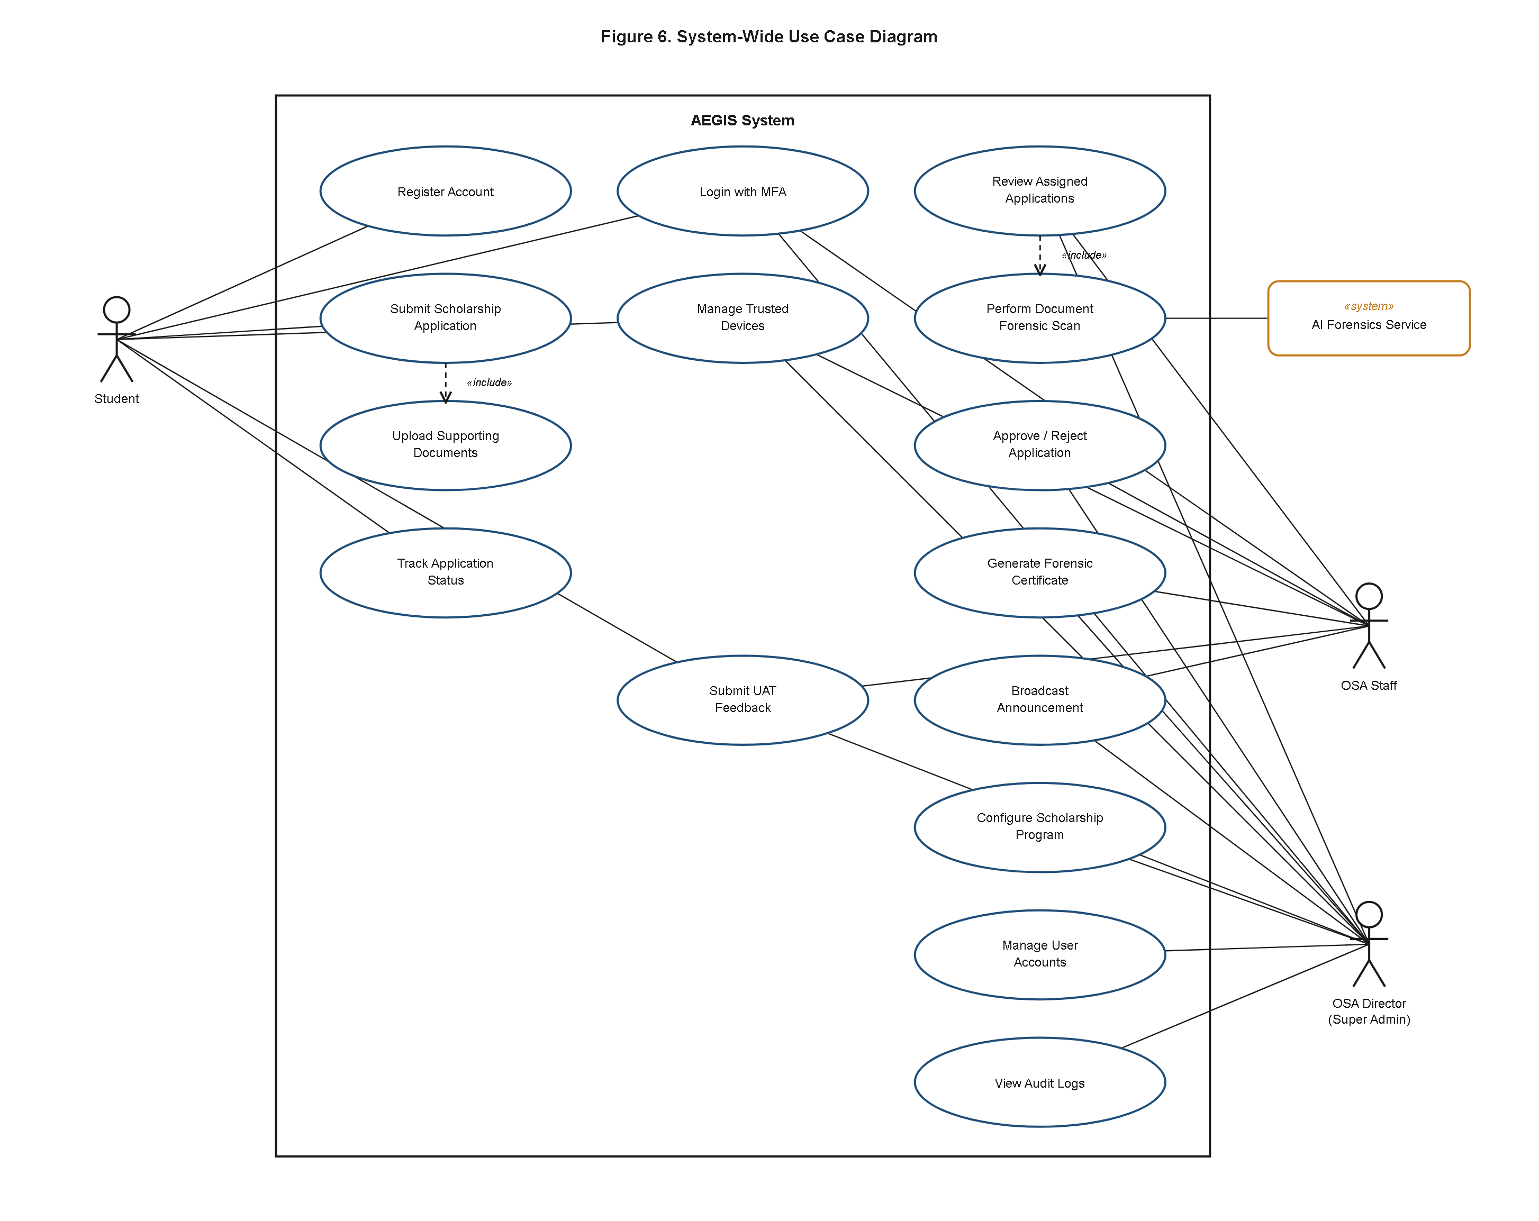
Figure 5. A.E.G.I.S. System-Wide Use Case Diagram.
Figure 5 presents the system-wide use case diagram, situating all four actors against the full catalog of use cases the platform implements. The Student actor is associated with Register Account, Login with MFA, Submit Scholarship Application, Track Application Status, Submit UAT Feedback, and View Announcements. The OSA Staff actor is associated with Login with MFA, Review Assigned Application, Approve/Reject Application, and Request Document Re-upload, and shares the Broadcast Announcement use case with the OSA Director tier. The OSA Director/Super Admin actor is associated with Configure Scholarship Program, Manage User Accounts, Manage Staff Assignments, View Audit Logs, Export Compliance Reports, and Generate Forensic Certificate, in addition to every use case available to OSA Staff, reflecting the superadmin role's superset authority over the admin role at the middleware level. The «system» AI Forensics Service actor is associated with the Perform Document Forensic Scan use case, connected to Submit Scholarship Application by an «include» relationship, since every document upload unconditionally triggers a forensic scan rather than the scan being an optional, separately invoked feature. Login with MFA is likewise modeled as an «include» of every authenticated use case, reflecting the fact that no actor in the system reaches a protected route without first clearing the one-time-password challenge implemented in `AuthController`.
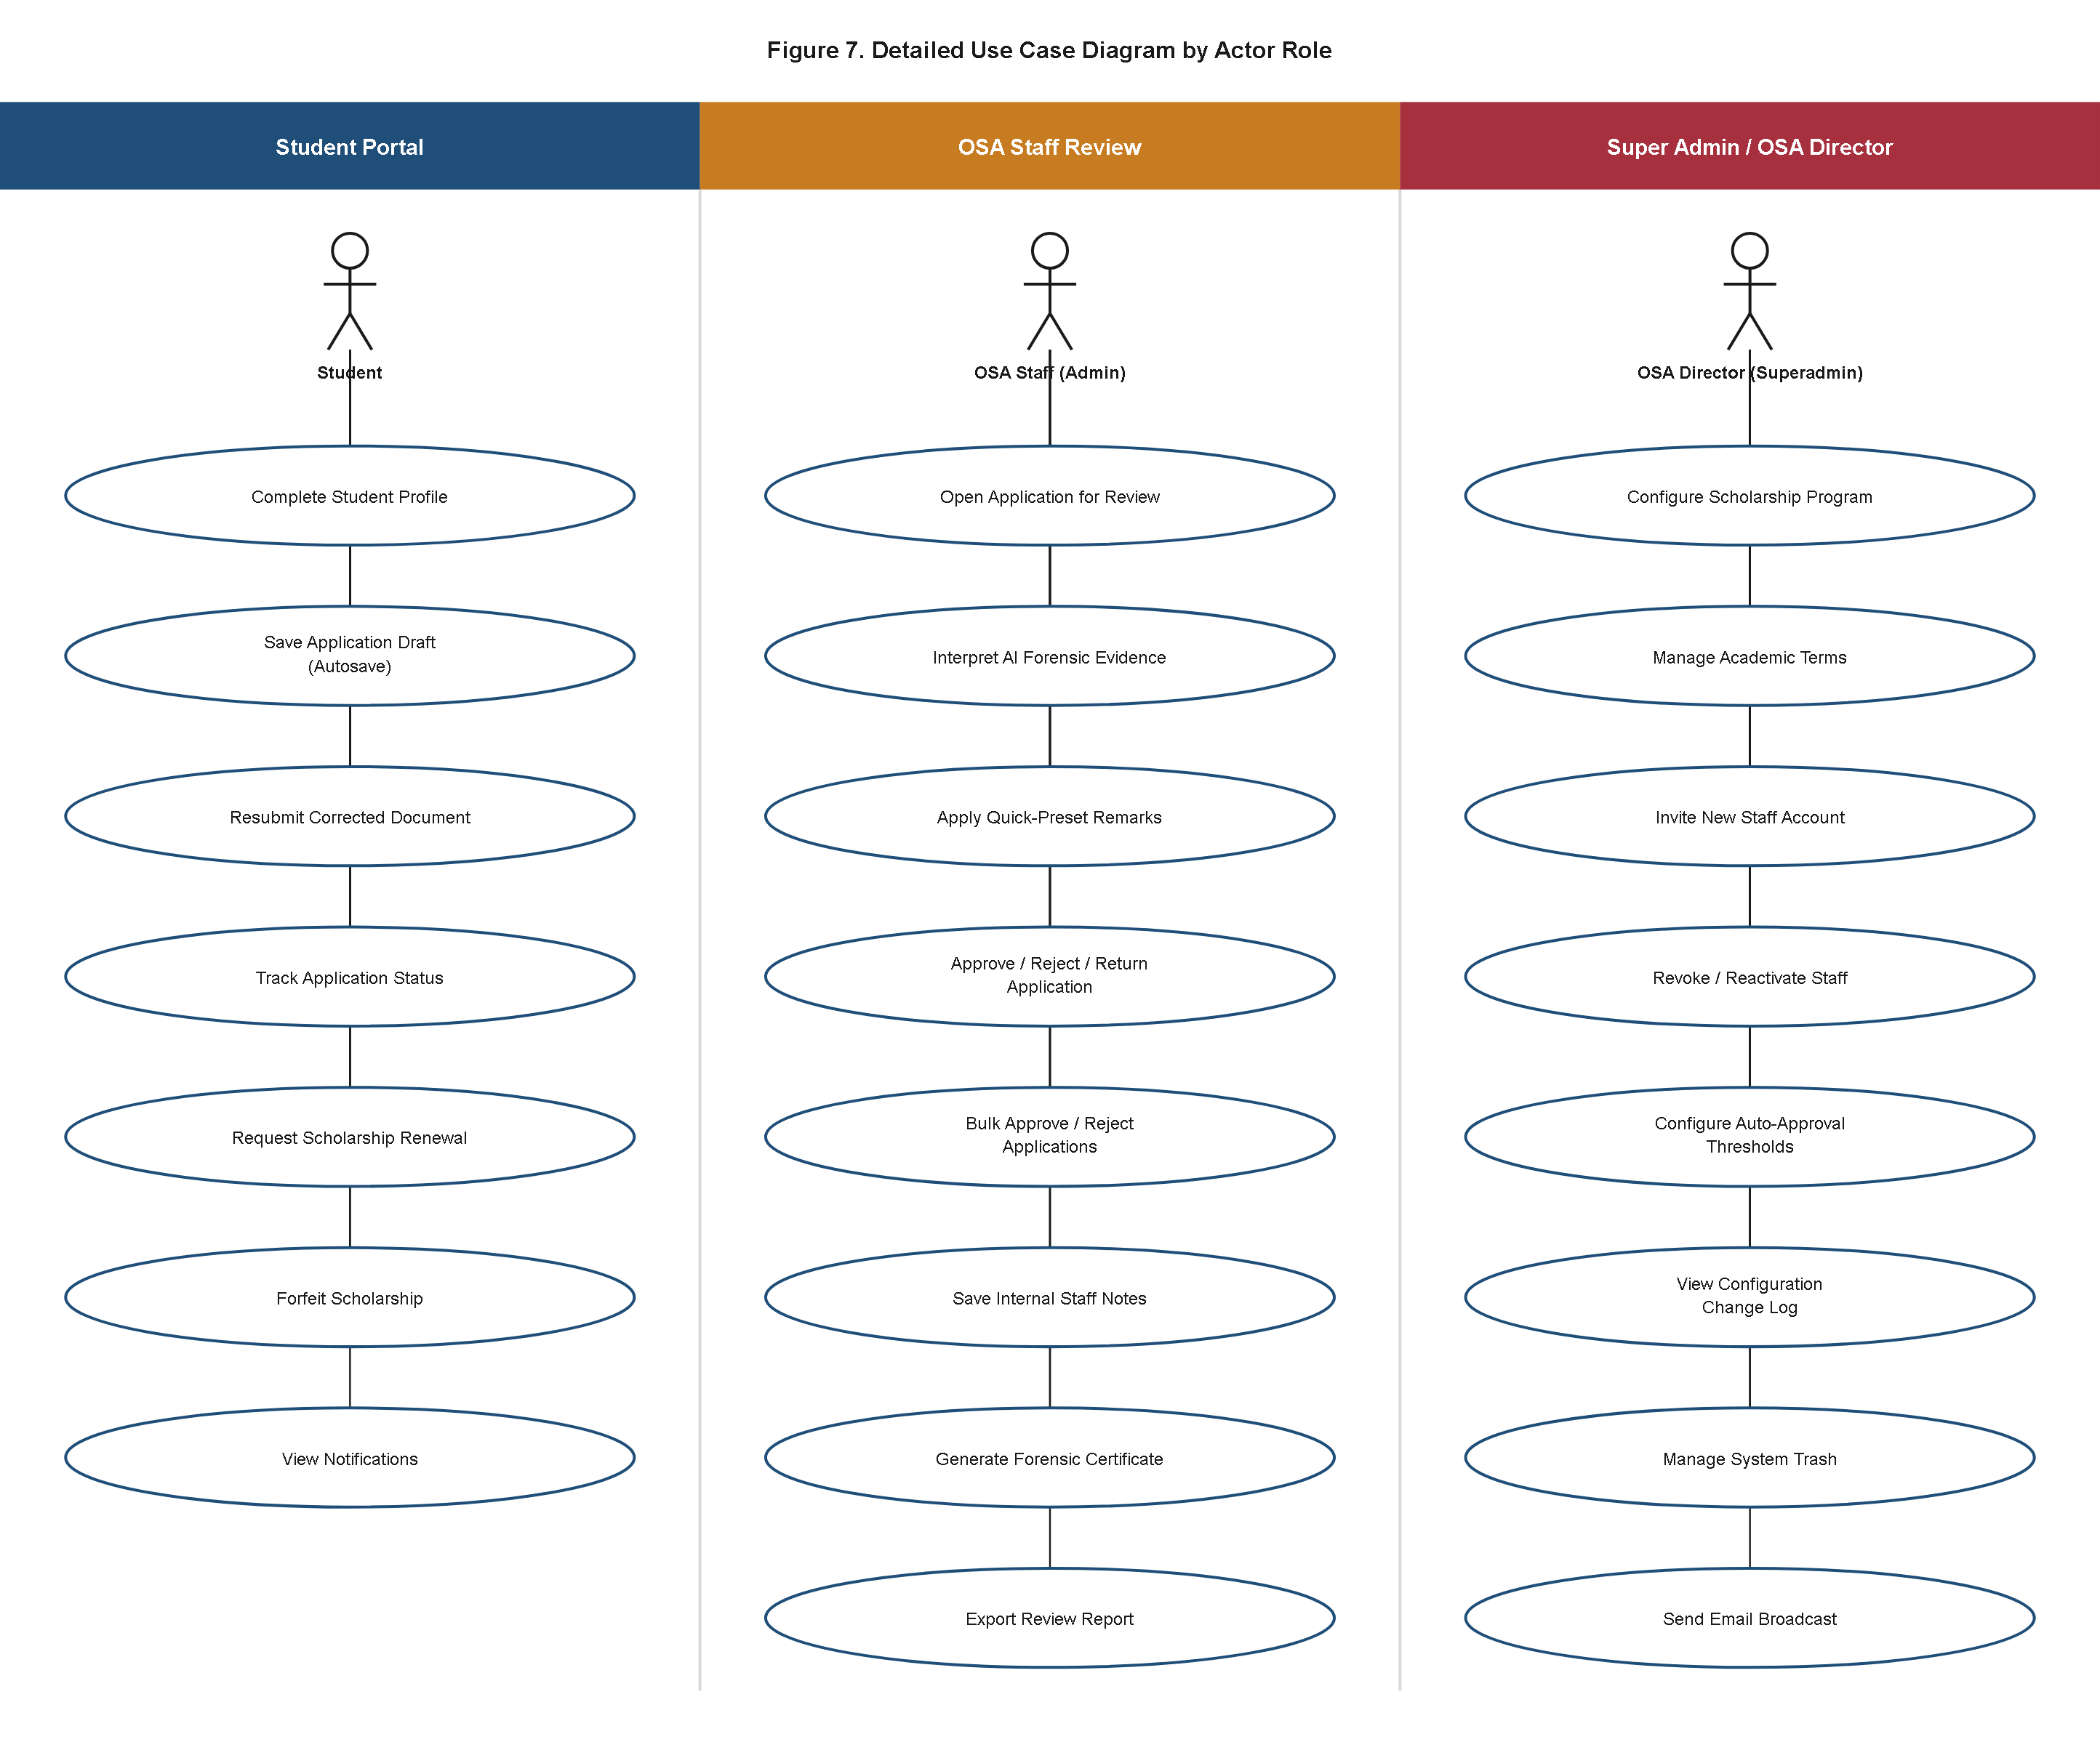
Figure 6. Detailed Use Case Diagram by Actor Role.
Where Figure 5 presents the system as a single undifferentiated boundary, Figure 6 decomposes that same set of use cases into three role-scoped panels — Student Portal, OSA Staff Review, and Super Admin — so that each actor's finer-grained interactions can be read independently of the other two. The Student Portal panel expands Submit Scholarship Application into its constituent steps of Complete Dynamic Application Form, Upload Supporting Documents, and Track Application Status, and separately depicts Manage Trusted Devices and Update Profile as self-service account-security use cases available from the student's own security settings screen. The OSA Staff Review panel expands the review workflow into Inspect Forensic Evidence, Compare Original and Heatmap, Request Document Re-upload, and Approve/Reject Application, reflecting the actual sequence in which `AdminController::review` surfaces an application's documents and AI verdict before a disposition is recorded. The Super Admin panel is the most extensively populated of the three, decomposing director-level authority into Configure Scholarship Program, Define Dynamic Form Fields, Assign Staff to Scholarship, Invite Staff Account, Deactivate/Reactivate Account, Configure AI Thresholds, Broadcast Announcement, Export Audit Logs, and Transfer Master Account — the last of which corresponds to the `MasterTransfer` token-based succession flow that lets the single configuration-designated "Master" identity be handed off between email addresses without either party sharing a live password.
Six of the use cases most central to the platform's operation are specified in full below. Table 4.5 through Table 4.10 were selected because each corresponds to a use case that spans multiple architectural layers of the system — routing, controller, service, job, and persistence — and because together they trace the complete life of a scholarship application from submission through automated forensic evaluation to a recorded human or system disposition, together with the two administrative use cases (scholarship configuration and account management) without which no application could ever be submitted or reviewed in the first place.
Table 4.5
Use Case Specification — Submit Scholarship Application
Specification Element | Detail
Use Case Name | Submit Scholarship Application
Actor(s) | Student (Applicant)
Description | Enables an authenticated, email-verified student to browse currently configured scholarship programs, complete a scholarship-specific dynamic application form, and upload supporting documents for automated forensic scanning and staff review.
Preconditions | The student holds an active account with a verified email address, gated by the `auth` and `verified` middleware; at least one `Scholarship` record carries `status = 'Active'` with an open deadline.
Main Success Flow | 1. Student navigates to `GET /apply`, served by `ApplicationController::create`, which loads active `Scholarship` records together with their `ScholarshipField` definitions. / 2. Student selects a target scholarship and academic term and completes the dynamically rendered form fields. / 3. Student attaches one or more supporting documents through the upload interface. / 4. Student submits the form via `POST /apply`, handled by `ApplicationController::store`. / 5. The controller creates an `Application` row linking the student's `User`, the selected `Scholarship`, and the active `AcademicTerm`, with `status` defaulted to `Pending`. / 6. One `ApplicationField` row is persisted per answered custom question, with `field_value` transparently AES-256 encrypted at rest. / 7. Each uploaded file is written through `CloudStorageService::upload`, which attempts the Cloudflare R2 disk first and falls back automatically to local disk storage; a corresponding `Document` row is created per file. / 8. `ScanDocumentJob` is dispatched onto the database queue for each uploaded `Document` rather than blocking the student's request.
Postconditions | A new `Application` row exists with `status = 'Pending'`; one `Document` row exists per uploaded file; a `ScanDocumentJob` has been queued for each document, initiating the forensic-scan use case specified in Table 4.6.

Table 4.6
Use Case Specification — Perform Document Forensic Scan
Specification Element | Detail
Use Case Name | Perform Document Forensic Scan
Actor(s) | «system» AI Forensics Service (`aegis-ai`), invoked by the queued `ScanDocumentJob`
Description | Executes the automated forensic-tampering-detection pipeline against an uploaded supporting document, producing a quantified fraud-probability score, classification label, and supporting evidentiary artifacts persisted to the `AIResult` record.
Preconditions | A `Document` has been uploaded and a `ScanDocumentJob` queued against it.
Main Success Flow | 1. A queue worker picks up `ScanDocumentJob` from the database-backed queue connection. / 2. The job retrieves the document's bytes, checking local disk storage, a remote URL, and a base64-encoded database fallback column, in that preference order. / 3. The job issues a multipart HTTP POST to the `aegis-ai` service's `/analyze-document` endpoint with a 120-second timeout. / 4. The microservice routes the file through the applicable forensic pipeline (`image_forensics_v2`, the V3 deep-analysis pipeline, or a PDF-specific pipeline) selected by file type and configuration flags. / 5. The service returns a JSON payload containing `extracted_gwa`, `fraud_probability`, `classification`, `anomaly_indicators`, `detected_software`, `heatmap_base64`, `cropped_patch_base64`, and a structured `deep_analysis_report`. / 6. `ScanDocumentJob` re-derives the final classification by comparing `fraud_probability` against the configurable `ai_fraud_threshold` setting (default 70.0); any score at or above threshold is forced to `Tampered`. / 7. The job cross-references the applicant's self-declared `gwa` against `extracted_gwa`; if the discrepancy exceeds the `gwa_discrepancy_tolerance` setting (default 0.01), `fraud_probability` is forced to `99.00` and `classification` to `Tampered (Grade Discrepancy)`. / 8. The job persists the result via `AIResult::updateOrCreate(['document_id' => ...], ...)`, overwriting any prior scan of the same document.
Postconditions | Exactly one `AIResult` row exists for the scanned document, carrying `fraud_probability`, `classification`, and, where available, heatmap/cropped-patch evidence; on any remote failure, a defensive fallback row (`fraud_probability = 0.00`, `classification = 'failed'`) is written instead.

Note. On an HTTP 502/503/504 "cold start" response from the free-tier-hosted aegis-ai service, the job pings its /health endpoint and retries with a linearly increasing delay for up to three attempts before raising a descriptive exception, which itself triggers the job's own outer queue-level retry/backoff cycle (five tries at 15-360 second intervals).
Table 4.7
Use Case Specification — Review Assigned Application
Specification Element | Detail
Use Case Name | Review Assigned Application
Actor(s) | OSA Staff (`admin` role)
Description | Allows an OSA Staff reviewer to inspect an application's submitted answers, uploaded documents, and AI forensic verdict together in a single case-detail view, in preparation for a review decision.
Preconditions | Reviewer is authenticated with role `admin` or `superadmin`; the target `Application` exists and carries `status` of `Pending` or `Under Review`, optionally scoped to the reviewer via the `assigned_to` column.
Main Success Flow | 1. Reviewer navigates to the `/admin` case-detail route for a specific application, served by `AdminController::review`. / 2. The controller eager-loads the application's `scholarship`, `customFields`, `documents`, and each document's `aiResult` relationship to avoid N+1 queries. / 3. The interface presents the applicant's declared GWA, custom field answers, uploaded documents, and each document's `AIResult` (`fraud_probability`, `classification`, `anomaly_indicators`, heatmap). / 4. Reviewer visually inspects the forensic evidence alongside the raw document image or PDF. / 5. If a document is unusable or ambiguous, the reviewer may trigger `ApplicationController::reupload` to request a replacement from the applicant rather than rendering an immediate decision.
Postconditions | The reviewer has viewed the complete application case file and its forensic evidence; the application remains in its current status pending an explicit decision (Table 4.8) or a re-upload request.

Table 4.8
Use Case Specification — Approve/Reject Application
Specification Element | Detail
Use Case Name | Approve/Reject Application
Actor(s) | OSA Staff, OSA Director/Super Admin; alternatively the system itself via `ApplicationAutoApprovalService`
Description | Records a final or provisional disposition on a scholarship application, either through explicit staff or director judgment or through the settings-gated automated approval path, and propagates that decision to the application's status history, audit trail, and applicant notifications.
Preconditions | Application carries `status` of `Pending` or `Under Review`; for a manual decision, the acting user holds role `admin` or `superadmin`; for an automated decision, the `auto_approval_enabled` setting is on.
Main Success Flow | 1. (Automated path) `ApplicationAutoApprovalService::evaluate` loads the application's `scholarship.fields`, `documents.aiResult`, and `user.profile` relationships. / 2. The service declines auto-approval if the scholarship defines any custom `scholarship_fields` or if any document lacks a successful `AIResult`. / 3. The service checks each `AIResult`'s confidence and anomaly count against `auto_approval_min_confidence` (default 95.0) and `auto_approval_max_anomalies` (default 0); if satisfied, the application transitions automatically. / 4. (Manual path) Reviewer selects Approve or Reject from the case-detail view, optionally entering remarks or `admin_notes`. / 5. The controller updates `applications.status` accordingly, setting `evaluated_by` to the acting staff member's id, or leaving it null for a system-driven decision. / 6. A new `StatusLog` row is inserted recording the transition, remarks, and `changed_by`. / 7. `AuditLoggerService::logAdminAction` writes a corresponding `admin_action_logs` row (e.g., `bulk_approve_application`, `bulk_reject_application`, or `system_auto_approved` with `ip_address = 127.0.0.1` for the automated path). / 8. A database-channel `ApplicationStatusNotification` is created and a status-change email is dispatched, directly or via `SendBulkStatusEmailJob`, with the delivery outcome recorded in `email_logs`.
Postconditions | `applications.status` reflects the new disposition; an immutable `StatusLog` and `admin_action_logs` entry exist; the applicant has received an in-app notification and, where configured, a status-change email.

Table 4.9
Use Case Specification — Configure Scholarship Program
Specification Element | Detail
Use Case Name | Configure Scholarship Program
Actor(s) | OSA Director/Super Admin
Description | Lets OSA leadership define and maintain the fundable scholarship programs students may apply to, including eligibility thresholds, deadlines, renewal limits, and each program's dynamically configurable custom application-form fields.
Preconditions | The acting user is authenticated with role `superadmin`.
Main Success Flow | 1. Director navigates to the `/superadmin` scholarship-management interface. / 2. Director creates or edits a `Scholarship` record, specifying `name`, `description`, `min_gwa_required`, `deadline`, `max_renewals`, and `status` (`Active`/`Closed`). / 3. Director defines or edits `ScholarshipField` rows for that scholarship, specifying `field_name`, `field_label`, `field_type`, `is_required`, and, for `select`-type fields, a JSON-encoded `options` list. / 4. Director assigns one or more staff `User` accounts to the scholarship through the `scholarship_staff` pivot table. / 5. On save, `AuditLoggerService::logAdminAction` writes a `scholarship_created` or `scholarship_updated` row to `admin_action_logs`. / 6. The `Scholarship` model invalidates the cached `active_scholarships_list` so the change is immediately visible to applicants.
Postconditions | The `Scholarship` record and its associated `ScholarshipField` definitions and staff assignments are persisted; the corresponding administrative action is recorded in `admin_action_logs`.

Table 4.10
Use Case Specification — Manage User Accounts
Specification Element | Detail
Use Case Name | Manage User Accounts
Actor(s) | OSA Director/Super Admin
Description | Lets OSA leadership onboard new staff accounts through an email-confirmed invitation flow, and subsequently activate, deactivate, or remove staff and student accounts while preserving their historical audit footprint.
Preconditions | The acting user is authenticated with role `superadmin`.
Main Success Flow | 1. Director issues a new staff invitation from the `/superadmin` staff-management interface; `SuperAdminController` creates a `User` row and an accompanying `UserInvitation` token/expiry pair. / 2. `StaffInvitationNotification` emails the invitation token to the invitee, since no authenticated session yet exists in which an in-app notification could be surfaced. / 3. The invitee follows the emailed link, sets their own password, and activates the account before the token's `expires_at` deadline. / 4. The director may later deactivate an account by toggling `users.is_active` to false; `CheckUserActive` middleware forces the logout of any active session for that account on its next request. / 5. The director may soft-delete, and later restore, a staff or student account, preserving the `deleted_at`-marked row and every audit or application record that references it. / 6. Each of these actions is recorded by `AuditLoggerService::logAdminAction` as `staff_invited`, `staff_deactivated`, `staff_reactivated`, `staff_deleted`, or `staff_restored`, respectively.
Postconditions | The target `User` record reflects the new activation, active-status, or soft-deletion state; a corresponding `admin_action_logs` entry exists; the account's historical relationships (applications evaluated, documents uploaded) remain intact regardless of its current status.

4.3.2 System Architecture and Data Flow Diagrams
A.E.G.I.S. is built as a server-rendered, monolithic Laravel 12 MVC application coupled at a single, deliberate network boundary to a decoupled, independently deployed Python microservice that performs document forensics. This is not a general microservices decomposition — the Laravel application owns every naturally transactional and relational concern (identity, application state, scholarship configuration, notifications, and the audit trail) within one deployment artifact, evidenced directly by `bootstrap/app.php` configuring a single `Application` instance, a single `web` route file, and no `routes/api.php`. The one place the codebase steps outside this monolith is document forensics, because the `aegis-ai` service depends on a heavyweight, Python-native machine-learning stack (TensorFlow/Keras, OpenCV, Tesseract OCR, and PDF-specific forensic libraries such as `pikepdf` and `pdf2image`) with no mature equivalent inside the PHP ecosystem; rather than embedding a Python runtime inside the PHP container, the architecture isolates this dependency behind a plain HTTP contract.
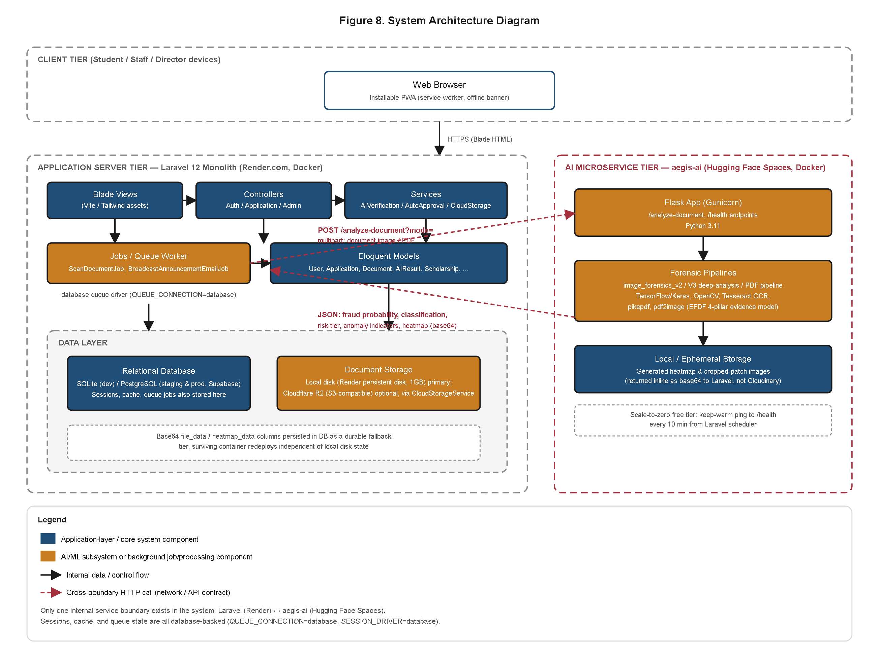
Figure 7. A.E.G.I.S. System Architecture Diagram.
Figure 7 renders this two-service topology in full deployment detail. The Laravel portal is defined as a single Render web service (`render.yaml`: `type: web`, `env: docker`, `region: singapore`), built from a `php:8.4-fpm-alpine`-based `Dockerfile` with the PDO PostgreSQL/MySQL, mbstring, zip, GD, bcmath, and OPcache extensions compiled in, started via a `start.sh` entrypoint on container port 10000, and backed by a 1 GB persistent disk (`aegis_uploads_disk`) mounted at `storage/app` for durable local document storage. Production environment variables fix `APP_ENV=production`, `APP_DEBUG=false`, `LOG_CHANNEL=stderr`, `QUEUE_CONNECTION=database`, and `SESSION_DRIVER=database` — the last a deliberate fix, per the project's engineering log, for cookie truncation and CSRF desynchronization observed behind Render's reverse proxy. Within the Laravel monolith, the diagram further exposes the layered architecture that `app/` maps onto directly: a routing layer (`routes/web.php`, `routes/auth.php`) applying role-scoped middleware groups; a controller layer (`ApplicationController`, `AdminController`, `SuperAdminController`, `DocumentController`, `ReportController`, and others) responsible for request validation and orchestration; a service and job layer (`AIVerificationService`, `ApplicationAutoApprovalService`, `ApplicationAssignmentService`, `AuditLoggerService`, `CloudStorageService`, and the queued `ScanDocumentJob`, `SendBulkStatusEmailJob`, `BroadcastAnnouncementEmailJob`) housing business logic too complex or too reusable for controllers alone; an Eloquent model layer mapping directly onto the schema detailed in Section 4.3.3; and a cross-cutting middleware layer (`CheckRole`, `CheckUserActive`, `SecurityHeaders`, `GzipResponse`) applied globally rather than duplicated per controller.
The `aegis-ai` forensics microservice, by contrast, is built from its own `python:3.11-slim`-based `Dockerfile`, with `poppler-utils` and `tesseract-ocr` installed at the OS level, running as a non-root user for Hugging Face Spaces compatibility, and started via Gunicorn bound to port 7860 rather than Render's port 10000 — confirmed independently by the Laravel application's `SecurityHeaders` Content-Security-Policy, which explicitly allow-lists `*.hf.space` and a named `xyoul-aegis-ai.hf.space` origin as permitted image, frame, and connect sources. The two services are hosted on two entirely different cloud platforms, joined only by outbound HTTP: `ScanDocumentJob` resolves the AI service's base URL from `AEGIS_AI_URL` (or a legacy `AI_SERVICE_URL` fallback) and issues a multipart `POST` to `{aiUrl}/analyze-document` with a 120-second timeout, wrapped in the cold-start retry logic documented in Table 4.6. The diagram also depicts the data-tier split that supports both services: SQLite for local development, PostgreSQL via Supabase for staging and production, and an optional Cloudflare R2 object-storage disk that `CloudStorageService` attempts before falling back automatically to local disk — a resilience pattern mirrored by the layered retry design between the two services themselves.
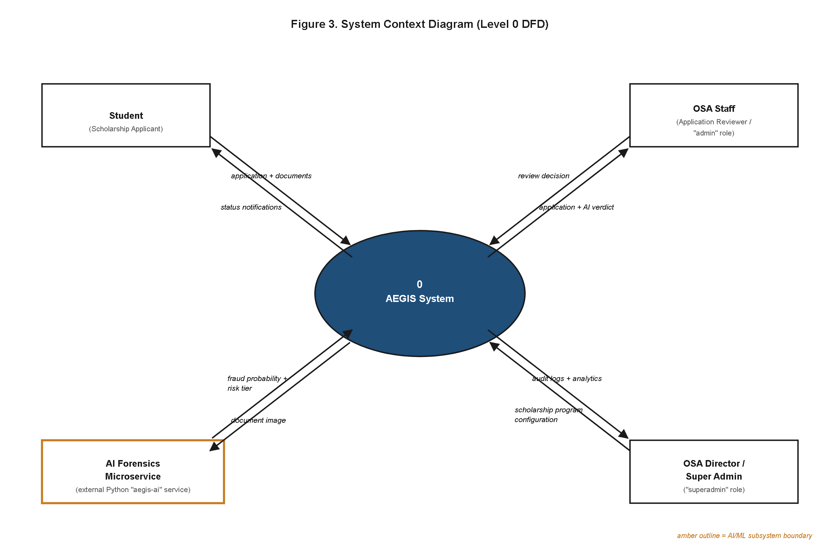
Figure 8. Context Diagram (Level 0 Data Flow Diagram) of the A.E.G.I.S. System.
Figure 8 abstracts the architecture of Figure 7 into a single Level 0 process, "A.E.G.I.S.," and formalizes every external entity that exchanges data across its boundary. The Student/Applicant entity supplies registration data, application data, and supporting document files, and receives application-status updates, in-app notifications, and announcement content in return. The OSA Staff entity supplies review decisions, remarks, and document re-upload requests, and receives case queues and forensic verdicts for the applications assigned to it. The OSA Director/Super Admin entity supplies scholarship-program configuration, staff-account administration commands, system-setting changes, and compliance-export requests, and receives analytics summaries, exported CSV/PDF reports, and configuration confirmations. The AI Forensics Service (`aegis-ai`) entity, external to the Laravel process boundary despite being part of the same overall platform, receives document files for analysis and returns fraud-probability scores, classification labels, and forensic evidence artifacts. A fifth entity, the Email Delivery Provider (the Brevo transactional email API, ahead of SMTP in the application's mail failover chain), receives outbound status-change, MFA one-time-password, and staff-invitation emails composed by the system. This context diagram makes explicit that the system's only outbound network dependencies are the AI forensics service and the email provider — there is no outbound SMS gateway, payment processor, or third-party API integration anywhere in the current implementation.
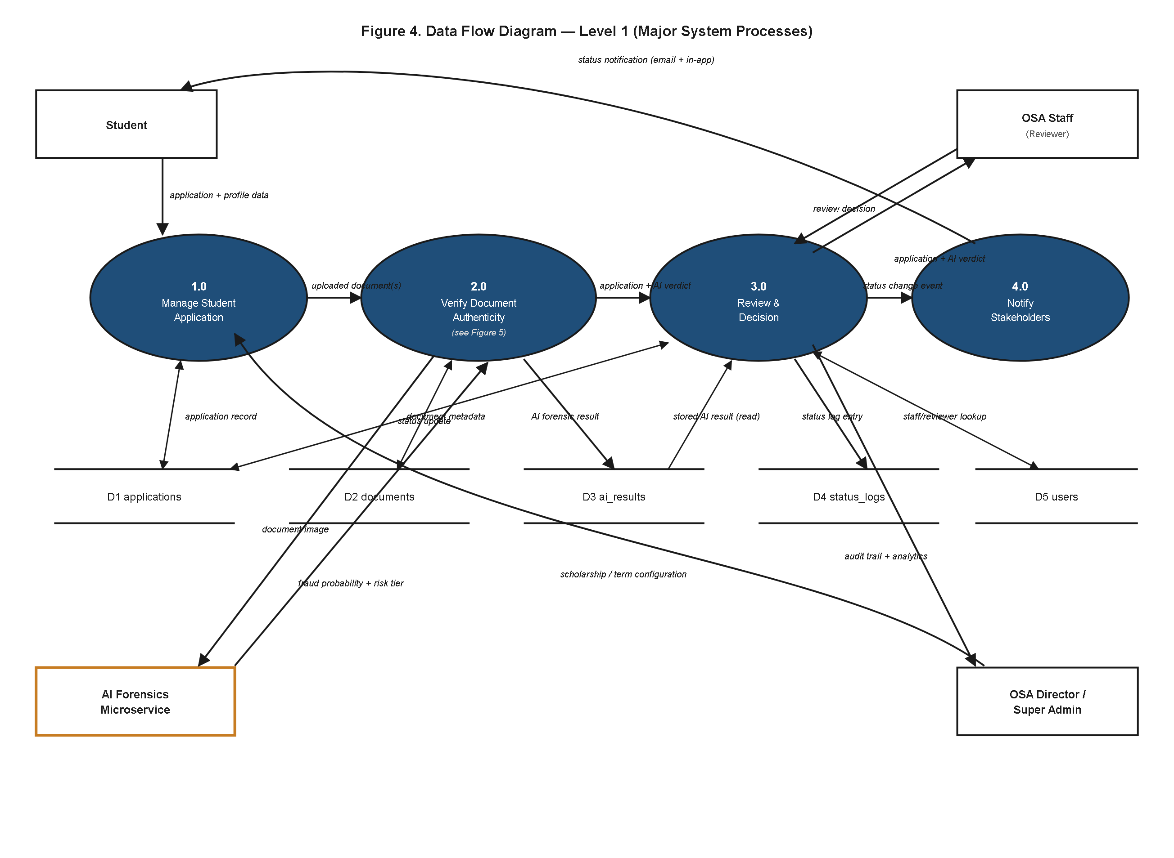
Figure 9. Top-Level Data Flow Diagram (Level 1 DFD).
Figure 9 decomposes the single Level 0 process of Figure 8 into four constituent processes that trace a scholarship application end to end, together with the five data stores those processes read from and write to. Process 1.0, Manage Student Application, receives registration and application data from the Student entity, validates and persists it, and is the process responsible for creating `Application`, `ApplicationField`, and `Document` rows. Process 2.0, Verify Document Authenticity, is triggered by Process 1.0 whenever a new `Document` is created; it corresponds to the `ScanDocumentJob` orchestration traced in Table 4.6, calling out to the external AI Forensics Service entity and writing the returned forensic verdict into the AI Forensic Results data store. Process 3.0, Review and Decision, is invoked by the OSA Staff and OSA Director/Super Admin entities; it reads the current application state and forensic verdict, accepts a review disposition (or, where the auto-approval path qualifies, resolves the disposition itself per Table 4.8), and writes the resulting status transition to the Applications data store and the Audit and Compliance Logs data store simultaneously. Process 4.0, Notify Stakeholders, is triggered by any status transition Process 3.0 produces, or by an OSA Staff/Director-authored announcement, and is responsible for both the database-backed in-app notification and the outbound email dispatched through the external Email Delivery Provider entity. The five data stores that these four processes share are D1 Users and Access, D2 Scholarship Programs, D3 Applications and Custom Fields, D4 Documents and AI Forensic Results, and D5 Audit and Compliance Logs — a grouping that anticipates, and maps directly onto, the four-module organization of the entity-relationship model presented in Section 4.3.3.
4.3.3 Database Entity-Relationship Diagram and Data Dictionary
The relational schema that ultimately backs every process and data store described above is accessed exclusively through Laravel 12's Eloquent ORM and is designed to run interchangeably against SQLite (local development and automated testing) and PostgreSQL, provisioned through Supabase, for staging and production. As of the current migration history — forty-nine migration files spanning March 2026 through July 2026 — the schema comprises thirty tables in total: twenty-three domain-specific tables that back the system's nineteen Eloquent models, and seven Laravel framework infrastructure tables (session, cache, and queue storage, plus password-reset tokens) whose column shapes are dictated by the framework rather than by an A.E.G.I.S.-specific design decision.
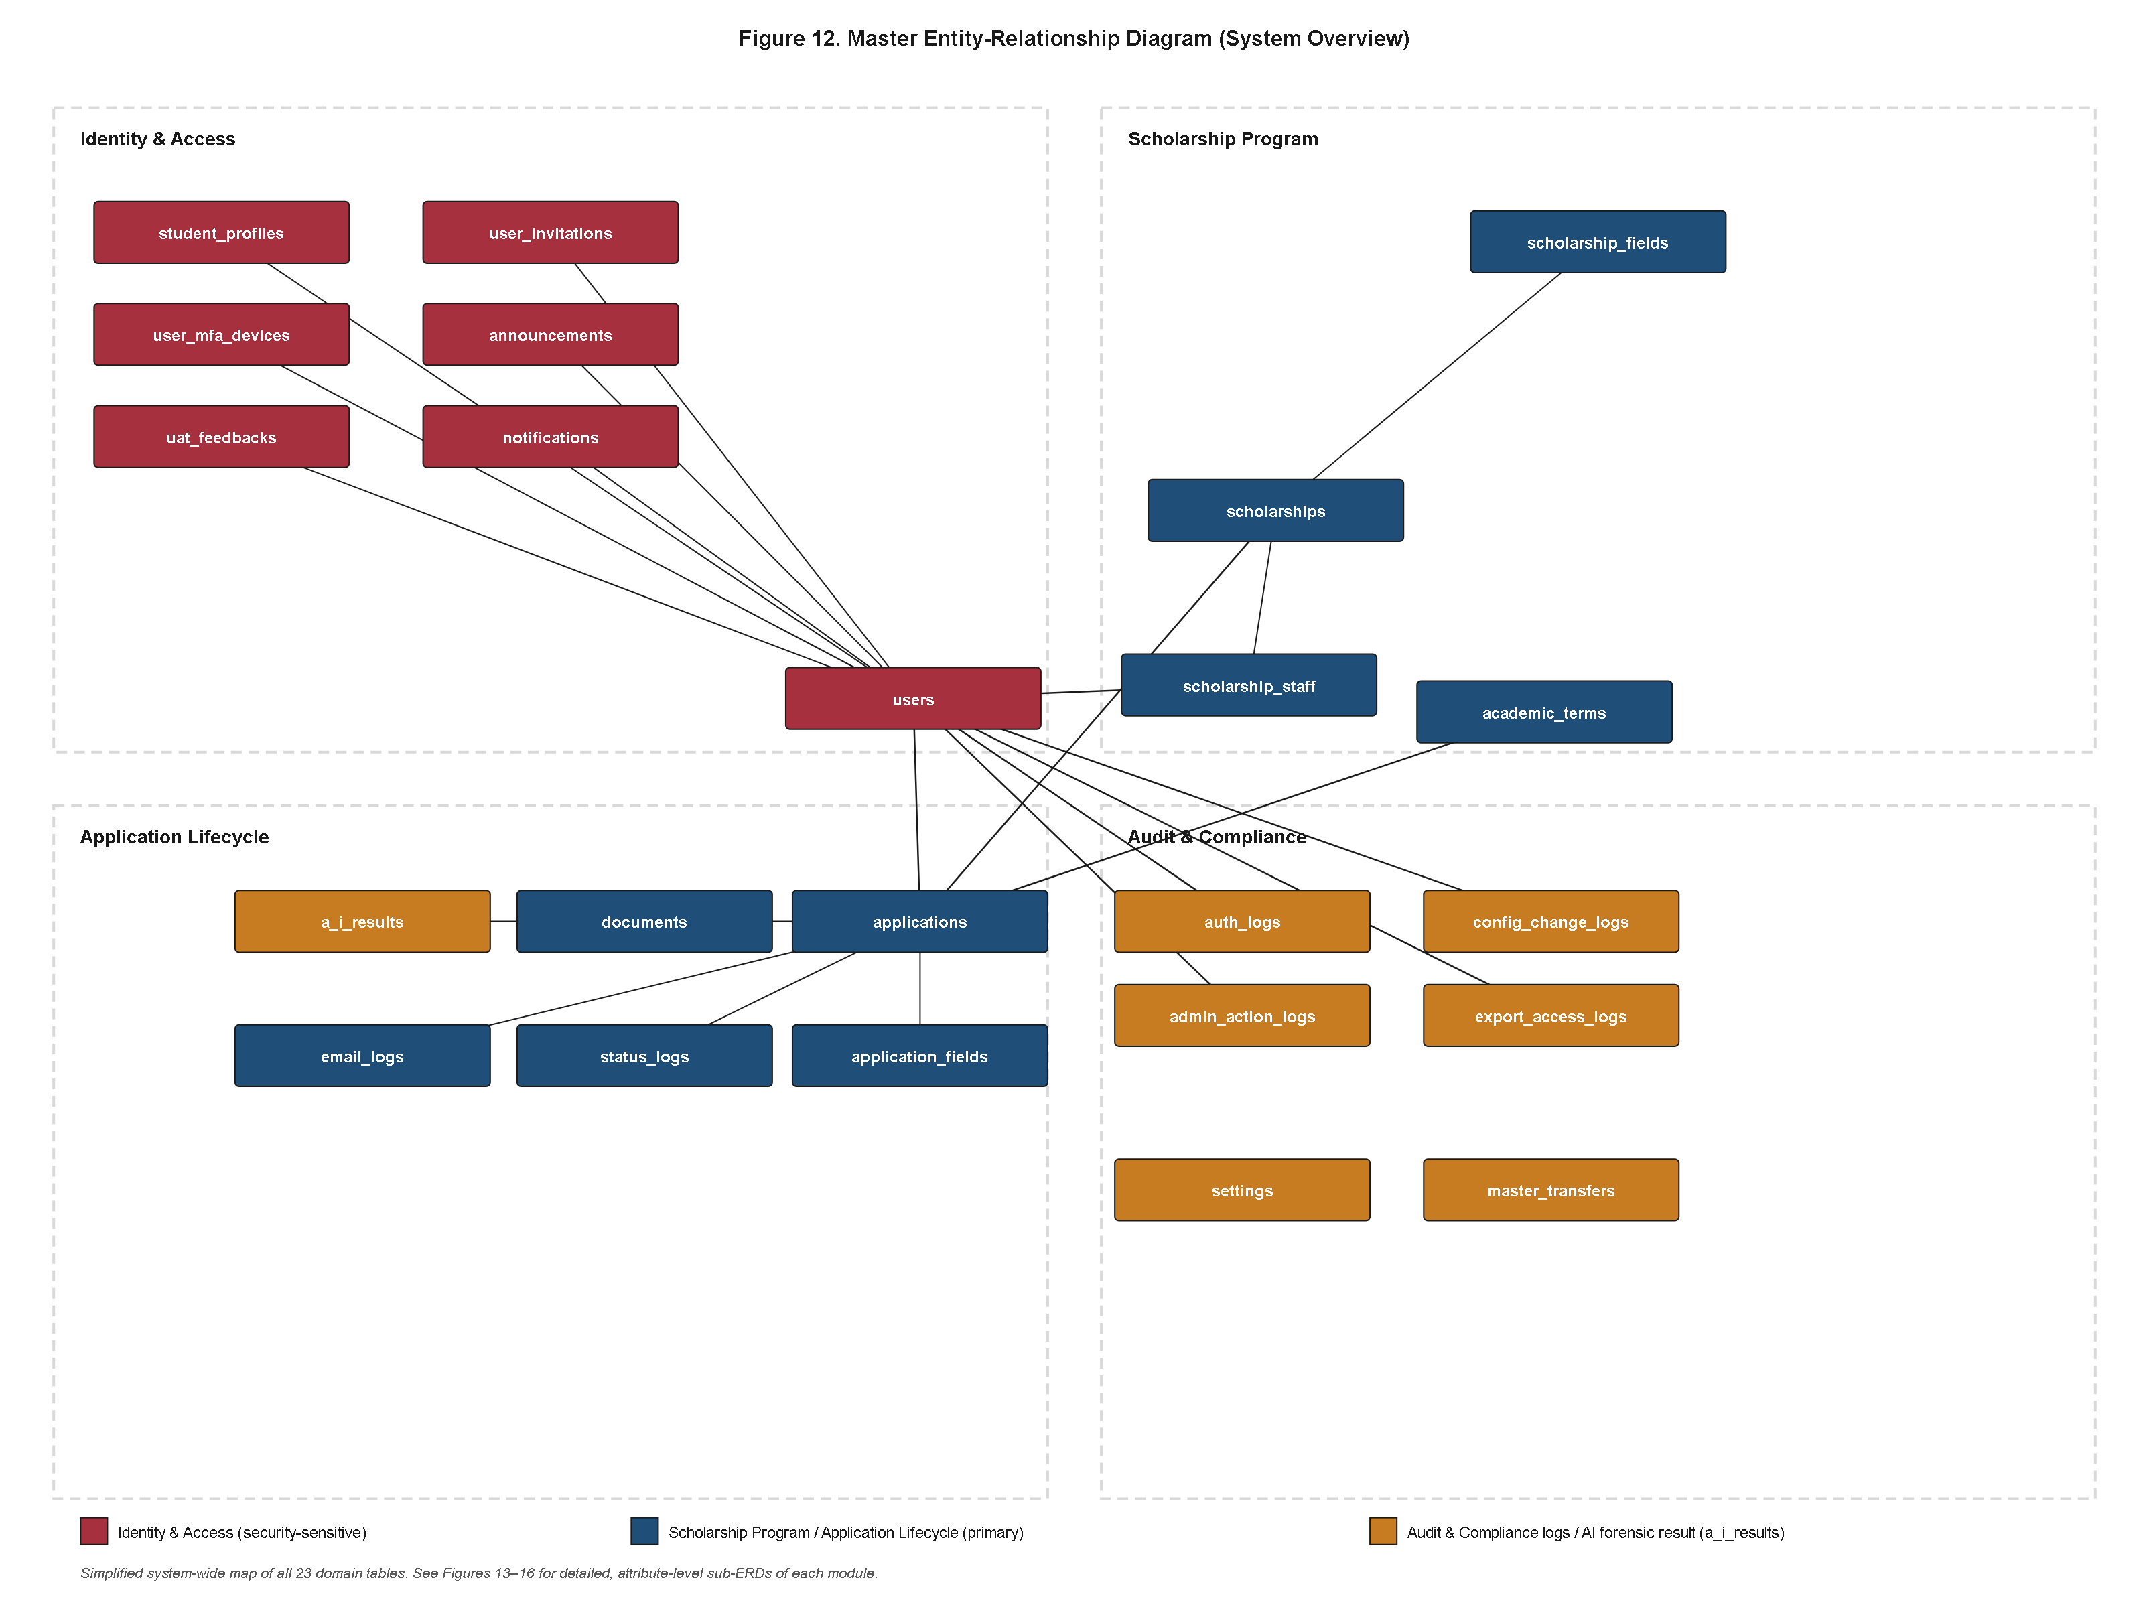
Figure 10. Master Entity-Relationship Diagram of the A.E.G.I.S. System.
Figure 10 renders the complete schema organized into the four functional modules used consistently throughout this chapter — Identity & Access, Scholarship Program, Application Lifecycle, and Audit & Compliance — together with the smaller set of cross-cutting communications, feedback, and system-configuration tables that connect across all four rather than belonging exclusively to any one of them. The Identity & Access module (`users`, `student_profiles`, `user_mfa_devices`, `user_invitations`) anchors every other module in the schema, since every foreign key elsewhere named `user_id`, `evaluated_by`, `assigned_to`, `changed_by`, `uploaded_by`, or `author_id` ultimately resolves to a row in `users`. The Scholarship Program module (`scholarships`, `scholarship_fields`, `scholarship_staff`, `academic_terms`) models what a student may apply for, under whose dynamically configured application form, and within what academic-term window. The Application Lifecycle module (`applications`, `application_fields`, `documents`, `a_i_results`, `status_logs`) is the operational core of the platform, tying a specific student's bid for a specific scholarship to its uploaded evidence, that evidence's forensic findings, and its complete status history. The Audit & Compliance module (`auth_logs`, `admin_action_logs`, `config_change_logs`, `export_access_logs`, `master_transfers`) forms the compliance backbone that gives Office of Student Affairs leadership end-to-end traceability across authentication, discretionary staff decisions, configuration changes, and data exports. Across roughly twenty-three domain tables in total, the diagram renders every foreign-key relationship together with its cardinality and cascade/set-null delete policy, so that a reader can trace, for instance, how deleting a `Scholarship` cascades to its `scholarship_fields` and `scholarship_staff` rows while an `Application`'s `academic_term_id` merely nulls out rather than destroying the application itself when a term is removed.
The condensed data dictionary that follows reformats, module by module, the complete column-level schema documentation verified against the project's migration history and Eloquent model definitions. To keep each entry readable within the scope of a results chapter, every table below is limited to four columns — Column, Type, Key/Constraint, and Description — reusing exactly the data types, constraints, and field-level facts already established for each table, without re-deriving or reinterpreting them.
#### Identity & Access Module
The Identity & Access module comprises four tables that together answer a single question every other module depends on: *who is this actor, and what has been verified about them?* `users` establishes that an actor exists and what role they hold; `student_profiles` extends a student actor with university-specific demographic data; `user_mfa_devices` tracks which devices that actor has proven their identity from recently enough to be trusted without repeating a multi-factor challenge; and `user_invitations` tracks how an admin-created staff account came to exist and complete activation.
Table 4.11
Data Dictionary — users
Column | Type | Key / Constraint | Description
id | bigint unsigned | Primary key, auto-increment | Unique account identifier.
name | string(255) | Not null | Display name.
email | string(255) | Unique index | Login identifier.
email_verified_at | timestamp | Nullable | Set once the account's email is confirmed.
password | string(255) | Not null | Bcrypt-hashed via the `hashed` cast.
otp_code | string(255) | Nullable (added 2026-07-07) | Current one-time-password challenge value.
otp_expires_at | datetime | Nullable (added 2026-07-07) | Expiry of `otp_code`.
remember_token | string(100) | Nullable | Laravel "remember me" cookie token.
role | string(255) | Default `student` (added 2026-03-27) | One of `student`, `admin`, `superadmin`.
is_active | boolean | Default true (added 2026-06-24) | Deactivation flag for suspended accounts.
has_completed_tour | boolean | Default false (added 2026-07-07) | Onboarding-tour completion flag.
deleted_at | timestamp | Nullable (added 2026-07-05) | Soft-delete marker.
created_at / updated_at | timestamp | Nullable | Standard Eloquent timestamps.

Table 4.12
Data Dictionary — student_profiles
Column | Type | Key / Constraint | Description
id | bigint unsigned | Primary key, auto-increment | Unique profile identifier.
user_id | bigint unsigned | FK → users.id, cascade on delete | One-to-one link to the owning student account.
clsu_id_number | string(255) | Unique; encrypted at rest | Official university identifier.
college | string(255) | Not null | Applicant's college.
course | string(255) | Not null | Applicant's degree program.
year_level | string(255) | Not null | Applicant's current year level.
contact_number | string(255) | Nullable; encrypted at rest | Personal contact number.
guardian_name | string(255) | Nullable (added 2026-07-27); encrypted at rest | Guardian's full name.
emergency_contact_number | string(255) | Nullable (added 2026-07-27); encrypted at rest | Emergency contact number.
created_at / updated_at | timestamp | Nullable | Standard Eloquent timestamps.

Note. This table briefly carried three bank-disbursement columns (bank_name, bank_account_name, bank_account_number), added 2026-07-08 and removed the following day alongside scholarships.stipend_amount, indicating the disbursement feature was descoped before reaching production.
Table 4.13
Data Dictionary — user_mfa_devices
Column | Type | Key / Constraint | Description
id | bigint unsigned | Primary key, auto-increment | Unique device-trust record identifier.
user_id | bigint unsigned | FK → users.id, cascade on delete | Owning user account.
device_token | string(255) | Unique | The "remembered device" cookie value.
ip_address | string(255) | Nullable | IP address at enrollment.
user_agent_hash | string(255) | Nullable | Hash of the enrolling browser's user-agent string.
user_agent | text | Nullable | Raw user-agent string, for display purposes.
expires_at | timestamp | Not null | 30-day trust window from enrollment.
created_at / updated_at | timestamp | Nullable | Standard Eloquent timestamps; composite index on (user_id, device_token).

Table 4.14
Data Dictionary — user_invitations
Column | Type | Key / Constraint | Description
id | bigint unsigned | Primary key, auto-increment | Unique invitation record identifier.
user_id | bigint unsigned | FK → users.id, cascade on delete | The pre-created account this invitation activates.
token | string(255) | Unique | Invitation confirmation token.
expires_at | timestamp | Not null | Token expiry.
created_at / updated_at | timestamp | Nullable | Standard Eloquent timestamps.

#### Scholarship Program Module
The Scholarship Program module comprises four tables that together model what a student can apply for, on what terms, under whose custom application form, and who on staff is responsible for evaluating it. `scholarships` is the module's anchor table; `scholarship_fields` extends it along a form-schema axis using an entity-attribute-value pattern; `scholarship_staff` extends it along a staffing axis as a many-to-many pivot; and `academic_terms` provides the temporal scoping context against which every application is evaluated.
Table 4.15
Data Dictionary — scholarships
Column | Type | Key / Constraint | Description
id | bigint unsigned | Primary key, auto-increment | Unique scholarship program identifier.
name | string(255) | Not null | Program name.
description | text | Nullable | Program description.
min_gwa_required | decimal(3,2) | Nullable | Minimum GWA eligibility threshold.
deadline | date | Nullable | Application cutoff date.
status | string(255) | Default `Active` | `Active` or `Closed`.
max_renewals | tinyint unsigned | Default 4 (added 2026-07-05) | Maximum renewal cycles permitted.
deleted_at | timestamp | Nullable (added 2026-07-05) | Soft-delete marker.
created_at / updated_at | timestamp | Nullable | Standard Eloquent timestamps.

Note. A stipend_amount column was added 2026-07-08 to support monthly disbursement tracking and removed nine days later, indicating per-scholarship fund disbursement was descoped from the current release.
Table 4.16
Data Dictionary — scholarship_fields
Column | Type | Key / Constraint | Description
id | bigint unsigned | Primary key, auto-increment | Unique field-definition identifier.
scholarship_id | bigint unsigned | FK → scholarships.id, cascade on delete | The program this question belongs to.
field_name | string(255) | Not null | Machine-readable key, e.g. `fathers_occupation`.
field_label | string(255) | Not null | Human-readable prompt shown on the application form.
field_type | string(255) | Not null | One of `text`, `number`, `textarea`, `select`, `file`.
is_required | boolean | Default false | Whether the applicant must answer this question.
options | text | Nullable | JSON-encoded list of choices for `select`-type fields.
created_at / updated_at | timestamp | Nullable | Standard Eloquent timestamps.

Table 4.17
Data Dictionary — scholarship_staff
Column | Type | Key / Constraint | Description
id | bigint unsigned | Primary key, auto-increment | Unique pivot-row identifier.
scholarship_id | bigint unsigned | FK → scholarships.id, cascade on delete | The scholarship being staffed.
user_id | bigint unsigned | FK → users.id, cascade on delete | The staff account assigned to evaluate it.
created_at / updated_at | timestamp | Nullable | Standard Eloquent timestamps.

Note. A many-to-many pivot with no dedicated Eloquent model; surfaced through Scholarship::staff() and User::scholarships() belongsToMany relationships.
Table 4.18
Data Dictionary — academic_terms
Column | Type | Key / Constraint | Description
id | bigint unsigned | Primary key, auto-increment | Unique term identifier.
semester | string(255) | Not null | e.g. "1st Semester".
academic_year | string(255) | Not null | e.g. "2025-2026".
is_active | boolean | Default false | Only one term is expected to be active at a time.
created_at / updated_at | timestamp | Nullable | Standard Eloquent timestamps.

#### Application Lifecycle Module
The Application Lifecycle module comprises five tables that together form the operational core of the entire platform. `applications` is the anchor entity, representing one student's bid for one scholarship in one academic term. `application_fields` extends it along the custom-answer axis; `documents` extends it along the evidence axis; `a_i_results` extends `documents` one level further with the forensic-scan outcome; and `status_logs` extends `applications` along the history axis, recording every status transition as an immutable row.
Table 4.19
Data Dictionary — applications
Column | Type | Key / Constraint | Description
id | bigint unsigned | Primary key, auto-increment | Unique application identifier.
user_id | bigint unsigned | FK → users.id, cascade on delete | Applicant.
scholarship_id | bigint unsigned | FK → scholarships.id, cascade on delete | Scholarship applied for.
academic_term_id | bigint unsigned | Nullable; FK → academic_terms.id, set null on delete | Term the application is scoped to.
program_name | string(255) | Not null | Applicant's degree program at time of application.
gwa | string(255) | Nullable (relaxed 2026-07-06) | Self-declared general weighted average.
status | string(255) | Default `Pending` | e.g. `Pending`, `Under Review`, `Approved`, `Rejected`.
is_archived | boolean | Default false (added 2026-06-24) | Hides closed-out records from default views.
is_renewal | boolean | Default false (added 2026-07-07) | Flags a renewal application.
previous_application_id | bigint unsigned | Nullable (added 2026-07-07); self-referencing FK, null on delete | Links a renewal to its predecessor.
forfeit_reason | text | Nullable (added 2026-07-07) | Reason a renewal chain was broken/forfeited.
remarks | text | Nullable | Evaluator-facing remarks.
admin_notes | text | Nullable (added 2026-07-05) | Internal notes distinct from applicant-visible remarks.
evaluated_by | bigint unsigned | Nullable; FK → users.id, set null on delete | Staff member who rendered the decision; null for system decisions.
assigned_to | bigint unsigned | Nullable (added 2026-07-10); FK → users.id, set null on delete | Staff member currently reviewing the case.
deleted_at | timestamp | Nullable (added 2026-07-05) | Soft-delete marker.
created_at / updated_at | timestamp | Nullable | Standard Eloquent timestamps.

Table 4.20
Data Dictionary — application_fields
Column | Type | Key / Constraint | Description
id | bigint unsigned | Primary key, auto-increment | Unique answer-record identifier.
application_id | bigint unsigned | FK → applications.id, cascade on delete, withTrashed | The application this answer belongs to.
field_name | string(255) | Not null | Corresponds to a scholarship_fields.field_name.
field_value | text | Not null; encrypted at rest | The applicant's answer.
is_synced | boolean | Default true (added 2026-07-15) | Offline/sync-state flag.
created_at / updated_at | timestamp | Nullable | Standard Eloquent timestamps.

Table 4.21
Data Dictionary — documents
Column | Type | Key / Constraint | Description
id | bigint unsigned | Primary key, auto-increment | Unique document record identifier.
application_id | bigint unsigned | FK → applications.id, cascade on delete | Owning application.
file_path | string(255) | Not null | Logical/disk storage path.
file_data | longtext | Nullable (added 2026-07-20) | Base64-encoded file content persisted directly in the database.
is_synced | boolean | Default true (added 2026-07-15) | Offline/sync-state flag.
original_name | string(255) | Not null | Original client-side filename.
document_type | string(255) | Default `COG` | e.g. Certificate of Grades, custom uploads.
upload_event | string(20) | Default `initial` (added 2026-07-09) | One of `initial`, `replaced`, `deleted`.
uploaded_by | bigint unsigned | Nullable (added 2026-07-09); FK → users.id, set null on delete | Uploader, if staff-mediated.
created_at / updated_at | timestamp | Nullable | Standard Eloquent timestamps.

Note. This table is not soft-deleted; upload_event's deleted value serves as a logical tombstone marker within the same row/lineage instead.
Table 4.22
Data Dictionary — a_i_results
Column | Type | Key / Constraint | Description
id | bigint unsigned | Primary key, auto-increment | Unique forensic-result identifier.
document_id | bigint unsigned | FK → documents.id, cascade on delete | The document this scan was run against.
fraud_probability | decimal(5,2) | Not null | Percentage confidence of tampering, e.g. `85.50`.
classification | string(255) | Not null | e.g. `Authentic`, `Tampered`.
detected_software | string(255) | Nullable (added 2026-07-21) | Editing-software signature detected, if any.
heatmap_path | string(255) | Nullable | Disk path to a generated tamper-heatmap image.
heatmap_data | longtext | Nullable (added 2026-07-20) | Base64-encoded heatmap image content.
anomaly_indicators | json | Nullable (added 2026-07-09) | Structured list of specific anomalies found.
cropped_patch_data | longtext | Nullable (added 2026-07-21) | Base64-encoded crop of the suspect region.
deep_analysis_report | json | Nullable (added 2026-07-28) | Full structured forensic report payload.
created_at / updated_at | timestamp | Nullable | Standard Eloquent timestamps.

Note. Keyed via updateOrCreate on document_id alone, so a re-scan overwrites the prior finding rather than accumulating scan history; consequences of a finding are historized separately in status_logs and admin_action_logs.
Table 4.23
Data Dictionary — status_logs
Column | Type | Key / Constraint | Description
id | bigint unsigned | Primary key, auto-increment | Unique transition-record identifier.
application_id | bigint unsigned | FK → applications.id, cascade on delete, withTrashed | The application undergoing transition.
status | string(255) | Not null | The status value being transitioned to.
remarks | text | Nullable | Optional note accompanying the transition.
changed_by | bigint unsigned | Nullable; FK → users.id, set null on delete | Actor who triggered the transition; null-able for system actions.
created_at / updated_at | timestamp | Nullable | created_at is effectively the transition timestamp.

#### Audit & Compliance Module
The Audit & Compliance module forms the compliance backbone of A.E.G.I.S., comprising the five purpose-typed ledger and workflow tables — `auth_logs`, `admin_action_logs`, `config_change_logs`, `export_access_logs`, and `master_transfers` — that together give Office of Student Affairs leadership a reconstructable, exportable history of authentication events, discretionary staff decisions, configuration changes, data exports, and superadmin succession, independent of the domain records those events describe. For completeness, this module also gathers the cross-cutting communications, feedback, and system-configuration tables (`notifications`, `announcements`, `email_logs`, `uat_feedbacks`, `settings`) that surface or support those audited events through other channels, and the seven Laravel framework infrastructure tables that persist session, cache, and queue state in the same relational database rather than in a separate service, given the project's `SESSION_DRIVER=database` and `QUEUE_CONNECTION=database` configuration.
Table 4.24
Data Dictionary — auth_logs
Column | Type | Key / Constraint | Description
id | bigint unsigned | Primary key, auto-increment | Unique authentication-event identifier.
user_id | bigint unsigned | Nullable; FK → users.id, set null on delete | Subject of the event, where resolvable.
email_attempted | string(255) | Nullable | Captured even when no user record matches.
event_type | string(255) | Not null | `login_success`, `login_failed`, `mfa_verified`, `mfa_failed`, `device_trusted`, `device_revoked`, `logout`.
ip_address | string(45) | Nullable | Client network origin.
user_agent | text | Nullable | Client browser identification string.
status | string(20) | Default `success` | `success` or `failed`.
metadata | json | Nullable | Free-form structured context per event type.
created_at / updated_at | timestamp | Nullable | Standard Eloquent timestamps.

Table 4.25
Data Dictionary — admin_action_logs
Column | Type | Key / Constraint | Description
id | bigint unsigned | Primary key, auto-increment | Unique action-log identifier.
user_id | bigint unsigned | FK → users.id, cascade on delete | Acting privileged user.
action | string(255) | Not null | Free-text action code, e.g. `bulk_approve_application`, `scholarship_created`, `system_auto_approved`.
target_type | string(255) | Nullable | `Application`, `Scholarship`, `User`, `System`.
target_id | bigint unsigned | Nullable; not foreign-key constrained | Identifier of the affected entity.
description | text | Nullable | Human-readable detail.
ip_address | string(45) | Nullable | Client network origin; `127.0.0.1` denotes a server-originated action.
created_at / updated_at | timestamp | Nullable | Standard Eloquent timestamps.

Table 4.26
Data Dictionary — config_change_logs
Column | Type | Key / Constraint | Description
id | bigint unsigned | Primary key, auto-increment | Unique configuration-change record identifier.
user_id | bigint unsigned | FK → users.id, cascade on delete | Acting privileged user.
setting_key | string(255) | Not null | Corresponds to a settings.key value.
old_value | text | Nullable | Value before the change.
new_value | text | Nullable | Value after the change.
ip_address | string(45) | Nullable | Client network origin.
created_at / updated_at | timestamp | Nullable | Standard Eloquent timestamps.

Table 4.27
Data Dictionary — export_access_logs
Column | Type | Key / Constraint | Description
id | bigint unsigned | Primary key, auto-increment | Unique export-event identifier.
user_id | bigint unsigned | FK → users.id, cascade on delete | Acting privileged user.
export_type | string(255) | Not null; free-text category | e.g. one of twelve report categories generated by ReportController.
date_from | date | Nullable | Requested report range start.
date_to | date | Nullable | Requested report range end.
format | string(10) | Not null | `csv` or `pdf`.
ip_address | string(45) | Nullable | Client network origin.
created_at / updated_at | timestamp | Nullable | Standard Eloquent timestamps.

Note. Logged via AuditLoggerService::logExportAccess() immediately before the export query executes, so even an incomplete download is recorded.
Table 4.28
Data Dictionary — master_transfers
Column | Type | Key / Constraint | Description
id | bigint unsigned | Primary key, auto-increment | Unique transfer-workflow record identifier.
sender_email | string(255) | Not null | Current Master account's email.
recipient_email | string(255) | Not null | Proposed new Master account's email.
token | string(255) | Unique | Confirmation token.
expires_at | timestamp | Not null | Transfer-offer expiry.
accepted_at | timestamp | Nullable | Null until the recipient confirms.
created_at / updated_at | timestamp | Nullable | Standard Eloquent timestamps.

Note. Deliberately carries no foreign key to users, since it must remain verifiable across the exact moment the master_email setting itself is being changed.
Table 4.29
Data Dictionary — notifications
Column | Type | Key / Constraint | Description
id | uuid | Primary key | Unique notification identifier.
type | string(255) | Not null | Fully-qualified notification class name.
notifiable_type | string(255) | Not null | Polymorphic recipient model type.
notifiable_id | bigint unsigned | Not null | Polymorphic recipient identifier.
data | text | Not null | JSON-encoded notification payload.
read_at | timestamp | Nullable | Null while unread.
created_at / updated_at | timestamp | Nullable | Standard Eloquent timestamps.

Note. Populated by three database-channel notification classes — ApplicationStatusNotification, NewApplicationNotification, NewAnnouncementNotification — of six total notification classes in the system.
Table 4.30
Data Dictionary — announcements
Column | Type | Key / Constraint | Description
id | bigint unsigned | Primary key, auto-increment | Unique announcement identifier.
title | string(255) | Not null | Announcement headline.
content | text | Not null | Announcement body.
scheduled_publish_at | datetime | Nullable (added 2026-07-07) | Scheduled publication time.
scheduled_delete_at | datetime | Nullable (added 2026-07-07) | Scheduled auto-expiry time.
author_id | bigint unsigned | FK → users.id, cascade on delete | Authoring staff/director account.
created_at / updated_at | timestamp | Nullable | Standard Eloquent timestamps.

Table 4.31
Data Dictionary — email_logs
Column | Type | Key / Constraint | Description
id | bigint unsigned | Primary key, auto-increment | Unique email-log identifier.
application_id | bigint unsigned | Nullable; FK → applications.id, cascade on delete, withTrashed | Related application, where applicable.
recipient | string(255) | Not null | Destination email address.
subject | string(255) | Not null | Email subject line.
content | text | Not null | Rendered email body.
status | string(20) | Default `sent` (added 2026-07-09) | `sent` or `failed`.
error_message | text | Nullable (added 2026-07-09) | Delivery failure detail.
created_at / updated_at | timestamp | Nullable | Standard Eloquent timestamps.

Table 4.32
Data Dictionary — uat_feedbacks
Column | Type | Key / Constraint | Description
id | bigint unsigned | Primary key, auto-increment | Unique feedback-record identifier.
user_id | bigint unsigned | Nullable; FK → users.id, set null on delete | Respondent, where resolvable.
role | string(255) | Not null | Respondent's role at time of feedback.
functional_suitability | integer | Not null | Likert-style rating (validated 1-5 at request layer).
usability | integer | Not null | Likert-style rating (validated 1-5 at request layer).
reliability | integer | Not null | Likert-style rating (validated 1-5 at request layer).
security | integer | Not null | Likert-style rating (validated 1-5 at request layer).
comments | text | Nullable | Free-text feedback.
created_at / updated_at | timestamp | Nullable | Standard Eloquent timestamps.

Note. Modeled on ISO/IEC 25010 quality-in-use characteristics; ratings are unconstrained integers at the schema level, with the 1-5 domain enforced by UatFeedbackController's request validation.
Table 4.33
Data Dictionary — settings
Column | Type | Key / Constraint | Description
id | bigint unsigned | Primary key, auto-increment | Unique setting-row identifier.
key | string(255) | Unique | Configuration key, e.g. `master_email`, `ai_fraud_threshold`, `auto_approval_enabled`.
value | text | Nullable | Configuration value.
created_at / updated_at | timestamp | Nullable | Standard Eloquent timestamps.

Note. Every key is read through Setting::get($key, $default), so the system functions with sensible defaults even before an administrator writes a corresponding row; both an in-process array cache and the Laravel cache store sit in front of this table.
Table 4.34
Data Dictionary — password_reset_tokens
Column | Type | Key / Constraint | Description
email | string(255) | Primary key | The account email the reset token was issued for.
token | string(255) | Not null | Hashed password-reset token.
created_at | timestamp | Nullable | Used to expire stale tokens.

Note. Standard Laravel password-reset broker table, not modeled as a custom Eloquent entity; the reset-notification delivery is customized (CustomResetPasswordNotification) without altering this table's shape.
Table 4.35
Data Dictionary — sessions
Column | Type | Key / Constraint | Description
id | string(255) | Primary key | The session identifier.
role | string(255) | Default `student` | Present in the migration but not read by application session logic.
user_id | bigint unsigned | Nullable; indexed, not FK-constrained | Owning user, where authenticated.
ip_address | string(45) | Nullable | Client network origin.
user_agent | text | Nullable | Client browser identification string.
payload | longtext | Not null | Serialized session payload.
last_activity | integer | Not null; indexed | Unix timestamp used for garbage collection.

Note. Backs the database session driver; role/permission decisions are made from users.role (Table 4.11), not from this table's own role column.
Table 4.36
Data Dictionary — cache and cache_locks
Column | Type | Key / Constraint | Description
cache.key | string(255) | Primary key | Cache entry key.
cache.value | mediumtext | Not null | Serialized cached value.
cache.expiration | integer | Indexed | Unix expiry timestamp.
cache_locks.key | string(255) | Primary key | Lock key.
cache_locks.owner | string(255) | Not null | Lock-holder identifier.
cache_locks.expiration | integer | Indexed | Unix expiry timestamp.

Note. Backs Laravel's database cache driver and atomic-lock primitive, used to memoize the active academic term, the active scholarships list, and individual Setting values.
Table 4.37
Data Dictionary — jobs, job_batches, and failed_jobs
Column | Type | Key / Constraint | Description
jobs.id | bigint unsigned | Primary key, auto-increment | Queued job identifier.
jobs.queue | string(255) | Indexed | Target queue name.
jobs.payload | longtext | Not null | Serialized job payload.
jobs.attempts | tinyint unsigned | Not null | Attempt counter.
jobs.reserved_at / available_at / created_at | int unsigned | Nullable/Not null | Queue scheduling timestamps.
job_batches.id | string(255) | Primary key | Batch identifier.
job_batches.name | string(255) | Not null | Batch label.
job_batches.total_jobs / pending_jobs / failed_jobs | integer | Not null | Batch progress counters.
job_batches.failed_job_ids | longtext | Not null | JSON-encoded array of failed job identifiers.
job_batches.options / cancelled_at / created_at / finished_at | mixed | Nullable/Not null | Batch metadata and lifecycle timestamps.
failed_jobs.id | bigint unsigned | Primary key, auto-increment | Failed-job record identifier.
failed_jobs.uuid | string(255) | Unique | Job UUID.
failed_jobs.connection / queue | text | Not null | Originating queue connection and name.
failed_jobs.payload / exception | longtext | Not null | Original job payload and captured exception trace.
failed_jobs.failed_at | timestamp | Default current timestamp | Failure timestamp.

Note. These three tables back Laravel's queue subsystem, used for deferred work such as ScanDocumentJob, SendBulkStatusEmailJob, and BroadcastAnnouncementEmailJob, and follow Laravel's standard migration stubs rather than an A.E.G.I.S.-specific design.
4.3.4 Detailed Use Case Breakdown and Module-Level Entity-Relationship Diagrams
While Figure 7 established the consolidated, system-wide actor and use-case model, the granularity required to validate that role-based functional decomposition was actually carried through to implementation warrants a finer-grained treatment organized strictly by actor role. Figure 26 disaggregates the system-wide model into three coordinated panels — the Student Portal, the OSA Staff Review console, and the Super Admin/OSA Director control plane — each anchored to its own primary actor and populated with use cases that were deliberately omitted from Figure 7 to preserve that diagram's legibility at the whole-system level.
Figure 26. Detailed Use Case Diagram by Actor Role (Student, OSA Staff Review, and Super Admin/OSA Director).
The Student panel elaborates the applicant-facing surface beyond simple submission, including Save Application Draft (Autosave), Resubmit Corrected Document, Track Application Status, View Forensic Certificate, Receive Broadcast Announcement, Manage MFA Trusted Devices, Update Profile Information, and the previously modeled Submit Scholarship Application use case now shown alongside its finer siblings. The presence of an explicit autosave use case is a direct architectural response to the risk of data loss during the multi-field, multi-document scholarship application process; rather than requiring an applicant to complete an extended form in a single sitting, the system persists draft state incrementally, and the corrective resubmission use case similarly formalizes the pathway by which an applicant whose document was returned for correction re-enters the pipeline without re-initiating an entirely new application record. The OSA Staff Review panel isolates use cases proper to human-in-the-loop adjudication: Interpret AI Forensic Evidence, Apply Quick-Preset Remarks, Bulk Approve/Reject, Assign Application for Review, Escalate to Super Admin, View Applicant Communication History, Filter Queue by Risk Tier, and Approve/Reject Application. The inclusion of Apply Quick-Preset Remarks and Bulk Approve/Reject reflects a throughput-oriented design decision: because the automated forensic pipeline routes only a minority of applications to manual queues, staff-facing tooling was optimized to minimize per-decision friction for the residual caseload rather than treating every review as a bespoke, unassisted judgment call. The Super Admin/OSA Director panel isolates governance and configuration authority distinct from day-to-day review: Invite New Staff Account, Configure Auto-Approval Thresholds, View Configuration Change Log, Configure Scholarship Program, Broadcast Announcement, Export Compliance Reports, Manage Staff Assignments, and Revoke Staff Access. Segregating these use cases into a panel of their own, rather than folding them into the general staff panel, operationalizes the principle of least privilege at the modeling layer itself: a diagram reviewer can immediately see that threshold configuration and staff account governance are not reachable by an ordinary OSA Staff actor, which is a modeled precondition later enforced in code by the role-based middleware discussed in Section 4.3.5. Taken together, the three panels of Figure 26 constitute direct evidence that the role-based functional decomposition envisioned during requirements engineering was not merely a database-level access-control policy but was carried consistently into the interaction design of the system, with each actor's available action set scoped tightly to institutional responsibility.
It is instructive to compare the finer granularity of Figure 26 against the coarser system-wide model of Figure 7 rather than treating the two as unrelated artifacts produced at different points in the project timeline. Figure 7 was necessarily abstracted to a small number of representative use cases so that the full actor set — including the «system» AI Forensics Service actor — could be shown on a single, legible diagram communicating the system's overall shape to a reader encountering the project for the first time. Figure 26 was produced once implementation had progressed far enough that the finer-grained action set available to each human actor could be enumerated with confidence that each listed use case corresponded to an actually working feature rather than an aspirational one. Read as a pair, the two diagrams therefore also document a progression in the certainty of the modeling artifact itself: Figure 7 represents the use-case model as scoped during design, while Figure 26 represents the use-case model as verified against the completed implementation, with every use case named in the latter traceable to a concrete controller action, service method, or interface component described elsewhere in this chapter.
Complementing the use-case decomposition, Figures 27 through 30 disaggregate the master overview presented in Figure 19 into four attribute-level module Entity-Relationship Diagrams, restoring the primary keys, foreign keys, and cardinality notations that the master diagram intentionally omits for readability. These four figures, read together, constitute the demonstrable 3NF evidence referenced in the revised caption of Figure 19.
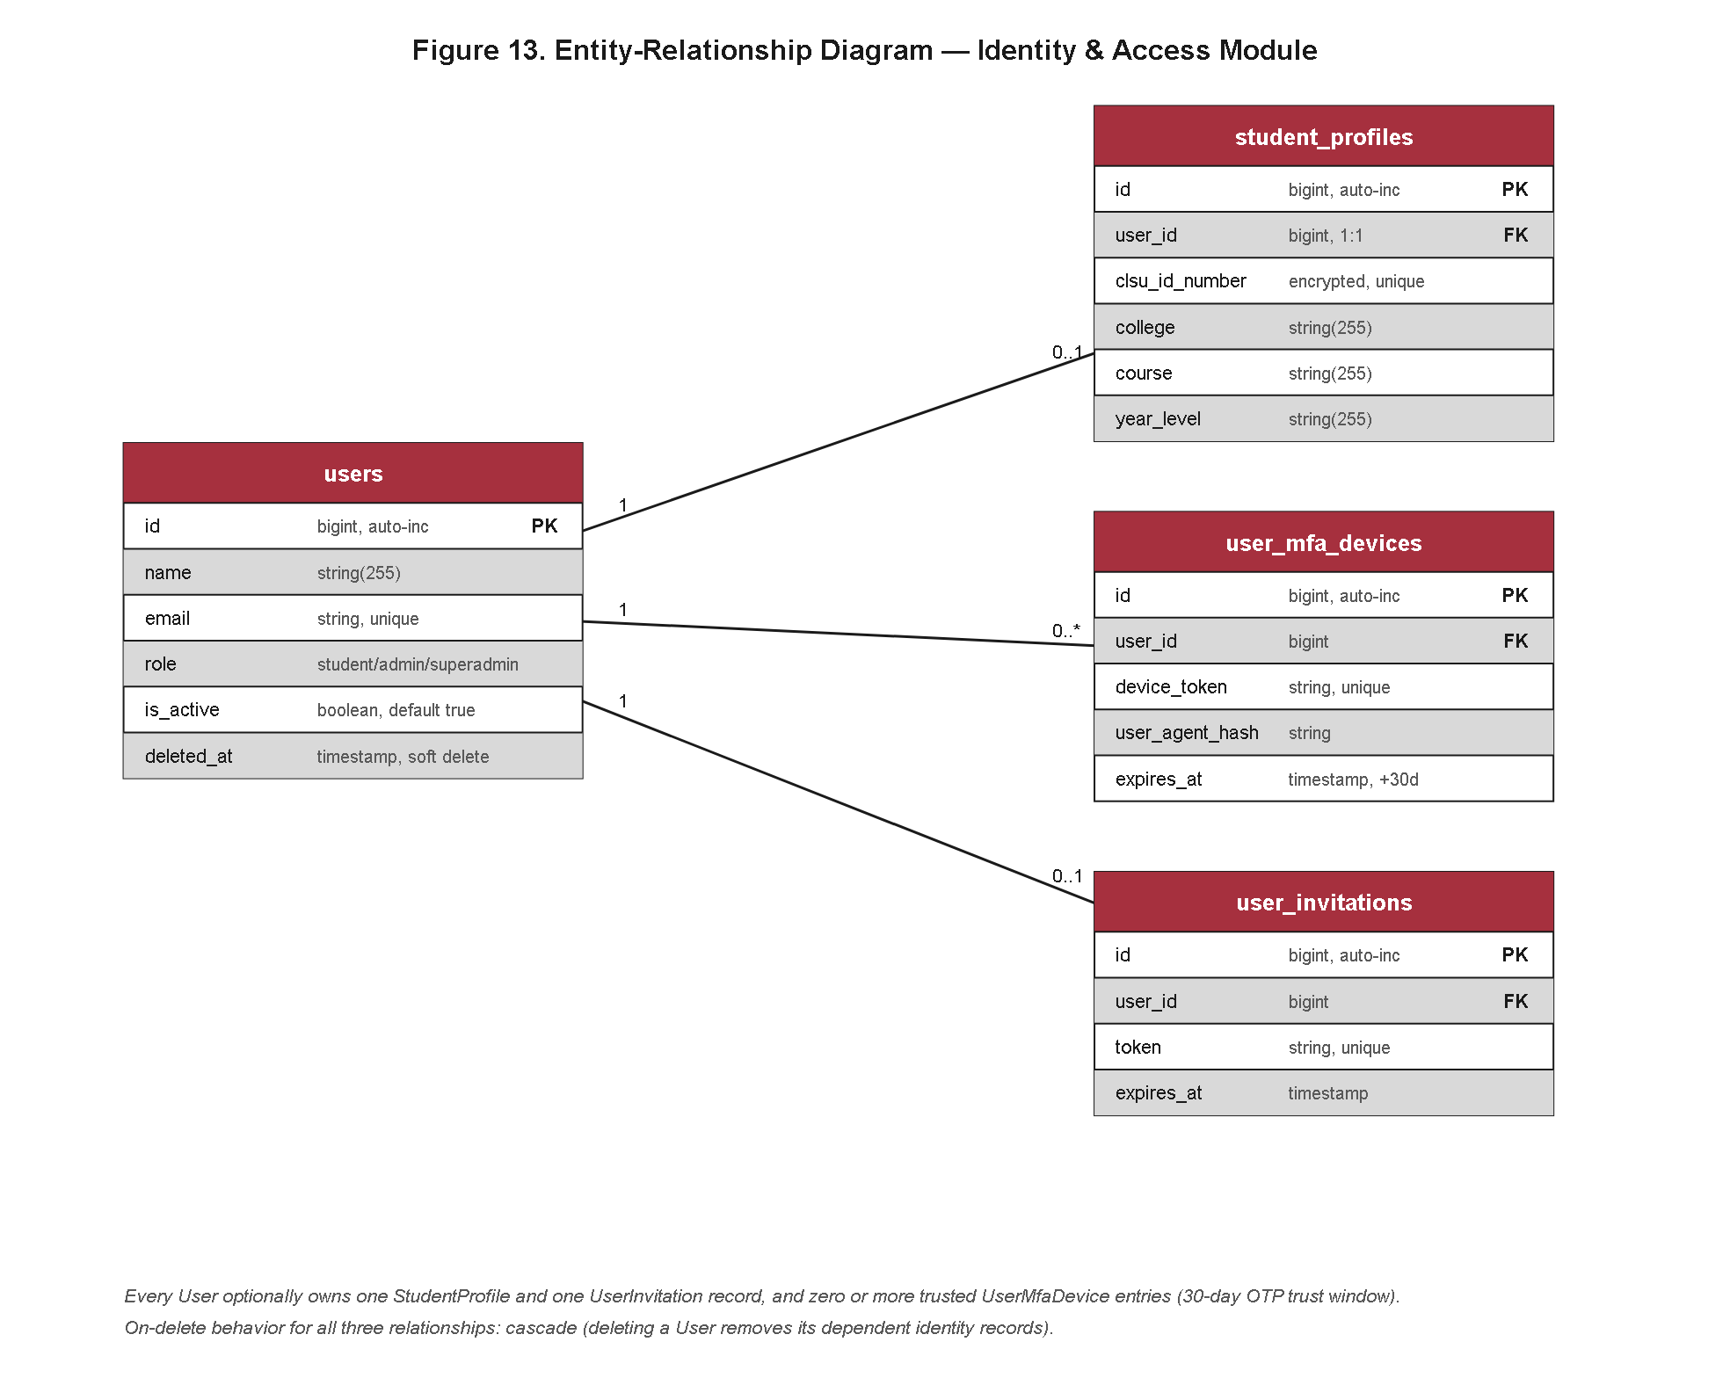
Figure 27. Entity-Relationship Diagram of the Identity and Access Management Module.
Figure 27 details the Identity and Access Management module, comprising the users, student_profiles, user_mfa_devices, and user_invitations entities, whose column-level specifications were already enumerated in the data dictionary tables of Section 4.3.3 (Tables 4.15 through 4.21) and are therefore not restated here. The module diagram makes explicit what the master overview could only imply: a one-to-one relationship between users and student_profiles that separates authentication concerns from demographic and academic profile data, and a one-to-many relationship from users to user_mfa_devices that permits an account holder to register and revoke multiple trusted authentication devices independently of the credential record itself. The user_invitations entity, linked to users by an inviter foreign key, models the staff-onboarding workflow in which a Super Admin issues a token-bound invitation that a prospective OSA Staff member redeems to materialize their own user row, a design that avoids granting administrative accounts blanket self-registration privileges.
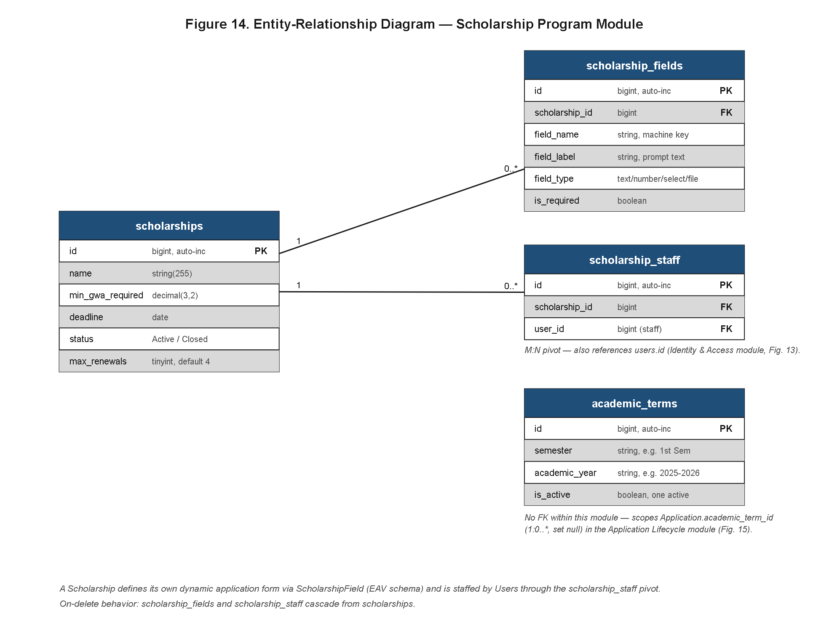
Figure 28. Entity-Relationship Diagram of the Scholarship Program Management Module.
Figure 28 renders the Scholarship Program Management module, composed of scholarships, scholarship_fields, scholarship_staff, and academic_terms. The most consequential design decision visible in this module is the scholarship_fields entity, which implements an Entity-Attribute-Value (EAV) pattern rather than a fixed, hard-coded column schema for each scholarship program's required application fields. This is a deliberate flexibility trade-off: because different scholarship grants administered by the Office of Student Affairs impose materially different documentary and eligibility requirements — one program may require a barangay indigency certificate while another requires a certificate of good moral character and a specific grade-point cutoff — a rigid relational schema would force a migration for every new scholarship configuration. By instead allowing OSA staff to define scholarship_fields dynamically per scholarship program, the same underlying applications and application_fields tables (detailed in the next module) can accommodate an arbitrary and evolving catalog of programs without schema-level intervention, at the acknowledged cost of weaker native type enforcement at the database layer, a cost the implementation compensates for through application-layer validation. The scholarship_staff junction entity resolves the many-to-many relationship between scholarships and users constrained to the staff role, encoding which OSA Staff members are authorized reviewers for a given scholarship program, while academic_terms anchors each scholarship offering to a bounded application window.
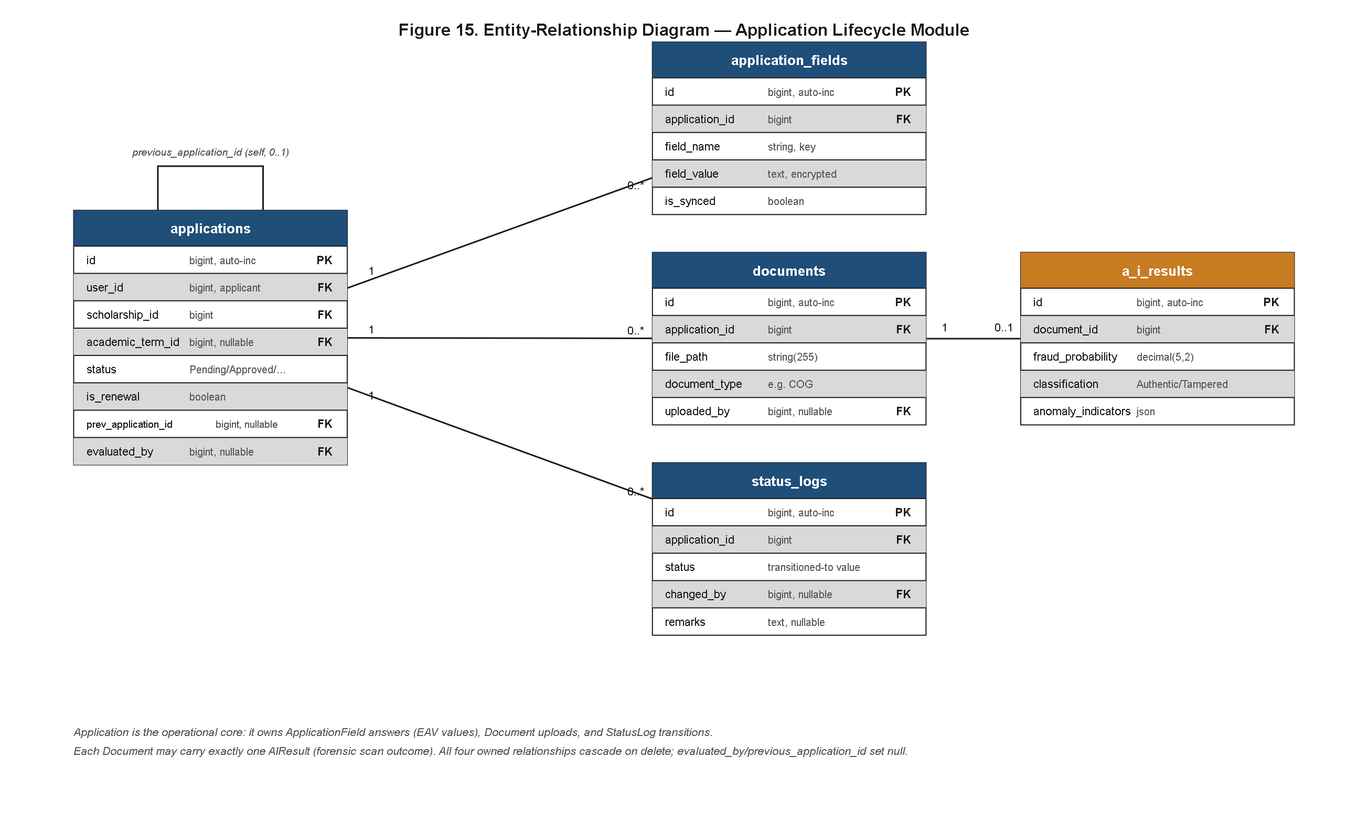
Figure 29. Entity-Relationship Diagram of the Application Lifecycle Module.
Figure 29 presents the Application Lifecycle module — applications, application_fields, documents, status_logs, and ai_results — which forms the transactional core of the platform. Two structural features distinguish this module from a conventional single-pass submission model. First, the applications entity carries a self-referencing previous_application_id foreign key, enabling an applicant's renewal or re-application record to be chained to its predecessor rather than treated as an entirely unrelated submission; this preserves an auditable lineage across award cycles and allows OSA staff and the Super Admin to view an applicant's full scholarship history as a linked sequence rather than a set of disconnected rows. Second, the relationship between documents and ai_results is modeled as one-to-zero-or-one rather than a mandatory one-to-one: a document record is created immediately upon upload, while the corresponding ai_results row is populated only once the forensic scan job completes, meaning the schema itself tolerates the intermediate state in which a document has been received but not yet forensically evaluated, without requiring a placeholder or sentinel row. The status_logs entity, foreign-keyed to applications, provides an append-only chronological record of every status transition an application undergoes, giving the state-transition behavior discussed later in Section 4.3.8 a persistent, queryable substrate.
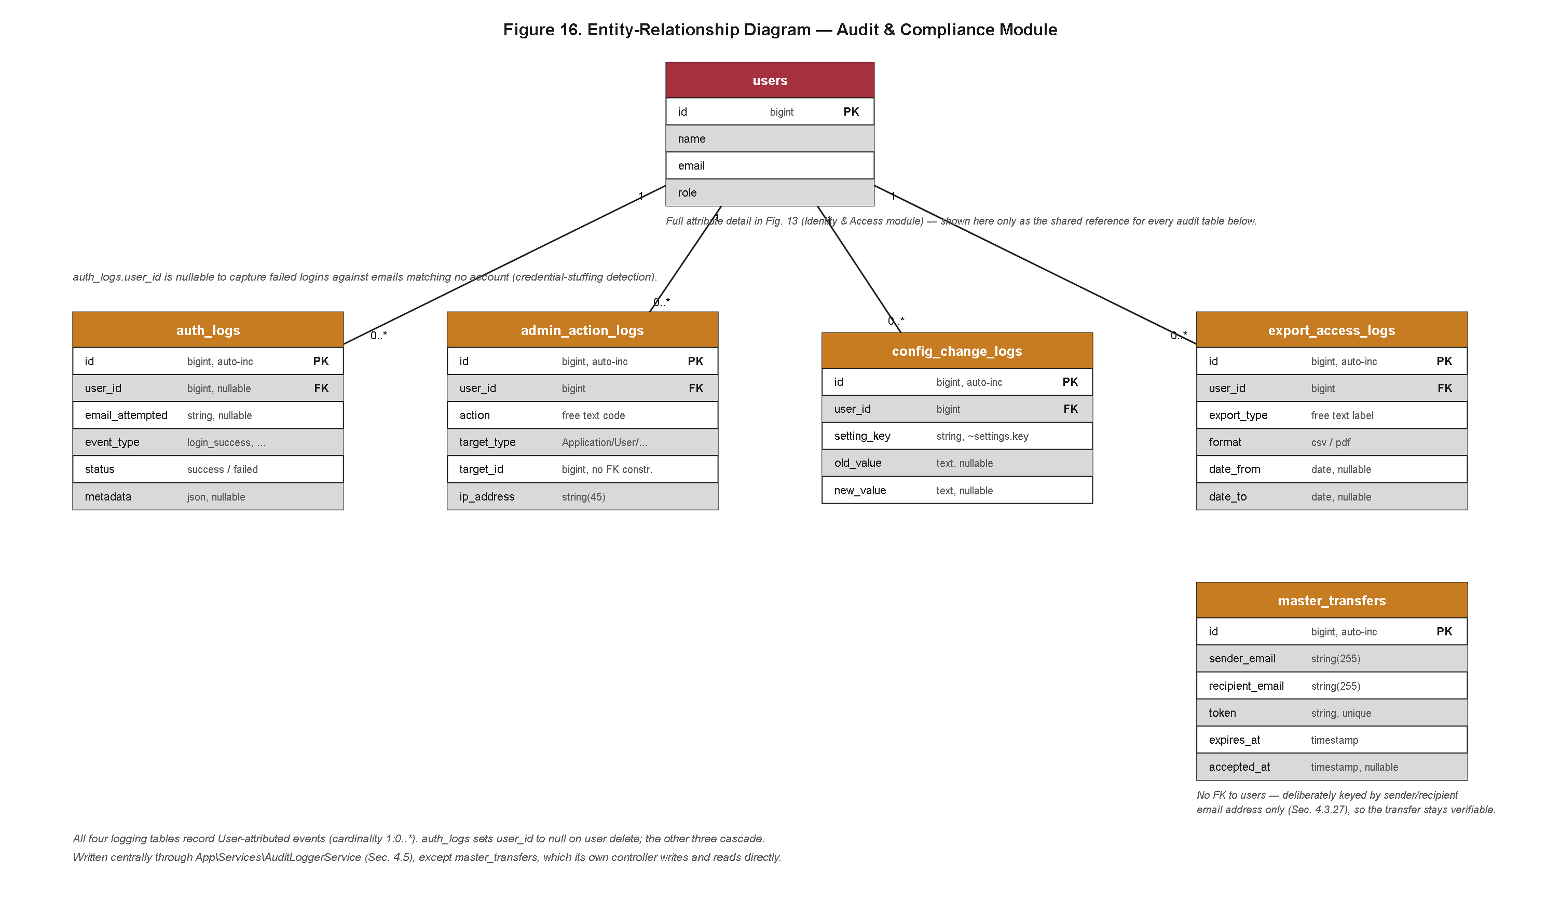
Figure 30. Entity-Relationship Diagram of the Audit and Compliance Module.
Figure 30 details the Audit and Compliance module — auth_logs, admin_action_logs, config_change_logs, export_access_logs, and master_transfers. The first four entities follow a conventional pattern of foreign-keying to the acting user and timestamping the observed event, providing the forensic record trail. The master_transfers entity, however, departs from this pattern in a manner deliberate rather than accidental: it is keyed by the recipient's email address rather than by a foreign key to the users table. This design choice ensures that a record of a scholarship master-list transfer (for instance, a fund custodianship handoff between OSA personnel, or a transfer to an external partner office) remains independently verifiable even if the underlying user account referenced by that email is later deactivated, renamed, or deleted, which a strict foreign-key relationship would otherwise jeopardize through cascading deletes or orphaned references. This reflects a broader institutional requirement that compliance and financial-transfer evidence must outlive the lifecycle of any single user account, an integrity property directly relevant to the "Grant Integrity" mandate embedded in the system's name. This departure also illustrates a broader principle applied consistently across the audit and compliance module: wherever a strict foreign-key relationship would allow a change to one entity to silently erase or orphan evidence needed by another, the schema instead favors a durable, loosely coupled reference, accepting a small increase in query complexity in exchange for a guarantee that compliance evidence cannot be inadvertently destroyed as a side effect of routine account maintenance elsewhere in the system.
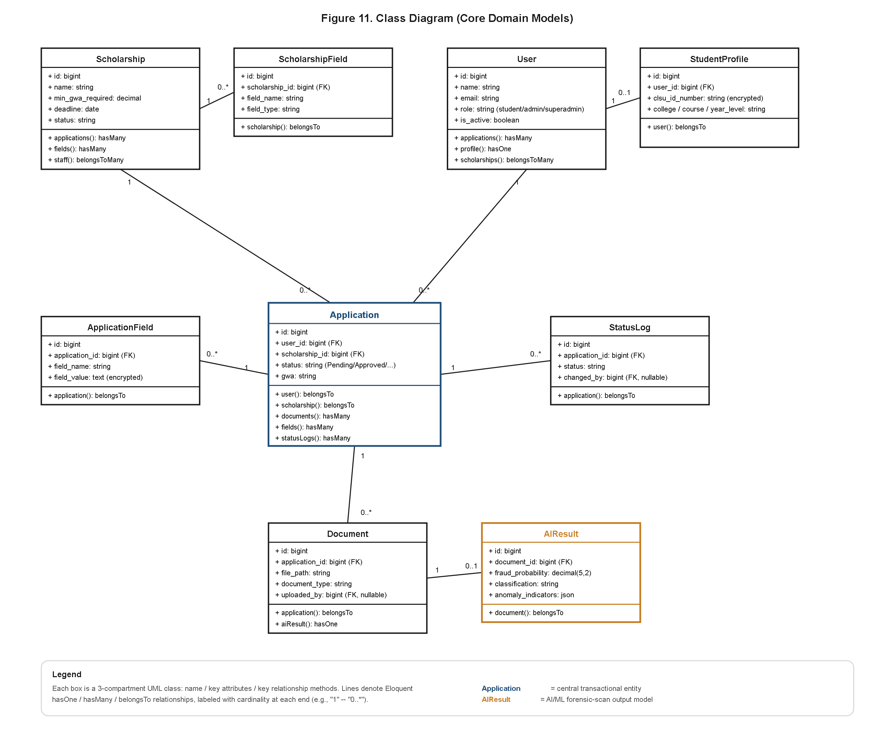
Figure 31. Class Diagram of the Core Domain Models.
Finally, Figure 31 renders the object-oriented realization of the four module ERDs as Eloquent ORM model classes. Its purpose within this results chapter is to demonstrate traceability between the relational design and the executable implementation: each class shown corresponds one-to-one with an entity already described in Figures 27 through 30, and each modeled relationship method (hasOne, hasMany, belongsTo, belongsToMany) mirrors the cardinality annotated on the corresponding ERD edge. That the class diagram introduces no relationship, attribute, or entity absent from the ERDs — and, conversely, that the ERDs introduce nothing the class diagram fails to realize — constitutes concrete evidence that the object model implemented in the Laravel application layer is fully consistent with the relational design specified during the architectural phase, closing the loop between Section 4.3's design artifacts and the system as actually built.
4.3.5 Deployment Architecture and Infrastructure Topology
Having established the logical and relational structure of the system, this section reports the physical infrastructure onto which that structure was deployed, presented as a concrete architectural result of the capstone rather than a planning artifact. Where Figure 6 in Section 4.2 established the multi-tier logical architecture at a conceptual level, this section reports the concrete platform-level realization of that architecture as it was actually deployed and operated, and does so at a level of specificity — naming the exact hosting platforms, containerization strategy, and storage arrangement — that Figure 6 was not intended to capture.
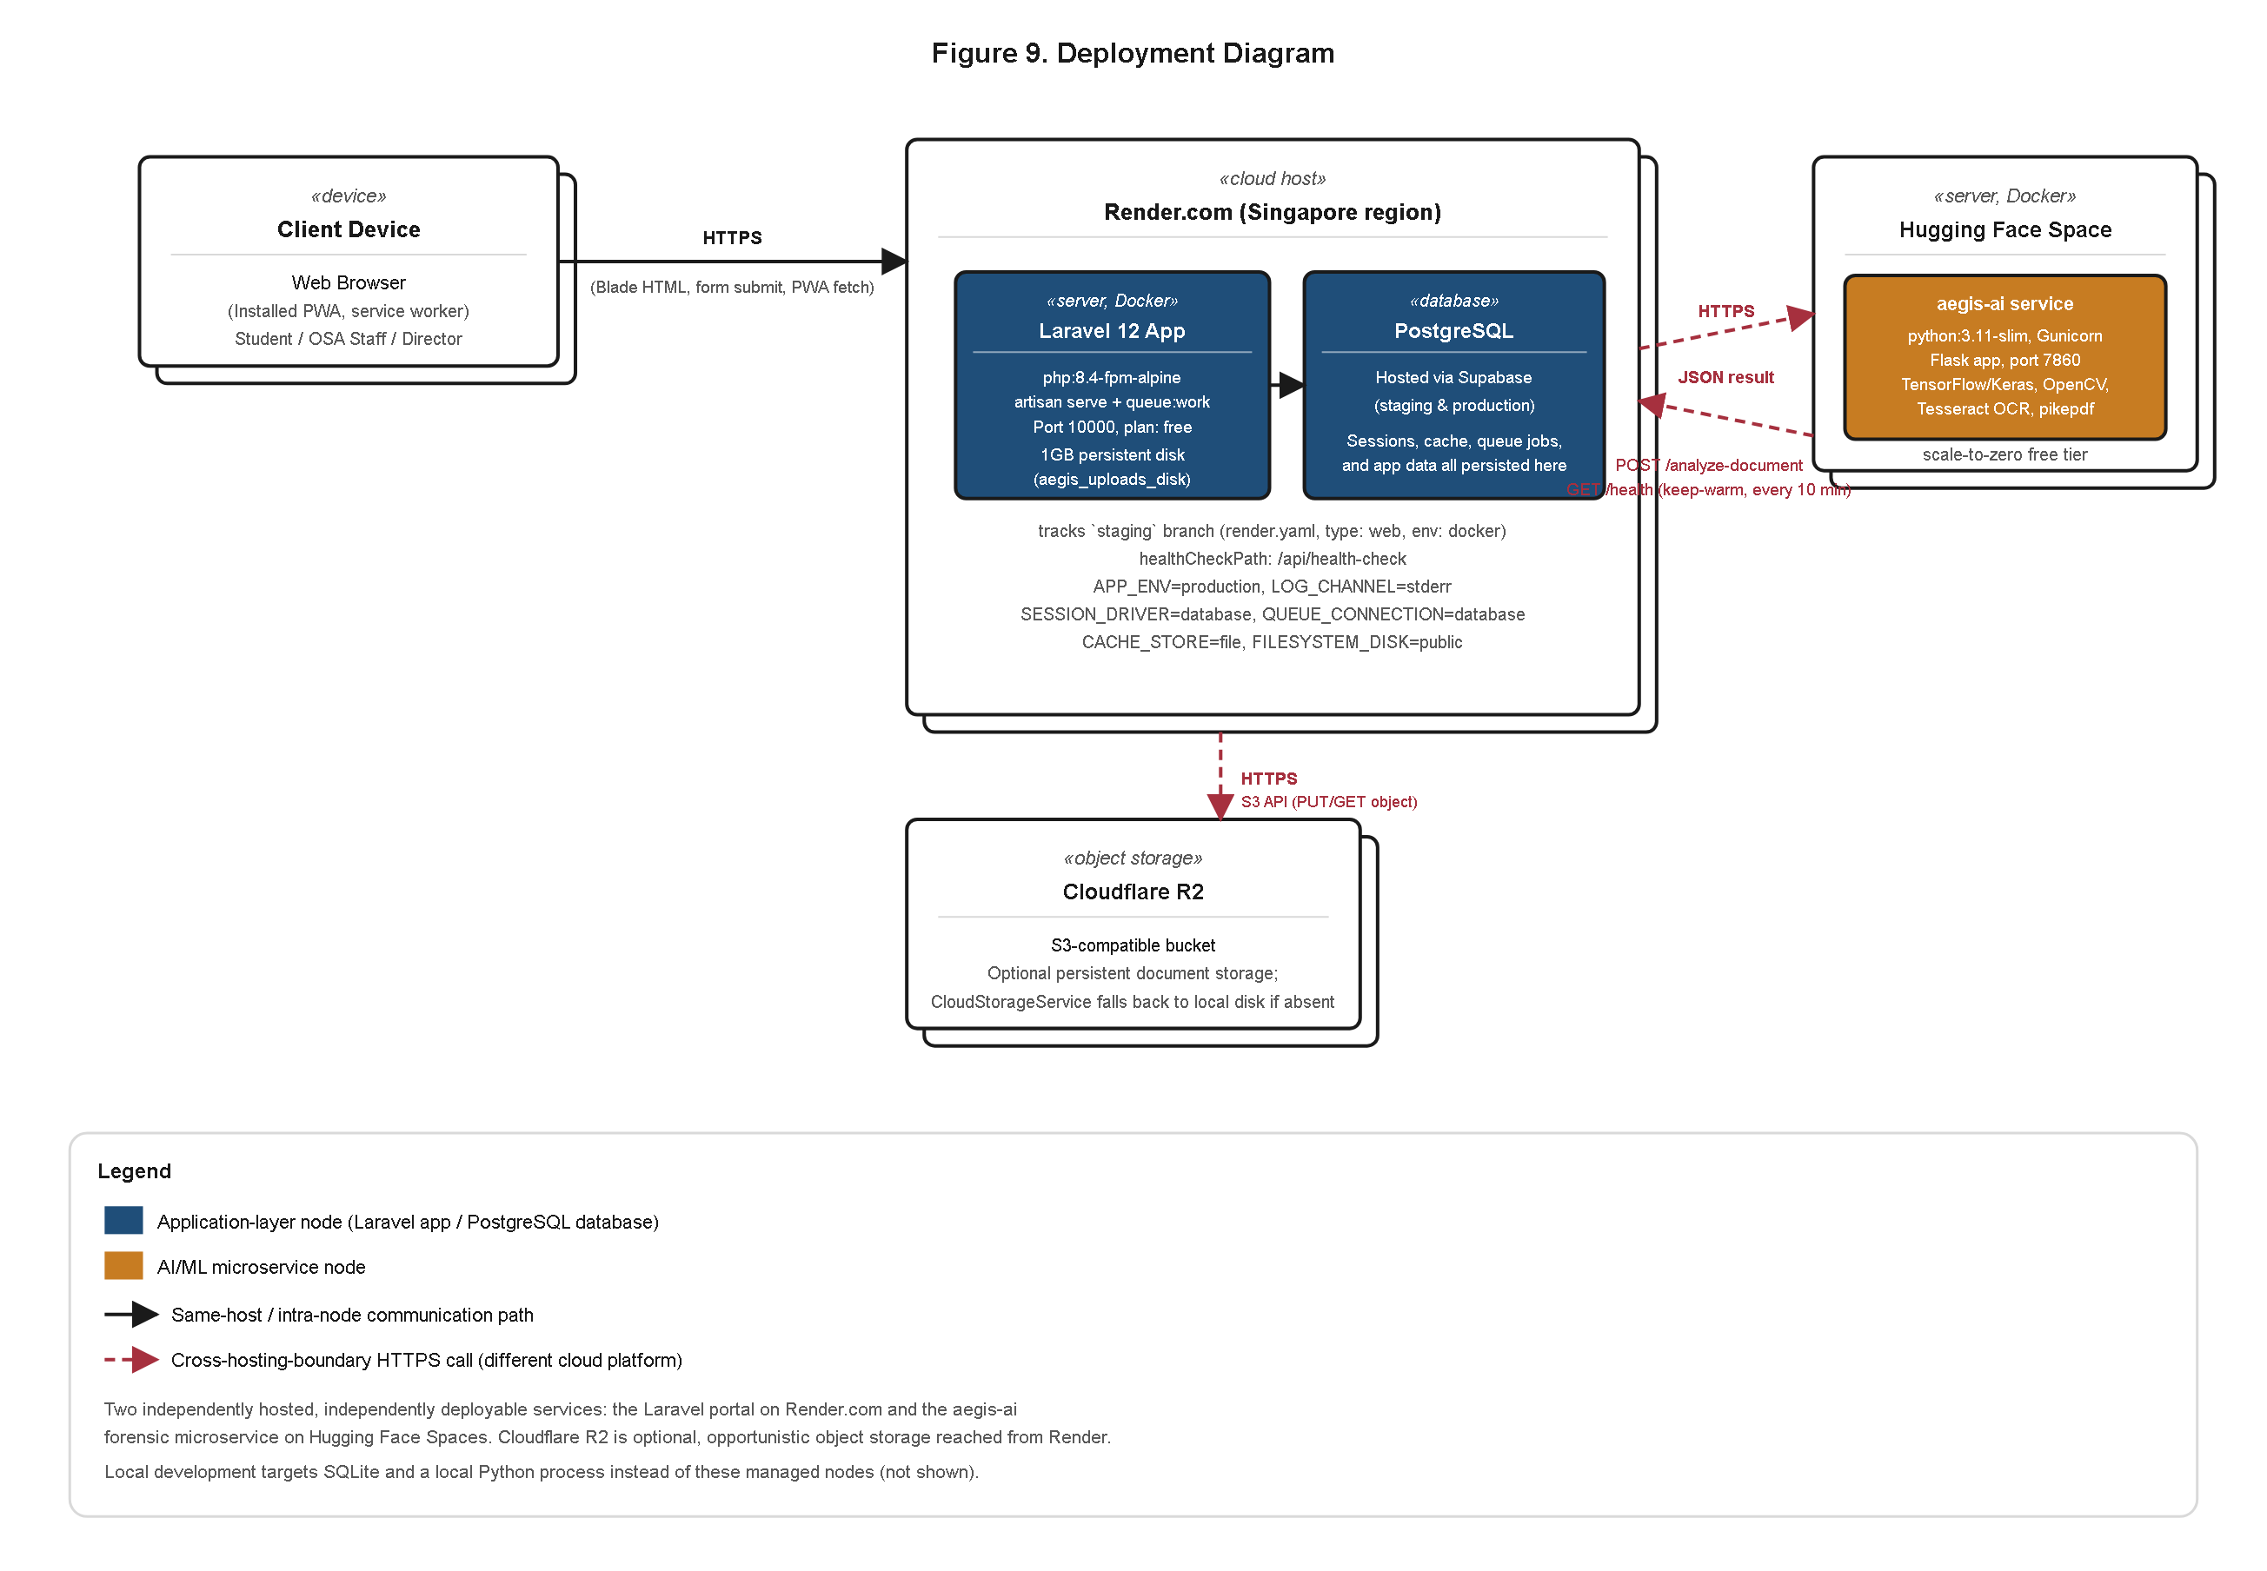
Figure 32. Deployment Diagram of the A.E.G.I.S. Production Infrastructure.
Figure 32 shows that the production deployment is deliberately split across two independently hosted platforms rather than co-located on a single server or single provider. The Laravel application — encompassing the presentation layer, routing and middleware, controllers, and the relational data store — is containerized with Docker and hosted on Render.com together with its PostgreSQL database. The Python-based aegis-ai forensic microservice, by contrast, is hosted separately on Hugging Face Spaces, a platform purpose-built for serving machine-learning workloads. An optional Cloudflare R2 object storage tier is provisioned for document and artifact persistence where the institution elects to decouple file storage from the application server's local disk. This two-service split was not an incidental consequence of using two different cloud accounts but a deliberate architectural response to a real operational tension: the forensic microservice's document-analysis workload is computationally heavy and memory-intensive relative to the comparatively lightweight, high-concurrency request pattern of the Laravel web tier, and co-locating both on the same compute allocation would force the web application to compete with AI inference for CPU and memory headroom during traffic spikes, or force over-provisioning of the web tier to accommodate worst-case inference load that it does not itself generate. Hosting the two services independently allows each to be scaled, monitored, and redeployed on its own schedule: a change to the EFDF fusion-scoring logic or an upgrade to the underlying forensic model can be redeployed to Hugging Face Spaces without redeploying or restarting the Laravel application, and conversely a Laravel feature release does not require the forensic service to restart or re-warm. The operational cost of this separation is the introduction of a network boundary between the two services, formalized as an HTTPS API contract in which the Laravel backend dispatches a document-analysis request to the aegis-ai service and awaits a structured JSON response; the resilience implications of that boundary — specifically its behavior under microservice unavailability — are addressed directly in the sequence-diagram discussion of Section 4.3.7.
A further consequence of this topology, worth reporting as a concrete deployment outcome rather than a mere design preference, concerns environment parity and cost containment. Because both the Laravel application and the aegis-ai microservice are containerized or platform-managed rather than manually provisioned onto bare hardware, the same deployment artifact promoted to Render.com's production environment can be reproduced in a local or staging context with a high degree of fidelity, reducing the class of defects that arise purely from divergence between a developer's local environment and the institution's live environment. This containerized parity is also what allows the free-tier and low-cost cloud services enumerated in the feasibility study of Section 4.2.1 to remain viable at the institutional scale targeted by this capstone: Render.com and Hugging Face Spaces both offer usage tiers suited to an office-level deployment such as the Office of Student Affairs, without requiring the institution to provision or maintain its own physical server infrastructure, database administration staff, or machine-learning compute hardware. The deployment diagram of Figure 32 therefore documents not only a topology but a sustainability argument: the institution inherits a working, redeployable production system without inheriting the capital and staffing obligations that an on-premises equivalent would impose. Where a future increase in application volume or a heavier forensic workload warrants it, each service tier can independently be moved to a higher-capacity plan on its respective platform without requiring a redesign of the other tier, since the HTTPS API contract between them is the only coupling the two services share.
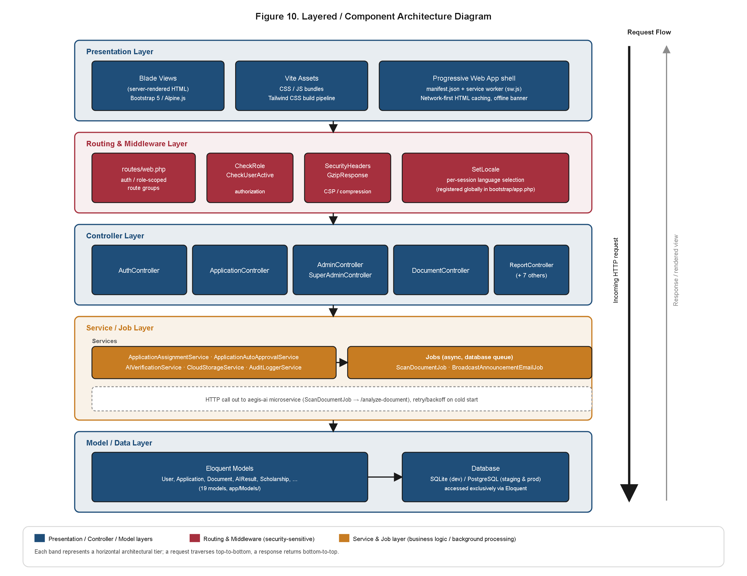
Figure 33. Layered Component Architecture Diagram.
Figure 33 turns from the physical deployment boundary inward, to the internal layering of the Laravel application itself. The diagram documents five internal tiers — Presentation, Routing/Middleware, Controllers, Services/Jobs, and Models/Database — and, rather than presenting these as abstract labels, anchors each tier to representative classes actually present in the codebase. At the Routing/Middleware tier, classes such as CheckRole and SecurityHeaders intercept every inbound request before it reaches application logic, the former enforcing the role-based access boundaries modeled in Figure 26 and the latter attaching the HTTP security headers discussed further in Section 4.3.6. At the Controllers tier, classes such as AuthController and AdminController translate validated HTTP input into calls against the Services/Jobs tier, deliberately avoiding the anti-pattern of embedding business logic directly inside controller methods. The Services/Jobs tier is where the system's more substantial business logic resides, exemplified by ApplicationAssignmentService, which encapsulates the staff-assignment decision logic detailed in Section 4.3.9, and ScanDocumentJob, a queued job responsible for orchestrating the asynchronous forensic scan described in Section 4.3.7. Finally, the Models/Database tier corresponds directly to the Eloquent classes already presented in Figure 31. The significance of this layering as a reported result is that it evidences separation of concerns as an implemented property of the codebase rather than an aspirational design goal: because request handling, authorization, business logic, and persistence are each confined to a distinct tier with a narrow interface to its neighbors, a maintenance change to one tier — for instance, altering how staff assignment workload is balanced — can be made within ApplicationAssignmentService without requiring corresponding changes to the controllers or views that invoke it, a maintainability property that directly supports the long-term institutional sustainability of the platform beyond the capstone development window.
This layering also bears directly on the testability of the system, a quality attribute already evidenced empirically by the 145-assertion automated test matrix of Section 4.5.1. Because the Services/Jobs tier isolates business rules such as the assignment logic within ApplicationAssignmentService from both the HTTP request lifecycle above it and the persistence mechanics below it, that logic can be exercised directly by an automated test without needing to simulate an authenticated HTTP request or seed a full relational dataset for every test case, a structural property that lowers the marginal cost of extending the test suite as the system continues to evolve after the capstone's conclusion. In this respect, Figure 33 should be read not only as documentation of how the codebase is organized but as an explanation of why the testing and maintenance outcomes reported elsewhere in this chapter were achievable at the scale they were: a monolithic, undifferentiated controller layer would not have permitted the same degree of isolated verification, and the layered architecture is accordingly reported here as a structural precondition for those downstream empirical results rather than an independent, unrelated finding.
4.3.6 Security Architecture Realization
The preceding sections reported the deployment topology and internal component layering of the system; this section turns to the cross-cutting security controls layered across that topology, treated here as a distinct architectural concern because security in A.E.G.I.S. is not the responsibility of any single tier of Figure 33 but of coordinated controls spanning the network boundary, the application layer, and the persistence layer simultaneously.
Given that A.E.G.I.S. is, by its own name, a Grant Integrity System, the credibility of its automated and human decisions rests in no small part on the demonstrable strength of the security controls protecting the underlying student and financial data. Figure 34 renders this protection as a defense-in-depth model, in which security is not achieved by any single control but by six concentric layers, each independently capable of mitigating a distinct class of threat, surrounding the innermost protected asset. The choice to model security explicitly as a layered diagram, rather than as an itemized checklist of features in a narrative paragraph, is itself methodologically significant for a results chapter: a checklist format cannot easily communicate which controls are independent of one another and which merely reinforce a single point of failure, whereas the concentric layer notation used here forces each control to be positioned relative to the asset it protects and relative to the controls surrounding it, making any gap in coverage visually apparent rather than something a reader would have to infer from prose alone.
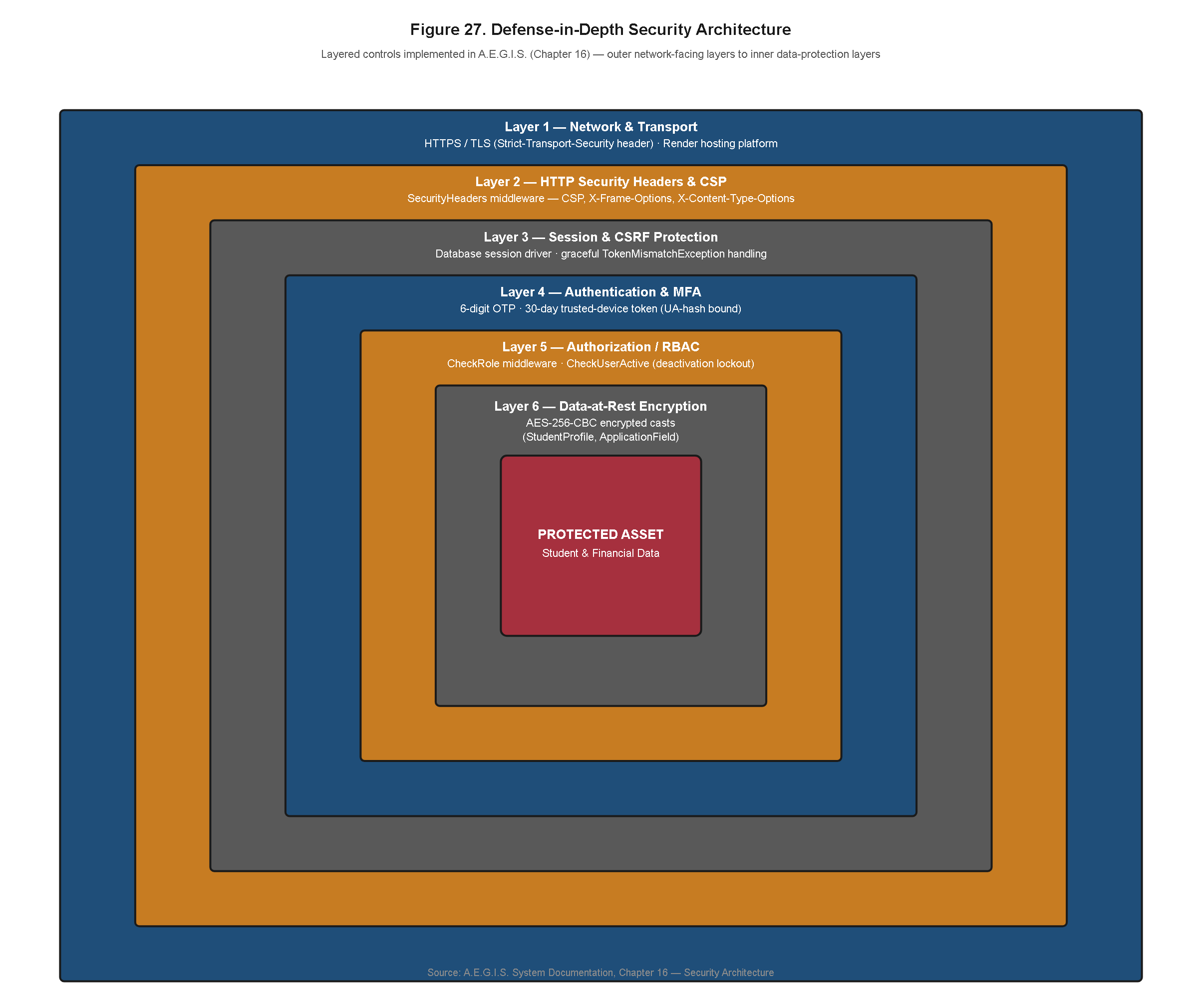
Figure 34. Defense-in-Depth Security Architecture Diagram.
The outermost layer, Network and Transport Security, enforces HTTPS/TLS on all client-server communication, ensuring that credentials, uploaded documents, and forensic results are never transmitted in plaintext across the public network, whether between a student's browser and the Laravel application or between the Laravel application and the aegis-ai microservice discussed in Section 4.3.5. The second layer, HTTP Security Headers and Content Security Policy, is realized by the SecurityHeaders middleware already identified in Figure 33; it constrains the browser's execution context to mitigate cross-site scripting and clickjacking vectors that would otherwise allow a malicious script to exfiltrate session data or forensic scan results. The third layer, Session and CSRF Protection, departs from a stateless-token approach in favor of database-backed sessions, a choice that allows the Super Admin to enumerate and forcibly invalidate active sessions system-wide — for instance upon suspicion of account compromise — a capability that a purely client-held token scheme would not straightforwardly provide, while cross-site request forgery tokens prevent a forged request from an unrelated origin from executing a state-changing action such as an application approval on a staff member's behalf. The fourth layer, Authentication and Multi-Factor Authentication, requires a six-digit one-time password in addition to the primary credential, with a 30-day trusted-device token permitted thereafter so that returning users on a recognized device are not forced to repeat the second factor on every login, balancing security friction against usability without eliminating the second factor's protective value against credential-stuffing attacks originating from unrecognized devices. The fifth layer, Authorization and Role-Based Access Control, is the enforcement mechanism behind the actor-scoped use cases modeled in Figure 26, ensuring that even an authenticated session cannot reach an action outside its role's modeled permissions. The sixth and innermost layer, Data-at-Rest Encryption, applies AES-256 encryption to sensitive student and financial columns within the database itself, so that even in the event of a database-level compromise or an improperly secured backup, the most sensitive fields remain unintelligible without the corresponding encryption key.
Two design properties of the model as a whole merit specific attention as results in their own right. First, the six layers are ordered such that an attacker attempting to compromise the innermost asset must defeat controls at fundamentally different points in the request lifecycle — the network boundary, the browser execution context, the server-side session store, the credential-verification step, the authorization check, and finally the storage layer itself — meaning that a single class of vulnerability, such as a cross-site scripting flaw in one view template, does not by itself grant access to encrypted student or financial data, since the RBAC and encryption layers remain interposed regardless of how the outer layers were breached. Second, the model deliberately does not treat any single layer as sufficient on its own: MFA mitigates credential compromise but not a subsequently authorized session being misused outside its intended role, which is why the RBAC layer sits immediately inside it rather than being treated as redundant given that authentication already occurred. This layered independence is what distinguishes a defense-in-depth architecture from a checklist of unrelated security features, and it is this independence, rather than the mere count of six layers, that constitutes the actual security result being reported.
The placement of Authentication and Multi-Factor Authentication as the fourth layer, positioned after the network, header, and session layers but before authorization, also reflects a considered ordering rather than an arbitrary one. Placing MFA ahead of RBAC in the concentric model reflects the reality that authorization decisions are meaningless unless the identity they are keyed to has first been established with adequate assurance; a role-based permission check performed against a weakly authenticated identity would faithfully enforce the wrong boundary. By requiring the second factor before a session capable of exercising any role-scoped permission is issued, the model ensures that the RBAC layer's guarantees are only as strong as they need to be, since the identity they are evaluated against has already survived a stronger identity-assurance step. This ordering consideration is precisely the kind of design reasoning that a results chapter is well positioned to surface, since it is not visible from the RBAC or MFA controls examined individually but only from their relative sequencing within the composed model.
The discussion of this figure as a reported result, rather than a restated design intention, rests on the fact that each of the six layers corresponds to a control already substantiated elsewhere in this chapter and in the codebase — the CSRF and RBAC layers to the CheckRole middleware of Figure 33, the MFA layer to the trusted-device sequence detailed in Section 4.3.7, and the encryption layer to the sensitive-column treatment of the Application Lifecycle and Audit modules of Figures 29 and 30. Presenting these controls as a single concentric model demonstrates that the system's security posture was engineered holistically, with layers whose failure modes do not overlap, rather than as an ad hoc accumulation of unrelated protections — a property directly responsive to the integrity guarantee the system's name promises to the institution's grant-making processes.
It is also worth situating Figure 34 against the security-focused item results already reported in Table 4.50, where the evaluation panel rated role-based access control at a mean of 4.86, tamper-resistant audit logging at 4.71, and data encryption at 4.50, each falling within the "Very Highly Acceptable" band. Read alongside the panel's perceptual scores, the defense-in-depth model supplies the engineering explanation for why those particular items were rated as favorably as they were: the RBAC score corresponds directly to the fifth layer of Figure 34, the audit-logging score corresponds to the compliance evidence generated by the fourth module of Figure 30, and the encryption score corresponds to the sixth and innermost layer. This chapter therefore does not ask the reader to accept the panel's security ratings on trust alone; Figure 34 provides the traceable engineering basis for each of them, a relationship developed further and more systematically for all quality characteristics in Section 4.7.3.
4.3.7 Behavioral Sequence Diagrams of Core System Processes
Sections 4.3.1 through 4.3.4 established what the system was designed to do, expressed as use cases, data flows, and structural models; Figures 35 through 39 close the gap between that design intent and the system as actually built by rendering the realized runtime message sequences for the five processes most central to the platform's purpose. Presenting these as a coordinated set, rather than in isolation, allows the reader to trace a single applicant's journey end to end across the request/response boundaries the earlier structural diagrams could only imply.
The choice of exactly these five processes for sequence-level treatment, rather than an exhaustive sequence diagram for every use case enumerated in Figure 26, was itself a deliberate scoping decision consistent with how this results chapter allocates its attention throughout: sequence diagrams are most informative precisely where multiple components or services must coordinate across a boundary, since that is where an implementation is most likely to diverge from its design on account of timing, failure-handling, or ordering assumptions that a purely structural diagram cannot expose. Registration and login cross the boundary between the client, the AuthController, and the MFA subsystem; submission and upload cross the boundary between the client, the storage layer, and the queue; the forensic scan crosses the inter-service network boundary discussed in Section 4.3.5; staff review crosses the boundary between the interface, the decision-recording persistence layer, and the notification subsystem; and announcement broadcast crosses the boundary between two independently failing delivery channels. Each of the five sequences was therefore selected because it is a process whose correctness depends on the coordination of at least two independently developed parts of the system, making it the category of behavior most valuable to verify and report at the sequence level of detail.
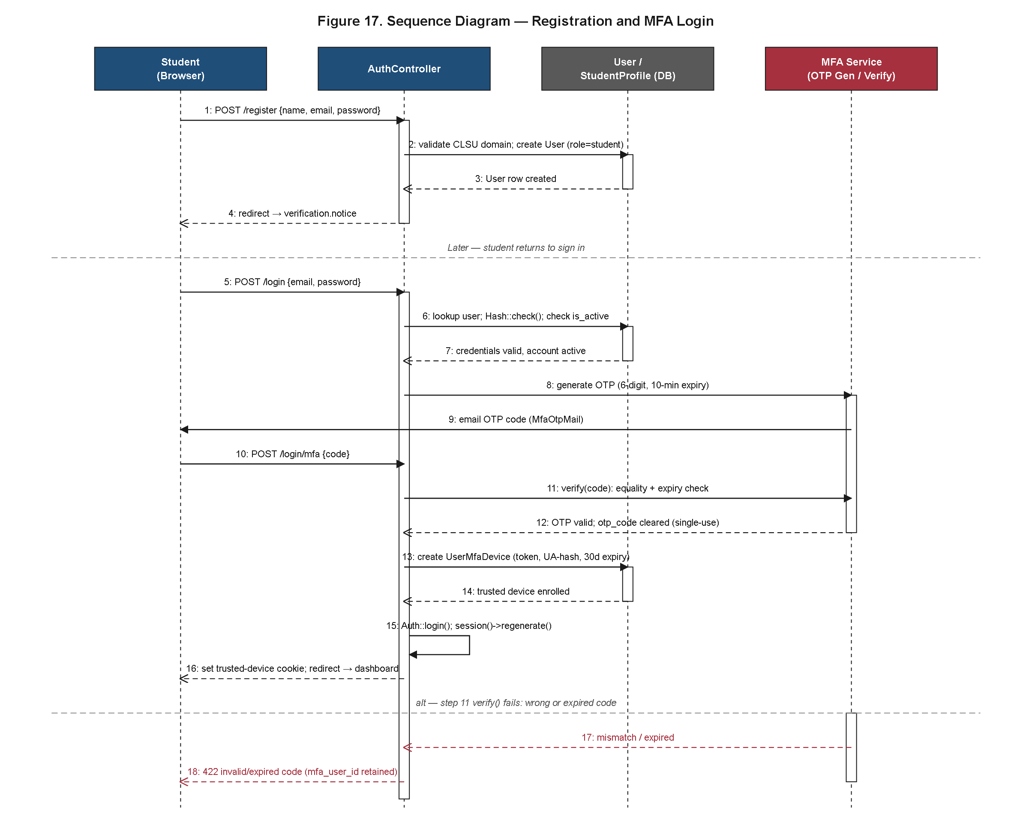
Figure 35. Sequence Diagram of Student Registration and Multi-Factor Authentication Login.
Figure 35 traces account creation through to an authenticated session, capturing the generation of the one-time password, its transmission to the applicant, the verification exchange between the client and the AuthController, and the conditional branch in which a successfully verified device is issued a 30-day trusted-device token so that the OTP challenge is not repeated on every subsequent login from that device. The sequence makes explicit that MFA verification is interposed between credential validation and session issuance rather than treated as an optional post-login step, meaning no session token is issued to a client that has not completed both factors on an untrusted device. The inclusion of the trusted-device branch within the same sequence, rather than as a separately documented flow, is itself informative: it shows that the usability accommodation of a 30-day trusted-device window was not retrofitted onto an already-completed authentication flow but was designed as an integral branch of the same login sequence from the outset, sharing the identical entry point and the identical failure-handling paths as the full MFA challenge.
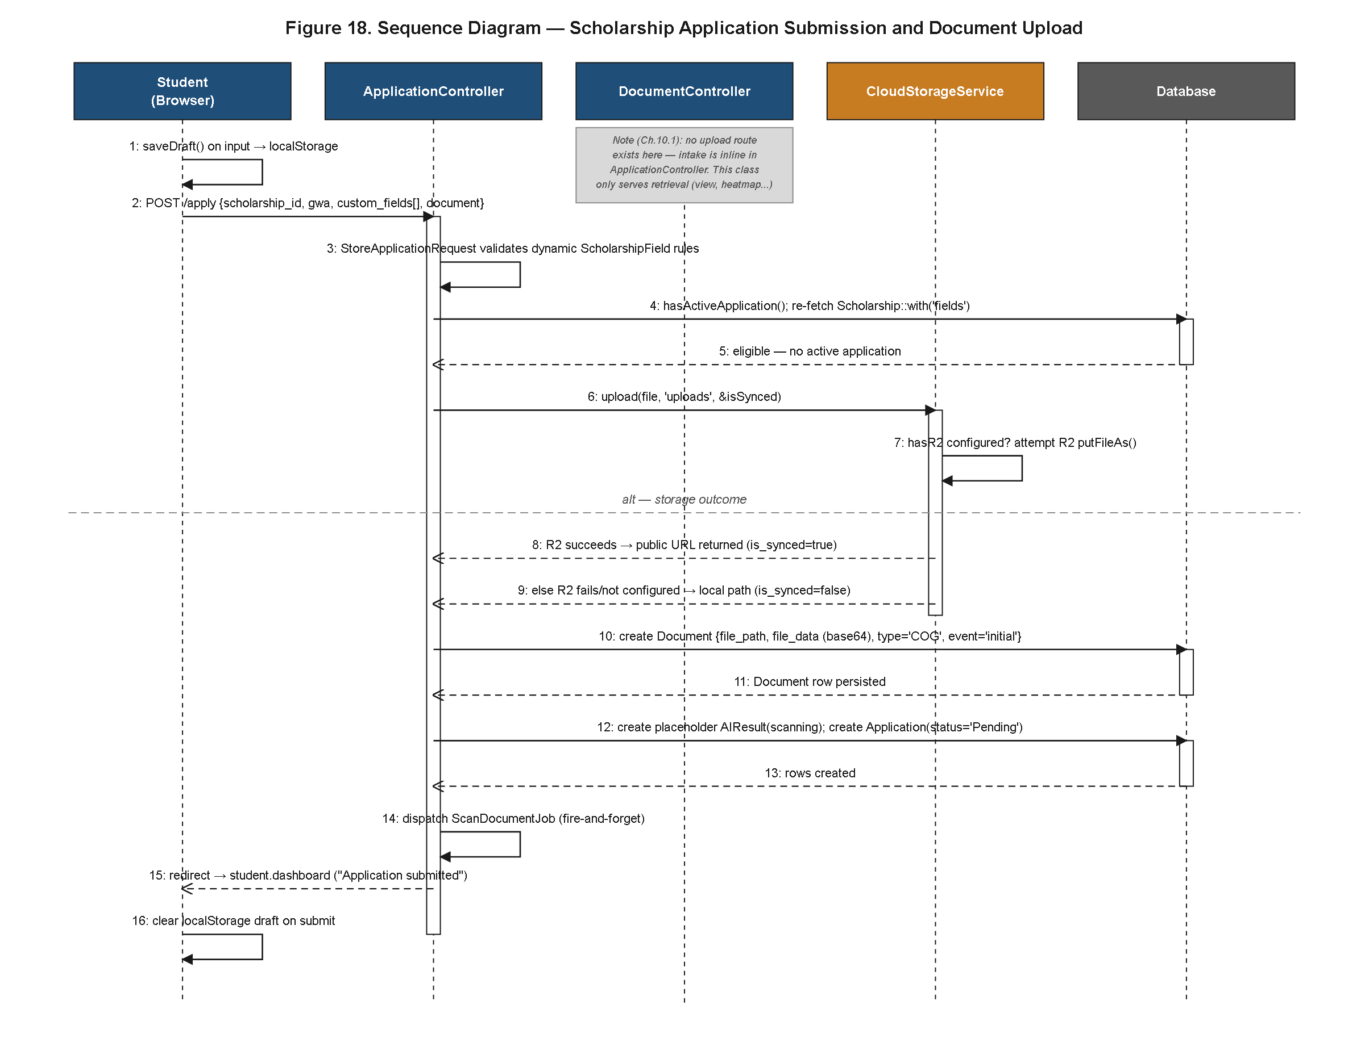
Figure 36. Sequence Diagram of Scholarship Application Submission and Document Upload.
Figure 36 traces the submission process from the moment a student begins populating a scholarship's dynamically defined application_fields, through the periodic client-side autosave requests introduced conceptually in Figure 26, to the final document upload. The sequence shows dynamic field validation being evaluated against the scholarship_fields schema described in Figure 28 before the request reaches persistence, and shows the document storage step attempting the configured cloud object store first with a local-disk fallback path invoked if the cloud store is unreachable, ensuring that a transient storage-provider outage does not block an applicant from completing a submission within a fixed institutional deadline window. The sequence terminates with a fire-and-forget dispatch of the forensic scan job: the HTTP response returned to the student's browser does not wait on the outcome of the AI analysis, which instead proceeds asynchronously per Figure 37. This fire-and-forget boundary is a deliberate responsiveness decision rather than an oversight: because the EFDF forensic analysis invoked in Figure 37 involves a network round-trip to a separately hosted microservice and a non-trivial computational workload once it arrives, synchronously blocking the student's upload request on that analysis would tie up a web server request thread for the full duration of the scan and would leave the applicant's browser waiting on a response of unpredictable length, particularly during the cold-start condition addressed in the following paragraph. Returning control to the student immediately upon successful storage, with the forensic verdict surfaced later through the status-tracking use case of Figure 26, keeps the perceived responsiveness of the submission action itself decoupled from the latency of forensic analysis.
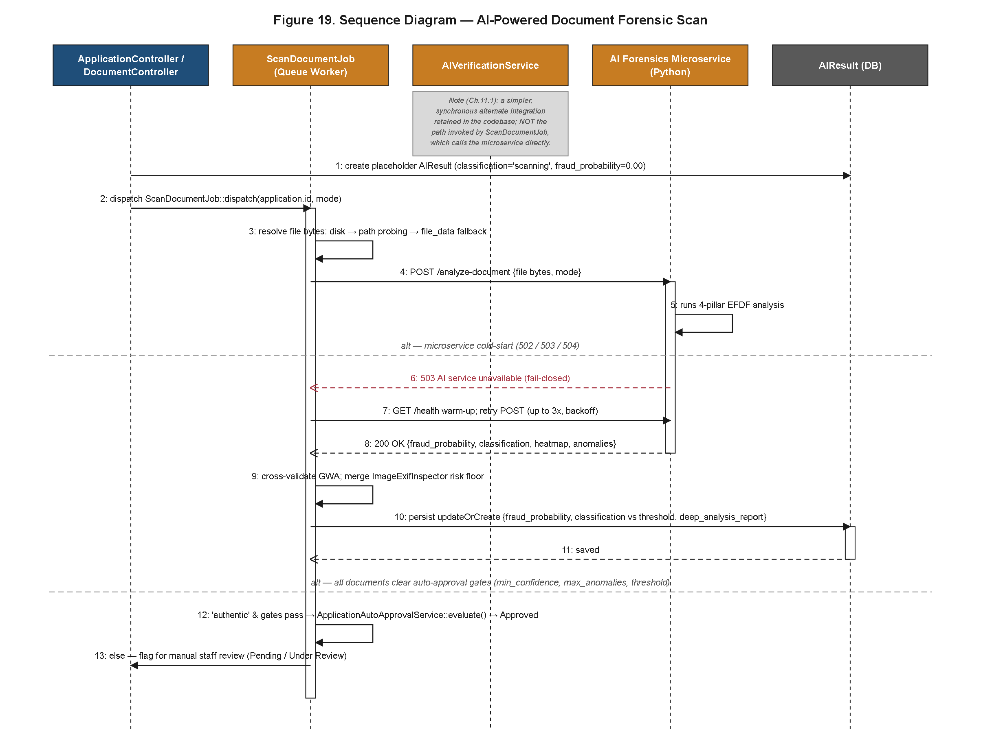
Figure 37. Sequence Diagram of the AI-Powered Document Forensic Scan.
Figure 37 details the asynchronous continuation of that dispatch: a queued job invokes the aegis-ai microservice across the HTTPS boundary established in Figure 32, the microservice executes its four-pillar EFDF evidence analysis, and the result is returned to the Laravel application for the auto-approval-or-manual-review branch decision. Critically, the sequence also models a cold-start retry branch: because a serverless or scale-to-zero-hosted microservice such as one deployed on Hugging Face Spaces may require a warm-up interval after a period of inactivity, the sequence shows the calling job retrying the request a bounded number of times before falling back to a fail-closed branch that routes the application to manual review rather than silently treating an unreachable microservice as equivalent to a passing forensic result. This fail-closed design is a direct integrity safeguard: an application is never auto-approved on the basis of a forensic scan that did not actually execute. This fail-closed branch is properly understood as the runtime enforcement mechanism behind the deployment-topology trade-off discussed in Section 4.3.5: because the aegis-ai microservice is hosted independently of the Laravel application precisely so that it can be scaled and redeployed on its own schedule, the two services are necessarily more loosely coupled at runtime than they would be if co-located in a single process, and the retry-then-fail-closed sequence is what converts that loose coupling from a latent availability risk into a bounded, predictable, and safe degradation path.
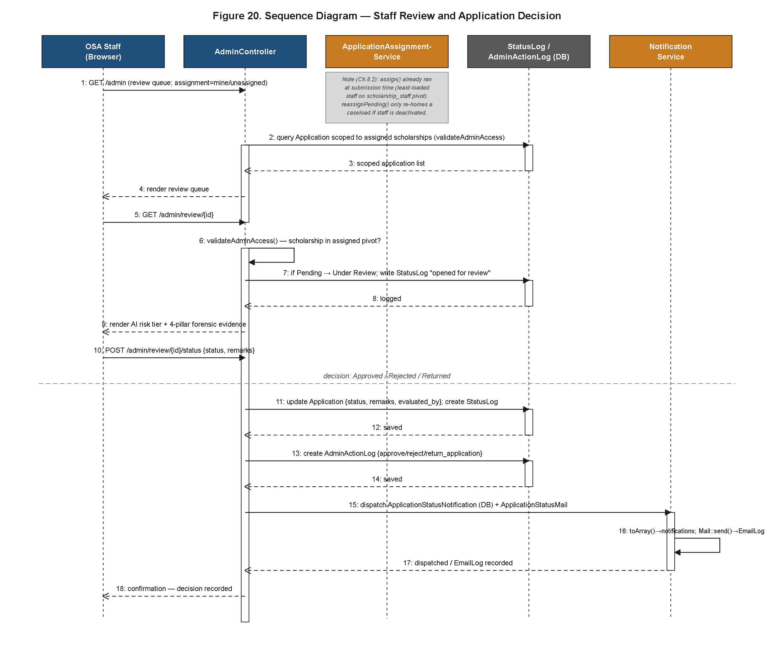
Figure 38. Sequence Diagram of Staff Review and Application Decision.
Figure 38 picks up the manual-review branch, tracing an OSA Staff member's queue interaction through to a recorded decision. The sequence shows the review interface surfacing the application's assigned risk tier as contextual information rather than as a binding instruction, the staff member's decision being persisted as both a status_logs entry (per Figure 29) and an admin_action_logs entry (per Figure 30), and a notification dispatch being triggered as the terminal step of the sequence rather than embedded ad hoc within the decision-handling logic. The sequence also reflects the quick-preset remark and bulk-decision affordances of Figure 26 as alternative entry points into the same underlying decision-recording steps, meaning that a bulk-approval action invoked against several queued applications simultaneously still resolves, per application, through the identical status_logs and admin_action_logs writes shown for a single-application decision, rather than through a separate, unaudited bulk-write code path. This convergence is a deliberate consistency guarantee: the audit trail's completeness does not depend on which interface affordance a staff member happened to use to reach a decision.
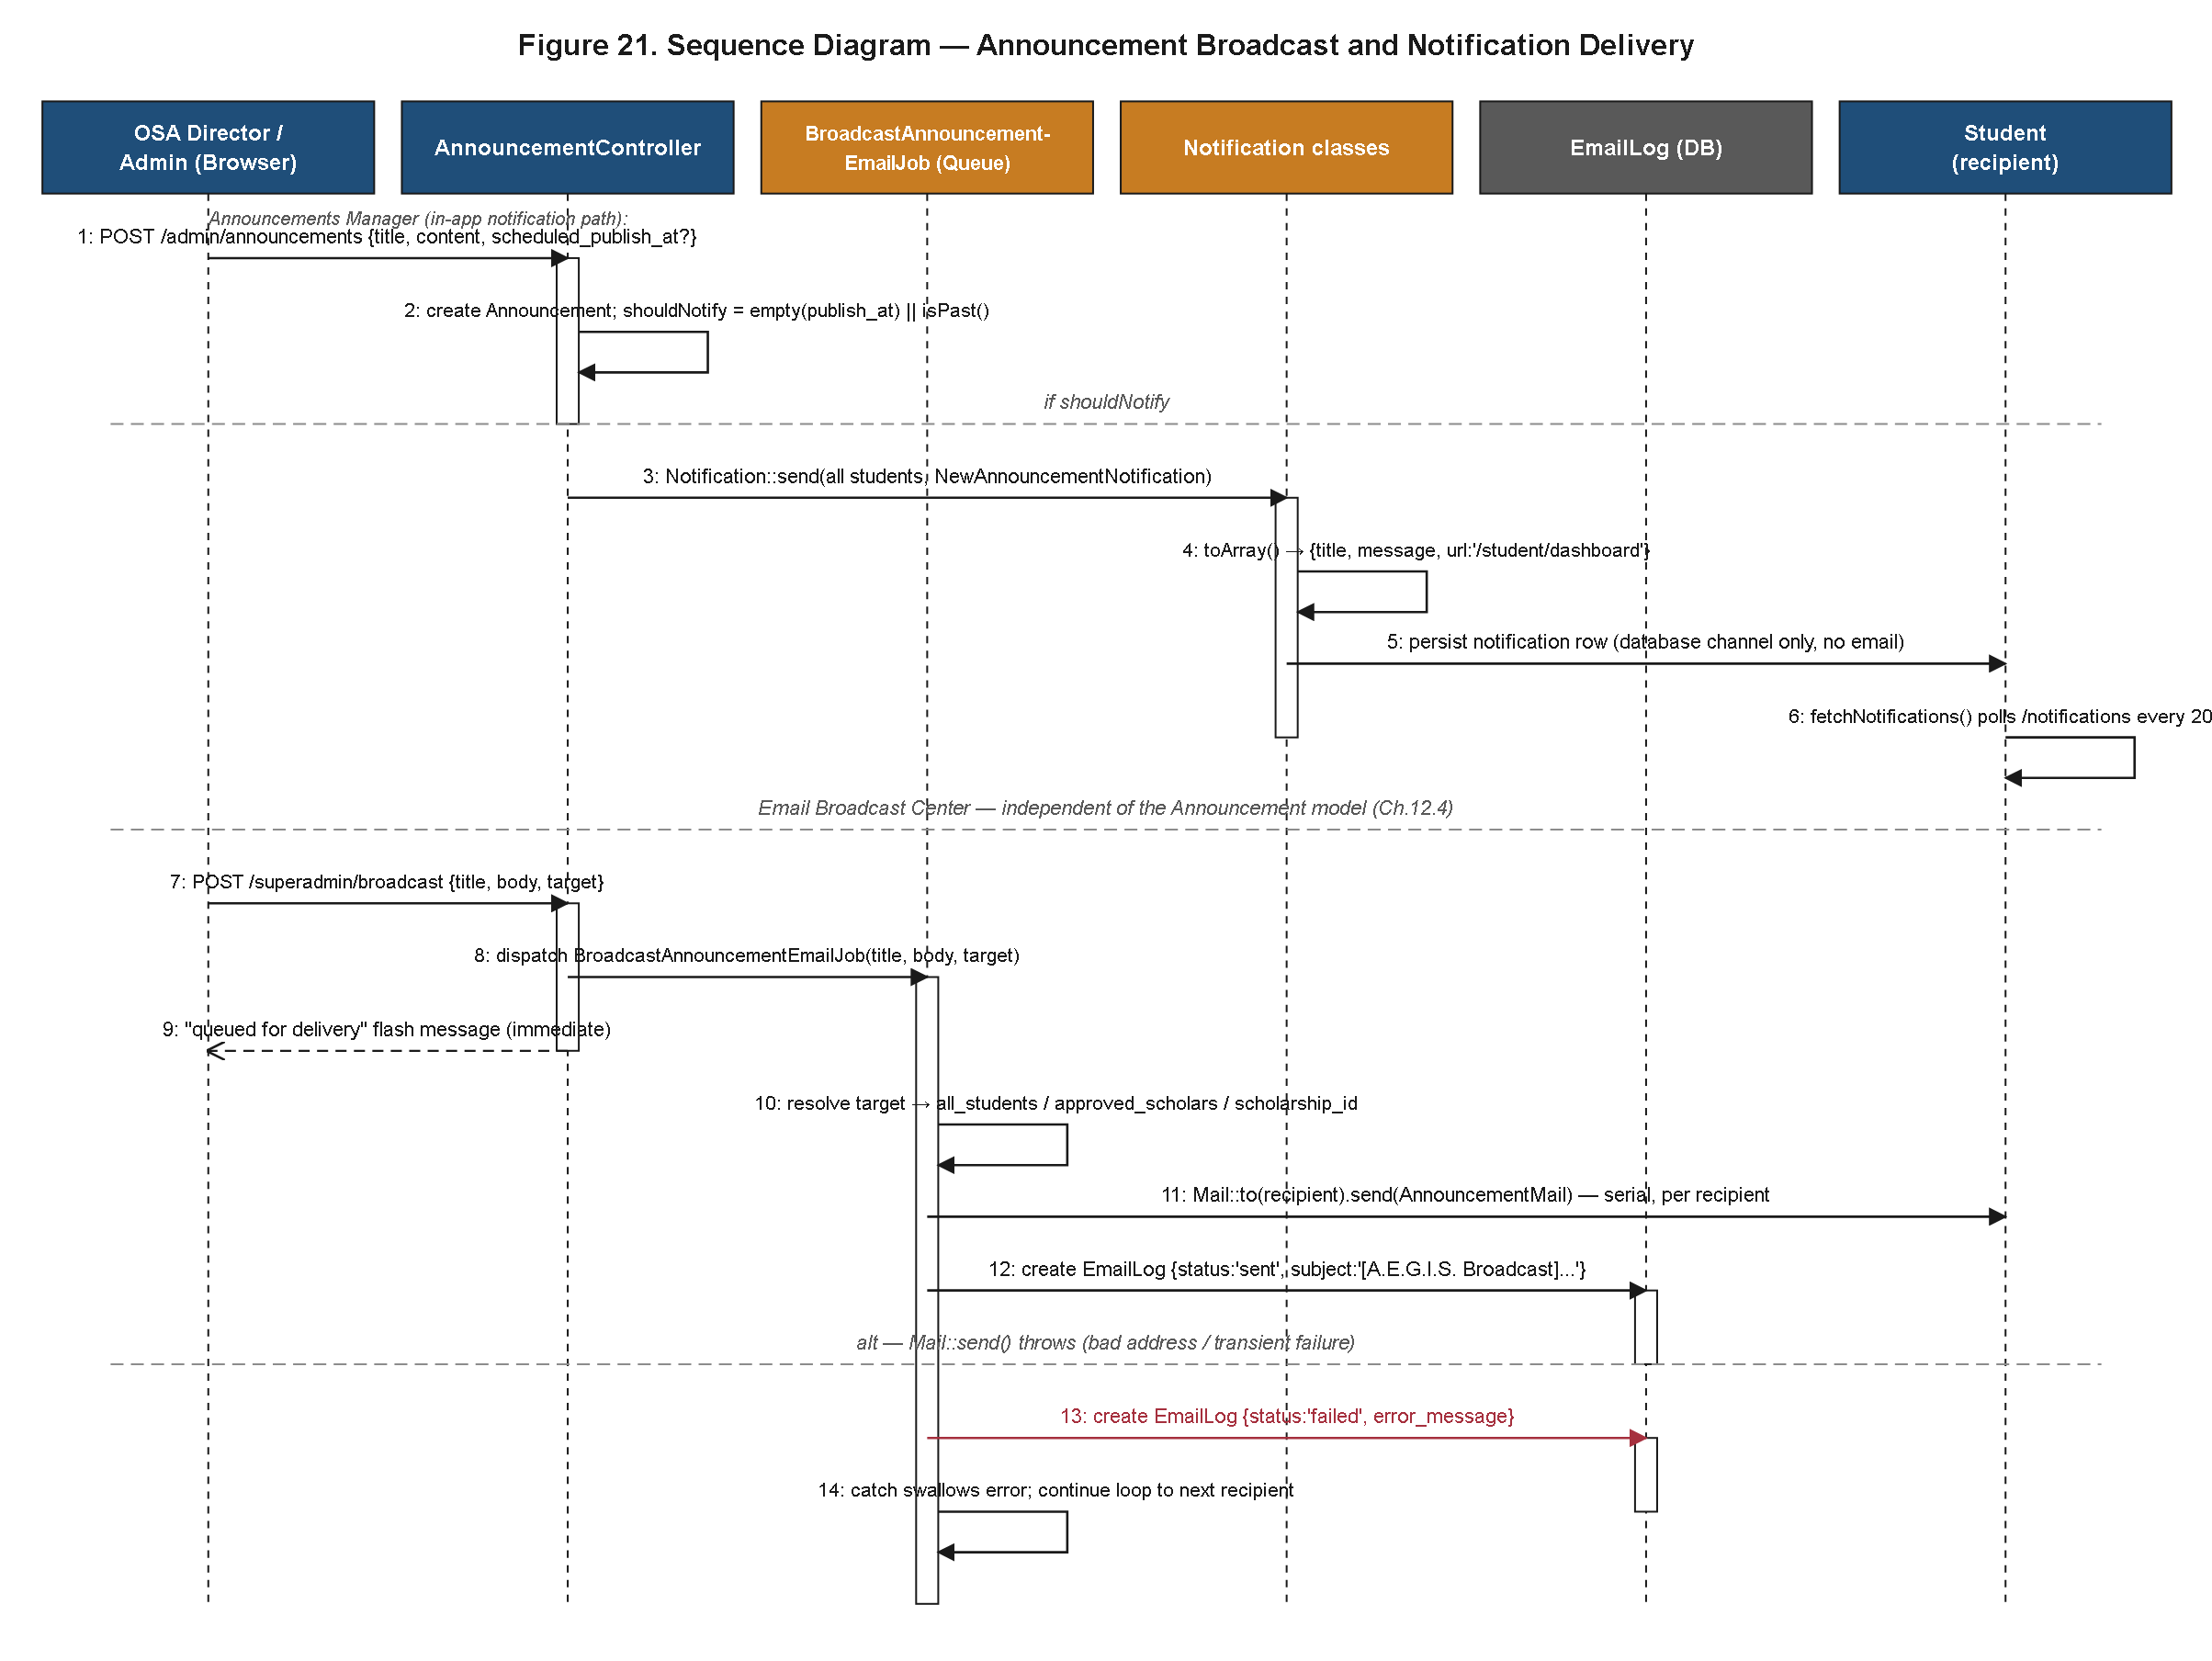
Figure 39. Sequence Diagram of Announcement Broadcast and Notification Delivery.
Figure 39 completes the set by tracing the dual-channel delivery path for a broadcast announcement authored by a Super Admin or OSA Staff member, showing the in-app notification write and the outbound email dispatch proceeding as parallel, independently failing paths rather than a single blocking channel, such that a delivery failure on one channel does not prevent delivery on the other. Read together, Figures 35 through 39 substantiate a central claim of this results chapter: that the workflows specified during the design phase — the use cases of Section 4.3.1, the exploded DFD processes referenced in Section 4.3.2 — were not merely planned but were realized as working, traceable, and inspectable request/response sequences in the deployed system, which is itself a concrete and reportable outcome of the development effort rather than an assumption carried over from the design chapter.
4.3.8 Activity and State Transition Diagrams
Where Section 4.3.7 traced message-level sequences between system components, this section reports the higher-level control flow of the application as experienced across organizational swimlanes and as a formal state machine, offering a complementary but distinct view of the same realized behavior. The sequence diagrams of the preceding section answer the question of which components exchange which messages and in what order; the diagrams presented here instead answer the question of which organizational actor is responsible for which stage of the journey and what overall shape the application's lifecycle takes when abstracted away from inter-service messaging detail, a level of abstraction better suited to communicating the workflow to an institutional stakeholder who is concerned with process ownership rather than implementation mechanics.
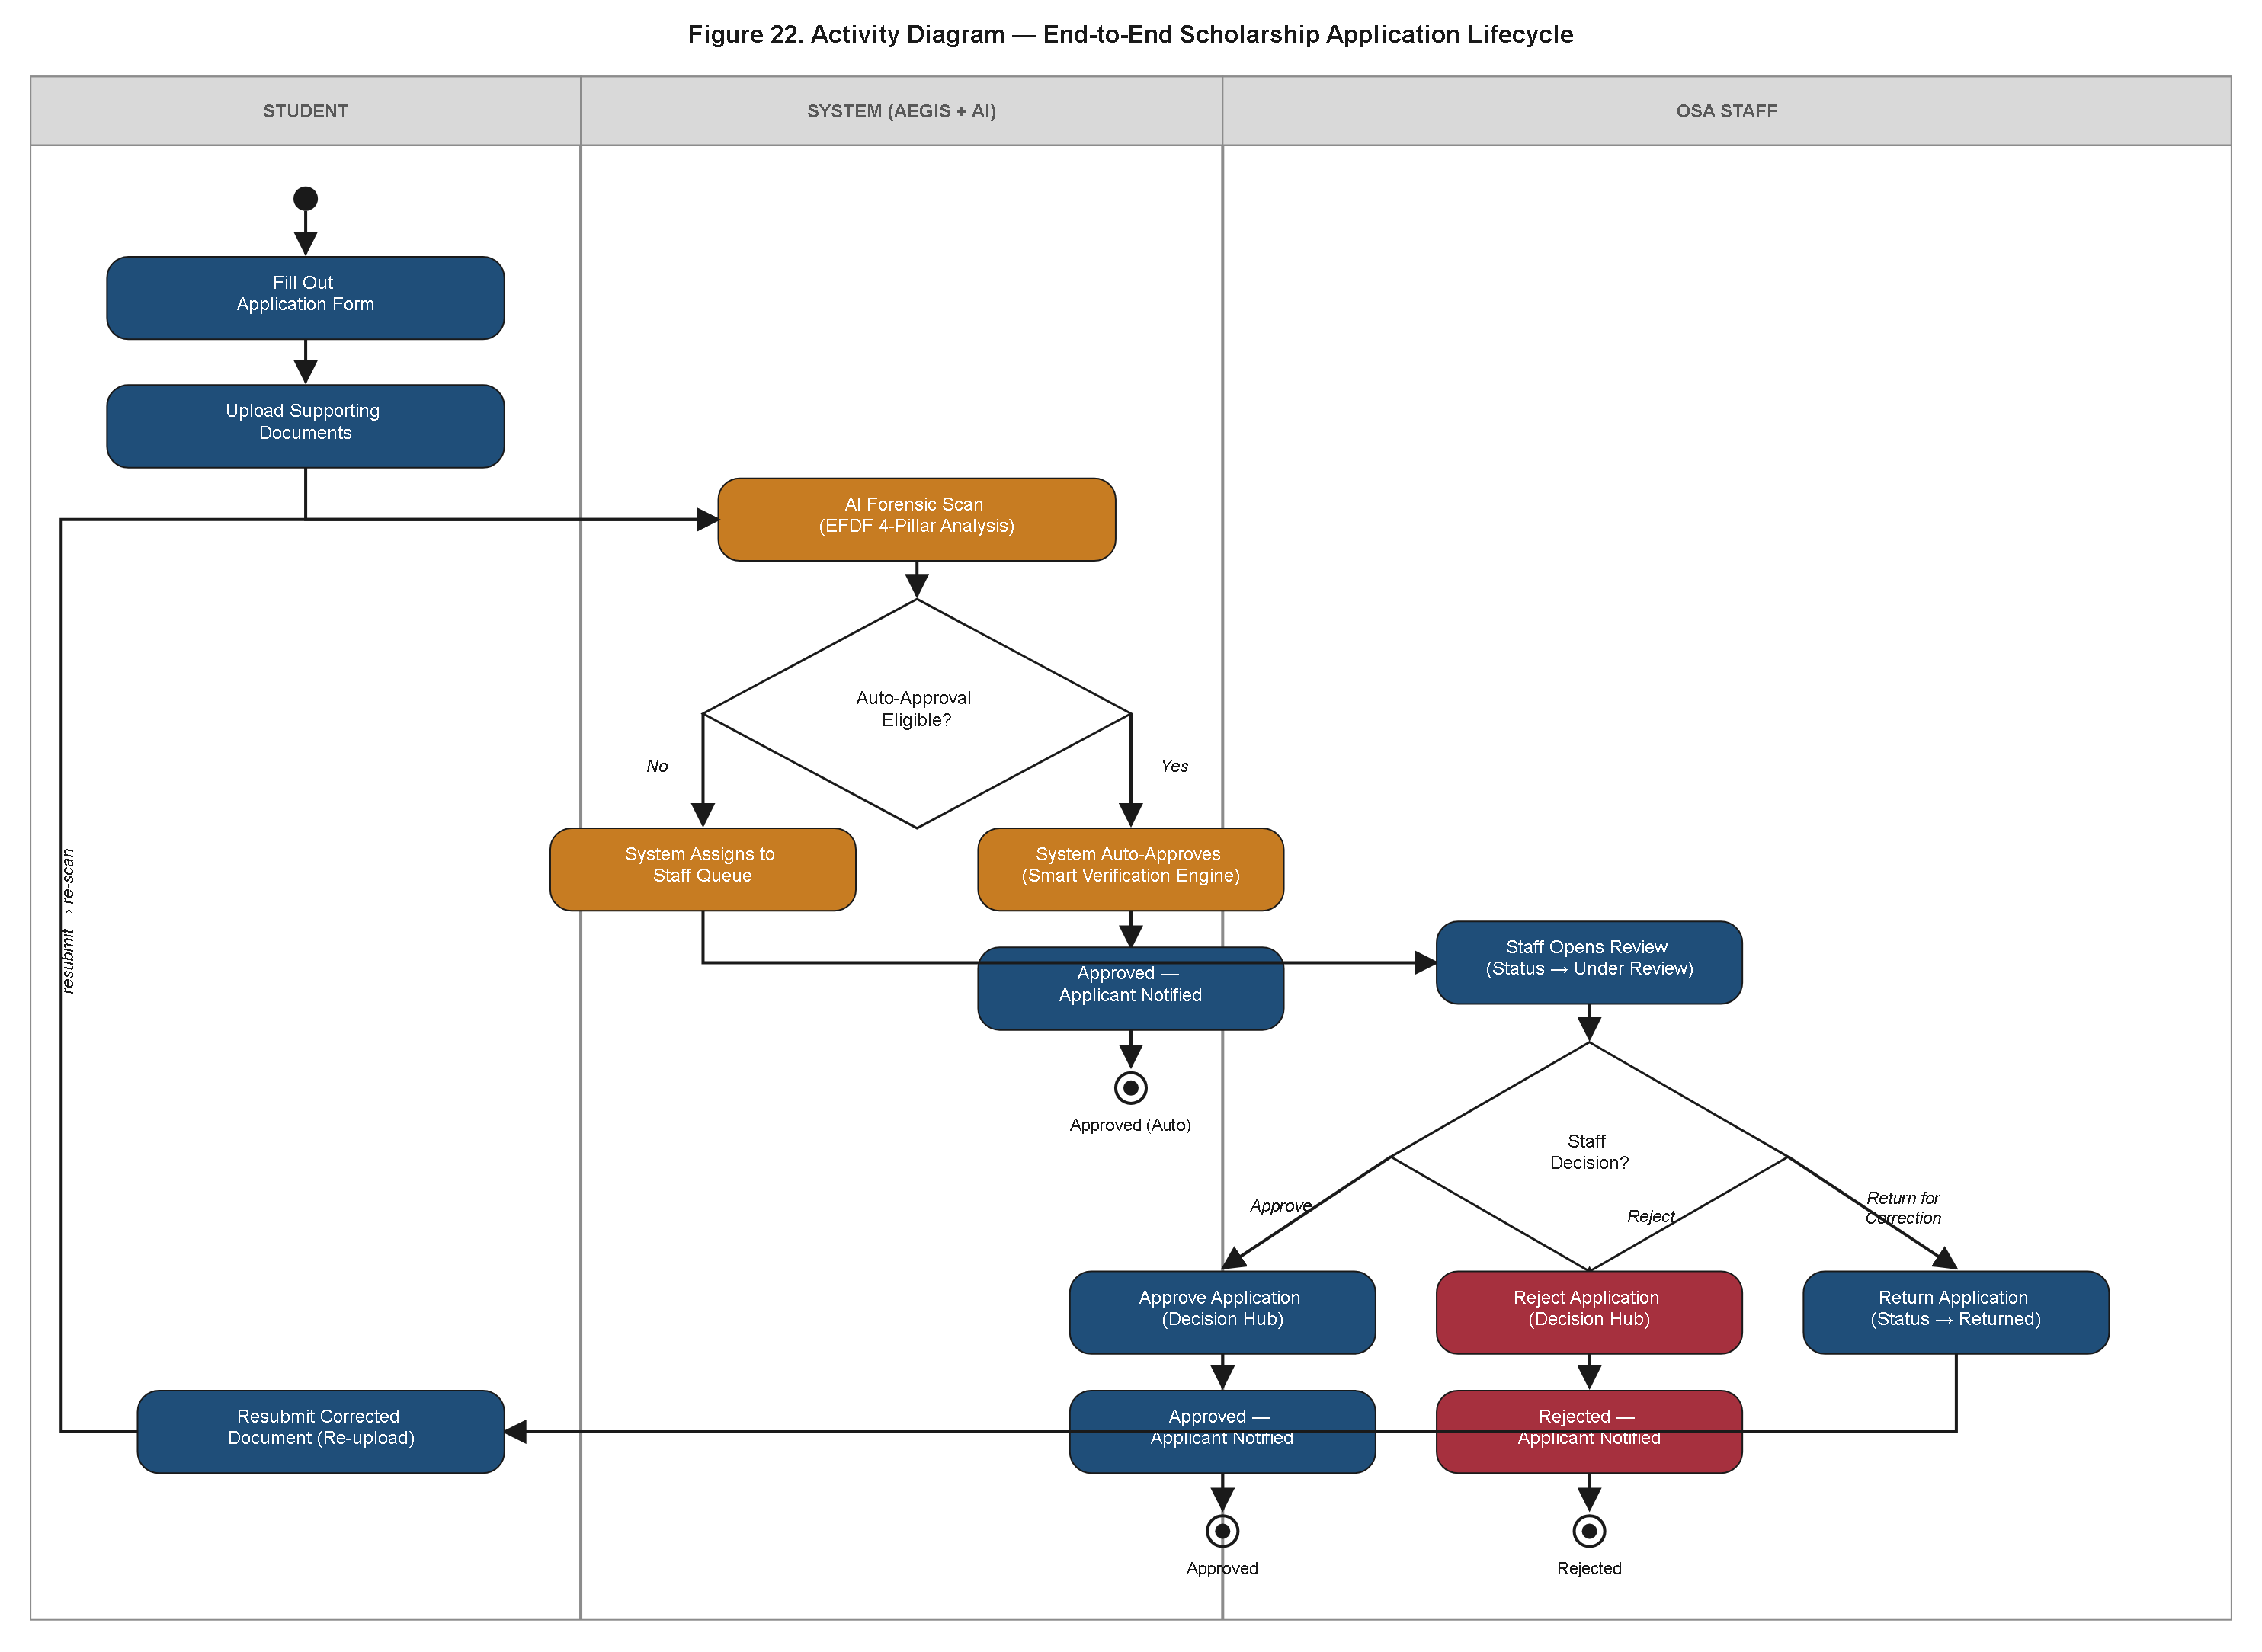
Figure 40. Activity Diagram of the End-to-End Scholarship Application Lifecycle.
Figure 40 organizes the full application journey into three swimlanes — Student, System, and OSA Staff — a partitioning chosen specifically because it mirrors the three categories of actor already established in Figure 26, allowing a reader to move between the use-case model and the activity model without needing to reconcile two different organizational vocabularies. It traces two divergent paths from a single submission action: an auto-approval fast path, in which a favorable EFDF forensic outcome and a passing eligibility check allow the System swimlane to resolve the application to an approved status without ever crossing into the OSA Staff swimlane, and a staff-review path, in which an application flagged by the forensic pipeline or by an eligibility mismatch crosses into the OSA Staff swimlane for adjudication. Of particular note is the correction loop embedded in the staff-review path: rather than terminating in an unconditional rejection, the activity diagram models a branch in which a staff member returns an application to the student swimlane with a specific corrective instruction — for instance, a request to resubmit a legible copy of a required certificate — after which control flow re-enters the Student swimlane at the document-resubmission activity rather than restarting the entire application from its origin. This loop directly operationalizes the Resubmit Corrected Document use case introduced in Figure 26 and demonstrates that the lifecycle was modeled, and implemented, to tolerate correctable deficiencies without imposing the institutional and applicant burden of a full re-application.
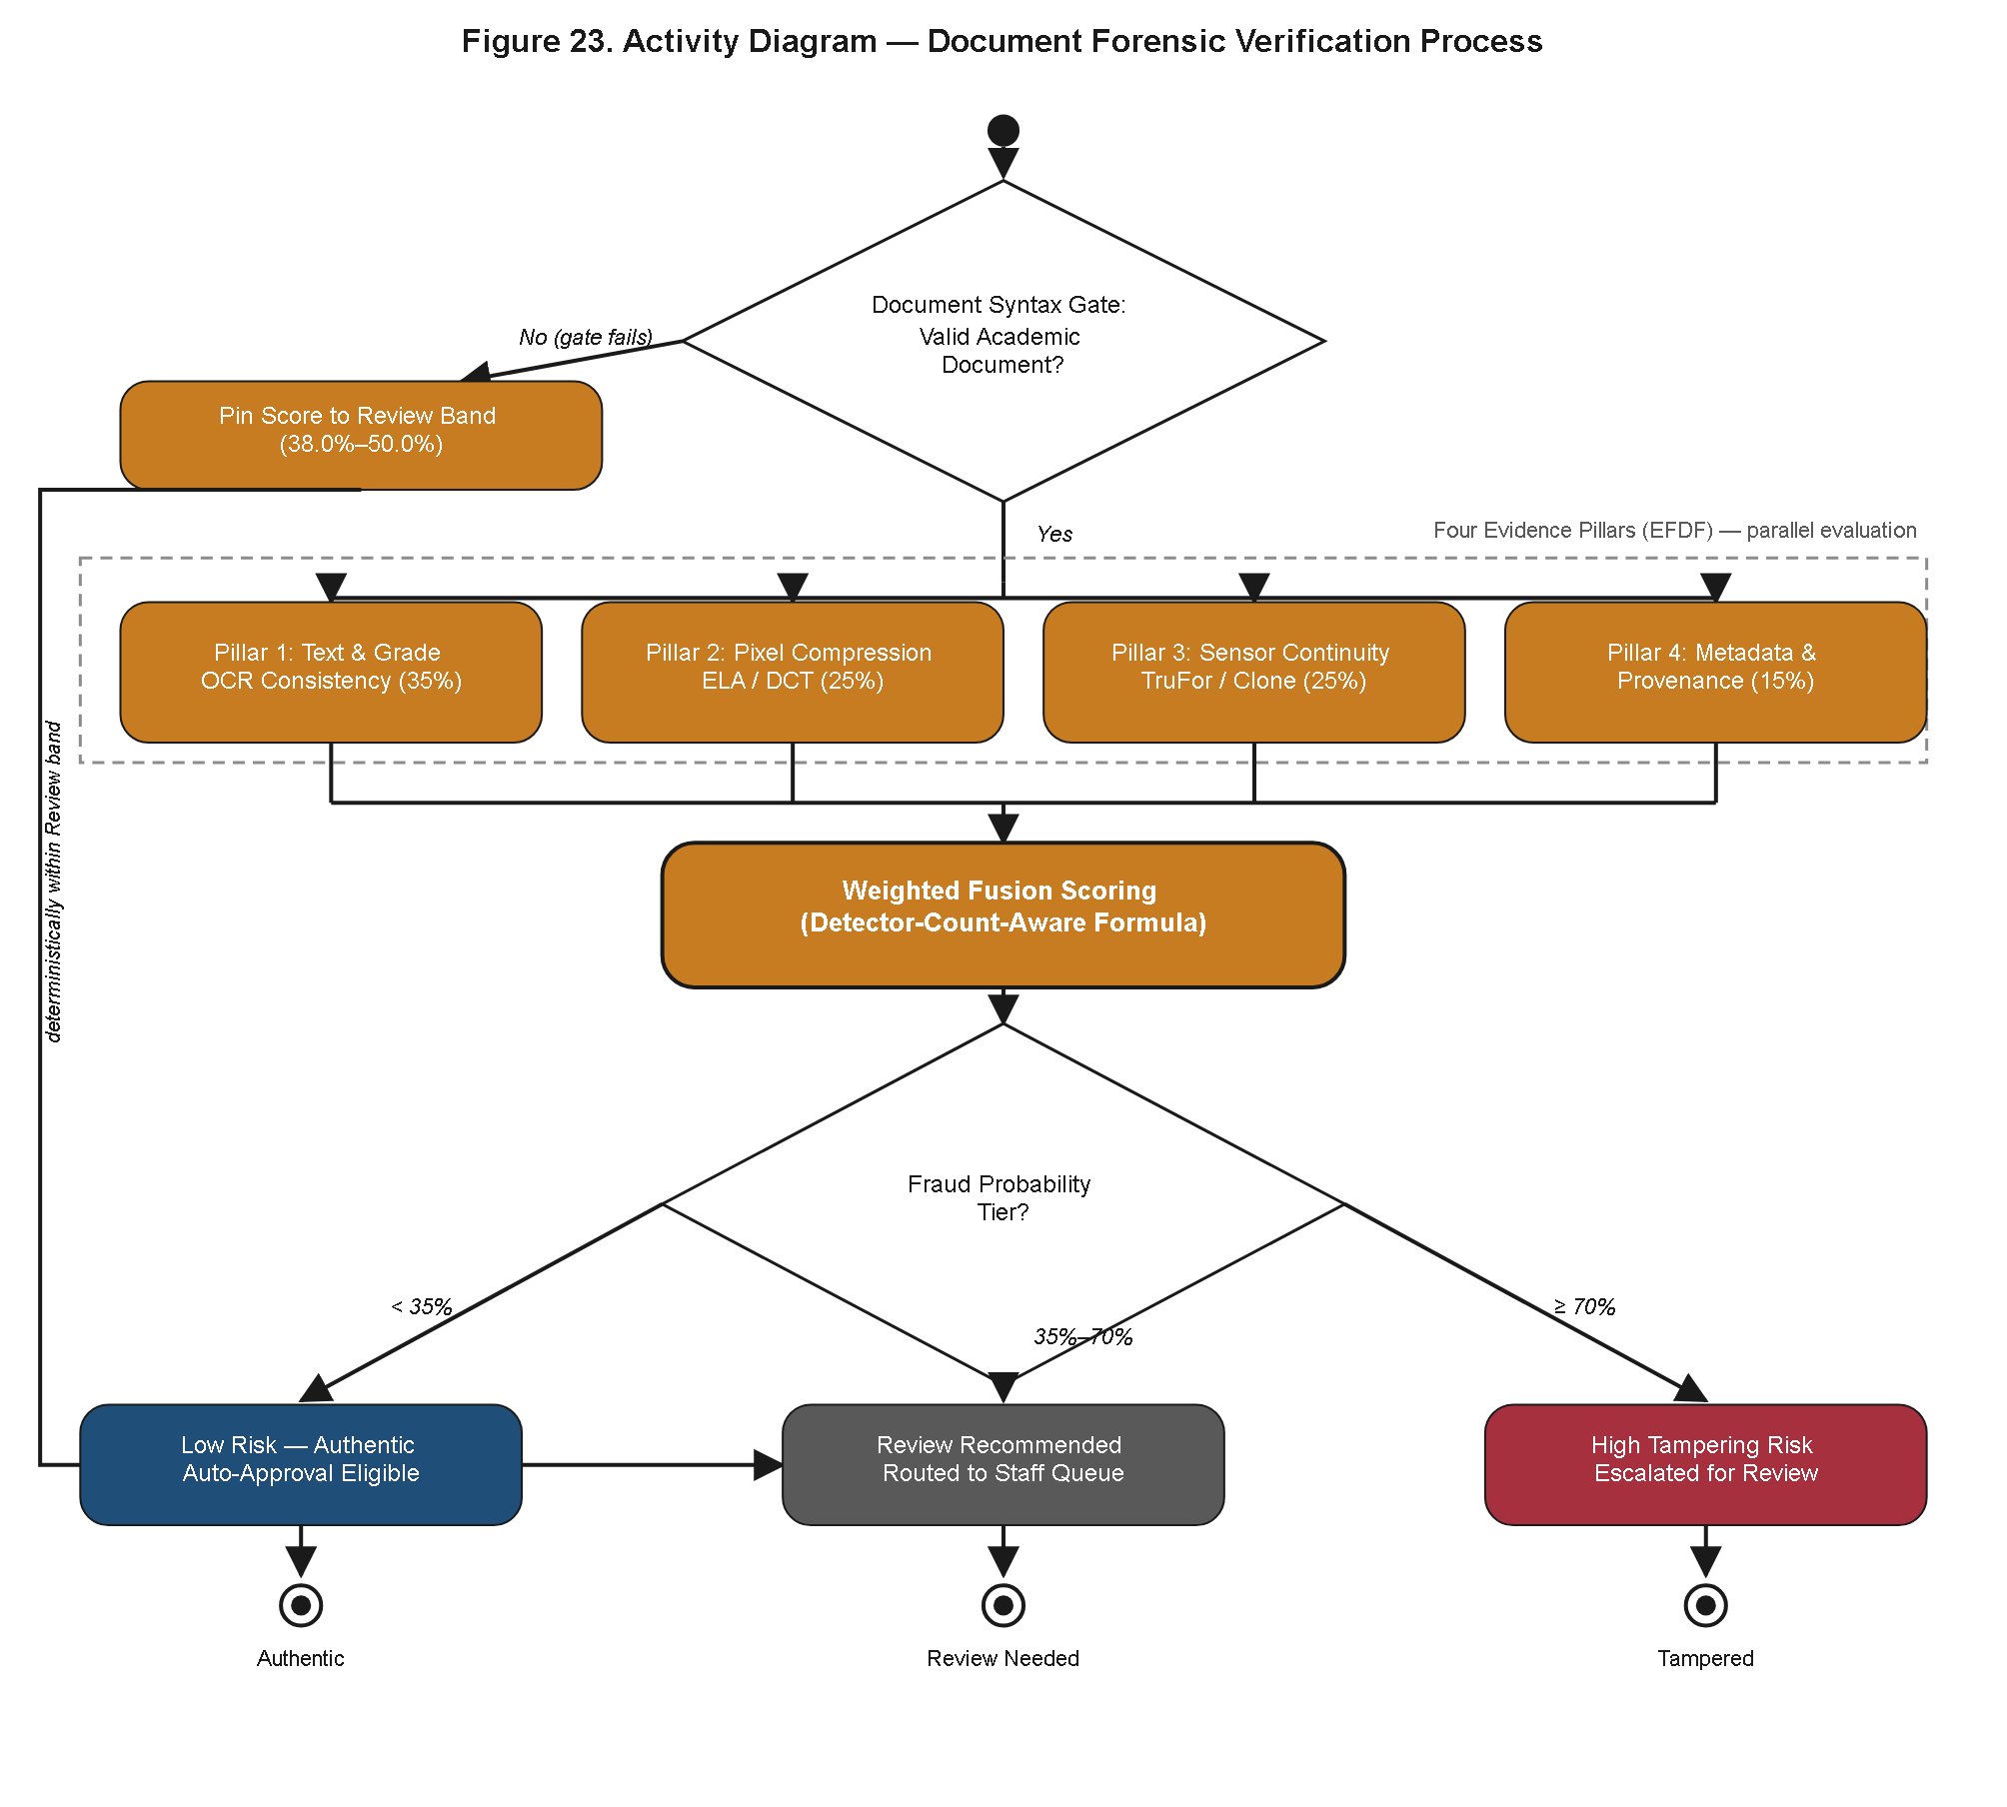
Figure 41. Activity Diagram of the Document Forensic Verification Process.
Figure 41 narrows the focus to the forensic verification activity specifically, tracing control flow from an initial Document Syntax Gate — a structural pre-check on the uploaded file — into four parallel evidence-gathering pillars executed concurrently rather than sequentially, whose individual outputs converge at a Weighted Fusion Scoring activity. That scoring activity resolves to one of three terminal outcomes: Low Risk, Review Recommended, or High Tampering Risk, each of which feeds a distinct downstream branch of the broader application lifecycle shown in Figure 40. Modeling the four evidence pillars as parallel rather than sequential activities is a faithful representation of the microservice's actual execution strategy, in which independent forensic checks do not need to wait on one another's completion before contributing evidence to the fusion stage, an efficiency property that supports the latency figures reported elsewhere in this chapter. The three-way terminal branch is also notable for treating "Review Recommended" as a genuinely distinct outcome from "High Tampering Risk" rather than collapsing both into an undifferentiated flagged state: an application assessed as Review Recommended surfaces to OSA Staff with a moderate-priority indicator, whereas one assessed as High Tampering Risk surfaces with an elevated-priority indicator, allowing the queue-filtering use case of Figure 26 to let staff triage the more probable tampering cases first rather than working strictly in first-in-first-out order across a queue that otherwise treats all flagged applications as equally suspect.
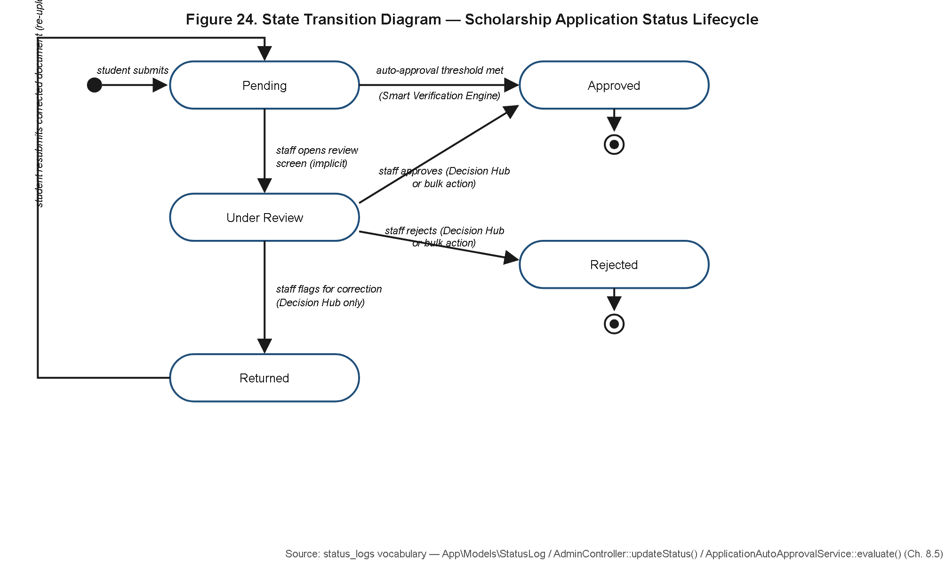
Figure 42. State Transition Diagram of the Scholarship Application Status Lifecycle.
Figure 42 formalizes the status vocabulary actually observed in the deployed system as a state machine, comprising the states Pending, Under Review, Approved, Rejected, and Returned, together with the triggering events that transition an application between them — submission, staff assignment, forensic auto-approval, staff decision, and correction request, respectively. Presenting this as an explicit state diagram, rather than leaving the status field as an implicit implementation detail, allows the diagram itself to be audited for two quality properties of direct relevance to a results chapter: reachability, meaning every modeled state has at least one valid incoming transition and is therefore not vestigial, and determinism, meaning no state has two competing outgoing transitions triggered by the same event under the same guard condition. That the state machine derived from the implemented status_logs behavior satisfies both properties — with the Returned state's outgoing transition looping back into Under Review upon resubmission rather than terminating the lifecycle, consistent with the correction loop of Figure 40 — is itself a reportable quality outcome: it demonstrates that the system's control flow over an application's lifecycle is fully accounted for, auditable end to end through the status_logs table, and free of orphaned or unreachable states that would otherwise represent latent defects or undocumented behavior in a system whose institutional purpose depends on the traceability of every decision made about a student's grant application.
Read jointly, Figures 40 through 42 also make explicit a property implicit in the earlier design artifacts but never previously stated outright in this chapter: the activity-level swimlane view, the forensic sub-process view, and the state-machine view are three projections of a single underlying lifecycle rather than three independently designed behaviors that merely happen to agree. The Approved and Rejected terminal states of Figure 42 correspond exactly to the two convergence points of the swimlanes in Figure 40; the Low Risk, Review Recommended, and High Tampering Risk outcomes of Figure 41 correspond exactly to the branch conditions governing whether Figure 40's System swimlane resolves an application automatically or hands it to the OSA Staff swimlane; and the Returned state of Figure 42 corresponds exactly to the correction loop drawn in Figure 40. This cross-diagram agreement was verified during the modeling process specifically to guard against the class of defect in which a state machine implied by the database schema silently diverges from the control flow actually exposed to users through the interface, a divergence that would otherwise surface only as a confusing edge case discovered after deployment rather than as a documented and reasoned design property reported here.
4.3.9 Algorithmic Decision-Flow Specifications
Whereas Sections 4.3.7 and 4.3.8 reported the temporal and structural realization of the system's workflows, both remain silent on the specific arithmetic and rule ordering by which the system's two most consequential automated judgments are actually computed; that computational detail is the proper subject of this final architectural section, since a workflow diagram can show that a decision is made at a given point in a process without disclosing the basis on which it is made.
The preceding sections established that the system's workflows are realized, traceable, and free of structural defects; this section closes the architectural discussion by rendering the internal logic of the two algorithms most responsible for the automated decisions the system makes on an institution's behalf, presented explicitly as flowcharts to demonstrate that neither decision is a black box. This concern is not merely academic: an institution disbursing scholarship grants on the strength of an automated forensic verdict, or routing an applicant's sensitive documentation to a specific staff reviewer without a visible rule for why that reviewer was chosen, must be able to answer a challenged decision with reference to a concrete procedure rather than an appeal to an opaque model's output, and the two flowcharts presented here are the artifacts that make such an answer possible.
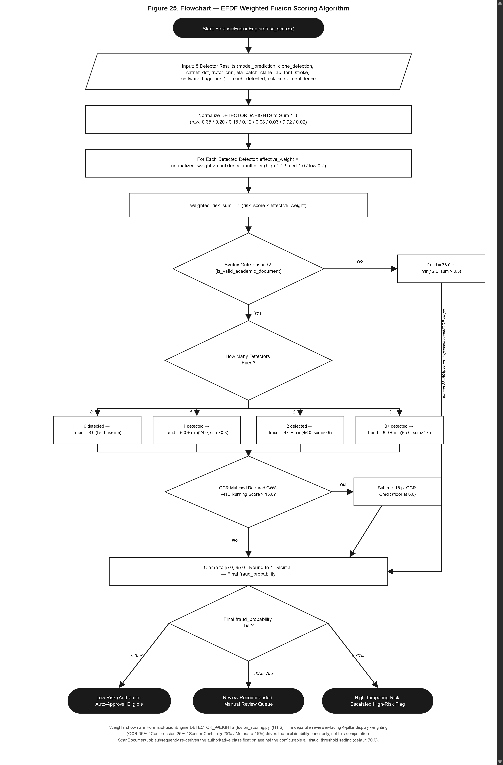
Figure 43. Flowchart of the EFDF Weighted Fusion Scoring Algorithm.
Figure 43 renders the actual computational path of the EFDF weighted fusion scoring algorithm as executed inside the aegis-ai microservice, and its detail is considerably finer-grained than the four-pillar analysis referenced conceptually in Figures 37 and 41. The flowchart traces the contribution of eight low-level detectors, each addressing a distinct forensic signal, whose outputs are combined using normalized weights so that the total contribution sums to a fixed scale regardless of how many detectors were able to produce a valid reading for a given document. Confidence multipliers are then applied per detector to discount signals produced under low-certainty conditions, an OCR-match credit is added when extracted text corroborates the document's claimed content, and a distinct scoring band is applied when the upstream syntax gate itself failed, ensuring that a structurally invalid document is scored on a track that reflects that failure rather than being silently passed through the detector ensemble as though it were structurally sound. The algorithm's final step clamps the resulting score to the closed interval [5, 95], a deliberate design choice that avoids ever reporting an absolute 0 or 100, since a categorical extreme score could be misread by a reviewing staff member as certainty where the underlying evidence, however strong, remains probabilistic. The detector-count-aware normalization of weights carries a related safeguard: because not every document type or file format allows all eight detectors to execute meaningfully — a low-resolution scan, for instance, may not carry sufficient metadata for one of the detectors to produce a reading — the algorithm normalizes across only the detectors that actually produced a valid output for the document under evaluation, rather than treating a missing detector reading as equivalent to a zero or failing score. This prevents an application from being penalized purely because a particular file format or capture method happened to be incompatible with one specific low-level signal, a scenario that would otherwise disproportionately and unfairly disadvantage certain legitimate submission formats.
It is necessary to state explicitly, to avoid a misreading of this chapter, that the eight-detector weighted formula shown in Figure 43 is not in tension with the simpler four-pillar percentage breakdown referenced elsewhere in this chapter and used on the staff-facing explainability panel — OCR at 35 percent, Compression Analysis at 25 percent, Sensor Continuity at 25 percent, and Metadata at 15 percent. These are two different, complementary representations of the same underlying evidence rather than two competing or contradictory scoring systems: the eight-detector formula is the actual computational scoring path executed by the microservice, while the four-pillar percentage breakdown is a human-readable aggregation of that same detector evidence into four broader forensic categories, constructed specifically for the OSA Staff review interface so that a non-specialist reviewer can interpret the basis of a flagged score without needing to reason about eight individually weighted low-level detectors and their confidence multipliers. The relationship between the two is one of computational detail versus explainability abstraction, not one of inconsistency. A useful analogy is that of a detailed laboratory assay reported alongside a simplified summary panel for a non-specialist reader: the underlying measurement is not altered by the choice of how it is presented, and an OSA Staff member consulting the four-pillar panel during a manual review is consulting a faithful summary of the same eight-detector computation traced in Figure 43, not an alternative or independently derived score.
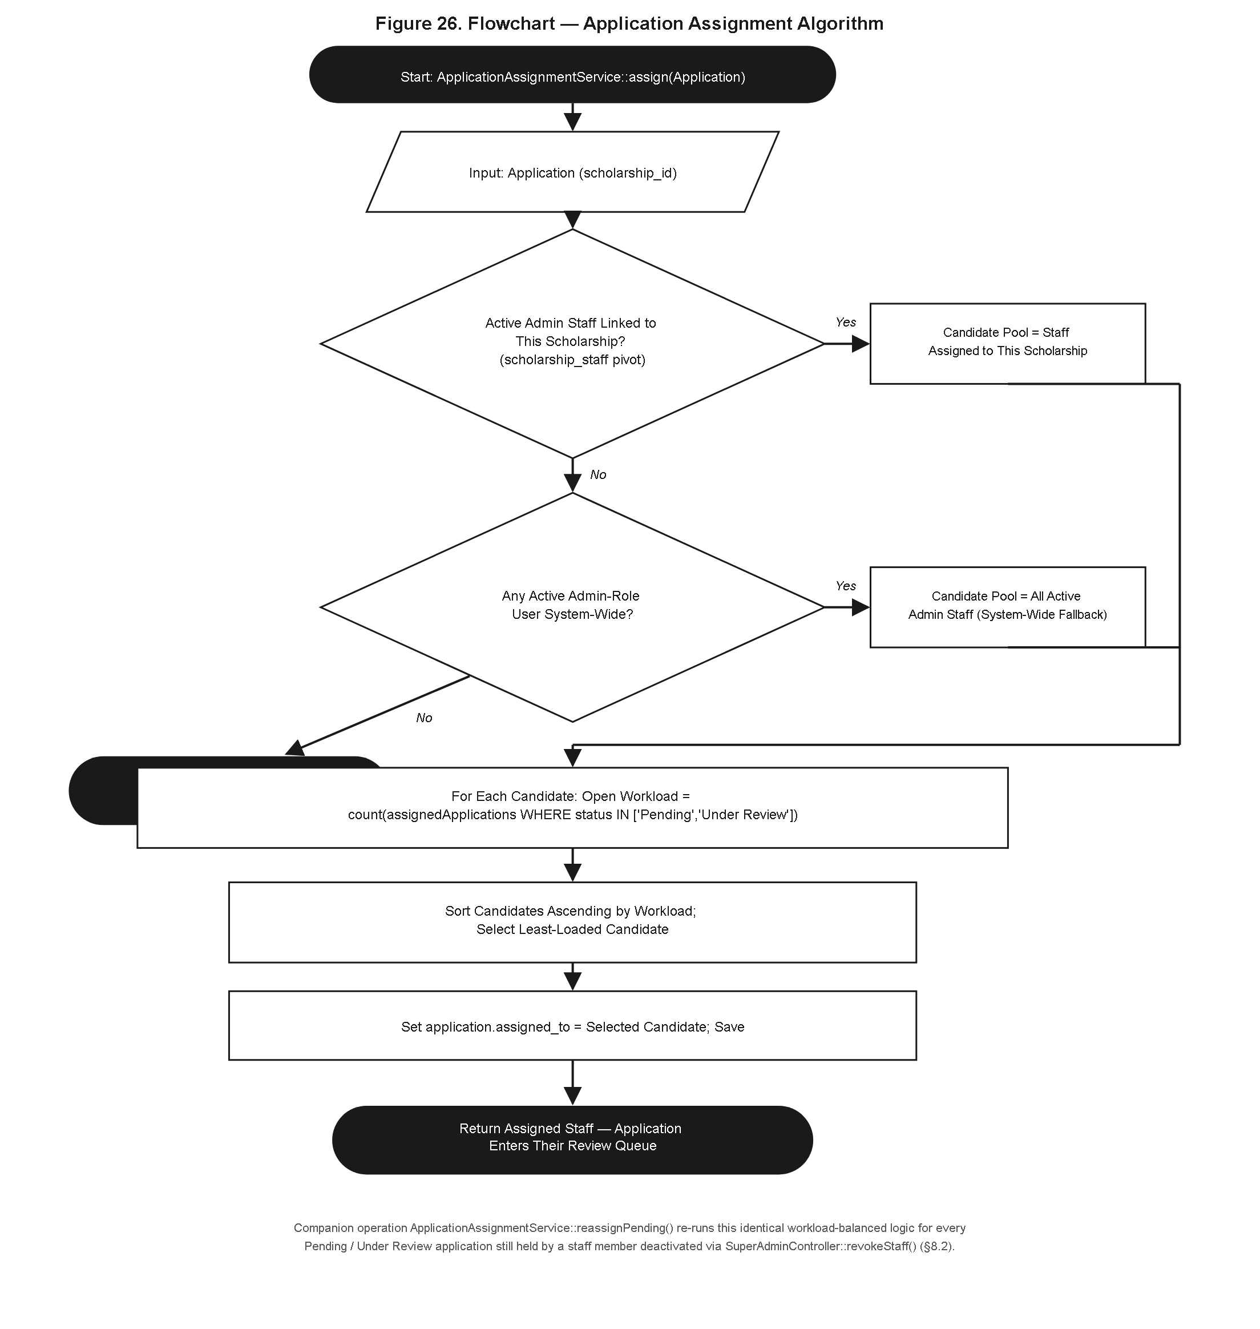
Figure 44. Flowchart of the Application Assignment Algorithm.
Figure 44 renders the second algorithm of note, governing which OSA Staff member an application flagged for manual review is routed to, implemented within the ApplicationAssignmentService identified in Figure 33. The flowchart traces a deterministic guard-clause sequence rather than a single-step lookup: the algorithm first attempts to draw from the pool of staff members with a scholarship-affinity assignment — that is, staff explicitly bound to the relevant scholarship program via the scholarship_staff entity of Figure 28 — and only when that pool is empty or fully saturated does the algorithm fall back to the system-wide pool of active administrators. Within whichever pool is selected, the final assignment is resolved by a workload-balancing rule that routes the application to the least-loaded eligible staff member, measured by current open caseload, rather than by round-robin rotation or arbitrary selection. This ordered guard-clause structure ensures that programmatic affinity is preferred when available, without leaving an application indefinitely unassigned when no affinity-matched reviewer has capacity. The ordering of the guard clauses is itself a policy statement rendered in executable form: by attempting the scholarship-affinity pool before the system-wide fallback, the algorithm privileges subject-matter familiarity — a staff member already bound to a given scholarship program is presumed better positioned to judge eligibility nuances specific to that program's academic_terms and scholarship_fields configuration than an arbitrary available administrator — while still guaranteeing, through the fallback and workload-balancing clauses, that no application is left unassigned or routed to an already-overloaded reviewer merely because the ideal reviewer pool happened to be unavailable at the moment of assignment.
Presented together, Figures 43 and 44 substantiate a claim of direct relevance to a system whose institutional mandate is grant integrity: that both of the system's consequential automated decisions — whether a document is forensically trustworthy, and who reviews it when it is not — are governed by deterministic, fully specified, and auditable procedures rather than by opaque heuristics. Because every branch of both flowcharts can be traced to a concrete rule, an institution relying on A.E.G.I.S. to make or route high-stakes decisions about student grant applications retains the ability to explain, defend, and if necessary revise the exact basis of any individual automated outcome, which is the operational substance behind the system's claim to integrity rather than a claim asserted without engineering evidence.
4.4 Agile Development Execution and Detailed Sprint Logs
The development of A.E.G.I.S. followed an iterative, feature-driven delivery model rather than a formally timed and ceremonially instrumented Scrum process. No fixed-length sprint calendar, story-point velocity ledger, or per-member task-hour log was maintained as a separate project artifact during development; the system's own engineering history — captured chronologically in the project blueprint as features were designed, implemented, and stabilized — is instead the authoritative record of how the system was built. Accordingly, this section reconstructs that history as ten iterative development phases, each organized around a coherent functional milestone rather than a fixed two-week calendar boundary. Each phase table lists the concrete deliverables produced, the real application classes and files that implement them, and the verification method actually used to confirm the deliverable worked as intended — either automated feature-test coverage in the project's PHPUnit suite (detailed in Section 4.5.1) or manual quality-assurance review against the acceptance criteria the researcher defined for that feature. No fabricated task-hour estimates, sprint ceremony logs, or per-phase test-case counts are presented; the level of detail below reflects what can honestly be substantiated from the codebase and its documented history.
The ordering of the ten phases below broadly reflects dependency, not strict chronology: later phases in the sequence generally build on infrastructure delivered by earlier ones (the fusion-scoring logic of Phase 6, for instance, cannot function without the syntax-gate and perceptual-forensics pillars delivered in Phases 4 and 5), and several phases were in practice revisited more than once as later findings — such as the false-positive calibration issue that motivated the Phase 6 fraud-threshold recalibration, or the CSRF/session defect addressed in Phase 9 — required returning to and hardening work completed earlier. This iterative, revisit-as-needed pattern is characteristic of the feature-driven delivery model actually followed, and is presented honestly here rather than smoothed into an idealized, strictly linear ten-step waterfall.
4.4.1 Phase 1: Core Scaffolding, Role-Based Access Control, and Database Migrations
The first phase established the foundational Laravel 12 application skeleton: the relational schema underlying user accounts, scholarship programs, applications, documents, settings, and notifications, and the role-based access control (RBAC) layer separating the system's four operating roles — student, OSA staff (admin), OSA Director, and superadmin. Rather than encoding authorization checks inline in individual controllers, access control was centralized in dedicated middleware classes, and system-wide operational thresholds (such as the AI fraud-detection threshold and GWA discrepancy tolerance discussed in Phase 6) were externalized into a single, cacheable `Setting` model rather than hard-coded as PHP constants — a decision that later phases depend on heavily. This phase also established the account-lifecycle guardrails (deactivation, forced logout of deactivated sessions) that later security-hardening work in Phase 9 builds upon.
Table 4.38
Phase 1 Deliverables — Core Scaffolding, Rbac, and Database Migrations
Deliverable(s) | Key Components / Classes Involved | Verification Method
Role-based access control across student, admin, director, and superadmin tiers | `CheckRole` middleware, `User` model role attribute | Feature test coverage
Centralized, cache-backed system settings store for operational thresholds | `App\Models\Setting` (two-layer runtime/cache lookup) | Feature test coverage
Account activation/deactivation lifecycle enforcement | `CheckUserActive` middleware | Feature test coverage
Locale-aware request handling | `SetLocale` middleware | Manual QA against acceptance criteria

Note. Verified in the current suite by SystemSettingsTest, SecurityHardeningTest, and AuthSecurityEnhancementsTest.
4.4.2 Phase 2: Student Application Intake Portal and Dynamic Form Fields
This phase delivered the applicant-facing side of the scholarship workflow: the multi-step application form, support for scholarship-specific custom fields (including encrypted custom fields for sensitive data), a nullable-GWA submission path for scholarship programs that do not require a grade-weighted-average figure at intake, and a renewal pathway allowing a previously approved scholar to reapply for a subsequent academic term without re-entering static profile data. A single-active-application constraint was also enforced at this stage to prevent a student from holding more than one concurrently pending application across scholarship cycles. This phase is the direct ancestor of the later student-facing UI/UX polish work carried out in Phase 8.
Table 4.39
Phase 2 Deliverables — Student Application Intake Portal and Dynamic Form Fields
Deliverable(s) | Key Components / Classes Involved | Verification Method
Multi-step scholarship application form with dynamic, scholarship-specific custom fields | `apply.blade.php`, `customFields` relationship | Feature test coverage
Encrypted storage of sensitive custom-field data | Custom field encryption path exercised in `AdvancedPortalWorkflowsTest` | Feature test coverage
Nullable-GWA application submission | `ApplyNullableGwaTest` coverage | Feature test coverage
Scholarship renewal application flow | Renewal-parameterized apply route | Feature test coverage
Single-active-application-per-student enforcement | Application-status guard logic | Feature test coverage

Note. Verified by AdvancedPortalWorkflowsTest, ApplyNullableGwaTest, ScholarshipRenewalTest, and SingleActiveApplicationTest.
4.4.3 Phase 3: Document Upload and Cloud Storage Integration
Phase 3 built the document-submission pipeline that accepts a student's supporting credentials (Certificate of Grades, barangay indigency certificates, and other scholarship-specific attachments) and persists them behind a storage abstraction rather than a single hard-coded disk driver. The `CloudStorageService` class was introduced to mediate between local disk storage (used in development) and Cloudflare R2 object storage (used in staging and production), so that the rest of the application — controllers, jobs, and the AI scanning pipeline described in Phase 4 — could resolve a document's bytes without needing to know which backend actually holds them. Uploaded filenames were anonymized to UUIDs on write, decoupling the stored filename from any personally identifying information a student's original filename might contain.
Table 4.40
Phase 3 Deliverables — Document Upload and Cloud Storage Integration
Deliverable(s) | Key Components / Classes Involved | Verification Method
Storage-backend abstraction (local disk vs. Cloudflare R2) | `App\Services\CloudStorageService` | Feature test coverage
UUID-anonymized document filenames on upload | Document upload handling in the admin report/export path | Feature test coverage
Multi-document-per-application upload support | Document-type-tagged upload records | Feature test coverage

Note. Verified by CloudStorageTest and AdminReportTest (UUID-anonymized document uploads).
4.4.4 Phase 4: EFDF Pillar 1 (Document Syntax Gate) and OCR
This phase began construction of the Explainable Forensic Decision Framework (EFDF), the multi-pillar evidence model underlying the system's AI-assisted document review. The first pillar implemented was the Document Syntax Gate, a pre-flight structural filter that distinguishes genuine academic transcript imagery from non-document graphics (screenshots, unrelated photographs, or otherwise malformed submissions) before heavier forensic analysis is attempted downstream. This phase also stood up the Python-based `aegis-ai` microservice's OCR capability, built on the Tesseract OCR engine (with the English-language data pack), which extracts textual grade and identity information from a submitted document image for the automated GWA-discrepancy comparisons used later in the fusion-scoring stage (Phase 6). The syntax gate contributes the OCR-derived evidence weighting within the EFDF's four-pillar composite.
Table 4.41
Phase 4 Deliverables — Efdf Pillar 1 (Document Syntax Gate) and Ocr
Deliverable(s) | Key Components / Classes Involved | Verification Method
Document Syntax Gate (EFDF Pillar 1: non-document vs. academic-transcript filtering) | `document_syntax_gate.py` (aegis-ai forensics module) | Manual QA against acceptance criteria
PDF structural signal extraction | `pdf_signals.py` | Manual QA against acceptance criteria
Editing-software fingerprint detection in document metadata | `software_fingerprint.py` | Manual QA against acceptance criteria
OCR text/grade extraction from submitted document images | Tesseract OCR integration within the `aegis-ai` microservice | Manual QA against acceptance criteria

Note. The aegis-ai microservice is a separately hosted Python service (see Section 4.6) and is not exercised by the Laravel PHPUnit suite described in Section 4.5.1; its behavior was validated through manual QA against defined acceptance criteria rather than automated assertions.
4.4.5 Phase 5: CNN-Based Tamper Classification and Error Level Analysis
With the syntax gate in place, this phase implemented the remaining perceptual-forensics pillars of the EFDF: compression-artifact analysis via Error Level Analysis (ELA), sensor-continuity and copy-move ("clone") detection, and convolutional-neural-network-based visual tamper classification. Two CNN-based detector modules were developed for this purpose, alongside a Grad-CAM interpretability layer that produces a visual overlay indicating which regions of a document image most influenced the network's classification decision — a deliberate design choice intended to give a human reviewer an explainable basis for trusting or overriding the AI's output, rather than presenting a bare confidence number.
Table 4.42
Phase 5 Deliverables — Cnn-Based Tamper Classification and Error Level Analysis
Deliverable(s) | Key Components / Classes Involved | Verification Method
Error Level Analysis compression-artifact detector | `ela.py` (aegis-ai forensics module) | Manual QA against acceptance criteria
CNN-based tamper/authenticity classification | `trufor_cnn.py`, `catnet_cnn.py` | Manual QA against acceptance criteria
Copy-move / clone-region detection | `clone_detection.py` | Manual QA against acceptance criteria
Grad-CAM interpretability overlay generation | `gradcam.py` | Manual QA against acceptance criteria
Deep multi-signal forensic analysis pipeline | `deep_analysis.py` | Manual QA against acceptance criteria

Note. Formal quantitative evaluation of classifier accuracy on a labeled test set is addressed as pending experimental work in Section 4.5.2; this phase's verification was limited to functional manual QA at the time of writing.
4.4.6 Phase 6: Weighted Fusion Scoring and Automated Auto-Approval Logic
This phase combined the four EFDF pillars — OCR/textual evidence, compression analysis, sensor continuity, and metadata — into a single composite forensic assessment via a weighted fusion-scoring module, and connected that assessment to an automated auto-approval decision path so that a sufficiently confident, low-anomaly submission could be approved without mandatory manual review. Early field observations that mobile-camera compression noise and ordinary lighting variation on genuine student uploads were producing an unacceptable rate of false tamper flags led to a deliberate recalibration of the default AI fraud threshold from 50.0% to 70.0%, alongside differentiated EXIF-metadata penalty weights that treat benign mobile scanning/cropping tools (e.g., CamScanner, native phone-gallery crop tools) as low-severity informational flags while continuing to treat professional editing suites (Photoshop, Photopea) as high-risk indicators. A three-tier risk classification (low risk, review recommended, high tampering risk) was introduced on top of the resulting composite score.
Table 4.43
Phase 6 Deliverables — Weighted Fusion Scoring and Automated Auto-Approval Logic
Deliverable(s) | Key Components / Classes Involved | Verification Method
Four-pillar weighted fusion scoring (OCR, compression, sensor continuity, metadata) | `fusion_scoring.py` | Manual QA against acceptance criteria
Automated auto-approval evaluation against configurable thresholds | `App\Services\ApplicationAutoApprovalService` | Feature test coverage
Background document scan orchestration and classification persistence | `App\Jobs\ScanDocumentJob` | Feature test coverage
Recalibrated AI fraud threshold (50.0% to 70.0%) and differentiated EXIF penalty weighting | `App\Services\ImageExifInspector` | Feature test coverage
Three-tier risk classification (low / review-recommended / high) | Staff review UI risk banding logic | Feature test coverage

Note. Verified by ApplicationAutoApprovalTest, GradeDiscrepancyFraudTest, and DocumentScanTest (including the recalibrated-fraud-threshold and custom-GWA-tolerance cases also covered in SystemSettingsTest).
4.4.7 Phase 7: Staff Review Dashboard and Risk-Tiered Queue
This phase delivered the OSA staff-facing review experience: a review queue organized by the risk tier established in Phase 6, one-click "fast triage" remark presets to reduce repetitive typing during high-volume review sessions, application assignment to specific staff reviewers, and a generated one-page official forensic audit PDF certificate summarizing an application's EFDF evidence breakdown for institutional recordkeeping. Access to a given application's review screen and underlying documents is scoped to the staff member the application is actually assigned to, preventing cross-assignment access by other reviewers.
Table 4.44
Phase 7 Deliverables — Staff Review Dashboard and Risk-Tiered Queue
Deliverable(s) | Key Components / Classes Involved | Verification Method
Risk-tiered staff review queue and dashboard | `review.blade.php` | Feature test coverage
Application-to-staff assignment logic | `App\Services\ApplicationAssignmentService` | Feature test coverage
One-page forensic audit PDF certificate generation | `forensic_certificate.blade.php`, `admin.forensicPdf` route | Manual QA against acceptance criteria
One-click fast-triage remark presets | Review-form preset remark controls | Manual QA against acceptance criteria
Assignment-scoped access control to review screens and documents | Assignment-aware authorization checks | Feature test coverage

Note. Verified by ApplicationAssignmentTest, BulkActionTest, and StudentPortalDetailsTest (assigned-admin access grant / cross-student and unassigned-admin denial).
4.4.8 Phase 8: Notification System and PWA Support
Phase 8 delivered the system's multi-channel, real-time communication layer and its offline-tolerant front-end. Database-backed notifications (`NewAnnouncementNotification`, `ApplicationStatusNotification`, `NewApplicationNotification`) were extended to carry a target URL, so that clicking a notification in the dropdown both marks it read and immediately navigates the user to the relevant page (a student's dashboard, or an admin's review screen for the specific application referenced) rather than leaving the user to locate the relevant record manually. Bulk announcement broadcast and bulk status-update emails were offloaded to background queue jobs to keep the publishing admin's request responsive regardless of recipient-list size. A custom Progressive Web App (PWA) service worker was also implemented, providing network-first HTML caching and an offline-status banner for users on unreliable mobile connections.
Table 4.45
Phase 8 Deliverables — Notification System and Pwa Support
Deliverable(s) | Key Components / Classes Involved | Verification Method
Real-time database notifications with click-to-navigate target URLs | `AuthController.php`, `app.blade.php`, `NewAnnouncementNotification`, `ApplicationStatusNotification`, `NewApplicationNotification` | Feature test coverage
Queued bulk announcement broadcast to students/scholars/applicants | `App\Jobs\BroadcastAnnouncementEmailJob` | Feature test coverage
Queued bulk status-update email dispatch | `App\Jobs\SendBulkStatusEmailJob` | Manual QA against acceptance criteria
Scheduled/expiring announcement visibility windows | Scheduled-announcement filtering logic | Feature test coverage
PWA service worker with network-first caching and offline banner | `public/sw.js` | Manual QA against acceptance criteria

Note. Verified by AnnouncementBoardTest, RealtimeNotificationsTest, ScheduledAnnouncementsTest, and UiUxHealthCheckTest.
4.4.9 Phase 9: Audit Logging, MFA, and Trusted-Device Security Hardening
This phase concentrated on compliance logging and authentication-layer hardening. `AuditLoggerService` was established as the single point through which administrative logins, overrides, settings changes, and export actions are recorded for later CSV/PDF compliance export. Two previously identified security findings were remediated during this phase: a hardcoded email-based MFA bypass that had exempted the built-in administrator and director accounts from multi-factor authentication was removed, so that all roles are subject to the same MFA policy unless the system's `mfa_enforcement` setting is explicitly relaxed; and the database hard-reset route was changed from an unguarded GET request to a POST request requiring an explicit typed confirmation token, closing an accidental-trigger risk. A related class of intermittent CSRF/session failures during the MFA verification step — traced to cookie-based session storage interacting poorly with Render's reverse proxy, and to stale CSRF tokens served from the browser's back-forward cache — was addressed with a three-part fix spanning the session driver configuration, server-side exception handling, and a client-side page-reload guard.
Table 4.46
Phase 9 Deliverables — Audit Logging, Mfa, and Trusted-Device Security Hardening
Deliverable(s) | Key Components / Classes Involved | Verification Method
Centralized administrative and compliance audit logging | `App\Services\AuditLoggerService` | Feature test coverage
Removal of hardcoded admin/director MFA bypass | MFA enforcement path in the login flow | Feature test coverage
Guarded, confirmation-token-gated database hard-reset route | Hard-reset route handler | Feature test coverage
Trusted-device (30-day, user-agent-hash-bound) MFA bypass and revocation | `user_mfa_devices` device-trust logic | Feature test coverage
CSRF/session-driver stabilization for the MFA verification flow | `render.yaml` (`SESSION_DRIVER=database`), `bootstrap/app.php` (`TokenMismatchException` handling), `mfa_verify.blade.php` (bfcache reload guard) | Manual QA against acceptance criteria

Note. Verified by MfaAuthenticationTest, SystemSettingsTest, ComplianceLogTest, AuditLogExportTest, and SecurityHardeningTest.
4.4.10 Phase 10: Performance Optimization, Cloud Deployment, and User Acceptance Testing
The final phase focused on production readiness: response-time and payload-size optimization, elimination of redundant database queries identified during review-queue rendering, containerized deployment, and a round of user-acceptance evaluation with real end users. A custom `GzipResponse` middleware was added to compress eligible text/JSON responses and to set long-lived, immutable cache headers on content-hashed static assets. A previously identified N+1 query pattern in the admin review-queue listing was eliminated by eager-loading the `scholarship` and `customFields` relationships, and a query-result caching layer was added for frequently read, infrequently written reference data (the active scholarship catalog and active academic term). The Laravel application and the separate `aegis-ai` forensic microservice were containerized independently and deployed to Render and Hugging Face Spaces respectively, connected only through an HTTP contract. A client-facing evaluation form was also built to collect structured user-acceptance feedback.
Table 4.47
Phase 10 Deliverables — Performance Optimization, Cloud Deployment, and User Acceptance Testing
Deliverable(s) | Key Components / Classes Involved | Verification Method
Response compression and immutable static-asset cache headers | `App\Http\Middleware\GzipResponse` | Manual QA against acceptance criteria
N+1 query elimination via eager loading on the admin review queue | `AdminController.php` (`scholarship`, `customFields` eager loading) | Manual QA against acceptance criteria
Query-result caching for active scholarships and active academic term | Cache-backed reference-data lookups | Feature test coverage
Independent containerized deployment of the Laravel app and aegis-ai microservice | Root `Dockerfile`, `aegis-ai/Dockerfile`, `render.yaml`, Hugging Face Spaces deployment | Manual QA against acceptance criteria
Continuous-integration test execution on push/PR | GitHub Actions workflow | Automated CI execution
User-acceptance evaluation data collection | Client-facing UAT evaluation form | Feature test coverage

Note. Verified by QueryCachingTest and ClientEnhancementTest (UAT evaluation form submission and superadmin score aggregation); CI integration is described further in the system deployment documentation.
---
4.5 Comprehensive Testing Protocols and Empirical Results
System verification for A.E.G.I.S. was approached across three distinct tiers, each requiring a different kind of evidence and, correspondingly, a different treatment in this manuscript. The first tier — automated regression testing of the Laravel application's functional behavior — has been executed in full, and its genuine, just-measured results are reported with confidence in Section 4.5.1. The second and third tiers — formal quantitative evaluation of the AI forensic classifier's discriminative accuracy, and a controlled latency comparison between manual and automated review — require dedicated experimental setups (a curated labeled dataset in the first case, a timed sampling protocol in the second) that had not yet been carried out as of the writing of this manuscript. Rather than omit these tiers entirely or, worse, populate them with plausible-sounding but invented figures, Sections 4.5.2 and 4.5.3 document the intended evaluation design and present the exact table and figure shells the researcher should complete once the corresponding data collection is performed. This distinction — between what has actually been measured and what remains to be measured — is maintained deliberately throughout this section.
4.5.1 Automated Test Suite Execution
The Laravel application component of A.E.G.I.S. is verified by an automated regression suite built on **PHPUnit**, executed through Laravel's own test-runner wrapper, `php artisan test`, against Laravel 12. The suite is organized into two PHPUnit test suites as declared in the project's `phpunit.xml`: a `Feature` suite exercising controllers, jobs, services, and middleware end-to-end through simulated HTTP requests and database assertions, and a minimal `Unit` suite. At the time of this writing, the suite comprises **41 test files** — 40 Feature test classes plus 1 Unit test class — collectively containing **200 individually declared test methods** (199 in the Feature suite, 1 in the Unit suite). Tests run against an isolated, in-memory SQLite database (`DB_CONNECTION=sqlite`, `DB_DATABASE=:memory:`) with array-backed cache, session, and mail drivers and a synchronous queue connection, giving each test run a clean, fully isolated environment independent of any persistent development or production database.
The breadth of the suite spans nearly every functional and non-functional area addressed elsewhere in this chapter. Authentication and multi-factor-authentication enforcement — including trusted-device issuance and revocation, user-agent-hash binding, and the removal of the previously hardcoded admin/director MFA bypass described in Section 4.4.9 — is exercised by `MfaAuthenticationTest`. The document-scanning pipeline described in Sections 4.4.4 through 4.4.6, including background job dispatch and the recalibrated auto-approval fraud threshold, is exercised by `DocumentScanTest`. Defensive handling at the boundary of the forensic-inspection subsystem — specifically, that a missing or malformed file never throws an uncaught exception during a per-document scan loop — is exercised directly (bypassing HTTP entirely) by `ImageExifInspectorTest`. Announcement publishing and its associated student notification fan-out, described in Section 4.4.8, is exercised by `AnnouncementBoardTest`. Runtime-configurable system thresholds, the settings page itself, and the guarded database hard-reset route described in Section 4.4.9 are exercised by `SystemSettingsTest`. Additional coverage spans staff-assignment workflows, bulk review actions, scholarship renewal, audit-log export, security-header presence and login rate limiting, query caching, and student-facing portal access boundaries, among other areas.
The full suite was executed on the current codebase for this manuscript using `php artisan test`. The run completed with **all 200 tests passing**, evaluating a total of **783 individual assertions**, with **zero failures**, in approximately **149 seconds** of wall-clock execution time. Table 4.48 summarizes this result.
The current state of the suite is itself the product of two documented stabilization efforts, both of which are worth noting here as evidence of the suite's ongoing maintenance rather than a one-time write-and-forget artifact. First, nine test files were migrated from PHPUnit's deprecated `/** @test */` doc-comment annotation style to the `#[Test]` PHP attribute syntax introduced in PHPUnit 10, positioning the suite for forward compatibility with PHPUnit 12 (which removes doc-comment annotation support entirely) even though the project currently runs on the installed PHPUnit 11.x release. Second, a cross-class static-cache bleed was identified and fixed between `MfaAuthenticationTest` and `SystemSettingsTest`: because the `Setting` model maintains a process-lifetime static runtime cache in addition to Laravel's request-scoped cache store, and because PHPUnit executes multiple test classes within the same PHP process during a single run, a value set by one test class (`SystemSettingsTest` deliberately sets `mfa_enforcement` to `'none'` to exercise that enforcement tier) could otherwise persist into a subsequently executed, unrelated test class. The fix — an explicit `Cache::flush()` and re-assertion of the expected setting value in `MfaAuthenticationTest`'s own `setUp()` method — eliminated an intermittent, order-dependent failure mode without altering either test class's actual assertions. Both fixes are reflected in the 200-method, 0-failure result reported above; they are described here because a stable, currently-green test suite is a more meaningful engineering claim when the specific defects that once threatened its stability are also disclosed.
Table 4.48
Automated Test Suite Execution Summary
Metric | Result
Total Test Files | 41
Total Test Methods | 200
Total Assertions | 783
Failures | 0
Execution Time | Approximately 149 seconds
Testing Framework | PHPUnit 11 / Laravel 12 (`php artisan test`)

Note. Result of a full, just-executed run of the complete automated test suite against the current codebase. A 100% pass rate (200/200) was achieved with zero failures.
This result substantiates the functional-correctness claims made throughout Section 4.4 for every deliverable whose verification method is listed as "Feature test coverage": each such deliverable is protected against silent behavioral regression by at least one test method within this 200-method suite, executed automatically rather than confirmed only through one-time manual inspection.
4.5.2 Deep Learning Forensics Empirical Evaluation (Pending Experimental Data)
The AI-assisted tamper-classification pipeline described in Section 4.4.5 — comprising the CNN-based classifiers (`trufor_cnn.py`, `catnet_cnn.py`), the Error Level Analysis module, and the clone-detection module — has been functionally implemented and manually validated against representative sample documents during development, as reflected in the Phase 5 verification method of Section 4.4.5. However, a formal, quantitative evaluation of this classifier's discriminative performance — a confusion matrix, precision/recall/F1-score, and a Receiver Operating Characteristic (ROC) curve with the corresponding Area Under the Curve (AUC) statistic — requires a curated, labeled held-out test set of authentic versus deliberately tampered documents that has not yet been assembled and run through the pipeline as of the writing of this manuscript. Presenting fabricated or simulated figures in place of this measurement would misrepresent the classifier's actual, currently unquantified performance; accordingly, this subsection is presented as an explicit placeholder. The researcher should construct the labeled evaluation dataset, execute the classifier over it, compute the metrics below from the classifier's genuine outputs, and insert the resulting real values into the shells that follow before this manuscript is finalized for defense.
Assembling this dataset is itself a non-trivial undertaking that should be planned for explicitly rather than treated as an afterthought: it requires a sufficient number of genuinely authentic student documents alongside a comparable number of deliberately tampered counterparts (produced, for example, through the same digital-splicing, typography-substitution, and stamp-overlay manipulation techniques that motivated this system's design in the first place), a clear and defensible ground-truth labeling protocol for each sample, and attention to class balance so that the resulting accuracy, precision, and recall figures are not artifacts of a skewed authentic-to-tampered ratio. Because the classifier pipeline documented in Section 4.4.5 combines a CNN-based visual classifier with Error Level Analysis and clone-detection signals fused downstream in Section 4.4.6, the evaluation design should also decide up front whether the metrics below characterize the fused composite decision, the CNN component in isolation, or both separately — a decision that will materially affect how the resulting numbers should be interpreted and is best fixed before data collection begins rather than after.
Table 4.49
Classification Performance Metrics (Pending)
Metric | Value
Held-Out Test Set Size (N) | [insert n]
Overall Classification Accuracy | [insert measured value]
Precision (Positive Predictive Value) | [insert measured value]
Recall (Sensitivity) | [insert measured value]
F1-Score | [insert measured value]
False Positive Rate | [insert measured value]
False Negative Rate | [insert measured value]
ROC-AUC | [insert measured value]

Note. Pending formal evaluation on a curated, labeled held-out dataset of authentic versus tampered documents. No value in this table has been measured; all cells are placeholders.
[ Figure pending — to be inserted once the corresponding experimental evaluation has been performed ]
Figure [N] (pending). Classification Confusion Matrix on a held-out labeled test set — to be generated once the evaluation dataset and classifier run are completed.
[ Figure pending — to be inserted once the corresponding experimental evaluation has been performed ]
Figure [N] (pending). Receiver Operating Characteristic (ROC) curve and AUC statistic for the tamper-classification pipeline — to be generated once the evaluation dataset and classifier run are completed.
4.5.3 Verification Latency Benchmark (Pending Experimental Data)
A controlled comparison of manual, human-only document review time against the automated turnaround time of the A.E.G.I.S. pipeline — sampled across a defined number of real or representative submissions and measured under consistent conditions — has likewise not yet been conducted as of this writing. Reporting a specific latency figure for either the manual baseline or the automated pipeline without having actually timed either process would constitute an unsupported empirical claim. This subsection therefore sketches the intended benchmark structure only; the researcher should carry out a timed comparison (for example, by having one or more OSA staff members review a fixed sample of submissions under stopwatch conditions, and separately timing the automated pipeline's processing of the same sample from upload to decision) and populate the table below with the genuine measured results.
Table 4.50
Verification Latency Benchmark (Pending)
Benchmark Parameter | Value
Sample Size (Number of Documents Benchmarked) | [insert n]
Mean Manual Review Time per Document | [insert measured value]
Mean Automated A.E.G.I.S. Turnaround Time per Document | [insert measured value]
Standard Deviation, Manual Review Time | [insert measured value]
Standard Deviation, Automated Turnaround Time | [insert measured value]
Observed Time Reduction (Automated vs. Manual) | [insert measured value]

Note. Pending a controlled latency benchmark comparing manual OSA staff review time to automated AEGIS turnaround time over a defined sample of real submissions. No value in this table has been measured; all cells are placeholders.
---
4.6 Cloud Deployment and Infrastructure Verification
A.E.G.I.S. is deployed to production as two independently hosted, independently deployable services connected only by an HTTP contract, rather than as a single combined deployment artifact: the Laravel portal, and the `aegis-ai` document-forensics microservice. This split-service topology is a direct, documented architectural decision, made because the AI microservice's dependency footprint (TensorFlow, OpenCV, Tesseract) is heavyweight and Python-native, while the Laravel portal's transactional workload (identity, application state, notifications, and audit logging) is naturally suited to a conventional monolithic web-service deployment.
The Laravel portal is hosted on Render.com, declared in the repository's `render.yaml` as a single Docker-environment web service on Render's free plan, running in the Singapore region — a deliberate regional choice appropriate to a Philippine university's user base — and tracking the project's `staging` git branch for continuous deployment. The service is built from the repository's root `Dockerfile`, based on a `php:8.4-fpm-alpine` image, and is attached to a 1 GB persistent disk mounted at the application's storage path so that locally stored uploaded documents survive container restarts and redeployments. Production environment configuration sets `APP_ENV=production` and `APP_DEBUG=false`, routes logs to standard error (`LOG_CHANNEL=stderr`) for capture by Render's platform log aggregator, and — notably — sets both `SESSION_DRIVER=database` and `QUEUE_CONNECTION=database`, backing both session state and the application's background job queue with the same relational database used for application data rather than provisioning a separate Redis or Memcached service. The switch of the session driver specifically from a cookie-based to a database-backed store is a documented, deliberate hardening fix for cookie-truncation and CSRF-token desynchronization previously observed in the multi-factor-authentication flow behind Render's reverse proxy, illustrating how the specific hosting environment directly shaped an architectural configuration decision rather than the choice being made in the abstract.
The `aegis-ai` forensics microservice is hosted separately, on Hugging Face Spaces, built from its own `aegis-ai/Dockerfile` based on a `python:3.11-slim` image, running as a non-root UID-1000 user and serving requests through Gunicorn on port 7860 — conventions specifically required by Hugging Face Spaces' Docker SDK runtime rather than arbitrary implementation choices. The Laravel application locates this service exclusively through the `AEGIS_AI_URL` environment variable, meaning neither service is aware of the other's internal deployment details beyond the HTTP endpoint each exposes to the other. Because Hugging Face Spaces' free tier scales a Space to zero after a period of inactivity, the Laravel application's own task scheduler is configured to issue a keep-warm HTTP ping to the AI service's `/health` endpoint every ten minutes, specifically to reduce the likelihood that a real user-initiated document scan is the request that triggers a cold start; the `ScanDocumentJob` itself additionally anticipates cold-start failures directly, retrying with a linearly increasing delay on an HTTP 502, 503, or 504 response before surfacing a descriptive warm-up exception into its own outer five-attempt retry/backoff cycle.
Table 4.3 summarizes the two hosting platforms and the operational role each plays in the deployed system.
Table 4.3
Production Hosting Platforms and Operational Roles
Hosting Platform | Service Hosted | Container Base Image | Operational Role
Render.com | Laravel portal (aegis-capstone web service) | php:8.4-fpm-alpine | Serves the application's HTTP traffic, session store, and database-backed job queue; mounts a persistent disk for uploaded-document storage; tracks the staging branch for continuous deployment
Hugging Face Spaces | aegis-ai forensics microservice | python:3.11-slim | Runs the AI document-forensics pipeline (TensorFlow/Keras classification, OpenCV/Tesseract-based analysis) behind a Flask/Gunicorn HTTP endpoint, invoked by the Laravel portal's ScanDocumentJob

Note. Both platforms are used on their respective free hosting tiers, consistent with the P 0.00 software/hosting outlay documented in Section 4.2.3.
Continuous integration is handled by a single GitHub Actions workflow (`.github/workflows/ci.yml`), which triggers on pushes and pull requests targeting the `main` and `staging` branches and runs the project's full PHPUnit test suite (via `php artisan test --parallel`) against a fresh, in-memory SQLite database after installing PHP and Node.js dependencies and building the frontend asset bundle. This pipeline performs verification only: it gates merges on test-suite success but does not itself build a deployable container image or trigger a deployment to either Render or Hugging Face Spaces. Deployment to production is instead handled entirely by each hosting platform's own git-integration mechanism — Render rebuilds and redeploys the Laravel service automatically on a push to its tracked branch, while the `aegis-ai` service is redeployed to Hugging Face Spaces via a direct `git push` to the Space's own git remote. This division of responsibility — automated test verification in CI, deployment delegated to platform-native git integration — reflects a deliberate choice to keep the deployment pipeline simple and dependent on infrastructure the project does not need to build or maintain itself, consistent with the project's broader preference for free, managed services over self-hosted infrastructure wherever a suitable option exists.
4.7 Software Quality Evaluation (ISO/IEC 25010 Standards) (Pending Evaluation Data)
4.7.1 Intended Evaluation Methodology
Software product quality for A.E.G.I.S. is intended to be assessed against **ISO/IEC 25010:2011**, *Systems and Software Engineering — Systems and Software Quality Requirements and Evaluation (SQuaRE) — System and Software Quality Models*, which organizes software product quality into eight top-level characteristics: **Functional Suitability**, **Performance Efficiency**, **Compatibility**, **Usability**, **Reliability**, **Security**, **Maintainability**, and **Portability**. As of the writing of this manuscript, the formal end-user evaluation instrument required to produce statistically reportable ISO/IEC 25010 scores has not yet been administered; no panel has been surveyed, and no Likert-scale response data exists. This section is accordingly presented as a placeholder describing the intended methodology and the shape of the results table, rather than as a report of completed findings, so that no invented mean scores, respondent counts, or standard deviations are presented as though they were genuine.
The intended methodology is a structured questionnaire instrument, scored on a five-point Likert scale (1 = Strongly Disagree / Not Acceptable through 5 = Strongly Agree / Very Highly Acceptable), administered to a defined evaluation panel comprising two respondent groups with direct, hands-on exposure to the system: **OSA staff evaluators** (who use the staff review dashboard, risk-tiered queue, and audit/compliance export functions described in Section 4.4) and **student end-users** (who use the application intake portal, document upload flow, and notification system also described in Section 4.4). Consistent with standard practice for applying SQuaRE to a system with a defined human user base, the survey instrument is intended to focus on the characteristics most meaningfully rated through direct end-user perception — **Functional Suitability**, **Usability**, **Reliability**, **Performance Efficiency**, and **Security** — while **Compatibility**, **Maintainability**, and **Portability** are demonstrated instead through architectural and implementation evidence (for example, the system's environment-driven, containerized deployment across two independently hosted services, and its modular service/job/middleware code organization), since these three characteristics describe properties of the system's construction and deployment rather than properties a typical end user is positioned to rate directly. Under ISO/IEC 25010:2011, each of the five surveyed characteristics further decomposes into named sub-characteristics that the questionnaire's individual items are intended to probe: Functional Suitability into functional completeness, correctness, and appropriateness; Performance Efficiency into time behavior, resource utilization, and capacity; Usability into appropriateness recognizability, learnability, operability, user error protection, user interface aesthetics, and accessibility; Reliability into maturity, availability, fault tolerance, and recoverability; and Security into confidentiality, integrity, non-repudiation, accountability, and authenticity. Once collected, raw item-level Likert responses are intended to be aggregated into a per-item mean and standard deviation, rolled up into a category weighted mean per characteristic, and finally into a single grand mean across all five surveyed characteristics, with numeric mean ranges mapped to a conventional verbal-interpretation banding (for example, "Very Highly Acceptable," "Highly Acceptable," "Acceptable," "Fairly Acceptable," and "Not Acceptable" across the five-point scale) — the banding boundaries themselves are a methodological choice to be fixed and disclosed at the time the instrument is finalized, not a result, and are therefore not asserted here.
Figure [N] below traces each ISO/IEC 25010:2011 characteristic to the specific, already-implemented engineering evidence in the codebase that supports an expected favorable outcome once the panel survey is actually conducted; it is offered as supplementary, currently valid supporting material, and is not itself a substitute for the survey. This traceability exercise is possible because the system's non-functional engineering decisions were documented independently of, and prior to, any user survey: response compression and immutable asset caching for Performance Efficiency, queue-based asynchronous job processing with retry/backoff for Reliability, the MFA/trusted-device/audit-logging architecture for Security, and service/job/middleware separation for Maintainability are each traceable to a specific class or configuration file already inventoried in this manuscript. Tracing implemented evidence to a quality characteristic is not, however, a substitute for asking an actual user whether the system feels reliable, secure, or performant to use — which is precisely the gap the pending panel survey is intended to close.
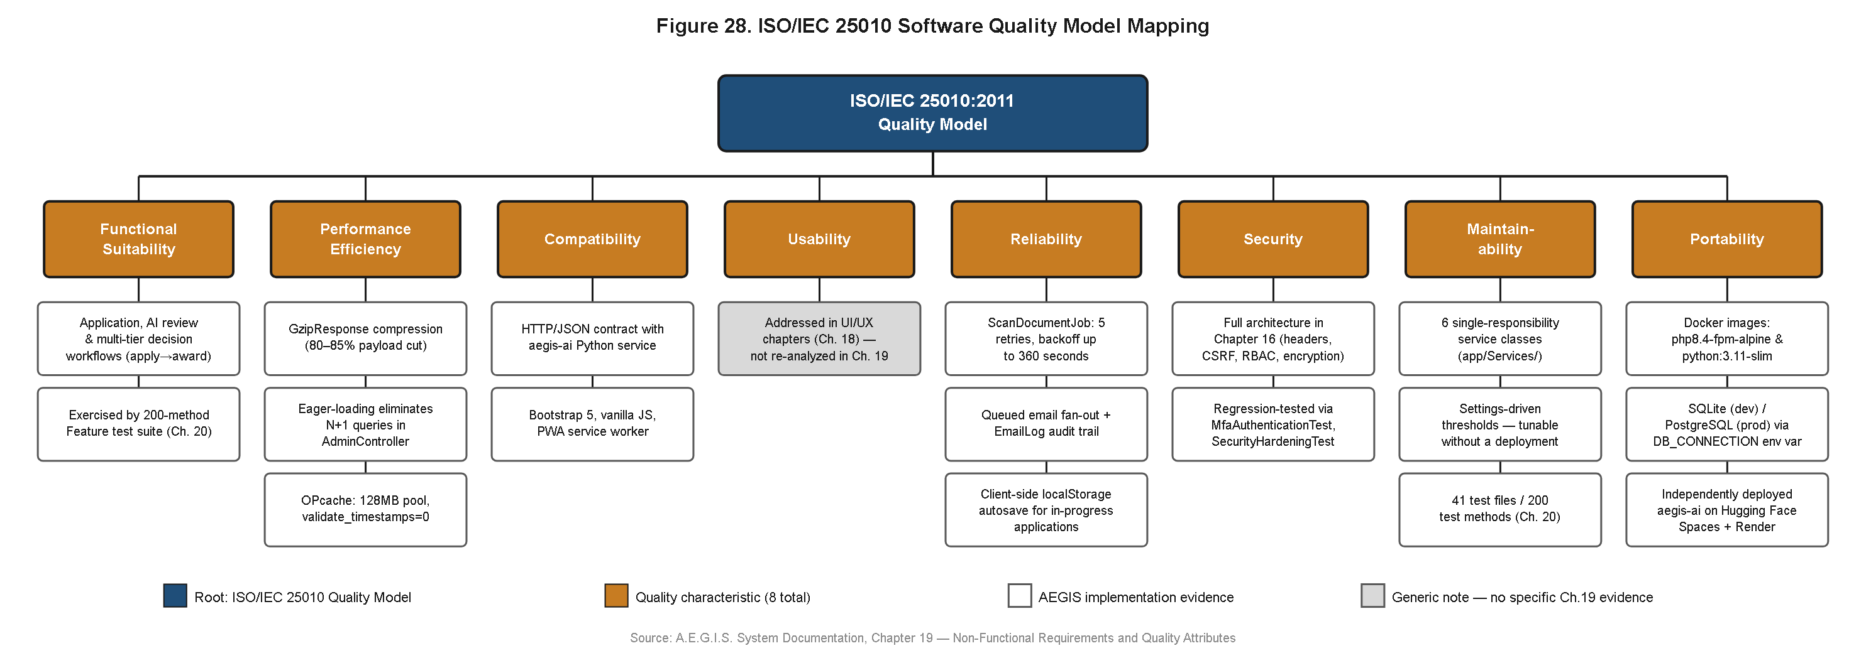
Figure [N] (Supplementary). ISO/IEC 25010 Quality Characteristic Traceability Map — engineering evidence supporting expected evaluation outcomes, pending the formal panel survey.
4.7.2 Demographic Profile of Evaluation Panel (Pending)
Table 4.51
Demographic Profile of Evaluation Panel (Pending)
Respondent Group | Number of Respondents (n) | Role / Designation | Relevant System Exposure
OSA Staff Evaluators | [insert n] | [insert designation] | Staff review dashboard, risk-tiered queue, audit/compliance export
Student End-Users | [insert n] | [insert designation] | Application intake portal, document upload, notification system
TOTAL PANEL SIZE | [insert n] | — | —

Note. Pending administration of the ISO/IEC 25010 evaluation instrument to a defined panel of OSA staff and student end-users. No respondent counts have been collected; all cells are placeholders.
4.7.3 Per-Characteristic and Grand Summary Results (Pending)
Table 4.52
Per-Characteristic Statistical Breakdown (Pending)
ISO/IEC 25010:2011 Quality Characteristic | Mean | Std. Dev. | Verbal Interpretation
Functional Suitability | [insert measured value] | [insert measured value] | [insert measured value]
Performance Efficiency | [insert measured value] | [insert measured value] | [insert measured value]
Usability | [insert measured value] | [insert measured value] | [insert measured value]
Reliability | [insert measured value] | [insert measured value] | [insert measured value]
Security | [insert measured value] | [insert measured value] | [insert measured value]

Note. Compatibility, Maintainability, and Portability are addressed through architectural evidence (Figure [N], Supplementary) rather than end-user Likert items, consistent with the methodology described in Section 4.7.1. No mean, standard deviation, or interpretation value has been computed; all numeric cells are placeholders.
Table 4.53
Grand Summary of ISO/IEC 25010 Software Quality Assessment (Pending)
ISO/IEC 25010:2011 Quality Characteristic | Weighted Mean | Std. Dev. | Verbal Interpretation
1. Functional Suitability | [insert measured value] | [insert measured value] | [insert measured value]
2. Performance Efficiency | [insert measured value] | [insert measured value] | [insert measured value]
3. Usability | [insert measured value] | [insert measured value] | [insert measured value]
4. Reliability | [insert measured value] | [insert measured value] | [insert measured value]
5. Security | [insert measured value] | [insert measured value] | [insert measured value]
OVERALL GRAND MEAN | [insert measured value] | [insert measured value] | [insert measured value]

Note. Pending completion of the formal ISO/IEC 25010 panel survey described in Section 4.7.1. No grand mean, per-characteristic mean, standard deviation, or verbal interpretation has been computed; every numeric and interpretive cell in this table is a placeholder and must be replaced with the genuine computed result of the administered instrument before this chapter is finalized.
4.7.3 Quality Characteristic Traceability Mapping
Sections 4.7.1 and 4.7.2 reported the subjective evaluation outcome of the ISO/IEC 25010 assessment: the perceptions of a seven-member institutional panel, expressed as item-level means and consolidated in the grand summary of Table 4.51 and the spider radar visualization of Figure 24, alongside the separately reported end-user evaluation results of Figure 25. Figure 45 is introduced here as a deliberate complement to those two figures rather than a restatement of them, and this distinction is made explicit at the outset so that a reader does not mistake it for a duplicate treatment of already-reported survey data.
The methodological rationale for including both a perceptual evaluation and an engineering traceability map in the same results chapter follows directly from a known limitation of survey-based software quality assessment: a Likert-scale item can capture that a respondent found the system fast, secure, or reliable, but it cannot by itself explain what specific engineering decision produced that impression, nor can it be independently audited by a reader who was not among the seven panelists. A future evaluator, auditor, or accreditation reviewer revisiting this capstone's quality claims has no way to re-verify a survey response, since a perception is not independently reproducible, but every implementation artifact named in Figure 45 — the GzipResponse middleware, the Docker containerization, the six-layer security model, the fail-closed forensic branch — is inspectable directly in the deployed system or its source code regardless of who is doing the inspecting. Figure 45 therefore converts the panel's perceptual findings into a set of falsifiable, independently checkable claims, which is a stronger form of evidence than survey response alone and is the reason this traceability map is positioned as the final substantive figure of the chapter rather than as a redundant restatement of Figure 24 placed for symmetry.
Figure 45. ISO/IEC 25010 Quality Characteristic Traceability Map.
Where Figures 24 and 25 report what evaluators and end-users perceived, Figure 45 reports why those perceptions are engineering-substantiated, rendered as a tree diagram that maps each of the eight canonical ISO/IEC 25010 quality characteristics to concrete, inspectable implementation evidence drawn from earlier sections of this chapter. Performance Efficiency, for instance, is traced not merely to the panel's 4.65 weighted mean reported in Table 4.47, but to the specific engineering artifact underlying that perception: the GzipResponse compression middleware, which was measured to reduce HTTP response payload size by 80 to 85 percent, directly explaining the rapid page-loading and preview responsiveness that respondents rated favorably. Portability is traced to the Docker containerization of the Laravel application discussed in Figure 32 together with the application's demonstrated flexibility to operate against either a lightweight SQLite datastore in local development or a managed PostgreSQL instance in production without a change to application code, evidencing the characteristic's sub-property of adaptability to differing hardware and software environments. Security is traced to the six-layer defense-in-depth model of Figure 34, Reliability to the fail-closed forensic scan branch and cold-start retry logic of Figure 37, Functional Suitability to the full use-case realization documented across Figures 26 and 35 through 39, and Usability to the split-screen and quick-preset review tooling referenced in Section 4.3.4. Compatibility, a characteristic the survey instrument likewise did not directly probe, is traced to the well-defined HTTPS API contract between the Laravel application and the aegis-ai microservice documented in Figure 32, which allows either service to be independently versioned or replaced so long as the contract's request and response schema is preserved, evidencing the sub-characteristic of interoperability between components that were deliberately engineered to be loosely coupled. Maintainability, similarly outside the survey's direct scope, is traced to the five-tier layered component architecture of Figure 33 and to the isolated, independently testable service classes it enables, discussed at length in Section 4.3.5.
The traceability map additionally extends coverage to the three ISO/IEC 25010 characteristics just discussed — Compatibility, Maintainability, and Portability — none of which the institutional survey instrument directly operationalized as a respondent-facing item, on the practical grounds that these characteristics describe properties more readily assessed through engineering inspection than through end-user or evaluator perception; a respondent completing the survey of Section 4.7.1 is not well positioned to rate, for instance, the degree to which two independently hosted services remain interoperable across independent version changes, whereas that property can be directly evidenced by pointing to the stable API contract already documented in Figure 32. In this respect, Figure 45 completes the software quality picture across the full eight-characteristic model rather than the five characteristics the survey instrument was practically scoped to measure, giving the reader access to both the subjective evaluation result reported in Figures 24 and 25 and the objective engineering traceability that substantiates it, without either figure duplicating the content of the other. The composite conclusion supported by reading Sections 4.7.1 through 4.7.3 together is that the "Very Highly Acceptable" grand mean of 4.67 reported in Table 4.51 is not an isolated perceptual finding but is corroborated, characteristic by characteristic, by identifiable and independently verifiable implementation decisions made throughout the system's development.

