**Application Engineering & Development**

**Report On University Model**

**Assignment 3**

Prepared by:

Girija Dhawale 1873112

Dhankuwar Sisodiya 1066439

Chaitanya Nakhare 1021070

**CONTENTS**

Abstract ……………………………………………………………………………3

Object Model ……………………………………………………………………...3

Object Model Diagram ……………………………………………………………4

University Object Model Elements ………………………………………………..5

Class Diagram ……………………………………………………………………..6

Sequence Diagram ………………………………………………………………

Operations Example ……………………………………………………………..

Proposed Solutions ……………………………………………………………..

Citations ………………………………………………………………………….

**Abstract:**

In this report we have presented a university model and how it can be used as a performance metric to measure the quality of education that a university is offering to its students. This report comprises of class diagram, sequence diagram and object model, which makes it easier to understand how different aspects contribute towards the success of a student and in turn help universities measure their quality of education. To begin with, it is important to keep track of the professional growth of the graduates over a period of 5 years in terms of their placement or promotions. Taking feedback from the alumni or conducting surveys would be a valuable insight too. The model helps us learn what courses were taken by the graduates and the faculty who taught those courses, how these courses helped them finding a placement, and how GPA and career growth are relevant. This report includes further description of the classes and methods to gain clarity on influence of one or several of these factors counting towards the ranking of a university.

**Object Model:**

The elements in a software application are visualized in terms of an object in the Object Model. The diagram below depicts the university model and shows how the performance can be measured in case of how good is the quality of education at a university. A university directory gives a list of universities, a university decides course pricing, manages colleges and students. A university has college directory, faculty directory and student directory. A college directory includes list of all colleges such as College of Engineering, College of Science and College of Arts etc. Every college has different department and thus list of all departments in a college forms a department directory. A department has course catalog and it includes a list of courses offered by the department. The degree requirements are set by the department, such as core courses or electives. In this way, the object model can answer various questions and help determining the factors that are instrumental to the professional growth of graduates.

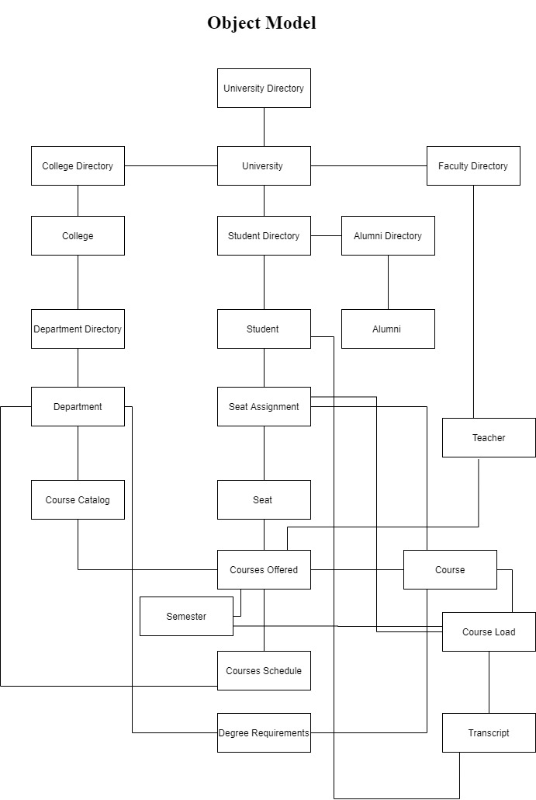

The object model consists of elements given below:

* University Directory
* University
* College Directory
* College
* Department Directory
* Department
* Course Catalog
* Course Offered
* Course
* Course Schedule
* Course Load
* Transcipt
* Degree Requirements
* Faculty Directory
* Teacher
* Student Directory
* Student
* Seat
* Seat Assignment
* Alumni Directory
* Alumni

**Class Diagram:**

The class diagram of the University model below describes the structure of the system by represeting it’s classes, attributes, relationships among objects and operations perfomed by these classes.

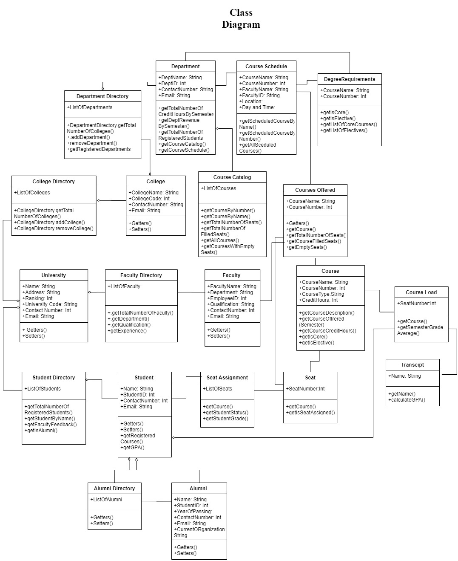

**Sequence Diagram:**

**Operations Example:**

**Proposed Solution:**

**Citations:**

Prof. Kal Bugrara’s Lecture Slides

<https://www.tutorialspoint.com/object_oriented_analysis_design/ooad_object_oriented_model.htm>

<https://www.draw.io/>