Please type your First NAME and Last INITIAL below with #DOLMN written on bottom and print.
If your name is too long, feel free to shrink the font or logo as needed. Please center your words.
Dining Out for Life

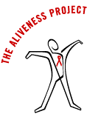
Susan Q.
#DOLMN

