Slide 63 — Trade #3 (Homework)
David & Sherry: production and consumption at a trade rate of 1 food = 0.2 wood

Setup (recap)
Person | Food/day | Wood/day | Opp. cost of 1 food | Opp. cost of 1 wood | Trade rate: 1 food = | Trade rate: 1 wood =
David | 8 | 4 | 0.5 wood | 2 food | 0.2 wood | 5 food
Sherry | 10 | 10 | 1 wood | 1 food | 0.2 wood | 5 food

- David has the lower opportunity cost of food (0.5 < 1 wood), so he has a comparative advantage in food; Sherry has the lower opportunity cost of wood (1 < 2 food), so she has a comparative advantage in wood.
- 30-day month. Maximum wood if both specialize fully in wood = 30×4 + 30×10 = 420.
- Both need 200 units of food, and want as much wood as possible on top of that.
- Trade rate for this homework: 1 unit of food costs 0.2 units of wood on the market.

Step 1 — Compare the trade rate to each person's opportunity cost of food
Buying food on the market costs only 0.2 wood per unit. That is cheaper than either producer's own cost of making food themselves (0.5 wood for David, 1 wood for Sherry). So for both of them, it makes more sense to not produce any food domestically and instead buy all the food they need through trade.

Step 2 — Production point
Both fully specialize in wood:
- David: 30 × 4 = 120 wood
- Sherry: 30 × 10 = 300 wood
Total production = (420 wood, 0 food)

Step 3 — Consumption point
They need 200 units of food, which they now buy entirely through trade at 0.2 wood per unit:
- Wood spent on food = 200 × 0.2 = 40
- Wood remaining = 420 − 40 = 380
Consumption point = (380 wood, 200 food)
Production (420, 0) → Consumption (380, 200)
Following the same formula pattern as slide 62: 380 = 420 − (200 − 0) × 0.2.

Graph
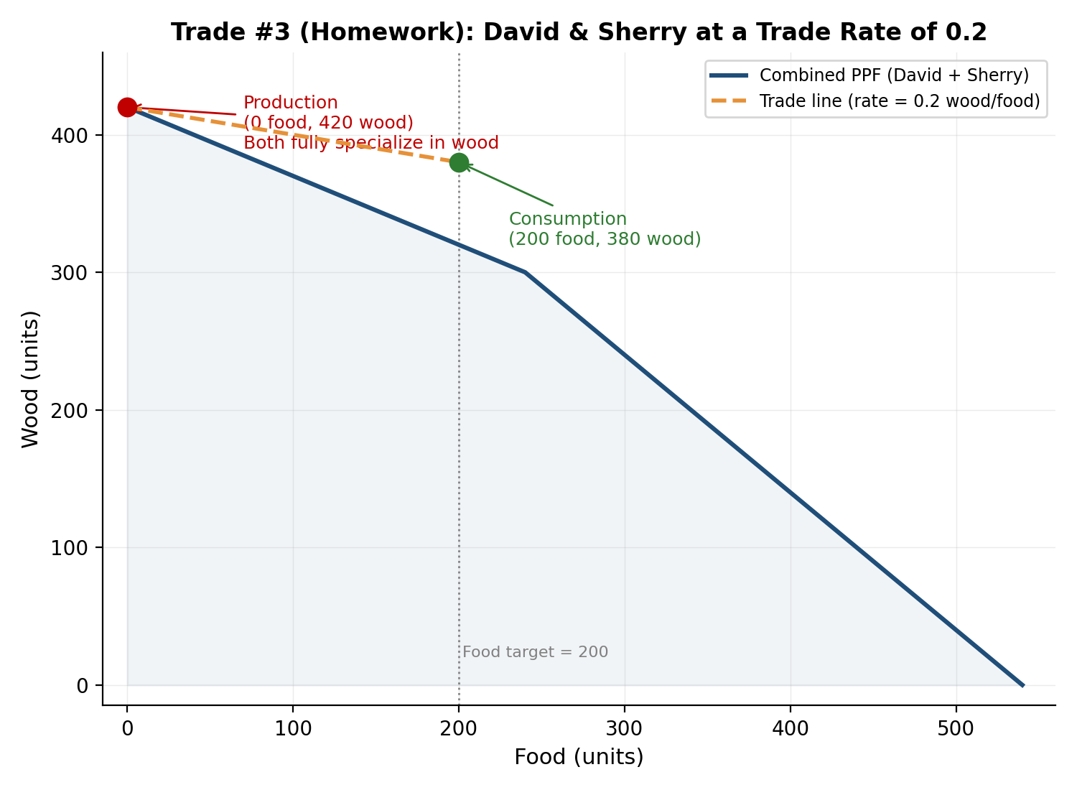
The combined production-possibility frontier (PPF) for David and Sherry together. The kink at 240 food occurs where David has switched all his time to food (the cheaper food producer) — beyond that point only Sherry's more expensive food production is available. The dashed line shows the trade path from the production point (0 food, 420 wood) to the consumption point (200 food, 380 wood), at the market rate of 0.2 wood per unit of food.

