UEFA vs FIFA Tie Break: Which Creates More Suspense?

Alessandro Di Mattia and Alex Krumer

2025-10-02

# Introduction

In the modern era of sports, and football in particular, retaining audience attention has become both more difficult and more crucial than ever before. Spectators today are exposed to a multitude of entertainment alternatives, making the task of sustaining engagement a key factor for the success and profitability of sport organizations. Beyond loyalty to a specific team, fans gain significant enjoyment from *non-instrumental information* — such as the suspense and uncertainty inherent in a match — which fulfills fundamental psychological needs (Ely et al., 2015; Zillmann, 2013). This value often drives consumer interest independently of the game’s final result, being rooted instead in the developments that lead to that outcome. (Vorderer et al., 2004)

The economic importance of fan engagement is underscored by the astonishing viewership and revenue generated by major tournaments. For instance, the 2022 FIFA World Cup in Qatar attracted approximately 2.87 billion viewers who watched at least one minute of coverage, while over 5 billion people engaged across broadcast, digital, and social media platforms, including 2.9 billion via linear TV and 2.7 billion through digital streaming (FIFA, 2023a, 2023b). Broadcasting and commercial rights from this World Cup cycle generated over USD 6.3 billion for FIFA, representing 83% of the organization’s revenue (FIFA, 2022).

Similarly, the UEFA European Championship continues to attract massive audiences, with Euro 2024 welcoming a cumulative stadium attendance of 2.67 million across its 51 matches and 5.7 billions of viewers worldwide through television (SportsPro Media, 2024; UEFA, 2024). These figures confirm that maintaining audience attention translates directly into financial success.

Given these stakes, the challenge for sports institutions is not only to increase the number of matches, but to design competitions that maximize suspense and engagement. Low-stakes games may decrease overall interest, while mechanisms that preserve uncertainty—such as tie-breaking rules can extend fan attention across the tournament. Understanding how tie-breaking procedures influence suspense is therefore not only a matter of sporting fairness, but also of monetary relevance, as it directly affects consumer demand, broadcaster revenues, and sponsor value.

In this paper, we investigate how alternative tie-breaking rules influence the level of suspense in international football tournaments. In particular, we compare the two main approaches adopted by governing bodies: FIFA’s adoption of overall goal difference and goals scored, and UEFA’s use of head-to-head results. Building on the established notion of match-level suspense introduced by Bizzozero et al. (2016), we extend the analysis to the group stage by developing a measure of suspense at the group level. To enrich this framework, we incorporate additional metrics of surprise and shock, highlighting how their dynamics differ under the two tie-breaking rules. In doing so, we demonstrate that suspense is not solely determined by match dynamics, but is also shaped by group-level factors that influence teams’ incentives to win, thereby directly affecting the suspense of the game itself.

The structure of the paper is as follows. Section 2 reviews the relevant literature. Section 3 presents the data, while Section 4 outlines the empirical strategy and methodological framework. Section 5 reports the results, and Section 6 concludes with final remarks.

# Literature Review

Our paper lies at the intersection of tournament design and the drivers of sport consumption. Recent contributions in sports economics have highlighted critical flaws in the rules and formats of international football competitions, showing how these deficiencies affect both the fairness of outcomes and the demand for the game. For instance, Csató & Gyimesi (2025) propose a novel framework to evaluate the cost of stake-less matches — games in which the result no longer influences qualification — for the newly approved 2026 FIFA World Cup format. Similalry, Lapré and Palazzolo (2022, 2023) demonstrate how FIFA’s seeding system has consistently failed to reduce competitive imbalance, thereby significantly lowering some teams’ chances of advancing in the competition. As concerns UEFA regulations, Csató (2020) show how flaws in the qualification rules can create scenarios where teams are incentivized not to win, revealing incentive-compatibility issues in current tournament designs.

To address such structural weaknesses, researchers have advanced a range of solutions, from probabilistic models that improve the predictive accuracy of ranking algorithms (Szczecinski & Roatis, 2022), to deterministic optimal scheduling that reduces collusion and stake-less games (Chater et al., 2021). Other studies focus on redesigning tournament formats and rules to eliminate misaligned incentives: this includes alternative qualification systems (Guajardo & Krumer, 2024), dynamic three-team formats(Troyano, 2023), and double-elimination structures (Rennó-Costa, 2023).

A related concern arises with the choice of tie-breaking rules, which directly shapes the fairness and stakes of group-stage matches. For example, Berker (2014) show that under certain rules, a team’s ranking can depend on the outcome of a match in which it does not participate. Similarly, Csató (2023) demonstrates that the likelihood of uncompetitive matches — where teams lack incentives to exert full effort — depends strongly on the tie-breaking criteria adopted. These findings highlight that poorly designed tie-breakers not only influence sporting outcomes but also affect the integrity and attractiveness of competitions.

The consequences of these design flaws are not limited to sporting fairness but extend to the economics of sport consumption. Formats and rules that generate collusion opportunities or reduce competitiveness undermine fan interest, diminishing both the entertainment value and commercial revenues of tournaments. Understanding the drivers of demand for both live attendance and broadcast audiences is therefore essential. Several studies identify in-game dynamics as key factors: Buraimo et al. (2020) show that suspense, surprise, and shock capturing the tension and emotional intensity of matches contribute to higher demand, particularly at specific moments of play. Likewise, Alavy et al. (2010) argue that the progression of the game, rather than its final outcome alone, is crucial, with greater uncertainty about results increasing spectator engagement. Similarly, Bizzozero et al. (2016) find a strong link between suspense and surprise on the one hand, and the demand for entertainment on the other. Finally, Buraimo et al. (2022) extend this perspective to television audiences, showing that demand cannot be explained solely by uncertainty of outcome but also depends on players’ quality and the significance of the match (e.g., title races, European qualification, or relegation battles).

Taken together, this domain of research shows that flawed formats and rules do not merely raise ethical and fairness concerns, but also undermine the economic value of competitions by reducing engagement and the attractiveness of matches. Our contribution builds on this insight by shifting the perspective to that of the spectator and examining how institutional features — in particular, tie-breaking rules — shape the stakes of a match and, ultimately, its perceived importance in the qualification race. By linking rule design to the creation of suspense and strategic incentives, our paper connects tournament structure directly to the determinants of fan interest and demand.

# Data

This study is based on a detailed dataset of all group stage matches from the FIFA World Cup and UEFA European Championship, focusing on goal-level and minute-by-minute match events. The data were scraped from Wikipedia and cross-checked with official sources from FIFA and UEFA. This allowed us to reconstruct how group standings evolved during matches under each tournament’s tie-breaking criteria, enabling a direct comparison of the suspense created by the two systems.

For the FIFA World Cup, we collected data from the 1986 to 2022 editions. From 1986 to 1994, there were 6 groups (Groups A to F), while from 1998 onwards the tournament expanded to 8 groups, each consisting of four teams. In the 6-group format, the top two teams from each group and the four best third-placed teams advanced to the knockout stage, whereas in the 8-group format only the top two teams in each group qualified for the elimination phase. Our dataset includes 455 goals, expanding to 6,789 entries when considering events recorded minute by minute.

For the European Championship, we collected data from 1984 to 2024. The first three editions had two groups (Group 1 and Group 2), then from 1996 to 2012 there were four groups (Groups A to D), and from 2016 onwards six groups (Groups A to F). As in the World Cup, the format with six groups allows the top two teams and the four best third-placed teams to qualify for the next round. In total, we recorded 207 goals and 4,044 minute-by-minute observations.

In both competitions, teams received two points for a win until 1992, and three points from 1994 onwards. One point was awarded for a draw, and zero for a loss throughout all editions.

## Data Collection

For every match in both competitions, we collected the following information:

* **Goals scored**: including the scoring team, exact minute, and the evolving scoreline.
* **Booking events**: yellow and red cards, including second yellow cards and straight red cards.
* **Substitutions**: the timing of each substitution and the total number per team.
* **Team Elo ratings**: Elo ratings as of the day before each tournament began, retrieved from <https://www.international-football.net/>.

Goal data were used to reconstruct real-time group standings after each event, under both FIFA and UEFA tie-breaking criteria. In addition, Elo ratings, bookings, and substitutions were incorporated to estimate the probability of each team winning, drawing, or losing after each goal. These estimates account for the cumulative impact of disciplinary events and tactical changes, following the approach of Titman et al. (2015). [1]

# Methodological Framework

Our methodological framework involves two levels of analysis: **group-level** and **match-level**. While the suspense indicator at the group level is, to the best of our knowledge, entirely new in the sports economics literature, and therefore constitutes the core of our contribution, we complement our main analysis with a match-level perspective. Specifically, we adopt the already established definitions of *suspense*, *surprise*, and *shock* from the existing literature as a robustness check and to provide a zoom-in analysis of the underlying dynamics behind group-level changes. As far as we are aware, these concepts have not yet been applied to data from the European Championship or FIFA World Cup.

## Group-Level Analysis

At the group level, we introduce a *binary suspense indicator* that captures the potential change in the composition of teams qualifying for the knockout stage. More precisely: A suspenseful moment occurs when a single goal in a group could alter the composition of teams qualifying to the elimination stage. The indicator is evaluated using two tracking procedures:

* **After each goal scored**, by updating the group standings with the current match results.
* **Minute by minute**, to track the evolution of suspense on a 90 minute scale.

This allows us to examine how long a group remains undecided, and how often suspense arises, under the two tie-breaking rules.

For example, in Group F of Euro 2024, entering the third and final matchday, Portugal and Turkey were in qualifying positions for the knockout stage. However, Turkey was playing against Czech Republic, and the match started 0–0. In that situation, a single goal by Czech Republic would have allowed them to overtake Turkey on points and qualify instead. Since the qualification status could change dramatically with just one goal, this scenario is marked as having maximum suspense (suspense = 1).

Another example can be drawn from Group A of Euro 2024. In the final match-day, Hungary scored in the 100th minute against Scotland, winning the match 1–0. At that point, this late goal put Hungary at 3 points with a goals difference of -3, making them temporarily one of the best third-placed teams, and therefore potentially qualifying for the knockout stage.

It seems reasonable to assume that before Hungary’s goal, the level of suspense was already quite high, as both Hungary and Scotland still had hopes of qualifying as one of the best third-placed teams. A goal from either side could have shifted the standings and affected the third-place rankings across groups.

At the time of Hungary’s goal, the four best third-placed teams included Hungary, while Albania (Group B) and Czech Republic (Group F) were the ones excluded. However, by the end of the group stage, Georgia (Group F) overtook Hungary, qualifying instead and eliminating Hungary. This is a posterior development that is not considered in the real-time suspense calculation for Group A. Suspense is evaluated based on the uncertainty during the match, not on outcomes from matches that are played in later groups.

A full explanation of the logic behind the definition of suspense is provided in Appendix A.1.

## Match-Level Analysis

At the match level, we adopt definitions of *shock*, *surprise*, and *suspense* commonly used in literature. These concepts are defined as follows:

### Suspense

Suspense is a forward-looking concept that evolves through the assessment of future events, often creating excitement or anxiety as the outcome remains uncertain (Bizzozero et al., 2016). Ely et al. (2015) formalized this notion before modeling demand for non-instrumental information, showing that an agent derives utility from *expecting* large changes in belief, even if those changes do not ultimately materialize.

In our framework, this intuition is employed through a formula that captures the potential for belief shifts via the uncertainty surrounding each possible match result — home win, draw, or away win. Specifically, we measure suspense using the expression , which is maximized when , meaning suspense is highest when all outcomes remain equally plausible.

Formally, the suspense after a goal is calculated as:

where are the predicted probabilities of each match outcome at that minute, and is the estimated goal frequency. The multiplier amplifies suspense in situations where the game is not only uncertain but also has a high expected frequency of impactful events, in this case goals. Specifically, represents the average goal-scoring rate per minute, calculated for each combination of tournament year and stage by dividing the total number of goals by the total number of minutes played within that group (with each match assumed to last 90 minutes).

### Surprise

Surprise captures the change in expectations caused by an event that has just occurred. Following Bizzozero et al. (2016), surprise is associated with the realization of something unexpected, a backward-looking reaction to how the actual event deviates from prior beliefs. It, therefore, reflects the shift in perceived outcomes after new information becomes available.

As formalized by Ely et al. (2015), surprise is linked to the *realized variance* in beliefs: the agent derives utility from the actual, observed updates in belief about outcomes over time.

In our implementation, surprise is measured by summing the absolute changes in the predicted probabilities for each possible result - home win, draw, and away win - before and after the event (goal scored):

where

Here, denotes the pre-match probability of outcome , and denotes the current probability of the same outcome.

This formulation captures how dramatically the perceived likelihood of different outcomes has shifted due to the goal.

### Shock

The *shock* captures the magnitude of deviation between the pre-match expectations and the current outcome probabilities. It reflects how surprising a moment is in terms of how much beliefs have changed since the beginning of the match.

Following Buraimo et al. (2020), shock is defined as the difference between current and pre-match outcome probabilities. Formally, we compute it as:

# Results

## Descriptive Statistics

Table 1: Descriptive statistics – Goal events

|  |  |  |  |  |  |  |  |  |
| --- | --- | --- | --- | --- | --- | --- | --- | --- |
| **Variable** | FIFA rules | | | | UEFA rules | | | |
|  | Mean | St. Dev. | Min | Max | Mean | St. Dev. | Min | Max |
| **Panel A: World Cup** |  |  |  |  |  |  |  |  |
| Goal minute | 51.97 | 26.89 | 1 | 96 | 51.97 | 26.89 | 1 | 96 |
| First half goal | 1.60 | 0.49 | 1 | 2 | 1.60 | 0.49 | 1 | 2 |
| Qualification changed | 0.19 | 0.40 | 0 | 1 | 0.19 | 0.39 | 0 | 1 |
| Qualification count | 0.75 | 0.98 | 0 | 4 | 0.73 | 1.03 | 0 | 5 |
| Suspense | 0.40 | 0.50 | 0 | 1 | 0.38 | 0.49 | 0 | 1 |
| Elo home | 1797 | 121 | 1492 | 2090 | 1797 | 121 | 1492 | 2090 |
| Elo away | 1838 | 141 | 1460 | 2160 | 1838 | 141 | 1460 | 2160 |
| *Observations* | 381 | | | | 381 | | | |
| **Panel B: Euro** |  |  |  |  |  |  |  |  |
| Goal minute | 52.41 | 26.30 | 2 | 100 | 52.41 | 26.30 | 2 | 100 |
| First half goal | 1.60 | 0.49 | 1 | 2 | 1.60 | 0.49 | 1 | 2 |
| Qualification changed | 0.32 | 0.47 | 0 | 1 | 0.28 | 0.45 | 0 | 1 |
| Qualification count | 1.27 | 1.40 | 0 | 6 | 1.08 | 1.27 | 0 | 6 |
| Suspense | 0.47 | 0.50 | 0 | 1 | 0.42 | 0.49 | 0 | 1 |
| Elo home | 1857 | 111 | 1600 | 2077 | 1857 | 111 | 1600 | 2077 |
| Elo away | 1896 | 113 | 1523 | 2127 | 1896 | 113 | 1523 | 2127 |
| *Observations* | 226 | | | | 226 | | | |

Table 2: Descriptive statistics – Minute by Minute events

|  |  |  |  |  |  |  |  |  |
| --- | --- | --- | --- | --- | --- | --- | --- | --- |
| **Variable** | FIFA rules | | | | UEFA rules | | | |
|  | Mean | St. Dev. | Min | Max | Mean | St. Dev. | Min | Max |
| **Panel A: World Cup** |  |  |  |  |  |  |  |  |
| Qualification changed | 0.20 | 0.40 | 0 | 1 | 0.20 | 0.40 | 0 | 1 |
| Qualification count | 0.65 | 0.87 | 0 | 4 | 0.62 | 0.90 | 0 | 5 |
| Suspense | 0.41 | 0.49 | 0 | 1 | 0.38 | 0.48 | 0 | 1 |
| Elo home | 1789 | 122 | 1492 | 2090 | 1789 | 122 | 1492 | 2090 |
| Elo away | 1841 | 142 | 1460 | 2169 | 1841 | 142 | 1460 | 2169 |
| *Observations* | 5,204 | | | | 5,204 | | | |
| **Panel B: Euro** |  |  |  |  |  |  |  |  |
| Qualification changed | 0.38 | 0.48 | 0 | 1 | 0.33 | 0.47 | 0 | 1 |
| Qualification count | 1.12 | 1.29 | 0 | 6 | 0.92 | 1.18 | 0 | 6 |
| Suspense | 0.52 | 0.50 | 0 | 1 | 0.47 | 0.49 | 0 | 1 |
| Elo home | 1848 | 113 | 1600 | 2077 | 1848 | 113 | 1600 | 2077 |
| Elo away | 1880 | 121 | 1523 | 2127 | 1880 | 121 | 1523 | 2127 |
| *Observations* | 2,979 | | | | 2,979 | | | |

Table 1, Panel A, shows that from a purely descriptive standpoint, the variable *qualification changed*, which captures whether the composition of teams qualifying for the next stage changes from one goal to the next, does not appear to be affected by the type of tiebreak rule used (FIFA or UEFA). However, the other two variables that capture the cumulative change at group level (*qualification count*), and the potential change in the group (*suspense*) suggest that FIFA’s tiebreak rules generate more changes and therefore higher overall suspense. While the maximum value of *qualification count* is higher under UEFA rules — indicating that in at least one group the qualifying composition changed five times — the mean values of both *qualification count* and *suspense* are lower under UEFA rules compared to FIFA’s. A similar pattern emerges in Panel B, where all three variables — *qualification changed*, *qualification count*, and *suspense —*  have lower average values under UEFA rules than under FIFA rules for the European Championships.

Table 2 confirms the same trend for the minute by minute analysis.

Table 3: Correlation matrices for goals-based aggregation in UEFA European Championship

|  | Elo std | Avg. qual. count | Avg. suspense |
| --- | --- | --- | --- |
| **UEFA** | | | |
| Elo std | 1.000 | -0.036 | 0.334 |
| Avg. qual. count | -0.036 | 1.000 | 0.253 |
| Avg. suspense | 0.334 | 0.253 | 1.000 |
| **FIFA** | | | |
| Elo std | 1.000 | 0.031 | 0.335 |
| Avg. qual. count | 0.031 | 1.000 | 0.445 |
| Avg. suspense | 0.335 | 0.445 | 1.000 |

Table 4: Correlation matrices for minute-by-minute aggregation in UEFA European Championship

|  | Elo std | Avg. qual. count | Avg. suspense |
| --- | --- | --- | --- |
| **UEFA** | | | |
| Elo std | 1.000 | -0.059 | 0.214 |
| Avg. qual. count | -0.059 | 1.000 | 0.218 |
| Avg. suspense | 0.214 | 0.218 | 1.000 |
| **FIFA** | | | |
| Elo std | 1.000 | 0.037 | 0.167 |
| Avg. qual. count | 0.037 | 1.000 | 0.352 |
| Avg. suspense | 0.167 | 0.352 | 1.000 |

## Correlation Analysis

Looking at the correlation analysis in Tables 3 and 4, we observe that the number of times the composition of qualifying teams changes is positively associated with the aggregate measure of suspense across all specifications. This relationship is again stronger under the FIFA tie-breaking rules, where a higher number of changes in the composition of qualifying teams consistently coincides with greater suspense. Turning to the role of group imbalance, measured by the standard deviation of Elo ratings, we find that suspense is positively correlated with Elo variation under both tie-breaking rules. By contrast, qualification turnover shows a weak negative correlation with Elo imbalance under the UEFA rule, but a weak positive correlation under the FIFA rule. Overall, this suggests that while suspense is generally higher in more imbalanced groups, the way group strength affects turnover in qualifying teams depends on the tie-breaking system applied.

Table 5: Correlation matrices for goals-based aggregation in FIFA World Cup

|  | Elo std | Avg. qual. count | Avg. suspense |
| --- | --- | --- | --- |
| **UEFA rule** | | | |
| Elo std | 1.000 | -0.123 | -0.125 |
| Avg. qual. count | -0.123 | 1.000 | 0.529 |
| Avg. suspense | -0.125 | 0.529 | 1.000 |
| **FIFA rule** | | | |
| Elo std | 1.000 | -0.060 | -0.281 |
| Avg. qual. count | -0.060 | 1.000 | 0.521 |
| Avg. suspense | -0.281 | 0.521 | 1.000 |
|  |  |  |  |

Table 6: Correlation matrices for minute-by-minute aggregation in FIFA World Cup

|  | Elo std | Avg. qual. count | Avg. suspense |
| --- | --- | --- | --- |
| **UEFA rule** | | | |
| Elo std | 1.000 | -0.058 | -0.177 |
| Avg. qual. count | -0.058 | 1.000 | 0.445 |
| Avg. suspense | -0.177 | 0.445 | 1.000 |
| **FIFA rule** | | | |
| Elo std | 1.000 | -0.003 | -0.301 |
| Avg. qual. count | -0.003 | 1.000 | 0.419 |
| Avg. suspense | -0.301 | 0.419 | 1.000 |

Looking at the correlation analysis in Tables 5 and 6, we again find that the number of times the composition of qualifying teams changes is positively associated with the aggregate measure of suspense, with correlations around 0.4 to 0.5 across specifications. In contrast to the European Championship, however, the measure of group imbalance is negatively correlated with both qualification turnover and suspense under all specifications. This indicates that in the World Cup, more balanced groups are associated with a greater likelihood of changes in the qualifying composition and with higher levels of suspense.

## Statistical Tests

Table 7: Differences between UEFA and FIFA tiebreak rules: mean differences and statistical tests

| **European Championship** | | |
| --- | --- | --- |
| **Metric** | Mean Diff. | p-value |
| Qualification Count | -0.325 | 0.063 (t-test), 0.055 (Wilcoxon) |
| Suspense | -0.125 | 0.010 (t-test), 0.007 (Wilcoxon) |
| **World Cup** | | |
| **Metric** | Mean Diff. | p-value |
| Qualification Count | -0.030 | 0.806 (t-test), 0.597 (Wilcoxon) |
| Suspense | -0.056 | 0.351 (t-test), 0.174 (Wilcoxon) |

*Note:* Reported values are mean differences computed as UEFA FIFA. Both paired t-tests and Wilcoxon signed-rank tests are reported: the t-test evaluates differences in means under approximate normality, while the Wilcoxon test provides a non-parametric robustness check.

As shown in Table 7, for the European Championship, we find some evidence that FIFA and UEFA rules differ in how often the composition of qualifying teams changes, and strong evidence that under the UEFA tiebreaking rule the probability of suspense is about 12.5 percentage points lower than under the FIFA rule. By contrast, for the World Cup we do not find any statistically significant differences between the two tiebreaking rules, either in qualification turnover or in suspense.

Overall, while the European Championship shows that suspense is higher in more imbalanced groups and that FIFA’s rules generate significantly more suspense than UEFA’s, in the World Cup suspense instead increases with group balance and no systematic differences emerge between the two tiebreaking systems.

## Suspense over time

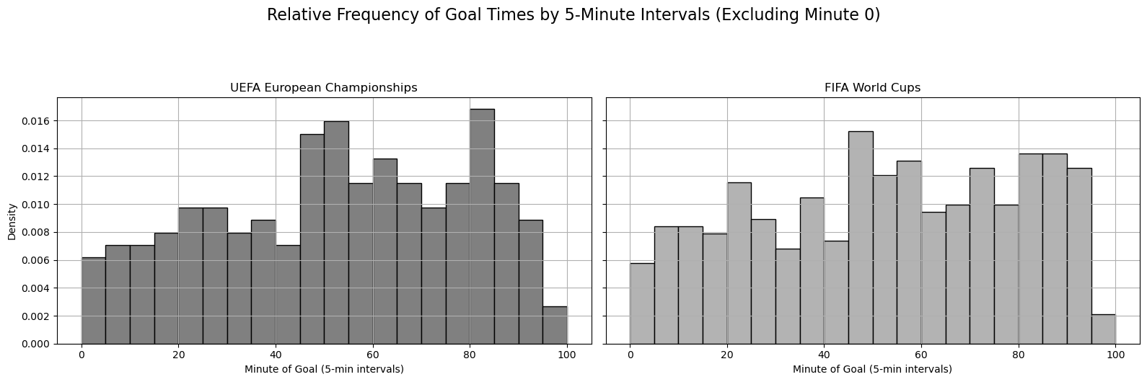

Figure 1: Goals distribution Europe vs World Cup

As shown in Figure 1, the two distributions appear broadly comparable, with both tournaments showing peaks in goal frequency around the 20th–30th minute in the first half and between the 45th–55th minute spanning the two halves. Toward the end of matches, differences emerge: in the European Championship, there is a distinct peak between the 80th–85th minute, while in the World Cup goals are more evenly spread across the 80th–90th minute. Overall, World Cup goals appear more evenly distributed across the full 100 minutes of play, whereas the European Championship exhibits sharper jumps in specific intervals.

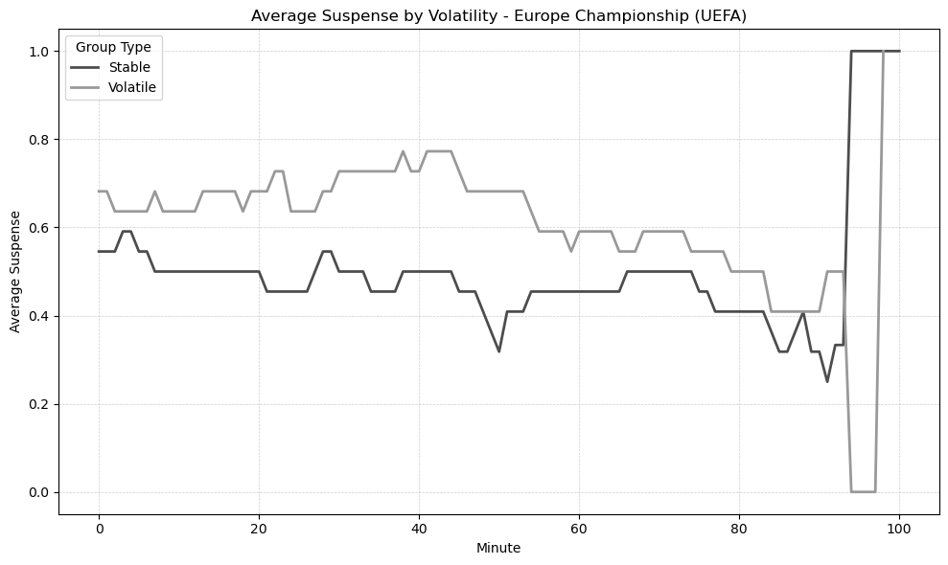

Figure 2

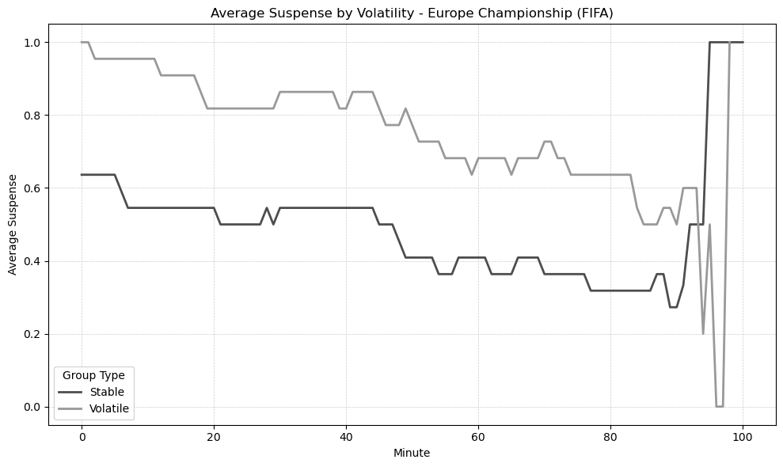

Figure 3

To further understanding the evolution of suspense over time, we classify the qualifications groups into stable and volatile depending on whether their average number of qualification changes lies below or above the median. This classification is then merged into the minute-by-minute dataset, allowing us to trace the trajectory of suspense separately for stable and volatile groups. In the European Championship under UEFA’s criteria (Figure 2), the difference between the two trajectories appears minimal at the start and end of matches, while the largest gap emerges between the 30th and 50th minutes, with the gap averaging around 0.2 overall. By contrast, under FIFA’s criteria (Figure 3), the difference between stable and volatile groups starts at about 0.4 and gradually narrows toward 0.2, with suspense steadily declining in both cases as time progresses.

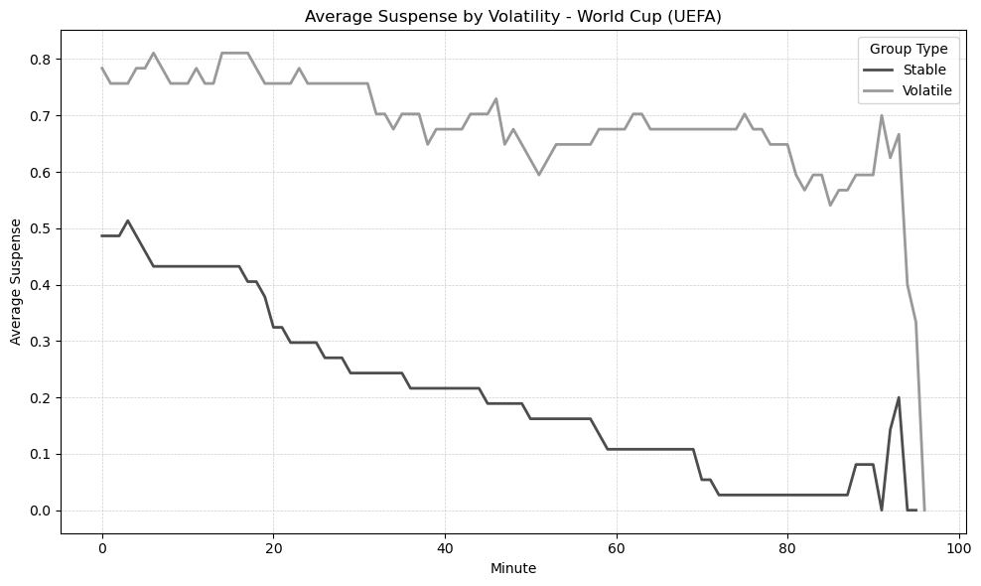

Figure 4

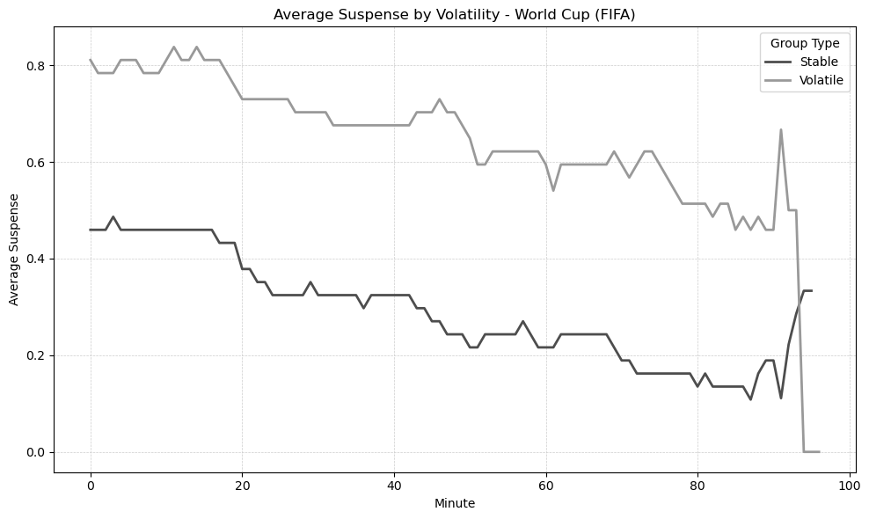

Figure 5

Turning to the World Cup, the difference in suspense between stable and volatile groups is substantial under both sets of criteria, amounting to roughly 0.3 under UEFA’s rules and 0.4 under FIFA’s (Figures 4 and 5). Under UEFA’s criteria, this gap widens over the course of the match and nearly doubles by the final minutes, suggesting that volatility becomes increasingly decisive for suspense toward the end of games. By contrast, under FIFA’s criteria the difference remains large but relatively stable throughout the match, with both trajectories showing a downward shift over time.

Taken together, these trajectories show that volatile groups systematically generate more suspense than stable ones, but the size and timing of this effect depend on both the competition and the tiebreaking system. The gap is moderate and concentrated in mid-match for the European Championship, whereas in the World Cup it is larger and more persistent, especially under FIFA’s criteria.

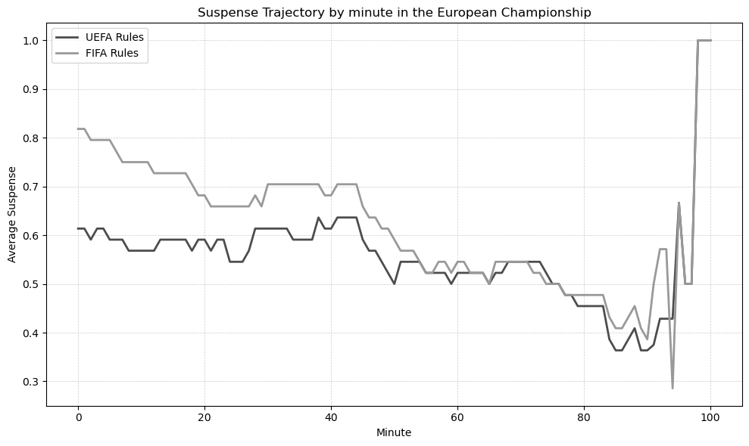

Figure 6

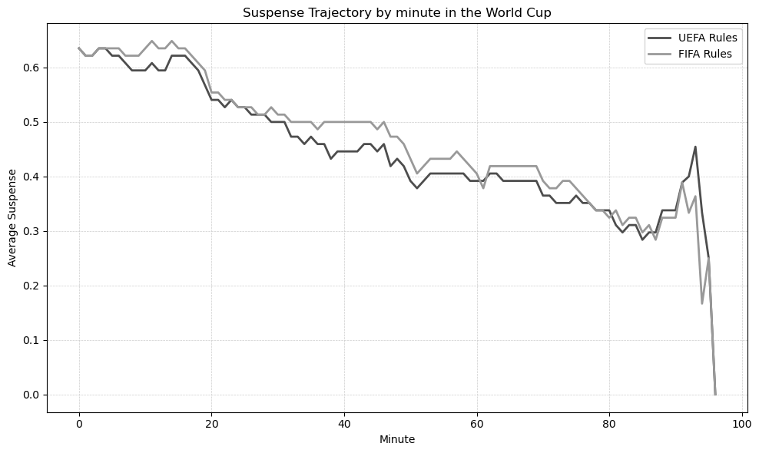

Figure 7

Figures 6 and 7 display the average suspense per minute under FIFA and UEFA tie-breaking rules for the European Championship and the World Cup, respectively. In both cases, FIFA’s rules generate systematically higher suspense, with the gap being more evident in the European Championship, especially in the early stages of matches. At the same time, the overall level of suspense is higher in the World Cup than in the European Championship, regardless of the rule set applied.

As highlighted in the statistical tests, FIFA’s tie-breaking rules systematically generate more suspense than UEFA’s. Combined with a more evenly goals distribution in the World Cup, this produces a setting where surprise is amplified - particularly in groups where the composition of qualifying teams changes frequently. In other words, both the institutional design of tie-breaking rules and the match dynamics of the World Cup contribute to making it the competition with the highest levels of perceived suspense.

Our findings provide empirical support for Csató (2023), who, in analyzing the 2022/23 UEFA Nations League, argues from both a theoretical perspective and through simulated outcomes that prioritizing goal difference (FIFA criteria) over head-to-head results (UEFA criteria) raises the stakes of matches played toward the end of the competition. While FIFA’s system appears to promote competitiveness by incentivizing teams to score more goals, it is important to note that the number of matches where this rule meaningfully changes incentives is limited — though not negligible.

## Match level

While at the group level the FIFA criteria (goal difference) generate more suspense by keeping a wider range of scenarios open, since a single goal affects the entire goal-difference tally rather than just the outcome of a single match, this results in group compositions changing more frequently and therefore higher suspense overall under FIFA rules.

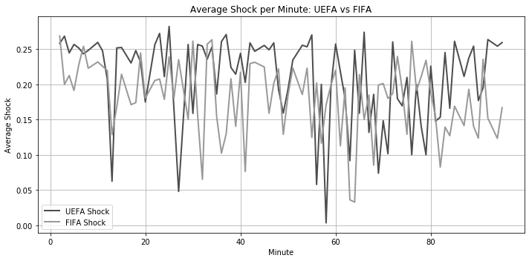

Figure 8

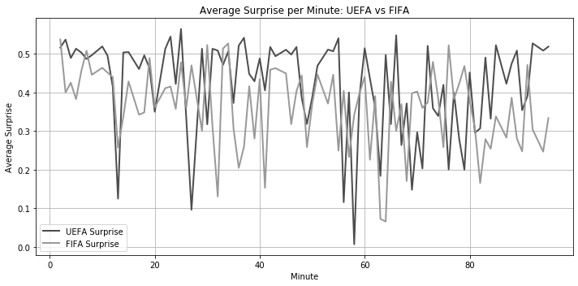

Figure 9

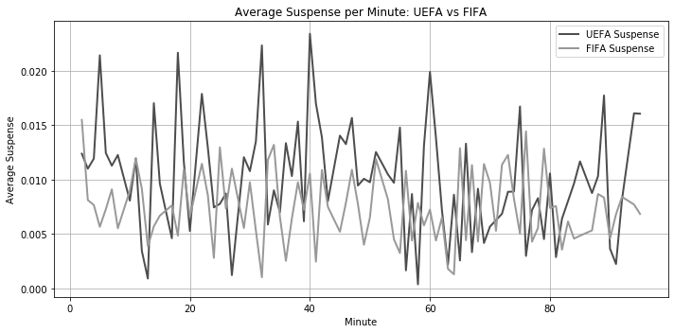

Figure 10

At the match level, however, as shown in Figures 8, 9, and 10, UEFA’s head-to-head criteria tend to produce greater suspense, shock, and surprise, along with larger fluctuations in these measures. This may be because prioritizing direct confrontations amplifies the impact of goals in decisive matches: any goal that alters the head-to-head result can drastically shift a team’s qualification prospects.

Building on this point, it is worth noting that Csató (2023) adopts a different approach to computing match probabilities. Instead of dynamically updating Elo-based win probabilities after each goal as we do, his framework derives goal expectations from Elo ratings using a Poisson model, where the expected number of goals for each team is estimated via a polynomial transformation of the Elo-derived win expectancy. To ensure comparability, we recalculated our suspense, surprise, and shock measures following this methodology. The resulting plots, reported in Figures 14, 15, and 16 in the Appendix, confirm the same patterns observed in our main analysis, reinforcing the conclusion that UEFA’s head-to-head criteria amplify match-level volatility relative to FIFA’s goal-difference rule.

Furthermore, we tried to combine the match-level suspense analysis with the group-level analysis by explicitly adjusting the underlying match probabilities when the qualification race was still on at group level. Specifically, we identify whether the third- or fourth-placed team in a group is already in contention or eliminated according to our binary indicator. If the team still in contention for the qualification is involved in the ongoing match, its win probability is tilted upward while the corresponding loss probability is reduced, while the draw probability remains approximately unchanged. This adjustment reflects the intuition that teams facing elimination may display greater motivation. We then recompute suspense, surprise, and shock based on these adjusted probabilities, ensuring that goal by goal dynamics evolve in line with group qualification dynamics. In this way, our match-level measures are directly linked to the group-level suspense of the qualification race under the two tie-breaking rules. Figures 11, 12, and 13 confirms that UEFA tiebreak highlight all three measure (Surprise, Shock, Suspense) even when group dynamics are taken into account.

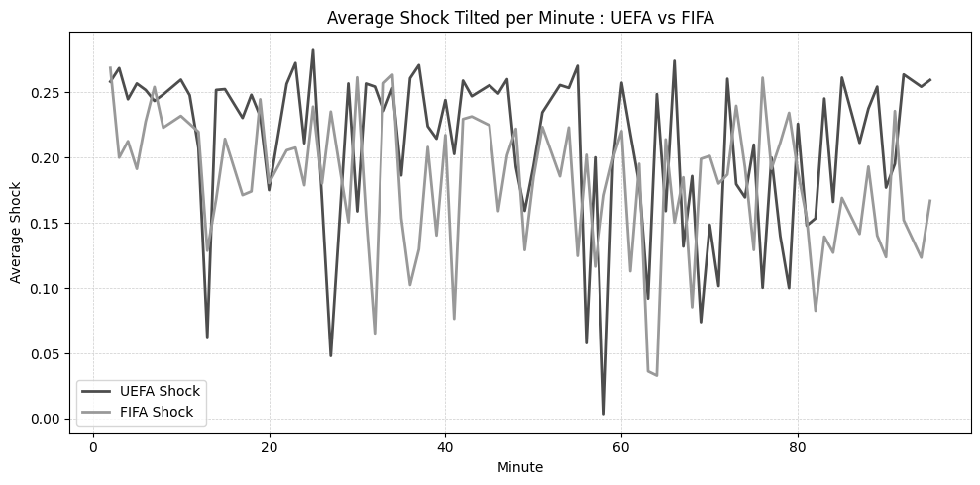

Figure 11

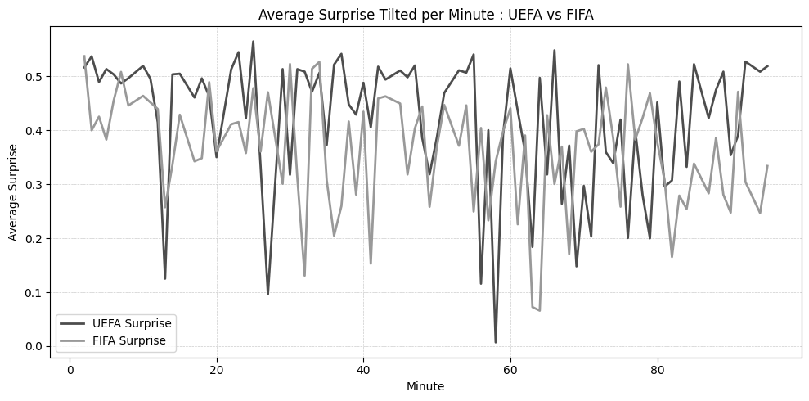

Figure 12

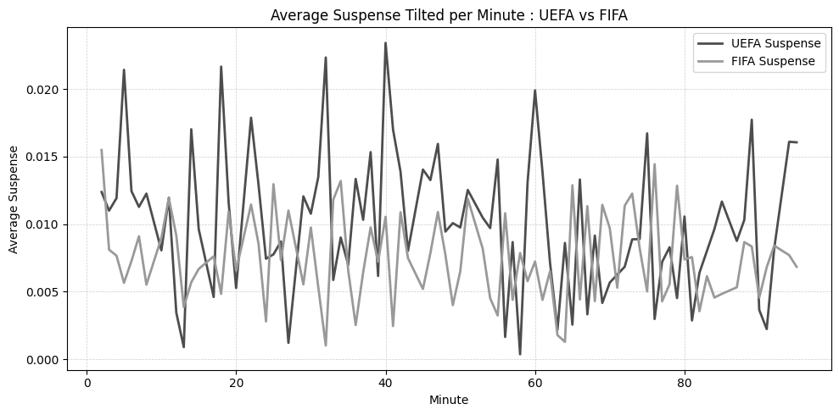

Figure 13

# Conclusion

# References

Alavy, K., Gaskell, A., Leach, S., & Szymanski, S. (2010). On the edge of your seat: Demand for football on television and the uncertainty of outcome hypothesis. *International Journal of Sport Finance*, *5*(2), 75.

Berker, Y. (2014). Tie-breaking in round-robin soccer tournaments and its influence on the autonomy of relative rankings: UEFA vs. FIFA regulations. *European Sport Management Quarterly*, *14*(2), 194–210.

Bizzozero, P., Flepp, R., & Franck, E. (2016). The importance of suspense and surprise in entertainment demand: Evidence from wimbledon. *Journal of Economic Behavior & Organization*, *130*, 47–63.

Buraimo, B., Forrest, D., McHale, I. G., & Tena, J. de D. (2020). Unscripted drama: Soccer audience response to suspense, surprise, and shock. *Economic Inquiry*, *58*(2), 881–896.

Buraimo, B., Forrest, D., McHale, I. G., & Tena, J. de D. (2022). Armchair fans: Modelling audience size for televised football matches. *European Journal of Operational Research*, *298*(2), 644–655.

Chater, M., Arrondel, L., Gayant, J.-P., & Laslier, J.-F. (2021). Fixing match-fixing: Optimal schedules to promote competitiveness. *European Journal of Operational Research*, *294*(2), 673–683.

Csató, L. (2020). When neither team wants to win: A flaw of recent UEFA qualification rules. *International Journal of Sports Science & Coaching*, *15*(4), 526–532.

Csató, L. (2023). How to avoid uncompetitive games? The importance of tie-breaking rules. *European Journal of Operational Research*, *307*(3), 1260–1269.

Csató, L., & Gyimesi, A. (2025). Increasing competitiveness by imbalanced groups: The example of the 48-team FIFA world cup. *arXiv Preprint arXiv:2502.08565*.

Ely, J., Frankel, A., & Kamenica, E. (2015). Suspense and surprise. *Journal of Political Economy*, *123*(1), 215–260.

FIFA. (2022). *FIFA annual report 2022: 2019–2022 cycle in review*. <https://publications.fifa.com/en/annual-report-2022/finances/2019-2022-cycle-in-review/2019-2022-revenue>.

FIFA. (2023a). *FIFA world cup qatar 2022: Total media engagement report*. <https://inside.fifa.com/tournament-organisation/audience-reports/qatar-2022/total-media-engagement>.

FIFA. (2023b). *Global engagement & audience report (executive summary)*. <https://inside.fifa.com/tournament-organisation/audience-reports/qatar-2022>.

Guajardo, M., & Krumer, A. (2024). Tournament design for a FIFA world cup with 12 four-team groups: Every win matters. In *The palgrave handbook on the economics of manipulation in sport* (pp. 207–230). Springer.

Lapré, M. A., & Palazzolo, E. M. (2022). Quantifying the impact of imbalanced groups in FIFA women’s world cup tournaments 1991–2019. *Journal of Quantitative Analysis in Sports*, *18*(3), 187–199.

Lapré, M. A., & Palazzolo, E. M. (2023). The evolution of seeding systems and the impact of imbalanced groups in FIFA men’s world cup tournaments 1954–2022. *Journal of Quantitative Analysis in Sports*, *19*(4), 317–332.

Rennó-Costa, C. (2023). A double-elimination format for a 48-team FIFA world cup. *arXiv Preprint arXiv:2301.03411*.

SportsPro Media. (2024). *Euro 2024 in numbers: Attendance, TV ratings, and social media impact*. <https://www.sportspro.com/insights/analysis/euro-2024-stats-tv-ratings-viewership-attendance-social-media-sales>.

Szczecinski, L., & Roatis, I.-I. (2022). FIFA ranking: Evaluation and path forward. *Journal of Sports Analytics*, *8*(4), 231–250.

Titman, A., Costain, D., Ridall, P., & Gregory, K. (2015). Joint modelling of goals and bookings in association football. *Journal of the Royal Statistical Society Series A: Statistics in Society*, *178*(3), 659–683.

Troyano, J. A. (2023). A new competition format to avoid collusion in three-team sports tournaments. *arXiv Preprint arXiv:2308.02507*.

UEFA. (2024). *A EURO to remember*. https://www.uefa.com/uefaeuro/history/news/0290-1ba5adefab2e-16914ae7e74f-1000–a-euro-to-remember/.

Vorderer, P., Klimmt, C., & Ritterfeld, U. (2004). Enjoyment: At the heart of media entertainment. *Communication Theory*, *14*(4), 388–408.

Zillmann, D. (2013). The psychology of suspense in dramatic exposition. In *Suspense* (pp. 199–231). Routledge.

# Appendix

## A.1. Suspense Criteria: Full Logic

The following rules describe the exact criteria we use to assign a suspense value of 1 (suspenseful moment) in both FIFA and UEFA group stages. A suspenseful moment is defined as one where a single goal may change the composition of teams qualifying for the knockout stage. These rules are applied after each goal and at each match minute during the group stage.

### Definition of Terms

* **Leading team**: The last team currently qualifying for the knockout stage. This can be either the 2nd-placed team (in groups where only the top two qualify) or the best-ranked 3rd-placed team (in tournaments where some third-placed teams also advance).
* **Lagging team**: The first team currently not qualifying for the knockout stage. This can be either the 3rd-placed team (in competitions where only the top two advance) or the 4th-placed team (in tournaments where some third-placed teams qualify).
* pts_diff: Difference in group points between the lagging and leading team.
* gls_diff: Difference in goal difference between the lagging and leading team.
* goals_scored_lagging, goals_scored_leading: Total goals scored in the group stage by each respective team.
* last_game_points_lagging, last_game_points_leading: Points the lagging or leading team is currently earning from the ongoing match (0, 1, 2, or 3).
* last_game_goals_diff_lagging, last_game_goals_diff_leading: Goal difference in the ongoing match for lagging or leading team.
* lagging_won: Head-to-head result of the lagging team against the leading team (1 if won, 0 if not played, -1 if lost).
* h2h: Equals 1 if the teams are facing each other in the current match, 0 otherwise.
* goal_minute: The minute in which the current goal occurred.

### Suspense Criteria: FIFA

* If year <= 1992 (2-point win system):
  + last_game_goals_diff_lagging , pts_diff , gls_diff , and goals_scored_lagging goals_scored_leading
  + last_game_goals_diff_lagging , pts_diff , gls_diff , and goals_scored_lagging goals_scored_leading
  + last_game_points_lagging , last_game_points_leading , h2h :
    - If last_game_points_leading and pts_diff
      * gls_diff
      * gls_diff and goals_scored_lagging goals_scored_leading
    - If last_game_points_leading and pts_diff
      * gls_diff
      * gls_diff and goals_scored_lagging goals_scored_leading
  + **H2H**:
    - From drawing to winning or losing to drawing:
      * last_game_goals_diff_lagging and pts_diff
      * last_game_goals_diff_lagging and pts_diff and goals_scored_lagging goals_scored_leading
* If year > 1992 (3-point win system):
  + **Minute 0**:
    - If gls_diff and pts_diff
    - If gls_diff and pts_diff : use head-to-head
  + **Winning scenarios**:
    - last_game_points_lagging , last_game_points_leading , pts_diff , h2h :
      * gls_diff
      * gls_diff and goals_scored_lagging goals_scored_leading
    - last_game_points_lagging , last_game_points_leading , pts_diff :
      * gls_diff
      * gls_diff and goals_scored_lagging goals_scored_leading
  + **Drawing scenarios**:
    - pts_diff , last_game_points_lagging
      * gls_diff
      * gls_diff and goals_scored_lagging goals_scored_leading
  + **Losing scenarios**:
    - pts_diff , last_game_goals_diff_lagging
      * gls_diff
      * gls_diff and goals_scored_lagging goals_scored_leading
    - pts_diff , last_game_goals_diff_lagging , gls_diff , goals_scored_lagging goals_scored_leading
  + **H2H scenarios**:
    - From drawing to winning:
      * last_game_goals_diff_lagging and pts_diff
      * last_game_goals_diff_lagging and pts_diff and goals_scored_lagging goals_scored_leading
    - From losing to drawing:
      * last_game_goals_diff_lagging and pts_diff
      * last_game_goals_diff_lagging and pts_diff and goals_scored_lagging goals_scored_leading
    - Tied scenarios:
      * last_game_goals_diff_lagging , pts_diff , gls_diff , goals_scored_lagging goals_scored_leading , goal_minute : head-to-head
      * last_game_points_lagging , pts_diff , gls_diff , goals_scored_lagging goals_scored_leading , goal_minute : head-to-head
    - Draw lots scenarios (suspense = 1) :
      * If year <= 1992, last_game_goals_diff_lagging , last_game_points_lagging , h2h , pts_diff , gls_diff
      * If year > 1992, last_game_goals_diff_lagging , h2h , pts_diff , gls_diff
      * If year > 1992, last_game_points_lagging , h2h , pts_diff , gls_diff

### Suspense Criteria: UEFA

* If h2h :
  + From losing to drawing:
    - If pts_diff and last_game_goals_diff_lagging
      * If gls_diff or
      * If gls_diff and goals_scored_lagging goals_scored_leading
    - If pts_diff and last_game_goals_diff_lagging
  + From drawing to winning:
    - If year and pts_diff and last_game_goals_diff_lagging
    - If year and pts_diff and last_game_goals_diff_lagging
* If h2h :
  + If pts_diff and last_game_goals_diff_lagging
  + From losing to losing or winning to winning:
    - If pts_diff , lagging_won , and
      * last_game_goals_diff_lagging or last_game_points_lagging
      * If gls_diff or
      * If gls_diff and goals_scored_lagging goals_scored_leading
    - If pts_diff and gls_diff and lagging_won
  + From losing to drawing:
    - If pts_diff and last_game_goals_diff_lagging
      * If lagging_won
      * If lagging_won and
        + gls_diff or
        + gls_diff and goals_scored_lagging goals_scored_leading
  + From drawing to winning:
    - If year and pts_diff and last_game_points_lagging or (goal_minute and last_game_points_lagging )
      * If lagging_won
      * If lagging_won and
        + gls_diff or
        + gls_diff and goals_scored_lagging goals_scored_leading
    - If year and pts_diff and last_game_points_lagging
      * If lagging_won
      * If lagging_won and
        + gls_diff or
        + gls_diff and goals_scored_lagging goals_scored_leading
      * If pts_diff and last_game_goals_diff_lagging
  + Leading from winning to drawing:
    - If year , last_game_points_leading , and pts_diff

## A.2. Match Dynamics and Bookings Adjustments

To incorporate match dynamics and disciplinary events, we adapt the framework of Titman et al. (2015), who jointly model goals and bookings in football matches. Specifically, we implement a set of rules that adjust the baseline Elo-derived win probabilities according to in-game events:

* **Yellow cards**: Each yellow card reduces the affected team’s win probability by , reflecting reduced squad stability and heightened risk of further sanctions.
* **Red cards**: Straight red cards impose a stronger penalty of . Second yellow (indirect red) cards impose a penalty of , with an additional adjustment of , accounting for accumulated fouls.
* **Substitutions**: Each substitution provides a small positive adjustment of , representing tactical flexibility and fresh player input.
* **Escalation effects**: When one team accumulates at least one card, the opponent also receives a minor penalty of , accounting for retaliation risk and increased match tension.
* **Scoreline adjustments**: Leading teams receive a reduction of per goal ahead (safer play), while tied matches add a penalty of for both teams, reflecting greater competitive tension.

## A.3. Additional Figures

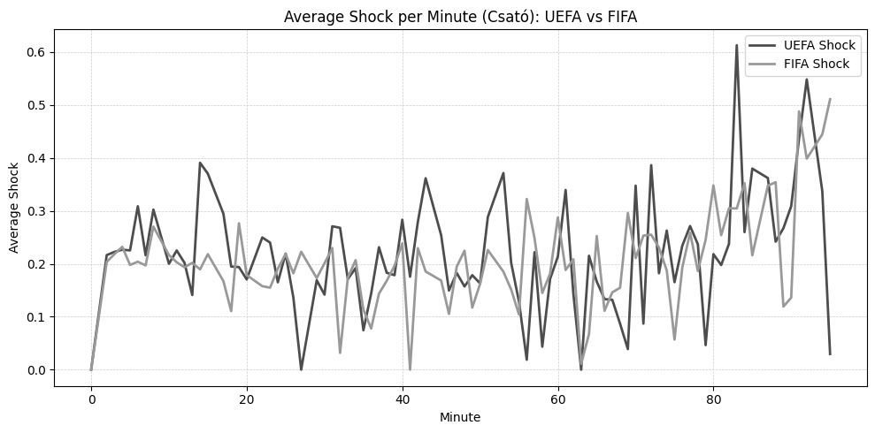

Figure 14

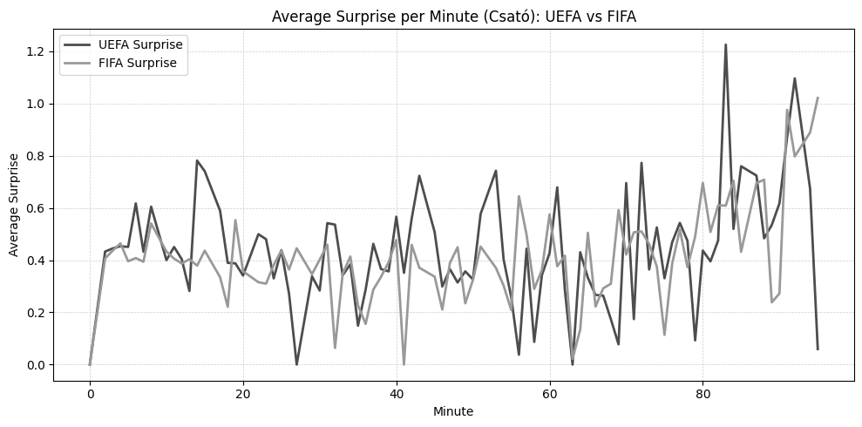

Figure 15

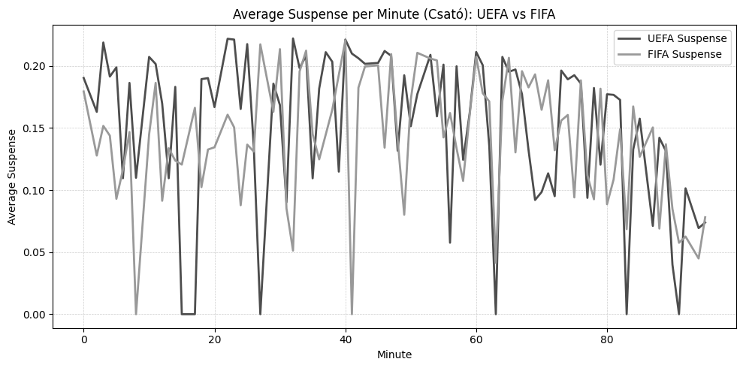

Figure 16

1. See Appendix A.2. for details on the rules applied to match dynamics and bookings.