

**College of Computer Studies – Quezon City**

**Final Project**

|  |  |  |  |
| --- | --- | --- | --- |
| **Team #:** | **Team Name:** | | **Team Logo** |
| **Team Members:** | |  |
|  | |  |
|  | |  |
|  | |  |
| **Course/Yr/Sec.:** | |  |  |

|  |  |
| --- | --- |
| **Project Website Name: Paws & Claws (Pet Shop)** | |
| **Website Description:** |  |
| **Paws & Claws** is a pet shop that offers a wide range of products and services for all kinds of pets. From dogs and cats to birds, fish, and small animals, you'll find everything you need to keep your furry, feathered, or scaly friend happy and healthy.  The store carries a variety of high-quality pet food, toys, treats, and accessories from top brands to ensure your pet gets the best nutrition and care possible. They also have a grooming salon where you can bring your pet for a bath, haircut, or nail trimming.  At Paws & Claws, you'll find a knowledgeable and friendly staff that can assist you in selecting the right products for your pet's needs. They are passionate about pets and will provide you with helpful advice and recommendations to make sure your pet is well taken care of.  Overall, Paws & Claws is a great place to shop for all your pet needs, and it's a one-stop-shop for everything you need to keep your pet healthy, happy, and entertained.  Below are the capabilities and limitations of the proposed project: | |
| **Website Features** | |
| * **Clear and easy-to-use navigation:** The website has a clear and intuitive navigation that makes it easy for visitors to find what they're looking for. The main categories of products, services, and information was prominently displayed on the homepage, and the website's menu are well-organized and easy to navigate. * **High-quality product photos and descriptions**: The website feature has a high-quality product photos and detailed descriptions for each item. This will help visitors make informed decisions when purchasing products online. * **Online ordering and payment options**: The website allow customers to order products online and pay securely through a payment gateway. This feature will make the shopping experience more convenient and efficient for customers. * **Customer reviews and testimonials:** Including customer reviews and testimonials on the website to help build trust with potential customers and provide social proof of the quality of the products and services offered by the Paws and Claws. * **Information about services offered:** Our pet shop offers services such as grooming, boarding, or veterinary care, the website provides detailed information about these services and how customers can book appointments. * **Educational resources:** The pet shop also provide educational resources such as blog posts, articles, and videos that provide valuable information about pet care and related topics. | |
| **Website Color and Text Palettes** | |

**Site Map**

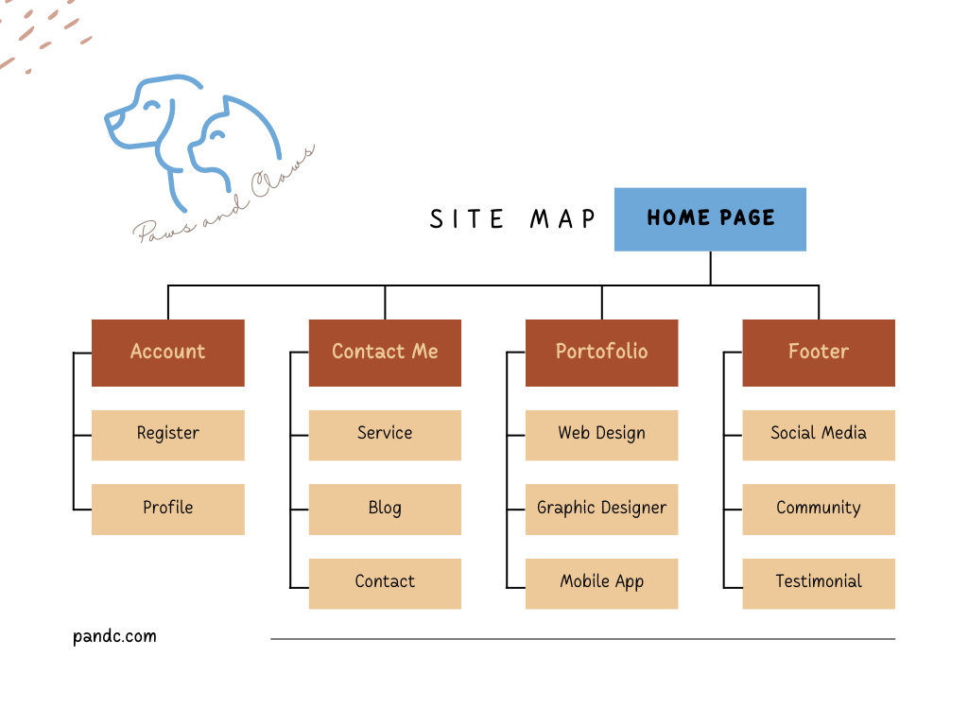

**Mock-ups**

*Attach here your proposed design for each page. Make sure to add a label.*

***Prototype Creation Tools:*** *Adobe XD, Sketch, Canva, or Figma.*