Reading guide

BluDevil digital-marketplace project

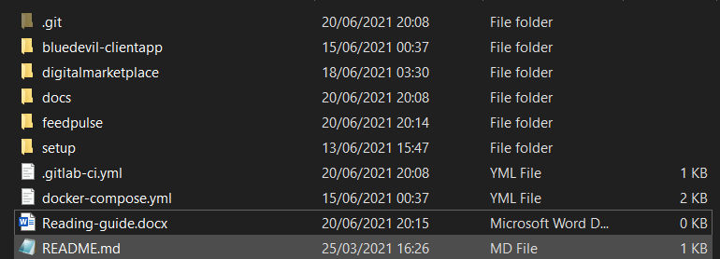

Figure Project-root-directory

# Documentation

In order to read the project documentation we have to start from the root directory and navigate to the docs directory. Inside the docs directory the most relevant and up-to-date documentation files are the design document ( Design_document_V1.5.docx) and the project plan (Project plan_IAS_v1.4.pdf). The project plan contains the product backlog with user stories but the most updated version of the backlog can be found inside the gitlab repository boards.

The feedback from all sprints for the individual and from the group project can be found inside the “feedpulse” directory.

# Applications

### Front-end

The front-end application can be found inside the “bluedevil-clientapp” directory.

### Back-end

The back-end application can be found inside the “digitalmarketplace” directory.

# Docker setup

In order to run the applications inside docker containers:

1. Download and install cisco anyconnect vpn and start the vpn.
2. Connect to the fontys servers (vdi.fhict.nl) and enter your credentials.
3. Navigate to the back-end application root folder and run gradle bootJar.
4. Open a new cmd/terminal and navigate to the project root folder.
5. In the cmd enter the command “docker-compose up” and wait for everything to start-up
6. Open the web browser and go to localhost:4200
7. Enjoy! 😊

Extra info: You can also run each docker image by yourself without the use of docker-compose.

Command to run the back-end application:

docker run -d -e "SPRING_PROFILES_ACTIVE=prod" -p 8080:8080 -t hemjy/digital-marketplace-bludevil:app-server

Command to run the front-end application:

docker run -d -p 4200:80 -t hemjy/digital-marketplace-bludevil:app-client