Main Page Wireframe-

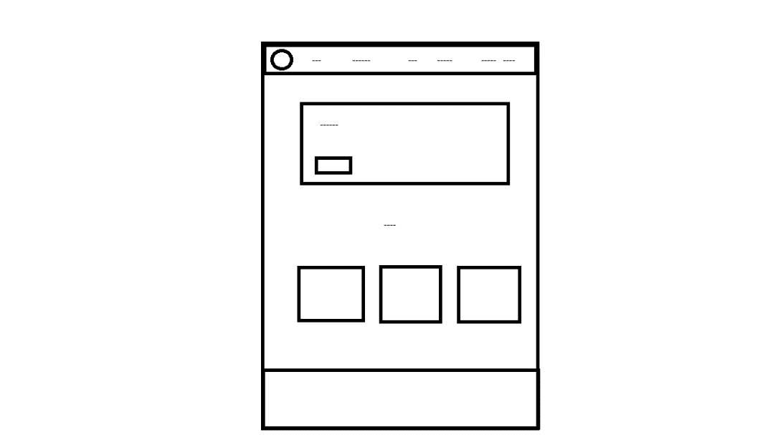

References-

<https://www.google.com>

<https://www.youtube.com>

<https://www.rcn.org.uk/Get-Involved/Campaign-with-us/Prevention-is-better-than-cure>

<https://www.favicon.cc/>

<https://www.nichepursuits.com/health-website-name-ideas/>

<https://www.pacificprime.com/health-insurance-plans/>

<https://www.w3schools.com/>

<https://getbootstrap.com/docs/5.0/getting-started/introduction/>