Chapter 06: Analysis of Form: Metrical and Lexical effects on the Phonology and Phonetics of DCE Intonation

# **1. Summary of Pitch Accent distributions**

The raw data is unbalanced since there is not an equal number of tokens per speaker per condition. In some cases there are no tokens from one speaker, effectively reducing the number of participants for that condition by one. To make the presentation of these data both honest and representative, summaries are provided based on both the raw unbalanced, and adjusted balanced data are presented.

## **1.1 Raw Data**

These table summarize the number of PA tokens per condition regardless of any imbalance in the number of utterances per speaker per condition or the number of speakers per condition.

## 1.1.1 Pre-nuclear Pitch Accents

Foot size data presented first followed by anacrusis data, since the anacrusis targets reflect the number of syllables of anacrusis under maximum foot-size conditions.

### PN Foot-size conditions

| foot_syls | (*) | L* | H* | >H* | L*H |
| --- | --- | --- | --- | --- | --- |
| 1 | 9 | 5 | 19 | 2 | 20 |
| 2 | 2 | 2 | 21 | 3 | 27 |
| 3 | 1 | 0 | 13 | 6 | 35 |
| 4 | 0 | 0 | 0 | 3 | 35 |

### PN Anacrusis conditions

| ana_syls | H* | >H* | L*H |
| --- | --- | --- | --- |
| 0 | 0 | 3 | 35 |
| 1 | 9 | 5 | 42 |
| 2 | 0 | 4 | 52 |
| 3 | 0 | 4 | 51 |

## 1.1.2 Nuclear Pitch Accents

### NUC Foot size

| foot_syls | L*H % | L*H L% |
| --- | --- | --- |
| 1 | 50 | 1 |
| 2 | 55 | 0 |
| 3 | 30 | 5 |
| 4 | 54 | 1 |

### NUC Preceding syllable count

| pre_syls | L*H % | L*H L% |
| --- | --- | --- |
| 0 | 50 | 4 |
| 1 | 55 | 0 |
| 2 | 55 | 0 |
| 3 | 37 | 1 |

## 1.1.3 Distribution PA and Nuclear Contour by speaker

### PN accents

| speaker | (*) | L* | H* | >H* | L*H |
| --- | --- | --- | --- | --- | --- |
| F5 | 5 | 0 | 8 | 6 | 31 |
| F6 | 3 | 0 | 0 | 1 | 46 |
| F12 | 0 | 1 | 0 | 0 | 47 |
| F15 | 0 | 0 | 2 | 3 | 48 |
| F16 | 0 | 0 | 0 | 0 | 50 |
| F17 | 1 | 6 | 4 | 1 | 35 |
| M4 | 4 | 0 | 16 | 5 | 21 |
| M5 | 0 | 0 | 17 | 0 | 33 |
| M8 | 0 | 0 | 5 | 9 | 34 |
| M9 | 0 | 0 | 30 | 9 | 6 |
| M10 | 0 | 0 | 6 | 1 | 43 |

### Nuclear Contours

| speaker | L*H % | L*H L% |
| --- | --- | --- |
| F5 | 34 | 0 |
| F6 | 35 | 0 |
| F12 | 23 | 10 |
| F15 | 30 | 0 |
| F16 | 35 | 0 |
| F17 | 28 | 0 |
| M4 | 31 | 0 |
| M5 | 33 | 0 |
| M8 | 23 | 1 |
| M9 | 25 | 1 |
| M10 | 34 | 0 |

## **1.2 Adjusted Data**

These Tables summarize the number of PA tokens per condition once adjusted to take into account in the number of utterances per speaker per condition and the number of speakers per condition.

This is the distribution of PAs across conditions adjusted for number of speakers per target and number of repetitions per speaker. It is a better representation of the distribution of the PAs per foot-size condition, although it is not the set of actual values.

## 1.1.1 Distribution PA and Nuclear Contour by speaker

### PN accents

| speaker | (*) | L* | H* | >H* | L*H |
| --- | --- | --- | --- | --- | --- |
| F5 | 5 | 0 | 8 | 6 | 31 |
| F6 | 3 | 0 | 0 | 1 | 46 |
| F12 | 0 | 1 | 0 | 0 | 47 |
| F15 | 0 | 0 | 2 | 3 | 48 |
| F16 | 0 | 0 | 0 | 0 | 50 |
| F17 | 1 | 6 | 4 | 1 | 35 |
| M4 | 4 | 0 | 16 | 5 | 21 |
| M5 | 0 | 0 | 17 | 0 | 33 |
| M8 | 0 | 0 | 5 | 9 | 34 |
| M9 | 0 | 0 | 30 | 9 | 6 |
| M10 | 0 | 0 | 6 | 1 | 43 |

### Nuclear Contours

| speaker | L*H % | L*H L% |
| --- | --- | --- |
| F5 | 34 | 0 |
| F6 | 35 | 0 |
| F12 | 23 | 10 |
| F15 | 30 | 0 |
| F16 | 35 | 0 |
| F17 | 28 | 0 |
| M4 | 31 | 0 |
| M5 | 33 | 0 |
| M8 | 23 | 1 |
| M9 | 25 | 1 |
| M10 | 34 | 0 |

## 1.2.2 Pre-nuclear Pitch Accents

### PN Foot Size

| foot_syls | (*) | L* | H* | >H* | L*H |
| --- | --- | --- | --- | --- | --- |
| 1 | 9 | 5 | 19 | 2 | 20 |
| 2 | 2 | 2 | 21 | 3 | 27 |
| 3 | 1 | 0 | 13 | 6 | 35 |
| 4 | 0 | 0 | 0 | 5 | 50 |

### PN Anacrusis

| ana_syls | H* | >H* | L*H |
| --- | --- | --- | --- |
| 0 | 0 | 5 | 50 |
| 1 | 9 | 5 | 41 |
| 2 | 0 | 4 | 51 |
| 3 | 0 | 4 | 51 |

## 1.2.3 Nuclear Pitch Accents

### NUC Foot size

| foot_syls | L*H % | L*H L% |
| --- | --- | --- |
| 1 | 50 | 5 |
| 2 | 55 | 0 |
| 3 | 49 | 6 |
| 4 | 54 | 1 |

### NUC Preceding syllable count

| pre_syls | L*H % | L*H L% |
| --- | --- | --- |
| 0 | 51 | 4 |
| 1 | 55 | 0 |
| 2 | 55 | 0 |
| 3 | 53 | 2 |

## **1.3 Graphical Summary of Balanced Data**

## 1.3.1 Pre-nuclear Pitch Accents

### PNs and Foot Size

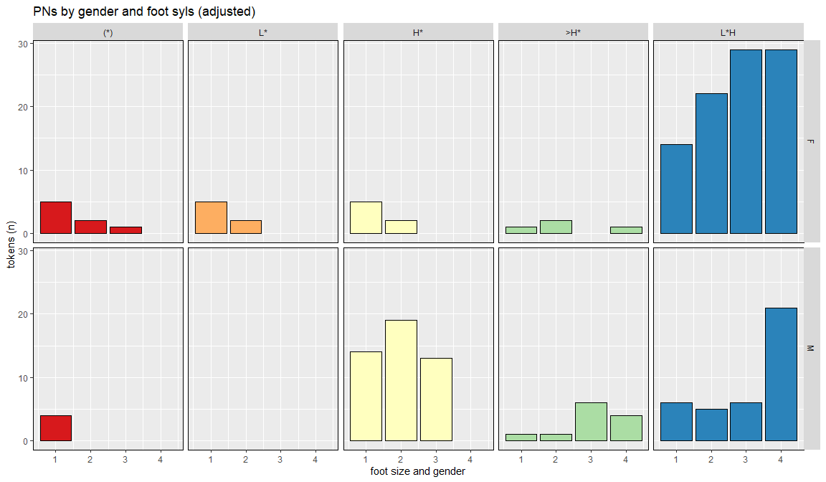

### PNs across foot size conditions (adjusted)

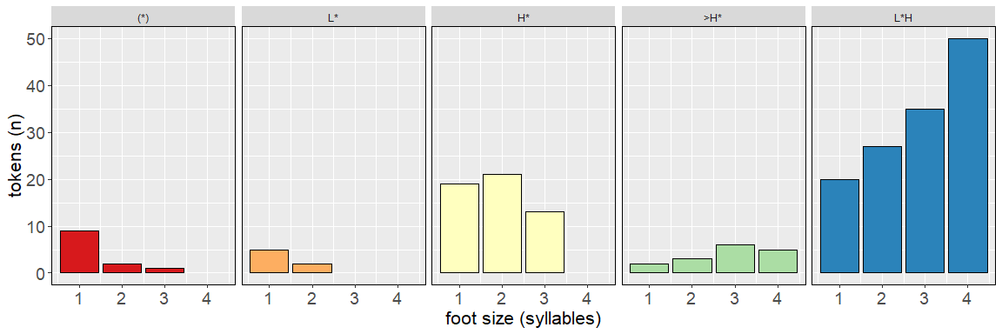

### PNs and Anacrusis

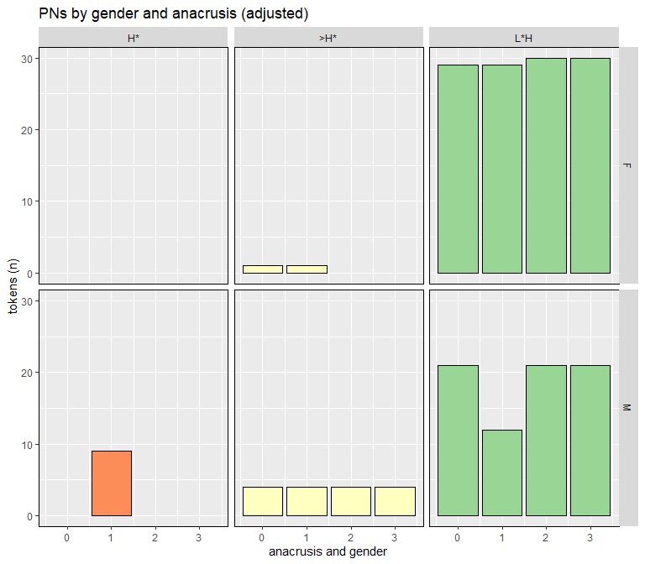

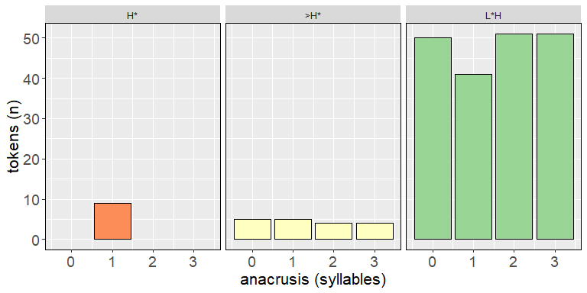

## 1.3.2 Nuclear Pitch Contours

### Nuclear Contours and Foot Size

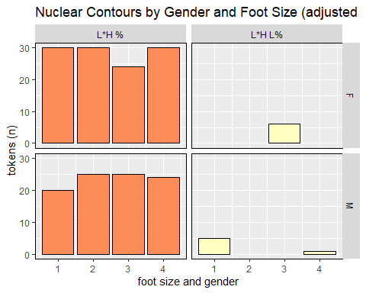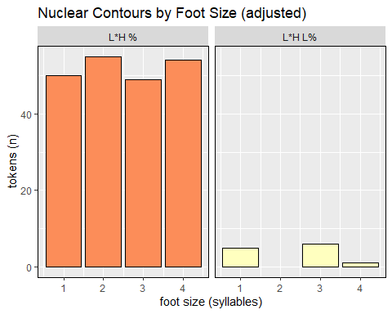

### Nuclear Contours and Preceding Syllables

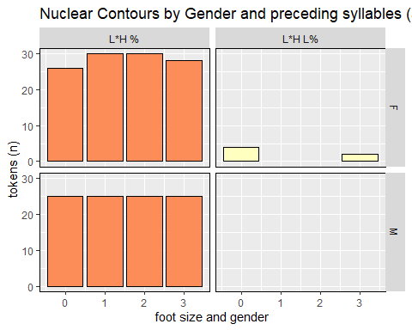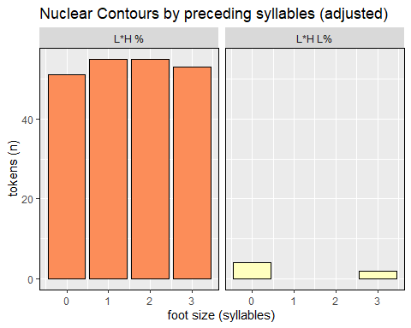

# **1.4 Initial boundary and downstep**

### foot size

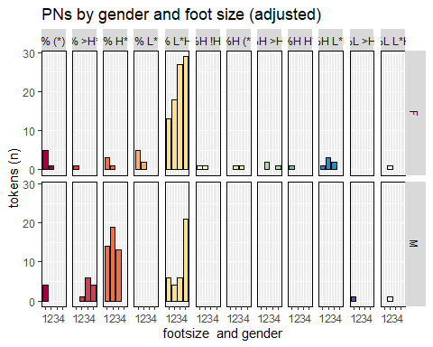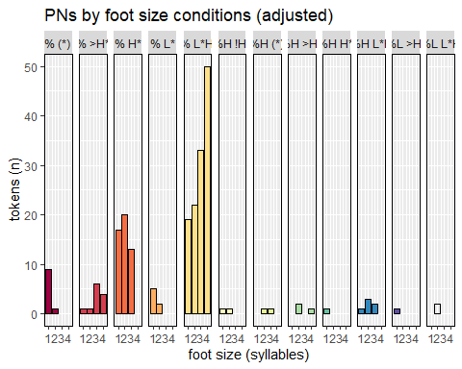

### anacrusis

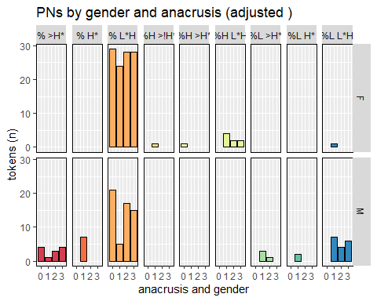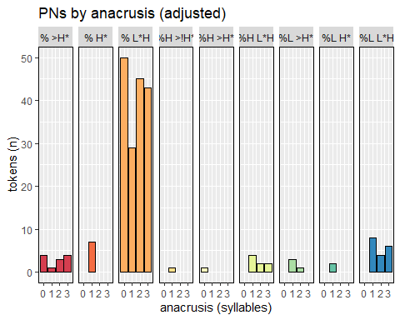

| speaker | % >H* | % H* | % L*H | %H >!H* | %H >H* | %H L*H | %L >H* | %L H* | %L L*H |
| --- | --- | --- | --- | --- | --- | --- | --- | --- | --- |
| F5 | 0 | 0 | 17 | 0 | 1 | 2 | 0 | 0 | 0 |
| F6 | 0 | 0 | 20 | 0 | 0 | 0 | 0 | 0 | 0 |
| F12 | 0 | 0 | 17 | 0 | 0 | 0 | 0 | 0 | 1 |
| F15 | 0 | 0 | 13 | 1 | 0 | 7 | 0 | 0 | 0 |
| F16 | 0 | 0 | 20 | 0 | 0 | 0 | 0 | 0 | 0 |
| F17 | 0 | 0 | 17 | 0 | 0 | 0 | 0 | 0 | 0 |
| M4 | 0 | 0 | 11 | 0 | 0 | 0 | 3 | 1 | 1 |
| M5 | 0 | 3 | 16 | 0 | 0 | 0 | 0 | 0 | 1 |
| M8 | 3 | 0 | 2 | 0 | 0 | 0 | 0 | 0 | 13 |
| M9 | 7 | 4 | 1 | 0 | 0 | 0 | 1 | 1 | 1 |
| M10 | 0 | 0 | 19 | 0 | 0 | 0 | 0 | 0 | 1 |

| speaker | % >H* | % H* | % L*H | %H >!H* | %H >H* | %H L*H | %L >H* | %L H* | %L L*H |
| --- | --- | --- | --- | --- | --- | --- | --- | --- | --- |
| F5 | 0 | 0 | 17 | 0 | 1 | 2 | 0 | 0 | 0 |
| F6 | 0 | 0 | 20 | 0 | 0 | 0 | 0 | 0 | 0 |
| F12 | 0 | 0 | 17 | 0 | 0 | 0 | 0 | 0 | 1 |
| F15 | 0 | 0 | 13 | 1 | 0 | 7 | 0 | 0 | 0 |
| F16 | 0 | 0 | 20 | 0 | 0 | 0 | 0 | 0 | 0 |
| F17 | 0 | 0 | 17 | 0 | 0 | 0 | 0 | 0 | 0 |
| M4 | 0 | 0 | 11 | 0 | 0 | 0 | 3 | 1 | 1 |
| M5 | 0 | 3 | 16 | 0 | 0 | 0 | 0 | 0 | 1 |
| M8 | 3 | 0 | 2 | 0 | 0 | 0 | 0 | 0 | 13 |
| M9 | 7 | 4 | 1 | 0 | 0 | 0 | 1 | 1 | 1 |
| M10 | 0 | 0 | 19 | 0 | 0 | 0 | 0 | 0 | 1 |

# **1.5 Individiual Results**

## F5

### Pre-nuclear contours

F5 Table: PN foot size effects on PA

| foot_syls | (*) | L* | H* | >H* | L*H |
| --- | --- | --- | --- | --- | --- |
| 1 | 1 | 0 | 4 | 0 | 0 |
| 2 | 2 | 0 | 1 | 1 | 1 |
| 3 | 1 | 0 | 0 | 0 | 4 |
| 4 | 0 | 0 | 0 | 1 | 4 |

F5 Table: PN anacrusis effects on PA

| ana_syls | (*) | L* | H* | >H* | L*H |
| --- | --- | --- | --- | --- | --- |
| 0 | 0 | 0 | 0 | 1 | 4 |
| 1 | 0 | 0 | 0 | 0 | 5 |
| 2 | 0 | 0 | 0 | 0 | 5 |
| 3 | 0 | 0 | 0 | 0 | 5 |

### Nuclear contours

F5 Table: NUC foot size effects on PA

| foot_syls | L*H % | L*H L% |
| --- | --- | --- |
| 1 | 5 | 0 |
| 2 | 5 | 0 |
| 3 | 5 | 0 |
| 4 | 5 | 0 |

F5 Table: NUC preceding syllable effects on PA

| pre_syls | L*H % | L*H L% |
| --- | --- | --- |
| 0 | 4 | 0 |
| 1 | 5 | 0 |
| 2 | 5 | 0 |
| 3 | 5 | 0 |

## F6

### Pre-nuclear contours

F6 Table: PN foot size effects on PA

| foot_syls | (*) | L* | H* | >H* | L*H |
| --- | --- | --- | --- | --- | --- |
| 1 | 3 | 0 | 0 | 1 | 1 |
| 2 | 0 | 0 | 0 | 0 | 5 |
| 3 | 0 | 0 | 0 | 0 | 5 |
| 4 | 0 | 0 | 0 | 0 | 5 |

F6 Table: PN anacrusis effects on PA

| ana_syls | (*) | L* | H* | >H* | L*H |
| --- | --- | --- | --- | --- | --- |
| 0 | 0 | 0 | 0 | 0 | 5 |
| 1 | 0 | 0 | 0 | 0 | 5 |
| 2 | 0 | 0 | 0 | 0 | 5 |
| 3 | 0 | 0 | 0 | 0 | 5 |

### Nuclear contours

F6 Table: NUC foot size effects on PA

| foot_syls | L*H % | L*H L% |
| --- | --- | --- |
| 1 | 5 | 0 |
| 2 | 5 | 0 |
| 3 | 5 | 0 |
| 4 | 5 | 0 |

F6 Table: NUC preceding syllable effects on PA

| pre_syls | L*H % | L*H L% |
| --- | --- | --- |
| 0 | 5 | 0 |
| 1 | 5 | 0 |
| 2 | 5 | 0 |
| 3 | 5 | 0 |

## F12

### Pre-nuclear contours

F12 Table: PN foot size effects on PA

| foot_syls | (*) | L* | H* | >H* | L*H |
| --- | --- | --- | --- | --- | --- |
| 1 | 0 | 1 | 0 | 0 | 4 |
| 2 | 0 | 0 | 0 | 0 | 5 |
| 3 | 0 | 0 | 0 | 0 | 5 |
| 4 | 0 | 0 | 0 | 0 | 3 |

F12 Table: PN anacrusis effects on PA

| ana_syls | (*) | L* | H* | >H* | L*H |
| --- | --- | --- | --- | --- | --- |
| 0 | 0 | 0 | 0 | 0 | 3 |
| 1 | 0 | 0 | 0 | 0 | 5 |
| 2 | 0 | 0 | 0 | 0 | 5 |
| 3 | 0 | 0 | 0 | 0 | 5 |

### Nuclear contours

F12 Table: NUC foot size effects on PA

| foot_syls | L*H % | L*H L% |
| --- | --- | --- |
| 1 | 5 | 0 |
| 2 | 5 | 0 |
| 3 | 0 | 5 |
| 4 | 5 | 0 |

F12 Table: NUC preceding syllable effects on PA

| pre_syls | L*H % | L*H L% |
| --- | --- | --- |
| 0 | 1 | 4 |
| 1 | 5 | 0 |
| 2 | 5 | 0 |
| 3 | 2 | 1 |

## F15

### Pre-nuclear contours

F15 Table: PN foot size effects on PA

| foot_syls | (*) | L* | H* | >H* | L*H |
| --- | --- | --- | --- | --- | --- |
| 1 | 0 | 0 | 1 | 0 | 4 |
| 2 | 0 | 0 | 1 | 1 | 3 |
| 3 | 0 | 0 | 0 | 0 | 5 |
| 4 | 0 | 0 | 0 | 0 | 5 |

F15 Table: PN anacrusis effects on PA

| ana_syls | (*) | L* | H* | >H* | L*H |
| --- | --- | --- | --- | --- | --- |
| 0 | 0 | 0 | 0 | 0 | 5 |
| 1 | 0 | 0 | 0 | 1 | 5 |
| 2 | 0 | 0 | 0 | 0 | 5 |
| 3 | 0 | 0 | 0 | 0 | 5 |

### Nuclear contours

F15 Table: NUC foot size effects on PA

| foot_syls | L*H % | L*H L% |
| --- | --- | --- |
| 1 | 5 | 0 |
| 2 | 5 | 0 |
| 4 | 5 | 0 |

F15 Table: NUC preceding syllable effects on PA

| pre_syls | L*H % | L*H L% |
| --- | --- | --- |
| 0 | 5 | 0 |
| 1 | 5 | 0 |
| 2 | 5 | 0 |
| 3 | 5 | 0 |

## F16

### Pre-nuclear contours

F16 Table: PN foot size effects on PA

| foot_syls | (*) | L* | H* | >H* | L*H |
| --- | --- | --- | --- | --- | --- |
| 1 | 0 | 0 | 0 | 0 | 5 |
| 2 | 0 | 0 | 0 | 0 | 5 |
| 3 | 0 | 0 | 0 | 0 | 5 |
| 4 | 0 | 0 | 0 | 0 | 5 |

F16 Table: PN anacrusis effects on PA

| ana_syls | (*) | L* | H* | >H* | L*H |
| --- | --- | --- | --- | --- | --- |
| 0 | 0 | 0 | 0 | 0 | 5 |
| 1 | 0 | 0 | 0 | 0 | 5 |
| 2 | 0 | 0 | 0 | 0 | 5 |
| 3 | 0 | 0 | 0 | 0 | 5 |

### Nuclear contours

F16 Table: NUC foot size effects on PA

| foot_syls | L*H % | L*H L% |
| --- | --- | --- |
| 1 | 5 | 0 |
| 2 | 5 | 0 |
| 3 | 5 | 0 |
| 4 | 5 | 0 |

F16 Table: NUC preceding syllable effects on PA

| pre_syls | L*H % | L*H L% |
| --- | --- | --- |
| 0 | 5 | 0 |
| 1 | 5 | 0 |
| 2 | 5 | 0 |
| 3 | 5 | 0 |

## F17

### Pre-nuclear contours

F17 Table: PN foot size effects on PA

| foot_syls | (*) | L* | H* | >H* | L*H |
| --- | --- | --- | --- | --- | --- |
| 1 | 1 | 4 | 0 | 0 | 0 |
| 2 | 0 | 2 | 0 | 0 | 3 |
| 3 | 0 | 0 | 0 | 0 | 5 |
| 4 | 0 | 0 | 0 | 0 | 2 |

F17 Table: PN anacrusis effects on PA

| ana_syls | (*) | L* | H* | >H* | L*H |
| --- | --- | --- | --- | --- | --- |
| 0 | 0 | 0 | 0 | 0 | 2 |
| 1 | 0 | 0 | 0 | 0 | 5 |
| 2 | 0 | 0 | 0 | 0 | 5 |
| 3 | 0 | 0 | 0 | 0 | 5 |

### Nuclear contours

F17 Table: NUC foot size effects on PA

| foot_syls | L*H % | L*H L% |
| --- | --- | --- |
| 1 | 5 | 0 |
| 2 | 5 | 0 |
| 3 | 1 | 0 |
| 4 | 5 | 0 |

F17 Table: NUC preceding syllable effects on PA

| pre_syls | L*H % | L*H L% |
| --- | --- | --- |
| 0 | 5 | 0 |
| 1 | 5 | 0 |
| 2 | 5 | 0 |
| 3 | 2 | 0 |

## M4

### Pre-nuclear contours

M4 Table: PN foot size effects on PA

| foot_syls | (*) | L* | H* | >H* | L*H |
| --- | --- | --- | --- | --- | --- |
| 1 | 4 | 0 | 1 | 0 | 0 |
| 2 | 0 | 0 | 5 | 0 | 0 |
| 3 | 0 | 0 | 3 | 1 | 1 |
| 4 | 0 | 0 | 0 | 0 | 1 |

M4 Table: PN anacrusis effects on PA

| ana_syls | (*) | L* | H* | >H* | L*H |
| --- | --- | --- | --- | --- | --- |
| 0 | 0 | 0 | 0 | 0 | 1 |
| 1 | 0 | 0 | 1 | 3 | 1 |
| 2 | 0 | 0 | 0 | 0 | 5 |
| 3 | 0 | 0 | 0 | 0 | 5 |

### Nuclear contours

M4 Table: NUC foot size effects on PA

| foot_syls | L*H % | L*H L% |
| --- | --- | --- |
| 1 | 5 | 0 |
| 2 | 5 | 0 |
| 3 | 5 | 0 |
| 4 | 5 | 0 |

M4 Table: NUC preceding syllable effects on PA

| pre_syls | L*H % | L*H L% |
| --- | --- | --- |
| 0 | 5 | 0 |
| 1 | 5 | 0 |
| 2 | 5 | 0 |
| 3 | 1 | 0 |

## M5

### Pre-nuclear contours

M5 Table: PN foot size effects on PA

| foot_syls | (*) | L* | H* | >H* | L*H |
| --- | --- | --- | --- | --- | --- |
| 1 | 0 | 0 | 5 | 0 | 0 |
| 2 | 0 | 0 | 5 | 0 | 0 |
| 3 | 0 | 0 | 4 | 0 | 1 |
| 4 | 0 | 0 | 0 | 0 | 5 |

M5 Table: PN anacrusis effects on PA

| ana_syls | (*) | L* | H* | >H* | L*H |
| --- | --- | --- | --- | --- | --- |
| 0 | 0 | 0 | 0 | 0 | 5 |
| 1 | 0 | 0 | 3 | 0 | 2 |
| 2 | 0 | 0 | 0 | 0 | 5 |
| 3 | 0 | 0 | 0 | 0 | 5 |

### Nuclear contours

M5 Table: NUC foot size effects on PA

| foot_syls | L*H % | L*H L% |
| --- | --- | --- |
| 1 | 5 | 0 |
| 2 | 5 | 0 |
| 3 | 3 | 0 |
| 4 | 5 | 0 |

M5 Table: NUC preceding syllable effects on PA

| pre_syls | L*H % | L*H L% |
| --- | --- | --- |
| 0 | 5 | 0 |
| 1 | 5 | 0 |
| 2 | 5 | 0 |
| 3 | 5 | 0 |

## M8

### Pre-nuclear contours

M8 Table: PN foot size effects on PA

| foot_syls | (*) | L* | H* | >H* | L*H |
| --- | --- | --- | --- | --- | --- |
| 1 | 0 | 0 | 0 | 0 | 5 |
| 2 | 0 | 0 | 2 | 1 | 2 |
| 3 | 0 | 0 | 0 | 5 | 0 |
| 4 | 0 | 0 | 0 | 2 | 1 |

M8 Table: PN anacrusis effects on PA

| ana_syls | (*) | L* | H* | >H* | L*H |
| --- | --- | --- | --- | --- | --- |
| 0 | 0 | 0 | 0 | 2 | 1 |
| 1 | 0 | 0 | 0 | 1 | 4 |
| 2 | 0 | 0 | 0 | 0 | 5 |
| 3 | 0 | 0 | 0 | 0 | 5 |

### Nuclear contours

M8 Table: NUC foot size effects on PA

| foot_syls | L*H % | L*H L% |
| --- | --- | --- |
| 1 | 0 | 1 |
| 2 | 5 | 0 |
| 4 | 5 | 0 |

M8 Table: NUC preceding syllable effects on PA

| pre_syls | L*H % | L*H L% |
| --- | --- | --- |
| 0 | 5 | 0 |
| 1 | 5 | 0 |
| 2 | 5 | 0 |
| 3 | 3 | 0 |

## M9

### Pre-nuclear contours

M9 Table: PN foot size effects on PA

| foot_syls | (*) | L* | H* | >H* | L*H |
| --- | --- | --- | --- | --- | --- |
| 1 | 0 | 0 | 5 | 0 | 0 |
| 2 | 0 | 0 | 5 | 0 | 0 |
| 3 | 0 | 0 | 5 | 0 | 0 |

M9 Table: PN anacrusis effects on PA

| ana_syls | (*) | L* | H* | >H* | L*H |
| --- | --- | --- | --- | --- | --- |
| 1 | 0 | 0 | 5 | 0 | 0 |
| 2 | 0 | 0 | 0 | 4 | 1 |
| 3 | 0 | 0 | 0 | 4 | 1 |

### Nuclear contours

M9 Table: NUC foot size effects on PA

| foot_syls | L*H % | L*H L% |
| --- | --- | --- |
| 1 | 5 | 0 |
| 2 | 5 | 0 |
| 3 | 1 | 0 |
| 4 | 4 | 1 |

M9 Table: NUC preceding syllable effects on PA

| pre_syls | L*H % | L*H L% |
| --- | --- | --- |
| 0 | 5 | 0 |
| 1 | 5 | 0 |
| 2 | 5 | 0 |

## M10

### Pre-nuclear contours

M10 Table: PN foot size effects on PA

| foot_syls | (*) | L* | H* | >H* | L*H |
| --- | --- | --- | --- | --- | --- |
| 1 | 0 | 0 | 3 | 1 | 1 |
| 2 | 0 | 0 | 2 | 0 | 3 |
| 3 | 0 | 0 | 1 | 0 | 4 |
| 4 | 0 | 0 | 0 | 0 | 4 |

M10 Table: PN anacrusis effects on PA

| ana_syls | (*) | L* | H* | >H* | L*H |
| --- | --- | --- | --- | --- | --- |
| 0 | 0 | 0 | 0 | 0 | 4 |
| 1 | 0 | 0 | 0 | 0 | 5 |
| 2 | 0 | 0 | 0 | 0 | 6 |
| 3 | 0 | 0 | 0 | 0 | 5 |

### Nuclear contours

M10 Table: NUC foot size effects on PA

| foot_syls | L*H % | L*H L% |
| --- | --- | --- |
| 1 | 5 | 0 |
| 2 | 5 | 0 |
| 3 | 5 | 0 |
| 4 | 5 | 0 |

M10 Table: NUC preceding syllable effects on PA

| pre_syls | L*H % | L*H L% |
| --- | --- | --- |
| 0 | 5 | 0 |
| 1 | 5 | 0 |
| 2 | 5 | 0 |
| 3 | 4 | 0 |