Generalsed Linear Mixed Model Analysis of Footsize effect on PN Phonology

AERodgers

2/18/2020

## **PNs** as fn of **foot size**

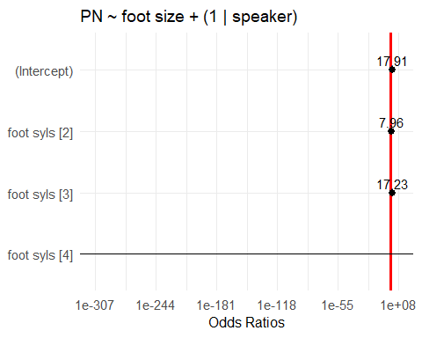

term

estimate

std.error

z.value

p.value

(Intercept)

2.885

0.904

3.192

0.0014

foot_syls2

2.074

0.919

2.258

0.0240

foot_syls3

2.847

1.204

2.365

0.0180

foot_syls4

20.086

7111.517

0.003

0.9977

sd__(Intercept)

2.248

NA

NA

NA

## pairwise comparisons

#### Foot size as intercept (0)

intercept

estimate

std.error

z.value

p.value

foot_syls1

2.885

0.904

3.192

0.0014

foot_syls2

4.959

1.161

4.272

0.0000

foot_syls3

5.732

1.399

4.096

0.0000

foot_syls4

22.891

6832.331

0.003

0.9973

#### Pairwise comparisons (1)

intercept

slope

estimate

std.error

z.value

p.value

foot_syls1

foot_syls2

2.074

0.919

2.258

0.0240

foot_syls1

foot_syls3

2.847

1.204

2.365

0.0180

foot_syls1

foot_syls4

20.086

7111.517

0.003

0.9977

foot_syls2

foot_syls3

0.773

1.367

0.565

0.5720

foot_syls2

foot_syls4

18.142

7590.019

0.002

0.9981

foot_syls3

foot_syls4

17.394

7683.718

0.002

0.9982