Analysis of PNs - Overview of *Foot* Effects on Alignment

Antoin Rodgers

11/02/2020

knitr::opts_chunk$set(  
 echo = FALSE,  
 message = FALSE,  
 warning = FALSE  
)

Create data tbls

# Looking at PN distribution by speaker, gender, and ana_syls

## # A tibble: 4 x 6  
## foot_syls `(*)` `L*` `H*` `>H*` `L*H`  
## <int> <dbl> <dbl> <dbl> <dbl> <dbl>  
## 1 1 9 5 19 2 20  
## 2 2 2 2 21 3 27  
## 3 3 1 0 13 6 35  
## 4 4 0 0 0 3 35

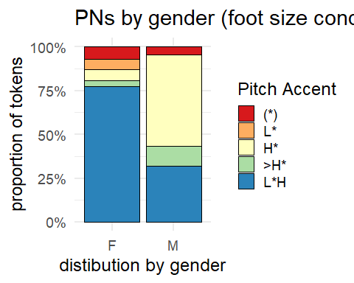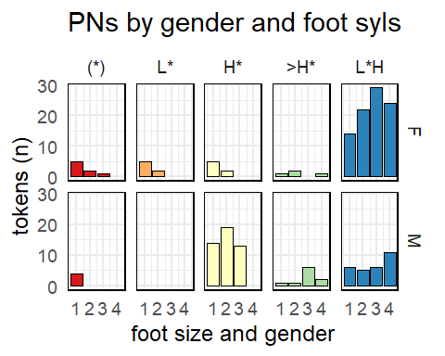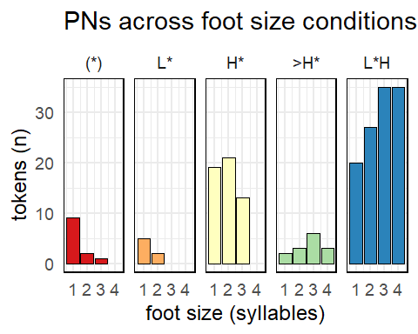

### Rejigging >H* by gender

I reran the distibution using the gendered >H* hypothesis.

Output and Figures

## # A tibble: 4 x 5  
## foot_syls `(*)` `L*` `H*` `L*H`  
## <int> <dbl> <dbl> <dbl> <dbl>  
## 1 1 9 5 20 21  
## 2 2 2 2 23 28  
## 3 3 1 0 13 41  
## 4 4 0 0 1 37

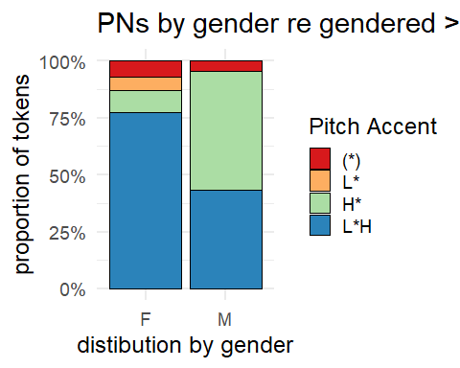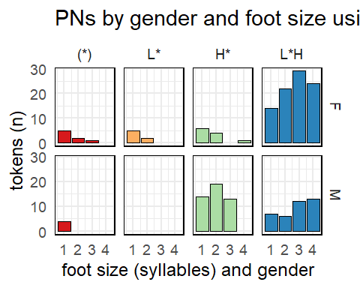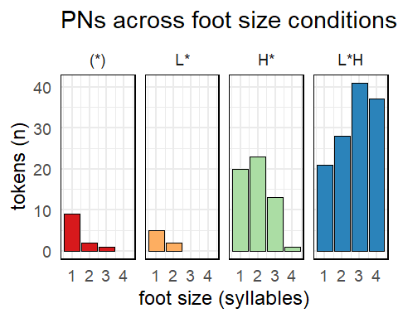

### Rejigging >H* by gender AND L*H / non-L*H