AERoPlot: a Praat plug-in for plotting data User’s Manual
Code and manual written by Antoin Eoin Rodgers
October 30th, 2020
AERoPlot version 1.4

Phonetics and Speech laboratory, Trinity College https://www.tcd.ie/slscs/clcs/psl/
Email: rodgeran@tcd.ie
Twitter: @phonetic_antoin

Table of Contents
1 Getting Started 3
2 F1-F2 Plots 4
2.1 Data Table UI 5
2.2 Main and Secondary Factor filtering 6
2.3 Tertiary Filters 6
2.4 Graphical Output Settings 7
2.5 Saving 8
3 Ladefoged-style plots 9
3.1 Data Table UI 10
3.2 Main and Secondary Factor filtering 10
3.3 Tertiary Filters 10
3.4 Graphical Output Settings 11
3.5 Saving 11
4 Formants-over-time Plots 12
4.1 Data Table UI 13
4.2 Reference time 14
4.3 Main and Secondary Factor filtering 14
4.4 Tertiary Filters 14
4.5 Graphical Output Settings 15
4.6 Saving 15
5 Colour Management 16
5.1 Add or Change colour scheme 16
5.2 Modify colour scheme 17
5.2.1 Re-sort by brightness 17
5.2.2 Re-sort by maximal perceptual difference 17
5.2.3 Re-sort manually 17
5.2.4 Match levels to colour in next plot only 18
6 Generate Data Table from Text Grid with Nested Tiers 18

Getting Started
First of all, I’m very please you somehow found your way here. I hope you find my plugin and this manual useful. Do get in touch if you have any comments, suggestions or queries. If for some strange reason you happen to have a copy of this manual but have not downloaded Praat or the AERoPlot Plugin, you need to visit this web page: https://github.com/AERodgers/plugin_AERoPlot. Follow the installation instructions there.
AERoPlot is a Praat plugin allows you to draw elegant and informative plots of data in Praat through a series of menus. There are four kinds of plot: F1F2 Plots (§0), Ladefoged-style plots (see §3), Formants-over-time Plots (See §4), and F0-CCP plots (not covered here).
When you run each plot, you will navigate your way through a series of menus in the following order: data table input menu, filter menu(s), graphical output menu. After this, the plot is drawn and you can save or discard it.
Once you have Praat up and running and installed the plugin, you can access the plot functions in two ways:
- Praat Objects Window → New → AERoPlot
- From the right-hand menu after you select a table in the objects window.
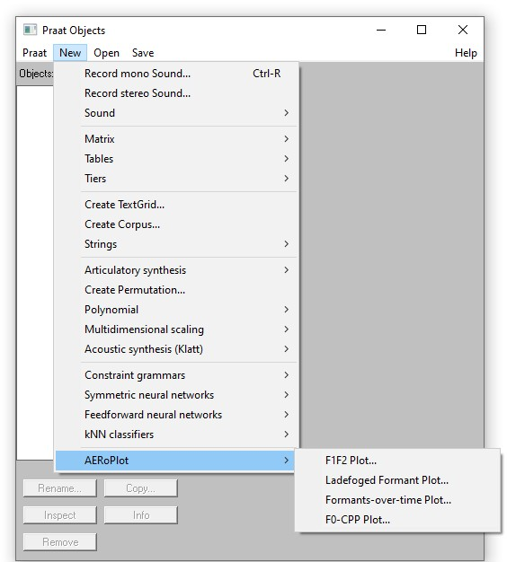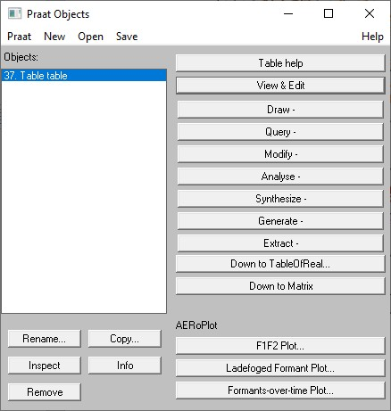

F1-F2 Plots
These plots display the F1-F2 values on a graph, with F1 is on the vertical plane and F2 the horizontal plane. They are arranged in such a way that the location of each sound in the acoustic space on the grid somewhat reflects the location of each sound impressionistically in terms of height and backness. Below is an example of adult female vowels from the Peterson and Barney dataset.

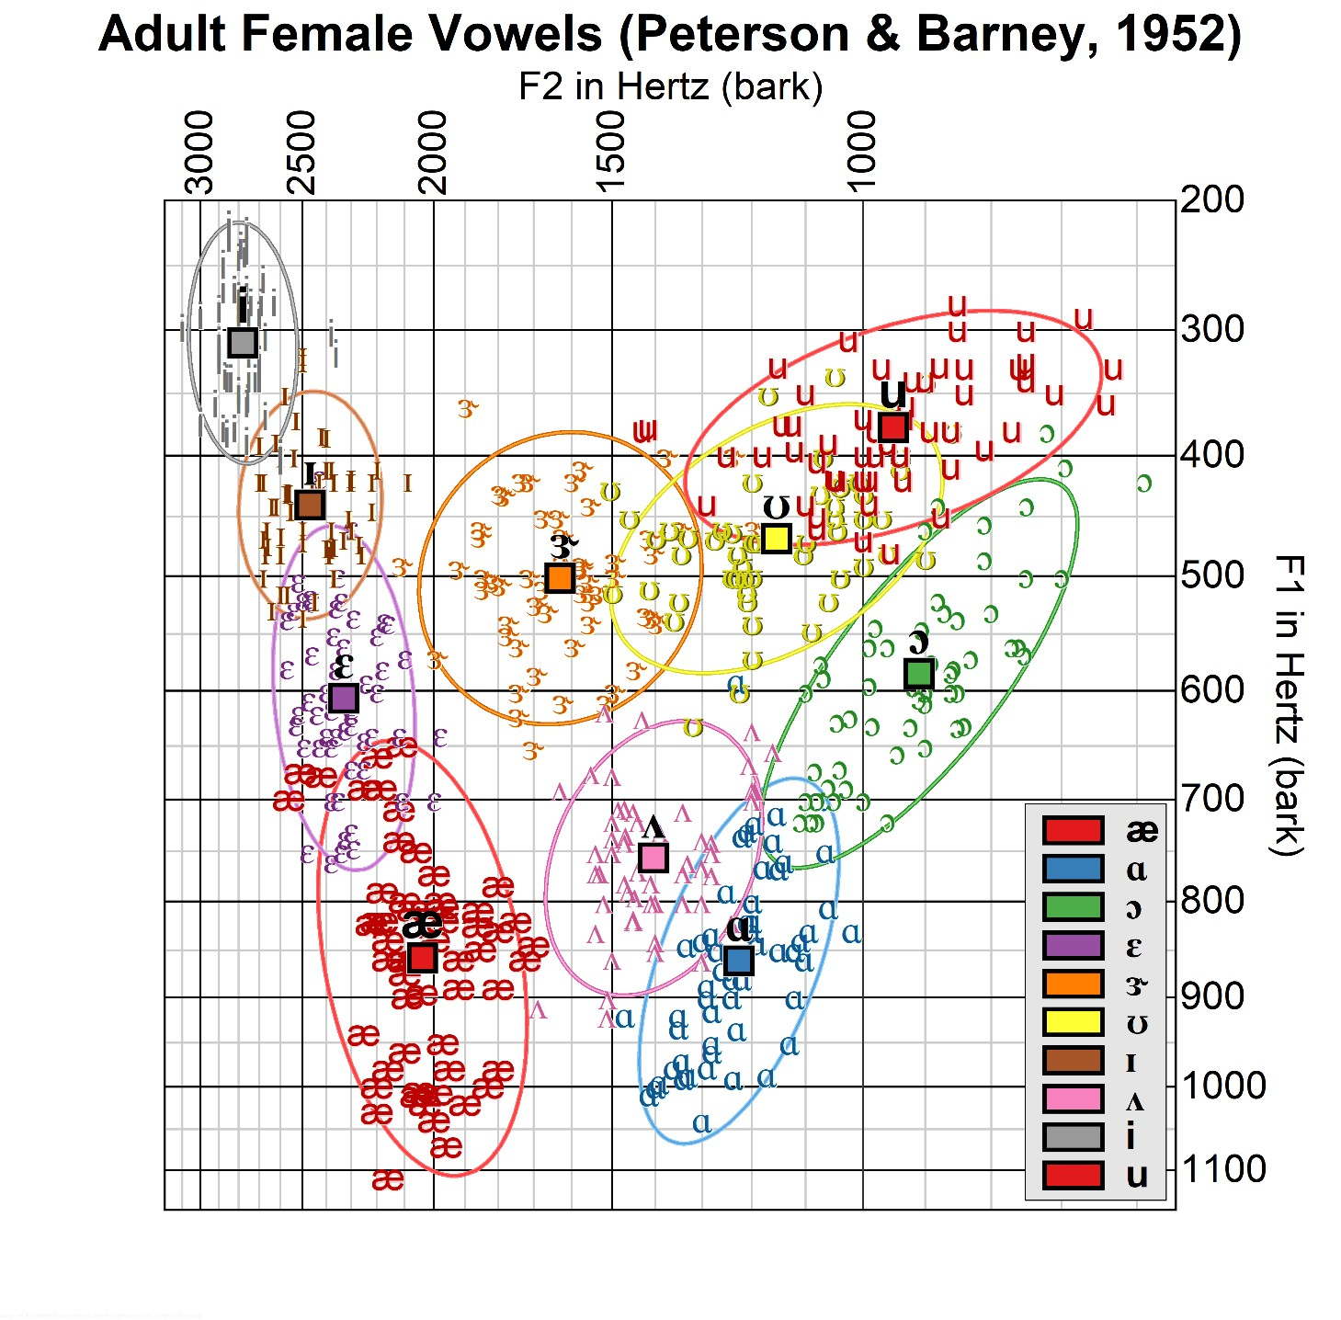

Data Table UI
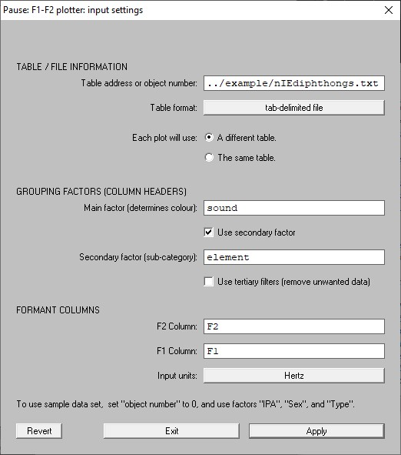
A

B

C

E

D

*

*

Green indicates
these options are the
same for every type
of formant plotter

in
AERoPlot.

  A | TABLE / FILE INFORMATION*  Table address or object number accepts both a full address of the data table (as in the example) OR the number of the table in the objects window. Typing “0” will load the Peterson and Barney (1952) data.  Table format allows you to choose between tab-delimited file (which will also open Praat tables) or CSV file formats. Each plot will use options indicate if you will be using the same table if you want to draw multiple plots. Select The same table if you don’t want to return to this menu again!  *Table options only appear if you use the drop-down menus.
  B | GROUPING FACTORS  Main Factor is the column heading which will always be used when plotting the chart. The colour scheme will always use this factor.  Use secondary factor allows you to choose a second column which will divide the main factor into sub-categories. For example, in the Peterson and Barney data, your main factor
   | might be IPA and the secondary factor Sex. This would calculate means and ellipses according to IPA × Sex. Use tertiary filters will allow you to filter out data listed in other columns in the table. This will trigger an extra menu which lists all other columns / factors in the data table which you might want to use for filtering out unwanted data. (For example, in the Peterson and Barney, you might want to filter out data from the Type “Child”.)
  C | FORMANT COLUMNS  Enter the column headers for F1 and F2 here.  You can choose between Hertz or Bark Scale as the Input Units. (There are currently no output options for other frequency scales.)
  D | ACCESSING TEST DATA  The text here shows you how to access the Peterson and  Barney data. This will disappear after the first time you use it.
  E | Revert resets menu options.  Exit does what it says on the tin.  Choose Apply to apply settings and move to the next menu

Main and Secondary Factor filtering
For the main factor (and secondary factor if you have selected one), an option menu will appear, which asks you to select which levels you want to display. This process is the same for each kind of formant plotter in AERoPlot.
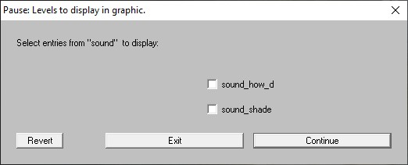

Tertiary Filters
If you chose tertiary filters, a menu will appear asking you which tertiary factors (columns) you wish to use for filtering out any unwanted data. This process is the same for each kind of formant plotter on AERoPlot.
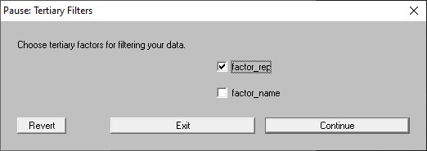
For each tertiary factor you choose, a filter menu will appear, which behaves in the exact same manner as the Main and Secondary Factor filters (see §2.1)
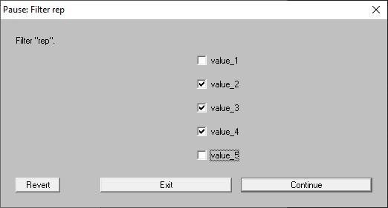

Graphical Output Settings
In this second major menu, you choose the setting related to the plot appearance.
NB: in version 1.4, you can also choose your font.
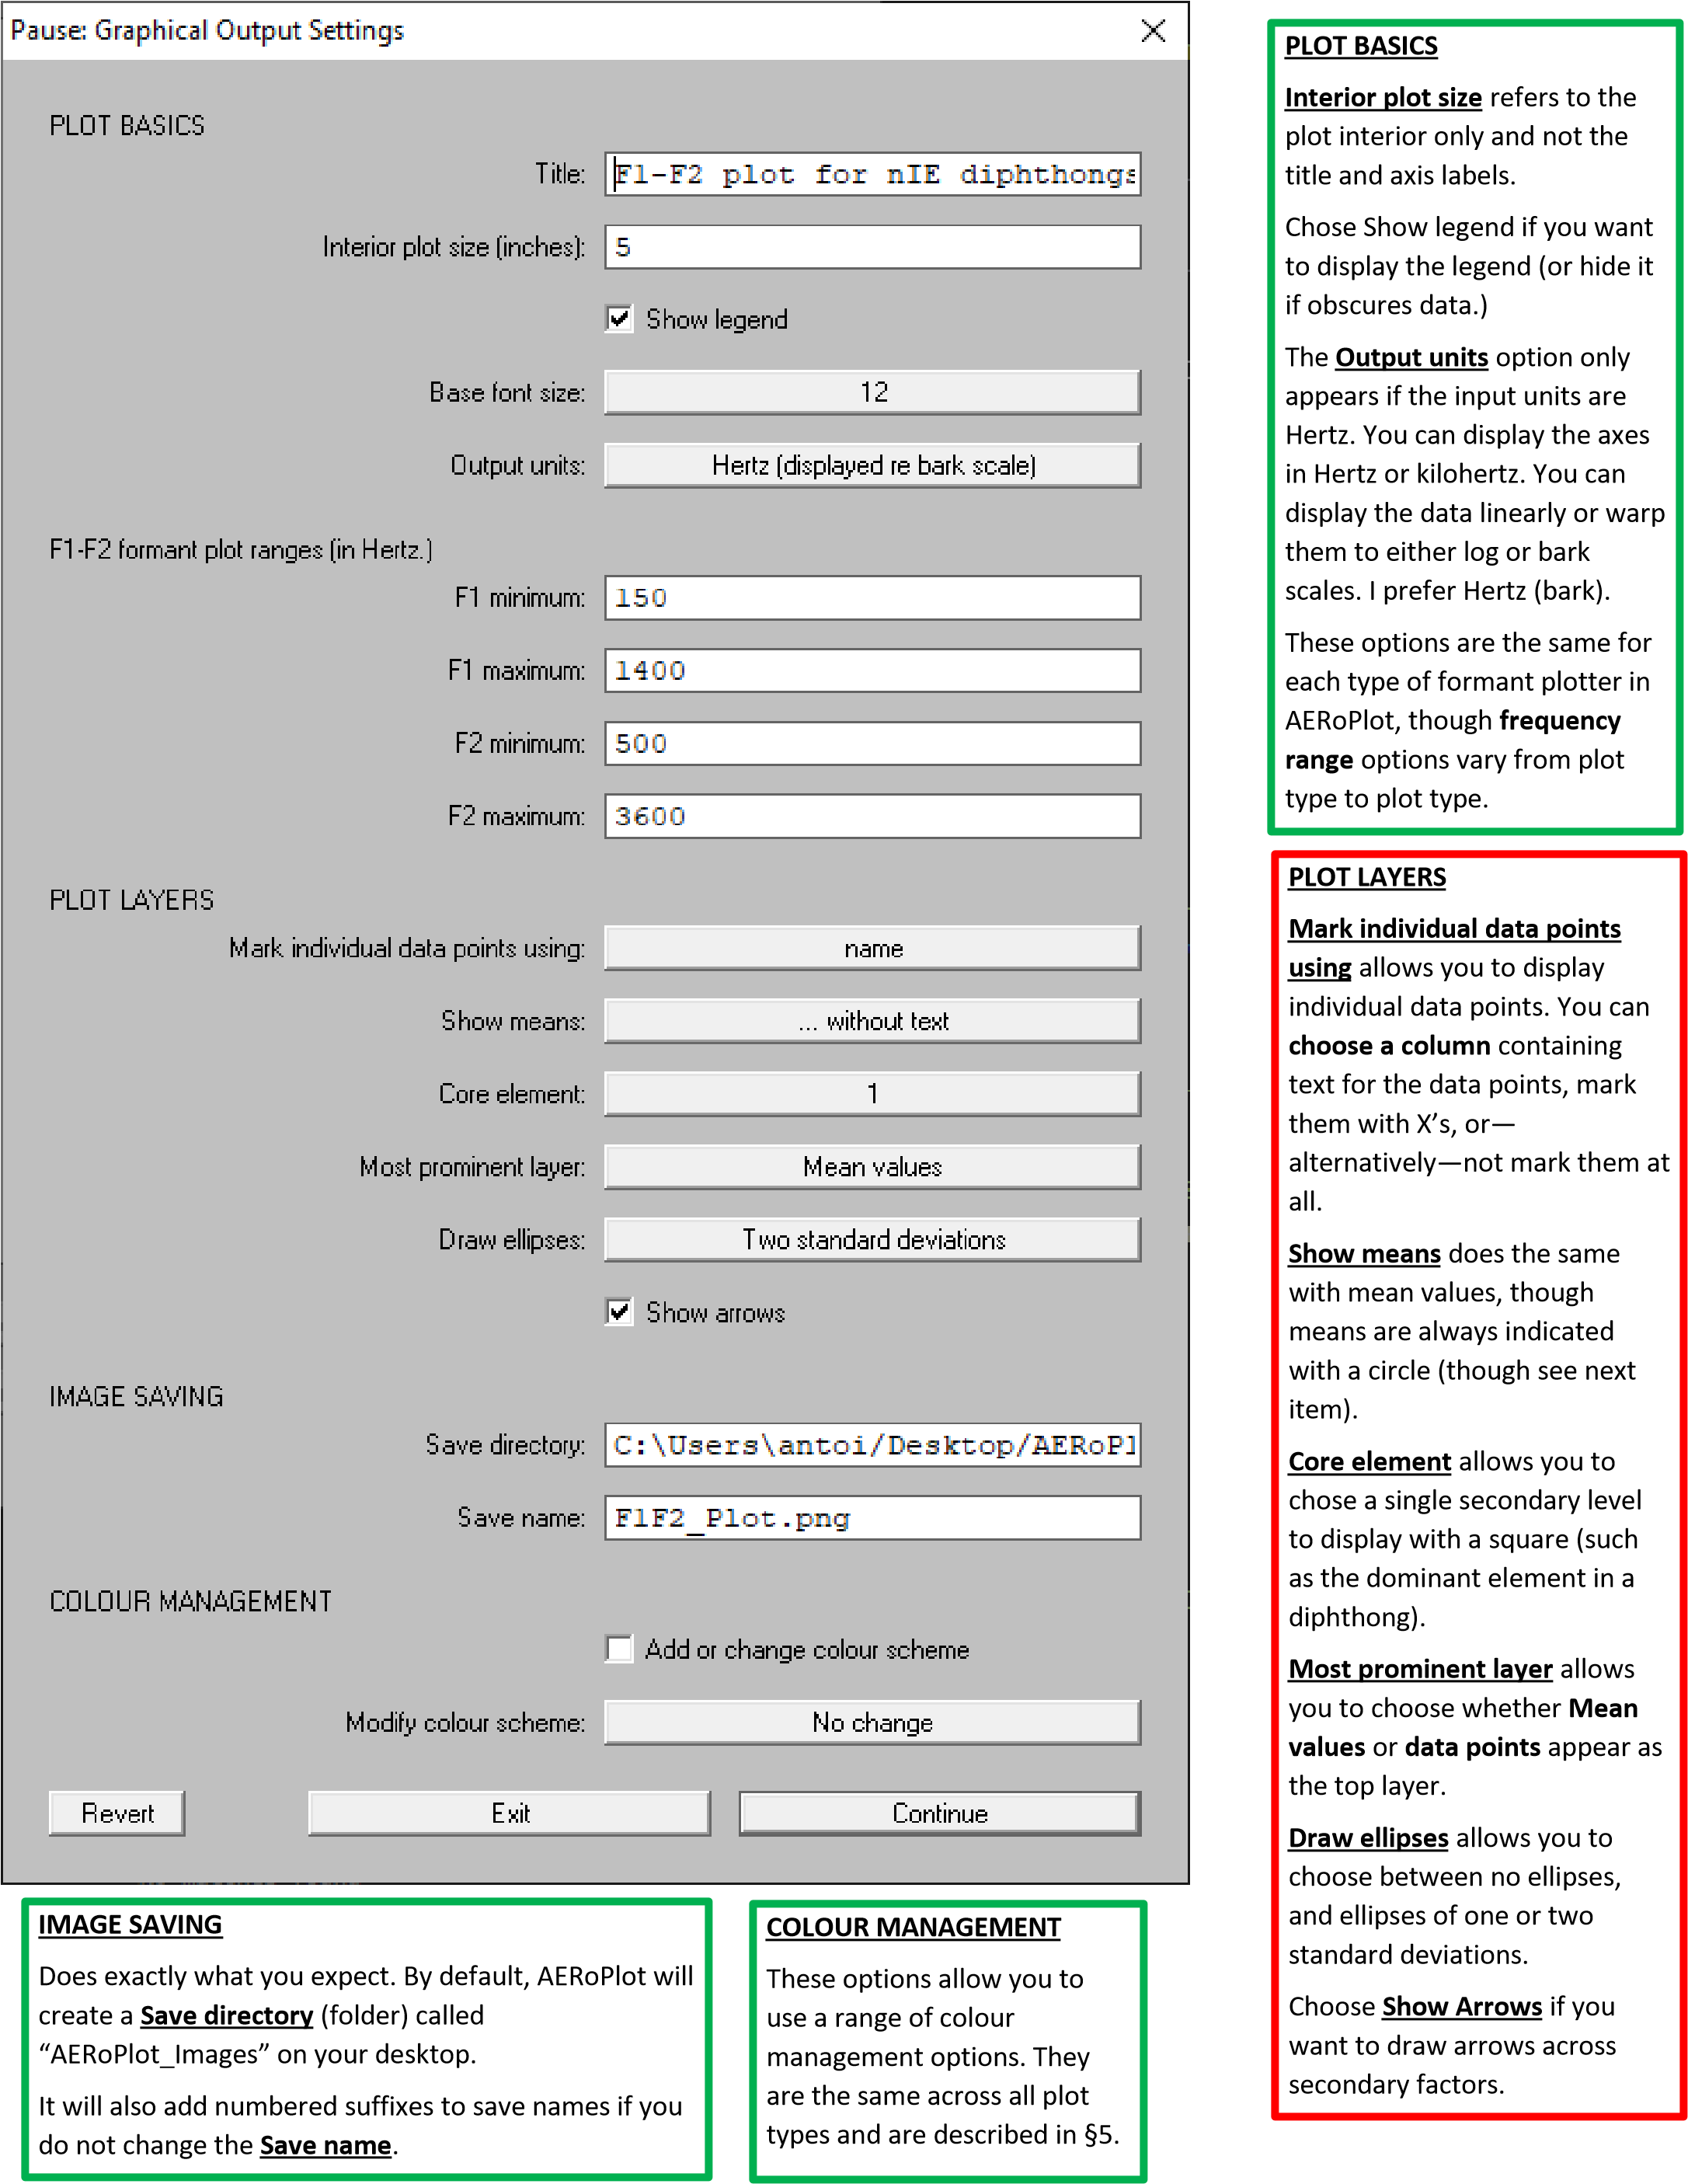

Saving
When the plot is drawn in the Picture window, you have options to Save and/or Exit the script.
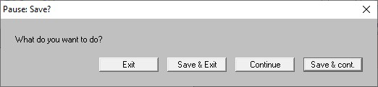
If you want to draw another plot, chose Continue or Save & cont.. These options will return you to the Main Input UI or the Filter menus depending on earlier choice for Each plot will use in the Data Table UI menu (§2.1).
These options are the same for every plot type in AERoPlot.
NOTE that the quality of the saved image is much higher than that displayed in the Praat Picture window, as can be seen in the images below.
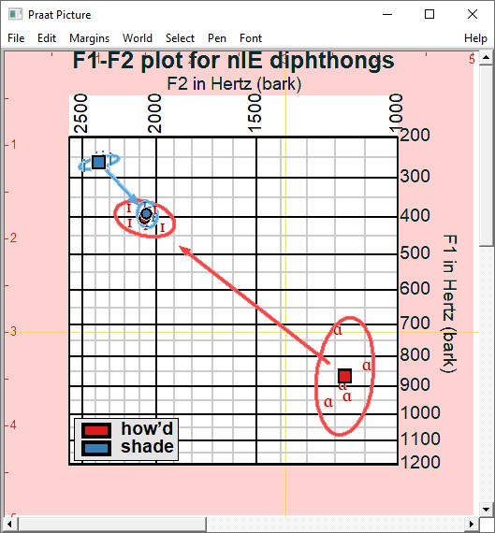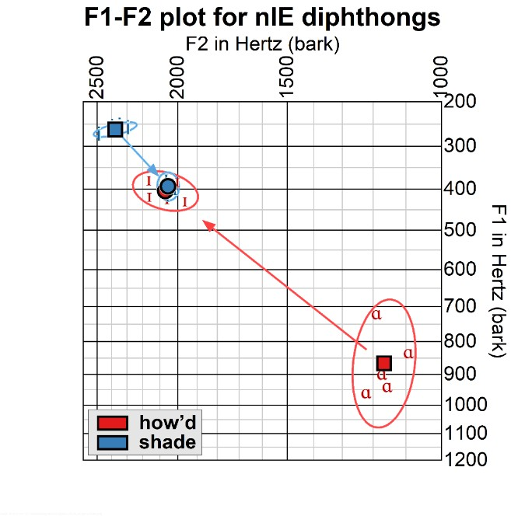
If your image is very large, it might not completely fit in the Picture window; however, it will still be saved correctly, as shown in the Ladefoged-style plot (§3) here.
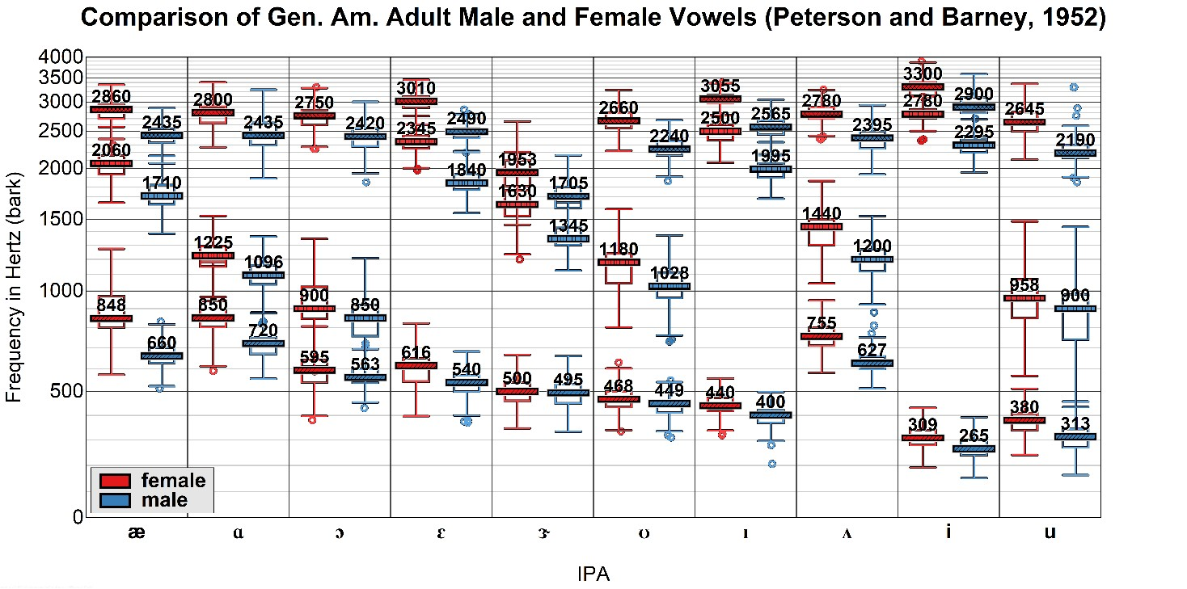

Ladefoged-style plots
These plots display formants along the Y-axis for each level (usually a vowel) of a sequencing factor (typically
Vowels). The secondary factor (comparison factor) can be stacked on the same vertical line or spread out along the x-axis.
The example below displays vowels in Hertz without any axis-warping. Note the legend is placed so as to avoid obscuring any text or data. (If this is not possible, use user can opt to hide the legend in the Graphical UI Menu.)
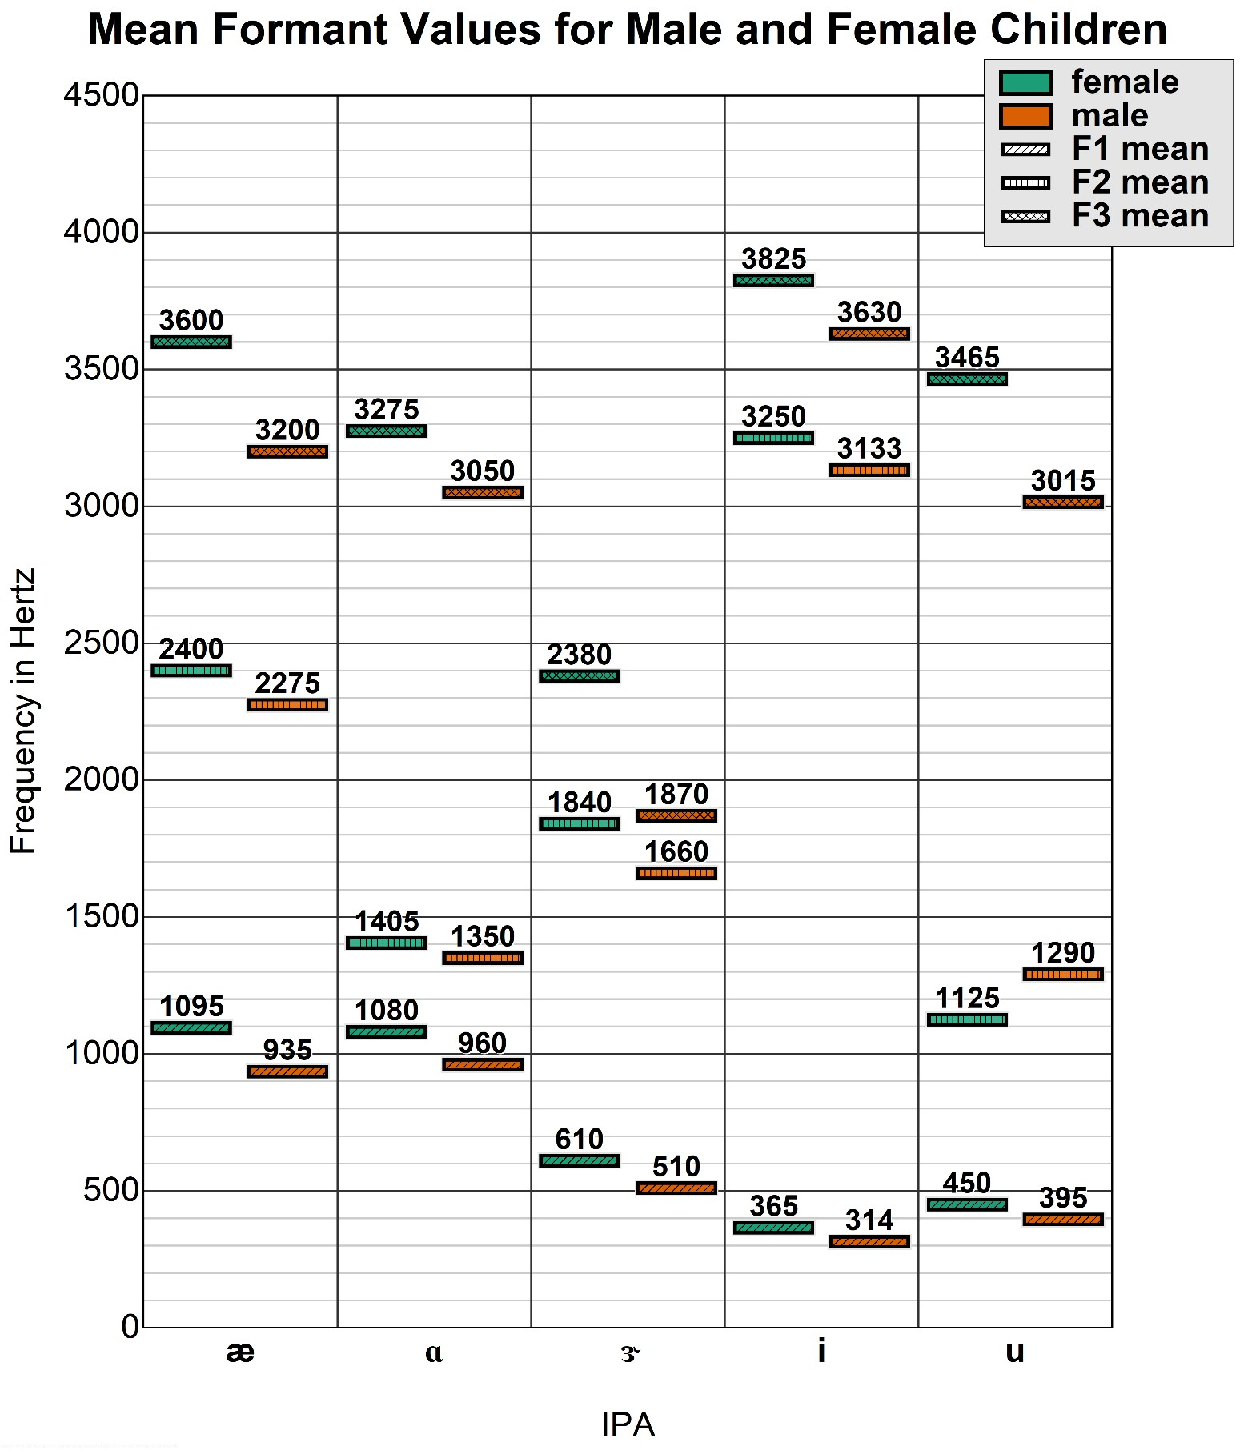

Data Table UI
Note, much of this is the same as the menu for the F1-F2 plotter (§2.1). The input shown in the example was used to create the chart above.
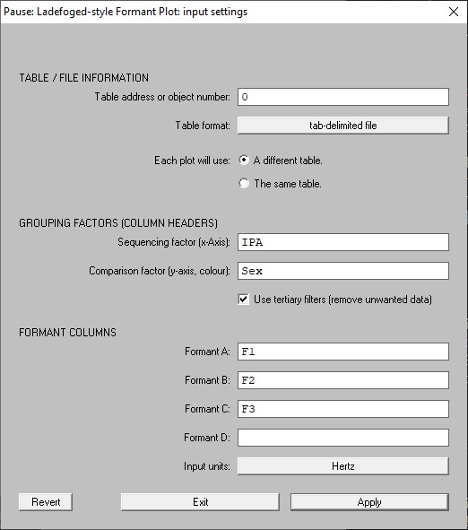
GROUPING FACTORS

Sequencing
factor

determines
which factor (column header)
will be used to determine
content along the x
-
axis. Here it
is
IPA
, as displayed in the plot
above.

Comparison factor

determines
how the sequencing factor will
be compared. In this case it is
Sex
.

Use
tertiary filter

§
(
3.3
)

was
selected here
to filter
in
subsequent menus
by
Type
,
“chi
ldren”.

FORMANT COLUMNS

You only need enter the column
names for the Formants you
wish to display.

Provide the names of the
columns you want to display in
order starting from
Formant A

and leave the remaining boxes
blank
.

Main and Secondary Factor filtering
See §2.2.

Tertiary Filters
See §2.3.

Graphical Output Settings
Only elements unique to the Ladefoged-style plots are explained here. For more information on Plot Basics, Plot Layers, and Image Saving, see §2.4. For Colour Management, see §5
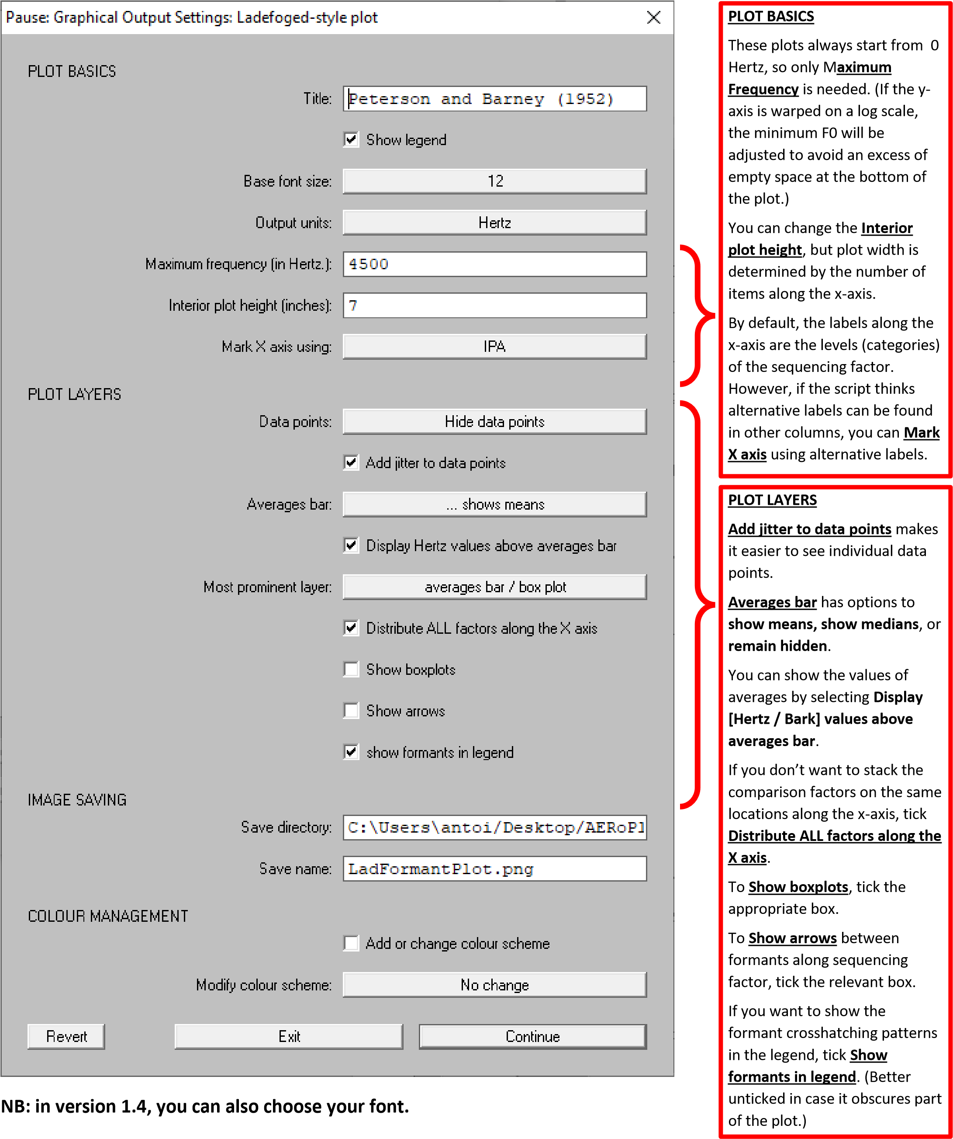

Saving
See §2.5

Formants-over-time Plots
These are quite similar to the Ladefoged-style plots. However, the x-axis displays time. These plots can be used to compare both temporal and spectral differences in formant structure, such as in diphthongs.
The example below compares two northern Irish English (Lurgan) diphthongs framed in the words “how’d” and “shade”.

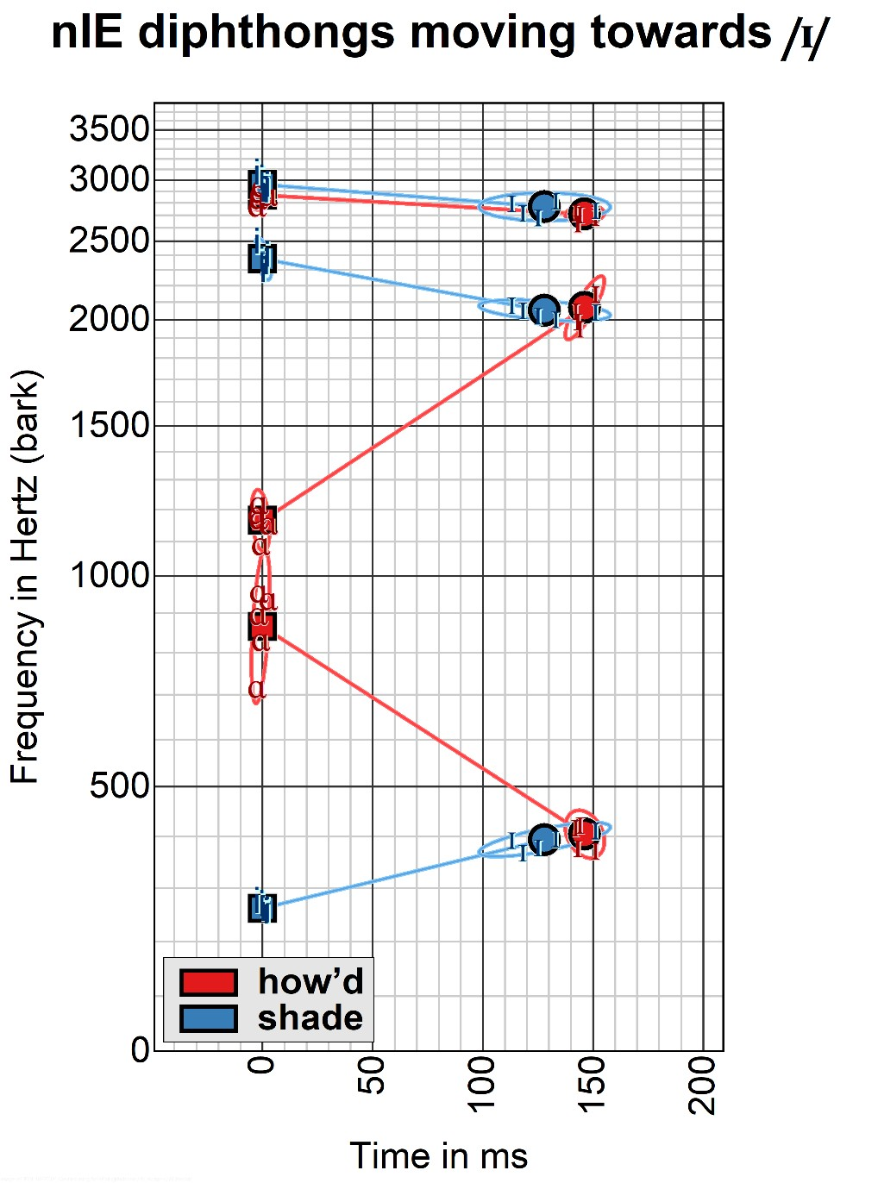

Data Table UI
Much of this is identical to the Data Table UIs in either the F1-F2 Plot (§2.1) or the Ladefoged-style plot (§3.1).
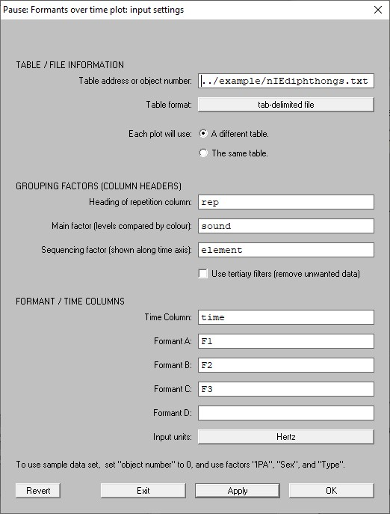
FORMANT / TIME COLUMNS

Write the name of the

Time
Column

in the relevant box.

You only need to enter the
column names for the
Formants

you wish to display. Enter the
names of the columns in order
starting from
Formant A
.

GROUPING FACTORS

If there are repetitions of
each
target in the data
, type the
appropriate column name in
R
epetition column
. Otherwise
leave it blank.

The
M
ain
factor

box identifies
the column containing items
which will be differentiated by
colour. (Here it is
sound
.)

Sequencing factor

determines
which factor (column header)
will be used to determine
content along the time axis.
Here is it the
(
element

of the
diphthong.)

Reference time
If you have not already adjusted the times relative to another element in the utterance, you can do so here by using the Make time relative to option menu. You can also choose not to do this or you can make time relative to one of items in the sequencing factor. (n this case, time is made relative to the first element in each diphthong.)
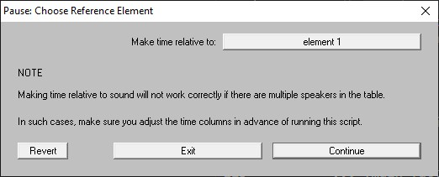

Main and Secondary Factor filtering
See §2.2.

Tertiary Filters
See §2.3.

Graphical Output Settings
Only elements unique to Formants-over-time plots are explained here. For the rest of Plot Basics, Plot Layers, and Image Saving, see §2.4. For Colour Management, see §5 NB: in version 1.4, you can also choose your font.
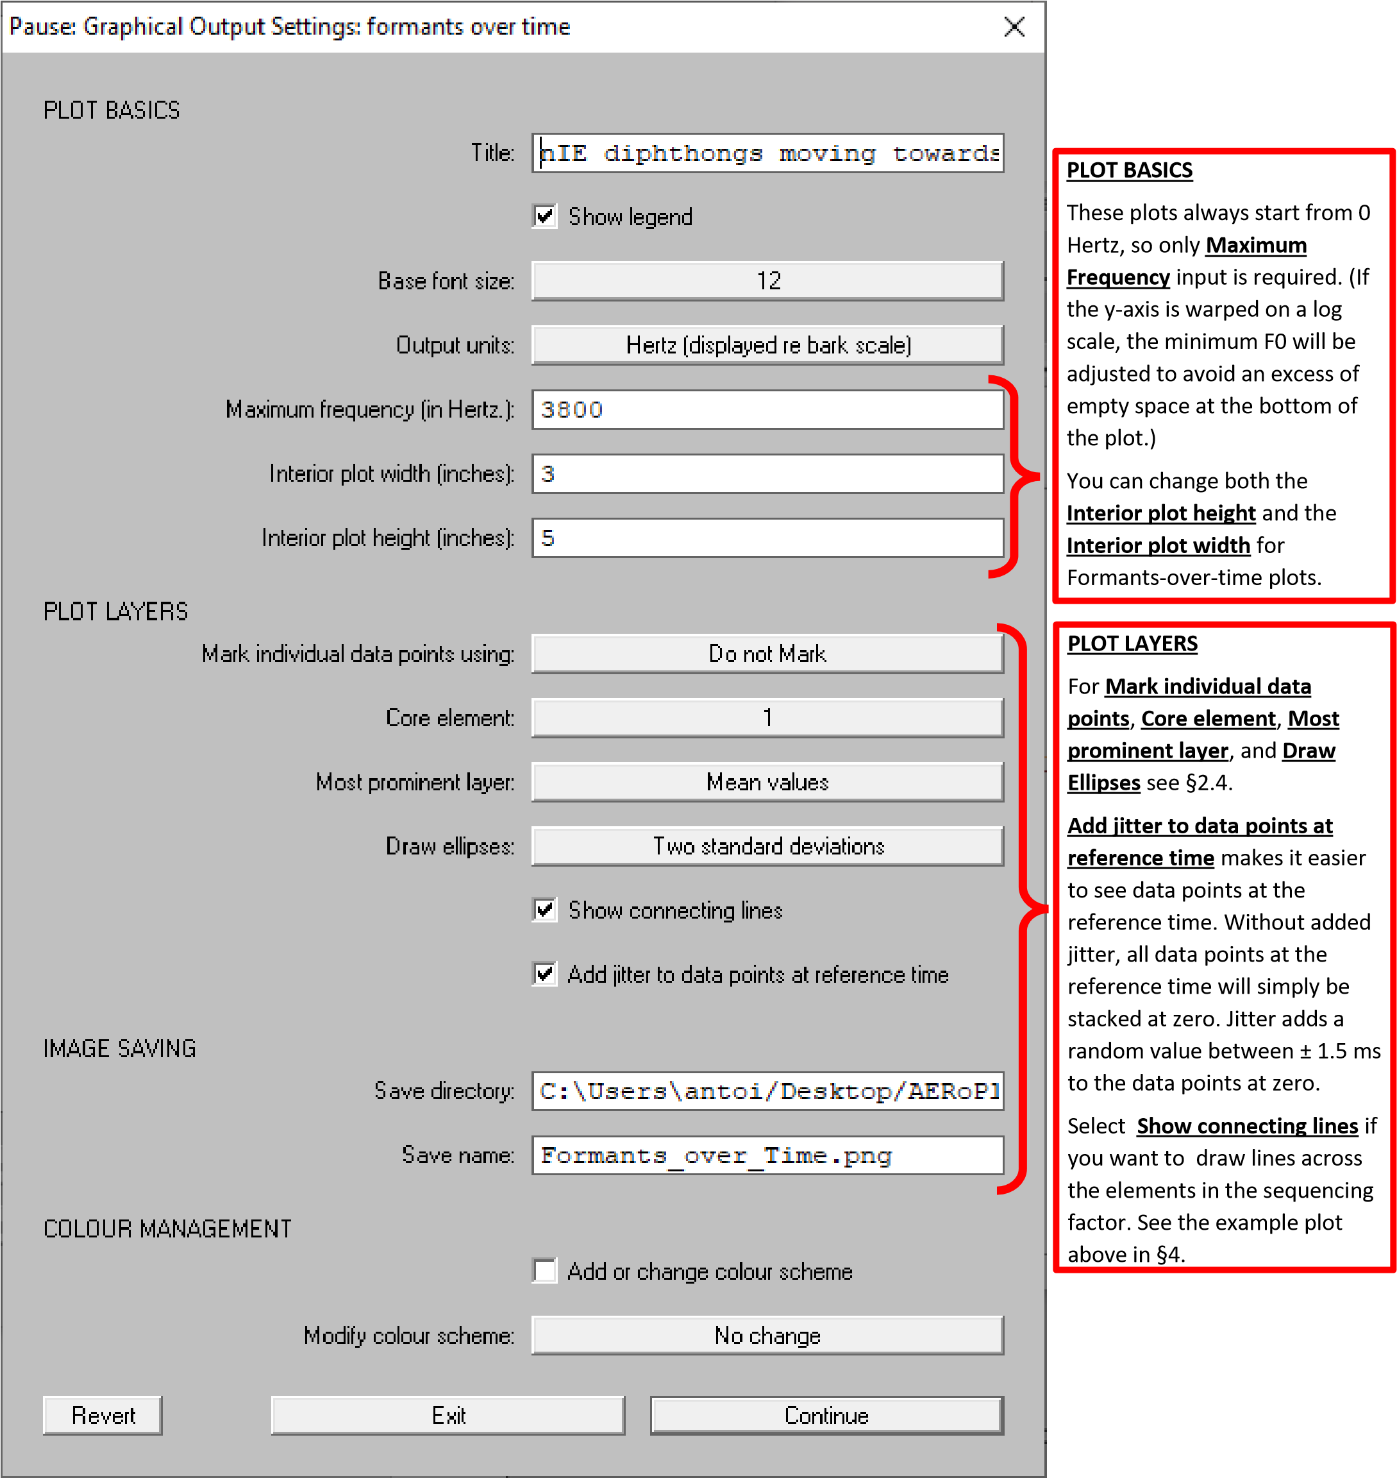

Saving
See §2.5

Colour Management
These options are shared across all plot types and appear at the bottom of each Graphical Output UI menu.
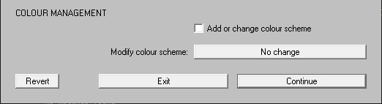

Add or Change colour scheme
This allows you to change the current colour scheme or add a new one using a JavaScript string. The first time this option is chosen, the Praat Info window explains how to create a new colour scheme using the colorbrewer2.org website.
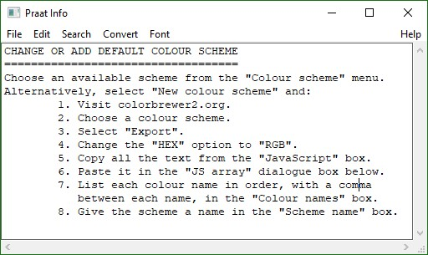
The current colour scheme is always named current. The first time you run AERoPlot, current is set to an adjusted version of Color Brewer Contrastive Set2. The JavaScript array for the current colour scheme is shown in JS array, the names of each colour in Colour names, and the colour scheme name in Scheme name.
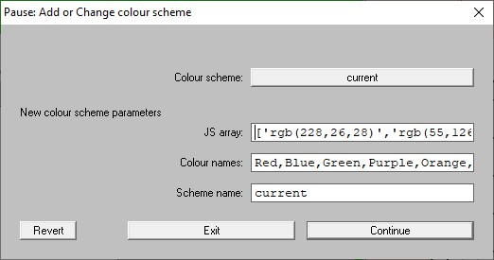
To change colour scheme, simply select a colour scheme from Colour scheme options. You can also save the current colour scheme simply choosing New colour scheme from the Colour scheme options, changing Scheme Name, and then hitting Continue.

Modify colour scheme
These options provide different means of re-arranging the order in which the current colour scheme accesses each colour. It is always set to No change by default.
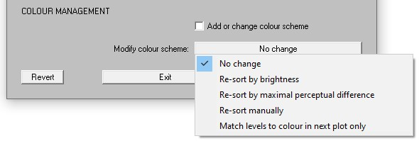

Re-sort by brightness
This automatically changes the default order of the current colour scheme so that the order of colours goes from darkest to lightest.

Re-sort by maximal perceptual difference
This automatically changes the default order of the current colour scheme so that each colour is as perceptually different as possible from all the previous colours. (Needs some optimising as everything I learned about Graph Theory came from the 2019 Hamilton Lecture and a few videos on YouTube and that’s about it.)
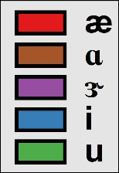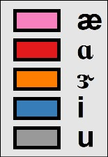 | Examples of a colour scheme automatically resorted by brightness (left) and maximal perceptual difference (right).

Re-sort manually
This allows you to manually change the sequence of colours in the current colour. Note, it will not allow you to use the same colour more than once in the sequence. I recommend swapping colours one at a time on this menu to avoid confusion.
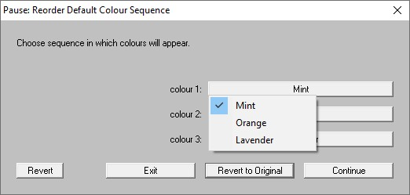

Match levels to colour in next plot only.
This allows you to manually (so to speak) match each of the levels in the main factor to a colour in the current colour scheme. It allows you to use each colour more than once, though this is not recommended. It does not save changes to the current colour scheme.
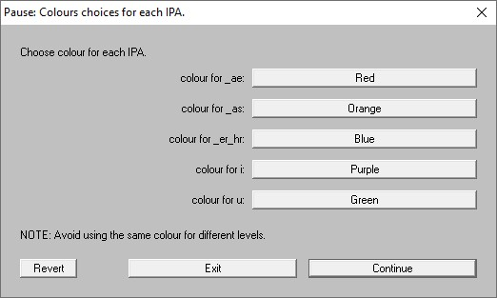

Generate Data Table from Text Grid with Nested Tiers
This is a data extraction tool, which processes a Text Grid and converts it into a data frame in table format. It also extracts formants from an associated sound object if one is selected.
As with the plot functions, you can access the table generation function in two ways:
- Praat Objects Window → New → AERoPlot
- From the right-hand menu after you select a sound and Text Grid together in the objects window.
This function assumes that the tiers are organised hierarchically, with the “base tier” being the lowest level in the hierarchy (e.g. the time points from which formant values will be extracted).

