Expression Trees 8/24/2026
The following trees are shown with their evaluations
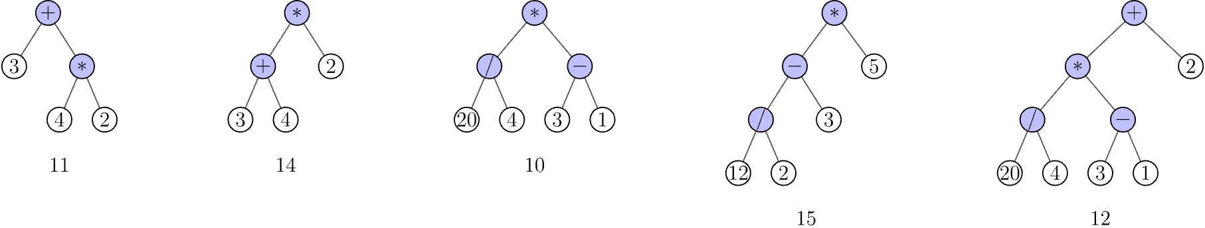
Evaluate each of the following trees
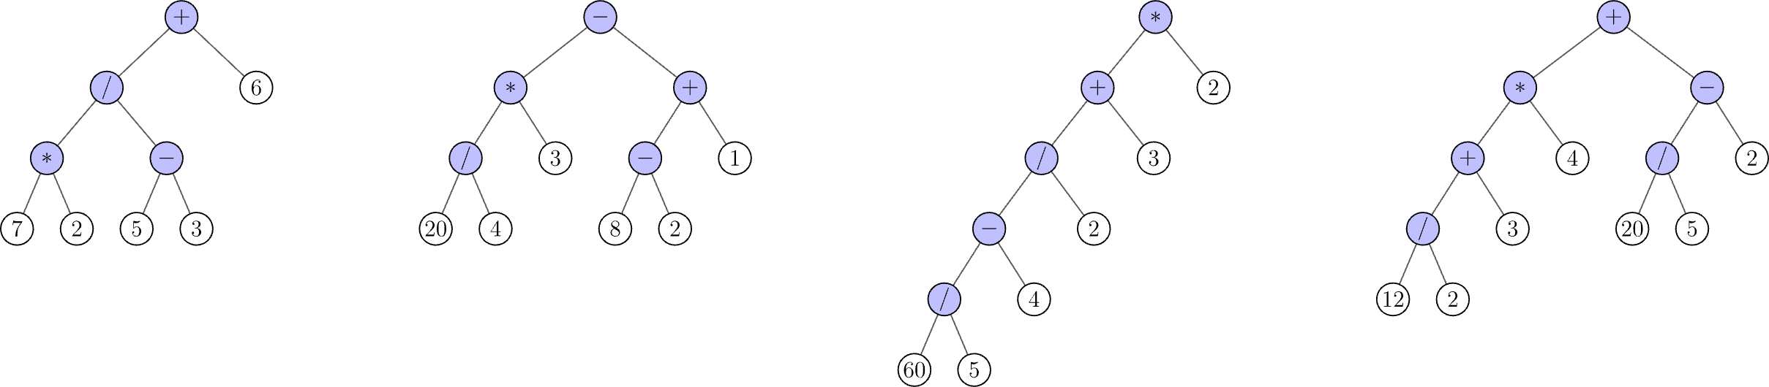

Now write a post-fix (RPN) expression for each of the four trees above

Next write an infix (normal math) expression for each of the same trees

Draw the trees corresponding to each of the following expressions
1 2 3 4 + - *

1 2 + 3 4 - 5 6 * * /

