Tree Search
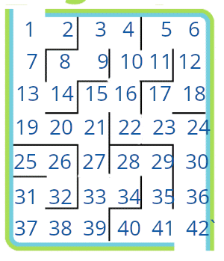
In the given maze, the start state is grid 1 and the goal state is grid 42. Create a BFS search tree to solve the maze. When listing the children of any node, list them in increasing numerical order. Also you should avoid repeating the same node anywhere in the tree.

What is the length of the solution path found by BFS?

Is BFS guaranteed to find the shortest solution path?

In a maze with n nodes, what is the worst case running time of BFS?

Now create a DFS tree for the same maze. Again be sure to explore the children of a state in increasing numerical order. Keep track of visited states because DFS only stops when it hits the goal or runs out of states to explore.

