# Yolo Bypass Fish Monitoring Program: Fish Sampling Metadata: Rotary Screw Trap, Fyke Trap, Beach Seine, 1998-2021

Version: 1.0

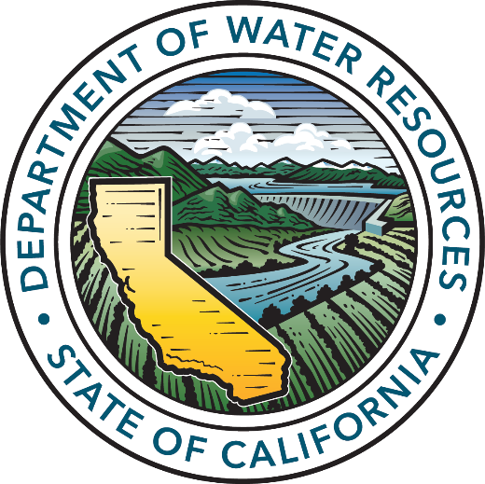

California Department of Water Resources

Division of Environmental Services

3500 Industrial Boulevard

West Sacramento, California 95691

## 

## Dataset Title Interagency Ecological Program: Fish catch and water quality data from the Sacramento River floodplain and tidal slough, collected by the Yolo Bypass Fish Monitoring Program, 1998-2021.

## Abstract

Largely supported by the Interagency Ecological Program (IEP), California Department of Water Resources (DWR) has operated a fish monitoring program in the Yolo Bypass, a seasonal floodplain and tidal slough, since 1998.

The objectives of the Yolo Bypass Fish Monitoring Program (YBFMP) are to:

1. Collect baseline data on water quality, chlorophyll, lower trophic level biota, and fish in the Yolo Bypass to monitor spatial and temporal changes in trends and abundance.
2. Analyze and communicate Yolo Bypass data with stakeholders and the scientific and management communities to address pertinent management-related questions.
3. Provide technical expertise on Yolo Bypass aquatic ecology and monitoring and sampling methods.

The YBFMP operates a rotary screw trap and fyke trap and conducts biweekly beach seine and lower trophic surveys in addition to maintaining water quality instrumentation in the bypass*.* Only juvenile and adult fish catch with associated water quality are presented in this dataset.

The rotary screw trap sampling objectives are to: (1) examine species abundance and life stage of juvenile outmigrants and resident small-bodied fishes, (2) identify temporal and spatial patterns in fish abundance and species composition, and (3) examine the effect of physical and environmental conditions on these patterns.

The fyke trap sampling objectives are to: (1) examine abundance of migrating and resident adult fishes, (2) identify temporal and spatial patterns in fish abundance and species composition, especially with regard to anadromous species, (3) examine the effect of physical and environmental conditions on these patterns, and (4) provide data on the timing and duration of species captured in the Yolo Bypass for comparison to those captured in other Sacramento Valley tributaries.

The beach seine surveys are conducted in the Yolo Bypass’s perennial channel (Toe Drain), inundated floodplain, disconnected inundated ponds, and perennial ponds. The objectives of Toe Drain and inundated floodplain beach seine sampling are: (1) to examine species abundance and composition in different water year types and inundation conditions, (2) to spatially compare fish abundance and diversity in the Yolo Bypass, and (3) to estimate growth rates and densities of salmon in the Yolo Bypass versus the Sacramento River. The objectives for beach seine sampling in disconnected inundated ponds are: (1) measure the diversity and abundance of fish species stranded in ponds located in different regions and habitats, (2) to compare relative densities of fish before and after floodplain drainage, (3) to examine the sources of fish mortality in ponds including temperature, desiccation and predation, (4) to develop long-term annual Yolo Bypass stranding indices for reference locations, and (5) to examine relationships between annual stranding indices and physical variables such as hydrology and temperature. The objectives for seine sampling in the perennial ponds are: (1) to examine seasonal fish species abundance and diversity in the Yolo Bypass versus the Sacramento River and (2) to examine species abundance and composition in different water year types.

The YBFMP serves to fill information gaps regarding environmental conditions in the bypass that trigger migrations and enhanced survival and growth of native fishes, as well as provide data for IEP synthesis efforts. YBFMP staff also conduct analyses of YBFMP monitoring data to address pertinent management related questions as identified by IEP. The Yolo Bypass has been identified as a high restoration priority by the National Marine Fisheries Service and US Fish and Wildlife Service Biological Opinions for Delta Smelt, Winter and Spring-run Chinook salmon and by California EcoRestore. The YBFMP informs the restoration actions that are mandated or recommended in these plans and provides critical baseline data on the ecology of the bypass and how it interacts with the broader San Francisco Estuary.

Key findings from the YBFMP include: (1) Yolo Bypass is a major factor regulating year class strength of splittail, *Pogonichthys macrolepidotus* (Sommer et al., 1997; Feyrer et al., 2006; Sommer et al., 2007a); (2) Yolo Bypass is a key migration corridor for adult fish of several listed and sport fish (Harrell and Sommer 2003); (3) it is one of the most important regional rearing areas for juvenile Chinook Salmon (Sommer et al., 2001a; 2005); (4) Yolo Bypass is a source of phytoplankton to the food web of the San Francisco Estuary (Jassby and Cloern 2000; Schemel et al., 2004; Sommer et al., 2004); and (5) Inundation of the Yolo Bypass enhances the quantity and quality of phytoplankton carbon to the downstream estuary (Lehman et al. 2007).

## Investigators

|  |  |  |  |  |  |  |
| --- | --- | --- | --- | --- | --- | --- |
| First Name | Middle Initial | Last Name | Organization | e-mail address | ORCID ID (optional) | Role in project |
|  |  | Interagency Ecological Program (IEP) | Interagency Ecological Program |  |  | Creator |
| Catarina |  | Pien | California Department of Water Resources | [Catarina.Pien@water.ca.gov](mailto:Catarina.Pien@water.ca.gov) | 0000-0003-4427-6300 | Creator, Field crew, Data contact |
| Nicole |  | Kwan | California Department of Water Resources | Nicole.Kwan@water.ca.gov | 0000-0003-1178-7788 | Creator, PI |

## Other personnel names and roles

|  |  |  |  |  |  |  |
| --- | --- | --- | --- | --- | --- | --- |
| First Name | Middle Initial | Last Name | Organization | e-mail address | ORCID ID (optional) | Role in project |
| Jesse |  | Adams | California Department of Water Resources | [Jesse.Adams@water.ca.gov](mailto:Jesse.Adams@water.ca.gov) | 0000-0002-0739-8782 | Field crew |
| Naoaki |  | Ikemiyagi | California Department of Water Resources | [Naoaki.Ikemiyagi@water.ca.gov](mailto:Naoaki.Ikemiyagi@water.ca.gov) |  | Field lead, Data contact |
| Nicole |  | Kwan | California Department of Water Resources | [Nicole.Kwan@water.ca.gov](mailto:Nicole.Kwan@water.ca.gov) | 0000-0003-1178-7788 | Creator, PI, Data contact |
| Catarina |  | Pien | California Department of Water Resources | [Catarina.Pien@water.ca.gov](mailto:Catarina.Pien@water.ca.gov) | 0000-0003-4427-6300 | Creator, Field crew |
| James |  | Robinson | California Department of Water Resources | [James.Robinson@water.ca.gov](mailto:James.Robinson@water.ca.gov) |  | Field lead |
| Emily |  | Hubbard | California Department of Water Resources | [Emily.Hubbard@water.ca.gov](mailto:Emily.Hubbard@water.ca.gov) |  | Field crew, Data entry |
| Parisa |  | Hubbard | California Department of Water Resources | [Parisa.Farman@water.ca.gov](mailto:Parisa.Farman@water.ca.gov) |  | Field crew, Data entry |
| Allison |  | Brady | California Department of Water Resources | [Allison.Brady@water.ca.gov](mailto:Allison.Brady@water.ca.gov) |  | Field crew, Data entry |
| Ted |  | Sommer | California Department of Water Resources | [Ted.Sommer@water.ca.gov](mailto:Ted.Sommer@water.ca.gov) |  | Associate |
| Louise |  | Conrad | Delta Stewardship Council | [Louise.Conrad@deltacouncil.ca.gov](mailto:Louise.Conrad@deltacouncil.ca.gov) |  | Associate |
| Brian | M | Schreier | California Department of Water Resources | [Brian.Schreier@water.ca.gov](mailto:Brian.Schreier@water.ca.gov) | 0000-0002-5075-3946 | Associate |

## License

This information is released under the Creative Commons license - Attribution - CC BY (<https://creativecommons.org/licenses/by/4.0/>). The consumer of these data ("Data User" herein) is required to cite it appropriately in any publication that results from its use. The Data User should realize that these data may be actively used by others for ongoing research and that coordination may be necessary to prevent duplicate publication. The Data User is urged to contact the authors of these data if any questions about methodology or results occur. Where appropriate, the Data User is encouraged to consider collaboration or co-authorship with the authors. The Data User should realize that misinterpretation of data may occur if used out of context of the original study. While substantial efforts are made to ensure the accuracy of data and associated documentation, complete accuracy of data sets cannot be guaranteed. All data are made available "as is." The Data User should be aware, however, that data are updated periodically, and it is the responsibility of the Data User to check for new versions of the data. The data authors and the repository where these data were obtained shall not be liable for damages resulting from any use or misinterpretation of the data. Thank you.

## Keywords

Yolo Bypass, San Francisco Estuary, Sacramento-San Joaquin Delta, Yolo Bypass Fish Monitoring Program, California Department of Water Resources, Interagency Ecological Program, rotary screw trap, fyke trap, beach seine, tidal slough, Chinook Salmon, Sacramento Splittail   
[LTER controlled vocabulary] aquatic ecosystems, freshwater, ecology, estuaries, rivers, floodplain, seasonality, long term, communities, food webs, surveys, fishes, abundance, endangered species, invasive species.

## Funding of this work:

Funding is provided by the State Water Project.

## Permitting of this work:

| PI First Name | PI Middle Initial | PI Last Name | Permitting Agency and Permit Type | Permit Number | Brief Description |
| --- | --- | --- | --- | --- | --- |
| Brian | M | Schreier | CDFW Scientific Collecting Permit, Specific Use (SCP) | S-182970002-19100-001 | The SCP covers all sampling activities and take of non-listed species. |
| Jeffrey |  | Holt/IEP | NMFS Scientific Research Permit | 1440-3R | The National Marine Fisheries Service (NMFS) requires that the YBFMP have an Endangered Species Act (ESA) permit for the take of federally listed salmonids (winter and spring run Chinook Salmon and Central Valley Steelhead) and Green Sturgeon. This permit is coordinated through the Interagency Ecological Program (IEP). |
| Jeffrey |  | Holt/IEP | USFWS Delta Smelt Take |  | The US Fish and Wildlife Service (FWS) requires that the YBFMP have an ESA permit for the take of federally listed Delta Smelt. The FWS ESA permit for YBFMP is coordinated through IEP. |
| Jeffrey |  | Holt/IEP | NMFS Marine Mammal Protection Act |  | NMFS requires the YBFMP to have a MMPA permit to cover the potential take or harassment of marine mammals by our sampling activities.  The sole usage of this permit for YBFMP is for the event that a sea lion gets trapped in our fyke trap. The MMPA permit for YBFMP is coordinated through IEP. |
| Nicole |  | Kwan | CDFW CESA MOU |  | DFW requires the YBFMP to have a CESA MOU to cover the take of state listed salmonids (winter and spring run Chinook Salmon) and osmerids (Delta and Longfin Smelt). |

## Timeframe

* Begin date: 1998-01-26
* End date: 2021-12-30
* Data collection ongoing or completed: ongoing

## Geographic location

* Verbal description: Yolo Bypass tidal slough and seasonal floodplain in Sacramento, California, USA.
* North bounding coordinates (decimal degrees): 38.79395205
* South bounding coordinates (decimal degrees): 38.23466149
* East bounding coordinates (decimal degrees): -121.5368316
* West bounding coordinates (decimal degrees): - 121.8073699

## Taxonomic species or groups

[Phylum] Chordata, Arthropoda

[Class] Osteichthyes, Actinopterygi, Cephalaspidomorphii, Crustacea, Malocostraca

## Methods

### I. Field Collection Methods

Water Quality  
Water quality and environmental parameters are recorded at the start of each sampling event. Water temperature (degrees Celsius), electrical conductivity (microSiemens/cm), specific conductance (microSiemens/cm), pH, dissolved oxygen (mg/L), and turbidity (FNU) are sampled with a YSI ProDSS handheld meter. Turbidity values are averaged over three readings. Secchi depth is measured in the shade. Tide, condition of sampling (condition code), Microcystis level, vegetation rank, direction of flow, and weather are also recorded with water quality parameters.

Screw Trap   
A single rotary screw trap is deployed at levee mile 14.5 near the base of the Yolo Bypass Toe Drain and is typically operated from January 1st through the end of June. If the first flush of the system occurs earlier, the screw trap will be deployed in December to capture out-migrating fishes. The trap site has been selected based on the following criteria for installation, operation, and maintenance: (1) suitable depth: greater than six feet at minimum flow and low tide; (2) suitable velocity: greater than two feet per second (fps) at minimum flow on an ebb tide (though during extremely low flow conditions, the trap may only make a handful of revolutions in a 24-hour period); (3) suitable anchoring points; and, (4) limited public access.

The trap is reached by truck via the Sacramento Deep Water Ship Channel/East Yolo Bypass levee. The trap is accessed daily using a small boat with an outboard motor during high flow or paddles during lower flow periods. During high flows and periods of high debris, the trap may be set intermittently through-out the day, or not set if the high flow becomes a safety concern. The screw trap operates using downstream flow as water strikes the angled baffles on the inside of the trapping cone. This force causes the cone to rotate and fish enter the upstream end of the rotating trapping cone, becoming trapped inside the trapping cone, and then fish are carried rearward into the livebox. Upon checking or pulling the trap fish are then collected using dipnets and transferred to separate buckets. Once all fish have been removed from the livebox, fish are measured to fork length on a wetted measuring board, and then released back into the Toe Drain. Chinook salmon, Smelt species, and other native species are sampled first followed by non-native species. Each fish is identified and counted, and then fork length to the nearest millimeter will be measured for up to 20-50 each species.

The screw trap cone is 8 feet in diameter and designed by EG Solutions (Corvallis, Oregon) (see Figure 1). The trap configuration is as follows: Length: 22.5 ft, Width: 12 ft, Weight: 1300 lbs, Cone: 8 ft diameter and 9 ft length with 2 ft on each end for shaft (total of 13 ft), Livebox: 4 ft by 5 ft with a 25 ft3 volume, Pontoons: 22.5 ft length and 20 in. width, with 9 ft between pontoons. During operation the trap is attached to a ¾” overhead cable originally installed December 2003 (replaced in 2011 after damage during a flood) with two ½” cables attached to each pontoon to align the trap in the center of the channel. The overhead cable is strung between two large trees, each with two ¼” guy cables connected to concrete T anchors. The trap has a rear anchor to maintain the traps position during low flow periods and strong flood tides. A revolution counter was installed on the main shaft of the screw trap in March 2013.

See DWR-6-SOP-018_v1.1_RotaryScrewTrapSampling for more information.

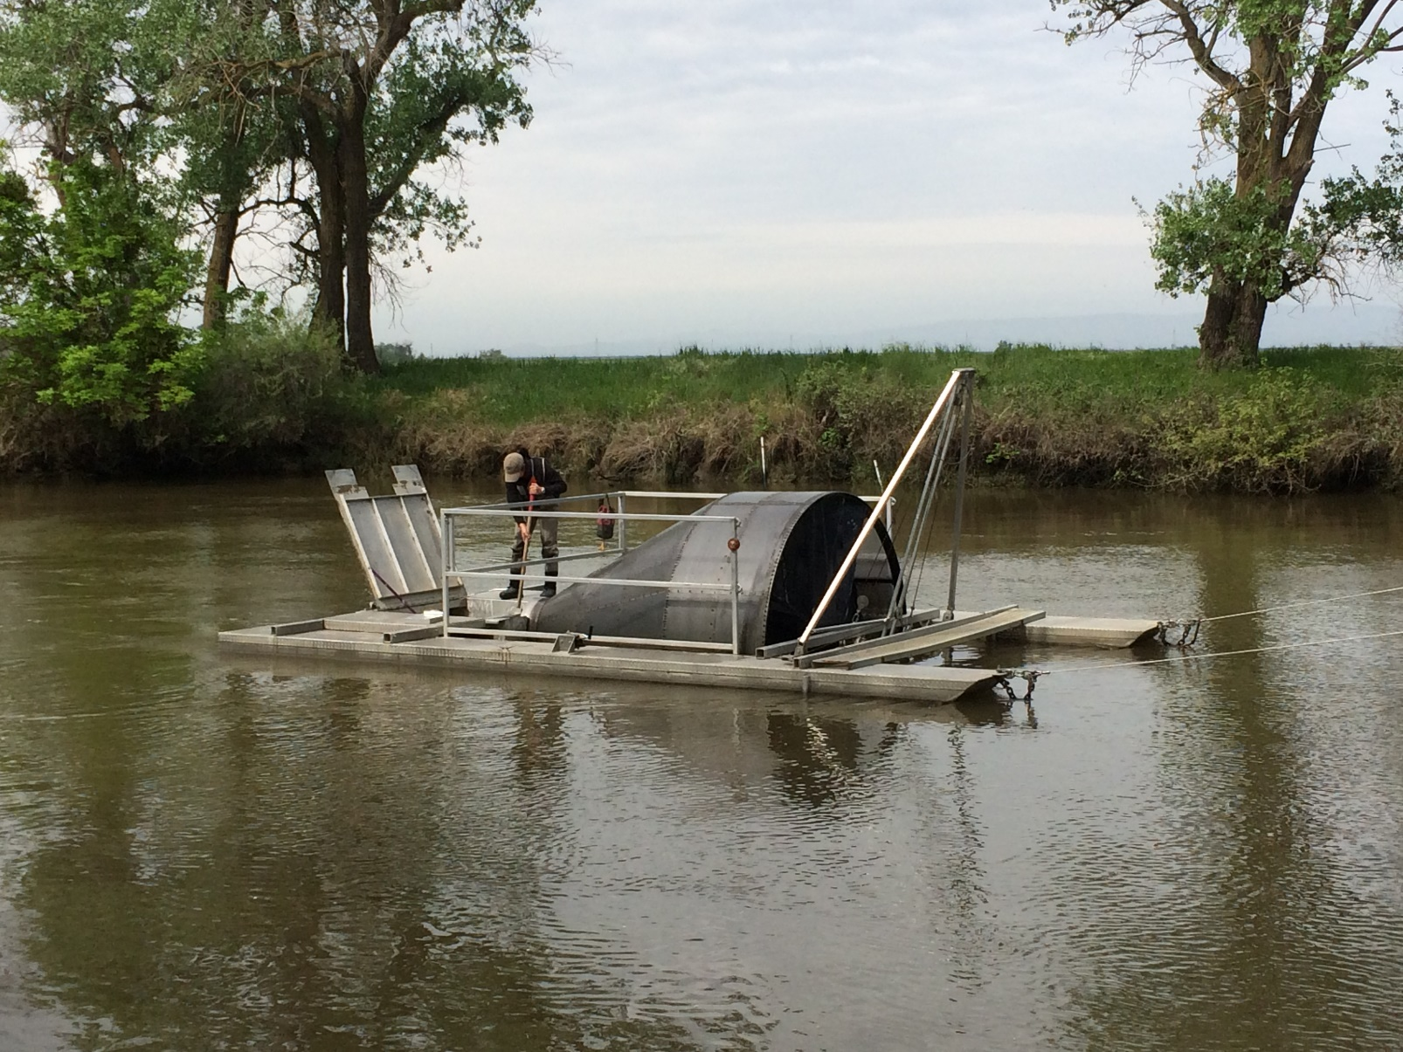

**Figure 1. YBFMP staff sampling rotary screw trap.**

#### Fyke Trap Sample Collection

The fyke trap is ten feet in diameter and twenty-four feet long with a modified design based on fyke traps operated by the California Department of Fish and Wildlife (CDFW) office in Stockton (see Figure 1). It is constructed out of square stainless steel tubing with galvanized chain link fencing for the main structural netting and black 0.5” square polypropylene fencing lining the terminal compartment to aid in retention and fish safety. The fyke trap is installed with one warning float attached to the downstream end of the trap and one float rigged to the upstream anchoring (nose) cable, trap guide and anchor cables are anchored to t-posts on the levee shoreline, and two guide ropes are also set to help guide the trap when it is rolled up the bank during the retrieval process. The fyke trap doesn’t cover the entire channel as wings are not used, and should not be viewed as a traditional fyke net.

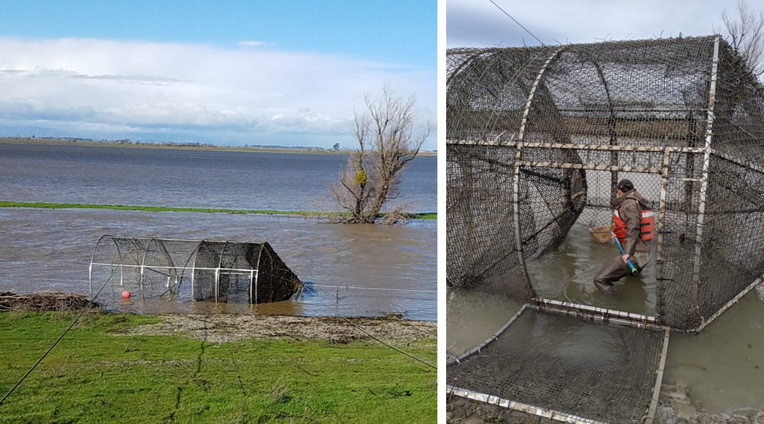

**Figure 1. Fyke trap sampling in the Toe Drain**

The fyke trap is typically deployed at the beginning of the week, checked daily, and pulled out at the end of the week. Operations are halted briefly in the summer (approximately July-September), when fish catches are low, and are reinitiated in the fall when adult salmon begin migrating up the Toe Drain. When the fyke trap is deployed and operational, fish enter the downstream opening of the trap (10 ft. diameter), pass through the first funnel (3 ft. diameter), and enter a central chamber, then move further through the second funnel (1 ft. 8 in. diameter), and become trapped inside the upstream (terminal) compartment. Captured fish are netted out of the compartment, identified to species, counted, and fork length is measured to the nearest millimeter for up to 20-50 individuals of each species, except for native species of special concern, for which all fish are counted and processed.

See DWR-6-SOP-017_v1.1_FykeTrapSampling for more information.

#### Beach Seine Sample Collection

Currently, beach seine sites are sampled every-other week with a single haul from a 25 ft by 4 ft (8 x 1.2 meters) pole seine (1/8” sq. mesh). These are modified beach seine hauls; because the levee banks are generally steep, the seine is towed parallel to the shoreline as opposed to netting straight toward the shoreline (see Figure 1).

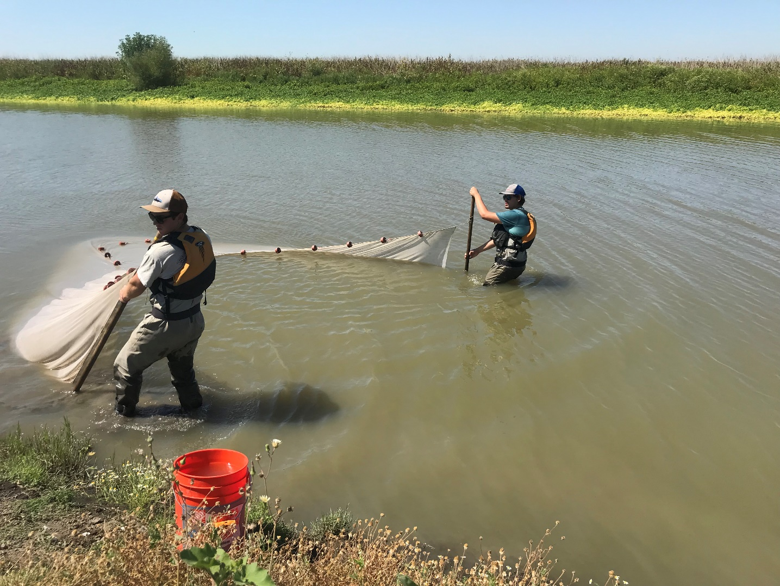

**Figure 1. Beach seining in the Toe Drain.**

The seine sites include one perennial pond (YB), nine sites along the Toe Drain (AL# [above Lisbon Weir] and BL# [below Lisbon Weir]) and four high flow sites to capture floodplain inundation periods (RD22, FW1, LIHF, and YB180; only sampled during floodplain inundation).

Generally, during flood events, sampling begins in the northern Bypass, gradually moving southward as the basin drains. Captured fish are identified to species, counted, and fork length is measured to the nearest millimeter for up to 20-50 individuals of each species, except for native species of special concern, for which all fish are counted and processed.

See DWR-6-SOP-016_v1.1_BeachSeineSampling for more information.

#### Fish Handling of Species of Special Concern

**Salmon:**The handling and sub-sampling protocol for special species caught in the rotary screw trap and beach seines follows California Department of Fish and Wildlife (CDFW) (1997) to minimize impacts to salmon, particularly endangered winter-run Chinook. Juvenile Chinook salmon are visually sorted between winter-run and juveniles of other races based on the Delta Model of daily length-at-date criteria of salvage facility catches (USFWS 1994; modified from Fisher 1992).

Any winter or spring-run sized salmon with a present adipose fin is immediately transferred to a separate bucket and processed for length, weight, and a fin-clip then released. Fall-run sized salmon with a present adipose fin are processed after winter-and-spring run. Any adipose fin-clipped salmon is euthanized and bagged individually (whirl-pak bags) and marked with sampling location, date, gear type, fork length, and time. Fish that are taken either directly or indirectly are then kept on ice in a cooler until transferred to the West Sacramento, CA office to be weighed, processed, and frozen at -20°C.

Captured salmonids are inspected for characters such as presence of yolk sac, parr marks, silvery appearance, and deciduous scales to determine life stage and/or degree of smolting. A simple life stage designation (F, P, or S) is determined for each fish measured:

1. **Fry (F)** = any fish still retaining a yolk sac or not yet fully buttoned-up,
2. **Parr (P)** = anything between a fry and a smolt. The presence of prominent parr marks across their lateral line,
3. **Smolt (S)** = fish starting to become/already are silver in color and shedding scales. Note, smolting fish may still have faded parr marks.

**Osmerids:**During periods of Delta Smelt presence, all Delta Smelt are prioritized and carefully identified to differentiate between Delta (*Hypomesus transpacificus*) and Wakasagi Smelt (*Hypomesus nipponensis*). Wakasagi are collected, while Longfin Smelt and Delta Smelt are released.

Identification is made based upon:

1. **Chromatophores:** Chromatophores refer to the dot pigmentation on the isthmus. Wakasagi will have two or more, Delta Smelt will have one or none. Juvenile Wakasagi, however, may be missing chromatophores.
2. **Caudal peduncle pigmentation:** This refers to pigmentation near the leading, anterior edge of the caudal fin. On Wakasagi, this area will consist of scattered spots whereas Delta Smelt will have a smaller number of spots that are clustered around the caudal fin in a V-shape.

**Native Species:**Native Cyprinids and Trout are scanned for PIT tags using a PIT tag reader. If the reader detects a tag, the tag number is written down and information is submitted to relevant IEP Project Work Teams.

**Other fishes**Following the processing of special species (salmon and smelt) all other fish >25mm in fork length are identified and counted: fork length is measured to the nearest millimeter on a wetted measuring board for up to 20-50 of each species. Occasionally, whole samples or fin clips from other fish species are collected for special studies or genetic identification. Any juvenile fish that cannot be field identified are preserved on ice with respective labels for individual identification and examined at the West Sacramento, CA office.   
  
See DWR-6-SOP-008_v1.3_ListedSpeciesHandling for more information.

### II. Sample Processing and Tracking

Post-Processing

* All genetic fin clips are stored in 95% ethanol and sent to contractors for genetic identification.
* CWT tags of ad-clipped salmon are extracted and read by YBMFP staff and reported in the online Regional Mark Information System (RMIS). See DWR-6-SOP-003_v1.1_CodedWireTagRecovery for more information.
* Diet samples, which are occasionally sampled for special studies, are prepared by YBFMP staff (removal of stomach, fixed in formalin) and sent to contractors for identification of contents.
* Whole fish heads (Otoliths) are kept for special studies.
* Otoliths can be stored a few recommended ways. If the otoliths are clean and completely free of fish parts, then they can be stored dry. Otoliths can be frozen (limiting the freeze/thaw action) or preserved in EtOH greater than 70%
* Osmerids collected are examined under a microscope for laboratory identification, photographed, and a fin clip is collected and sent to contractors for genetic ID. See DWR-6-SOP-008_v1.3_ListedSpeciesHandling for more information.

Sample Tracking  
Samples are tracked on a spreadsheet both for permitting reasons and to maintain a list of genetic samples. A chain of custody (COC) listing sample number, date, time, location, type, and study/project is sent to contractors, who check that all samples are accounted for. Signatures are required of both the person responsible for sending the sample package, and the person receiving it. Once the sample is sent, the contractor is notified of approximate date of delivery.

Contractor  
Genetic identification of fishes is conducted by the Genomic Variation Laboratory at the University of California Davis. One contract covers Chinook salmon run-type, while the other covers genetic identification of Osmerids and other fish species (varies depending on special studies).

Genetic identification of Chinook salmon run-type:

Location: 2403 Meyer Hall, Department of Animal Science, UC Davis. One Shields Avenue, Davis, CA 95616  
Lab phone: 530-752-6351  
PI contact: Mariah Meek [mhmeek@msu.edu](mailto:mhmeek@msu.edu)  
Lab Director: Andrea D. Schreier [amdrauch@ucdavis.edu](mailto:amdrauch@ucdavis.edu)  
Main technician contact: Emily Funk ([ecfunk@ucdavis.edu](mailto:ecfunk@ucdavis.edu))

Genetic identification of Osmerids and other fishes:

Location: 2403 Meyer Hall, Department of Animal Science, UC Davis. One Shields Avenue, Davis, CA 95616  
Lab phone: 530-752-6351  
PI contact: Amanda Finger [ajfinger@ucdavis.edu](mailto:ajfinger@ucdavis.edu)  
Main technician contact: Emily Funk ([ecfunk@ucdavis.edu](mailto:ecfunk@ucdavis.edu))   
Additional technician contact: Mary Badger ([mebadger@ucdavis.edu](mailto:mebadger@ucdavis.edu))

Diet contents associated with historical fish studies were identified and enumerated by the Wetland Ecology Team at the University of Washington.

Location: 1122 N.E. Boat Street, Seattle, WA, 98195   
Phone: 206-543-7532   
Contact: Jeff Cordell [jcordell@uw.edu](mailto:jcordell@uw.edu)

### III. Quality Assurance and Control

Four levels of quality control are conducted on data:

1. Field data are checked by someone other than the data recorder prior to leaving each field site,
2. Datasheets are checked while being entered into the Microsoft Access database, which has customized error-checking and data validation checks,
3. A separate DWR staff member compares data from original field sheets to data entered into the database,
4. Finally, data are sorted and/or summarized to highlight erroneous outliers. In addition to data sorting, qualitative analyses are conducted on the water quality data by creating multi-layered visualizations of data in R-studio including; boxplots, histograms, and regressions of correlated water quality parameters from sampling sites across time. Outlier tests were also run on water quality data and used to identify suspicious data. See Fish_Publication_QAQC_Workflow_v1.0 for more details.

Notes on Data Quality and Usage:

Dataset Structure:

* YBFMP is now publishing in the tidy format (separate tables similar to the way they are organized in the relational database) in order to follow best data practices of reducing duplication of data in any given table. This reduces errors and file size and helps with clarity for how data are sampled and organized. See Fish_Workflow_Tables.pdf for the organizational structure published here, and the keys used to join tables. More information and resources can be provided by the IEP Data Utilization Workgroup (see <https://iep.ca.gov/Data/Data-Utilization-Working-Group>).
* We have included a flat file of environmental/water quality and catch data for those who are not familiar with joining tables, or using R, but have also included instructions in integrate_fish_data.Rmd for customizing the dataset (e.g. for seeing length data with water quality data, seeing salmon data only, smelt data only) using different joins.

Water Quality:

* We have flagged some of the water quality data based on visual inspection of outliers, and outlier tests. See Flag_WQ and Comment_WQ columns for flags. To remove any flagged data, see line 86 in integrate_fish_data.Rmd.

Rotary Screw Trap:

* When ESA listed fish are caught, some operational flexibility is required, for example shorter day-time only sets are fished when we near the lethal take limit for Delta Smelt, winter-run Chinook salmon, and Steelhead/Rainbow Trout (*Oncorhynchus mykiss*). High debris loads can also mandate shorter sets, which have been as short as one hour in some instances. Volume cannot be measured because there has not always been a flow-meter in place; effort is generally reported in trap operation hours. However, “set”, “check” and “pull” dates and times were not always accurately reported, and therefore operation hours must be calculated as an estimate using the fish capture events in some years. Due to less consistent tracking and inconsistencies of sampling effort prior to 2010, best estimated hours of sampling are summarized on a monthly scale prior to 2010. Daily estimates are provided starting in 2010.
* The screw trap cone only spins when water is flowing downstream. This means that the trap does not samples as efficiently when net flow is reverse of the cone during flood tides or downstream flow is slower. Using hours for catch-per-unit effort may be useful for long term trends but is hard to compare on the daily scale due to these flow differences. The revolution counter data, starting in 2013, helps account for this flow effect.

Fyke Trap:

* Effort is generally reported in trap operation hours, which is calculated based on fyke “set”, “check” and “pull” dates and times. While these were relatively well reported in comparison with the rotary screw trap, there may be instances where these were not correctly reported.

Rotary Screw Trap and Beach Seine:

* Based on a subset of samples that were genetically identified, species identification of minnows and basses <30mm may not be reliable to the species level.
* We began to identify all killifish as “Killifish” starting August 9, 2021 because this was the first date we genetically identified some of our killifish as Bluefin Killifish. After comparing field photos with genetic IDs, we decided we could not accurately speciate between Rainwater and Bluefin Killifish in the field, and thus combined the two species into “Killifish.” When using the data, please note that there is a good chance a portion of Rainwater Killifish prior to this date are also Bluefin Killifish, but we do not have confirmation and have thus left these as Rainwater Killifish.

### IV. Archiving

#### Sample Archive

All salmon, smelt, and fish associated with special studies are kept in the YBMFP lab freezer, sorted by year, species, and run (if applicable). There is no defined storage period but samples are typically archived until no longer usable. Fish brought back from the field for identification are often disposed of after their identification is confirmed. More information is available in Sample Archiving Guide.

Data Management and Archiving  
Field data are collected and recorded on paper datasheets by DWR personnel, scanned weekly, then entered into a Microsoft Access database. The monitoring program is currently transitioning to a new database called WISKI, which will replace Microsoft Access by the end of 2023. Paper datasheets are archived in binders that are stored at the West Sacramento DWR office, and electronic copies are archived on DWR/AEU Network drives.

Genetic results are received from the contractor via email in an Excel spreadsheet. Data are printed and entered into the Access database by DWR personnel. Hard copies of the data are stored in binders at the West Sacramento DWR office. Electronic copies of results for taxonomic analyses are archived on DWR/AEU Network drives. Salmon genetic results are also entered into a separate Excel spreadsheet.

### V. Calculations and Analysis

#### Catch Per Unit Effort (CPUE) Calculations

**Rotary Screw Trap and Fyke Trap:**

-or-

where Time can be months, days, or hours.   
Revolutions are only available for screw trap data from 2013-current.

See “Notes on Data Quality” for more information.

**Beach Seine:**

Volume = length * width * height   
Note: height is calculated by averaging the water height at each end of the beach seine net.

### VI. Historical Changes

#### Equipment

**Physical Water Quality:**Prior to 2011, YSI 63, and possibly others. Between 2011-October 2016, a YSI 556 was used. Starting October 2016, a YSI ProDSS was used.

**Turbidity:**February 2012-October 2016: Glass vials of water were collected and analyzed with Hach 2100Q portable turbidimeter. Starting in October 2016, the YSI ProDSS was used.

**Screw Trap:** 1998: a 5 ft rotary screw trap (RTSR5) was used for one less than month in January and February during high flows after which the 8 ft screw trap (RSTR8) was used.

**Fyke Trap:** (1) in 1998 and 1999 there were two traps fishing four months a year and seven days a week, (2) in 2001 a second trap was deployed, (3) in 2002 there was a design change in the fyke trap and three fyke traps were deployed, (4) between 2003 and 2006 the trap was check every-other day instead of daily, and (5) in 2014 and 2015 clogging by water hyacinth rendered the trap likely ineffective for some period and the trap was out of operation and then relocated (from October to December).

**Beach Seine:** Before October of 2012, a 50ft by 4ft beach seine was used to conduct sampling. From October 2012 to present, a 25ft by 4ft beach seine has been used.

Field Sampling

**Rotary Screw trap**

Rotary screw trap (RSTR8) operation began in 1998, deployment generally occurs from December/January through June, and that period of months has been sampled relatively consistently every year of the monitoring program. Throughout the history of the program there have sometimes been two rotary screw traps in place (1998 and 1999), the screw trap has been installed one month early to capture winter flooding events (December 2012), and operational challenges have augmented its sampling frequency (see below for specific changes).

**2000-2009:** the rotary screw trap was often set over weekends and checked every 1-2 days

**2010:** the operation of the trap was changed to daily checks and only set on weekends during some flooding events

**2011:** Damage due to high debris loads resulted in several weeks of no operation in late March and April

**2012:** High catches of ESA listed species resulted in shorter daytime only sets intermittently from January through March

**2016:** High catches of ESA listed species resulted in shorter daytime only sets intermittently for one month (March 29th through April 26th)

**2017:** Short day-time only sets intermittently from January to May due to high flows

**2019:** Short day-time only sets intermittently from February to May due to high flows

**2020-2021:** Not sampled from 3/18/20 through 3/7/2021 due to COVID-19 pandemic.

**Fyke trap:**

**1998**: During the first year of the program and a high flow year, a Fyke net was deployed intermittently off the Yolo Bypass Causeway bridge from January to February. This method was removed from the program after 1998, after which only the Fyke trap was used, 1999-2018

**2000 – 2009:** the high number of sampling hours were due to the fyke trap often being fished over weekends and checked every 1-2 days

**2002:** Conductivity starts being collected  
**May 2008:** Specific Conductivity, pH, Dissolved Oxygen start being collected

**2010**: operation of the fyke trap changed to daily checks with no weekend fishing in 2010  
**February 2012:** Turbidity starts being collected

**2014**: clogging by water hyacinth likely reduced trap efficiency for some period and the trap was out of operation and then temporarily relocated to a downstream location (Alt_Fyke). Trap was not operated October 10th to November 13th

**2015**: clogging by water hyacinth likely reduced trap efficiency for some period and the trap was out of operation and then temporarily relocated to a downstream location (Alt_Fyke). Trap not operated from December 1st to 10th.

**2016**: trap was not operated in November for bank reconstruction  
**Late October 2016-present:** Turbidity readings taken by YSI instead of Hach turbidimeter.   
**2017**: trap was operated intermittently during high flood times.

**2020**: Not sampled from 3/18/20–10/14/2020 due to COVID-19 pandemic.  
**2021:** Not sampled from 12/7/2020-3/2/2021 due to COVID-19 pandemic. Not sampled 10/25/2021-10/29/2021 due to historic rainfall causing large amounts of vegetation and flow that made it unsafe to deploy Fyke Trap.

**Beach Seine:**

**1998-1999:** additional seining efforts during a high flood year were conducted in addition to the 50 ft seine (SEINE50), such as SEIN30 (30 ft), SEINE100 (100 ft), SEINCOVE (beach seine cove set), SEINENCL (beach seine enclosure), and PSEIN100 (100 ft purse seine).

**1998-2006**: additional sampling was conducted during floodplain inundation and drainage events.   
**2002**: seining effort was reduced to what it is today in order to help provide a long-term database on fish use of the basin. Conductivity starts being collected.  
**2007**: additional sites were sampled in the Cache Slough complex.  
**2008**: additional sampling was conducted during floodplain inundation and drainage events, not including sites in the Cache Slough complex.   
**May 2008:** Specific Conductivity, pH, Dissolved Oxygen start being collected.  
**2010**: the additional above Lisbon Weir (AL 1-4) and below Lisbon (BL 1-5) were added as year-round sampling to provide better spatial and temporal data on fish assemblages within the Yolo Bypass Toe Drain.   
**2011-2012**: additional sampling was conducted during floodplain inundation and drainage events.  
**February 2012:** Turbidity starts being collected**.**  
**2015**: Site BL6 was added because of difficulty sampling BL5 in 2012, 2013, and 2014 due to clogging from water hyacinth (e.g. complete site coverage).   
**Late October 2016-present:** Turbidity readings taken by YSI instead of Hach turbidimeter.   
**2018**: AL-2 was removed based on analyses of AL sites showing homogenous fish catches across sites during both wet and dry years (report available upon request), and AL1 was moved 30 m upstream due to erosion during the 2017 flood.  
**2019**: Added vegetation rank to field data sheets.  
**Sept. 2019**: Changed the name of the Cache Creek Sinks (CCS1-7) sites to the Toe Drain at Road 22 (RD22) for the high flow beach seine site.   
**2020**: Not sampled from 3/18/20 - 4/19/21 due to COVID-19 pandemic.  
**8/9/2021:** Beach seine length standardized to 30m for all sites.  
**1998-present:**

* In 1998, 1999, 2000, 2001, 2002, 2003, 2004, 2005, 2006, 2008, 2011, 2012, 2013, 2015, 2016, 2017, 2018, and 2019 additional sampling was conducted during floodplain inundation and drainage events.
* Throughout the history of the program there have been three perennial pond sites:

1. Yolo Basin Wetlands “study pond”, located next the tree grove at I-80 Causeway (YB),
2. a Fremont Weir wetlands pond, located approximately 1 mile south of the weir along the east levee (FW pond), and
3. Sacramento Bypass (scour pond and large earthen pond at south levee) (SW). Historically, depending on pond size, 1-3 three standard "U.S. Fish and Wildlife-style" (e.g. perpendicular) beach seine hauls would be performed at random coordinates around the perimeter of each pond site.

**All:**

**2019:** added vegetation rank to field data sheets.  
**10/25/2021:** added SampleAltered, FlowDirection variables to data sheets.

#### Genetic Sampling

**2016:** Sampling fin clips for genetic analysis began to help identify the different runs of salmon present in the Yolo Bypass and allow for more accurate federal and state take reporting. Genetics on YBFMP salmon were also analyzed from 2012-2016, though this data was collected for and belongs to the Ecological Restoration Program (CDFW).   
**2011:** Genetic sampling (via fin clip or swab) of smelt began.  
**2018-2019:** Genetic sampling (via fin clip) of Hitch was conducted for a special study.  
**2018:** Genetic sampling (via fin clip) of Sacramento Blackfish began.  
**2019:** Genetic sampling (via fin clip) of Lamprey began.  
**2021:** Genetic subsampling (via fin clip) of Killifish began in August to differentiate between Rainwater and Bluefin Killifish.

See DWR-6-MET-007_Genetics_v1.2 for additional information.

#### Coded Wire Tag Sampling

**2016:** CWTs began to be processed and read by YBFMP staff. Prior to this they were sent out externally for processing.

### VII. Review Processes

QA/QC processes are described in Methods. No other review is conducted.

### VIII. Methods References

| **Reference Location or DOI** | **Reference Title** |
| --- | --- |
| https://github.com/AEU-DISE/publish_fish/tree/main/metadata/methods_references | DWR-6-SOP-003_v1.1_CodedWireTagRecovery |
| https://github.com/AEU-DISE/publish_fish/tree/main/metadata/methods_references | DWR-6-SOP-006_v1.1_LaboratoryDissectionofFish |
| https://github.com/AEU-DISE/publish_fish/tree/main/metadata/methods_references | DWR-6-SOP-008_v1.3_ListedSpeciesHandling |
| https://github.com/AEU-DISE/publish_fish/tree/main/metadata/methods_references | DWR-6-SOP-016_v1.1_BeachSeineSampling |
| https://github.com/AEU-DISE/publish_fish/tree/main/metadata/methods_references | DWR-6-SOP-017_v1.1_FykeTrapSampling |
| https://github.com/AEU-DISE/publish_fish/tree/main/metadata/methods_references | DWR-6-SOP-018_v1.1_RotaryScrewTrapSampling |
| https://github.com/AEU-DISE/publish_fish/tree/main/metadata/methods_references | DWR-6-MET-007_Genetics_v1.2 |
| https://github.com/AEU-DISE/publish_fish/tree/main/metadata/methods_references | Fish_Publication_QAQC_Workflow_v1.0 |
| https://github.com/AEU-DISE/publish_fish/blob/main/metadata/YBFMP_Fish_Data_Organization.pdf | Fish_Workflow_Tables.pdf |

## Data Table

**Table name:** Sampling Effort

**Table description:** Sampling Effort for Beach Seine (SeineVolume) and Traps (Hours), starting 2010

| **Column name** | **Description** | **Unit or**  **code explanation or date format** | **Missing value code** |
| --- | --- | --- | --- |
| EventID | Event Key |  |  |
| SeineLength | Length of seine sample | meter | NA |
| SeineWidth | Width of seine sample | meter | NA |
| SeineDepth | Depth of seine sample | meter | NA |
| SeineVolume | Volume of seine sample | cubicmeter | NA |
| TrapStatus | Status of trap | Check = checked trap; Pull = pulled trap; Set = set trap (no catch) | NA |
| TrapHours | Hours trap was fished | hour | NA |

**Table name:** Water Quality and Environmental Data

**Table description:** Water quality and environmental data, event level data

| **Column name** | **Description** | **Unit or**  **code explanation or date format** | **Missing value code** |
| --- | --- | --- | --- |
| EventID | Event Key |  |  |
| StationCode | Station Abbreviation | See station table |  |
| Datetime | Date and Time of Sample | Y-M-D h:m:s |  |
| SampleDate | Date of Sample | Y-M-D |  |
| WaterTemp | Temperature of water | celsius | NA |
| SpecificConductance | Specific conductivity of water | microSeimensPerCentimeter | NA |
| Conductivity | Electrical conductivity of water | microSeimensPerCentimeter | NA |
| Turbidity | Turbidity of water | nephelometricTurbidityUnit | NA |
| DO | Dissolved oxygen concentration | milligramsPerLiter | NA |
| pH | Total pH of water | dimensionless | NA |
| Secchi | Secchi depth sample collected | meter | NA |
| Tide | Tidal stage | Ebb = moving from high to low; Flood = moving from low to high; High = 30 minutes before or after high; Low = 30 minutes before or after low | NA |
| WeatherCode | Weather at time of water quality sample | CLD = overcast or cloud cover > 50%; CLR = clear; FOG = foggy; NIT = night; RAN = rain | NA |
| VegetationRank | Level of effect of vegetation on sample | 1 = no vegetation present; 2 = vegetation present but no impact to sample; 3 = vegetation present and impact to sample; 4 = vegetation present and prevented sample from being taken | NA |
| SubstrateCode | Substrate of Sampling Site | AVG = aquatic vegetation; GRV = gravel; MUD = mud; PAV = pavement; SND = sand; TVG = terrestrial vegetation such as grass during overtopping | NA |
| HabitatType | Habitat of Sampling Site | AG = agricultural; NV = 1998-specific code; RIP = riparian; VEG = vegetation | NA |
| MicrocystisRank | Visual rating of Microcystis in sampled body | 1 = Microcystis absent; 2 = low-widely scattered colonies; 3 = medium-adjacent colonies | NA |
| MethodCode | Sampling Method Code | BSEIN = beach seine; FKTR = fyke trap; RSTR = rotary screw trap | NA |
| GearCode | Sampling Gear Code | FKNT = fyke net, used in 1998; FKTR = fyke trap; RSTR5 = rotary screw trap, 5’ diameter; RSTR8 = rotary screw trap, 8’ diameter; SEIN100 = 100’ beach seine, 1.5 inch mesh; SEIN30 = 30’ beach seine, 1.5 inch mesh; SEIN50 = 50’ beach seine, 1.5 inch mesh with 4ft bag | NA |
| GearConditionCode | Condition of gear during sample such as high debris | 1 = Good (normal); 2 = Fair (sample partially compromised; less than 50% loss in effort or catch) | NA |
| SampleAltered | Was sampling altered? (no effect on sample) | Y = Yes but does not affect quality of sample | NA |
| FieldComments | Field comments |  |  |
| Flag_WQ | Flag for water quality data | NA and 1 = acceptable; 2 = suspicious; 3 = highly suspicious |  |
| Comment_WQ | What was flagged | Order is WaterTemp, Conductivity, SpecificConductance, DO pH, Turbidity, Secchi |  |

**Table name:** Individual Fish Lengths and Associated Data

**Table description:** Individual fish lengths and associated data

| **Column name** | **Description** | **Unit or**  **code explanation or date format** | **Missing value code** |
| --- | --- | --- | --- |
| OrganismID | Individual Organism Key |  |  |
| FishGenID | Fish Genetic Key |  | NA |
| EventID | Event Key |  |  |
| OrganismCode | Organism Code | See taxonomic table |  |
| ForkLength | Fork Length | millimeter |  |
| TotalLength | Total Length | millimeter | NA |
| Weight | Weight | gram | NA |
| Sex | Sex | F = female; M = male; U = unknown | NA |
| RaceByLength | Salmon Race based on length | Fall = fall run; LateFall = late fall run; Spring = Spring run; Winter = winter run | NA |
| StageCode | Life stage | Applicable to Chinook Salmon: ADT = adult; PAR = Parr (anything between a fry and a smolt. Should have prominent parr marks across lateral line.); SMT =  Smolt (fish starting to become/already silver in color and shedding scales. Smolting fish may still have faded parr marks.); TRS =  Transitional (between parr and smolt, this is no longer used as of 2020). | NA |
| Dead | Fish dead or not dead | No = not dead; Yes = dead | NA |
| Expression | Fish level of sexual expression | EGGS = eggs expressed; MILT = milt expressed | NA |
| GeneticSample | Genetic sample taken | TRUE = genetic sample taken; FALSE = genetic sample not taken | NA |
| FishIDComments | Fish ID comments |  |  |

**Table name:** Salmon Genetics

**Table description:** Salmon genetics data

| **Column name** | **Description** | **Unit or**  **code explanation or date format** | **Missing value code** |
| --- | --- | --- | --- |
| SalmGeneticRowID | Salmon genetics key |  |  |
| FishGenID | Fish genetic key |  |  |
| GeneticID | Genetically identified race ID | Fall = fall run; LateFall = late fall run; Spring = spring run; Winter = winter run; n/p = not provided | NA |
| Probability1 | Probability of GeneticID | dimensionless | NA |
| GeneticID2 | 2nd most likely genetic race ID | Fall = fall run; LateFall = late fall run; Spring = spring run; Winter = winter run; n/p = not provided | NA |
| Probability2 | Probability of GeneticID2 | dimensionless | NA |
| Comments_Salmon | Comments about salmon |  |  |
| Comments_SalmonDataUsage | Comments about using salmon data |  |  |

**Table name:** Smelt Genetics

**Table description:** Smelt genetics data

| **Column name** | **Description** | **Unit or**  **code explanation or date format** | **Missing value code** |
| --- | --- | --- | --- |
| SmeltGeneticRowID | Smelt genetics key | DSM = Delta Smelt; HYB_DSM_WAG = hybrid Delta Smelt/Wakasagi; HYB_LFS_WAG = hybrid Longfin Smelt/Wakasagi; LFS = Longfin Smelt; UNK = unknown; WAG = Wakasagi |  |
| FishGenID | Fish genetic key |  |  |
| qDSM | Probability of being Delta Smelt | dimensionless | NA |
| qWAG | Probability of being Wakasagi | dimensionless | NA |
| qLFS | Probability of being Longfin Smelt | dimensionless | NA |
| GeneticID | Genetically identified species |  | NA |
| Comments_Smelt | Comments about smelt |  |  |

**Table name:** Integrated Water Quality and Fish Catch

**Table description:** Water quality, environmental data and total fish catch

| **Column name** | **Description** | **Unit or**  **code explanation or date format** | **Missing value code** |
| --- | --- | --- | --- |
| EventID | Event Key |  |  |
| StationCode | Station Code |  |  |
| Datetime | Date and Time of Sample | Y-M-D h:m:s |  |
| SampleDate | Date of Sample | Y-M-D |  |
| WaterTemp | Temperature of water | celsius | NA |
| SpecificConductance | Specific conductivity of water | microSeimensPerCentimeter | NA |
| Conductivity | Electrical conductivity of water | microSeimensPerCentimeter | NA |
| Turbidity | Turbidity of water | nephelometricTurbidityUnit | NA |
| DO | Dissolved oxygen concentration | milligramsPerLiter | NA |
| pH | Total pH of water | dimensionless | NA |
| Secchi | Secchi depth sample collected | meter | NA |
| Tide | Tidal stage | Ebb = moving from high to low; Flood = moving from low to high; High = 30 minutes before or after high; Low = 30 minutes before or after low | NA |
| WeatherCode | Weather at time of water quality sample | CLD = overcast or cloud cover > 50%; CLR = clear; FOG = foggy; NIT = night; RAN = rain | NA |
| VegetationRank | Level of effect of vegetation on sample | 1 = no vegetation present; 2 = vegetation present but no impact to sample; 3 = vegetation present and impact to sample; 4 = vegetation present and prevented sample from being taken | NA |
| SubstrateCode | Substrate of Sampling Site | AVG = aquatic vegetation; GRV = gravel; MUD = mud; PAV = pavement; SND = sand; TVG = terrestrial vegetation such as grass during overtopping | NA |
| HabitatType | Habitat of Sampling Site | AG = agricultural; NV = 1998-specific code; RIP = riparian; VEG = vegetation | NA |
| MicrocystisRank | Visual rating of Microcystis in sampled body | 1 = Microcystis absent; 2 = low-widely scattered colonies; 3 = medium-adjacent colonies | NA |
| MethodCode | Sampling Method Code | BSEIN = beach seine; FKTR = fyke trap; RSTR = rotary screw trap | NA |
| GearCode | Sampling Gear Code | FKNT = fyke net, used in 1998; FKTR = fyke trap; RSTR5 = rotary screw trap, 5’ diameter; RSTR8 = rotary screw trap, 8’ diameter; SEIN100 = 100’ beach seine, 1.5 inch mesh; SEIN30 = 30’ beach seine, 1.5 inch mesh; SEIN50 = 50’ beach seine, 1.5 inch mesh with 4ft bag | NA |
| GearConditionCode | Condition of gear during sample such as high debris | 1 = Good (normal); 2 = Fair (sample partially compromised; less than 50% loss in effort or catch) | NA |
| SampleAltered | Was sampling altered? (no effect on sample) | Y = Yes but does not affect quality of sample | NA |
| FieldComments | Field comments |  |  |
| Flag_WQ | Flag for water quality data | NA and 1 = acceptable; 2 = suspicious; 3 = highly suspicious |  |
| Comment_WQ | What was flagged | Order is WaterTemp, Conductivity, SpecificConductance, DO pH, Turbidity, Secchi |  |
| SampleID | Sample Key |  |  |
| EventID | Event Key |  |  |
| OrganismCode | Organism Code | See Taxonmic table |  |
| Count | Count | number |  |
| SeineVolume | Seine Volume | cubicmeter |  |
| TrapStatus | Status of trap | Check = checked trap; Pull = pulled trap; Set = set trap (no catch) | NA |
| TrapHours | Hours trap was fished | hour | NA |

**Table name:** Monthly Trap Effort

**Table description:** Trap effort in monthly hours, use for data prior to 2010

| **Column name** | **Description** | **Unit or**  **code explanation or date format** | **Missing value code** |
| --- | --- | --- | --- |
| MethodCode | Sampling Method Code | FKTR = fyke trap; TSTR = rotary screw trap |  |
| Year | Year | dimensionless |  |
| Month | Month Abbreviation (3 letters) |  |  |
| OperationTimeHRS | Hours Sampled | hour |  |
| Comments | Comments |  |  |

**Table name:** Stations

**Table description:** Station information

| **Column name** | **Description** | **Unit or**  **code explanation or date format** | **Missing value code** |
| --- | --- | --- | --- |
| StationCode | Station Code |  |  |
| StationName | Station Name |  |  |
| StationNumber | Station Number, from WDL |  |  |
| Latitude | Latitude of sample location | degree |  |
| Longitude | Longitude of sample location | degree |  |
| PeriodOfRecordFrom | Start date of station |  |  |
| PeriodOfRecordTo | End date of station |  |  |
| MonitoringType | Monitoring type – routine, special study, North Delta Flow Action |  |  |
| MethodCode | Method sampled for station | BSEIN = beach seine; FKTR = fyke trap; RSTR = rotary screw trap |  |

**Table name:** Fish Taxonomy

**Table description:** Fish taxonomic information

| **Column name** | **Description** | **Unit or**  **code explanation or date format** | **Missing value code** |
| --- | --- | --- | --- |
| OrganismCode | Organism Code |  |  |
| IEPFishCode | IEP standardized fish code |  |  |
| CommonName | Common Name |  |  |
| Native | Native or Invasive | N = native; I = invasive | NA |
| Phylum | Taxonomic Phylum |  | NA |
| Class | Taxonomic Class |  | NA |
| Order | Taxonomic Order |  | NA |
| Family | Taxonomic Family |  | NA |
| Genus | Taxonomic Genus |  | NA |
| Species | Species designation |  | NA |
| Taxa | Lowest taxon determined |  |  |

**Table name:** Total Fish Catch

**Table description:** Total fish catch

| **Column name** | **Description** | **Unit or**  **code explanation or date format** | **Missing value code** |
| --- | --- | --- | --- |
| SampleID | Sample Key |  |  |
| EventID | Event Key |  |  |
| OrganismCode | Organism Code |  |  |
| Count | Count | number |  |

## Articles

|  |  |  |
| --- | --- | --- |
| Article DOI or URL (DOI is preferred) | Article title | Journal title |
| <https://doi.org/10.1002/tafs.10028> | Effects of Extreme Hydrologic Regimes on Juvenile Chinook Salmon Prey Resources and Diet Composition in a Large River Floodplain | Transactions of the American Fisheries Society |
| https://doi.org/10.1371/journal.pone.0208084 | Role of freshwater floodplain-tidal slough complex in the persistence of the endangered delta smelt | PloS one |
| <https://doi.org/10.1111/eff.12372> | Seasonal floodplain‐tidal slough complex supports size variation for juvenile Chinook salmon (Oncorhynchus tshawytscha) | Ecology of Freshwater Fish |
| <https://doi.org/10.1007/s10641-017-0631-0> | Rearing and migration of juvenile Chinook salmon (Oncorhynchus tshawytscha) in a large river floodplain | Environmental Biology of Fishes |
| * <https://doi.org/10.1577/M05-113.1> | Importance of flood dynamics versus intrinsic physical habitat in structuring fish communities: evidence from two adjacent engineered floodplains on the Sacramento River, California | North American Journal of Fisheries Management |
| <https://doi.org/10.1007/s10750-006-0273-2> | Managing floodplain inundation for native fish: production dynamics of age-0 splittail (Pogonichthys macrolepidotus) in California’s Yolo Bypass | Hydrobiologia |
| * <https://doi.org/10.1577/M04-208.1> | Habitat use and stranding risk of juvenile Chinook Salmon on a seasonal floodplain | North American Journal of Fisheries Management |
| [https://doi.org/10.1577/1548-8659(2002)131<0966:SAROSI>2.0.CO;2](https://doi.org/10.1577/1548-8659(2002)131%3C0966:SAROSI%3E2.0.CO;2) | Spawning and rearing of splittail in a model floodplain wetland | Transactions of the American Fisheries Society |
| [https://doi.org/10.1577/1548-8446(2001)026<0006:CYB>2.0.CO;2](https://doi.org/10.1577/1548-8446(2001)026%3C0006:CYB%3E2.0.CO;2) | California’s Yolo Bypass: evidence that flood control can be compatible with fisheries, wetlands, wildlife, and agriculture | Fisheries |
| <https://doi.org/10.1139/f00-245> | Floodplain rearing of juvenile chinook salmon: evidence of enhanced growth and survival | Canadian Journal of Fisheries and Aquatic Sciences |
| <https://doi.org/10.1007/s10641-020-00974-9> | Contrasting the migratory behavior and stranding risk of White Sturgeon and Chinook Salmon in a modified floodplain of California | Environmental Biology of Fishes |
| <https://doi.org/10.1111/eff.12095> | Large‐bodied fish migration and residency in a flood basin of the Sacramento River, California, USA | Ecology of Freshwater Fish |

**Additional:** Screw trap data is also published annually in the Interagency Ecological Program (IEP) Newsletter as the “Yolo Bypass Fisheries Monitoring Status and Trends Report” : <https://water.ca.gov/Programs/Environmental-Services/Interagency-Ecological-Program>

## Scripts/code (software)

| **File name** | **Description** | **Scripting language** |
| --- | --- | --- |
| clean_fish_tables.Rmd | Clean tables and run QA/QC of entire dataset | R |
| integrate_fish_data.Rmd | Integrate tables to make flat file. Includes a few alternatives for how you want to see the data. | R |
| qc_calculate_effort_traps.Rmd | Calculate and QC effort data for rotary screw trap and fyke trap, 2010 to present. The output of this file is brought into clean_fish_tables.Rmd. | R |

## Data provenance

| **Dataset title** | **Dataset DOI or URL** | **Creator (name & email)** | **Contact (name & email)** |
| --- | --- | --- | --- |
|  |  |  |  |

## Notes and Comments

### Versioning History

| **Version number** | **Date created** | **Description of changes** | **Justification for change** | **Version editor(s)** | **Contact info** |
| --- | --- | --- | --- | --- | --- |
| **1.0** | 6/10/2022 | Combined individual metadata documents into fish metadata for data publication | Data publication | Catarina Pien | Catarina.Pien@water.ca.gov |

## Appendix

#### Field Data Sheet

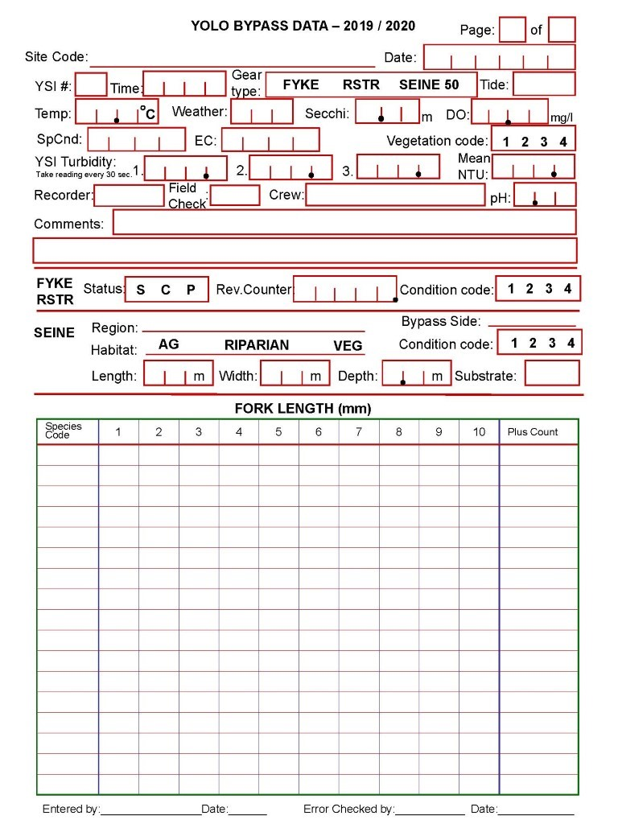

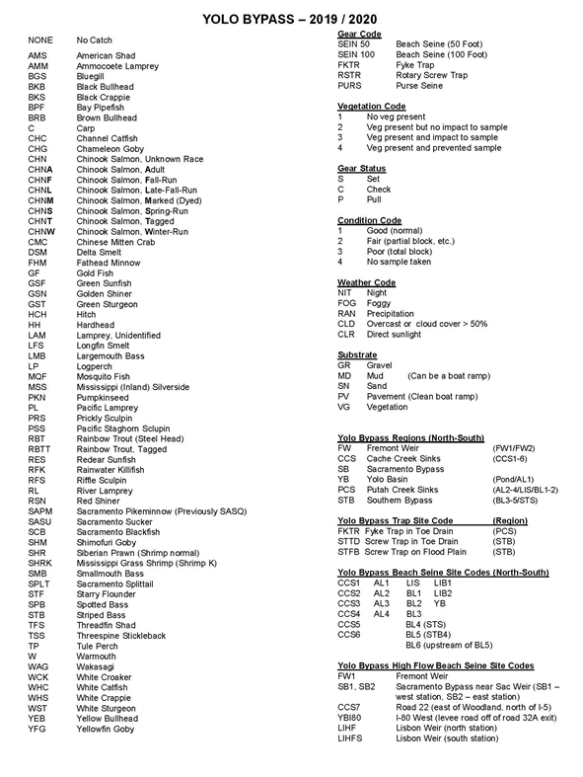

-END OF DOCUMENT-