# Yolo Bypass Fish Monitoring Program: Genetics Metadata

## Dataset Title

Interagency Ecological Program: Genetic identification of salmon run and unidentifiable fish caught on the Yolo Bypass, collected by the Yolo Bypass Fish Monitoring Program, 2015-2019.

## Short name or nickname you use to refer to this dataset:

IEP_YBFMP_Genetics

## Abstract

Largely supported by the Interagency Ecological Program (IEP), the California Department of Water Resources (DWR) has operated a fisheries and invertebrate monitoring program in the Yolo Bypass since 1998. The main objectives of the Yolo Bypass Fish Monitoring Program (YBFMP) are to collect baseline data on lower trophic levels (phytoplankton, zooplankton and insect drift), juvenile and adult fish, hydrology, and water quality parameters. As the Yolo Bypass has been identified as a high restoration priority by numerous regulatory agencies, these baseline data are critical for evaluating success of future restoration projects. In addition, the data have already served to increase our understanding of the role of the Yolo Bypass in the life history of native fishes, and its ecological function in the San Francisco Estuary.

The YBFMP operates several sampling programs to catch fish and targets different life stages. The rotary screw trap and beach seines along the Toe Drain target juvenile fish. The fyke trap, also located in the Toe Drain, targets larger adult fish, though some adult fish can also be caught in seines. For fish that are difficult to identify in the field, such as phenotypically similar species or runs of salmon that don’t match length to date estimates, a fin clip or swab can be taken for genetic identification. Genetic identification allows for more accurate species counts and serves as a QC check to ensure we are correctly identifying species.

## Investigators

|  |  |  |  |  |  |  |
| --- | --- | --- | --- | --- | --- | --- |
| First Name | Middle Initial | Last Name | Organization | e-mail address | ORCID ID (optional) | Role in project |
|  |  | Interagency Ecological Program (IEP) |  |  |  | creator |
| Brian | M | Schreier | California Department of Water Resources | Brian.Schreier@water.ca.gov | 0000-0002-5075-3946 | Creator, Associate |
| Mallory | E | Bedwell | California Department of Water Resources | Mallory.Bedwell@water.ca.gov | 0000-0001-9553-6032 | Creator |

## Other personnel names and roles

Field crew, associate, data entry etc. with e-mail addresses, organization and ORCID ID.

|  |  |  |  |  |  |  |
| --- | --- | --- | --- | --- | --- | --- |
| First Name | Middle Initial | Last Name | Organization | e-mail address | ORCID ID (optional) | Role in project |
| Brian | M. | Schreier | California Department of Water Resources | [Brian.Schreier@water.ca.gov](mailto:Brian.Schreier@water.ca.gov) | 0000-0002-5075-3946 | Creator, Associate |
| Jesse |  | Adams | California Department of Water Resources | [Jesse.Adams@water.ca.gov](mailto:Jesse.Adams@water.ca.gov) | 0000-0002-5075-3946 | Field crew |
| Mallory |  | Bedwell | California Department of Water Resources | [Mallory.Bedwell@water.ca.gov](mailto:Mallory.Bedwell@water.ca.gov) | 0000-0001-9553-6032 | Creator, Field crew |
| Allison |  | Brady | California Department of Water Resources | Allison.Brady@water.ca.gov |  | Field crew, Data entry |
| Parisa |  | Farman | California Department of Water Resource | Parisa.Farman@water.ca.gov |  | Field crew, data entry |
| Naoaki |  | Ikemiyagi | California Department of Water Resources | [Naoaki.Ikemiyagi@water.ca.gov](mailto:Naoaki.Ikemiyagi@water.ca.gov) |  | Field Crew |
| Nicole |  | Kwan | California Department of Water Resources | [Nicole.Kwan@water.ca.gov](mailto:Nicole.Kwan@water.ca.gov) | 0000-0003-1178-7788 | Field Crew |
| Catarina |  | Pien | California Department of Water Resources | [Catarina.Pien@water.ca.gov](mailto:Catarina.Pien@water.ca.gov) | 0000-0003-4427-6300 | Field Crew |
| Emily |  | Hubbard | California Department of Water Resources | Emily.Hubbard@water.ca.gov |  | Field Crew, Data entry |

## License

This information is released under the Creative Commons license - Attribution - CC BY (<https://creativecommons.org/licenses/by/4.0/>). The consumer of these data ("Data User" herein) is required to cite it appropriately in any publication that results from its use. The Data User should realize that these data may be actively used by others for ongoing research and that coordination may be necessary to prevent duplicate publication. The Data User is urged to contact the authors of these data if any questions about methodology or results occur. Where appropriate, the Data User is encouraged to consider collaboration or co-authorship with the authors. The Data User should realize that misinterpretation of data may occur if used out of context of the original study. While substantial efforts are made to ensure the accuracy of data and associated documentation, complete accuracy of data sets cannot be guaranteed. All data are made available "as is." The Data User should be aware, however, that data are updated periodically, and it is the responsibility of the Data User to check for new versions of the data. The data authors and the repository where these data were obtained shall not be liable for damages resulting from any use or misinterpretation of the data. Thank you.

## Keywords

Yolo Bypass, San Francisco Estuary, Sacramento-San Joaquin Delta, **Yolo Bypass Fish Monitoring Program**, California Department of Water Resources, **Interagency Ecological Program**, beach seine, fyke, rotary screw trap, salmon, chinook, Sacramento blackfish, hitch   
[LTER controlled vocabulary] fish, genetics

## Funding of this work:

Add rows to table if several grants/contracts were involved, list only the main PI, start with main grant first:

|  |  |  |  |  |  |  |  |  |
| --- | --- | --- | --- | --- | --- | --- | --- | --- |
| PI First Name | PI Middle Initial | PI Last Name | PI ORCID ID (optional) | Title of Grant | Funding Agency | Funding Identification Number | Permitting Agency and Permit Type | Permit Number |
| Brian | M | Schreier |  |  |  |  | CDFW – Scientific Collecting Permit, Specific Use | S-182970002-19100-001 |
| Brian | M | Schreier |  |  |  |  | IEP Delta Smelt Take |  |
| Gregg |  | Erickson/ IEP |  |  |  |  | NMFS Scientific Research Permit | 1440-2R |
| Ted |  | Sommer |  |  |  |  | CDFW – CESA MOU |  |

## Timeframe

* Begin date: 2016-01-01
* End date: current
* Data collection: ongoing

## Geographic location

* Verbal description: Toe Drain on the Yolo Bypass
* North bounding coordinates (decimals): 38.74979
* South bounding coordinates (decimals): 38.27428
* East bounding coordinates (decimals): -121.588083

West bounding coordinates (decimals): -121.664178

|  |  |  |  |  |
| --- | --- | --- | --- | --- |
| Station Name | Station Code | Latitude | Longitude | Type of Site |
| Screw Trap in Toe Drain | **STTD** | 38.353383 | -121.643 | Regular |
| Putah Creek Sinks | **PCS** | 38.466958 | -121.591 | Regular |
| Above Lisbon 3 | **AL3** | 38.5185 | -121.588623 | Regular |
| Above Lisbon 4 | **AL4** | 38.49439 | -121.588583 | Regular |
| Below Lisbon 1 | **BL1** | 38.46681 | -121.590851 | Regular |
| Below Lisbon 2 | **BL2** | 38.43189 | -121.607053 | Regular |
| Below Lisbon 3 | **BL3** | 38.38939 | -121.626278 | Regular |
| Below Lisbon 4 | **BL4** | 38.35496 | -121.6422 | Regular |
| Below Lisbon 5 | **BL5** | 38.27428 | -121.664178 | Regular |
| Below Lisbon 6 | **BL6** | 38.282465 | -121.663182 | Alternate / discontinued |
| Toe Drain at Lisbon Weir | **LIS** | 38.474816 | -121.588584 | Discontinued |
| Yolo Basin | **YB** | 38.56538 | -121.630989 | Regular |
| Toe Drain at Road 22 (formally Cache Creek Sinks 7) | **RD22** | 38.676367 | -121.643972 | High Flow |
| Fremont Weir 1 | **FW1** | 38.74979 | -121.635232 | High Flow |
| Sacramento Weir | **SW** | 38.605219 | -121.564176 | High Flow |
| Lisbon Weir – High Flow Site North | **LIHF** | 38.47417 | -121.588083 | High Flow |
| Yolo Bypass West Side near I80 | **YBI80** | 38.56531 | -121.638005 | High Flow |

## Taxonomic species or groups (not required)

## Methods

### I. Field Collection Methods

#### Fish Collection

Genetic analyses are conducted on species of interest sampled by the Yolo Bypass Fish Monitoring Program staff using a beach seine, rotary screw trap, or fyke trap (see respective SOPs). When a species of interest is sampled, staff first consult the Species Take Guide/Cheat Sheet to decide whether to keep or release the fish (Figure 1). The cheat sheet is updated yearly by the genetics sample lead and field leads, and a copy is kept in the genetics kit, which is taken out into the field. Based on the Take Cheat Sheet, fish may be fin clipped in the field or back in the lab. For juvenile Chinook salmon, it is first determined if the adipose fin is present and what run it is by using the Length-by-Date document in the data clipboard before referencing the Take Cheat Sheet. If taking whole fish, an appropriately sized whirl pack is labeled with Date, Location, Time, FishTagID, FL, and Weight (if applicable). An internal label is then filled out for the species/run and included in the whirl pack with the fish. The fish is then brought back to the lab freezer in a small cooler filled with ice. When using the small cooler, the whirl pack is placed inside of a Ziplock bag to avoid direct contact with the ice. If the fish needs to be fin-clipped (associated Species of Interest Log), dissected (subset of salmon) or photographed (smelt), the processing is finished back at the lab.

**Figure 1: 2020 Species Take Guide / Cheat Sheet**

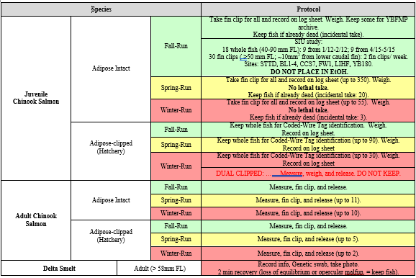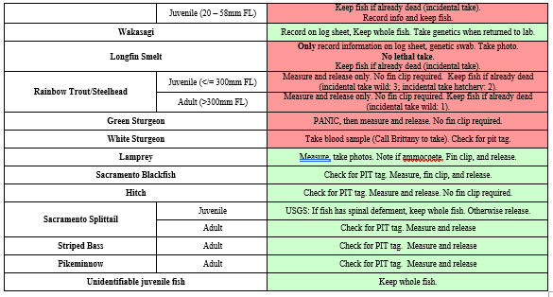

#### Fin Clip Collections / Vials

For fish in which a fin clip is to be collected, an appropriate Species of Interest Log (Figure 2) is used. The log contains an alphanumeric code or FishTagIDs for use in identifying fish (e.g. **2020Ad_plus-F_001** (Adipose fin, FallRun), **2020Ad_min-S_001** (No adipose fin, Spring Run). This unique code is copied onto the YBFMP fish data sheet as well being used to label the fish. Before fin clipping the fish, the fields listed on the Species of Interest Log are filled out and copied on the YBFMP datasheet as described below in “Data Recording”.

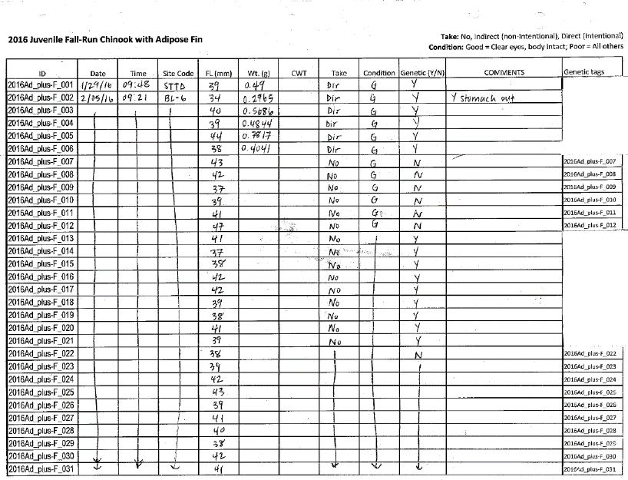**Figure 2: Example Species of Interest Log Sheet for Juvenile Fall run Chinook Salmon with adipose fin.**

A 2.5 ml microcentrifuge tube filled with 95% ethanol is prepared for the fin clip. A minimum 10:1 ratio of preservative to tissue is used to prevent exposure of the tissue to air. The lid of the vial is labeled with the last three numbers of the fish’s corresponding FishTagID from the Species of Interest Log, as well as the Year and Species Code (for salmon, include “F”, “S”, or “W” as well). A corresponding inner label located on right-hand side of the Species of Interest Log is cut this from the log and placed into the vial. An alcohol wipe is used to sterilize a pair of scissors and a small portion of the upper caudal fin is cut. The clip is placed into the vial and sealed (Figure 3). If the fish is being released, staff are careful not to cut too much of the fin, as it would impair the fish’s ability to swim.

**Figure 3: A Fin clip taken from the upper caudal fin of a fish and placed in a microcentrifuge tube.**

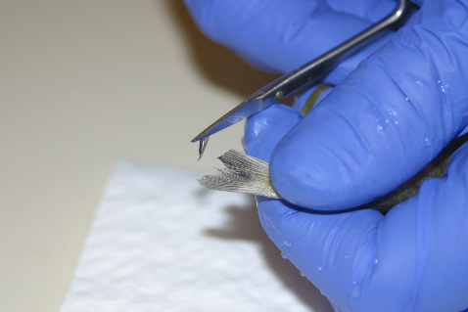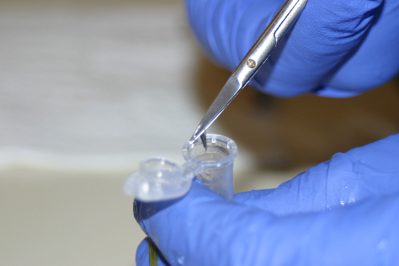

#### Data Recording

Sampling information is recorded on the species of interest log sheet specific to each species. Details of the genetic sampling are also recorded on the regular YBFMP fish data sheet. FishTagID, fork length, take, condition, and stage or adipose presence or absence is recorded if applicable (Figure 4).

**Figure 4: An example YBFMP fish data sheet with salmon genetic details recorded.**

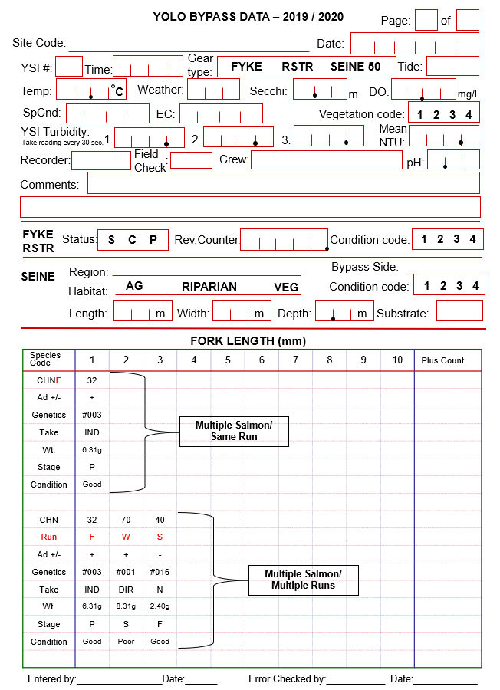

### II. Sample Processing and Tracking

Sample Tracking  
Fin clips are periodically transferred to the contract manager. The contract manager then compares labeled tubes with the species of interest log sheets to ensure that all recent clips have been accounted for. Once species of interest log entries have been confirmed, data for each clip are copied over to a working chain of custody (COC) and an annual COC. Once staff accumulate sufficient samples, they send samples, along with the COCs, to contractors, who check that all samples are accounted for. Signatures are required of both the person responsible for sending the sample package, and the person receiving it. Once the sample is sent, the contractor is notified of approximate date of delivery. The contracted lab will email back raw data either with a percent probability of run type (salmon) or genetic match for fish ID (all other fish).

Contractor  
Genetic identification of fishes is conducted by the Genomic Variation Laboratory at the University of California Davis. One contract covers Chinook salmon run-type, while the other covers genetic identification of Osmerids and other fish species.

Genetic identification of Chinook salmon run-type:

Location: 2403 Meyer Hall, Department of Animal Science, UC Davis. One Shields Avenue, Davis, CA 95616  
Lab phone: 530-752-6351  
PI contact: Mariah Meek [mhmeek@msu.edu](mailto:mhmeek@msu.edu)  
Lab Director: Andrea D. Schreier [amdrauch@ucdavis.edu](mailto:amdrauch@ucdavis.edu)  
Main technician contact: Emily Funk ([ecfunk@ucdavis.edu](mailto:ecfunk@ucdavis.edu))

Genetic identification of Osmerids and other fishes:

Location: 2403 Meyer Hall, Department of Animal Science, UC Davis. One Shields Avenue, Davis, CA 95616  
Lab phone: 530-752-6351  
PI contact: Amanda Finger [ajfinger@ucdavis.edu](mailto:ajfinger@ucdavis.edu)  
Main technician contact: Emily Funk ([ecfunk@ucdavis.edu](mailto:ecfunk@ucdavis.edu))  
Additional technician contact: Mary Badger ([mebadger@ucdavis.edu](mailto:mebadger@ucdavis.edu))

#### Sample Archive

UC Davis keeps extracted DNA in their facility.

### III. Quality Assurance and Control

#### Sample Identification

All field staff have taken a fish identification course for California freshwater and anadromous fishes. Fish identification resources and dichotomous keys are carried with the field crew if needed, and the field lead always checks fish identification if in question. Field identification of fish using phenotypic characteristics may not be the correct genetic identification.

#### Data Quality Control

Four levels of quality control are conducted on data:

1. Field data are checked by someone other than the data recorder prior to leaving each field site,
2. Datasheets are checked while being entered into the Microsoft Access database, which has customized error-checking and data validation checks,
3. A separate DWR staff member compares data from original field sheets to data entered into the database,
4. In the Microsoft Access database, each FishTagID is linked between the original data entry field and the table results entry. If a FishTagID is missing or incorrect in the original data entry it cannot be entered into the table and vice versa. This helps eliminate mistakes in FishTagID use or replications of entries.

#### Notes on Data Quality

Based on a subset of samples that were genetically identified, species identification of minnows and basses <30mm may not be reliable to the species level.

### IV. Data Storage

#### Data Management and Archiving

Field data are collected and recorded on paper datasheets by DWR personnel, then entered into a Microsoft Access database. The monitoring program is currently transitioning to a new database called WISKI, which will replace Microsoft Access by the end of 2020. The field data from the species of interest log sheets is also entered into corresponding excel files. Paper datasheets are archived in binders that are stored at the West Sacramento DWR office, and electronic copies are archived on DWR/AES Network drives.

Taxonomic results are received from the contractor via email in an Excel spreadsheet. Data are printed and entered into the Access database and corresponding excel files by DWR personnel. Hard copies of the data are printed and stored in binders at the West Sacramento DWR office. Electronic copies of results for taxonomic analyses are archived on DWR/AES Network drives.

### V. Historical Changes

#### Methods

**2015:** Genetic analysis of species of interest started. A fin clip for genetic analysis was taken from Juvenile Chinook salmon and their catch Date, catch time, catch site, catch gear, fork length, weight, and presence or absence of adipose fin were recorded. Adult Chinook salmon were fin clipped and their catch date, location of catch, time of catch, acoustic tag ID and serial number, fork length, sex, presence or absence of adipose fin, and floy tag number were recorded. Delta Smelt, Longfin Smelt, and Wakasagi were fin clipped and their catch date, catch time, catch site, catch gear, fork length, weight, sex, and number of chromatophores were recorded. Older, frozen samples from before 2016 were also fin clipped and send for genetic analysis.

**2016:** Genetic analysis for juvenile Chinook salmon, adult Chinook salmon, Delta Smelt, Longfin Smelt, and Wakasagi continued, however gear type was no longer recorded. Also, direct or indirect take, poor or good fish condition, and fin clip taken or not began to be recorded for all species. For Delta Smelt and Wakasagi, V-shape on caudal peduncle and release information were recorded as well. Reproductive condition (milt, eggs, or unknown) also began to be recorded for Delta Smelt. Rainbow Trout was added to the species of interest genetic analysis with all the same parameters recorded as juvenile Chinook salmon including gear type.

**2017:** Genetic analysis for juvenile Chinook salmon, adult Chinook salmon, Rainbow Trout, Delta Smelt, Longfin Smelt, and Wakasagi continued. For Adult Chinook salmon, acoustic tag ID and serial number was no longer recorded.

**2018:** Genetic analysis for juvenile Chinook salmon, adult Chinook salmon, Delta Smelt, Longfin Smelt, and Wakasagi continued and Hitch and Sacramento Blackfish were added as well. Hitch were fin clipped and catch date, catch time, catch site, catch gear, fork length, weight, direct or indirect take, and fin clip taken or not was recorded. Sacramento Blackfish were processed the same way as Hitch except presence or absence of PIT tags were recorded as well. Total length and weight began to be recorded for adult Chinook salmon.

**2019:** Genetic analysis for juvenile Chinook salmon, adult Chinook salmon, Delta Smelt, Longfin Smelt, Wakasagi, Hitch, and Sacramento Blackfish continued. Whether the fish was smolting or not and a distinction between lab weight and field weight began to be recorded for juvenile Chinook salmon. The number or dorsal rays and anal rays began to be recorded and weight was no longer recorded for Hitch. Lab weight instead of field weight started to be recorded for Sacramento Blackfish. Lamprey was added to the species of interest genetic analysis. Catch date, catch time, catch site, catch gear, fork length, presence or absence of eyes, direct or indirect take, condition, and whether or not a fin clip was taken were recorded. Weight was no longer recorded for adult Chinook salmon. Fin clips were taken for Rainbow Trout, but not analyzed. They are currently stored at UCD. The blackfish and lamprey samples that were collected are being used for studies at the GVL, and not necessarily Yolo reporting or studies.

**2020:** Genetic analysis for juvenile Chinook salmon, adult Chinook salmon, Delta Smelt, Longfin Smelt, Wakasagi, Sacramento Blackfish, and Lamprey continued. Genetic analysis was no longer done for Hitch, due to inability for the current locus used for genetic identification to distinguish between Hitch, California Roach, and Blackfish. Life stage (ammocoete or macropthalmia) was recorded for Lamprey. Stage (smolt, parr, or fry) was recorded for juvenile Chinook salmon rather than if they were smolting or not. Fin clips were taken for Rainbow Trout, but not analyzed. The blackfish and lamprey samples that were collected are being used for studies at the GVL, and not necessarily Yolo reporting or studies.

**2021:** Swabs for SHERLOCK analysis were added to the cheat sheet for all caught salmonids and delta smelt. These swabs will be taken along the side of the fish and placed in PBS buffer for analysis. Genetic analysis began for Killifish on August 9, 2021 to help differentiate between Bluefin and Rainwater Killifish.

## Data Tables

**Table Description:**

|  |  |  |  |
| --- | --- | --- | --- |
| Column name | Description | Unit or code explanation or date format | Empty value code |
|  |  |  |  |
|  |  |  |  |
|  |  |  |  |
|  |  |  |  |
|  |  |  |  |
|  |  |  |  |
|  |  |  |  |

## Articles

List articles or reports citing this dataset or have used this dataset in the past.

|  |  |  |
| --- | --- | --- |
| Article DOI or URL (DOI is preferred) | Article title | Journal title |
|  |  |  |
|  |  |  |
|  |  |  |
|  |  |  |
|  |  |  |
|  |  |  |
|  |  |  |

## Scripts/code (software)- Optional

List any software scripts/code you would like to archive along with your data. These may include processing scripts you wrote to create, clean, or analyze the data.

|  |  |  |
| --- | --- | --- |
| File name | Description | Scripting language |
|  |  |  |
|  |  |  |
|  |  |  |
|  |  |  |
|  |  |  |
|  |  |  |
|  |  |  |

## Data provenance

Were these data derived from other data? If so, you will want to document this information, so users know where these data come from.

|  |  |  |  |
| --- | --- | --- | --- |
| Dataset title | Dataset DOI or URL | Creator (name & email) | Contact (name & email) |
|  |  |  |  |
|  |  |  |  |
|  |  |  |  |
|  |  |  |  |
|  |  |  |  |
|  |  |  |  |
|  |  |  |  |

### Notes and Comments

#### Versioning History

|  |  |  |  |  |  |
| --- | --- | --- | --- | --- | --- |
| **Version number** | **Date created** | **Description of changes** | **Justification for change** | **Version editor** | **Contact info** |
| **1.0** | 1/14/2021 | Finalized metadata using Yolo Bypass template | Standardized and elaborated on metadata documents for YBFMP internal review, based on template from EDI and IEP | Mallory Bedwell (content), Amanda Casby (content), Catarina Pien (standardization) | [Mallory.Bedwell@water.ca.gov](mailto:Mallory.Bedwell@water.ca.gov),  [Catarina.Pien@water.ca.gov](mailto:Catarina.Pien@water.ca.gov) |
| **1.2** | 5/23/2022 | Added Killifish sampling | Updating fish metadata for data publication, noticed this needed to be added | Catarina Pien | [Catarina.Pien@water.ca.gov](mailto:Catarina.Pien@water.ca.gov) |
|  |  |  |  |  |  |
|  |  |  |  |  |  |