DWR/DISE Aquatic Ecology Unit

**Standard Operating Procedures**

Last Revised: [10/01/21] [JR, AB]

Version: 1.1

# Yolo Bypass Fish Monitoring Program: Coded Wire Tag Recovery

Hatchery juvenile salmon are injected with a small piece of narrow-gauge wire (0.25mm diameter). The wire has been laser-printed with a numeric code that indicates where and when a fish was released. In addition to these coded wire tags (CWT), these hatchery fish are marked externally by clipping the adipose fin. The below procedure provides guidance on how to extract, read, and record CWTs for the Yolo Bypass Fish Monitoring Program in order to examine how Chinook salmon utilize the Yolo Bypass floodplain, how many hatchery fish make their way through the Yolo Bypass floodplain, and how hatchery Chinook salmon presence varies depending on water year type.

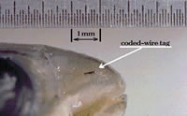

## Equipment:

* Fitted nitrile gloves
* CWT V-detector
* Wooden CWT calibration standard
* Magnetic bar
* Paper towels
* Scalpel
* Plastic forceps
* Isopropyl alcohol wash bottle
* DI wash bottle
* Magnetized tag reading pencil
* Tag reading jig
* Dissecting microscope
* AEU laptop
* Freezer inventory datasheet
* CWT datasheet
* Small tag bags
* Post-it colored tabs

## Methods:

### A. Storing adipose fin clipped fish:

The field crew will freeze all Chinook salmon that have the adipose fin clipped (“Ad –“ or “Ad minus”), in a plastic bag with a unique head tag, which includes a unique fish identification number, date and time of collection, weight and fork length.

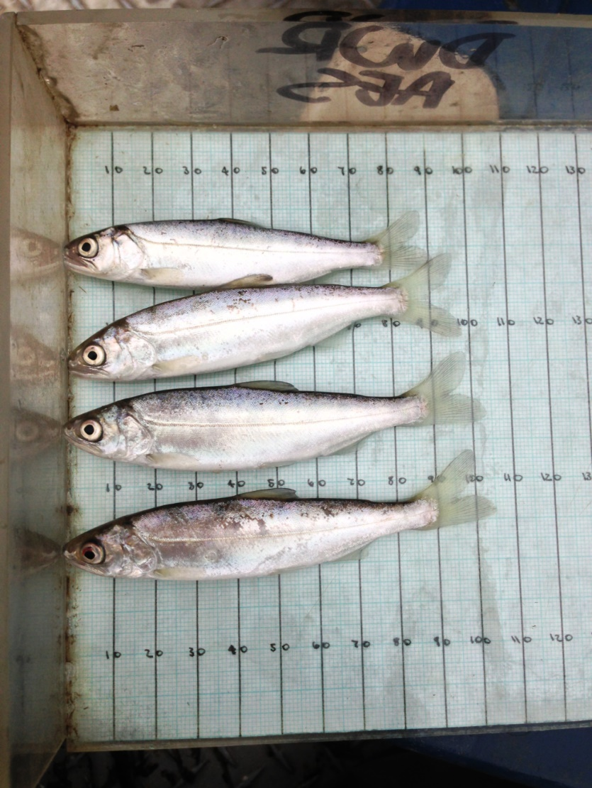

**No Adipose Fin**

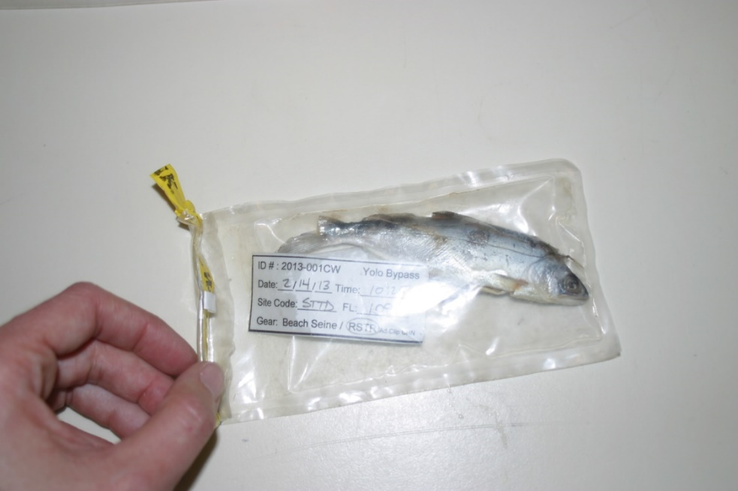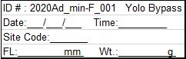

### B. Prepping CWT extraction workstation:

1. Start by removing any rings, watches, and other metals that may set off the detector. Put on a pair of fitted nitrile gloves (wearing loose fitting gloves can make the tag cleaning process more difficult), and safety glasses.
2. Always start with a clean workspace. After removing everything from the semi-enclosed acrylic workstation, sweep the entire station with the bar magnet to ensure that someone else’s lost tag won’t turn up.
3. Wipe the workstation clean using a paper towel moistened with alcohol.
4. Next, make sure the CWT V-Detector works by waving the wooden CWT calibration standard. Adjust the V-Detector sensitivity if necessary.
5. Only paper towels, scalpel, plastic forceps, measuring board, dissecting probe, and the V-detector should be in the station.

**Note:** CWT dissection, reading and recording is best done in pairs. One person dissects and reads the CWT, while the second records data and QA/QC’s the CWT reading.

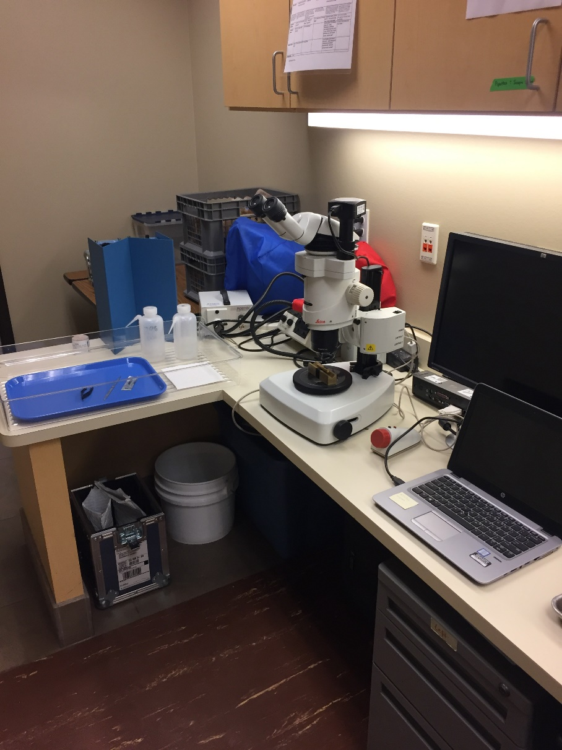

### C. CWT extraction:

1. 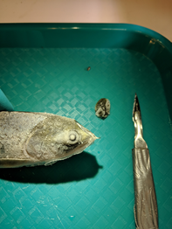Pass the fish headfirst through V-Detector to verify a CWT is present.

**Note:** If the V-Detector does not beep after multiple tries, record the fish as “no tag found” on the datasheet and take a fin clip from the caudal fin. Place the fin clip in a vial with ethanol and label it with the FishID.

1. If the adipose fin is clipped, and the V-Detector beeps, use the scalpel to remove the CWT tag from the nose of the fish.
2. If a clipped fish beeps, but you cannot find the tag after a thorough search, then continue making thin slices and use the V-detector between every slice to help locate the tag. Once the piece that contains the tag has been found, wave the remainder of the fish to check if there is another tag in the fish.

**Note:** The otoliths may need to be removed if the head is heavily dissected. Place dissected otoliths in an Eppendorf tube inside the plastic bag with the rest of the carcass. Use otolith tag sheet to validate fish IDs.

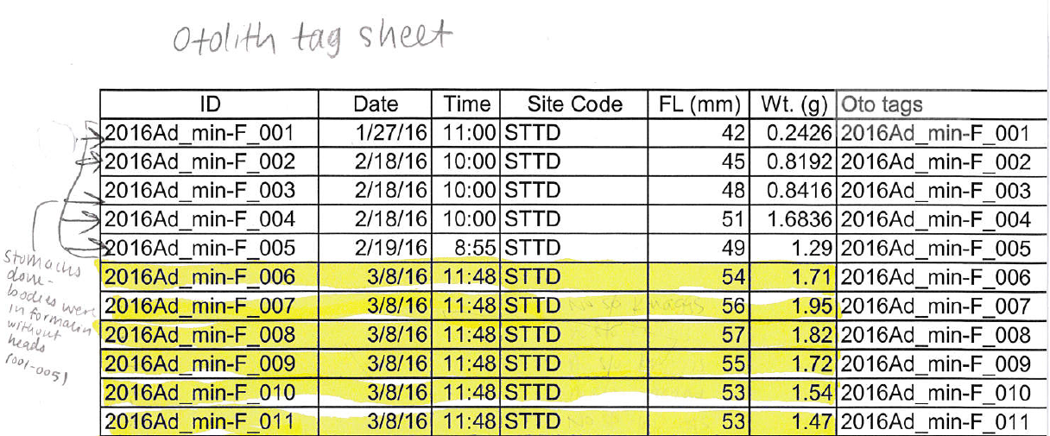

1. Afterwards, keep cutting the piece of tissue with the CWT into smaller sections until the CWT can be seen and removed. CWTs are often found stuck to the scalpel because both the tag and scalpel are magnetized.

**Note:** All metallic objects such as rings, watches, lights, and magnets should be kept away from the V-detector to avoid false readings. Vibrations (e.g., bumping the table) will also give false readings. If several fish in a row do not register as having tags, check the detector with the wooden CWT calibration standard.

1. Carefully place the tag onto the palm of one hand, gently squirt with Isopropyl. Let it sit for 5 seconds then use one finger from the other hand to press the tag into your palm and “scrub” it. Press harder than you think you need to in order to get all fish residue off and be very gentle when removing your finger so that the tag doesn’t fly off your hand. Do this 2-3 times then rinse with a small amount of DI water in your palm.

**Note:** If a tag is lost during the cleaning process and is not found after searching with the magnetic bar, record “tag lost” on the datasheet and take a fin clip from the caudal fin. Place the fin clip in a vial with ethanol and label the outside with the FishID.

**Note:** Keep your hands over your workstation tray so that if the tag does get lost or fall you can use the bar magnet to recover it.

### D. Reading a CWT

Decimal CWTs have numbers laser-etched onto the sides of the wire. The decimal tag uses a ‘flag’ character to mark the beginning of the tag code. This flag character will be placed to the left of the first digit of the agency number. The agency number will always be either “06” for State or “05” for Federal. The decimal tag could either be a full decimal tag or a half-length decimal tag.

1. For reliability and ease of use, the code is replicated on four sides of the wire with the starting point offset by two-character positions. This redundancy makes a tag readable no matter where it is cut.
2. Full decimal tags follow a six-digit code:
   1. In this example, the agency code is “06”, D1 is “46”, and D2 is “71”. The code would then be written as 06-46-71. 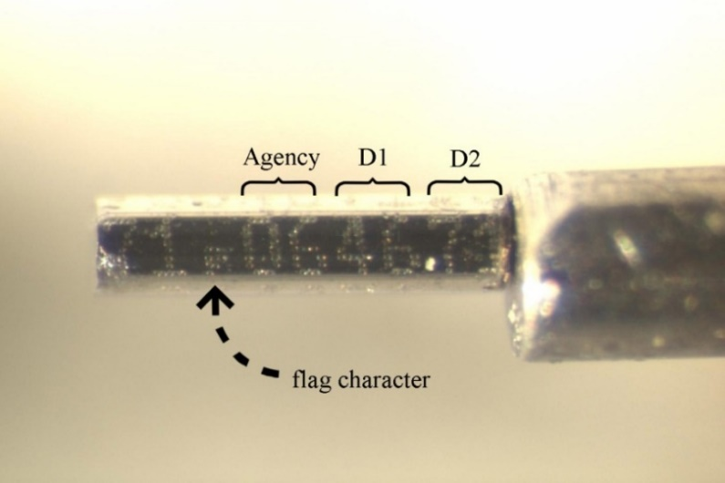
   2. In this example, the code is written 16-58-09. The vertical white lines in the figure show the length of a full tag and one possible cut.

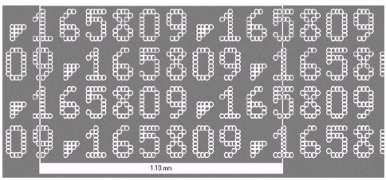

1. Half- length decimal tags have five symbols (agency, D1, D2, D3, and D4).
   1. The four data words are only one digit each. To fit the data on the tag, the words are written on two longitudinal rows.
   2. The row with the flag character contains the two digits of the agency code and D1. Aligned below it are D2, D3, and D4.
   3. The code is repeated once and offset to gain reliability.
   4. example of CWT agency identifiers via tag numbersIn this example, the agency = 16, D1 = 05, D2 = 08, D3 = 00 and D4 = 09 (written 16-05-08-00-09). The white lines in the figure show the size of the half-length decimal tag, and one possible tag cut.
   5. In this example, the CWT code is 061294 (06-01-02-09-04).

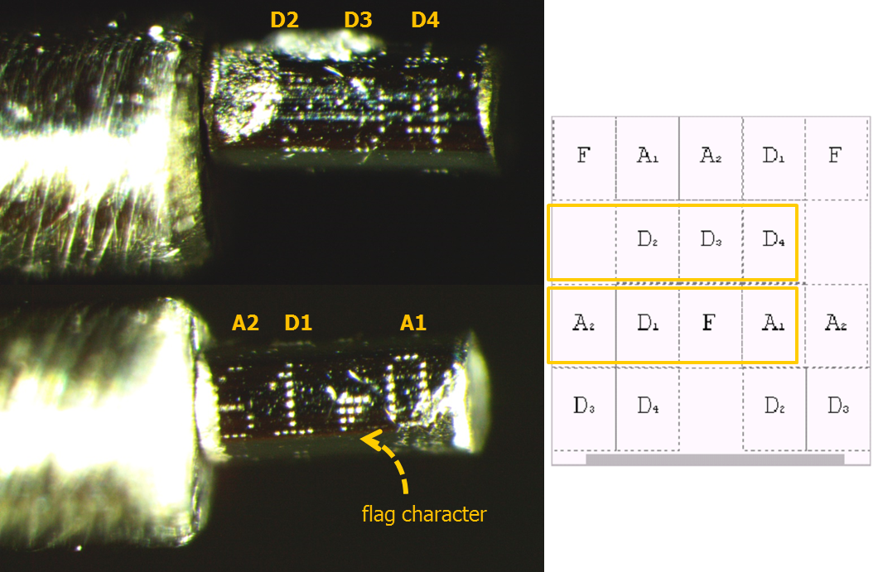

### E. Data Recording

1. Information is recorded on both the freezer inventory and CWT data sheet.
2. The freezer inventory records the fish’s capture information and the date of CWT dissection. All “Ad minus” fish should be recorded on the freezer inventory sheet on the day of collection, each fish should be on its own individual row.

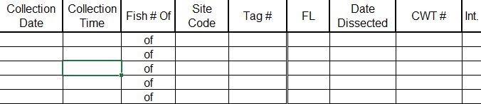

1. The CWT data sheet records the CWT code and the initials of the individuals processing and reviewing the CWT extraction. Also, record the fish ID # from the original label (Tag #), sample date, sample time, station code and fork length at capture. Then record the number of fish collected on that sample date (if 4 fish are collected on a certain sample date, the first fish of that date would be 1 of 4).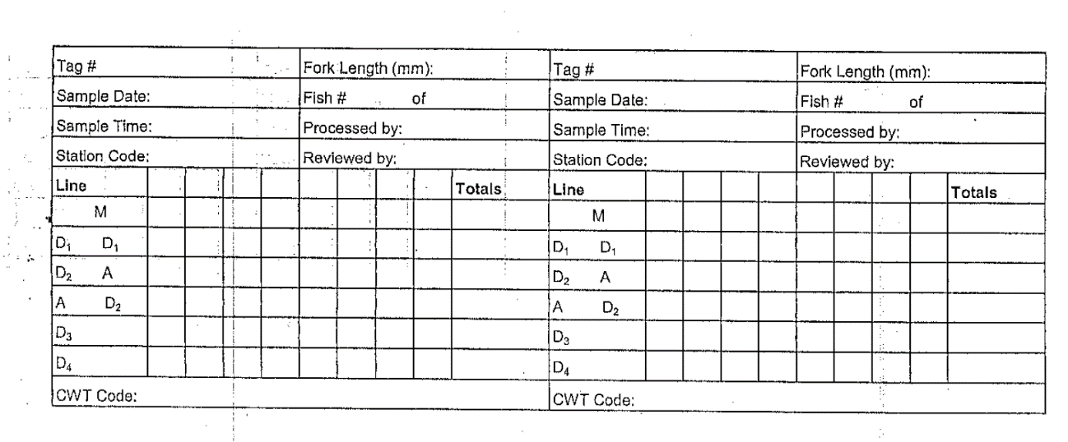

**Note:** The tag box is used for recording binary tags, which we are unlikely to encounter and have not been included in this SOP

1. If the adipose fin is clipped, and the V-Detector does not beep, the CWT processor will write “**no beep**” on the CWT data sheet. Then, a second person will check the tag and V-Detector. If there is still no beep, the CWT processor will write “**no tag**” on the CWT data sheet in the “CWT Code” section.
2. If the tag is found within the workstation, write “**tag lost and found**,” your initials, and the date on the CWT datasheet and process the tag as normal (i.e., read tag and record tag code). In addition, write “tag lost and found” under the comments section on the CWT summary data sheet with a reference to the appropriate head number and tag code.
3. After reading and recording the tag code, place the tag on the sticky side of a post-it flag, and then place into a small tag bag (4 cm x 5 cm). The easiest way to handle the tag is to let it stick to the magnetized tag reading pencil and then gently touch the tag to the post-it flag. Be sure the tag is lying on its side in the bag, so it won’t poke through the bag and get lost.

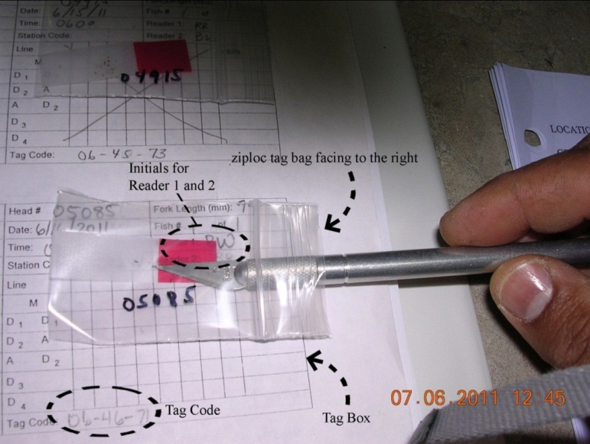

1. Do not tape the mouth of the bag closed. Apply tape lengthwise across the long edge of the bag and press onto the page sideways so that the zip end of the bag is facing to the right. Make sure to tape the bag in the correct square (i.e., tag box) in the CWT data sheet, so it does not cover the area of another tag box.
2. If a tag is found outside the acrylic workstation, or there is another reason to doubt it is the tag just lost (e.g., a full tag was lost but a half tag was found), put the tag in a small plastic bag and tape it to a new CWT data sheet. Notify the group that a missing tag was found outside the workstation for further evaluation. In addition, write “**missing tag found**,” your initials, and the processing date in the tag code space. Before working on the next fish, make sure to clean the workspace and start with a clean paper towel.
3. Take notes of any inconsistencies on the CWT and freezer inventory data sheet.
4. After the dissection and reading of CWT tags either:
   1. The CWT tag ID is associated with a special study which includes isotope or genetic analysis and the fish cannot be placed in formalin.

OR

* 1. The CWT tag is not associated with any known special studies and can be processed for stomach and otolith samples in the same procedure as Ad+ fish

**Note:** See dissection SOP for more details on how to finish processing the Chinook salmon sample.

### F. Photographing CWT

1. Connect camera to dissecting microscope and laptop computer.

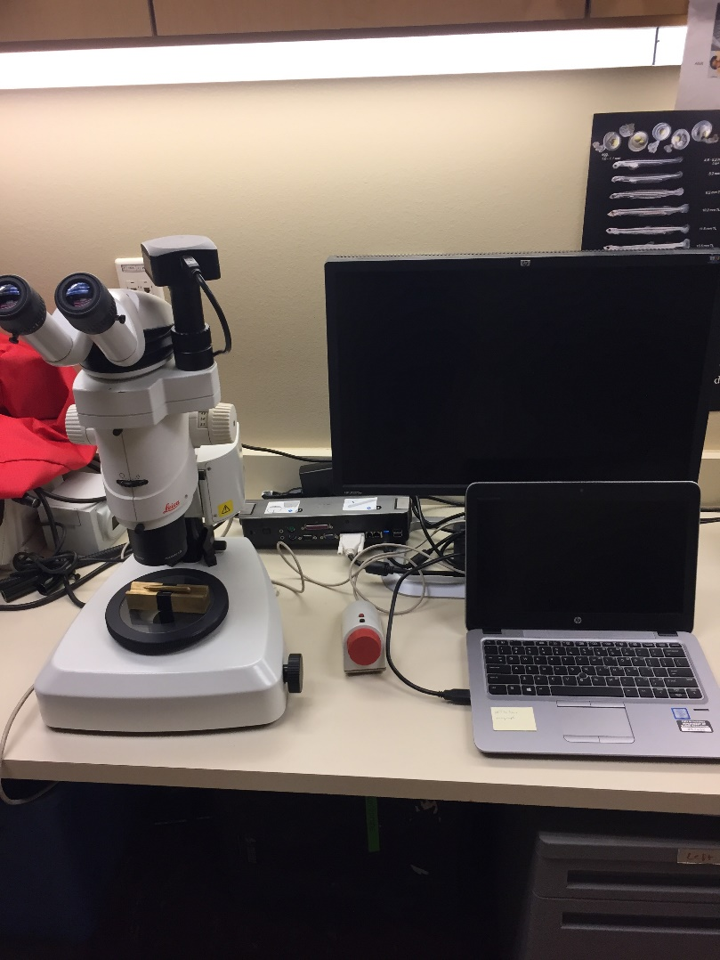

**Note:** Make sure to adjustdiopter settings on the microscope before attempting to focus images on the computer. It will be much easier to focus the computer image once the microscope is in focus.

instructions on how to prepare microscope for viewing. Text reads as:
Interpupillary distance, eye contact:
Interpupillary distance:
The interpupillary distance is correct when you see a single circular field when viewing with both eyes. Look into the eyepiece and use both hands to move the eyepiece tubes closer together or further apart.
Locating the exit pupil:
The distance between eye and eyepiece measures approximately 22mm for 10x/21B wide-field eyepieces for persons wearing glasses and 12mm for 10x/21 wide-field eyepieces. Slowly approach the eyepieces with your eyes until you can see the complete image field without corner cutting.

Image details:

* Interpupillary distance is correct when you see a single circular field when viewing with both eyes
  + Look into the eyepieces and use both hands to move the eyepiece tubes closer together or further apart
* Locating the exit pupil: the distance between eye and eyepiece measures approximately 22mm for 10x/21B wide-field eyepieces for persons wearing glasses and 12mm for 10x/21 wide-field eyepieces
  + Slowly approach the eyepieces with your eyes until you can see the complete image field without corner cutting

1. Arrange lights to reduce glare and increase contrast. Use ambient light (microscopy light and room lights) to adjust available light and increase contrast. Use goose-neck lights to direct light perpendicular to CWT tag to decrease glare.

**Note:** It may take some time and several minor adjustments to reduce glare while providing enough light to see the numbers clearly.

1. Once the CWT code is in focus and easily legible (may have to remove and clean again if can’t easily read numbers), take a photo of the entire tag code to be used for QAQC. If tag is damaged or hard to read, take multiple photos of the replicate offset numbers as you rotate the tag to get the full tag code.
2. The photographs should then be transferred off the laptop and onto the Yolo shared drive [\\cnrastore-des\DESSRV20\M & A Branch Data\Yolo Bypass\YOLO BYPASS DATA\Yolo Biological Data\Fish\CWT recovery data\CWT photos] in a folder named for the capture year.

### G. Reporting

1. A third individual will review the photographs and QA/QC the CWT codes
2. Input the CWT codes into the CWT table in the Fish Database, species of interest log sheets, and a new YEARCWT excel file (use past years as reference) in the Yolo Bypass Data drive – CWT recovery data folder [\\cnrastore-des\DESSRV20\M & A Branch Data\Yolo Bypass\YOLO BYPASS DATA\Yolo Biological Data\Fish\CWT recovery data].
3. To find the hatchery information related to the CWT codes, use the website: <https://www.rmpc.org/>
   1. Go to RMIS standard reporting and create an account with your email if you do not already have one.
   2. On the left sidebar select tagged releases
      1. Enter tag codes one per line (hit enter after each one)
      2. When all your codes are entered click retrieve
      3. Click the Detail-&-Map button to get all the info to fill in excel sheet

**Note:** Codes are not always updated right away. If you get the error “Your releases query contains the following invalid tag codes” that probably means the codes have not been updated yet and you will not be able to find the hatchery information. Try again later. (example: 2019 tags were not available November 2019)

1. A final spreadsheet must be sent to Catarina Pien [[catarina.pien@water.ca.gov](mailto:catarina.pien@water.ca.gov)] by September 30 of each year and she will update Jason Azaz [[jason.azat@wildlife.ca.gov](mailto:jason.azat@wildlife.ca.gov)]. Jason Azaz will report our juvenile CWT captures to RMIS (Regional Mark Information System).

## Past editors & Collaborators:

* [2016] - Pascal Goertler: prepared this document for the Aquatic Ecology Section.
* [2019] - JT Robinson and Amanda Casby: made updates and improvements to the protocol to better fit the process. The main changes included what to do with the datasheets, adding more explicit instructions on removing the tag, and adding more pictures.
* [April 2020] - Amanda Casby and Nicole Kwan: made updates as a part of the Yolo Bypass Fish Monitoring Program Review. The main changes included formatting changes, a few notes about special cases of fish, and the addition of what to do with the final spreadsheet.
* [December 2020] – Nicole Kwan: some formatting edits and migration to the Yolo Drive.
* [October 2021] – Made a few formatting edits and changed DES to DISE and AES to AEU