DWR/DISE Aquatic Ecology Unit

**Standard Operating Procedures**

Last Revised: [8/31/21] (NK, CP)

Version: 1.1

Yolo Bypass Fish Monitoring Program: Laboratory Dissection of Fish

A number of smelt, fall, late-fall and spring run Chinook salmon, and other juvenile fish species of interest are preserved for the monitoring programs fish collection. These fish are dissected depending on species type and, for salmon, the presence of adipose fins. The primary goal for these fish is to create an archive of Chinook salmon for future directed flood plain research studies, preserve stomachs for potential diet analysis, archive Delta smelt and Wakasagi photos for morphological comparisons, and save heads for potential otolith microchemistry and tissue sampling.

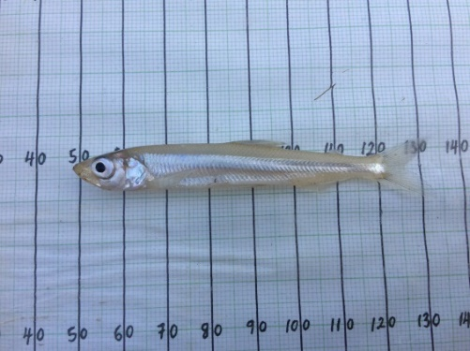 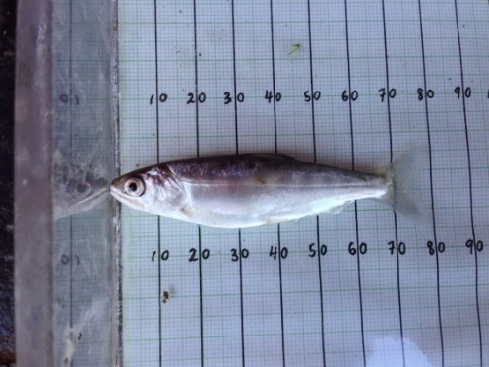 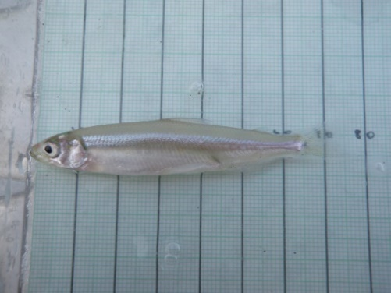

# Equipment:

* AES dissection kit
  + Metal tray
  + Scalpel
  + Scissors
  + Sharpie, pencil
  + Internal label for body
  + Ethanol to clean surfaces
  + Weigh boat
* Scale
* 10% formalin
* 95% ethanol
* Glass sample vials
* AES laptop
* Dissecting scope

# Methods:

## A. Immediately upon return from the field with lethal samples:

NOTE: Smelt, salmon or other juvenile fish of interest will be brought back to the laboratory on ice.

1. Determine what dissection process the fish needs to go through based on its species:

* Salmon (without an adipose fin): Place whole fish in freezer, follow the CWT SOP
* Salmon (with an adipose fin): Follow steps 2-6 below
* Smelt: Follow step 2, then proceed to section B: Smelt Laboratory Processing
* Other Juvenile fish: Follow steps 2-6 below unless otherwise instructed for a special study

1. Weigh the fish in a weigh boat from the AEU dissection kit on the lab scale.
2. Clean scissors with alcohol wipes for each fish. Cut one lobe of the caudal fin and place it in a 2.5 mL microcentrifuge tube with non-denatured ethanol. Remove a “genetic tag” from the corresponding Species of Interest Log sheet, and place in the tube with the genetics sample. Then, fill out each fish’s date, time and location of capture, fork length, weight, etc. on the Species of Interest Log sheet and the Yolo Bypass fish datasheet.

NOTE: For more details on Yolo Bypass Fish Monitoring Program genetic procedures, see the Genetics SOP.

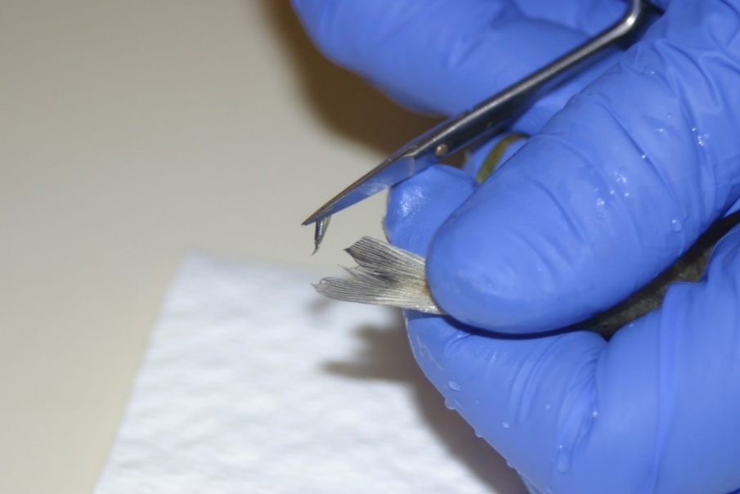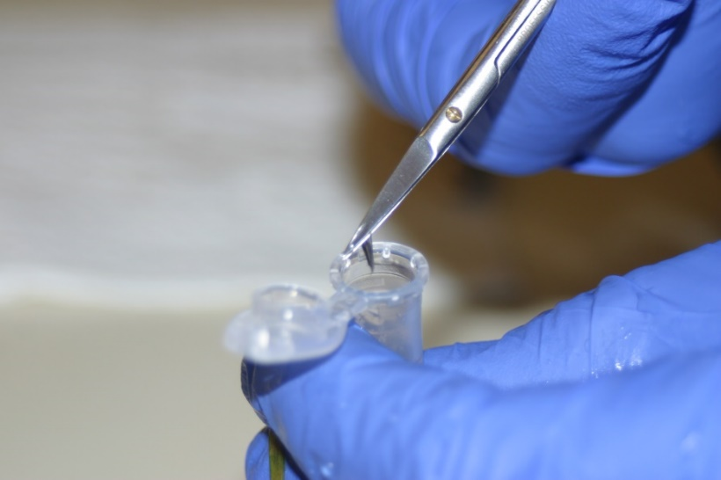

1. Use a clean scalpel to cut the fish just behind the operculum. Place the stomach in a glass sample vial with a new label and enough 10% formalin to be fully submersed.

* NOTE: For Instructions on how to make a 10% formalin, reference the 10% Formalin Mixture SOP
* NOTE: The otolith is very close to the operculum, so don’t cut to the left of the operculum.

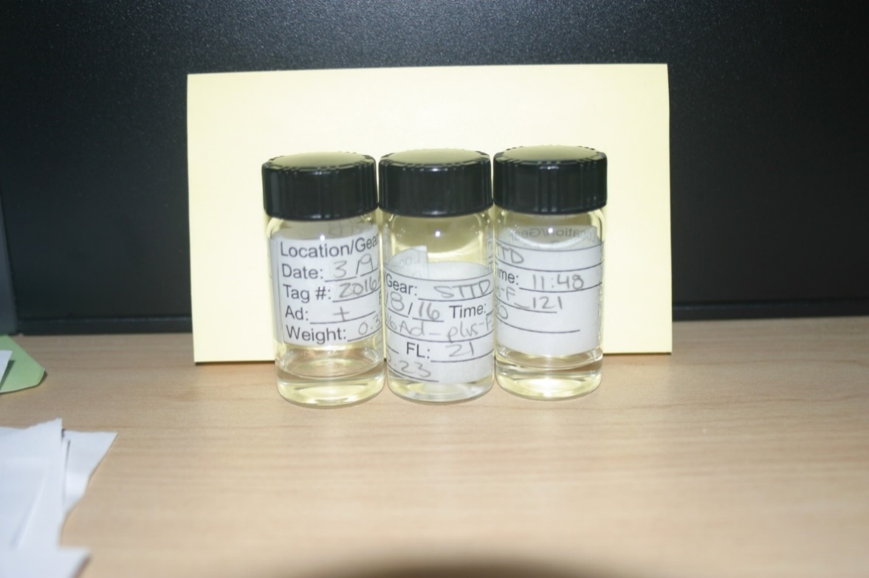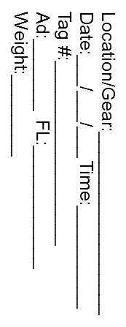

1. Put the head back in the original whirl pack with the original label and place it in the corresponding species Ziplock bag in the freezer.

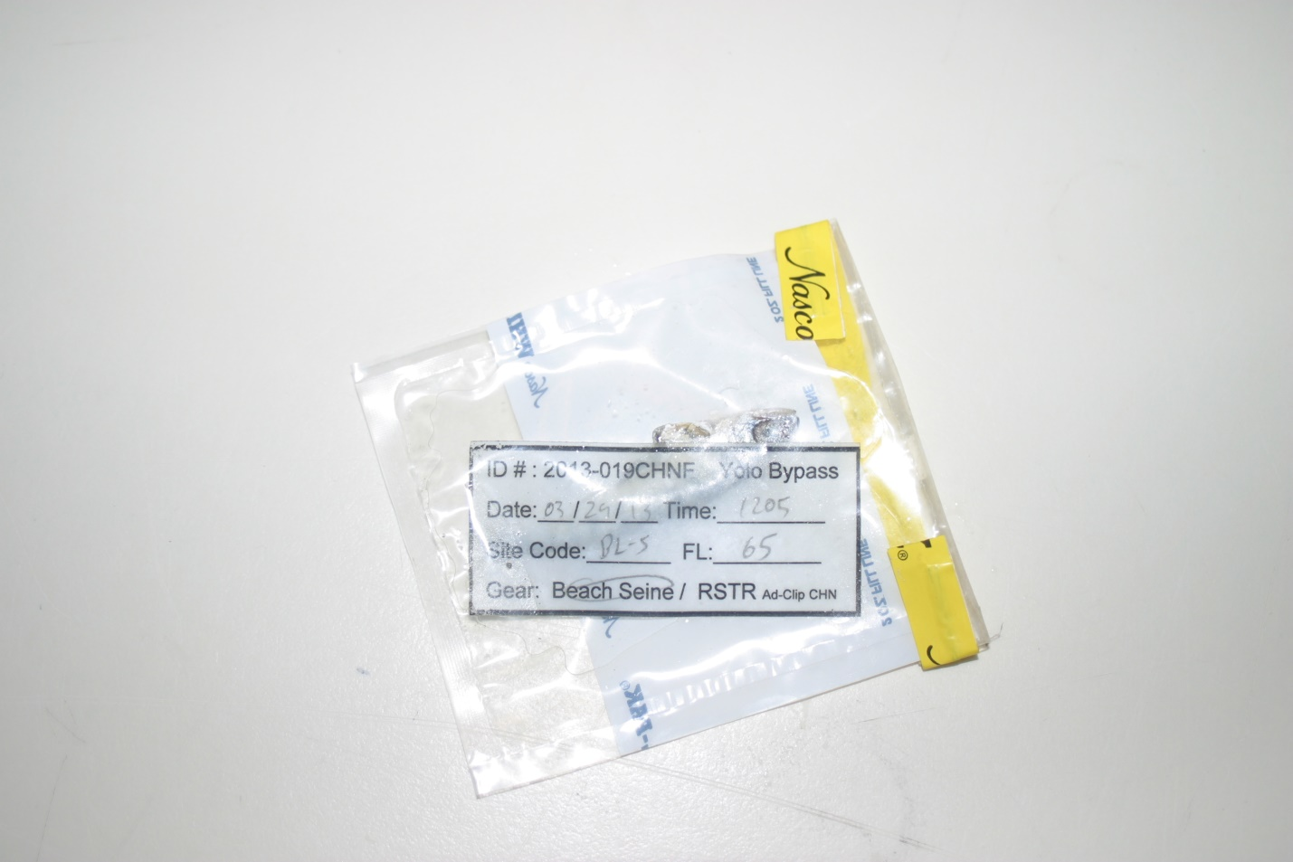

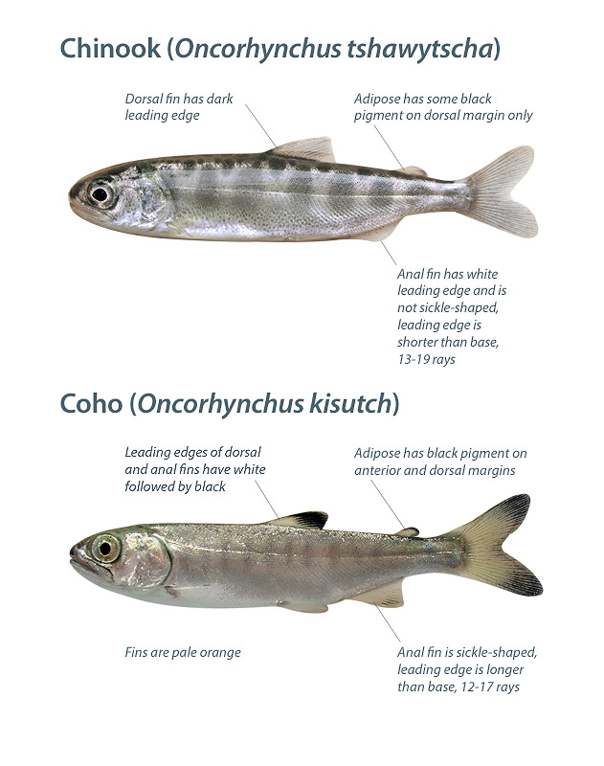

Put back in original bag, with original label and then in the freezer

Put in jar, with new label and formalin

Clean scissors for each sample

Put in tube, with small label

**Otolith is around here, so don’t cut to the left of the operculum**

1. Record all details on the associated Species of Interest Log sheet.

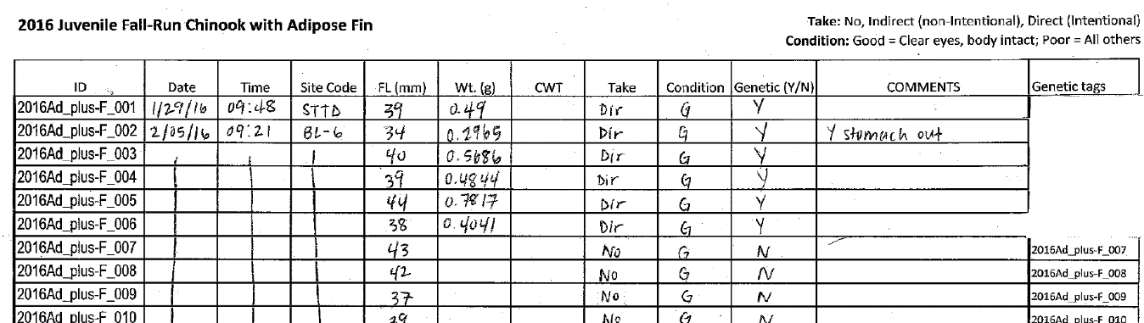

1. Anytime a listed species (whole or specific parts) is transferred to an entity outside of DWR, a Chain of Custody (COC) must accompany the exchange. The COC should be signed by both parties and a copy placed in the ESA Take Reporting Binder (currently in JT Robinson’s cube). The COC should also be scanned and added into a relevant project folder.

## B. Smelt Laboratory Processing

1. Place fish under the dissection scope to check for general morphology, chromatophores, and v-shaped pigmentation on caudal peduncle.

* NOTE: At least two staff members should look at each smelt and a consensus is needed to make a species call.
* Chromatophores: Look for the isthmus, check for pigmentation. Chromatophore is the dot pigmentation on isthmus. Wakasagi has two or more chromatophores on the isthmus. Delta Smelt has one or no chromatophore on their isthmus.
  + - Juvenile Wakasagi may be missing chromatophores, they develop chromatophores as they mature.

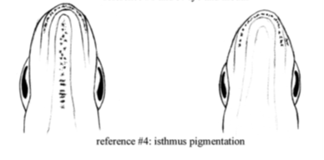

Figure: Wakasagi (left) and Delta Smelt (right) isthmus pigmentation.

* V shape: Look for pigmentation on top of the caudal peduncle of the fish. Wakasagi will have scattered spots all around the top, while Delta Smelt will have smaller number of spots that are clustered around the caudal fin, creating a sort of v-shape.

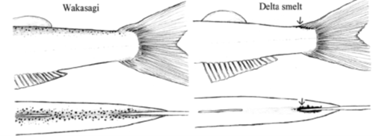

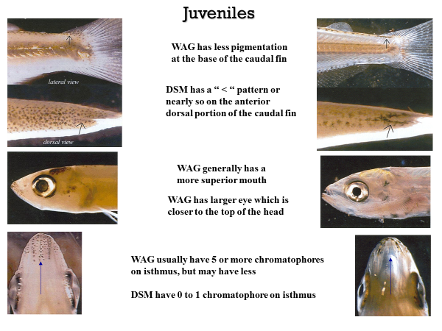

1. Once a species ID has been determined, write down information (# of chromatophores, v-shape, etc.) on the associated species of interest log sheet.
2. Take pictures of each smelt using dissecting scope camera and the unit laptop. Pictures should include one of the isthmus, one of the caudal peduncle (top view), and full side body shot. Examples:

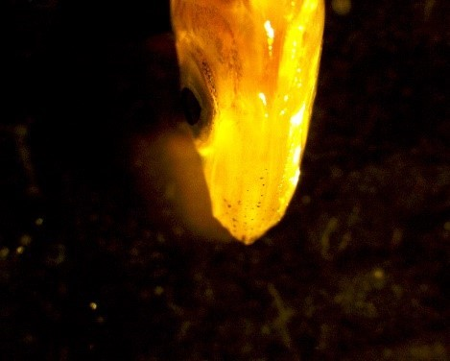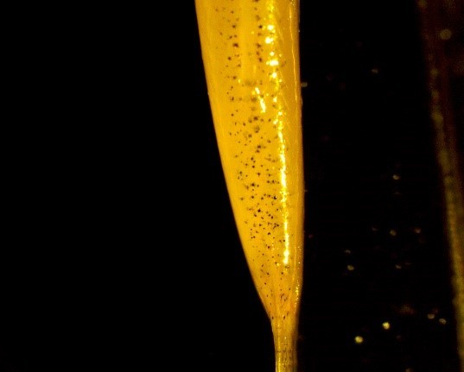

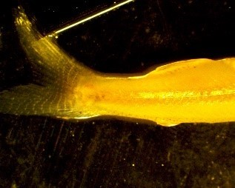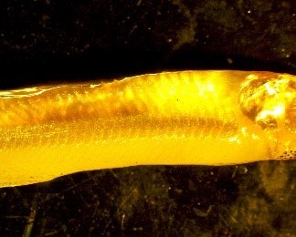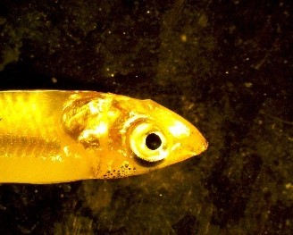

* Save each picture file with the genetic ID and photo number (ex: “2020_WAG_001-01”). Be consistent in the use of “_” or “-“

1. Take a fin clip for genetic identification (see general instructions above in section A)
2. Preserve whole fish in a glass sample vial in 95% ethanol.

## C. Special Studies

If necessary for a special study, follow the instructions below for stomach dissection and/or otolith removal.

### I. Stomach dissection:

1. Open body cavity by using a scalpel to cut across the belly from the anal vent to the operculum, exposing the organs, as pictured below:

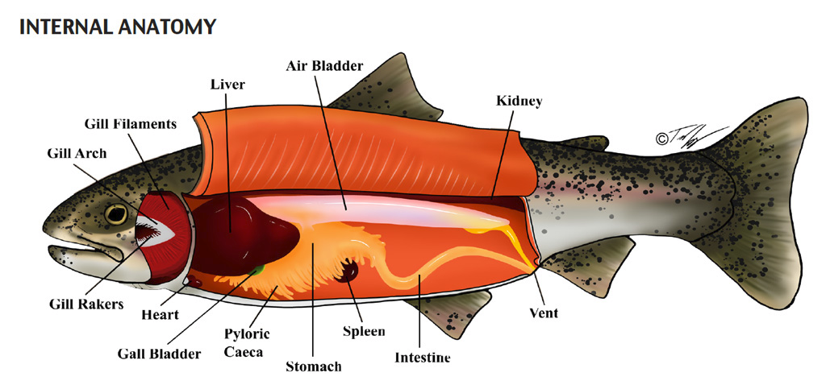

1. Remove the stomach by cutting at the esophagus and intestine. Once the stomach is removed, clean it by removing pyloric caeca and intestine so that only stomach (J-shape) is included. Place stomach into original vile and discard the rest of the body.

more detailed internal view of salmon, highlighting the J-shaped part of the stomach to be removed during dissection

### II. Otolith dissection:

Otoliths are ear stones which lay down daily rings, similar to rings on a tree, and can be used to estimate age, growth, stress and habitat use. Otoliths are small and can be difficult to dissect.

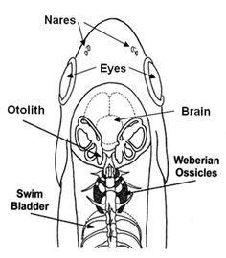



1. Cut into skull starting above the eye through the forehead, moving straight back past the operculum (yellow line in figure above).

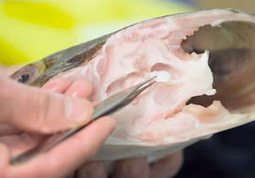

1. Pull back the top of the skull. The otoliths are located at the base of the semicircular canals (used for equilibrium, a fish’s version of the inner ear) towards the back and beneath the brain; vertically level with the eyes.
2. Otoliths are encased in a membrane, and Osteichthyes have three pairs of otoliths. The largest pair of otoiths, sagittae otoliths, should be removed with forceps and placed into an Eppendorf tube with a premade label, identical to that fish’s genetic tag.
   * If only one otolith can be found or either otolith is broken it should be noted on the dissection sheet.
   * Be careful to place otolith fully into the Eppendorf tube.
   * Clean dissection area between samples, because lapilli otoliths from larger fish can be mistaken for sagitaae otoliths from smaller fish.

# Past SOP editors and collaborators:

* [4/29/2020] – Nicole Kwan, Craig Stuart, and Amanda Casby: Updated format, content, and photos for this SOP.
* [10/22/2020] – Nicole Kwan and Amanda Casby: Made final edits as part of the internal review.
* [12/29/2020] – Nicole Kwan: Updated formatting and migrated to Yolo Drive.
* [8/30/2021] – Nicole Kwan & Cat Pien: Updated Division and Unit names; moved COC information from smelt to general section; removed duplicate line about genetic sampling; changed title from “juvenile fish” to just “fish”