Yolo Bypass Fish Monitoring Program: Laboratory Dissection of Fish

Document Control Number: DWR-6-SOP-007

Version: 2.0

Status: In-progress

Effective Date:6/23/2022

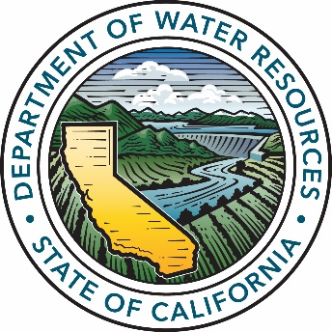

Department of Water Resources

Division of Integrated Science and Engineering

3500 Industrial Blvd

West Sacramento, CA, 95691

# 

|  |  |
| --- | --- |
|  |  |
| Name position and program division | Name position and program division |
|  |  |
| Name position and program division | Name position and program division |
|  |  |
| Name position and program division | Name position and program division |
|  |  |
| Name position and program division | Name position and program division |
|  |  |
| Name position and program division | Name position and program division |
|  |  |
| Name position and program division | Name position and program division |

Contents

Title Page 1

Approval Page 2

Contents 3

Acronyms & Abbreviations 5

Scope and Application 5

Contact Information 5

Personnel Requirements 5

Technical Considerations 6

Safety 6

Sample Management 6

Chain of Custody 7

Sample Collection, Preservation, Shipment and Storage 8

Equipment & Supplies 8

Cleaning and Preparation 8

Reagents and Standards Preparation 9

Calibration and Maintenance 10

Procedure 10

Procedure Subsections 10

Quality Control /Quality Assurance (QA/QC) 11

Routine Maintenance 12

Corrective Action 12

Data Analysis & Calculations 12

Data Reporting 13

Pollution Prevention & Waste Management 13

References 13

Revision History 14

Past SOP editors & Collaborators / Acknowledgements 14

Appendices 14

Acronyms & Abbreviations

|  |  |
| --- | --- |
| Acronym | Full Name |
| YBFMP | Yolo Bypass Fish Monitoring Program |
| EtOH | Ethanol |
| GVL | Genomics Variation Lab |
|  |  |

Scope and Application

Several smelt, fall, late-fall and spring run Chinook salmon, and other juvenile fish species of interest are preserved for the monitoring program’s fish collection. These fish are dissected depending on species type and, for salmon, the presence of adipose fins. The primary goal for these fish it to create an archive of chinook salmon for future directed flood plain research studies, preserve stomachs for potential diet analysis, archive Delta smelt and Wakasagi photos for morphological comparisons, and save heads for potential otolith microchemistry and tissue sampling.

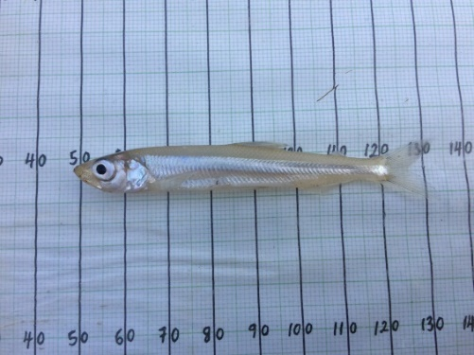 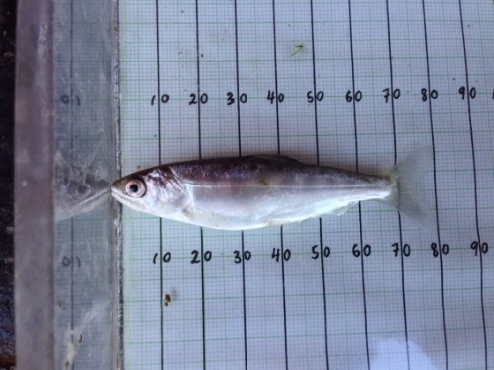 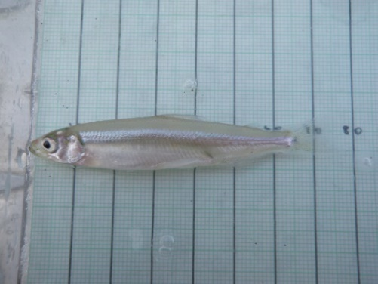

Contact Information

**Contract Manager and field lead:**

Naoaki Ikemiyagi

[Naoaki.ikemiyagi@water.ca.gov](mailto:Naoaki.ikemiyagi@water.ca.gov)

Personnel Requirements

Personnel will be trained on fish handling. Personnel will first conduct the sampling while being watched by another team member who is well-practiced in the sampling procedure.

Technical Considerations

**N/A**

Safety

All personnel should proceed with caution while using sharp cutting tools like a scalpel.

**Chemical Safety**

|  |  |  |
| --- | --- | --- |
| Chemical | GHS Tags | Hazard Warnings |
| 37% Formaldehyde |  | 1. Skin corrosion and serious eye damage (blindness) 2. Flammable (keep away from open flames or heat sources) 3. Health hazard (carcinogen) 4. Acute toxicity (severe) |
| Ethyl Alcohol |  | 1. Flammable (keep away from open flames or heat sources) 2. Irritant, dermal sensitizer, acute toxicity (harmful) 3. Health hazard (carcinogens) |

Safety Responses – Based on the hazards above:

1. After Skin Contact: Wash affected area with soap and water. Rinse/flush exposed skin gently using water for 15-20 minutes. See medical advice if discomfort or irritation persists.
2. After Eye Contact: Protect unexposed eye. Rinse/flush exposed eye(s) gently using water for 15-20 minutes (use eyewash station if available). Remove contact lens(es) if able to do so during rinsing. Seek medical attention if irritation persists or if concerned.
3. After Swallowing: Rinse mouth thoroughly. Do not induce vomiting.
4. After inhalation: Remove individual to fresh air and keep comfortable for breathing.

Sample Management

**Required.** N/A

Chain of Custody

All relevant data should be written down on the species of interest log sheets (:\YOLO BYPASS DATA\Yolo Biological Data\Fish\Genetics Data\Species of Interest log Sheets) and the data sheet from that day’s sampling.

Anytime a listed species (whole or specific parts) is transferred to an entity outside of DWR, a Chain of Custody (COC) must accompany the exchange. The COC should be signed by both parties and a copy placed in the ESA Take Reporting Binder (currently in JT Robinson’s cube). The COC should also be scanned and added into a relevant project folder. (:\YB_Contracts).

Sample Collection, Preservation, Shipment and Storage

Samples are stored either in preservative (95% Ethanol or 10% formalin) or are stored in a Whirl pack in the freezer. See details below.

Equipment & Supplies

**Required.**

* AES dissection kit
  + Metal Tray
  + Scalpel
  + Scissors
  + Sharpie and pencil
  + Internal label for body
  + Ethanol (70% Isopropyl alcohol prep pad wipes) to clean surfaces
  + Weigh boat
* Scale
* 10% formalin
* 95% ethanol
* Glass sample vials
* AEU laptop
* Dissecting microscope

Cleaning and Preparation

**Required.**

Reagents and Standards Preparation

For Chemical Preparation:\YB_Standard Operating Procedures\Chemicals\ DWR-6-SOP-011_v2.0_Chemical Handling and Prep

**NOTE**: For 10% Formalin, follow guidelines for preparation without Rose Bengal Dye

Calibration and Maintenance

**Required.** N/A

Procedures

**Immediately upon return from the field with lethal samples:**

**Note**: smelt, salmon or other juvenile fish of interest will be brought back to the laboratory on ice.

1. Determine what dissection process the fish needs to go through based on its species:

* Salmon (without an adipose fin): Place whole fish in freezer, follow the CWT SOP (:\YB_Standard Operating Procedures\Fish Sampling & Processing\ DWR-6-SOP-003_v2.0_CodedWireTagRecovery)
* Salmon (with an adipose fin): Follow steps 2-6 below
* Smelt: Follow step 2, then proceed to section B: Smelt Laboratory Processing
* Other Juvenile fish: Follow steps 2-6 below unless otherwise instructed for a special study

1. Weigh the fish in a weigh boat from the AEU dissection kit on the lab scale only if the condition of specimen is good. Those not in good condition will not give accurate weights.
2. Clean scissors with alcohol wipes for each fish. Cut one lobe of the caudal fin and place it in a 2.5 mL microcentrifuge tube with non-denatured ethanol. Remove a “genetic tag” from the corresponding Species of Interest Log sheet, and place in the tube with the genetics sample. Then, fill out each fish’s date, time and location of capture, fork length, weight, etc. on the Species of Interest Log sheet and the Yolo Bypass fish datasheet.

**NOTE**: For more details on Yolo Bypass Fish Monitoring Program genetic procedures, see the Genetics SOP.

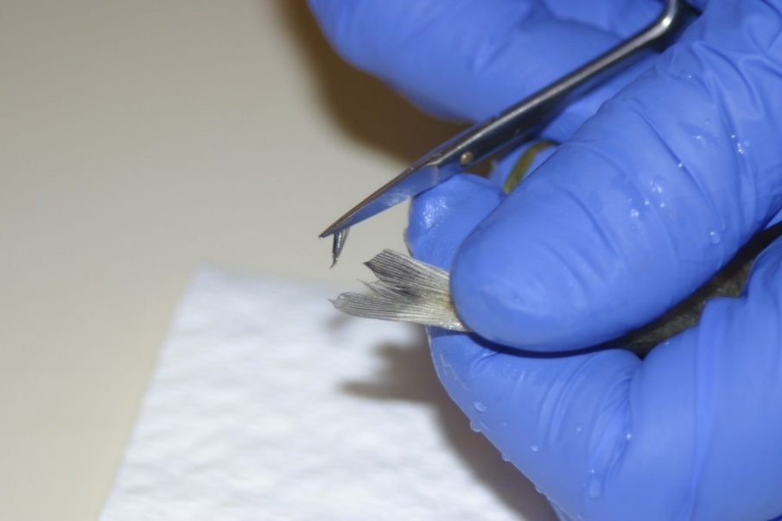 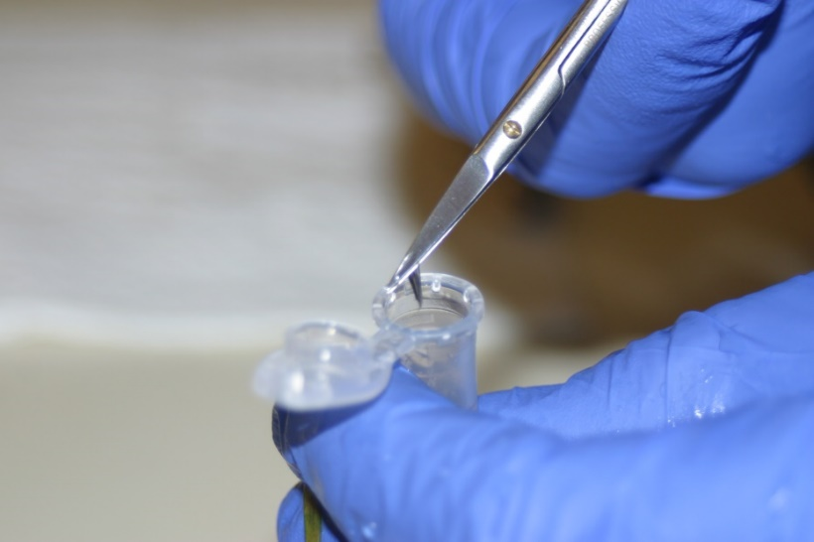

1. Use a clean scalpel to cut the fish just behind the operculum. Place the stomach in a glass sample vial with a new label and enough 10% formalin to be fully submersed.

**NOTE:** Some fish may be too large for the glass stomach vials. If so, follow the guide for removing the stomach in the Special Studies section below and place whole fish with stomach taken out into the whirl pack back in the freezer. Write on the whirl pack that the stomach has been taken out.

**NOTE**: For Instructions on how to make a 10% formalin, reference the Chemical Handling and Prep SOP.

**NOTE**: The otolith is very close to the operculum, so don’t cut to the left of the operculum.

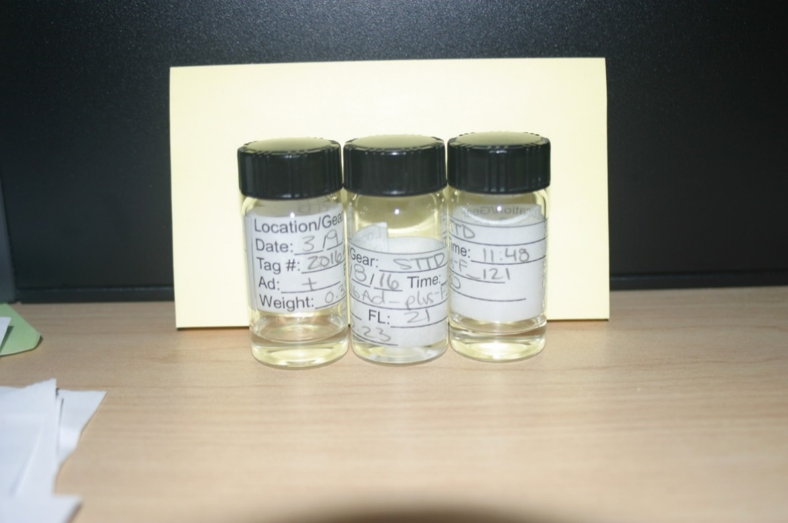

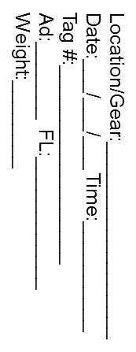

1. Put the head back in the original whirl pack with the original label and place it in the corresponding species Ziplock bag in the freezer.

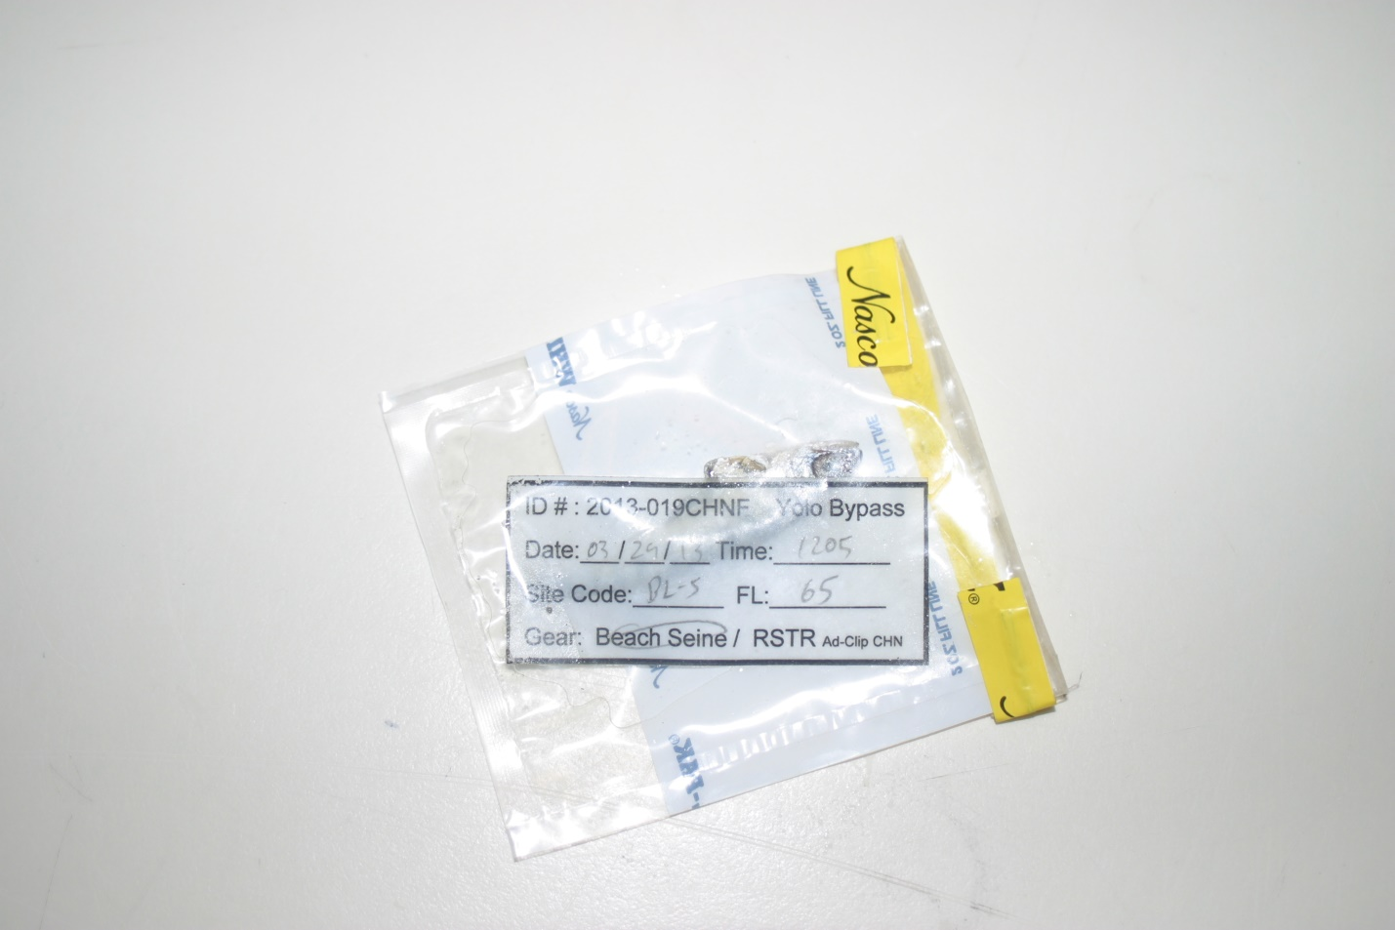

1. Record all details on the associated Species of Interest Log sheet.

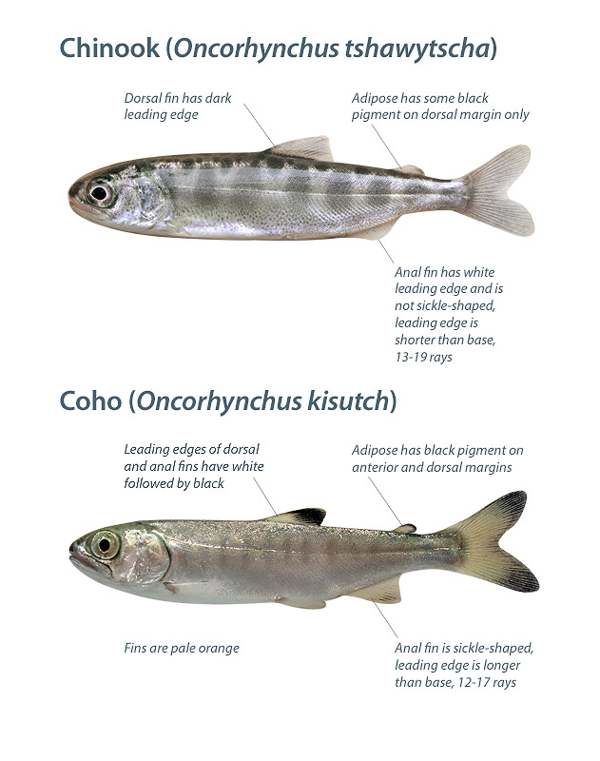

Put back in original bag, with original label and then in the freezer

Put in jar, with new label and formalin

Clean scissors for each sample

Put in tube, with small label

**Otolith is around here, so don’t cut to the left of the operculum**

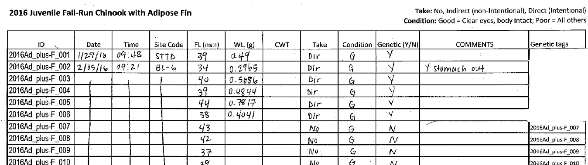

1. Anytime a listed species (whole or specific parts) is transferred to an entity outside of DWR, a Chain of Custody (COC) must accompany the exchange. The COC should be signed by both parties and a copy placed in the ESA Take Reporting Binder (currently in JT Robinson’s cube). The COC should also be scanned and added into a relevant project folder.

**Smelt Laboratory Processing:**

1. Place fish under the dissection scope to check for general morphology, chromatophores, and v-shaped pigmentation on caudal peduncle.

* **NOTE**: At least two staff members should look at each smelt and a consensus is needed to make a species call.
* Chromatophores: Look for the isthmus, check for pigmentation. Chromatophore is the dot pigmentation on isthmus. Wakasagi has two or more chromatophores on the isthmus. Delta Smelt has one or no chromatophore on their isthmus.
  + - Juvenile Wakasagi may be missing chromatophores, they develop chromatophores as they mature.

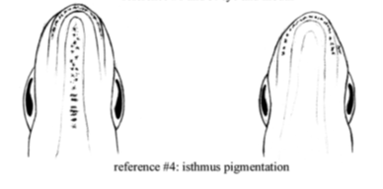

Figure: Wakasagi (left) and Delta Smelt (right) isthmus pigmentation.

* V shape: Look for pigmentation on top of the caudal peduncle of the fish. Wakasagi will have scattered spots all around the top, while Delta Smelt will have smaller number of spots that are clustered around the caudal fin, creating a sort of v-shape.

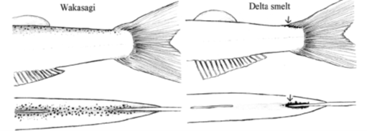

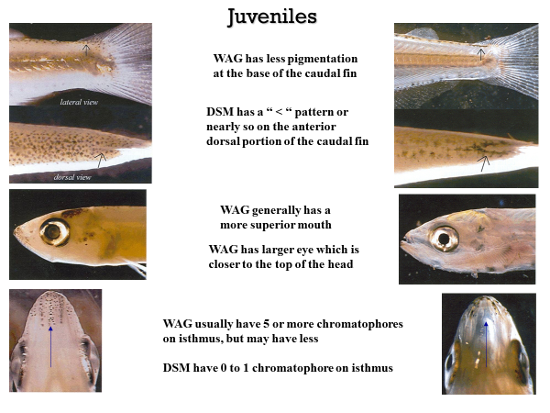

1. Once a species ID has been determined, write down information (# of chromatophores, v-shape, etc.) on the associated species of interest log sheet.
2. Take pictures of each smelt using the dissecting scope and your phone camera. Pictures should include one of the isthmus, one of the caudal peduncle (top view), and full side body shot. Examples:

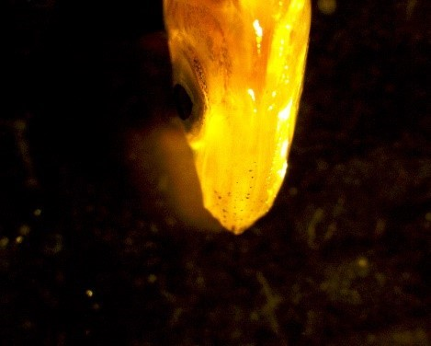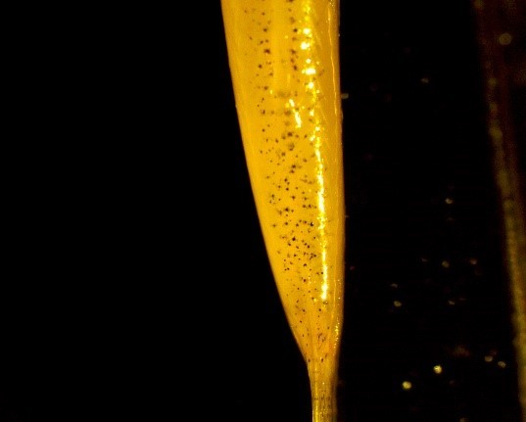

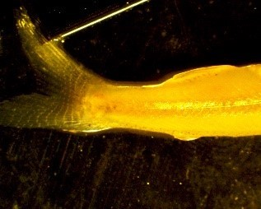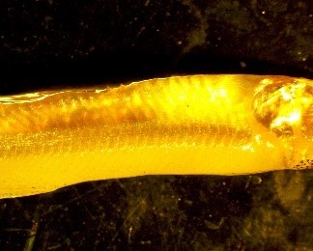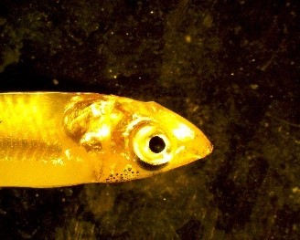

* Save each picture file with the genetic ID and photo number (ex: “2020_WAG_001-01”). Be consistent in the use of “_” or “-“

1. Take a fin clip for genetic identification (see general instructions above in section A)
2. Preserve whole fish in a glass sample vial in 95% ethanol.

**Special Studies:**

If necessary for a special study, follow the instructions below for stomach dissection and/or otolith removal.

1. Stomach dissection:
   1. Open body cavity by using a scalpel to cut across the belly from the anal vent to the operculum, exposing the organs, as pictured below:

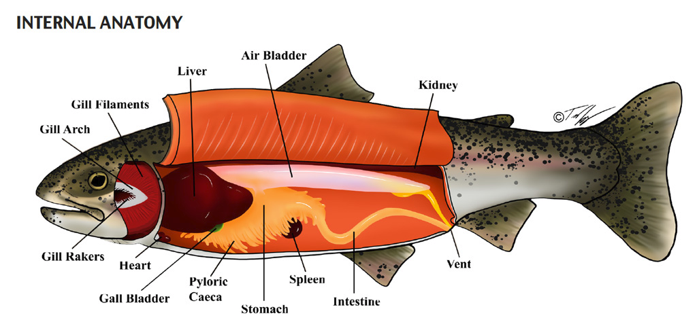

* 1. Remove the stomach by cutting at the esophagus and intestine. Once the stomach is removed, clean it by removing pyloric caeca and intestine so that only stomach (J-shape) is included. Place stomach into original vile and discard the rest of the body.

more detailed internal view of salmon, highlighting the J-shaped part of the stomach to be removed during dissection

1. Otolith Dissection:

Otoliths are ear stones which lay down daily rings, similar to rings on a tree, and can be used to estimate age, growth, stress and habitat use. Otoliths are small and can be difficult to dissect.

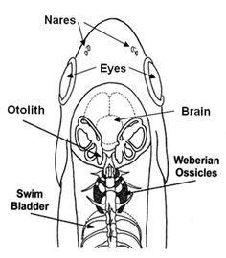



* 1. Cut into skull starting above the eye through the forehead, moving straight back past the operculum (yellow line in figure above).

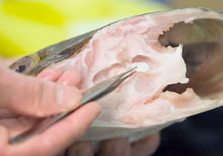

* 1. Pull back the top of the skull. The otoliths are located at the base of the semicircular canals (used for equilibrium, a fish’s version of the inner ear) towards the back and beneath the brain; vertically level with the eyes.
  2. Otoliths are encased in a membrane, and Osteichthyes have three pairs of otoliths. The largest pair of otoiths, sagittae otoliths, should be removed with forceps and placed into an Eppendorf tube with a premade label, identical to that fish’s genetic tag.
     + If only one otolith can be found or either otolith is broken it should be noted on the dissection sheet.
     + Be careful to place otolith fully into the Eppendorf tube.
     + Clean dissection area between samples, because lapilli otoliths from larger fish can be mistaken for sagitaae otoliths from smaller fish.

Quality Control /Quality Assurance (QA/QC)

**Required.** N/A

Routine Maintenance

**As Needed.** N/A

Corrective Action

**Required.** N/A

Data Analysis & Calculations

**Required.** N/A

Data Reporting

**Required.** N/A

Pollution Prevention & Waste Management

Any chemical waste should be disposed of in the proper waste container. See Chemical Handling and Prep SOP.

References

Genetics SOP:\YB_Standard Operating Procedures\Fish Sampling & Processing\ DWR-6-SOP-007_v2.0_Genetics

Chemicals SOP:\YB_Standard Operating Procedures\Chemicals\ DWR-6-SOP-011_v2.0_Chemical Handling and Prep

Revision History

|  |  |  |  |  |
| --- | --- | --- | --- | --- |
| **Revision** | **Effective Date** | **Section** | **Description of Change** | **Justification of Change** |
| 1.0 | 4/29/2020 | All | New document | Nicole, Craig and Amanda: updated format, content and photos. |
|  | 10/22/2020 |  | Edits | Nicole and Amanda: made final edits as part of the internal review |
|  | 12/29/2020 |  | Formatting | Nicole: updated formatting and migrated to the Yolo Drive |
|  | 8/30/2021 |  | Edits | Nicole and Cat: updated division and unit names, moved COC information from smelt to general section, removed duplicate line about genetic sampling, changed title from “juvenile fish” to just “fish” |
| 2.0 | 6/23/2022 |  | Formatting | Emily: Updated document to new format from QA |
| 2.1 | 8/21/2023 |  | Edits | Luke: Put in changes to smelt/wagasaki pictures and added clarifying notes. |

Past SOP editors & Collaborators / Acknowledgements

|  |  |  |  |  |  |
| --- | --- | --- | --- | --- | --- |
| **First Name** | **Middle Initial** | **Last Name** | **Organization** | **e-mail address** | **Author/ editor** |
| Nicole |  | Kwan | DWR | nicole.kwan@water.ca.gov | Author |
| Craig |  | Stuart | DWR |  |  |
| Amanda |  | Casby | DWR | No longer at DWR |  |
| Cat |  | Pien | DWR | No longer at DWR |  |
| Emily |  | Hubbard | DWR | [Emily.hubbard@water.ca.gov](mailto:Emily.hubbard@water.ca.gov) | editor |
| Luke | A | Olson | DWR | [Luke.olson@water.ca.gov](mailto:Luke.olson@water.ca.gov) | editor |

Appendices