Yolo Bypass Fish Monitoring Program: Genetics SOP

Document Control Number: DWR-6-SOP-007

Version: 2.1

Status: In-progress

Effective Date: 6/23/2022



Department of Water Resources

Division of Integrated Science and Engineering

3500 Industrial Blvd

West Sacramento, CA, 95691

# 

|  |  |
| --- | --- |
|  |  |
| Name position and program division | Name position and program division |
|  |  |
| Name position and program division | Name position and program division |
|  |  |
| Name position and program division | Name position and program division |
|  |  |
| Name position and program division | Name position and program division |
|  |  |
| Name position and program division | Name position and program division |
|  |  |
| Name position and program division | Name position and program division |

Contents

Title Page 1

Approval Page 2

Contents 3

Acronyms & Abbreviations 5

Scope and Application 5

Contact Information 5

Personnel Requirements 5

Technical Considerations 6

Safety 6

Sample Management 6

Chain of Custody 7

Sample Collection, Preservation, Shipment and Storage 8

Equipment & Supplies 8

Cleaning and Preparation 8

Reagents and Standards Preparation 9

Calibration and Maintenance 10

Procedure 10

Procedure Subsections 10

Quality Control /Quality Assurance (QA/QC) 11

Routine Maintenance 12

Corrective Action 12

Data Analysis & Calculations 12

Data Reporting 13

Pollution Prevention & Waste Management 13

References 13

Revision History 14

Past SOP editors & Collaborators / Acknowledgements 14

Appendices 14

Acronyms & Abbreviations

|  |  |
| --- | --- |
| Acronym | Full Name |
| EtOH | Ethanol |
| GVL | Genomic Variation Lab |
| NMFS | National Marine Fisheries Service |
| PFD | Personal Flotation Device |
| QA | Quality Assurance |
| QC | Quality Control |
| YBFMP | Yolo Bypass Fish Monitoring Program |

Scope and Application

Genetic verification is done for species of interest sampled by the Yolo Bypass Fish Monitoring Program’s rotary screw trap, beach seine, and fyke trap. Genetic verification aims to answer the questions:

* What species of fish are we catching in our sampling methods?
* Are we correctly identifying fish in the field?
* Are we correctly assigning run type for Salmon using length by date estimates?

A small tissue sample is taken from the fish to be identified and preserved in EtOH. It is then given to one of our two contractors for genetic analysis. Salmon samples are sent to Michigan State University and all other fish identification is conducted by the Genomic Variation Lab (GVL) at UC Davis.

Contact Information

**Contract Manager and field lead:**

Naoaki Ikemiyagi

[Naoaki.ikemiyagi@water.ca.gov](mailto:Naoaki.ikemiyagi@water.ca.gov)

Personnel Requirements

Personnel will be trained on fish handling. Personnel will first conduct the sampling while being watched by another team member who is well-practiced in the sampling procedure. Personnel will look over the MSDS for 95% EtOH.

Technical Considerations

* Fin clips should be taken only when the fish is greater than 25 mm in length.
* Fish should be handled as little as possible and should be processed quickly and returned to the water.
* DNA cross-contamination is always a potential issue that can compromise results from molecular studies (i.e. the contamination of one sample of DNA with DNA from another sample). To avoid cross-contaminating DNA specimens, you should use sterile laboratory techniques in the field or in the laboratory. Prior to every fin clip collection from a specimen, the scalpel, knife, razor blade, or scissors and forceps must be cleaned thoroughly with a 70% Isopropyl alcohol prep pad to remove any possible previous DNA.
* Wet tissue samples need to be completely immersed and not exposed to air (vial should be filled to the top). Exposure of alcohol-stored tissue to air can cause cell wall fracturing and loss of DNA into the liquid buffer. A minimum 10:1 ratio of preservative to tissue is desired.
* Samples in EtOH exposed to extreme sun/ heat may damage the DNA. Store samples in a cool, dark location.

Safety

**Chemical Safety**

|  |  |  |
| --- | --- | --- |
|  | GHS Tags | Hazard Warnings |
| Ethyl Alcohol (EtOH) |  | 1. Flammable (keep away from open flames or heat sources) 2. Irritant, dermal sensitizer, acute toxicity (harmful) 3. Health hazard (carcinogens) |

Information on chemical safety can be found in the MSDS binder located under the remote fume hood or online at [https://sdsbinderworks.com/] (username: dwr, password: water)

Field Safety

* Fish could carry zoonotic diseases or have environmental toxins on their skin. Wash hands after handling fish.
* Always wear a PFD near the water.

Sample Management

**Required.** N/A (already discussed in other sections of document)

Chain of Custody

* Contracts: Yolo Bypass:\\YB_Contracts
* Genetics data: Yolo Bypass:\\YOLO BYPASS DATA\Yolo Biological Data\Fish\Genetics Data
  + When samples are sent to contractors, a copy of the species of interest log sheet are attached as well

Sample Collection, Preservation, Shipment and Storage

Genetics samples are stored in small vials of ethanol. Boxes of these are currently stored in Naoaki’s cubicle until it’s time to deliver them to UC Davis GVL to be processed.

Equipment & Supplies

* Genetics Kit
  + Whirl Packs (insert sizes available here)
  + Fine point Sharpie
  + Species of Interest log sheets
  + Species of Interest internal labels
  + 2ml microcentrifuge tubes w/ 95% ethanol (provided by contractors)
  + Dissection scissors
  + Tweezers
  + 70% Isopropyl Alcohol Prep pad wipes
* Scale
* Yolo Bypass Fish Datasheet
* Ice chest w/ice

Cleaning and Preparation

Genetics kit will be cleaned at the end of the year and then prepped for the next year. See Routine Maintenance: New Year section below.

Calibration and Maintenance

Genetics kit will be checked periodically to ensure all supplies are present and in good working order.

* Make note in the field if we are filling up the species of interest log sheets. New pages should be printed out back at the office once full sheets have been used up.
* Routinely inspect the box containing ethanol vials. If vials don’t contain adequate ethanol (i.e. they weren’t closed properly and some evaporated), new ones should be prepared.
* Genetics kit should be monitored and restocked with 70% isopropyl alcohol wipes throughout the year depending on usage. Make sure to throw away used ones.
* Check scissors / tweezers for rust.

Sample Collection Procedure

Fish Collection

1. Determine if the sampled fish should be kept or released by consulting the Species Take Guide/Cheat Sheet (updated yearly by genetics sample lead and field leads) which can be found in the genetics kit; follow the protocol for collection listed on this guide.

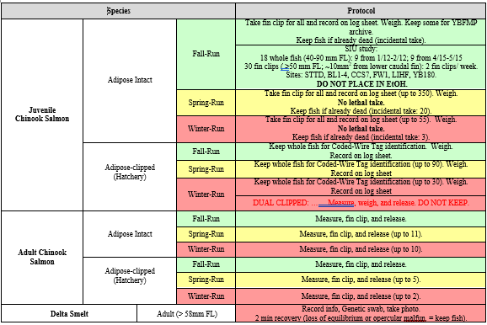

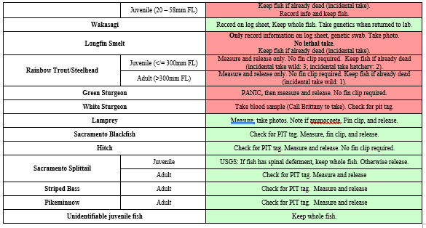

*Example take guide. Genetic sampling protocol is broken down by species. Take guide is updated annually, so please check the correct years folder in the species of interest log sheets for the correct guide. DO NOT USE THIS FIGURE AS A GUIDE.*

1. Based on the Take Cheat Sheet, fish may be fin clipped in the field (if take is not required or not possible due to listing status) or back in the lab, the whole fish may be taken, or the fish is released.
   1. See Section C of this document for taking fin clips if just taking clip in the field.
   2. For Chinook salmon, predetermining if the adipose fin is present and what run it will be necessary. Use the Length-by-Date table in the genetics kit to determine expected run type based on length and catch date.
   3. For Threespine Sticklebacks, the whole fish is put into the large plastic vial with other specimens and kept.
2. Whole Fish
3. If taking whole fish, label an appropriately sized whirl pack with Date, Location, Time, FishTagID, FL, and Weight (if applicable). Find and fill out the correct internal label for the species/run and include this in the whirl pack with the fish.
   1. Internal paper labels are printed for each species of interest and stored in the genetics kit.
4. Bring the fish back to the lab freezer in a small cooler filled with ice. When using the small cooler, place the whirl pack inside of a Ziplock bag to avoid direct contact with the ice.
5. If the fish needs to be fin-clipped (associated Species of Interest Log), dissected (subset of salmon) or photographed (smelt), finish processing the fish back at the lab. Be sure to follow the Laboratory Dissection of Fish SOP for the specific fish and use internal labels.
6. Fin Clip Collections/Vials
7. For fish in which a fin clip is to be collected, first find the appropriate Species of Interest Log. The log will have an alphanumeric code or FishTagIDs for use in identifying fish [e.g. 2020Ad_plus-F_001 (Adipose fin, Fall Run), 2020Ad_min-S_001 (No adipose fin, Spring Run)]. This unique genetic number should be copied onto the YBFMP fish data sheet as well for each respective fish.
8. Before fin clipping the fish, fill out the fields listed on the Species of Interest Log and copy these entries on the YBFMP datasheet as described below in “Data Recording”.
9. Prepare a 2.5 ml microcentrifuge tube filled with 95% ethanol for the fin clip. Tubes pre-filled with preservative can be found in the tube storage box located in the genetics kit. Label the lid of the vial with the last three numbers of the fish’s corresponding FishTagID from the Species of Interest Log, as well as the Year and Species Code (for salmon, include “F”, “S”, or “W” as well) [e.g. 2023 CHNF 001]. Use a thin Sharpie for labeling. A corresponding inner label is located on right-hand side of the Species of Interest Log. Cut this from the log and place into the vial.
10. Next, use a 70% Isopropyl alcohol wipe to sterilize a pair of tissue scissors and cut a small portion (1 cm x 1 cm square) of the upper caudal fin. Place this clip into the vial of 70% EtOH and snap closed. If the fish is alive and will be released, be sure not to cut too much of the fin, as this will impair the fish’s ability to swim. For fish that were collected according to the Species Take Guide, refer to the fish dissection protocol instead regarding how much of the caudal fin to clip.

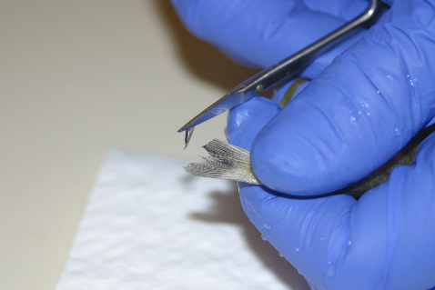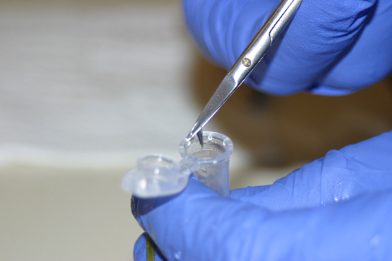

*Taking a fin clip and placing it in a tube pre-filled with ethanol.*

Data Collection and Entry Procedure

1. Data Recording
2. Record sampling information on the species of interest log sheet specific to each species found in the genetics kit. Be sure to complete all sections and explain in the comments any important notes.
3. Record details of the genetic sampling on the regular YBFMP fish data sheet as well. Include FishTagID, FL, take, condition, and stage or ad +/- if applicable. See example sheet below for recording salmon.
4. When you have returned to the office, enter the field data as seen in section B.

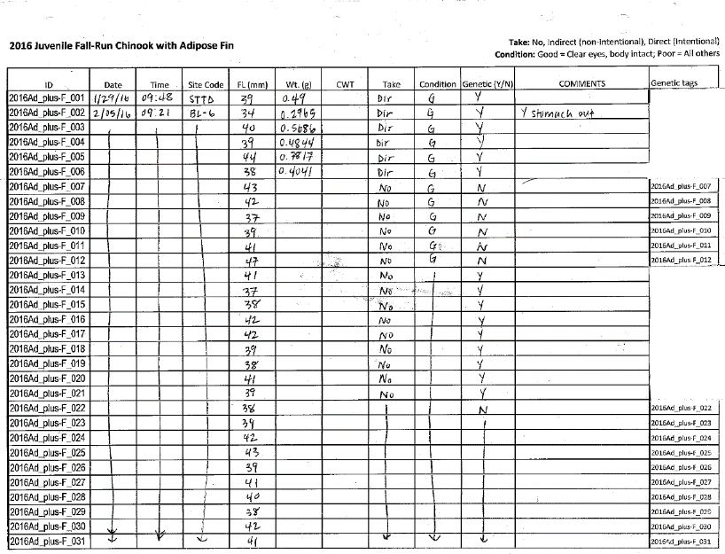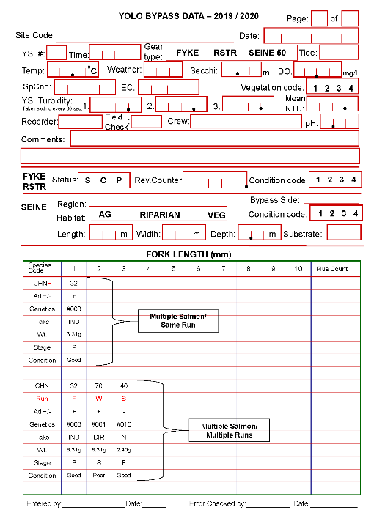

*Examples of a filled species of interest log sheet (left) and a filled fish data sheet (right).*

1. Transferring Data to the Yolo Bypass Network Data Drive
2. Start by entering the Fish Yolo Bypass Data Sheet into the Fish_Yolo2011_DB_20221006_WORKING.accdb fish database. Enter all fish as normal as seen in the Yolo Fish Data Entry Guide SOP, then add the extra details for species of interest.

* Enter the FishTagID and be sure to double check for correct “_” and “–” before finishing as it is important when later entering genetic results.
* If the fish was taken, be sure to include whether it was Direct or Indirect.
  + Direct: Taken intentionally while fish was alive by killing the fish with a flick.
  + Indirect: Taken accidentally with fish being found dead or in bad condition upon processing in the field. Sometimes fish that are not usually taken will be if take is indirect (such as certain runs of salmon).
* Include the field weight, or lab weight if taken.
* Add any comments.
* For Salmon, be sure to include Mark, Race, and Stage.

1. Once normal fish data has been entered into Fish_Yolo2011_DB_20221006_WORKING.accdb, proceed to enter data into the species of interest logs.
2. Every other week, scientific aids will make sure that all species of interest logs are up to date in the folder found below and the Environmental Scientist in charge of reporting (currently JT Casby) will bring the species of interest log sheets up to the office from the genetics kit or report directly from the inputted Species of Interest Log in the drive. Steps on how to enter the Species of Interest Log are:

* You can find all species here: "YOLO BYPASS DATA:\Yolo Biological Data\Fish\Genetics Data\Species of Interest log Sheets."
* Select the current year and enter the folder “Filled in datasheets.”
* Once you have found the correct species datasheet, enter the information from the genetics kit sheets exactly as written.
* Return the datasheets to the genetics kit promptly when finished.
* The species of interest log sheets in the “Filled in datasheets” folder should be QC’ed when a sheet is fully filled up or at the end of the year (whichever comes first).

1. Once a sheet has been filled for a Species of Interest Log, write “Entered by … on XX/XX/XXXX” at the top of the sheet with your initials and the day the last entry was entered for that sheet. Stick a note saying “Needs QA / QC” on the sheet and hand off to another scientific aid for QA / QC and given to the respective Environmental Scientist in charge of reporting (currently JT Casby). For further information on genetics QA / QC, see Quality Control / Quality Assurance Procedure below.
2. Submitting Samples
3. Once a box of vials has been filled, all sample vials should be brought to genetics sampling lead (currently Naoaki Ikemiyagi) for storage until submission to the GVL at UC Davis for genetic ID.
   1. Occasionally certain species will be needed for submitting at certain time intervals. Genetics sampling lead will ask for them or collect them as needed.
   2. Salmon samples are run on a Fluidigm chip and the other fish are ID’d using Sanger sequencing. Both labs require large batches to run either on a chip or a plate, so samples can be turned in big batches.
   3. COC will be prepared using the species of interest log sheets
   4. Email Emily Funk ([ecfunk@ucdavis.edu](mailto:ecfunk@ucdavis.edu)) when salmon samples are ready
   5. Email Mary Badger ([mebadger@ucdavis.edu](mailto:mebadger@ucdavis.edu)) when fish ID samples are ready
4. Entering Genetic Results in Database
5. A few times a year, fin clips are sent to the Genomic Variation Laboratory at UC Davis to run the genetic identification tests.
6. The Environmental Scientist that receives these results (currently Naoaki Ikemiyagi) will print them and place them in the “Genetics” folder in the “to be entered” bin in the scientific aid cubicle.
7. These results can then be entered into excel and the fish database depending on species.
8. SALMON

* Enter the genetic results into the master salmon genetics excel sheet found here: "YOLO BYPASS DATA:\Yolo Biological Data\Fish\Genetics Data\Salmon\CHN genetic IDs_YBFMP_2015-present.xlsx."
  + If wanted, you can create an access query to filter all field data for entering to make things easier.
* Copy and paste the general fish information from the species of interest log sheets to avoid any mistypes in transferring.
* Enter the genetic results into the fish database table called “SalmGenetics.”
* Be careful when entering the FishTagID because the ID entered in the table MUST match a fish that was entered in the catch data. If there is an error message when entering the best way to start investigating is to look back at the date the fish you are trying to enter was caught. Often there will be a small error in “_” or “–” in the ID. Fix the error in the original catch data OR genetics table depending on where it is incorrect then carry on. You may need to close and reopen the database after you fix the error to get the message to go away.
* Write “entered on mm/dd/yyyy” with your initials on the results sheet and place it in the “Genetics” folder in the Needs QA / QC bin.

1. SMELT

* Enter the genetic results into the fish database table called “SmeltGenetics.”
* As mentioned above, be careful when entering the FishTagID because the ID entered in the table MUST match a fish that was entered in the catch data. If there is an error message when entering the best way to start investigating is to look back at the date the fish you are trying to enter was caught. Often there will be a small error in “_” or “–” in the ID. Fix the error in the original catch data OR genetics table depending on where it is incorrect then carry on. You may need to close and reopen the database after you fix the error to get the message to go away.
* Write “entered on mm/dd/yyyy” with your initials on the results sheet and place it in the “Genetics” folder in the Needs QA / QC bin.

1. OTHER

* We currently do not have a place where Hitch (genetics taken 2018-2019) or Sacramento Blackfish (genetics taken 2018-present) genetic results are entered electronically.
* The binder with the hard copies of species of interest log sheets is in the second scientific aid cube.

Quality Control / Quality Assurance Procedure

1. Field data sheets are looked over before leaving a site to ensure all data has been filled in and looks reasonable.

Species of Interest Log Sheets

* The species of interest log sheets in the “Filled in datasheets” folder should be QC’ed when a sheet is fully filled up or at the end of the water year (whichever comes first).
* To QC these sheets, use the original log sheet from the field for comparison to the typed version in Excel to make sure there were no errors when transferring the data.
* If there were mistakes, fix them accordingly.
* If a number or observation seems unreasonable, check with the fish datasheet from that day to see if there were any special conditions or notes that didn’t get put on the log sheet comments. You can also check with the field crew listed on the fish datasheet to see if they remember anything from that day (as a last resort).
* If there are more than 3 errors in one sheet, the sheet should be kept for a second person to QA/QC.
* After the log sheet has been QC’ed write “QAQC mm/dd/yyyy” with your initials on it and bring it to the Environmental Scientist (currently JT Casby) with the hard copies of past species of interest log sheets for archiving.
  + IF it needs a secondary QC, place it back in the “needs QC” folder with a note.
  + IF it is a Hitch or Sacramento Blackfish log sheet, the binder for archiving is in the second scientific aid cube.
* On the species of interest QAQC document in Sharepoint, the dates entered and QAQC can be continuously updated throughout the year if sheets are constantly being completed.
* At the end of each water year, enter the last date that got entered into the Species of Interest Log into the Aquatic Ecology Unit Sharepoint under “YBFMP Data Resources/Data Entry_QAQC Tracker_Current/Species of Interest” and QAQC any uncompleted species logs. Mark the date of QAQC in the QAQC tracker and put status as “Complete”.
  + Sometimes runs of certain species will be over before the end of the water year, such as adult and juvenile Chinook Salmon. If that is the case, the status can be marked “Completed” and dates of entry and QAQC can be entered.

Genetic Results from GVL

* Depending on the species, you may need to QA/QC genetics data in more than one spot.
* For SALMON, QC the master Salmon genetics excel sheet in the shared drive and the salmon genetics table in the fish database.
* For SMELT, QC the smelt genetics table in the fish database.
* For MISC, there is no place currently where the genetics are entered electronically to QC.
* To QC this data, use the printed genetics results sheet to compare to what was typed into the appropriate database or excel sheet to make sure there were no errors when transferring the data.
* If there were mistakes, fix them accordingly.
* If there are more than 3 errors in one sheet, the sheet should be kept for a second person to QA/QC.
* After QC, write “QAQC mm/dd/yyyy” with your initials on the results sheet and bring it to the Environmental Scientist (currently Nicole Kwan) with the hard copies of past species of interest genetic results sheets.
* IF it needs a secondary QC, place it back in the needs QC folder with a note.

Fish Yolo Bypass Datasheets

* QA/QC these sheets as you normally would. Take special note of the FishTagID, weight, mark, race, and take for the applicable species of interest.
* Be sure to include condition in the comments if it has been forgotten.
* If there were mistakes, fix them accordingly.
* If there are more than 3 errors in one sheet, the sheet should be kept for a second person to QA/QC.
* When finished with the QC process, 3-hole punch the datasheets and add them to the corresponding trap and year binder.
* IF it needs a secondary QC, place it back in the needs QC folder with a note.

Routine Maintenance

A. New Year Preparations

1. At the end of each calendar year, new species of interest log sheets and internal labels need to be made and printed for the genetics kit.
2. In early September, touch base with everyone at a section meeting about any changes that need to be made from the following years log sheets. This could include adding or getting rid of a column on a log sheet or adding or reducing the number of species we take fin clips from.
3. Once you have determined any updates that need to be made for the next year, make a copy of the previous years Species of Interest Log sheets folder to edit. (example: for the 2020 updates, the 2019 folder was copied then the copied version was edited).
4. Be sure to update the filled in datasheets folder, log sheets to print, and tags/internal labels.
5. If headers need to be updated, you can find them in the “Log Sheet Headers” folder.

* There is a character limit for typing in the header column so the easiest way to make a new header is to type it in a text box in Microsoft Word then save it as an image.
* Once you have saved the image, click on Margins – Custom Margins – Header/Footer – Custom Header.
* From there, you can insert your saved picture into the section you want it in.
* You may also need to edit the header and footer margins in the Margins section.

1. Once all the edits are complete, print the log sheets and tags/internal labels on Rite in the Rain (All-Weather) paper.

* Print 1-5 pages of the log sheets depending on expected catch (example: we expect to catch a lot of fall run ad-plus Chinook, so print pages 1-5, however we don’t expect to catch a lot of winter run ad-plus Chinook, so just print one page).
* Add a colored post-it tab to the top of the log sheets (just page one if you have multiple pages for a species) and label it with the species code (example: CHNF+ or SCB).
* If you printed multiple pages for a species, add a paper clip to the top to keep them together.
* Cut out the internal labels and place them in piles by species and numerical order. Put a rubber band around each set.

1. Once all prep is completed, have another scientific aid check over them to make sure everything looks correct.
2. At the end of the last day of sampling in the current calendar year, take out all the previous year’s log sheets and labels to replace with the new year’s set. This is also a good time to clean out the genetics kit by getting rid of any trash, making sure all writing utensils work, and that all sampling tools are in good condition.
3. The previous year’s log sheets can then be taken upstairs. Be sure to check if all of them have been entered into Excel and follow guidelines found in Quality Control / Quality Assurance Procedure section above to make sure everything is QAQC.
4. Update the species take guide (found in the corresponding species of interest log sheets folder) based on the NMFS take table (salmon numbers) that will be sent by the AEU supervisor. Also update to reflect any special studies that have requested samples and any size or markings to look for.
5. Once the table has been updated, it can be printed, laminated, and added to the fish binder.

Corrective Action

**Required.** N/A

Data Reporting

**Required.** N/A

References

**Required.**

Revision History

|  |  |  |  |  |
| --- | --- | --- | --- | --- |
| **Revision** | **Effective Date** | **Section** | **Description of Change** | **Justification of Change** |
| 0.1 | 3/16/20 | All | New document | Amanda Casby: Created the document “Species of Interest SOP” |
| 0.2 | 3/19/20 | All | Edits to wording | Nicole Kwan: Made a few edits to wording from original document. |
| 1.0 | 4/20 | All | Changed title of document | Amanda Casby and Mallory Bedwell: Updated the document to be considered the “Genetics SOP”, added alternative text for photos, made some formatting changes. |
| 1.1 | 9/13/21 | All | Updated data location; updated division and unit names after reorg | Nicole Kwan: Updated staff information for where to store QA/QC’ed data; updated Division and Unit names |
| 1.2 | 9/16/21 | Safety section | Added section | Mallory Bedwell: added a safety section |
| 1.3 | 3/28/22 | Routine maintenance | Species take guide | Mallory Bedwell: added info about updating the species take guide. |
| 2.1 |  | All | Changes to QAQC procedure and updates to submitting. | Luke Olson: Changed where to track QAQC and entry for species of interest log and when to submit vials. |

Past SOP editors & Collaborators / Acknowledgements

|  |  |  |  |  |  |  |
| --- | --- | --- | --- | --- | --- | --- |
| **First Name** | **Middle Initial** | **Last Name** | **Organization** | **e-mail address** | **ORCID ID (optional)** | **Author/ editor** |
| Amanda |  | Casby | DWR | No longer at DWR |  | Author |
| Nicole |  | Kwan | DWR | Nicole.kwan@water.ca.gov |  | editor |
| Mallory |  | Bedwell | DWR | No longer at DWR |  | editor |
| Luke | A | Olson | DWR | Luke.olson@water.ca.gov |  | editor |

Appendices