DWR/DISE Aquatic Ecology Unit

**Standard Operating Procedures**

Last Revised: 9/15/2021 (JA)

Version: 1.1

# Yolo Bypass Fish Monitoring Program: Beach Seine Sampling

YBFMP beach seining is conducted in coordination with the IEP. Beach seine surveys are conducted in Yolo Bypass’s perennial channel (i.e., the Toe Drain), perennial ponds, seasonal ponds, and inundated floodplain. The main objective is to monitor nearshore habitat use by small adult and juvenile fish species. The nine core sites include the YB pond, AL1,3, and 4 as well as BL1-5, though not all sites are sampled regularly. The high flow sites are RD22, FW1, SW, LIHF, and YBI80, and are only seined during times of floodplain inundation or high flows. Sampling days are usually scheduled with the tidal cycle, providing an adequate amount of water at sites but shallow enough that field crew workers can wade safely.

## Equipment:

* 25ft x 4ft pole seine
* Measuring tape
* Type III PFD’s
* Throw bag
* Secchi
* YSI handheld (ProDSS)
* 5-gallon buckets (at least 2)
* Cut resistant gloves
* Small fish measuring boards (2)
* Small fishing nets
* 2 aerators
* Fish data clipboard/binder
  + Data sheets
  + Fish ID keys
  + Scientific collection permits
  + Pens/pencils
* Genetics kit (see Genetics SOP)

## Requirements Before Operation:

### A. Crew:

A successful beach seining program requires professional and technical staff dedicated to the success of the project. Winter and Spring storm events increase river discharge and debris loads, making sampling more difficult, dangerous, and time consuming. Sampling all beach seine sites during these periods often requires working long and physically taxing periods.

A minimum crew of two is required for sampling, though three is ideal (two for pulling the seine and one for taking water quality samples). A field lead, typically an Environmental Scientist, supervises the field crew. The field lead oversees the project, schedules the crew, and facilitates communication with crew members, supervisors, project leads and collaborators.

### B.Training**:**

Before participation in the beach seine surveys, all personnel are briefed by a field lead during the tailgate safety training. All personnel must be able to swim and feel comfortable working in challenging terrain and conditions such as heat and cold, uneven ground, stinging insects, and potentially dangerous equipment. In addition to these requirements, CPR, Wilderness First Aid, and Swift Water Rescue Training should be completed as soon as possible and certification maintained.

### C. Safety:

Life Jackets (Type III PFD) must always be worn by all personnel when operating in or around the water. Under normal conditions, staff will sample the nearshore habitat along the Toe Drain. Sampling will often occur to the edge of the natural shelf created by the main channel, avoiding the drop-off. Due to poor visibility from high turbidity in the Toe Drain, care must be taken when conducting beach seines to avoid falling or overtopping waders. Wader belts should be tight to prevent excess water infiltration if overtopping does occur. Spare clothes are kept in the AEU trucks in the event they are needed and should be used to reduce the chance of hypothermia. During hot conditions, staff should be informed of the heat illness prevention plan prior to field sampling. A large cooler of ice water is required for the field crew in hot temperatures.

Other things to lookout for while working along the Toe Drain:

* Electric fences may be put up for the livestock at certain times of the year.
* Barbwire fences may be upright or broken and could be scattered around, watch your step.
* Watch out for any potential allergic reactions as you are exposed to various biohazards in the field (e.g., *Microcystis,* wasps, bees, etc.)
* Check to see if Microcystis is present or if sampling conditions make it likely (warm and stagnant water during spring and summer). If there is any sampling with risk of exposure directly from water or indirectly from handling equipment, one should follow guidelines in the Microcystis Safety Protocol.

## Methods:

### Sample Collection:

Beach seine procedures are split into two parts: Fish sample collection and water quality collection. This SOP will focus on the fish sample collection procedures, refer to the water quality section of the lower trophic SOP for details on collecting water quality data.

1. Crew members must wear appropriate field attire. Depending on the time of year, this can include eye protection, sunscreen, hats, layers for cold weather, and gloves. It is also important for crew members to adjust their waders and PFD to fit properly.
2. Gather all necessary equipment before heading down the levee to the water’s edge. ***SAFETY NOTE****: walking down the levee can present tripping hazards such as drop-offs and hidden holes, and slopes can be steep and muddy/slippery, especially after rain. Proceed with caution to each site.*
   1. Pole seine
   2. YSI ProDSS handheld
   3. Fish data clipboard/binder
   4. Two 5-gallon buckets filled with:
      1. Small fish measuring boards
      2. Throw bag
      3. Measuring tape
      4. Small nets
      5. Aerators
   5. Secchi disc
   6. Genetics kit
3. Typically, a crew of three will be present for a beach seine sampling event. For a crew of three, two crew members will conduct the beach seine collection while the third crew member collects water quality data. In the case of a crew of only two, both crew members will assist with water quality and then conduct the beach seine.

#### Core Sites

1. Two crew members will carry the beach seine to the start of the transect, at the downstream painted stake or marker.
   1. **Note:** during high-flows and/or inundation, stakes will not be visible, therefore crew members will need to use the tape measure to mark a 30m transect (maximum).
2. The crew member handling the outside pole will enter the water first. The second crew member will put the seine into the water, handing it off to the first crew member while the second member enters the water.
   1. **Note:** during high-flows and/or inundation, the water level at the core sites will be deeper than normal and usually over-topping the bank of the shore. These conditions require extra safety awareness as the turbid water will make it difficult to determine where the drop-off is from the shoreline.
3. Both crew members will carefully unwrap the net in the water. The crew member on the outside pole can assist the unwrapping process by slowly walking the outside pole perpendicular, away from shore, towards the center of the channel, while the other crew member stays at the nearshore position.
   1. **Note**: crew should become comfortable wading out to deeper water while handling the outside pole. This person should walk carefully and use the pole to check before taking each step.
   2. **Note**: during high-flows and/or inundation, crew must use caution when wading with the outside pole. **Sites are not accessible and should not be sampled if the drop-off is less than 4m from the water’s edge or it is too deep to wade safely.**
4. Once most of the net has been unwrapped, check to make sure the net is free of twists, all floats are at the surface, and the net is opened and facing upstream.
   1. **Note:** during high-flows and/or inundation, high water velocities can make it more challenging to operate the net and can also increase the chance of slipping. To mitigate this, avoid wading as deep as you might during calmer conditions.
5. Once both crew members are in position (net perpendicular to shore), measure the width of the seine by counting the colored tape makers (in meters) along the top of the net. The width should be either 4, 5, or 6 meters, depending on the depth of the water and weather conditions. Report width to the recorder.
6. Record the average depth of the seine. Both crew members will set the bottom of the net poles on the benthos, while holding them vertically in the water column. Using the marked measurements on the poles, determine the depth of each pole. Average the two depths and report depth to the recorder. Crew members must also take note of the bottom substrate and report it to the recorder (e.g., mud, vegetation, gravel, cobble)
7. Both crew members start together by pulling the beach seine upstream, parallel with the shoreline. Caution should be used to ensure crew members are in line with each other (this will help keep the fish contained in the path of the net).
   1. **Note:** As crew members haul the beach seine upstream, they must do their best to keep the poles dragging along the ground to ensure the lead line drags along the benthos.

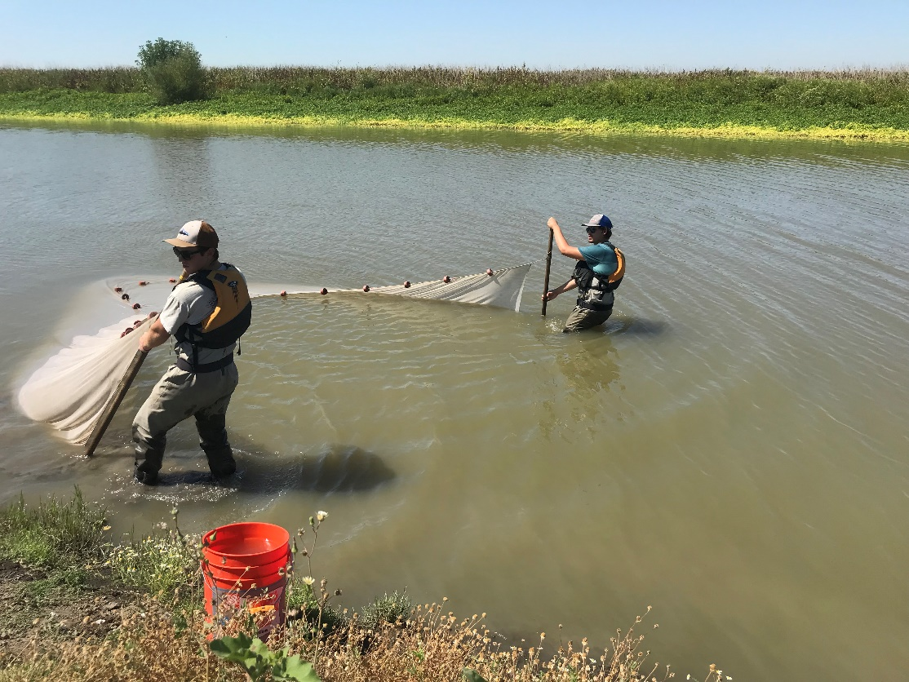

Image 1: Crew pulling seine parallel to shore.

1. Approaching the end of the transect at the upstream stake, the near shore crew member will stop and hold position at the stake while the outside crew member passes the stake and continues to make a wide turn back towards shore to meet the other crew member. Once both poles are together, crew members will prepare to remove the seine from the water.

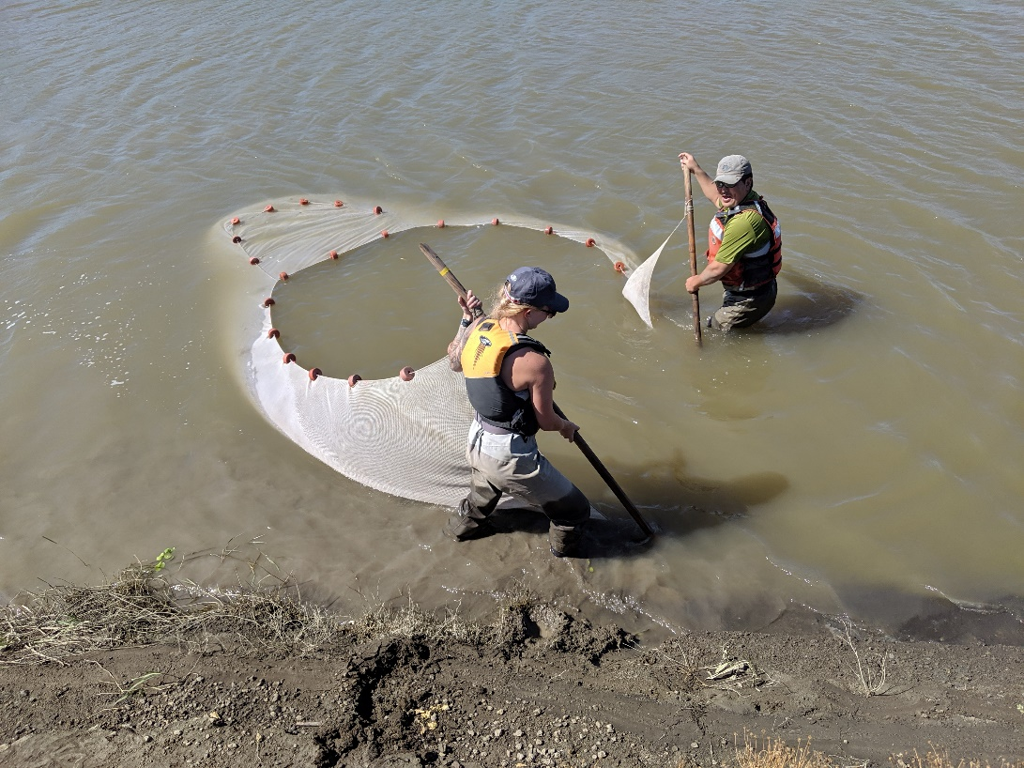

Image 2: Crew bringing seine poles together at end of seine pull.

1. One crew member will take both poles together and slowly pull the seine onto shore. The other crew member will keep the lead lines together and on the bottom as the seine is pulled out. This will ensure that no fish escape.
   1. **Note**: the crew member handling the lead lines should wear gloves in case the net picked up any thorny branches, fishing hooks, bees, or other sharp objects.
   2. While the seine is being pulled out of the water, the crew member holding the lead lines is in control of the speed and should instruct the other crew member to speed up, slow down, or stop as needed to ensure proper seine removal without loss of fish. Communication is key here!

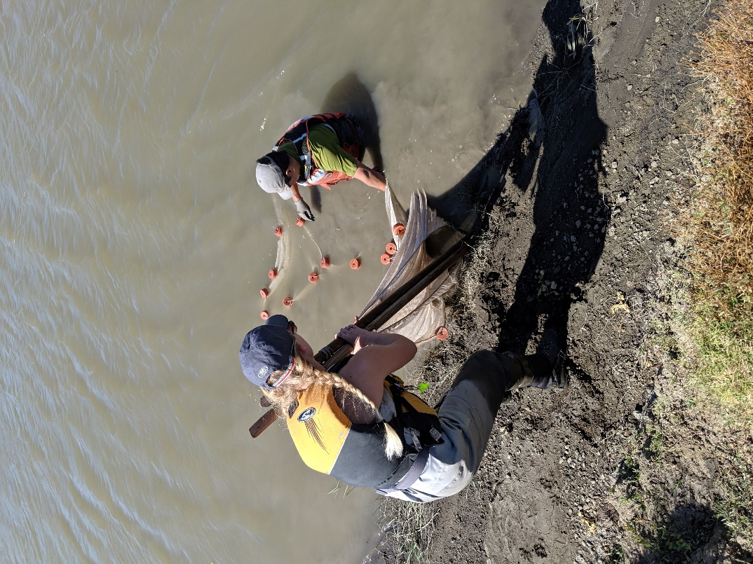

Image 3: Crew slowly lifting seine out of the water along the bank.

1. When the crew member reaches the end of the lead line, they will halt the process and “bag” the rest of the seine for transport up onto the levee.
   1. The “bagging” process takes some practice!
   2. In general, these are the steps to follow:
      1. At the end of the secured lead line, grab the net in that area and lift it slightly out of the water. This should leave you with the seine purse dangling in the water (with all the fish).
      2. While holding the seine purse, grab the net and gently shake so any fish that might have been stuck to the walls of the net fall into the purse.
2. Depending on the conditions of the shoreline, the crew member with the seine can either walk it up to the bucket of water or hand it off to another crew member to place in the bucket on shore.
3. Once the seine purse has been placed in the bucket of water, open both wings of the seine and lay them out on either side of the bucket. Visually inspect the wings to check if any fish were missed.
4. Next, slowly begin to pull the excess net out from the bucket, making sure to keep fish in the bucket. Once you’ve removed most of the net, leave enough to allow the fish to be fully submerged in the water. Adjust the net as necessary.

#### High Flow Sites, BL5, and the YB Pond

* BL5, the high flow sites, and the YB pond typically require a modified seining method but follow the core site’s general procedures. The following will give a short description of the different hauling approaches for each site.
  1. **BL5**: This site is regularly seined as part of the core sites but differs slightly in its physical features as it sits in a cove and lacks a major drop-off. **BL5 is significantly influenced by tide fluctuations and aquatic vegetation overgrowth, it may by unseinable at times.** For this site, we typically perform a standard perpendicular beach seine haul towards shore. Both crew members will start by walking together perpendicular away from shore, with the beach seine, and measure their distance with the tape measurer. Then, both crew members will unwrap the seine, measure out the net, and begin hauling the seine back towards the shore. At times, you may have to perform a beach seine haul similar to the core sites (parallel with shore) depending on the present conditions.
  2. **FW1 and RD22**: Depending on the flood conditions and available space at FW1 and RD22, the **J-seine** method might be required to perform a sample collection. A j-seine involves two crew members, one to stand in place at the nearshore position and the second to walk out into the water (measuring the width of the net) with the other pole and perform a sweeping “J” motion with the net back toward the shore. Once both crew members have met back at the shoreline, they will process the fish following the procedures below.

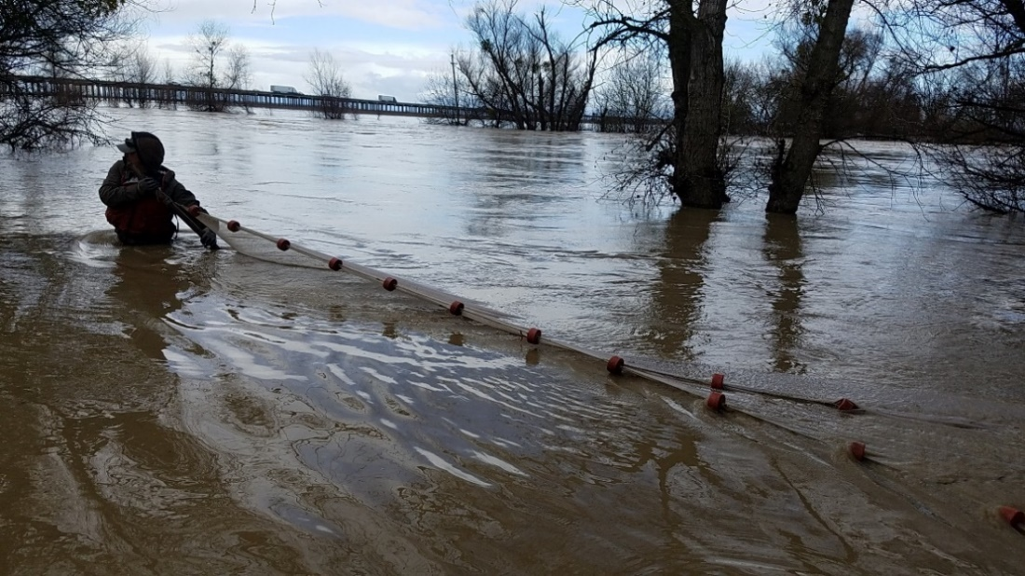

Image 4: J-seine at an overtopping site. Picture view from the person holding the pole on shore.

* 1. **SW, LIHF, YBI80**: The conditions at these high flow sites are going to depend on depth and velocity of the high flows. Typically, you will perform a beach seine haul similar to the core sites (parallel with shore) but occasionally, you will need to perform a beach seine haul similar to BL5 (perpendicular to shore), whichever the case, remember to make a note on the datasheet.

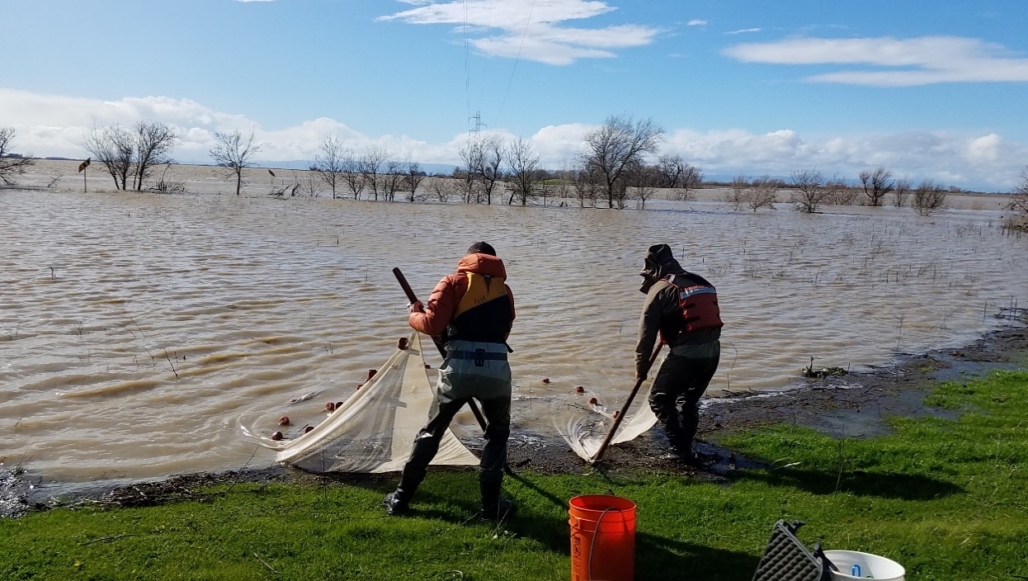

Image 5: Landing a beach seine at the high-flow Lisbon site.

* 1. **YB Pond**: The YB pond is located in Yolo Bypass floodplain and can only be accessed intermittently and when flooding is absent. Follow the steps for BL5 when performing a beach seine haul at the YB pond.

### Fish Processing:

1. The two crew members who pulled the beach seine will typically process the first while the third crew member will continue to record data.
2. Crew members will position themselves on either side of the bucket. The bucket should be placed near the water’s edge for easy fish release.

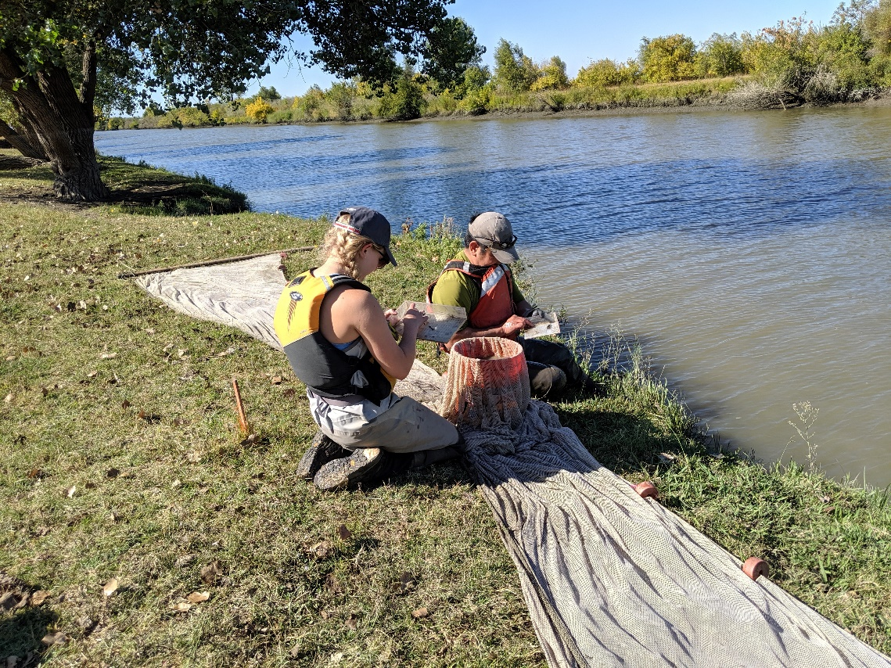

Image 6: Crew members sorting through fish.

1. Using the small fish measuring boards, both crew members will retrieve a fish (one-by-one), identify it by species, and measure it in fork length (FL). Once the fish has been recorded, it will be gently released back into the water (or in a secondary bucket if too far from water’s edge).

**Reminders**:

* + 1. Only fish (and shrimp) greater than or equal to 25mm are counted
    2. Begin plus counting species after 20 individuals of a nonnative species and 50 individuals of a native species have been measured
    3. If a fish is dead, let the recorder know and the recorder will circle the FL of the fish on the data sheet
    4. If a shrimp is expressing eggs, let the recorder know and the recorder will note a small “E” in upper right-hand corner of the box with FL

1. Species of interest, such as salmon or Sacramento blackfish, should be processed with the genetics kit. If these species are caught, place them in a separate bucket with an aerator for further genetic processing. Refer to Genetics SOP [YoloBypass:\YB_Standard Operating Procedures\Fish Sampling & Processing\DWR-6-SOP-007_v1.0_Genetics] for more information on how to process species of interest.
2. When there are no more fish remaining in the seine, crew members must lift the seine out of the bucket, then dump the remaining water in the bucket through a small net to ensure any fish that may have escaped or been stuck to the outside of the net get counted as well. Identify and measure any fish caught here as well.
3. Once all the fish have been processed and the recorder has collected all the necessary information on the data sheet, a different crew member **must** check over the data sheet to look for any inconsistencies or missing data. Then they will initial in the Field Check Box at the top of the data sheet.
4. Collect all the gear, wrap-up the beach seine, and return to the truck to move onto the next site.

### Field Data Sheet

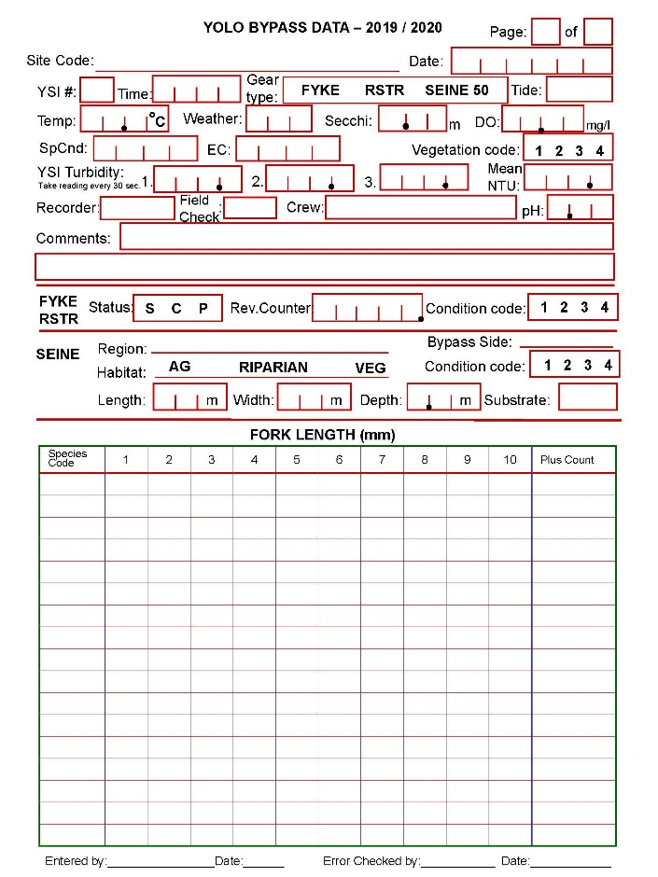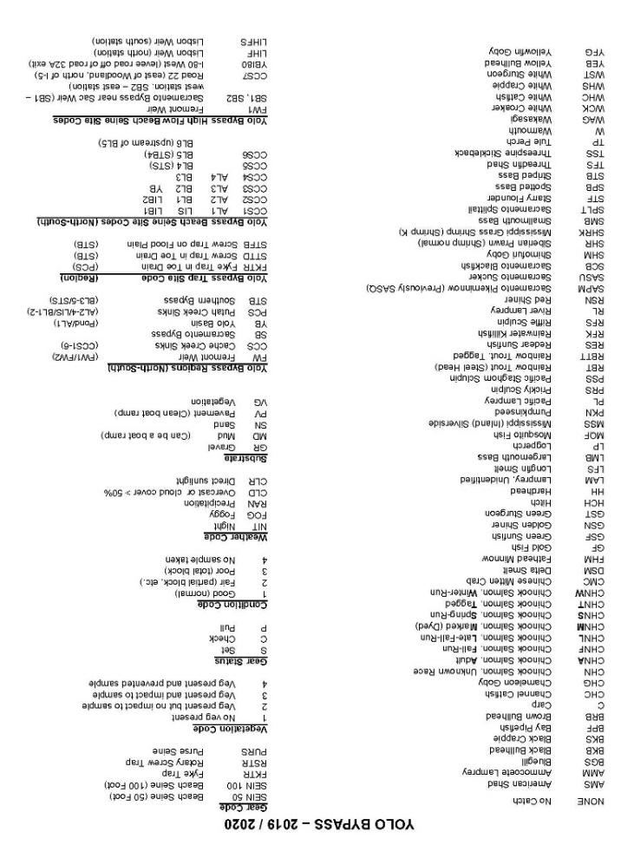

## Appendix I: Permitting

All necessary permits must be obtained from appropriate local, state, federal agencies. Sufficient time must be allotted during the planning period to secure permits. A list of the necessary permits required for installation of the rotary trap is listed below:

* **Scientific Collection Permit (SCP):** The California Department of Fish and Wildlife (DFW) requires that the YBFMP have a valid SCP for all field collection activities.  The SCP covers all sampling activities and take of non-listed species.
* **NMFS Section 10(a)(1)(A):** The National Marine Fisheries Service (NMFS) requires that the YBFMP have an Endangered Species Act (ESA) permit for the take of federally listed salmonids (winter and spring run Chinook Salmon and Central Valley Steelhead) and Green Sturgeon.  This permit is coordinated through the Interagency Ecological Program (IEP).
* **FWS Section 7:** The US Fish and Wildlife Service (FWS) requires that the YBFMP have an ESA permit for the take of federally listed Delta Smelt.  This permit is coordinated through IEP.
* **Marine Mammal Protection Act (MMPA):** NMFS requires the YBFMP to have a MMPA permit to cover the potential take or harassment of marine mammals by our sampling activities.  This permit is coordinated through IEP.
* **California Endangered Species Act (CESA) Memorandum of Understanding (MOU):** DFW requires the YBFMP to have a CESA MOU to cover the take of state listed salmonids (winter and spring run Chinook Salmon) and osmerids (Delta and Longfin Smelt).

Each permit carries with it various stipulations for trap deployment that must be rigidly adhered to. Several contain language requiring periodic reporting of operations and data while others need only be kept appraised of the continuation of trapping efforts from year to year.

## Appendix II: Maintenance

Throughout the year the beach seine will be assessed for any damage. Holes near the basket are especially important to mend as soon as possible.

* Any tears to seine should be mended using wax thread and a needle. These supplies can be found in the cage as well as some of the trucks. Ensure the mending is tight and secure once complete.
  + If holes large enough for fish to escape are noticed in the basket area of the seine during sampling, these holes should be immediately mended in the field. If this cannot occur, the sample condition should be changed to reflect the possible loss of fish.
* Once the marked measurements on the seine poles are no longer readable, they should be redone. Wait until the poles are fully dry and make these marks with Sharpie.
* The flagging on the float line that denotes 1m increments occasionally fall off. When this happens, they should be replaced with new flagging knots.
* If the lead or float line detaches from the seine poles, re-wrap them around the pole and secure with multiple UV resistant zip ties.

Occasionally, sites will also need some maintenance.

* When banks become too steep to ascend after pulling the seine, use a shovel to carve out some steps for crew members to climb the banks.
* Sometimes the wooden markers on the site will be pulled out or otherwise lost. When this happens, new markers should be put in the ground with the correct spacing.
* When markers become less visible, clear brush around them and re-paint them with orange spray paint.

## Past SOP editors and collaborators:

* 5/14/2020 – Craig Stuart: Created SOP and updated procedures to reflect current sampling process.
* 6/17/2020 – Nicole Kwan: Finished editing for consistency with other fish sampling SOPs; added photos; added maintenance procedures.