DWR/DISE Aquatic Ecology Unit

**Standard Operating Procedures**

Last Revised: 10/21/2021 (NK, NI)

Version: 1.1

# Yolo Bypass Fish Monitoring Program: Fyke Trap Sampling

The YBFMP uses a fyke trap to examine the species composition and the timing and duration of large fish migrations through the Yolo Bypass relative to different physical conditions. The trap is typically deployed at the beginning of the week, checked daily, and then pulled out at the end of the week. The focus has been on anadromous fish species (i.e. adult Chinook Salmon and sturgeon); however useful data is also collected on other fishes. The objectives of the fyke trap are to: (1) examine abundance, species, and life history composition of migrating and resident adult fishes; (2) identify temporal and spatial patterns in fish abundance and species composition, especially with regard to anadromous species; (3) examine the effect of physical and environmental conditions on these patterns; and, (4) to compare timing and duration of species captured in the Yolo Bypass to those captured in other Sacramento Valley tributaries.

## Equipment:

* Fyke trap
* Truck w/ winch
* Winch controller
* Safety strap (safety donut?)
* Wire clamp
* Heavy-duty glove (for winch)
* Type III PFD – fitted life jacket
* Secchi
* YSI handheld (ProDSS)
* 5-gallon bucket
* Cut resistant gloves
* Large fish measuring board
* Large fish net
* Boat poles (3)
* Fish clipboard/binder
  + Data sheets
  + Fish ID keys
  + Scientific collection permits
  + Pens/pencils
* Genetics kit (w/ tag-reading wand)

## Requirements Before Operation:

### Crew:

A successful sampling operation requires a team of professional and technical staff that is dedicated to the success of the project. Winter and spring storm events increase river discharge and debris loads, making sampling more difficult, dangerous, and time consuming.

A minimum crew of two is required for sampling operations, though three is ideal (one for operating the winch, one for guiding safety ropes, and one for taking water quality). A field lead, typically an Environmental Scientist, supervises the field crew. The field lead oversees the project, schedules the crew, and maintains communication with crew members.

### Training

Before participation in the fyke trap operations, all personnel must be briefed with the tailgate safety training by a field lead. All personnel must be able to swim. In addition to these requirements, CPR and Swift Water Rescue Training should be attended and completed as soon as feasible.

### Safety:

The fyke trap (and the associated rigging) represents a hazard. Water velocities around the traps are often high, and subsequently there is a potential drowning hazard if a person were to get caught on the sides or under the trap, inside the trap, or on the cables. If the traps safety cable systems were to fail, drowning or crushing could result from the momentum and weight of the trap. In order to minimize risks for crew members and the public, the following requirements must be met:

* A minimum of two persons shall operate the trap at any given time and they will be within visual contact while working on the trap.
* Life jackets must always be worn by personnel while operating the trap.
* Personnel will wear footgear with non-skid soles.
* Personnel will not cross behind trap (between the trap and the water) while it is out of the water, except when both safety lines are tied off.
* A person will only enter the trap if both safety lines are tied off.
* Standard precautions should be taken by personnel to keep hands and loose clothing away from trap and cables during operation.
* Before trap operation, personnel will check visually for mechanical problems, such as loose or broken cables or debris blocking the trap. If needed, debris will be cleared, or the trap re-secured. Personnel will check all guide cables, safety lines, and moving parts for excessive wear daily.
* Check to see if Microcystis is present or if sampling conditions make it likely (warm and stagnant water during spring and summer). If there is any sampling with risk of exposure directly from water or indirectly from handling equipment, one should follow guidelines in the Microcystis Safety Protocol [<https://cawater.sharepoint.com/:w:/r/sites/dwrdoc-aes/Shared%20Documents/Yolo%20Bypass%20Drive/SP_Safety/Safety%20Plans%20%26%20Tailgates/Yolo%20Bypass/Microcystis%20Safety%20Protocol%20121420.docx?d=wad84bb3f5aea4a23b010991af253b55a&csf=1&web=1&e=Vtg6uY>].

## Methods:

*Fyke trap sampling procedures are split into two parts: Fish sample collection and water quality collection. This SOP will focus on the fish sample collection procedures, refer to the Lower Trophic Sampling Collection SOP, Discrete Water Quality Section for details on collecting water quality.

### Positioning the truck upon arrival:

1. Park the truck on the levee road facing the Toe Drain (perpendicular to the channel) so that the winch is in-line with the fyke trap retrieval cable. See image 1 below.
   1. Make sure the truck is on level ground during muddy conditions or sloped slightly downhill during dry conditions.
2. Set the parking brake and make sure the front tires are blocked with a 4” x 4” wood block, or something similar.

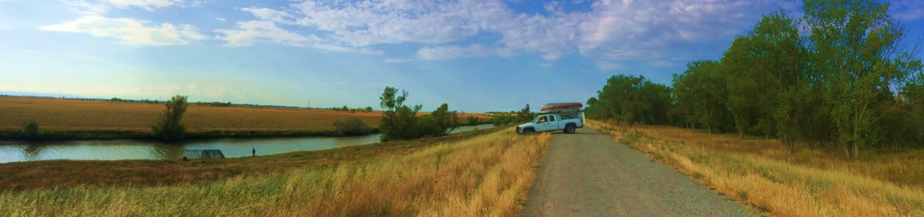

Image 1: Truck in position to winch the fyke trap during dry condition

### Preparing the winch:

1. The winch operator must put on heavy-duty (leather) gloves before handling the winch cable.
2. Make sure that the winch clutch is locked into proper position (engaged or free spool mode) to prevent damage to the gear.
3. Position the clutch into free spool mode to pull out the winch cable and attach to the trap retrieval cable.
4. Walk the cable slowly down the levee until you’ve reached the desired hookup position with the winch cable.
5. Leave at **least seven** wraps of cable on the winch spindle prior to engaging the winching of the fyke trap. See image 2 below.

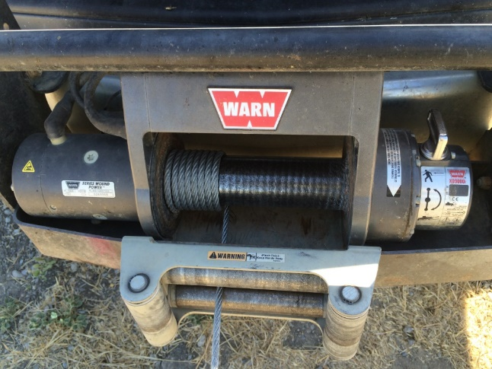

Image 2: Seven wraps of cable left on the winch spool

1. Firmly secure the cable clamp to the trap retrieval cable. (**Note: Always make sure that the cable is completely locked into the clamp or this could cause the clamp to fail.)**

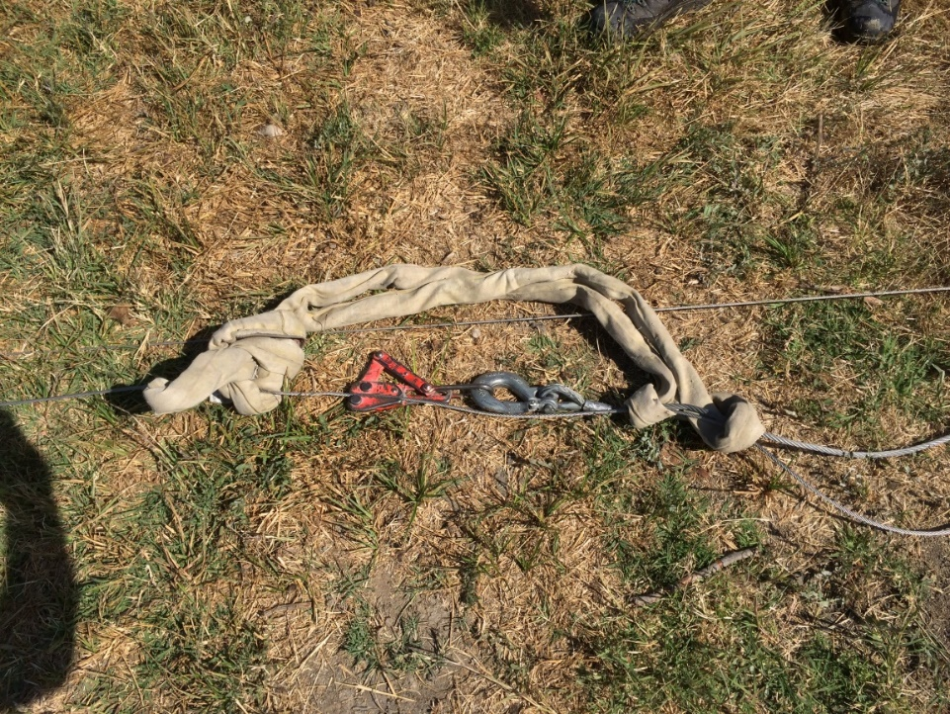

Image 3: Cable clamp secured on the trap retrieval cable with heavy tow strap.

* + Attach a heavy tow strap over the winch cable just above the cable clamp to absorb energy in case the clamp or retrieval cable fail during winch operation. A jacket or similar object will work as well if a heavy tow strap is unavailable.
  + All personnel not operating the winch should stand on the down slope side of the cable clamp. Always keep your distance and use caution around the cable when it’s under tension.
  + When operating the winch, assess your situation and plan the pull carefully.
  + Take your time when using the winch and communicate with hand signals with the personnel who are attending to the fyke trap safety ropes.
  + Keep hands and jewelry/clothing clear of the winch cable during operation.
  + Only one person should handle the winch cable and operate the remote control.
  + The winch operator should be in position to guide the winch cable onto the spool evenly, but when the winch is under strain it is recommended to move to the side of the vehicle and/or stand behind the driver’s side door.
  + Be as neat as possible when re-spooling and always watch your fingers while guiding the cable.
  + Do not over-tighten the cable when respooling. Leave an inch or two of slack.
  + Inspect the winch, cable, shackles, straps, and any other appurtenances for fatigue or damage. Listen to the winch during operation and stop if you hear any grinding or indication of mechanical failure.

### Retrieving the trap:

1. Before beginning to retrieve the trap, the winch operator should engage the clutch and turn on the truck (Ford only) prior to operating the winch; this improves and creates less drain on the batteries.
2. One or two personnel should be assisting the winch operator by keeping tension on the front and rear guide ropes. They should also watch the front guide cable to make sure that it is free of any snags along the bank and doesn’t wrap on the trap doors.
3. Be aware of where the fyke trap nose cable is. No one should be in the water while the fyke trap is moving unless they are completely out of the range of the nose cable.
4. The personnel assisting with the guide ropes should also be responsible for letting the winch operator know when the trap has reached the proper position and/or if there are any problems with the trap during the winching process.
5. The winch operator will check to make sure all personnel are clear and ready to bring up the trap. With one hand positioned on the cable at least 3 feet from the winch spool and the other hand managing the controller, the winch operator will slowly begin to bring up the trap, guiding the cable to wrap-up smoothly around the spool.
6. Make sure that once the fyke trap is winched into position, both the front and rear safety ropes are first securely tired off to the T-posts with 3 wraps followed by a clove hitch. (**Note: This must be done first before anyone gets near or in the fyke trap.**)
7. If possible, try to position the trap so that it remains in at least a foot of water to protect the fish from injuring themselves.

### Fish Processing:

Discrete water quality data should be collected by one or two people following the procedures outline in the Lower Trophic Sampling Collection SOP, Discrete Water Quality Section: Yolo Bypass:\YB_Standard Operating Procedures\Lower Trophic Sampling DWR-6-SOP-015_v1.6_LowerTrophicSampleCollection.

1. All personnel fishing the trap must put on a PFD prior to getting in and working around the trap.
2. Unhook the two bungee cords and secure them to the door. Slowly lower the door to the ground. If bungies break or look warn out, replace with new bungies.
3. One person will be responsible for getting into the trap and another person will safely hand him/her the large fish net. Make sure to hold the net pole as far forward as possible and if the fish is too large have someone assist with lifting the net out of the fyke trap door**. (Note: If fish are too big for the net, use the two-person cradle and try to measure fish in water with a tape measure to alleviate stress.)**

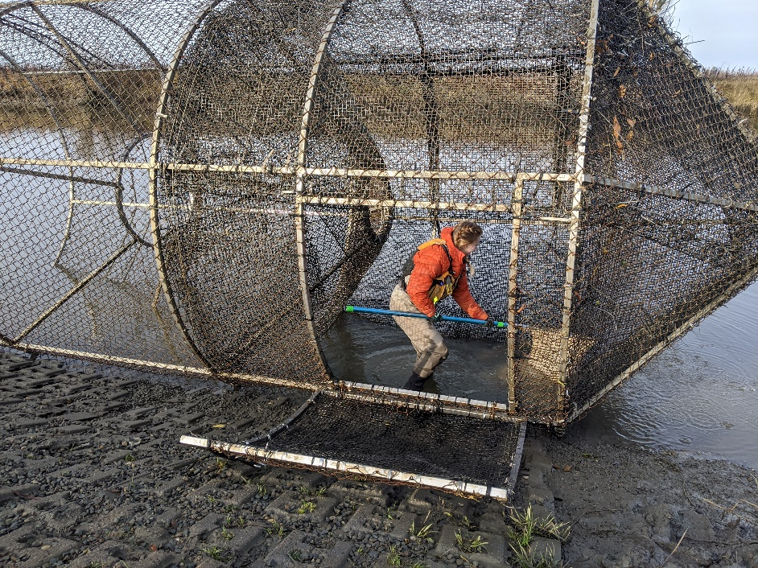

Image 4. Crew member netting fish in trap.

1. Use the net to remove the fish from the trap and transport them to a large bin or bucket of water up on the bank prior to being processed.
   1. If there are a lot of fish in the trap, it may be helpful to net a few fish at a time, so that the rest of the fish remain in the water within the trap.

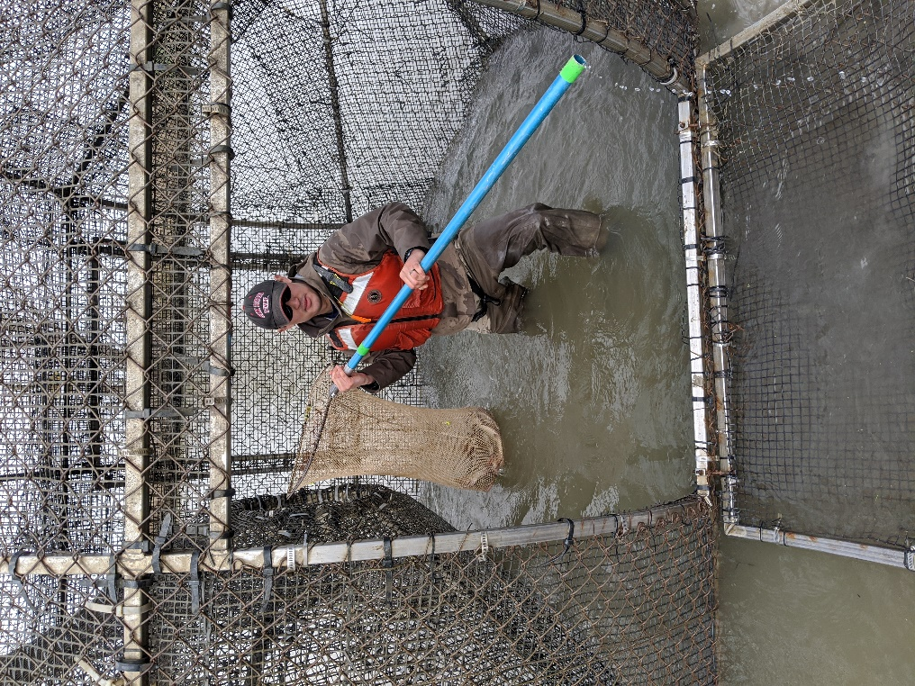

Image 5. Crew member preparing to hand off fish to second crew member outside of the trap.

1. Each fish will be identified by species and measured in fork length (FL) on the large measuring board.
   1. For each species, once 20 invasive or 50 native individuals have been measured, begin plus counting any individuals greater than or equal to 25 mm.
   2. If a native cyprinid or Sacramento sucker (SASU) is caught, be sure to use the tag-reading wand to check for a PIT tag on the ventral (stomach) region. **If a tag is detected, record tag number on data sheet**.
   3. Other species of interest (Chinook salmon and sturgeon) will have their own specific SOP for genetic processing and tagging that can be found in the Listed Species Handling SOP: Yolo Bypass\YB_Standard Operating Procedures\Fish Sampling & Processing\DWR-6-SOP-008_v1.3_ListedSpeciesHandling.docx

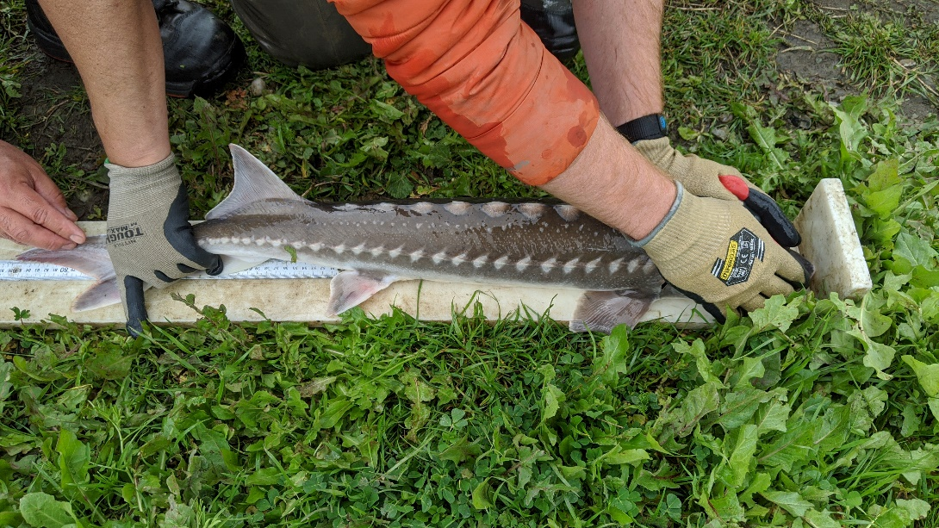

Image 6. Sturgeon being measured after capture in the fyke trap.

1. Once all fish are believed to be netted out and processed, firmly secure the trap door closed with both bungee cords.
2. Once everyone is clear of the fyke trap, the winch operator should winch the trap up the bank while one person checks the trap for any missed fish. If there are any missed fish the trap will then be winched to the next door and the guide ropes securely tied to T-posts before personnel enters trap to retrieve fish. Repeat step 5.
3. If no fish are left in the trap, proceed to deploy (or pull up) the fyke trap.

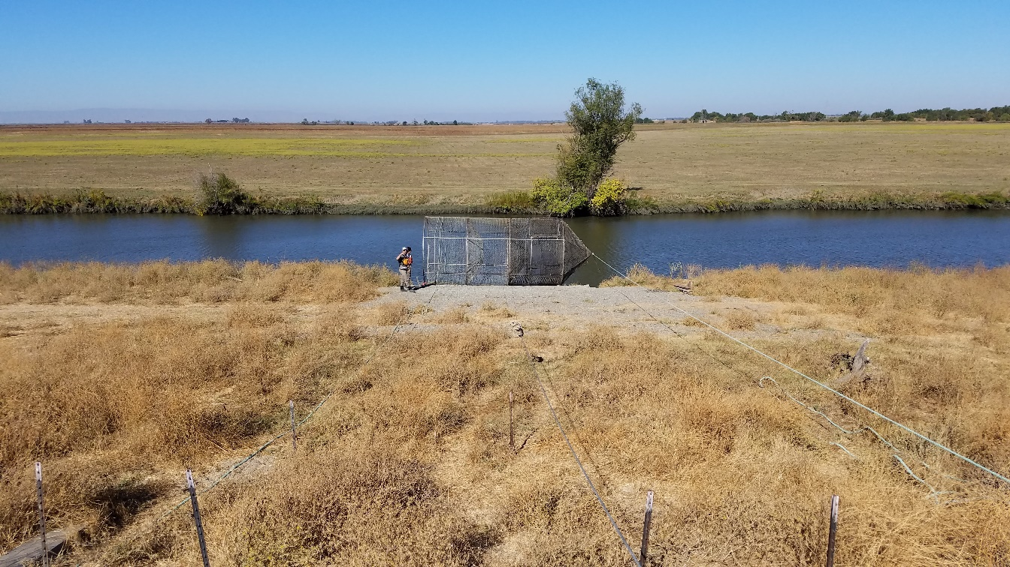

Image 7. Fyke trap pulled on shore with safety lines tied off.

## Appendix I: Permitting

All necessary permits must be obtained from appropriate local, state, federal agencies. Sufficient time must be allotted during the planning period to secure permits. A list of the necessary permits required for the fyke trap is listed below:

* **Scientific Collection Permit (SCP):** The California Department of Fish and Wildlife (DFW) requires that the YBFMP have a valid SCP for all field collection activities.  The SCP covers all sampling activities and take of non-listed species.
* **NMFS Section 10(a)(1)(A):** The National Marine Fisheries Service (NMFS) requires that the YBFMP have an Endangered Species Act (ESA) permit for the take of federally listed salmonids (winter and spring run Chinook Salmon and Central Valley Steelhead) and Green Sturgeon.  This permit is coordinated through the Interagency Ecological Program (IEP).
* **FWS Section 7:** The US Fish and Wildlife Service (FWS) requires that the YBFMP have an ESA permit for the take of federally listed Delta Smelt.  This permit is coordinated through IEP.
* **Marine Mammal Protection Act (MMPA):** NMFS requires the YBFMP to have a MMPA permit to cover the potential take or harassment of marine mammals by our sampling activities.  This permit is coordinated through IEP.
* **California Endangered Species Act (CESA) Memorandum of Understanding (MOU):** DFW requires the YBFMP to have a CESA MOU to cover the take of state listed salmonids (winter and spring run Chinook Salmon) and osmerids (Delta and Longfin Smelt).

Each permit carries various stipulations for trap deployment that must be rigidly adhered to. Several contain language requiring periodic reporting of operations and data while others need only be kept appraised of the continuation of trapping efforts from year to year.

## Appendix II: Maintenance

1. Damage

Before the first set in September/October, the fyke will be inspected for damage to the frame and netting. During the next 9 months of operation, damage will continue to be assessed and repairs made as needed.

* Any tears to the mesh paneling can be mended using UV resistant zip ties. Larger holes should be mended by placing a square of new mesh over the hole and zip tying it in place.
* In areas where the internal mesh is coming away from the fencing frame material, zip ties should be used to pin them back together.
* Occasionally the door hinge will need to be tightened and the hose clamps connecting the fencing material to the door frame will need to be replaced.
* Be sure that any zip ties and hose clamps are tightened such that the tail ends are facing away from the interior of the trap so that they do not pose an injury risk to captured fish.

1. Alignment

The fyke trap will also occasionally become crooked or shift down/upstream from its desired position. This often will lead to the issue of the guide cables wrapping around the doors to enter the trap.

If the trap becomes crooked:

* Pull the trap out of the water and process any fish.
* After this, ensure that the winch cable is engaged and taught and remove the safety rope connected to whichever end of the trap needs to be pushed towards the channel in order to straighten the trap.
* Slacken the winch line slowly while two crew members push the crooked end of the trap towards the channel.
* Once it is straight, remove the second safety line and roll the trap back into the channel. If it is the end of the sampling week, reattached the second safety line instead and proceed with trap pull procedures.

If the trap has shifted up or downstream:

* Notes:
  + Most commonly it will shift downstream, especially when flows are high during events like overtopping or large agricultural flows.
  + If possible, try to make adjustments on a “set” or “pull” day in order to minimize the number of times you need to reposition the truck. If you plan to do this on a “set” day, try to prepare on the day you pull the fyke by pre-positioning the wood board (see below).
  + Do not attempt this when the levee is wet as the truck might slip or get stuck.
* If the trap was already set, pull the trap out of the water and process any fish.
* If the trap is also crooked, straighten it as described above.
* Position the trap so that one of the long frame bars rests on a 2x6’ wooden board (stored near the trap). The board should just overhang the leading edge of the frame bar.
* Tie off the safety lines and detach the winch.
* Drive the truck down the levee and position it facing the nose of the trap (if you are pulling upstream).
  + Leave at least 20’ between the truck and the trap.
  + Place wheel chocks in front of the tires. A minimum of two should be used, one in front of each front tire. Use the wooden chock for fyke “pull” days as extra support.
* Take the long, weighted tow strap and weave it around the frame bar sitting on the wood and around one of the support bars going up to the nose. This may take some time and it sometimes helps to use a screwdriver to reach the loop end and guide it through the frame material.
  + **Make sure that all the tension will be applied to the frame bars and not just the fencing material.**
* Pull the loop through so that its connection with the trap is at the end of V shape.
* Put the other ends of the V into the winch hook.
* Wrap the smaller weighted loop around the winch cable, in between the trap and the truck.
* Guide the excess winch cable into the spool. Once taught, the winch operator should stand behind the open truck door and use the winch to pull the trap towards the truck.
  + All other crew members should stand far away.
* One other crew member should stand further up the levee and keep track of where the base of the cone is relative to the ramp edges. Once the cone base is about 1’ from the edge of the ramp, this crew member will signal to the winch operator to stop.
* After the trap is in position, carefully slack the winch cable (note the truck may shift slightly when you do this).
* Unhook/respool the winch and take the long, weighted loop off the fyke.

## Past SOP editors and collaborators:

* 6/4/2020 – Craig Stuart: Created SOP describing the standard process of setting, checking and pulling the fyke trap for sampling protocols and operating the winch. Liberally borrowed language and safety information from the AES Field to Lab Manual.
* 6/17/2020 – Nicole Kwan: Finished editing for consistency with other fish sampling SOPs; added photos; added maintenance procedures.
* 10/21/2021 – Nicole Kwan and Naoaki Ikemiyagi: Updated fyke objectives, made edits to language, edited safety rope tie off description, and updated referenced SOPs.