# Yolo Bypass Fish Monitoring Program: Water Quality Metadata

Document Number: DWR-6-MET-Draft Phyto

Version: 1.0

Status: DRAFT

Effective Date:



California Department of Water Resources

Division of Environmental Services

3500 Industrial Boulevard

West Sacramento, California 95691

## Dataset Title

Interagency Ecological Program: Phytoplankton data from the Sacramento River floodplain and tidal slough, collected by the Yolo Bypass Fish Monitoring Program, 1998 - Present

## Short Name

IEP-YBFMP Phytoplankton

## Abstract

The Yolo Bypass Fish Monitoring Program (YBFMP) operates a rotary screw trap and fyke trap and conducts biweekly beach seine and lower trophic surveys in addition to maintaining water quality instrumentation in the bypass*.* The YBFMP serves to fill information gaps regarding environmental conditions in the bypass that trigger migrations and enhanced survival and growth of native fishes, as well as provide data for IEP synthesis efforts. YBFMP staff also conduct analyses of YBFMP monitoring data to address pertinent management related questions as identified by IEP. The Yolo Bypass has been identified as a high restoration priority by the National Marine Fisheries Service and US Fish and Wildlife Service Biological Opinions for Delta Smelt, Winter and Spring-run Chinook salmon and by California EcoRestore. The YBFMP informs the restoration actions that are mandated or recommended in these plans and provides critical baseline data on the ecology of the bypass and how it interacts with the broader San Francisco Estuary. Our overall program objectives include:

1. Collect baseline data on water quality, chlorophyll, lower trophic level biota, and fish in the Yolo Bypass to monitor spatial and temporal changes in trends and abundance.
2. Analyze and communicate Yolo Bypass data with stakeholders and the scientific and management communities to address pertinent management related questions.
3. Provide technical expertise on Yolo Bypass aquatic ecology and monitoring and sampling methods.

Specifically, the objectives of the phytoplankton monitoring are to:

1. Examine spatial and temporal trends in phytoplankton productivity in the Yolo Bypass.
2. Examine relationships between abiotic conditions, phytoplankton, zooplankton, and fish populations in Yolo Bypass.
3. Determine the impacts of water project operations, agricultural uses, and restoration projects in the Yolo Bypass floodplain.

We sample phytoplankton as discrete water samples along with nutrient and chlorophyll data taken biweekly along with lower trophic tows (sites SHR and STTD only). Water is sampled at three sites along the Yolo Bypass and Sacramento River, then processed and analyzed by an internal DWR laboratory.

## Investigators

|  |  |  |  |  |  |  |
| --- | --- | --- | --- | --- | --- | --- |
| First Name | Middle Initial | Last Name | Organization | e-mail address | ORCID ID (optional) | Role in project |
|  |  | Interagency Ecological Program (IEP) |  |  |  | Creator |
| Nicole |  | Kwan | California Department of Water Resources | [Nicole.kwan@water.ca.gov](mailto:Nicole.kwan@water.ca.gov) | 0000-0003-1178-7788 | Creator, Associate, Data contact |
| Jesse |  | Adams | California Department of Water Resources | [Jesse.Adams@water.ca.gov](mailto:Jesse.Adams@water.ca.gov) | 0000-0002-0739-8782 | Database Manager, Field crew, Data contact |

## Other personnel names and roles

|  |  |  |  |  |  |  |
| --- | --- | --- | --- | --- | --- | --- |
| First Name | Middle Initial | Last Name | Organization | e-mail address | ORCID ID (optional) | Role in project |
| Nicole |  | Kwan | California Department of Water Resources | [Nicole.Kwan@water.ca.gov](mailto:Nicole.Kwan@water.ca.gov) | 0000-0003-1178-7788 | Creator, Associate, Data contact, Field crew |
| Jesse |  | Adams | California Department of Water Resources | [Jesse.Adams@water.ca.gov](mailto:Jesse.Adams@water.ca.gov) | 0000-0002-0739-8782 | Field crew |
| Mallory |  | Bedwell | California Department of Water Resources | [Mallory.Bedwell@water.ca.gov](mailto:Mallory.Bedwell@water.ca.gov) | 0000-0001-9553-6032 | Field crew |
| Naoaki |  | Ikemiyagi | California Department of Water Resources | [Naoaki.Ikemiyagi@water.ca.gov](mailto:Naoaki.Ikemiyagi@water.ca.gov) |  | Field crew |
| Catarina |  | Pien | California Department of Water Resources | [Catarina.Pien@water.ca.gov](mailto:Catarina.Pien@water.ca.gov) | 0000-0003-4427-6300 | Database Manager, Field crew, Data contact |
| JT |  | Robinson | California Department of Water Resources | James.robinson@water.ca.gov |  | Field Crew |
| Allison |  | Brady | California Department of Water Resources | [Allison.brady@water.ca.gov](mailto:Allison.brady@water.ca.gov) |  | Field Crew |
| Parisa |  | Farman | California Department of Water Resources | [Parisa.farman@water.ca.gov](mailto:Parisa.farman@water.ca.gov) |  | Field Crew |
| Emily |  | Hubbard | California Department of Water Resources | [Emily.hubbard@water.ca.gov](mailto:Emily.hubbard@water.ca.gov) |  | Field Crew |
| Brian | M | Schreier | California Department of Water Resources | [Brian.Schreier@water.ca.gov](mailto:Brian.Schreier@water.ca.gov) | 0000-0002-5075-3946 | Associate |
| Ted |  | Sommer | California Department of Water Resources | [Ted.Sommer@water.ca.gov](mailto:Ted.Sommer@water.ca.gov) |  | Associate |
| Louise |  | Conrad | California Department of Water Resources | [Louise.Conrad@deltacouncil.ca.gov](mailto:Louise.Conrad@deltacouncil.ca.gov) |  | Associate |

## License

This information is released under the Creative Commons license - Attribution - CC BY (<https://creativecommons.org/licenses/by/4.0/>). The consumer of these data ("Data User" herein) is required to cite it appropriately in any publication that results from its use. The Data User should realize that these data may be actively used by others for ongoing research and that coordination may be necessary to prevent duplicate publication. The Data User is urged to contact the authors of these data if any questions about methodology or results occur. Where appropriate, the Data User is encouraged to consider collaboration or co-authorship with the authors. The Data User should realize that misinterpretation of data may occur if used out of context of the original study. While substantial efforts are made to ensure the accuracy of data and associated documentation, complete accuracy of data sets cannot be guaranteed. All data are made available "as is." The Data User should be aware, however, that data are updated periodically, and it is the responsibility of the Data User to check for new versions of the data. The data authors and the repository where these data were obtained shall not be liable for damages resulting from any use or misinterpretation of the data. Thank you.

## Keywords

Yolo Bypass, San Francisco Estuary, Sacramento-San Joaquin Delta, Yolo Bypass Fish Monitoring Program, California Department of Water Resources, Interagency Ecological Program, tidal slough, floodplain, Sacramento River, phytoplankton

## Funding of this work:

Funding is provided by the State Water Project.

## Timeframe

* Begin date: 2013-10-30
* End date: 2020-12-01
* Data collection: ongoing

## Geographic location

* Yolo Bypass tidal slough and seasonal floodplain in Sacramento, California, USA.
* North bounding coordinates (decimal degrees): 38.79395205
* South bounding coordinates (decimal degrees): 38.23466149
* East bounding coordinates (decimal degrees): -121.5368316
* West bounding coordinates (decimal degrees): - 121.8073699

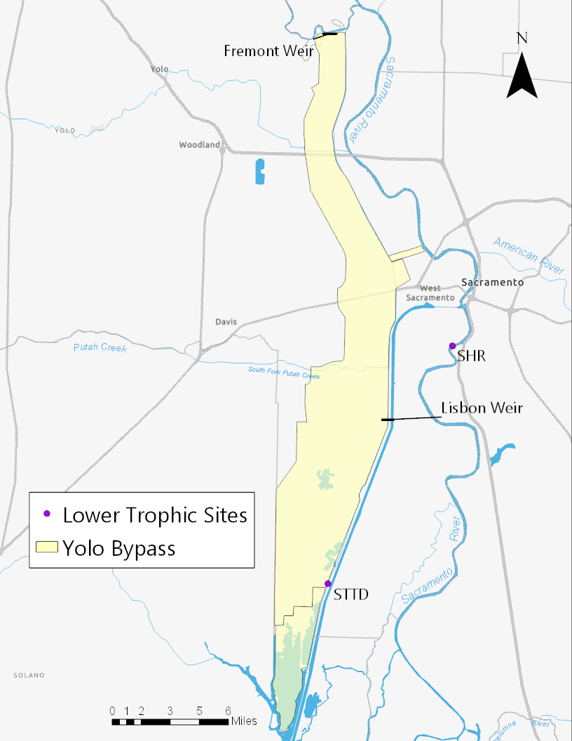

Phytoplankton Sites

|  |  |  |  |  |
| --- | --- | --- | --- | --- |
| # | Site Code | Location | Latitude | Longitude |
| 1 | LIS | Yolo Bypass Toe Drain Below Lisbon Weir | 38.47482 | -121.58858 |
| 2 | SHR | Sacramento River at Sherwood Harbor | 38.53188 | -121.528 |
| 3 | STTD | Screw Trap in Toe Drain | 38.35338 | -121.643 |

## Taxonomic species or groups

Phytoplankton collected by the YBFMP fall into four broad categories: cyanobacteria, diatoms, green algae (including green algal flagellates), and various flagellate groups (excluding green algal flagellates). These categories are further subdivided as follows (see table immediately following this list for detailed descriptions of these taxa):  
  
1. Cyanobacteria

Coccoid/Colonial  
Filamentous

2. Diatoms

Centric  
Pennate  
Araphid  
Monoraphid  
Biraphid

3. Green Algae

Desmids  
Filamentous  
Green Algal Flagellates  
Non-motile Coccoid/Colonial

4. Flagellate Groups*

Chrysophytes  
Cryptomonads  
Dinoflagellates  
Euglenoids  
Haptophytes  
Nanoflagellates  
Synurophytes  
Xanthophytes

**\*Note:** Some groups contain non-flagellated species; however, the taxa collected by the EMP have all been flagellated taxa.

|  |  |
| --- | --- |
| **Algal Type** | **Description** |
| Pennate Diatom | Diatom with siliceous, bilaterally symmetrical valves (symmetry about a line). |
| Centric Diatom | Diatom with siliceous, radially symmetrical valves (symmetry about a point). |
| Chrysophyte | Unicellular biflagellate with an external covering (if present) of scales or a lorica (a protective envelope around the cell). |
| Ciliate | Unicellular protist with hair-like cilia covering the cell. Most are non-photosynthetic. |
| Coccolithophore | Unicellular alga covered with calcium carbonate plates or scales called coccoliths. |
| Cyanobacterium | Prokaryotic alga (lacks flagella and membranes around internal structures); growth can be coccoid/unicellular, colonial, or filamentous. |
| Cryptophyte | Unicellular biflagellate with a unique furrow/gullet system. |
| Green Alga | Alga with predominantly green pigment. Growth habit may be unicellular, filamentous, coccoid/colonial, or flagellated. |
| Dinoflagellate | Unicellular biflagellate with a theca (cellulose plates) as the external covering. |
| Euglenoid | Unicellular flagellate with 1 or 2 flagella. External covering is a pellicle (an outer protein-based layer). Not all euglenoids are photosynthetic. |
| Haptophyte | Unicellular biflagellate covered by non-siliceous scales and possessing a haptonema (flagella-like structure). |
| Nanoflagellates | Very small flagellates (<10µm) that are of unknown taxonomic origin. May or may not be photosynthetic. |
| Silico-flagellate | Unicellular alga that produces a siliceous skeleton as part of its life cycle. |
| Synurophyte Flagellate | Unicellular biflagellate covered in siliceous scales. May form colonies. |
| Xanthophyte Flagellate | Solitary unicellular alga with 1 or 2 flagella. |

## Methods

* 1. Field Collection Methods   
     Water quality and phytoplankton samples are simultaneously collected in 1-liter Nalgene collection bottles, rinsed three times with a small volume of sample water, and submerged below the surface of the water, filled, and capped tightly. Sample collection bottles are then immediately stored in a closed cooler with ice, in the dark, and transported to the DWR laboratory for homogenization, transfer, and preservation.

Once in the laboratory, water grabs from a single station are homogenized using a churn splitter. Collection bottles are first gently inverted and then slowly emptied into the churn splitter minimize aeration and ensure suspended materials are transferred to the churn splitter. The contents of the churn splitter are homogenized with an agitator disk, and once sufficiently homogenized, the water is dispensed through a spigot back into the original sample collection bottles. A sample is then carefully poured from one of the collection bottles into a 50mL amber bottle prefilled with 1mL of Lugol’s solution to preserve and stain specimens. The amber bottle is capped, and all samples are stored in the dark at room temperature for at least two weeks before shipping samples to BSA Environmental Services, Inc. for taxonomic identification, measurements, and enumeration. Please see the YBFMP SOP on Lower Trophic Sample Collection for more details.

##### Laboratory Methods

Currently, phytoplankton samples are analyzed by BSA Environmental, Inc. Phytoplankton are identified to the lowest taxonomic level possible using the Utermöhl method and APHA standard methods (Utermöhl 1958, APHA 1998). An aliquot is allowed to settle onto a counting chamber for a minimum of 12 hours. The aliquot volume is adjusted according to the algal population density and turbidity of the sample. For the Delta, the aliquot volume is usually about 10 ml. Aliquots are enumerated at a magnification of 630X using a Leica DMIL inverted microscope. For each settled aliquot, phytoplankton in randomly chosen transects are counted and photos are taken of the specimen, first encounter; measurements are made with an ocular micrometer. Taxa are enumerated as they appear along the transects. A minimum of 400 total algal units are counted, and a minimum of 100 algal units of the dominant taxon. For taxa that are in filaments or colonies, the number of cells per filament or colony is recorded. Length measurements are performed on 25 algal units of the dominant taxon, and up to 5 units of each minor taxon. The measurements taken are 1st greatest axial length, 2nd greatest axial length, and 3rd greatest axial length.

Organism counts for each sample can be converted to organisms/ml using the following formula:  
Organisms/ml = (C x Ac) / (V x Af x F)  
where:  
C = count obtained  
Ac = Area of cell bottom (mm2)  
Af = Area of each grid field (mm2)  
F = Number of fields examined  
V = volume settled, in ml  
This simplifies to:  
Organisms/ml = C / cV  
where:  
C = count obtained  
cV = counted volume, in ml (cV = Ac /(V x Af x F))  
Algal biovolume can be calculated from the dimensions using, for example, the formulas given for different algal shapes by Kellar et al. (1980).

* 1. Sample Processing and TrackingSample Processing Contractor  
     *Since July 2009* (see historical changes for more information)  
     BSA Environmental Services, Inc.

23400 Mercantile Rd. #8

Beachwood, OH 44122  
216-765-0582

Sample Tracking  
A chain of custody (COC) listing sample ID, station, date, time, number of vials/bottles, sample type, and study/project is sent to the taxonomy contractor (BSA Environmental Services, Inc.) who upon receipt check that all samples are accounted for and undamaged. Signatures are required of both the person responsible for dropping off the samples, and the person receiving it.

##### Quality Assurance and Control

Data received from the taxonomy contractor are checked for accuracy and completeness by the contract manager at DWR and any issues are communicated between the contract manager and contractor.

#### Calibrations

None

#### Sample Identification

Contractor must provide photographic documentation of taxon (species or genus) identification when it is first encountered. This includes all algal taxa and all non-algal protists. A taxon and appropriate life-stages will be photographed only once. There must be only one taxon per photograph. For each organism that cannot be identified, the Contractor provides photographic documentation in case the organism(s) are identified later. DWR requires a permanent reference mount of certain taxa (for example, when a new species is discovered) from the contractor.

Notes on Data Quality  
None

##### Data Storage

Taxonomic results are received from the contractor via email in an Excel spreadsheet. Electronic copies of results for taxonomic analyses are archived on DWR/AES Network drives.

After taxonomic identification and enumeration by the contractor, samples are shipped back to DWR where they are stored for 5 years and then disposed of.

##### Calculations and Analysis

None

##### Historical Changes

None

## Methods References

| **Reference Location or DOI** | **Reference Title** |
| --- | --- |
| AEU | DWR-6-SOP-015_v1.7_LowerTrophicSampleCollection |

## Data Tables

Table Description: Phytoplankton collection and taxonomy datasheet column definitions

|  |  |
| --- | --- |
| **Column Name** | **Definition** |
| MethodCode | Name of sample processing method |
| SampleDate | Date sample was collected |
| SampleTime | Time sample was collected |
| StationCode | Alpha-numeric code for station |
| Depth (m) | Depth sample was taken at in meters |
| Volume Received (mL) | Volume received by the contractor in milliliters |
| Volume Analyzed (mL) | Volume analyzed by the contractor in milliliters |
| Percent of Sample Counted | Percent of the sample that was processed |
| Field-of-view (mm²) | Area of each grid field in square millimeters |
| Slide/ Chamber Area (mm²) | Area of cell bottom in square millimeters |
| Area Counted | Area counted in square millimeters |
| Number of Fields Counted | Number of microscope fields counted |
| Factor | Multiplier for calculating organisms per milliliter |
| BSA_TIN | BSA Taxonomic Identification Number |
| Taxon | Phytoplankton Taxon Name (genus and species) |
| Diatom/SoftBody | Type of phytoplankton (diatom: silica-based cell wall, or soft body: cell wall lacking silica) |
| Genus | Phytoplankton Genus Name |
| Species | Phytoplankton Species Name |
| Synonym | Taxonomic Synonym (if applicable) |
| Unit Abundance | Natural Unit Abundance |
| Total Cells Counted | Total Cells Counted |
| GALD 1 | First Greatest Axial Linear Dimension in microns |
| GALD 2 | Second Greatest Axial Linear Dimension in microns (if applicable) |
| GALD 3 | Third Greatest Axial Linear Dimension in microns (if applicable) |
| Colony/Filament/Individual Group Code | Alphabetic code for phytoplankton growth form |
| BSA# | BSA Sample Number |
| Taxonomist | Initials of taxonomist who processed the sample |
| Comments | Comments from the taxonomist who processed the sample |
| Shape | Shape of an individual cell of the phytoplankton taxon |
| Biovolume 1 | Biovolume of first cell measured in cubic microns |
| Biovolume 2 | Biovolume of second cell measured in cubic microns (if applicable) |
| Biovolume 3 | Biovolume of third cell measured in cubic microns (if applicable) |
| Biovolume 4 | Biovolume of fourth cell measured in cubic microns (if applicable) |
| Biovolume 5 | Biovolume of fifth cell measured in cubic microns (if applicable) |
| Biovolume 6 | Biovolume of sixth cell measured in cubic microns (if applicable) |
| Biovolume 7 | Biovolume of seventh cell measured in cubic microns (if applicable) |
| Biovolume 8 | Biovolume of eighth cell measured in cubic microns (if applicable) |
| Biovolume 9 | Biovolume of ninth cell measured in cubic microns (if applicable) |
| Biovolume 10 | Biovolume of tenth cell measured in cubic microns (if applicable) |

## Articles

None

## Scripts/Code (software)

## Data Provenance

NA

## Notes and Comments

*Versioning History*

| **Version number** | **Date created** | **Description of changes** | **Justification for change** | **Version editor(s)** | **Contact info** |
| --- | --- | --- | --- | --- | --- |
| 1.0 | 05/06/2022 | New Effective version | New Document | Jesse Adams | Jesse.Adams@water.ca.gov |

-End of document-