A

Project Report
On

Home of Flavours – Food Ordering System Using QR Code

Submitted by

Div: C
MCA – I SEM – II

Under the guidance of

Dr. Bharati Pandurang Kawade

For the Academic Year 2025-26



Kondhawa, Pune.

Date: 20 April 2026

CERTIFICATE

This is to certify that Our team has successfully completed his/her project work entitled "Home of Flavours – Food Ordering System Using QR Code" in partial fulfilment of MCA – I SEM – II MCA25201: Python Programming Lab course for the year 2025-2026. He/she has worked under our guidance and direction.

Date: 20 April 2026
Place: Pune

DECLARATION

I certify that the work contained in this report is original and has been done by me under the guidance of my guide.

- The work has not been submitted to any other Institute for any degree or diploma.
- I have followed the guidelines provided by the Institute in preparing the report.
- I have conformed to the norms and guidelines given in the Ethical Code of Conduct of the Institute.
- Whenever I have used materials (data, theoretical analysis, figures, and text) from other sources, I have given due credit to them by citing them in the text of the report and giving their details in the references.

Name and Signature of Project Team Members:

Sr. No. | SRN No. | Name of Students | Signature
1 | 31252611 | Vishal Jitender Thakur
2 | 31252228 | Ankit Daulat Lotiyal
3 | 31252571 | Vaishnavi Surwade

INDEX

Sr. No. | Chapter | Page No.
1 | CHAPTER 1: INTRODUCTION
1.1 | Abstract
1.2 | Existing System and Need for System
1.3 | Scope of System
1.4 | Operating Environment Hardware and Software
1.5 | Brief Description of Technology Used
2 | CHAPTER 2: PROPOSED SYSTEM
2.1 | Feasibility Study
2.2 | Objectives of the Proposed System
3 | CHAPTER 3: ANALYSIS AND DESIGN
3.1 | Entity Relationship Diagram (ERD)
3.2 | Class Diagram
3.3 | Use Case Diagrams
3.4 | Table Design
3.5 | Data Dictionary
3.6 | Sample Input and Output Screens
4 | CHAPTER 4: CODING SAMPLE CODE
5 | CHAPTER 5: LIMITATIONS OF SYSTEM
6 | CHAPTER 6: PROPOSED ENHANCEMENTS
7 | CHAPTER 7: CONCLUSION
8 | CHAPTER 8: BIBLIOGRAPHY

CHAPTER 1: INTRODUCTION

1.1 Abstract
The "Home of Flavours" project is a web-based food ordering system designed for restaurants and cafes. It allows customers to browse a digital menu, add items to a cart, and place orders either for dine-in at a specific table or as takeaway. The system leverages QR code technology to streamline the ordering process. Each table has a unique QR code that directs customers to the menu pre-set with their table number, eliminating manual input errors.
The backend is built using the Django web framework (Python), the frontend uses Bootstrap 5 for responsive design, and SQLite3 serves as the database. The admin panel allows managers to add/delete menu items, view live orders by table, generate bills, and manage QR codes for tables.

1.2 Existing System and Need for System
In traditional restaurant systems, customers rely on paper menus and waitstaff to take orders manually. This approach has several drawbacks:
- Errors in order-taking due to miscommunication between customers and waitstaff.
- Delays in placing and processing orders, especially during peak hours.
- Increased manpower costs for maintaining a large number of waitstaff.
- Difficulty in tracking orders per table and managing billing efficiently.
- No digital record of orders for analytics or dispute resolution.

The proposed system addresses all these issues by allowing customers to self-order through a web interface, reducing dependency on waitstaff and ensuring accurate, real-time order tracking.

1.3 Scope of System
- Customers can browse a categorized digital menu and add items to a cart.
- The system supports dine-in (with table selection) and takeaway orders.
- Managers/admins can add or remove menu items through the web interface.
- QR codes unique to each table are generated and managed by the admin.
- Order management per table is supported with real-time listing.
- Bill generation with GST calculation is supported.
- Customer reviews and ratings can be submitted.
- User authentication using phone number is implemented.
- Order history is accessible to registered customers.

1.4 Operating Environment Hardware and Software

Server-side Requirement

Software Requirement | Hardware Requirement
Operating System: Windows 7 or above | Processor: Intel Core i3 or above
Front End: HTML5, CSS3, Bootstrap 5, jQuery | RAM: 4GB or above
Back End: Python 3.14+, Django 4.1.2 | HDD: 512 GB or above
Database: SQLite3
Web Browser: Chrome, Mozilla Firefox

Client-side Requirement

Software Requirement | Hardware Requirement
Operating System: Windows 7 or above | Processor: Intel Core i3 or above
Web Browser: Chrome, Mozilla Firefox | RAM: 2GB or above
Smartphone with camera (for QR scanning) | HDD: 512 GB or above

1.5 Brief Description of Technology Used
Django 4.1.2: A high-level Python web framework that follows the Model-View-Template (MVT) architecture. It handles URL routing, ORM-based database operations, authentication, and admin panel generation.
Python 3.14+: The primary programming language used for the backend logic, data processing, and business rules.
Bootstrap 5: A responsive front-end CSS framework used to create mobile-friendly pages including the menu, cart, login, and admin views.
jQuery / JavaScript: Used for client-side interactivity such as cart management via local Storage, dynamic quantity updates, and AJAX calls.
SQLite3: A lightweight relational database used to store user accounts, menu items, orders, reviews, and bills.
Qrcode (Python library): Used to generate unique QR codes for each table that link directly to the menu URL with a table parameter.
Pillow: Python Imaging Library used to handle image uploads for menu item pictures.

CHAPTER 2: PROPOSED SYSTEM

2.1 Feasibility Study
Technical Feasibility: The project uses widely available and well-documented technologies — Python, Django, SQLite, Bootstrap 5, and the qrcode library. All tools are open-source and freely available. The system can run on any standard laptop or server with Python installed.
Economic Feasibility: The system uses entirely free and open-source tools, requiring no licensing cost. Deployment can be done on free-tier cloud platforms (like Railway, Render, or Heroku) or a low-cost shared hosting server. The economic investment is minimal compared to commercial POS systems.
Operational Feasibility: The system has a simple and intuitive web interface for both customers and admins. Customers only need a smartphone to scan a QR code and a browser to place orders. Admins manage everything through the Django web interface without requiring technical expertise.

2.2 Objectives of the Proposed System
- To provide a digital, QR code-based menu browsing and ordering system for customers.
- To allow table-specific order tracking for efficient service management.
- To enable restaurant admins to manage the menu, view orders, and generate bills digitally.
- To reduce order errors by eliminating manual communication between customers and waitstaff.
- To provide a billing system with GST tax calculation and invoice generation.
- To support customer registration, login, and order history using phone-based authentication.
- To allow customers to leave reviews and ratings for the restaurant.
- To generate and manage QR codes for each table from the admin interface.
- To store all order and billing records for future reference and analytics.

CHAPTER 3: ANALYSIS AND DESIGN

3.1 Entity Relationship Diagram (ERD)
The system has the following main entities and relationships:
- User (phone, first_name, last_name, cafe_manager, order_count) — places Orders.
- MenuItem (name, category, desc, pic, price, list_order) — referenced in Orders.
- Order (order_id, items_json, name, phone, table, price, order_time, bill_clear) — linked to User and Bill.
- Bill (order_items, name, bill_total, phone, bill_time) — generated from Orders.
- Rating (name, comment, r_date) — submitted by Users.
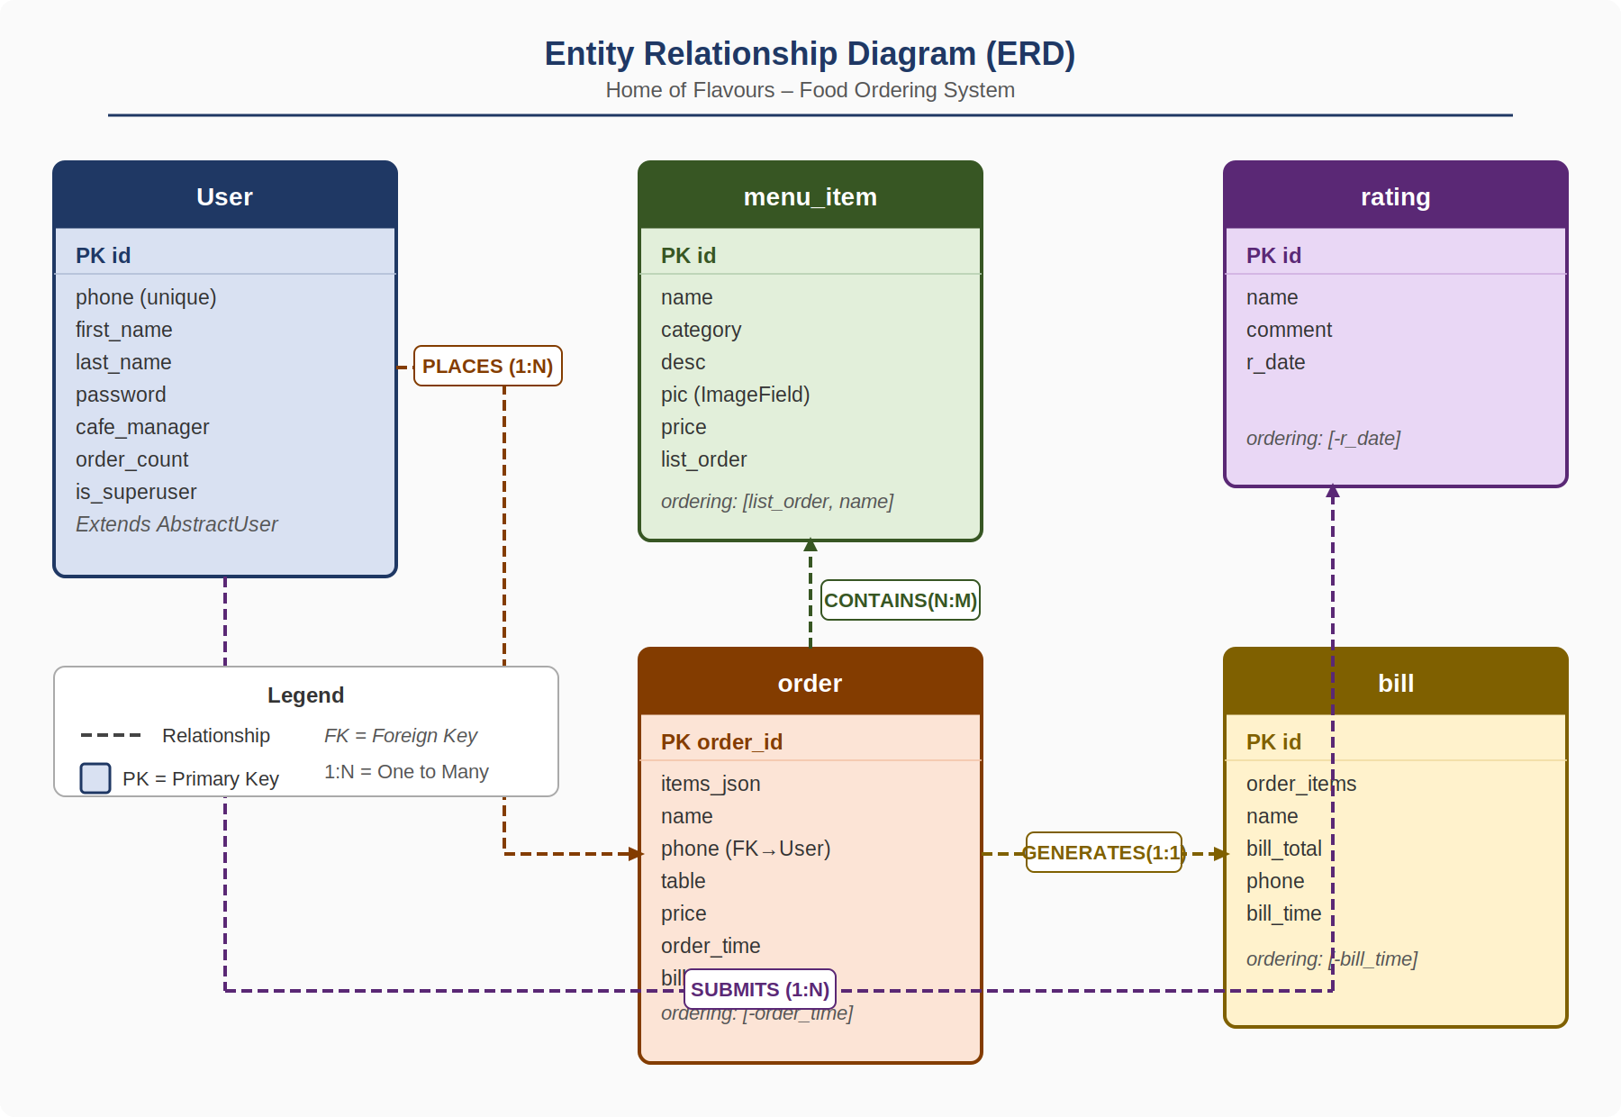

3.2 Class Diagram
The Django models represent the class structure of the system. The main classes are: User (extends AbstractUser), menu_item, order, bill, and rating. The User class is connected to order via the phone field. The order class stores items as a JSON string referencing menu_item names and prices.
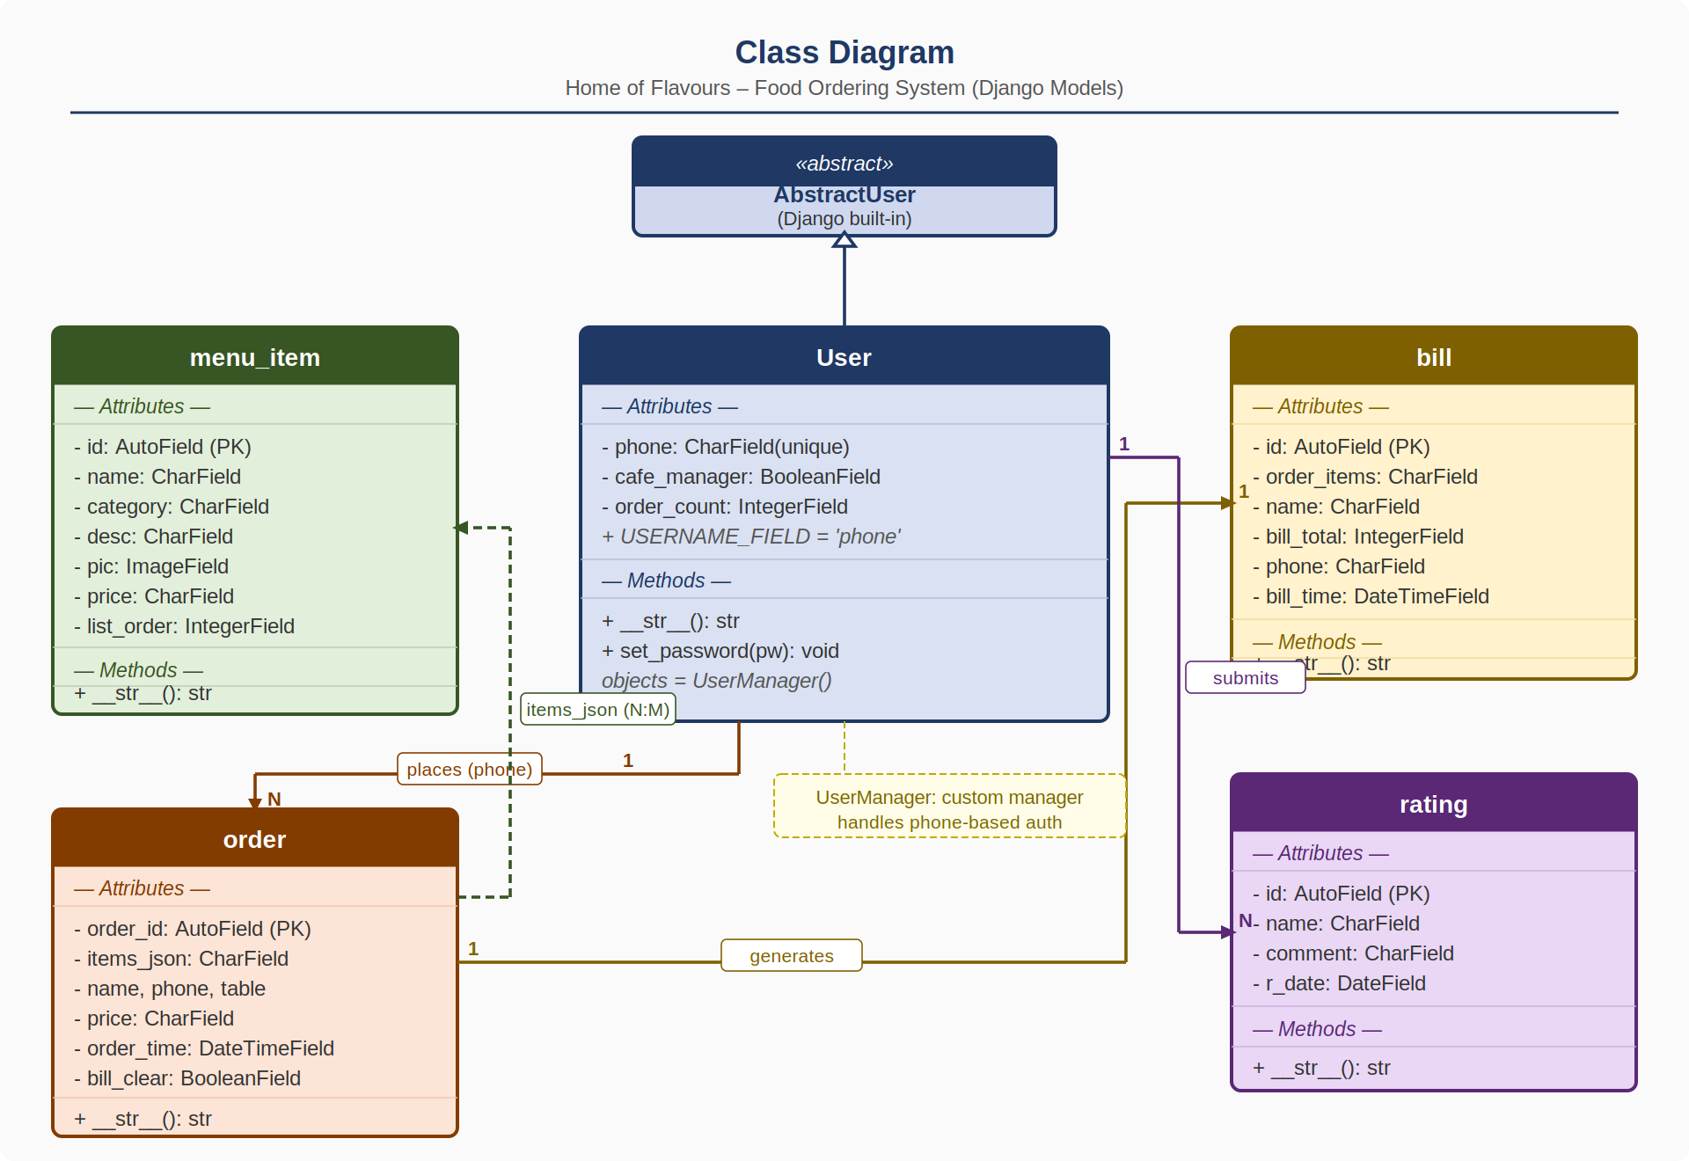

3.3 Use Case Diagrams
Actors in the system: Customer and Admin/Manager.
Customer Use Cases:
- Browse Menu
- Add Items to Cart
- Place Order (Dine-In / Takeaway)
- View Order History
- Submit Review
- Login / Signup / Forgot Password
- Edit Profile

Admin/Manager Use Cases:
- Add/Delete Menu Items
- View All Orders (by Table)
- Generate Bill for a Table
- Generate QR Codes for Tables
- View Billing History
- View Dashboard (total orders, revenue, customers)
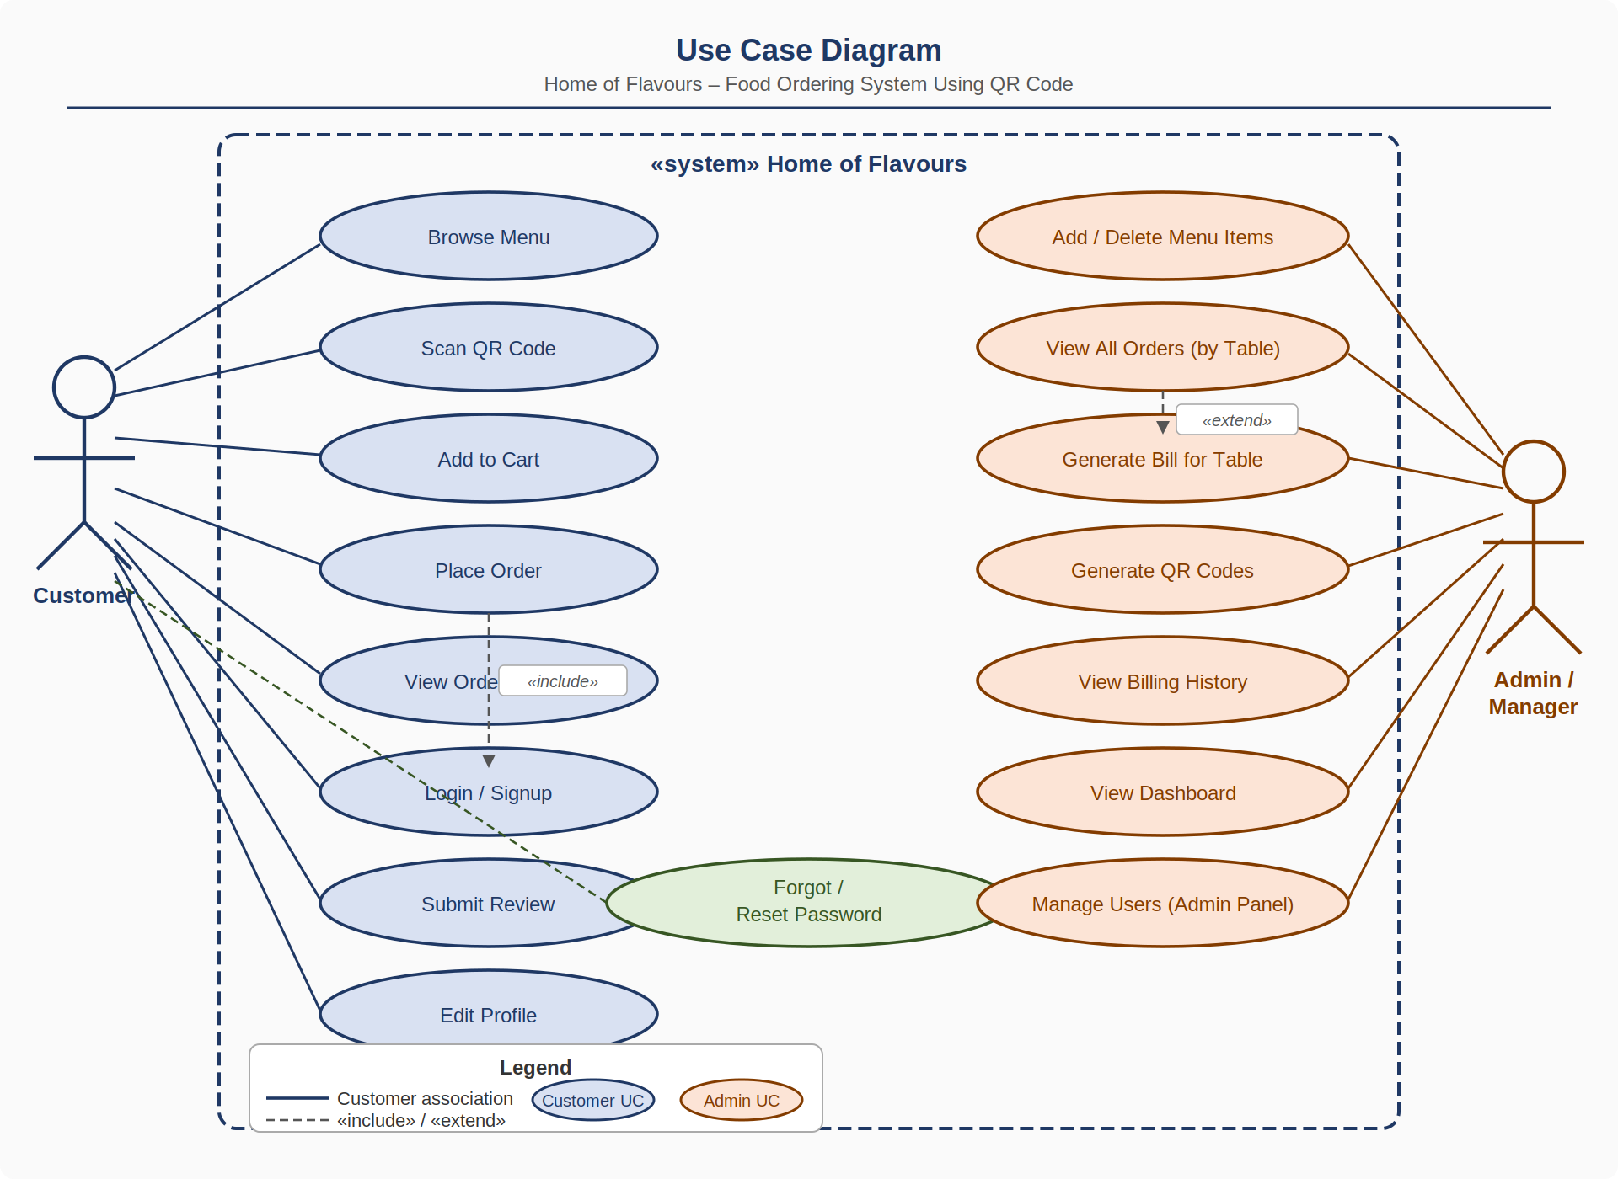

3.4 Table Design
The following tables are used in the SQLite3 database:

Table: cafe_user
Column | Data Type | Constraints
id | INTEGER | PRIMARY KEY, AUTO
phone | VARCHAR(10) | UNIQUE, NOT NULL
first_name | VARCHAR(150)
last_name | VARCHAR(150)
password | VARCHAR(128) | NOT NULL
cafe_manager | BOOLEAN | DEFAULT FALSE
order_count | INTEGER | DEFAULT 0
is_superuser | BOOLEAN | DEFAULT FALSE

Table: cafe_menu_item
Column | Data Type | Constraints
id | INTEGER | PRIMARY KEY, AUTO
name | VARCHAR(50) | NOT NULL
category | VARCHAR(50) | DEFAULT ""
desc | VARCHAR(250)
pic | VARCHAR(100) | Image path
price | VARCHAR(4) | DEFAULT "0"
list_order | INTEGER | DEFAULT 0

Table: cafe_order
Column | Data Type | Constraints
order_id | INTEGER | PRIMARY KEY, AUTO
items_json | VARCHAR(5000) | JSON string
name | VARCHAR(30) | Customer name
phone | VARCHAR(10)
table | VARCHAR(15) | DEFAULT "take away"
price | VARCHAR(5) | Total price
order_time | DATETIME | Auto set
bill_clear | BOOLEAN | DEFAULT FALSE

Table: cafe_bill
Column | Data Type | Constraints
id | INTEGER | PRIMARY KEY, AUTO
order_items | VARCHAR(5000) | Serialized dict
name | VARCHAR(50) | Customer name
bill_total | INTEGER | Total amount
phone | VARCHAR(10)
bill_time | DATETIME | Auto set

3.5 Data Dictionary
Field | Table | Type | Description
phone | cafe_user | VARCHAR(10) | Unique identifier for user login
cafe_manager | cafe_user | BOOLEAN | True if user is a restaurant manager
order_count | cafe_user | INTEGER | Total orders placed by the user
items_json | cafe_order | VARCHAR(5000) | JSON-encoded ordered items with qty and price
table | cafe_order | VARCHAR(15) | Table number or "Take Away"
bill_clear | cafe_order | BOOLEAN | True if bill has been generated for the order
list_order | cafe_menu_item | INTEGER | Controls display order of menu categories
bill_total | cafe_bill | INTEGER | Total bill amount in INR
order_items | cafe_bill | VARCHAR(5000) | Serialized dict of all items in the bill

3.6 Sample Input and Output Screens
1. Home Page – Dashboard showing total orders, customers, and revenue.
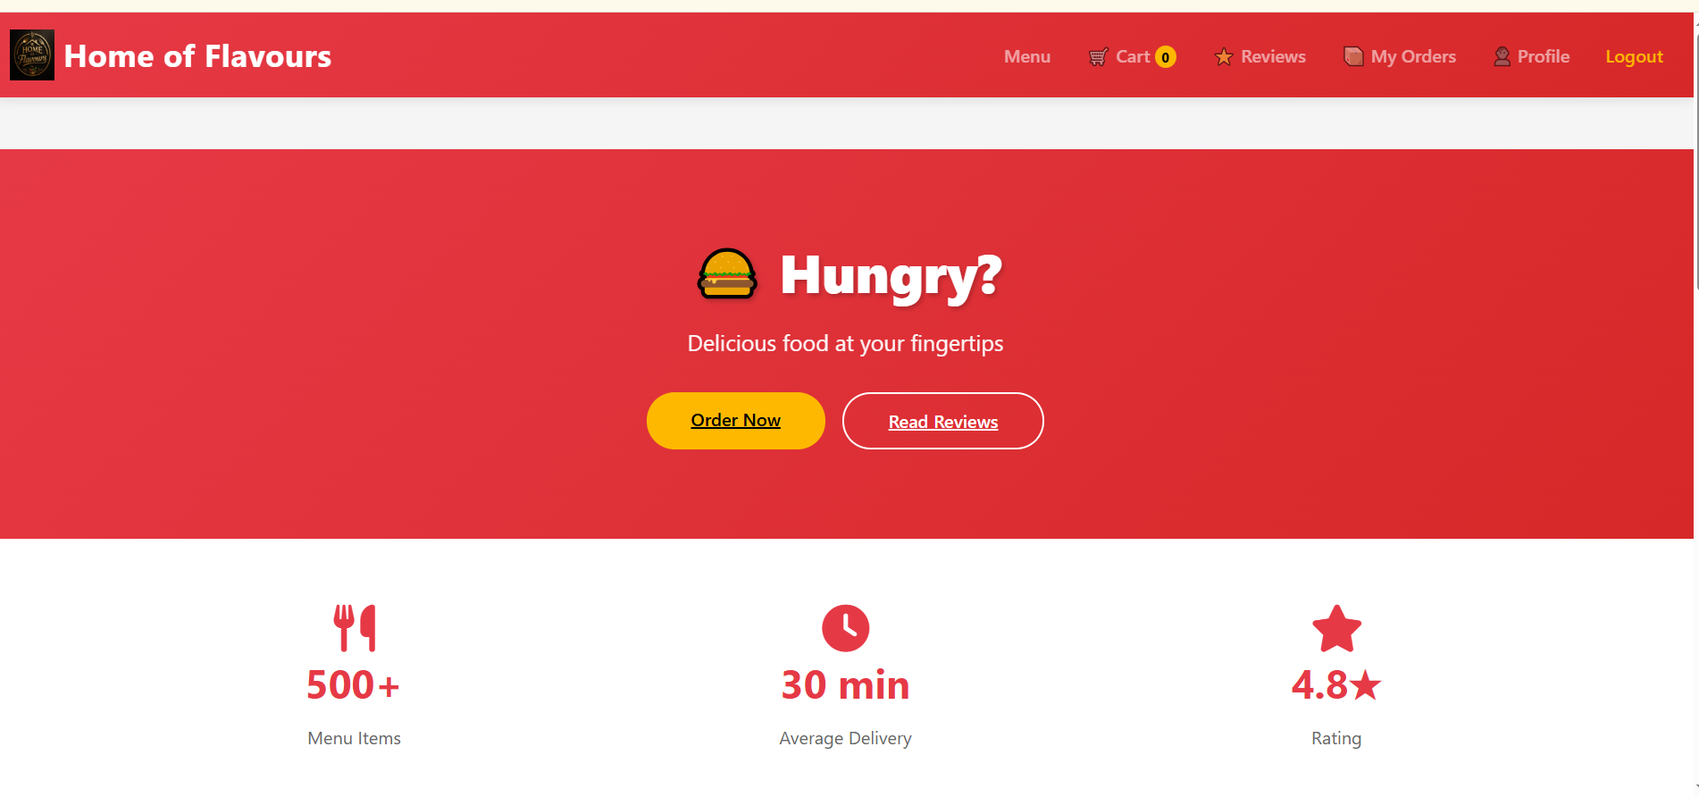
2. Menu Page – Categorized list of menu items (Papad, Starter, Gravy, Rice, etc.).
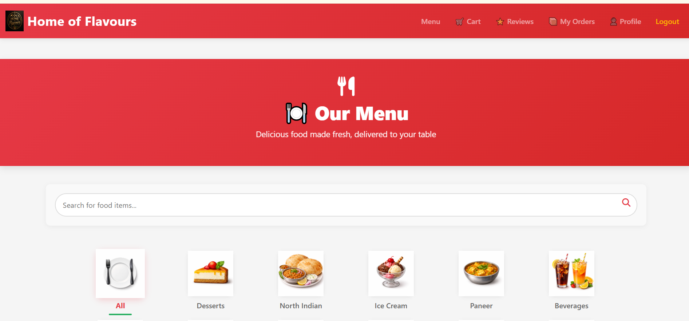

3. Cart Page – Items added to cart with quantity and total price.
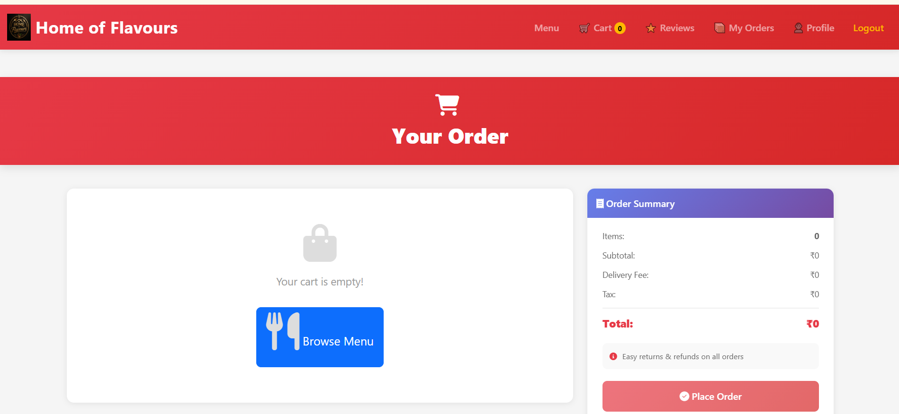
4. Login/Signup Page – Phone-based authentication form.
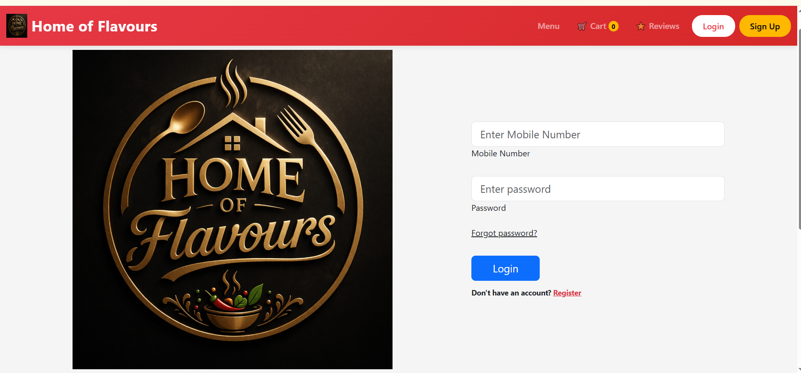
5. All Orders Page – Admin view of orders grouped by table.
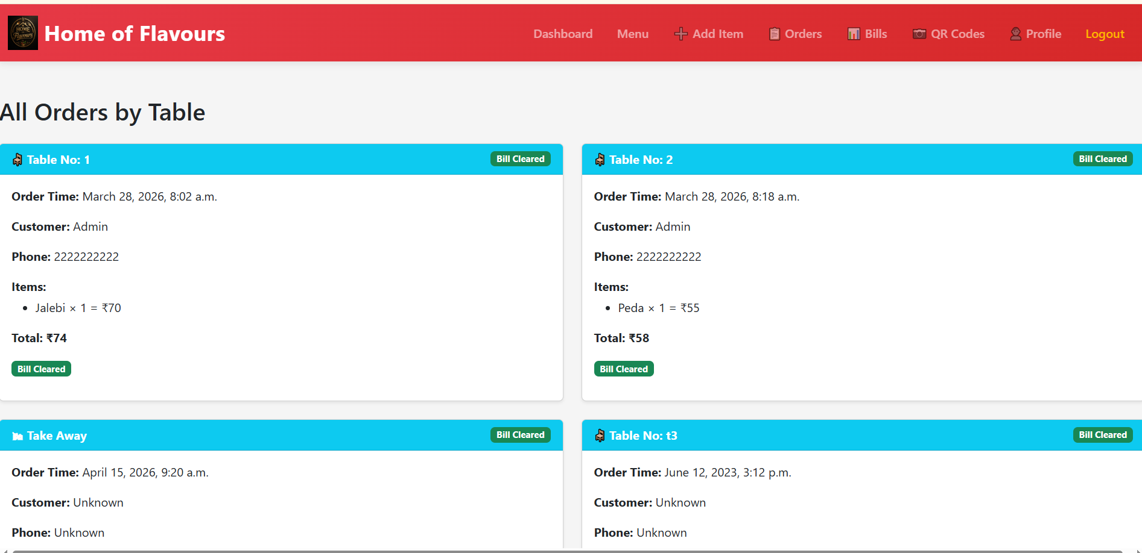

6. Generate Bill Page – Bill with item breakdown, subtotal, tax (5%), and total.
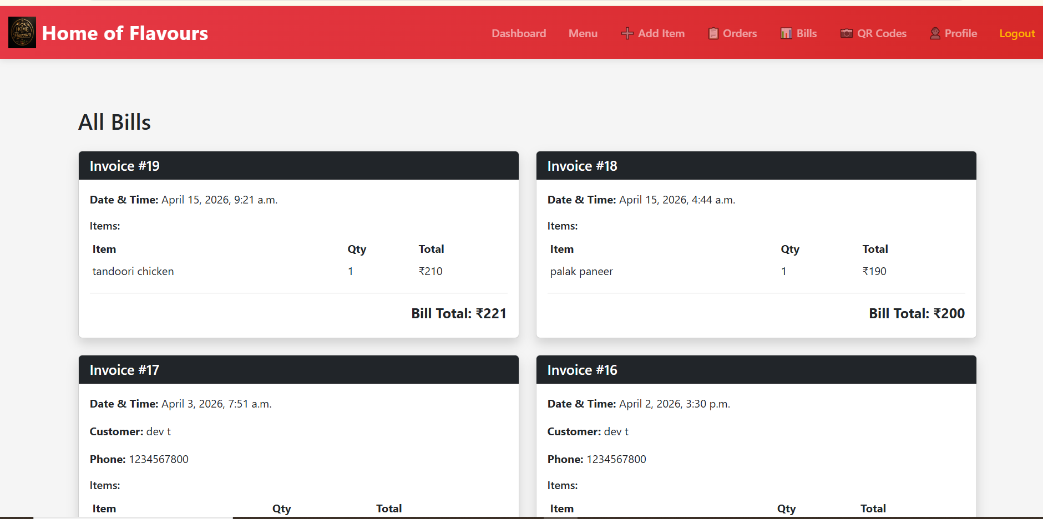
7. QR Manager Page – Table QR code generation and display.
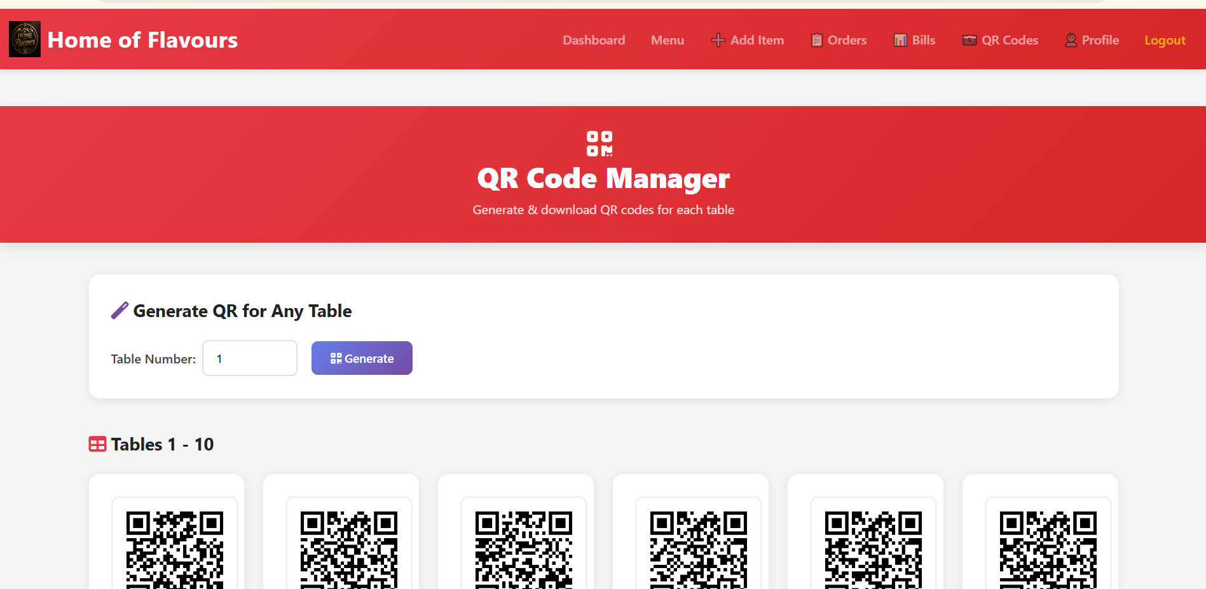
8. Admin Page – Customer order history by table.
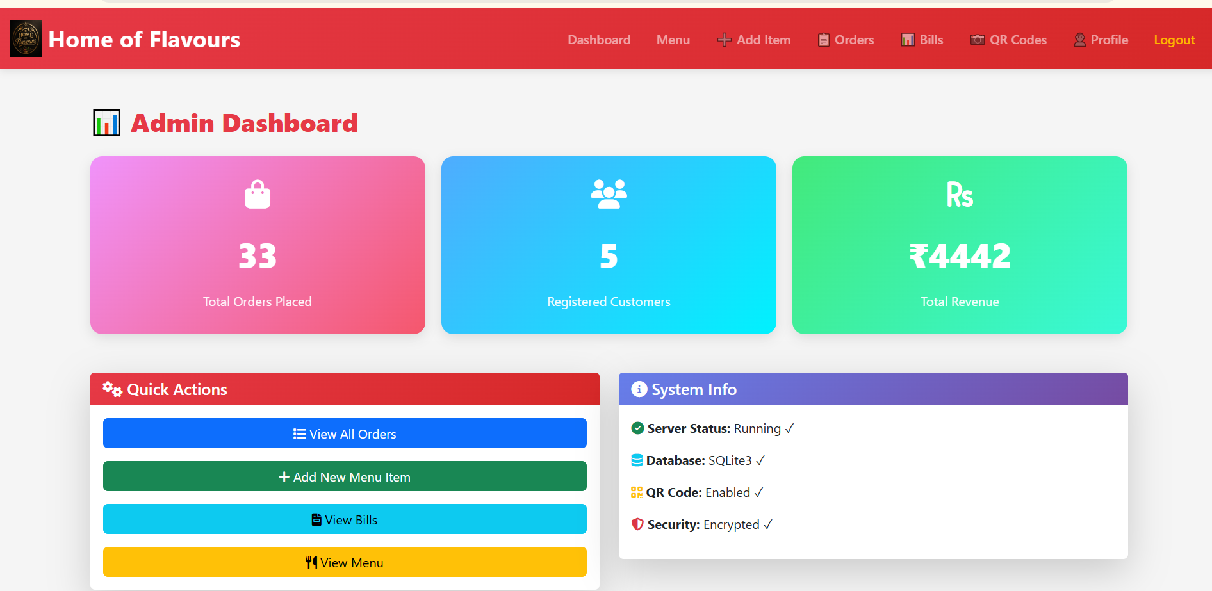

CHAPTER 4: CODING SAMPLE CODE

4.1 models.py – Database Models
User Model (Phone-based Authentication):
from django.db import models
from django.contrib.auth.models import AbstractUser
from .manager import UserManager

class User(AbstractUser):
email = None
username = None
phone = models.CharField(max_length=10, unique=True)
cafe_manager = models.BooleanField(default=False)
order_count = models.IntegerField(default=0)
objects = UserManager()
USERNAME_FIELD = "phone"
REQUIRED_FIELDS = []

class menu_item(models.Model):
name = models.CharField(max_length=50)
category = models.CharField(max_length=50, default="")
desc = models.CharField(max_length=250)
pic = models.ImageField(upload_to="fimage")
price = models.CharField(max_length=4, default="0")
list_order = models.IntegerField(default=0)

class order(models.Model):
order_id = models.AutoField(primary_key=True)
items_json = models.CharField(max_length=5000)
name = models.CharField(max_length=30, default="")
phone = models.CharField(max_length=10, default="")
table = models.CharField(max_length=15, default="take away")
price = models.CharField(max_length=5, default="0")
order_time = models.DateTimeField(auto_now_add=True)
bill_clear = models.BooleanField(default=False)

4.2 views.py – QR Code Generation
import qrcode
from django.http import HttpResponse

def generate_qr_code(request, table_number):
if not request.user.is_superuser:
messages.error(request, "Only admins can generate QR codes!")
return redirect("menu")
qr_link = request.build_absolute_uri(f"/menu?table={table_number}")
qr = qrcode.QRCode(version=1,
error_correction=qrcode.constants.ERROR_CORRECT_L,
box_size=10, border=4)
qr.add_data(qr_link)
qr.make(fit=True)
img = qr.make_image(fill_color="black", back_color="white")
response = HttpResponse(content_type="image/png")
img.save(response, "PNG")
return response

4.3 views.py – Order Placement (cart view)
def cart(request):
if request.method == "POST":
name = request.user.first_name + " " + request.user.last_name
phone = request.user.phone
items_json = request.POST.get("items_json", "{}")
table_number = request.POST.get("table_value", "null")
total = request.POST.get("price", "0")
new_order = order(name=name, phone=phone,
items_json=items_json, table=table_number, price=total)
new_order.save()
messages.success(request, "Order Placed Successfully!")
return redirect("my_orders")
return render(request, "cart.html")

CHAPTER 5: LIMITATIONS OF SYSTEM

- The system uses SQLite3, which is not suitable for high-traffic production environments. A migration to PostgreSQL or MySQL would be required for scalability.
- Cart data is stored in the browser's local Storage. This means the cart is lost if the browser is cleared or the customer switches devices.
- There is no real-time order notification for admins. The "All Orders" page must be manually refreshed to see new orders.
- No integrated payment gateway is available. The system only supports cash/offline payment at the time of billing.
- The QR code links use the server's current URL (localhost during development), which means QR codes need to be regenerated when deploying to a live domain.
- Phone-based OTP verification is not implemented; password reset is done without identity verification via OTP.
- The system does not support multiple restaurants or branches — it is designed as a single-outlet solution.
- No push notification or email/SMS alert is sent to customers when their order status changes.
- The analytics dashboard is basic (total orders, revenue, customers) and does not include graphical charts or date-range filtering.

CHAPTER 6: PROPOSED ENHANCEMENTS

- Payment Gateway Integration: Integrate Razor pay or Stripe for online payments, allowing customers to pay digitally at checkout.
- Real-time Order Notifications: Use Django Channels (WebSocket) to push new order alerts to the admin panel without page refresh.
- OTP-based Authentication: Add phone OTP verification using services like Twilio or MSG91 for secure login and password reset.
- Multi-language Support: Add multilingual support for menus to serve regional customers.
- Mobile App Development: Build a React Native or Flutter mobile app for both customers and admins.
- Database Upgrade: Migrate from SQLite3 to PostgreSQL for better concurrency, reliability, and scalability in production.
- Advanced Analytics: Add a dashboard with graphical revenue charts, peak hour analysis, and item-wise sales reports.
- Table Reservation System: Allow customers to book tables in advance through the website.
- REST API / GraphQL: Develop a REST or GraphQL API to enable third-party app integrations and mobile clients.
- Cloud Image Storage: Migrate media files to AWS S3 or Cloudinary for scalable image management.

CHAPTER 7: CONCLUSION

The "Home of Flavours – Food Ordering System Using QR Code" project successfully demonstrates the development of a full-featured, web-based food ordering platform using Python and Django. The system effectively replaces the traditional manual ordering process with a streamlined digital workflow.
Customers benefit from a self-service menu browsing and ordering experience triggered by scanning a table-specific QR code. Admins gain a powerful management interface to handle menu items, track orders by table, and generate itemized bills with GST automatically applied.
The project covers core software engineering concepts including MVC/MVT architecture, relational database design, user authentication, session management, file uploads, and QR code generation. The use of Bootstrap 5 ensures the interface is responsive and accessible across devices.
While the current implementation uses SQLite and is designed for single-restaurant use, the architecture is modular and can be extended to support payment gateways, real-time notifications, and multi-branch operations in future iterations.
Overall, this project provides a practical and effective solution for modern cafe and restaurant management, significantly improving operational efficiency and customer experience.

CHAPTER 8: BIBLIOGRAPHY

[1] Django Documentation – https://docs.djangoproject.com/
[2] Bootstrap 5 Documentation – https://getbootstrap.com/docs/5.0/
[3] Python Official Documentation – https://docs.python.org/3/
[4] qrcode Python Library – https://pypi.org/project/qrcode/
[5] Pillow (PIL Fork) Documentation – https://pillow.readthedocs.io/
[6] SQLite Documentation – https://www.sqlite.org/docs.html
[7] W3Schools – HTML, CSS, JavaScript Reference – https://www.w3schools.com/
[8] Mozilla Developer Network (MDN) – https://developer.mozilla.org/
[9] GitHub Repository – https://github.com/Vishal67th/Order-food-using-QR_code-main

