Chapter 5: Electronic Structure and Chemical Periodicity
CHEM 139 — Open Educational Resource (2026 ed.) · CC BY 4.0

Chapter Opener: Why a Sodium Flame is Yellow
Drop a tiny chip of sodium metal into a Bunsen burner flame and the flame turns a vivid yellow-orange. Drop a chip of lithium and you get red. Potassium gives violet. Calcium, bright orange. Strontium, deep crimson — the same metal that paints the night sky in a Fourth-of-July finale. Chemists have been able to distinguish these elements by flame color for two hundred years. In the late 1800s the colors became the starting point for one of the deepest discoveries in science: that the energies inside an atom come in discrete steps, like the notes on a piano, and the colors are produced when an electron drops from one step to the next.
This chapter takes that insight and uses it to organize all 118 elements. We will see why the periodic table has the shape it has, why atomic size shrinks across a row and grows down a column, why metals appear on the left and nonmetals on the right, and why the orderly march of element properties — chemical periodicity — was visible to chemists decades before anyone could explain it. The explanation, when it finally came in the 1920s, was the modern quantum theory of the atom, and it is the foundation on which the rest of the course rests.

Chapter Learning Outcomes
- State the periodic law and explain its basis in electron configuration.
- Identify periods, groups, and blocks on the periodic table; classify elements as metals, nonmetals, or metalloids.
- Describe the quantum mechanical model of the atom in terms of shells, subshells, and orbitals.
- Write full and condensed ground-state electron configurations for elements with Z = 1 through 36.
- Draw orbital box diagrams applying the Aufbau principle, the Pauli exclusion principle, and Hund's rule.
- Predict and explain periodic trends in atomic radius and metallic character.

5.1 The Periodic Law
Arrange the elements in order of increasing atomic number, and a striking pattern emerges: every so often, the chemical and physical properties repeat. Lithium, sodium, potassium, rubidium, and cesium all react vigorously with water; they all form +1 ions; they all conduct electricity. Helium, neon, argon, krypton, xenon are all colorless gases that almost never react. The periodic law (sometimes called the law of chemical periodicity) states this regularity formally: the chemical properties of the elements vary periodically with atomic number.
The original version of the law, due to Dmitri Mendeleev in 1869, was based on atomic mass instead of atomic number, but the central insight survived: properties recur at regular intervals. The modern version, with Z replacing mass, fixed several anomalies in the original (e.g., the position of tellurium and iodine) and is the version we use today.
HISTORICAL VIGNETTE — Dmitri Mendeleev (1834–1907): The youngest of perhaps fourteen children of a Siberian schoolteacher, Mendeleev wrote his periodic table in 1869 while preparing a textbook for general chemistry students. He listed the 63 elements known at the time on cards with their atomic masses and properties, then shuffled them — apparently in a single sleepless night — until the columns matched. When elements would not fit, he left gaps in the table and predicted properties of the missing ones. His predictions for "eka-aluminum" and "eka-silicon" — soon verified by the discovery of gallium (1875) and germanium (1886) — established the predictive power of his table. He never received a Nobel Prize, partly due to political enmities; element 101 (mendelevium) is named for him.

5.2 The Periodic Table
The periodic table is the visual realization of the periodic law. The horizontal rows are called periods (numbered 1 through 7); the vertical columns are called groups. Two numbering systems for groups exist:
- The IUPAC numbering, 1 through 18, runs left to right across the entire table.
- The older A/B numbering uses Roman numerals (Group IA, IIA, IIIA … VIIIA across the main groups, plus Group VIII (Fe/Co/Ni triads) and IB–VIIB across the transition metals.
Both numbering systems will appear on different periodic tables you encounter; learn to recognize both. In this book we use the IUPAC numbering when a numerical group is needed.

Shape of the Periodic Table
The table is not rectangular. It has a 14-element-wide block (the inner-transition metals) split off and printed below the main table. That separated block is the f-block, which we will explain in Section 5.10. The two rows below the main table are called the lanthanide series (Z = 57–71) and the actinide series (Z = 89–103). Their separation is purely cosmetic — without the split, the table would be too wide to fit on a page.
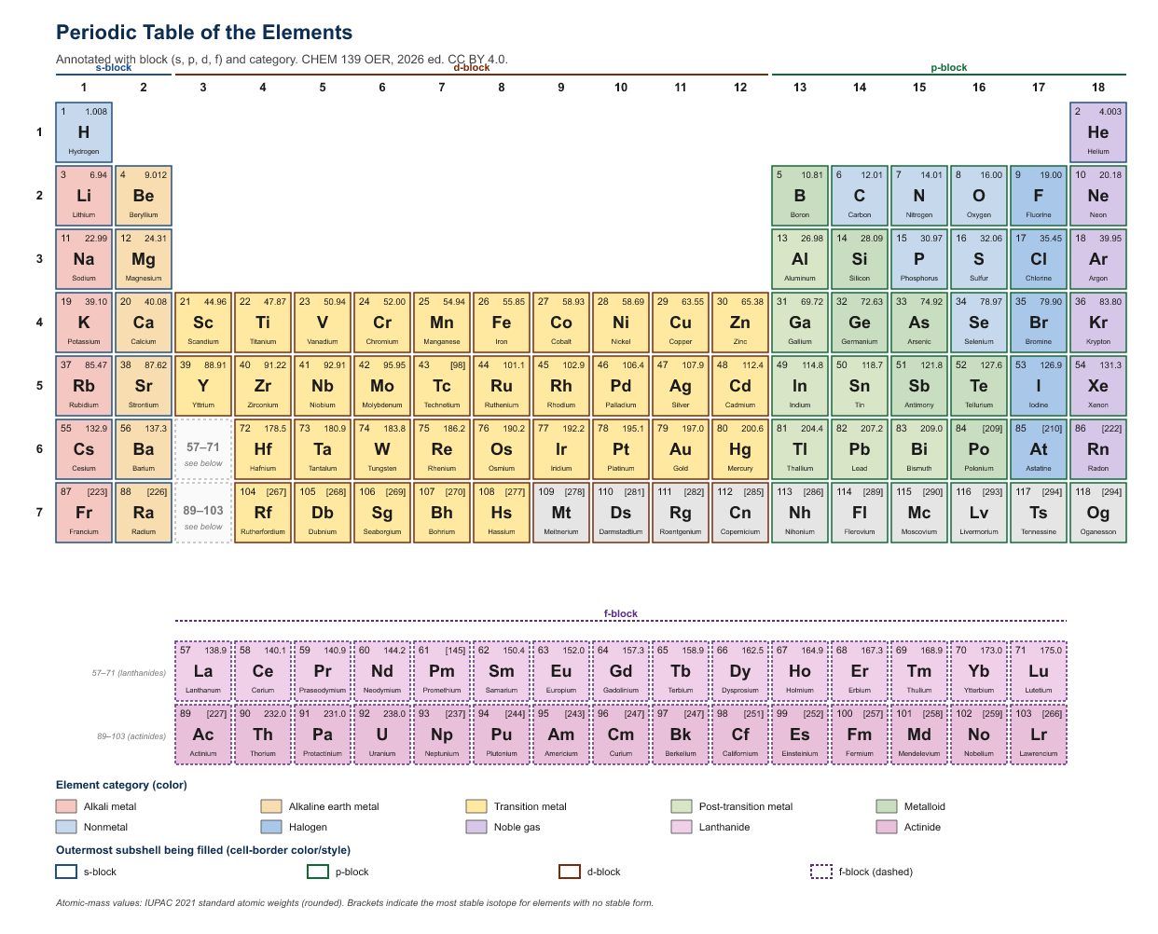
Original figure for the CHEM 139 OER textbook (2026 ed.). Built from public IUPAC 2021 / NIST element data. Licensed CC BY 4.0.
Figure 5.1 — The periodic table annotated with blocks and metallic character.
Alt text: An 18-column, 7-row periodic table colored to show s, p, d, and f blocks plus the metal/metalloid/nonmetal regions.
Description: A standard wide-form periodic table (18 columns × 7 rows, with the 14-column f-block printed underneath). Columns 1–2 colored light yellow (s-block); columns 13–18 colored light blue (p-block, except He, which sits in column 18); columns 3–12 colored light green (d-block); the lanthanide and actinide rows colored light pink (f-block). Above the table, column numbers 1–18 (IUPAC) and the older roman-numeral group labels (IA–VIIIA, IB–VIIIB) are shown side-by-side. A heavy zigzag stair-step line drawn from B to At separates metals (left, ~80% of elements, shaded gray border) from nonmetals (right, white border). Six metalloids (B, Si, Ge, As, Sb, Te) labeled with a dashed border. Above the table, four named groups: Group 1 = "Alkali metals"; Group 2 = "Alkaline earth metals"; Group 17 = "Halogens"; Group 18 = "Noble gases." Use Arial 10 pt for symbols, 8 pt for atomic numbers.
Caption: Figure 5.1 — The periodic table colored by block (s, p, d, f) and divided into metals (left of stair-step), nonmetals (right), and metalloids (along the stair-step boundary).

5.3 The Energy of an Electron
In the early 1900s, chemists' confidence that electrons orbited the nucleus like planets orbiting the Sun ran into the same problem that all classical pictures of the atom run into: a charged particle moving in a circle should radiate energy continuously and spiral into the nucleus, taking the atom apart in less than a millisecond. Atoms manifestly do not do this. Something about the inside of an atom is different from the outside.
The resolution came from quantum mechanics, the new physics developed in the 1920s. Three of its features matter for chemistry:
- Electrons in atoms have energies that are quantized. Only specific energy values are allowed; intermediate values are forbidden. Energy levels are the rungs on a ladder, not the slope of a ramp.
- Electrons occupy regions of space called orbitals, each of which has a characteristic shape. Orbitals are not orbits; they are probability distributions for finding the electron.
- An electron in a given orbital has a definite set of energy and shape but does not have a definite position; an electron is best pictured as a fuzzy cloud whose density is highest where the electron is most likely to be.
HISTORICAL VIGNETTE — Erwin Schrödinger (1887–1961): In 1926 the Austrian physicist Schrödinger wrote down the equation that bears his name, the central equation of quantum mechanics. Solutions to the Schrödinger equation for the hydrogen atom yielded exactly the energy levels needed to explain the discrete colors of the hydrogen spectrum and predicted the shapes of all the atomic orbitals s, p, d, f. Schrödinger shared the 1933 Nobel Prize in Physics for the work. He spent much of his later career in Dublin, where he wrote the influential 1944 book What Is Life?, which inspired Watson and Crick's eventual discovery of the structure of DNA.

5.4 Electron Shells (Principal Energy Levels)
The energies of an electron in an atom are organized into shells, also called principal energy levels. Shells are labeled by an integer n = 1, 2, 3, 4, …; the smaller n, the closer to the nucleus and the lower the energy. Each shell can hold a maximum number of electrons given by 2n² — the n=1 shell holds at most 2; n=2 holds at most 8; n=3 holds at most 18; n=4 holds at most 32, and so on. We rarely deal with electrons in shells beyond n=4 in introductory chemistry.
Table 5.1 — Electron shell capacities.
Shell n | Subshells | Max e⁻ per subshell | Max e⁻ in shell (2n²)
1 | 1s | 2 | 2
2 | 2s, 2p | 2, 6 | 8
3 | 3s, 3p, 3d | 2, 6, 10 | 18
4 | 4s, 4p, 4d, 4f | 2, 6, 10, 14 | 32

5.5 Electron Subshells (s, p, d, f)
Each shell is divided into subshells, labeled by letters s, p, d, f. The letters come from spectroscopic terms (sharp, principal, diffuse, fundamental) and have stuck. Subshells differ in shape and in maximum capacity:
Table 5.2 — The four subshell types.
Subshell | Number of orbitals | Max electrons | Shape (qualitative)
s | 1 | 2 | Spherical
p | 3 (px, py, pz) | 6 | Two-lobed (dumbbell)
d | 5 | 10 | Mostly four-lobed
f | 7 | 14 | Eight-lobed (complicated)
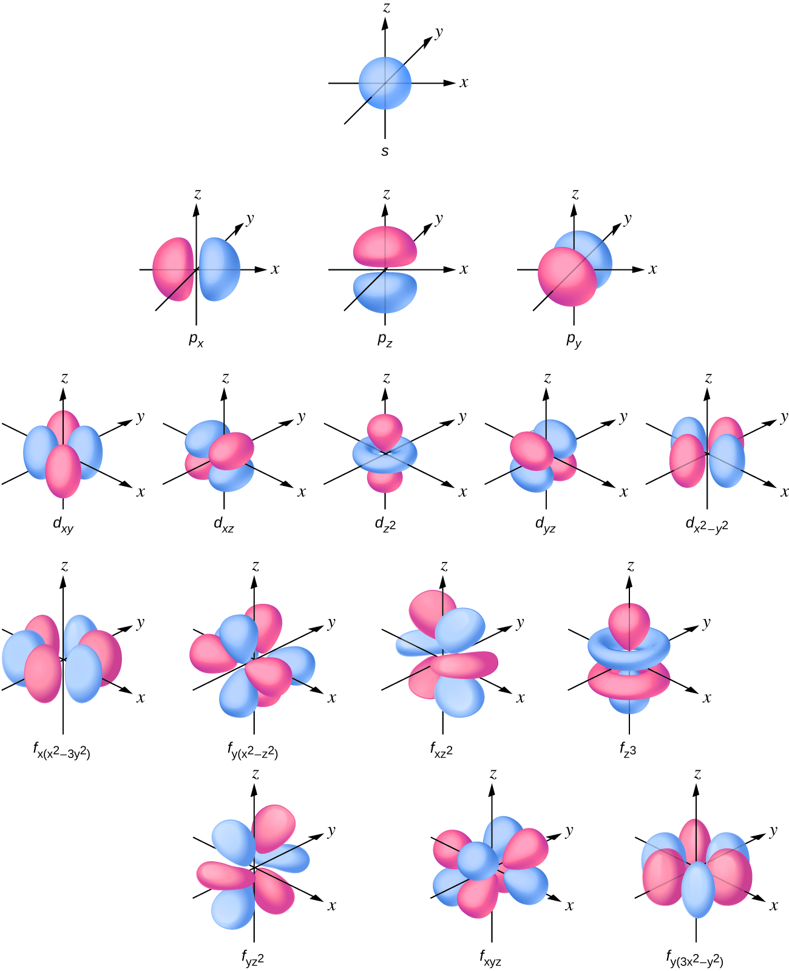
Adapted from OpenStax Chemistry 2e, Figure 6.21 (Flowers, Theopold, Langley, Robinson). Access for free at openstax.org. Licensed CC BY 4.0.
Figure 5.2 — Shapes of s, p, and d orbitals.
Alt text: Schematic 3D shapes of one s orbital, three p orbitals, and a sample d orbital.
Description: Three side-by-side panels, each ~2 inches square. Left panel: a single sphere centered on a small black dot (the nucleus), labeled "s orbital (spherical)." Middle panel: three dumbbell shapes drawn through the nucleus on the x, y, and z axes, labeled "p orbitals (px, py, pz)." Right panel: a single d_{x²−y²} shape — four lobes pointing along the +x, −x, +y, −y directions in a clover-leaf pattern — labeled "d orbital (one of five)." Use Arial 11 pt for labels.
Caption: Figure 5.2 — Schematic shapes of s, p, and d orbitals. The nucleus is at the origin; orbital surfaces enclose the regions of high probability of finding the electron.

5.6 Electron Orbitals and Electron Spin
An orbital is a single region of space, defined by quantum mechanics, that can hold at most two electrons. Each subshell contains a fixed number of orbitals (s = 1, p = 3, d = 5, f = 7). Two electrons in the same orbital must have opposite spins, a quantum-mechanical property captured by the up-arrow / down-arrow convention (↑ and ↓). The rule that no two electrons in an atom can have the same set of quantum numbers — including spin — is the Pauli exclusion principle.

5.7 Electron Configurations
An electron configuration is a list of which subshells are occupied and by how many electrons in the ground state of an atom. We write it as a list of subshell labels with electron counts as superscripts: 1s², 2s², 2p⁶, 3s², and so on.

The Aufbau Principle
Aufbau is the German word for "building up." The Aufbau principle says: to write the electron configuration of an atom, place electrons one at a time into the lowest-energy orbital that has room, and continue until all electrons are accommodated.
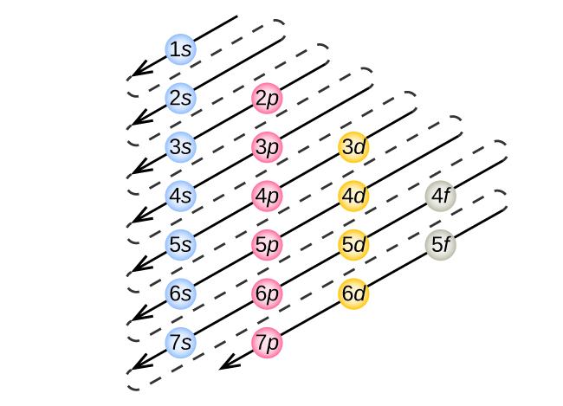
Adapted from OpenStax Chemistry 2e, Figure 6.26 (Flowers, Theopold, Langley, Robinson). Access for free at openstax.org. Licensed CC BY 4.0.
Figure 5.3 — Aufbau filling order (diagonal-arrow diagram).
Alt text: A grid of subshell labels with diagonal arrows showing the order in which subshells are filled.
Description: A 7×4 grid. Rows correspond to shells n = 1 through 7. Columns correspond to subshells s, p, d, f, in that order. Cells filled with subshell labels (1s, 2s, 2p, 3s, 3p, 3d, 4s, 4p, 4d, 4f, 5s, 5p, 5d, 5f, 6s, 6p, 6d, 7s, 7p). Diagonal arrows starting at 1s, then 2s, then 2p, 3s, then 3p, 4s, then 3d, 4p, 5s, then 4d, 5p, 6s, then 4f, 5d, 6p, 7s, then 5f, 6d, 7p — each arrow drawn from upper right to lower left, with the next arrow starting just below where the last one ended. Use Arial 11 pt for cell text and a clear blue color for the arrows.
Caption: Figure 5.3 — The diagonal-arrow rule shows the order in which electrons fill subshells: 1s, 2s, 2p, 3s, 3p, 4s, 3d, 4p, 5s, 4d, 5p, 6s, 4f, 5d, 6p, 7s, 5f, 6d, 7p.
Memorize the order: 1s 2s 2p 3s 3p 4s 3d 4p 5s 4d 5p 6s 4f 5d 6p 7s 5f 6d 7p. The 4s appearing before the 3d, and 5s before 4d, are common student traps.
Table 5.3 — Full ground-state electron configurations for Z = 1 through 36.
Z | Symbol | Configuration
1 | H | 1s¹
2 | He | 1s²
3 | Li | 1s² 2s¹
4 | Be | 1s² 2s²
5 | B | 1s² 2s² 2p¹
6 | C | 1s² 2s² 2p²
7 | N | 1s² 2s² 2p³
8 | O | 1s² 2s² 2p⁴
9 | F | 1s² 2s² 2p⁵
10 | Ne | 1s² 2s² 2p⁶
11 | Na | 1s² 2s² 2p⁶ 3s¹
12 | Mg | 1s² 2s² 2p⁶ 3s²
13 | Al | 1s² 2s² 2p⁶ 3s² 3p¹
14 | Si | 1s² 2s² 2p⁶ 3s² 3p²
15 | P | 1s² 2s² 2p⁶ 3s² 3p³
16 | S | 1s² 2s² 2p⁶ 3s² 3p⁴
17 | Cl | 1s² 2s² 2p⁶ 3s² 3p⁵
18 | Ar | 1s² 2s² 2p⁶ 3s² 3p⁶
19 | K | [Ar] 4s¹
20 | Ca | [Ar] 4s²
21 | Sc | [Ar] 4s² 3d¹
22 | Ti | [Ar] 4s² 3d²
23 | V | [Ar] 4s² 3d³
24 | Cr | [Ar] 4s¹ 3d⁵ *
25 | Mn | [Ar] 4s² 3d⁵
26 | Fe | [Ar] 4s² 3d⁶
27 | Co | [Ar] 4s² 3d⁷
28 | Ni | [Ar] 4s² 3d⁸
29 | Cu | [Ar] 4s¹ 3d¹⁰ *
30 | Zn | [Ar] 4s² 3d¹⁰
31 | Ga | [Ar] 4s² 3d¹⁰ 4p¹
32 | Ge | [Ar] 4s² 3d¹⁰ 4p²
33 | As | [Ar] 4s² 3d¹⁰ 4p³
34 | Se | [Ar] 4s² 3d¹⁰ 4p⁴
35 | Br | [Ar] 4s² 3d¹⁰ 4p⁵
36 | Kr | [Ar] 4s² 3d¹⁰ 4p⁶
* Cr and Cu are exceptions to the strict Aufbau filling order; the half-filled (4s¹ 3d⁵) and fully-filled (4s¹ 3d¹⁰) configurations are slightly more stable than the strict prediction.

Condensed (Noble-Gas) Configurations
For elements past argon, the inner-shell portion of the configuration is often abbreviated by the symbol of the previous noble gas in brackets. Thus, K is written [Ar] 4s¹ instead of 1s² 2s² 2p⁶ 3s² 3p⁶ 4s¹. The condensed form is faster to write and emphasizes the valence electrons (those outside the noble-gas core), which determine chemistry.
EXAMPLE 5.1: Writing an electron configuration
Write the full and condensed ground-state electron configurations for sulfur (Z = 16).
Step 1 — Apply Aufbau order until 16 electrons are placed: 1s² 2s² 2p⁶ 3s² 3p⁴.
Step 2 — Verify total: 2 + 2 + 6 + 2 + 4 = 16. ✓
Step 3 — Identify the previous noble gas: neon (Z = 10), with configuration 1s² 2s² 2p⁶.
Step 4 — Write condensed: [Ne] 3s² 3p⁴.
ANSWER: Full = 1s² 2s² 2p⁶ 3s² 3p⁴; condensed = [Ne] 3s² 3p⁴.

5.8 Electron Orbital Diagrams
An orbital diagram represents each orbital as a box (or a horizontal line) and each electron as an arrow inside the box. By convention an up-arrow is drawn first; the second electron in the same orbital is a down-arrow.
Two additional rules apply:
- Pauli exclusion principle. An orbital can hold at most two electrons, and they must have opposite spins (↑↓).
- Hund's rule. Within a degenerate set of orbitals (orbitals in the same subshell, all with the same energy), electrons enter singly with parallel spins before any orbital receives a second electron. The carbon 2p subshell, for example, holds two electrons in two different p orbitals (↑↑) — not a single doubly-occupied orbital.
EXAMPLE 5.2: Orbital diagram for nitrogen (Z = 7)
Draw the orbital diagram and write the electron configuration.
Step 1 — Configuration: 1s² 2s² 2p³.
Step 2 — Diagram (boxes shown as bracket notation):
1s: [↑↓]
2s: [↑↓]
2p: [↑ ][↑ ][↑ ] ← Hund's rule: three electrons go into the three p orbitals singly with parallel spin
Note that the three unpaired p electrons are why nitrogen often forms three covalent bonds (Chapter 6).
EXAMPLE 5.3: Orbital diagram for oxygen (Z = 8)
Draw the orbital diagram for oxygen.
Step 1 — Configuration: 1s² 2s² 2p⁴.
Step 2 — Diagram:
1s: [↑↓]
2s: [↑↓]
2p: [↑↓][↑ ][↑ ] ← four p electrons: one orbital paired, the other two singly occupied
Two unpaired electrons explain why oxygen is paramagnetic — a fact that surprised early chemistry students and confirmed Hund's rule.

5.9 Electron Configurations and the Periodic Law
Why do the chemical properties recur every 8, then 18, then 32 elements? Because the outer-shell electron configurations recur on the same schedule. The valence-shell configuration of all the alkali metals is ns¹ (one electron in the outermost s orbital). The valence configuration of all the halogens is ns² np⁵ (one electron short of a full set). The configuration of all the noble gases is ns² np⁶ (a full set, except for helium with 1s²). The chemistry follows the configuration; the periodicity in the table follows the chemistry; the table is a map of electron configurations.

5.10 Electron Configurations and the Periodic Table
The periodic table can be read directly as an Aufbau diagram. The columns where each subshell is being filled define the four blocks:
- s-block: Groups 1 and 2 (plus He). Outer subshell being filled is ns.
- p-block: Groups 13–18 (excluding He). Outer subshell is np.
- d-block: Groups 3–12 (transition metals). Outer subshell is (n−1)d.
- f-block: Lanthanides and actinides (the two rows below the table). Outer subshell is (n−2)f.
To find the electron configuration of an element, you can simply trace its position on the table. Iron (Z = 26) sits in period 4, group 8 (d-block). The electrons fill: 1s, 2s, 2p, 3s, 3p, 4s, then four into the 3d. Configuration: [Ar] 4s² 3d⁶.

5.11 Classification of Elements
Three crosscutting classifications are commonly applied to the periodic table:
- Metals, nonmetals, and metalloids. Metals (left of the stair-step) are shiny, conduct heat and electricity, are malleable and ductile, and tend to lose electrons. Nonmetals (right of the stair-step) are dull, poor conductors, brittle, and tend to gain electrons. Metalloids (along the stair-step: B, Si, Ge, As, Sb, Te) have intermediate properties.
- Representative (main-group), transition, and inner-transition elements. Representative elements are the s- and p-block (Groups 1, 2, 13–18). Transition elements are the d-block. Inner-transition elements are the f-block.
- Named groups. Group 1 (excluding H): alkali metals. Group 2: alkaline-earth metals. Group 17: halogens. Group 18: noble gases.

5.12 Chemical Periodicity — Trends

Atomic Size (Atomic Radius)
The size of an atom — its atomic radius — depends on two competing factors: how far the outer electrons are from the nucleus (which makes the atom larger) and how strongly the nucleus pulls them in (which shrinks the atom). The competition produces two clean trends:
- Across a period (left to right): atomic radius DECREASES. The nuclear charge increases (more protons), but the outer electrons are added to the same shell, so the increased pull dominates and the atom contracts.
- Down a group (top to bottom): atomic radius INCREASES. Each successive period adds an outer shell, which is farther from the nucleus.
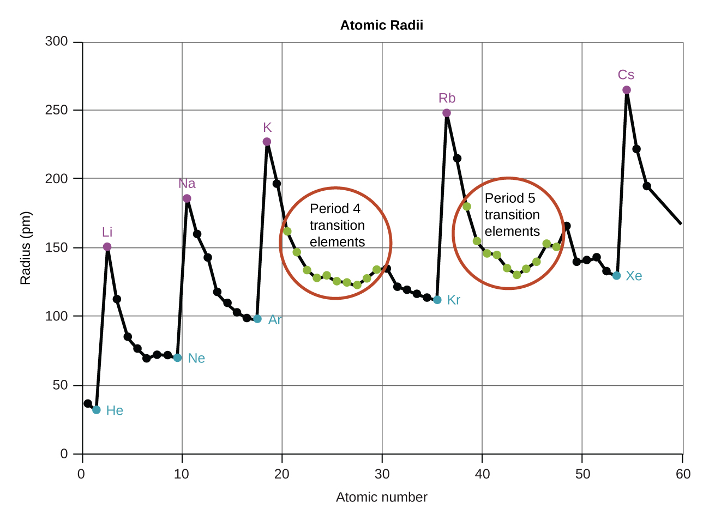
Adapted from OpenStax Chemistry 2e, Figure 6.31 (Flowers, Theopold, Langley, Robinson). Access for free at openstax.org. Licensed CC BY 4.0.
Figure 5.4 — Periodic trend in atomic radius.
Alt text: A schematic periodic table showing the directions of increase for atomic radius using bold arrows.
Description: A simplified periodic-table outline (just the column-row grid, no element labels) drawn ~5 inches wide. A bold blue arrow pointing UP along the right edge of the table is labeled "Atomic radius INCREASES." A second bold blue arrow pointing LEFT along the bottom edge is labeled "Atomic radius INCREASES." Two thin gray arrows at the top and right edges, pointing DOWN and RIGHT respectively, indicate the directions of decrease and are labeled "DECREASES." Show three sample atom circles drawn at increasing sizes — one small (top right), one medium (middle), one large (bottom left) — to reinforce the visual.
Caption: Figure 5.4 — Atomic radius decreases left-to-right across a period and increases top-to-bottom down a group.

Metallic Character
Metallic character — the tendency to behave as a metal — increases as atoms become larger and more willing to lose electrons. Therefore:
- Across a period (left to right): metallic character DECREASES.
- Down a group (top to bottom): metallic character INCREASES.
The most metallic element on the periodic table is therefore the one farthest down and farthest left — francium (Fr). The most nonmetallic is the one farthest up and farthest right (excluding the unreactive noble gases) — fluorine (F).
REMINDER: Atomic-radius and metallic-character trends both run in the same diagonal direction (down-and-left for INCREASING). Many textbook trends — including ionization energy and electronegativity, which we will see in later chapters — run the opposite way (up-and-right for INCREASING). Memorize the diagonal.

Practice Problems by Topic

Periodic Law and Periodic Table

Shells, Subshells, Orbitals

Electron Configurations

Orbital Diagrams

Periodic Trends
- State the periodic law.
Solution: Properties of the elements vary periodically (in a regular, repeating fashion) with increasing atomic number.
- Identify the period and group of
- Mg (Z=12),
- Br (Z=35),
- Fe (Z=26).
Solution:
- Period 3, Group 2.
- Period 4, Group 17.
- Period 4, Group 8.
- Name two named groups and one element in each.
Solution: Alkali metals — Na; halogens — Cl. Many possible answers.
- Why are noble gases unreactive (qualitatively)?
Solution: Their valence shells are full (ns² np⁶, except He = 1s²); they have very little tendency to gain or lose electrons.
- Maximum number of electrons in shell n=4?
Solution: 2(4²) = 32.
- How many orbitals in a 3p subshell?
Solution: 3.
- Maximum number of electrons in a 4d subshell?
Solution: 10.
- How many subshells does shell n=3 contain? Name them.
Solution: Three: 3s, 3p, 3d.
- Write the full configuration for:
- Be,
- Si,
- Ar.
Solution:
- 1s² 2s².
- 1s² 2s² 2p⁶ 3s² 3p².
- 1s² 2s² 2p⁶ 3s² 3p⁶.
- Write the condensed configuration for:
- Ca,
- Mn,
- As,
- Br.
Solution:
- [Ar] 4s².
- [Ar] 4s² 3d⁵.
- [Ar] 4s² 3d¹⁰ 4p³.
- [Ar] 4s² 3d¹⁰ 4p⁵.
- Why is K written [Ar] 4s¹ rather than [Ar] 3d¹?
Solution: The 4s subshell is lower in energy than 3d at this point in the periodic table; Aufbau order fills 4s first.
- Identify the element with configuration 1s² 2s² 2p⁶ 3s² 3p⁵.
Solution: Total electrons = 17 → chlorine (Cl).
- Identify the element with [Kr] 5s² 4d¹⁰ 5p².
Solution: Z = 36 + 14 = 50 → tin (Sn).
- Draw the orbital diagram for fluorine (Z = 9).
Solution: 1s [↑↓]; 2s [↑↓]; 2p [↑↓][↑↓][↑ ]. Configuration 1s² 2s² 2p⁵.
- How many unpaired electrons in P (Z = 15)?
Solution: P configuration: [Ne] 3s² 3p³. Three unpaired electrons (one in each 3p orbital, by Hund's rule).
- State Hund's rule.
Solution: Within a degenerate (equal-energy) set of orbitals, electrons enter singly with parallel spins before any orbital receives a second electron.
- State the Pauli exclusion principle.
Solution: No two electrons in an atom can share the same set of all four quantum numbers; equivalently, an orbital can hold at most two electrons, and they must have opposite spins.
- Which is larger: Na or K? Explain.
Solution: K — both are alkali metals; K is one period below Na, so it has one more shell of electrons and therefore a larger atomic radius.
- Which is larger: Na or Cl? Explain.
Solution: Na — both are in period 3, but Na has fewer protons (11 vs. 17), so the nuclear pull on its outer electrons is weaker and the atom is larger.
- Rank in order of increasing atomic radius: Mg, Si, S, Cl.
Solution: All in period 3. Going left to right radius decreases, so largest to smallest: Mg > Si > S > Cl. Increasing: Cl < S < Si < Mg.
- Which is more metallic: Mg or Cl? Mg or Ca?
Solution: Mg is more metallic than Cl (across the period); Ca is more metallic than Mg (down the group).

Additional Practice Problems by Topic

Periodic Law and Periodic Table
- State the modern periodic law.
Solution: The properties of the elements are periodic functions of their atomic numbers.
- Identify the period and group of:
- Mg,
- Br,
- Fe,
- Sn,
- I.
Solution:
- period 3, group 2;
- period 4, group 17;
- period 4, group 8;
- period 5, group 14;
- period 5, group 17.
- Identify whether each is a metal, metalloid, or nonmetal: Si, K, S, Ge, Mg, Cl, As.
Solution: Metals: K, Mg. Metalloids: Si, Ge, As. Nonmetals: S, Cl.
- Name the family for each group: 1, 2, 17, 18.
Solution: 1 = alkali metals (excluding H), 2 = alkaline earth metals, 17 = halogens, 18 = noble gases.
- Why are Mendeleev’s gaps in the original periodic table considered a triumph of his approach?
Solution: He left blanks for elements he predicted should exist with specific properties; the later discovery of Ga, Sc, and Ge confirmed his predictions and validated the periodic-law approach.

Shells, Subshells, Orbitals
- List the subshells in the n = 3 shell and the number of orbitals in each.
Solution: n = 3 contains 3s (1 orbital), 3p (3), and 3d (5) subshells; total 9 orbitals, 18 electrons capacity.
- How many electrons can fit in the n = 4 shell?
Solution: 4s + 4p + 4d + 4f = 1 + 3 + 5 + 7 = 16 orbitals × 2 electrons each = 32 electrons.
- What is the maximum number of electrons in any single orbital? State the principle.
Solution: 2 electrons (with opposite spins) by the Pauli exclusion principle.
- Identify the subshell labels (s, p, d, f) by the value of the angular-momentum quantum number ℓ.
Solution: ℓ = 0 (s), 1 (p), 2 (d), 3 (f).
- Sketch the shape (in words) of an s and a p orbital.
Solution: s orbital: spherically symmetric around the nucleus. p orbital: dumbbell shape with two lobes on opposite sides of the nucleus along one axis (px, py, or pz).

Electron Configurations
- Write the ground-state electron configuration of N (Z = 7).
Solution: 1s² 2s² 2p³.
- Write the ground-state electron configuration of Ca (Z = 20).
Solution: 1s² 2s² 2p⁶ 3s² 3p⁶ 4s² (or [Ar] 4s²).
- Write the noble-gas-shorthand configuration of Br (Z = 35).
Solution: [Ar] 4s² 3d¹⁰ 4p⁵.
- Identify the element whose ground-state configuration is [Ne] 3s² 3p⁴.
Solution: 2 + 8 + 2 + 4 = 16 electrons → Z = 16, sulfur (S).
- Write the electron configuration of Fe (Z = 26) and identify the number of valence electrons.
Solution: [Ar] 4s² 3d⁶. Fe has 8 outer-shell electrons (4s² 3d⁶) participating in chemistry as transition-metal valence electrons.

Orbital Diagrams
- Draw the orbital diagram (in arrows-in-boxes notation, described) for O.
Solution: 1s [↑↓] 2s [↑↓] 2p [↑↓][↑][↑]. Hund’s rule: singly occupy each 2p orbital before pairing.
- How many unpaired electrons in the ground state of P (Z = 15)?
Solution: [Ne] 3s² 3p³ → three unpaired electrons in 3p (one in each 3p orbital).
- State Hund’s rule.
Solution: Within a degenerate set of orbitals (same energy), electrons occupy separate orbitals with parallel spins before pairing.
- Explain why the ground state of carbon has two unpaired electrons rather than one pair in 2p.
Solution: With two electrons in 2p, Hund’s rule places one in each of two different p orbitals (spins parallel); pairing in a single 2p orbital would cost more energy than occupying two orbitals separately.
- How many unpaired electrons in Fe and Fe²⁺ in their ground states? (Use [Ar] 4s² 3d⁶ for Fe.)
Solution: Fe: 4 unpaired electrons (3d⁶ fills 1 orbital fully and singly occupies the remaining 4). Fe²⁺: lose the 4s electrons first → [Ar] 3d⁶; still 4 unpaired electrons.

Periodic Trends
- Rank in order of increasing atomic radius: Na, K, Rb, Cs.
Solution: Na < K < Rb < Cs (radius increases down a group).
- Rank in order of increasing first ionization energy: Na, Mg, Al.
Solution: Na < Al < Mg. (Mg is anomalously high due to its filled 3s²; Al loses one 3p electron more easily.)
- Which has greater electronegativity: O or S?
Solution: O. Electronegativity decreases down a group; oxygen sits above sulfur.
- Predict whether atomic radius increases or decreases left-to-right across a period and explain.
Solution: Decreases. Effective nuclear charge grows as Z increases (electrons added to the same shell), pulling the cloud inward.
- Order the radii: Mg, Mg²⁺, O, O²⁻. Explain.
Solution: O²⁻ > O ≈ small change discussion; for the isoelectronic set Mg²⁺, O²⁻ have same 10 electrons but different nuclear charges. Order from smallest to largest: Mg²⁺ < Mg, and Mg²⁺ < O²⁻. Detailed: Mg²⁺ (smallest), then O, then Mg, then O²⁻. (Cations are smaller than the parent atom; anions larger; isoelectronic species shrink as Z increases.)

Multi-Concept Problems
- An element X has condensed configuration [Ne] 3s² 3p⁵.
- Identify X.
- In what group, period, and block does X sit?
- How many valence electrons does X have?
- Predict the most likely ion charge.
Solution:
- Z = 10 + 7 = 17 → Cl.
- Group 17, Period 3, p-block.
- 7 valence electrons (3s² 3p⁵).
- One short of an octet → gains 1 electron → Cl⁻.
- A neutral atom has 24 electrons.
- Identify the element.
- Write the expected and actual condensed configuration.
- Account for the discrepancy.
Solution:
- Z = 24 → Cr.
- Expected: [Ar] 4s² 3d⁴; actual: [Ar] 4s¹ 3d⁵.
- Half-filled 3d subshell (3d⁵) is energetically more stable than 3d⁴, so one 4s electron promotes to 3d.
- Two atoms, A and B, both have 8 valence electrons. A has Z = 18; B has Z = 36.
- Same group?
- Same period?
- Compare atomic radii.
Solution:
- Yes — both are noble gases (Group 18).
- No — A is in Period 3 (Ar); B is in Period 4 (Kr).
- Kr > Ar — atomic radius increases down a group.
- An element in Period 3 has 4 unpaired electrons in its ground state.
- Identify possible candidates.
- Which one is correct?
Solution:
- In Period 3, the 3p subshell is filling. With 4 unpaired electrons, the configuration must be 3s² 3p⁴? — no, that has 2 unpaired by Hund (paired pair + 2 singly). Try 3s² 3p² (2 unpaired) — no. Actually, no Period-3 ground-state element has 4 unpaired electrons. The best candidate is silicon (Si, 3s² 3p²), with 2 unpaired.
- The premise is impossible; the maximum unpaired in Period 3 is 3 (P, 3p³). The student should reconsider the question.
- Sketch the trend in atomic radius across Period 2 (Li → Ne) and explain the trend at the particle level.
Solution: Atomic radius decreases monotonically from Li (largest) to Ne (smallest, except possibly Ne being slightly larger than F because of e–e repulsion). The trend is driven by increasing nuclear charge pulling the same shell of electrons in tighter.

Multiple Choice Practice Test
- Periodic law states that properties vary periodically with:
(A) mass
(B) melting point
(C) atomic number
(D) atomic radius
- Number of orbitals in a d subshell:
(A) 1
(B) 3
(C) 5
(D) 7
- Maximum electrons in n=3 shell:
(A) 2
(B) 8
(C) 18
(D) 32
- Configuration of P (Z=15):
(A) 1s²2s²2p⁶3s²3p²
(B) 1s²2s²2p⁶3s²3p³
(C) 1s²2s²2p⁶3s¹3p⁴
(D) 1s²2s²2p⁵3s²3p⁴
- Condensed configuration of Br:
(A) [Ar]4s²4p⁵
(B) [Kr]5s¹
(C) [Ar]4s²3d¹⁰4p⁵
(D) [Ar]3d¹⁰4p⁵
- Element with [Kr]5s²4d¹⁰5p⁴:
(A) Sb
(B) Te
(C) Sn
(D) I
- Hund's rule says electrons:
(A) pair before single occupation
(B) single occupation with parallel spins before pairing
(C) always go to the lowest orbital
(D) go in pairs only
- Largest atom:
(A) Li
(B) Na
(C) K
(D) Rb
- Most metallic of the following:
(A) O
(B) S
(C) Se
(D) Cs
- Element in Period 4, Group 12, d-block:
(A) Fe
(B) Cu
(C) Zn
(D) Ga
Answer Key: 1-C 2-C 3-C 4-B 5-C 6-B 7-B 8-D 9-D 10-C

Concepts to Remember
- Periodic law: properties of elements vary periodically with atomic number.
- The periodic table is divided into periods (rows), groups (columns), and four blocks (s, p, d, f) that mirror the Aufbau filling order.
- Electrons in atoms have quantized energies: only specific values are allowed.
- Shells (n = 1, 2, 3, …) hold up to 2n² electrons; subshells (s, p, d, f) hold 2, 6, 10, 14 electrons; orbitals hold up to 2 electrons.
- Aufbau order: 1s, 2s, 2p, 3s, 3p, 4s, 3d, 4p, 5s, 4d, 5p, 6s, 4f, 5d, 6p, 7s, 5f, 6d, 7p.
- Pauli exclusion principle: no two electrons in an atom share all four quantum numbers (max 2 per orbital, opposite spins).
- Hund's rule: degenerate orbitals fill singly with parallel spins before any one is doubled.
- Cr and Cu are anomalies: half-filled and fully filled d subshells are preferred over the strict Aufbau prediction.
- Atomic radius decreases left-to-right across a period (more nuclear pull, same shell) and increases top-to-bottom down a group (added shells).
- Metallic character increases down and to the left; nonmetallic character increases up and to the right.
- Metals dominate the left of the table; nonmetals the right; metalloids occupy the stair-step.

Key Terms Glossary
Atomic radius (5.12) — A measure of an atom's size; commonly defined as half the distance between the nuclei of two bonded atoms of the element.
Aufbau principle (5.7) — Electrons occupy the lowest-energy available orbital first when building up an atom's configuration.
Block (5.10) — A region of the periodic table (s, p, d, or f) defined by the type of subshell being filled.
Electron configuration (5.7) — A list of the subshells occupied by an atom's electrons, with the number of electrons in each shown as a superscript.
Group (5.2) — A vertical column on the periodic table; elements in the same group share similar valence electron configurations and chemistry.
Hund's rule (5.8) — Within a degenerate set of orbitals, electrons enter singly with parallel spins before pairing.
Metalloid (5.11) — An element with properties intermediate between metals and nonmetals (B, Si, Ge, As, Sb, Te).
Orbital (5.6) — A region of space defined by a single set of quantum numbers; can hold at most two electrons.
Orbital diagram (5.8) — A representation in which each orbital is drawn as a box and each electron as an arrow showing spin.
Pauli exclusion principle (5.6) — No two electrons in an atom may have the same set of all four quantum numbers.
Period (5.2) — A horizontal row on the periodic table; corresponds to a particular value of the principal quantum number n for the outermost shell.
Periodic law (5.1) — The properties of the elements vary periodically with atomic number.
Quantum number (5.3, 5.6) — An integer (or half-integer for spin) describing one feature of an electron in an atom: n, ℓ, mℓ, mₛ in the modern formulation.
Shell, principal energy level (5.4) — Set of orbitals with the same value of n; max 2n² electrons.
Subshell (5.5) — Subdivision of a shell; types are s, p, d, f.
Valence electrons (5.10) — The electrons in the outermost shell, primarily responsible for an atom's chemical behavior.

Instructor Notes

Common Student Difficulties
- Students forget the diagonal rule and place 3d before 4s. Drill the order until automatic.
- Hund's rule is often misremembered as "electrons pair as fast as possible." Reverse it.
- Cr and Cu anomalies trip up students who insist on the strict Aufbau order. Show the half-filled-stability argument; do not present the anomaly as arbitrary.
- Periodic trends: students confuse atomic radius (down/left increases) with ionization energy (up/right increases). Treat the diagonal as the key idea.

Recommended In-Class Activities
- Periodic-table coloring exercise: distribute blank tables; students color s, p, d, f blocks; metals/metalloids/nonmetals; named groups.
- Configuration relay: rotating teams write configurations of randomly drawn elements on the board; class checks.
- Trend predictions: students rank atoms in unfamiliar pairs (Sc vs. Br, Sr vs. Sn) using the periodic table only.

Lab Connections
- Flame-test lab: students observe characteristic flame colors of Li, Na, K, Cu, Sr, Ca, Ba salts. Connects discrete-energy-level theory to direct observation. Pair with a brief reading on emission spectroscopy.

End of Chapter 5.

