Chapter 10: States of Matter
CHEM 139 — Open Educational Resource (2026 ed.) · CC BY 4.0

Chapter Opener: A Liquid That Behaves Like Glass
Water is the most familiar substance on Earth. It is also one of the strangest. Almost every other liquid contracts when it freezes; water expands. Almost every other liquid has a boiling point near that predicted by the size of its molecules; water's boiling point is about 200 °C higher than the simple prediction. Almost every other liquid has a modest specific heat; water's is the highest of any common substance, which is why oceans regulate Earth's climate and why a marathon runner can sweat through 80 °F afternoons without overheating. The reason for water's anomalies is a small set of attractions between its molecules called hydrogen bonds — and those attractions are part of a larger story about how molecules pull on one another even when they are not chemically bonded.
This chapter ties together concepts from across the book: the kinetic-molecular picture of matter, the bonding ideas of Chapter 6, and the energy ideas you will see throughout your science career. By the end you should be able to predict whether a substance is a solid, liquid, or gas at a given temperature, why some liquids evaporate quickly and others not at all, and why a glass of ice water is exactly 0 °C until the last sliver of ice has melted.

Chapter Learning Outcomes
- State the postulates of kinetic-molecular theory and use them to explain solid, liquid, and gas behavior.
- Distinguish crystalline and amorphous solids; classify crystalline solids by bonding type.
- Define melting point and relate it to intermolecular force strength.
- Explain viscosity, surface tension, and evaporation at the molecular level.
- Define vapor pressure; explain how temperature and intermolecular forces affect it; relate vapor pressure to boiling point.
- Identify and rank the four major intermolecular forces (London < dipole–dipole < hydrogen bonding; ion–dipole stronger still).
- Explain water's anomalous properties (high boiling point, high specific heat, ice density anomaly) in terms of hydrogen bonding.

10.1 The Kinetic Molecular Theory of Matter
The kinetic molecular theory (KMT) explains the behavior of matter from the bottom up by making five postulates about the particles that compose it:
- Matter is made of small particles (atoms, molecules, or ions).
- The particles are in constant motion.
- The particles attract each other (the strength of the attraction depends on the substance).
- The particles have kinetic energy whose AVERAGE value depends only on temperature: higher T, higher average KE.
- The particles also have potential energy from their positions; the balance between kinetic energy ("want to fly apart") and potential energy from attraction ("want to stick together") determines whether the substance is a solid, liquid, or gas at the given temperature.
Solid → liquid → gas is a progression of increasing kinetic energy (and breaking attractions). Cooling reverses the progression. Adding pressure can squeeze a gas into a liquid; reducing pressure can let a liquid evaporate or even sublimate.

10.2 The Solid State
Solids have definite shape and volume because their particles are held in fixed positions by attractive forces. Solids divide into crystalline and amorphous forms.
- Crystalline solids have particles arranged in a regular, repeating three-dimensional pattern called a crystal lattice. They have sharp melting points (a clean transition at one temperature). Examples: NaCl, ice, diamond, quartz.
- Amorphous solids have no long-range order; their particles are arranged like a frozen liquid. They soften over a range of temperatures rather than melting sharply. Examples: glass, rubber, most plastics.

10.3 Types of Crystalline Solids
Four classes of crystalline solid are distinguished by the kind of particle in the lattice and the kind of attraction holding them together.
Table 10.1 — Types of crystalline solids.
Type | Particles in lattice | Attractive force | Properties | Examples
Ionic | cations and anions | ion–ion (electrostatic) | high m.p., hard, brittle, conduct only when molten or dissolved | NaCl, MgO, CaF₂
Molecular | molecules | London + dipole–dipole + (sometimes) H-bond | low m.p., soft, generally non-conductive | ice, sugar, dry ice (CO₂), I₂
Covalent network | atoms covalently bonded throughout | covalent bonds (very strong) | very high m.p., very hard, generally non-conductive (except graphite) | diamond, graphite, quartz (SiO₂)
Metallic | metal cations in a sea of mobile electrons | metallic bond | variable m.p., malleable, ductile, excellent conductors | Cu, Fe, Au, brass, steel

10.4 Melting and Melting Points
The melting point of a solid is the temperature at which it changes to liquid. At the molecular level, melting happens when the particles' kinetic energy is finally large enough to break the lattice's attractive forces and let particles flow past one another.
Therefore: the stronger the attractions between particles, the higher the melting point. Ionic solids (with strong + / − attractions) generally melt much higher than molecular solids (with weak London or dipole–dipole attractions). The melting points of NaCl (801 °C), water (0 °C), and methane (−183 °C) span a range of nearly 1000 °C, almost entirely explained by the strength of the intermolecular force.

10.5 The Liquid State
Liquids have particles close together but free to move past one another. They have definite volume but indefinite shape (taking the shape of the container). Liquid volume is hardly compressible (because the particles are nearly touching). At the molecular level, the strength of intermolecular forces in a liquid sets nearly every bulk property: viscosity, surface tension, vapor pressure, and boiling point.

10.6 Viscosity
Viscosity is the resistance of a liquid to flow. Honey is viscous; water is not. Higher viscosity → liquid pours more slowly. Two molecular factors increase viscosity:
- Stronger intermolecular forces (more attraction = harder to slip past one another).
- Larger molecules with more potential to tangle (especially long chains).
Viscosity always DECREASES with temperature: higher T → more kinetic energy → easier to overcome attractions and slip past.

10.7 Surface Tension
The molecules at the surface of a liquid feel attractive forces only from below and from the side, never from above (there are no liquid molecules above the surface). The asymmetry pulls the surface inward, minimizing its area. Surface tension is the energy per unit area needed to expand a liquid's surface.
Surface tension explains why a paperclip, denser than water, can float if placed flat on the surface (it never breaks the skin); why water beads on a freshly waxed car (cohesion > adhesion); and why insects can walk on ponds. Stronger intermolecular forces → higher surface tension.

10.8 Evaporation
Even below the boiling point, some molecules at the surface have enough kinetic energy to overcome the attractive forces holding them in the liquid and escape into the gas phase. This process is called evaporation. The most energetic molecules escape, leaving the average kinetic energy (= temperature) of the remaining liquid lower — which is why evaporation cools the liquid (the basis of sweating in humans and refrigeration in machines).

10.9 Equilibrium Vapor Pressure and Boiling Point
In a sealed container, evaporation continues until the rate of molecules leaving the liquid equals the rate of molecules condensing back. The pressure exerted by the gas-phase molecules at this dynamic equilibrium is the equilibrium vapor pressure. Vapor pressure depends on temperature and on intermolecular forces:
- Higher temperature → higher vapor pressure (more molecules have enough KE to escape).
- Stronger IMFs → lower vapor pressure (harder for molecules to escape).
The boiling point is the temperature at which the vapor pressure equals the external (atmospheric) pressure; at that point bubbles of vapor can form throughout the liquid, not just at the surface. "Normal boiling point" is the boiling point at exactly 1.000 atm. At high altitude (lower atmospheric pressure), water boils below 100 °C — which is why pasta cooks slower in Denver than in Miami.
Table 10.5 — Equilibrium vapor pressure of water at selected temperatures.
T (°C) | Vapor pressure (mmHg) | T (°C) | Vapor pressure (mmHg)
0 | 4.6 | 55 | 118.0
5 | 6.5 | 60 | 149.4
10 | 9.2 | 65 | 187.5
15 | 12.8 | 70 | 233.7
20 | 17.5 | 75 | 289.1
25 | 23.8 | 80 | 355.1
30 | 31.8 | 85 | 433.6
35 | 42.2 | 90 | 525.8
40 | 55.3 | 95 | 633.9
45 | 71.9 | 100 | 760.0
50 | 92.5
Source: CRC Handbook of Chemistry and Physics; rounded to 1 decimal place. The 100 °C entry equals exactly 760.0 mmHg by the definition of the normal boiling point.
Vapor pressures of selected liquids at 25 °C, for comparison:
- Water: 23.8 mmHg
- Ethanol: 60 mmHg
- Acetone: 230 mmHg (much higher → more volatile)
- Diethyl ether: 545 mmHg (very volatile)
- Mercury: 0.002 mmHg (very low → minimal evaporation)

10.10 Intermolecular Forces
Intermolecular forces (IMFs) are attractions BETWEEN molecules (or between ions and molecules). They are weaker than the intramolecular bonds (covalent or ionic bonds within a molecule), but they are responsible for almost every physical property: melting and boiling points, viscosity, surface tension, vapor pressure, solubility. Five categories matter:

(1) London (Dispersion) Forces
Weak, instantaneous attractions present in ALL molecules and atoms. They arise from temporary fluctuations in the electron cloud that briefly create instantaneous dipoles. London forces are the only intermolecular force in nonpolar molecules (e.g., O₂, CH₄, noble gases). Strength increases with the size and number of electrons (more electrons → larger fluctuations → stronger London force). For nonpolar substances, London forces alone explain why I₂ is solid at room temperature while F₂ is a gas.

(2) Dipole–Dipole Forces
Attractions between the permanent dipoles of polar molecules. The δ+ end of one molecule attracts the δ− end of a neighbor. Dipole–dipole forces are stronger than London forces of similar size molecules. Examples: HCl, CH₂Cl₂, H₂S.

(3) Hydrogen Bonding
A specially strong type of dipole–dipole force that occurs ONLY when a hydrogen atom is covalently bonded to F, O, or N (the three most electronegative common atoms). The H bears a large δ+ and is small enough to approach a lone pair on a neighboring F, O, or N very closely. Hydrogen bonds are typically 5–10× stronger than ordinary dipole–dipole forces. Examples: H₂O, NH₃, HF, alcohols, DNA base pairing.

(4) Ion–Dipole Forces
Attractions between an ion and the partial charge of a polar molecule. Stronger than dipole–dipole forces. Critical to the dissolution of ionic compounds in polar solvents (NaCl in water: Na⁺ surrounded by O atoms of water; Cl⁻ surrounded by H atoms of water).

(5) Ion–Ion Forces
Strictly speaking these are the bonds inside an ionic compound (Chapter 6), not forces between separate molecules — but they are sometimes listed alongside intermolecular forces because they are the strongest of the bunch and dominate the properties of ionic compounds.
Approximate ranking (weakest to strongest, for comparable molecule sizes):
London < dipole–dipole < H-bond < ion–dipole < ion–ion
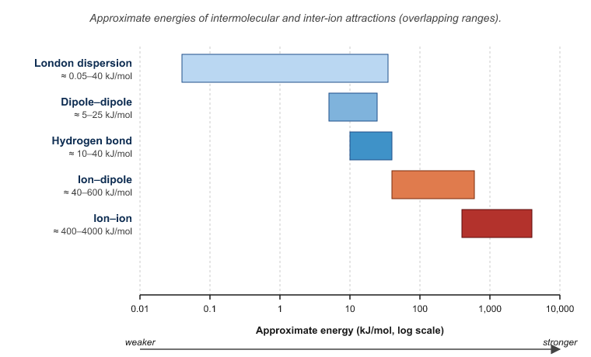
Original figure for the CHEM 139 OER textbook (2026 ed.). Licensed CC BY 4.0.
Figure 10.1 — Hierarchy of intermolecular forces.
Alt text: A vertical bar diagram showing the five force types ranked by relative strength.
Description: A bar chart with a horizontal axis labeled "Approximate energy (kJ/mol)." Five bars stacked vertically, each labeled at its right end: "London dispersion" (≈ 0.05–40 kJ/mol), "Dipole–dipole" (≈ 5–25 kJ/mol), "Hydrogen bond" (≈ 10–40 kJ/mol), "Ion–dipole" (≈ 40–600 kJ/mol), "Ion–ion" (≈ 400–4000 kJ/mol). Bars colored from light blue (weakest) to dark red (strongest). Use Arial 11 pt for labels.
Caption: Figure 10.1 — Approximate energies of intermolecular and inter-ion attractions. Note that ranges overlap; for similar-sized molecules, hydrogen bonds dominate over ordinary dipole–dipole.
Table 10.2 — Boiling points and dominant IMFs for selected substances.
Substance | Mass (g/mol) | B.P. (°C) | Dominant IMF
He | 4.0 | −269 | London (very weak; only 2 electrons)
Ne | 20 | −246 | London
Ar | 40 | −186 | London (more electrons → stronger London than Ne)
Kr | 84 | −153 | London
CH₄ | 16 | −164 | London (nonpolar)
NH₃ | 17 | −33 | H-bond
H₂O | 18 | 100 | H-bond (very strong; 2 H, 2 LP per molecule)
HF | 20 | 20 | H-bond
H₂S | 34 | −60 | Dipole–dipole (no H-bond; S is below the F,O,N threshold)
HCl | 36.5 | −85 | Dipole–dipole
HBr | 81 | −67 | Dipole–dipole + larger London
HI | 128 | −35 | Dipole–dipole + still larger London
Source: CRC Handbook; rounded to integer °C. Note the dramatic anomalies in the H₂O, NH₃, and HF rows compared to the trend predicted by mass alone — that is the signature of hydrogen bonding.

10.11 Hydrogen Bonding and the Anomalous Properties of Water
Water is small, light, and based on the same Group 16 oxygen as much-heavier H₂Te. By size alone we would predict it to boil somewhere around −80 °C. It boils at +100 °C — a 180 °C anomaly explained almost entirely by hydrogen bonding.

High Boiling Point
Each H₂O molecule can donate up to two hydrogen bonds (it has two H's) and can accept up to two (it has two lone pairs on O). The result is a dense network of hydrogen bonds that takes a great deal of energy to break — much more than London forces in similarly sized molecules. The heat of vaporization of water (40.7 kJ/mol at 100 °C) is correspondingly large.
Table 10.4 — Heats of vaporization and melting points for water and selected compounds.
Substance | M.P. (°C) | Δ_fus H (kJ/mol) | B.P. (°C) | Δ_vap H (kJ/mol)
H₂O | 0 | 6.01 | 100 | 40.7
NH₃ | −78 | 5.66 | −33 | 23.4
CH₄ | −183 | 0.94 | −164 | 8.2
C₂H₅OH | −114 | 4.6 | 78 | 42.3
Hg | −39 | 2.30 | 357 | 59.1

High Specific Heat
Specific heat is the energy required to raise the temperature of 1 g of substance by 1 °C. Water's specific heat (4.184 J/g·°C) is the highest of any common substance. Most of the energy goes into breaking and re-forming hydrogen bonds, not into raising kinetic energy. This is why oceans buffer Earth's climate and why the human body, which is ~70% water, can endure modest temperature swings without breaking down.
Table 10.3 — Specific heat values for selected substances.
Substance | Specific heat (J/g·°C)
Water (liquid) | 4.184
Water (ice, 0 °C) | 2.09
Water (steam, 100 °C) | 2.01
Ethanol | 2.44
Aluminum | 0.897
Iron | 0.449
Copper | 0.385
Gold | 0.129
Mercury | 0.140
Source: NIST. Specific heat depends weakly on temperature; values are at 25 °C unless noted.

Density Anomaly: Why Ice Floats
In almost every other substance, the solid is denser than the liquid (and so sinks if dropped into the liquid). Ice is less dense than liquid water: it floats. Why? In liquid water, hydrogen bonds form, break, and re-form as molecules tumble; the overall packing is fairly tight (density ≈ 1.000 g/mL at 4 °C). In ice, the hydrogen bonds become rigid and lock each water molecule into a tetrahedral cage. The cage is open and roomy: the lattice has more empty space than the liquid does. Density of ice is 0.917 g/mL — about 8% less than liquid water. The ecological consequence is enormous: lakes freeze top-down, leaving liquid water below, which lets fish and aquatic plants survive winter.
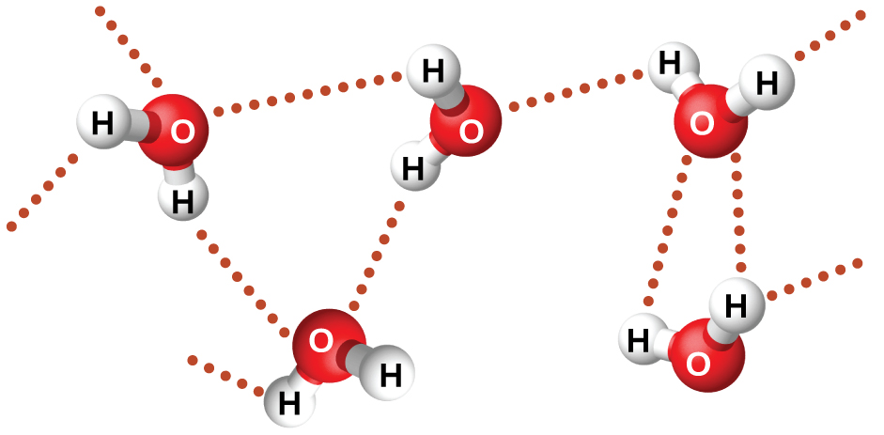
Adapted from OpenStax Chemistry 2e, Figure 10.10 (Flowers, Theopold, Langley, Robinson). Access for free at openstax.org. Licensed CC BY 4.0.
Figure 10.2 — Hydrogen-bond network in liquid water vs. ice.
Alt text: Two side-by-side diagrams showing water molecules in liquid and ice phases, with hydrogen bonds drawn as dashed lines.
Description: Two square panels. Left panel labeled "Liquid water": ~10 water molecules drawn as bent angular Lewis structures (H–O–H), packed closely in random orientations, with several dashed dotted lines connecting an H of one molecule to the O of another (H-bonds, transient). Below: "Density 1.000 g/mL at 4 °C; H-bonds form and break rapidly." Right panel labeled "Ice": same molecules arranged in a regular hexagonal lattice with each water molecule tetrahedrally surrounded by 4 others via dashed H-bonds. Below: "Density 0.917 g/mL; rigid tetrahedral cage with open hexagonal channels." Use Arial 11 pt for labels.
Caption: Figure 10.2 — In liquid water, hydrogen bonds are transient and packing is dense. In ice, the rigid tetrahedral lattice opens up, lowering the density.

Phase Diagram of Water
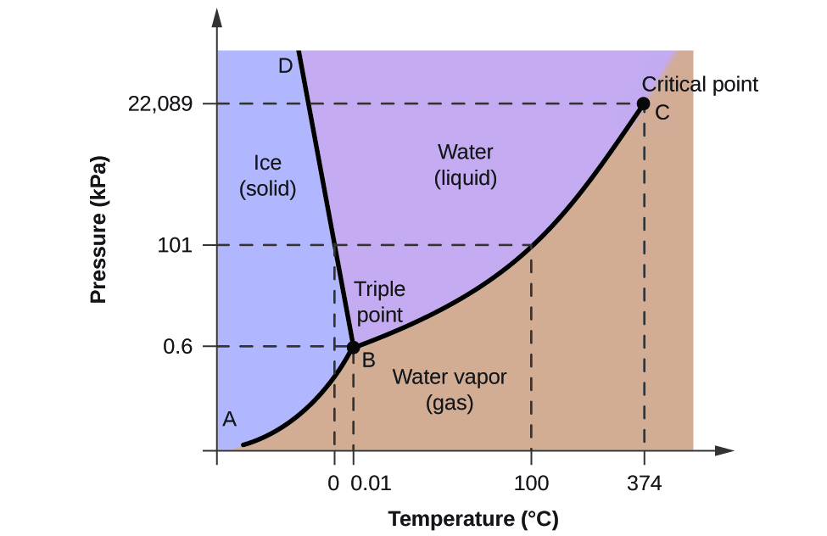
Adapted from OpenStax Chemistry 2e, Figure 10.31 (Flowers, Theopold, Langley, Robinson). Access for free at openstax.org. Licensed CC BY 4.0.
Figure 10.3 — Phase diagram of water (schematic, not to scale).
Alt text: A pressure-temperature plot showing the solid, liquid, and gas regions of water, divided by curves meeting at the triple point and ending at the critical point.
Description: Plot with horizontal axis labeled "Temperature (°C)" running from −10 to 400, and vertical axis labeled "Pressure" running from below 0.006 atm to above 218 atm (use a logarithmic axis if possible). Three regions: "SOLID (ice)" (upper left, light blue); "LIQUID (water)" (center, light green); "GAS (steam)" (right, light yellow). Three curves: solid–liquid (nearly vertical, slight negative slope — water is unusual in that the line tilts to the LEFT going up, opposite most substances); solid–gas (sublimation curve, lower left); liquid–gas (vapor pressure curve, ending at critical point). Mark the triple point at T = 0.01 °C, P = 0.006 atm. Mark the critical point at T = 374 °C, P = 218 atm. Mark the normal melting point at (0 °C, 1 atm) and normal boiling point at (100 °C, 1 atm) on the appropriate curves. Use Arial 11 pt for axis labels.
Caption: Figure 10.3 — Phase diagram of water. The negative slope of the solid–liquid line means that increasing pressure on ice can melt it — the basis of how ice skates work.

Practice Problems by Topic

KMT and States

Crystal Types

Liquid Properties

Intermolecular Forces

Vapor Pressure and Boiling

Specific Heat

Anomalies of Water
- Use KMT to explain why a gas is highly compressible but a liquid is not.
Solution: Gas particles are far apart with mostly empty space; pressure can squeeze them closer. Liquid particles are nearly touching; further compression is resisted by particle–particle repulsion.
- If T is doubled (in K), what happens to the average kinetic energy of the particles?
Solution: Doubles. KE_avg ∝ T(K).
- Identify whether each is a crystalline or amorphous solid:
- NaCl,
- glass window,
- diamond,
- butter,
- dry ice (CO₂).
Solution: Crystalline: a, c, e. Amorphous: b, d (butter and glass have no long-range order).
- Classify each as ionic, molecular, covalent network, or metallic:
- Ag,
- ice,
- MgO,
- graphite.
Solution:
- metallic;
- molecular;
- ionic;
- covalent network.
- Why does diamond have such a high melting point?
Solution: Covalent network: each C atom is covalently bonded to 4 other C atoms. To melt, many strong covalent bonds must break, requiring enormous energy. M.P. ≈ 3550 °C.
- Predict whether each property would increase or decrease as IMF strength increases:
- viscosity,
- surface tension,
- vapor pressure,
- boiling point.
Solution:
- increase;
- increase;
- DECREASE;
- increase.
- Why does evaporation cool a liquid?
Solution: The molecules with the highest KE escape; the remaining particles have a lower average KE, which corresponds to lower temperature.
- Vapor pressure of water at 25 °C is 23.8 mmHg, at 75 °C is 289.1 mmHg. Why does water boil at lower temperature on a high mountain?
Solution: Atmospheric pressure decreases with altitude, so the vapor pressure required to boil decreases. Water reaches the (lower) atmospheric pressure at a lower temperature.
- List all the IMFs present in:
- Cl₂,
- HCl,
- H₂O,
- NaCl(s).
Solution:
- London only.
- London + dipole–dipole.
- London + dipole–dipole + hydrogen bonding.
- Ion–ion (NaCl is an ionic solid).
- Which has higher boiling point: F₂ or Cl₂? Explain.
Solution: Cl₂ — both are nonpolar, so London dominates; Cl has more electrons → larger London → higher b.p.
- Predict which has higher boiling point: H₂O or H₂S. Explain.
Solution: H₂O — both are bent polar molecules of similar size, but H₂O can hydrogen-bond (O–H), H₂S cannot (S is not as electronegative). H₂O b.p. = 100 °C; H₂S b.p. = −60 °C.
- Why is NH₃ a gas at room temperature but H₂O a liquid?
Solution: Both H-bond, but H₂O has more H-bonding capacity (2 H's and 2 LP per molecule, vs. NH₃ with 3 H's and only 1 LP). Average network is denser for H₂O. NH₃'s b.p. is −33 °C, well below room temperature.
- From Table 10.5: at what temperature is water's vapor pressure 31.8 mmHg?
Solution: 30 °C.
- If the atmospheric pressure is 525.8 mmHg, at what temperature does water boil?
Solution: 90 °C (from Table 10.5).
- Why does spilled water on a tile floor evaporate even at 20 °C?
Solution: The vapor pressure of water at 20 °C (17.5 mmHg) is positive; molecules with enough KE escape. Net evaporation continues as long as the surrounding air is not saturated.
- How much heat is needed to raise 100.0 g of water from 25.0 °C to 75.0 °C?
Solution: q = m × c × ΔT = 100.0 × 4.184 × 50.0 = 20,920 J = 20.9 kJ.
- How much heat is released when 50.0 g of aluminum cools from 80.0 °C to 25.0 °C?
Solution: q = 50.0 × 0.897 × (−55.0) = −2466.8 J = −2.47 kJ (heat released).
- Compare the temperature rise of 100 g of water vs. 100 g of iron when each absorbs 1000 J.
Solution: Water: ΔT = 1000 / (100 × 4.184) = 2.39 °C. Iron: ΔT = 1000 / (100 × 0.449) = 22.27 °C. Water rises ~10 × less, illustrating water's high specific heat.
- Density of ice is 0.917 g/mL; of liquid water at 4 °C is 1.000 g/mL. Volume increase upon freezing 1.00 kg of water?
Solution: Volume of liquid = 1.00 × 1000 / 1.000 = 1000 mL. Volume of ice = 1.00 × 1000 / 0.917 = 1090.5 mL. Increase ≈ 90.5 mL (≈ 9% expansion).
- Why do water pipes burst in winter?
Solution: Water expands when it freezes (~9% increase in volume); the expansion exerts enormous pressure on enclosed pipes, which fail at their weakest point.

Additional Practice Problems by Topic

KMT and States
- State the four central postulates of the kinetic-molecular theory for gases.
Solution: (1) Gases consist of many small particles in random motion. (2) The volume of the particles is negligible compared with the volume of the container. (3) Particles exert no attractive or repulsive forces on each other. (4) Average kinetic energy of the particles is proportional to absolute temperature.
- Explain why a gas exerts pressure on the walls of its container.
Solution: Gas particles strike the walls; each collision transfers momentum. The total force per unit area from many such collisions per second is the pressure.
- If the absolute temperature of a gas doubles, by what factor does the average kinetic energy change?
Solution: Doubles. ⟨KE⟩ ∝ T.
- Order solid, liquid, and gas by typical particle separation and order/disorder.
Solution: Particle separation: solid ≲ liquid ≪ gas. Order: solid (most ordered) > liquid > gas (most disordered).
- Why are gases highly compressible and liquids essentially incompressible?
Solution: Gas particles are widely separated, so the empty space can be compressed. Liquid particles are already in contact; further compression must overcome strong short-range repulsions.

Crystal Types
- Identify the crystal type of each: NaCl, diamond, Cu, ice, dry ice (CO₂).
Solution: NaCl ionic; diamond covalent network; Cu metallic; ice molecular (H-bonded); dry ice molecular.
- Predict the relative melting points of an ionic crystal and a molecular crystal of similar molar mass.
Solution: The ionic crystal melts much higher because Coulombic attractions among ions are far stronger than intermolecular forces in molecular solids.
- Why are metals typically good electrical conductors in the solid state, while ionic crystals are not?
Solution: Metals have a delocalized “sea” of valence electrons free to move; ionic solids have ions locked in lattice positions, so charges cannot flow. Molten ionic compounds, however, do conduct.
- Explain why diamond is one of the hardest known substances.
Solution: Each carbon atom is bonded covalently to four neighbors in a 3D network. Deforming the crystal requires breaking strong directional covalent bonds throughout the structure.
- A solid is brittle, has a high melting point, dissolves in water, and the solution conducts electricity. Identify the crystal type.
Solution: Ionic. Brittleness, high m.p., water-solubility, and ionic conductivity in solution are signature properties.

Liquid Properties
- Define surface tension and give an everyday example.
Solution: Surface tension is the energy required to increase the surface area of a liquid (the inward pull on surface molecules). Example: water beads on a waxed surface; insects walk on water.
- Compare the viscosity of water and honey, and link the difference to intermolecular forces.
Solution: Honey is much more viscous. Honey contains sugars that form many hydrogen bonds among large molecules, increasing internal resistance to flow.
- Explain capillary action in a thin glass tube of water.
Solution: Adhesive forces between water and glass exceed cohesive forces among water molecules. Water climbs the tube against gravity until adhesion balances the weight of the column.
- Why does water have a higher boiling point than methane (CH₄), although both have similar molar mass?
Solution: Water hydrogen-bonds; methane has only weak London dispersion forces. Stronger intermolecular forces in water raise its boiling point dramatically.
- Define vapor pressure of a liquid.
Solution: The pressure exerted by the vapor in equilibrium with its liquid at a given temperature. It increases with temperature and depends on the strength of intermolecular forces.

Intermolecular Forces
- Identify the dominant IMF in: CH₄, HF, CH₃OH, NaCl, Ne.
Solution: CH₄ dispersion; HF hydrogen bonding (and dipole–dipole, dispersion); CH₃OH hydrogen bonding; NaCl ionic forces (not strictly an IMF — a solid lattice); Ne dispersion.
- Rank in order of increasing boiling point: CH₄, CH₃OH, H₂O.
Solution: CH₄ (−161 °C) < CH₃OH (65 °C) < H₂O (100 °C). Water hydrogen-bonds with two donors and two acceptors per molecule, beating methanol.
- Explain why noble gas boiling points increase from He to Xe.
Solution: Larger atoms have more electrons and more polarizable clouds, so London dispersion forces grow stronger down the group, raising boiling points.
- Which has a higher boiling point: HBr or HCl? Explain.
Solution: HBr. Both are dipole–dipole, but HBr has more electrons and larger dispersion forces, dominating the slightly larger H—X dipole of HCl.
- Why is CHCl₃ a higher-boiling liquid than CH₄ of similar molar mass family?
Solution: CHCl₃ has a permanent dipole (polar) and large dispersion forces from many electrons. CH₄ is nonpolar with much smaller dispersion forces.

Vapor Pressure and Boiling
- Define the boiling point of a liquid in terms of vapor pressure.
Solution: The temperature at which the liquid’s vapor pressure equals the external (atmospheric) pressure.
- Why does water boil at a lower temperature on a high mountain?
Solution: Atmospheric pressure is lower at altitude, so the vapor pressure required to match it is reached at a lower temperature.
- Predict whether ethanol or water has the higher vapor pressure at 25 °C, given that ethanol’s boiling point (78 °C) is below water’s (100 °C).
Solution: Ethanol. Lower boiling point means higher vapor pressure at any given temperature — ethanol’s intermolecular forces are weaker than water’s.
- Explain why a pressure cooker speeds up cooking.
Solution: Sealed pressure rises; water boils at a higher temperature (e.g., ≈120 °C at 2 atm). Hotter water cooks foods faster.
- If a liquid’s vapor pressure at 50 °C is 250 mmHg, will it boil at 50 °C and standard atmospheric pressure (760 mmHg)? Explain.
Solution: No. Boiling occurs only when vapor pressure equals atmospheric pressure (760 mmHg). At 50 °C the vapor pressure is far below that, so it only evaporates.

Specific Heat
- How much heat is required to raise 100.0 g of water from 25.0 °C to 75.0 °C? (c = 4.184 J/g·°C.)
Solution: q = mcΔT = 100.0 × 4.184 × 50.0 = 20920 J = 20.9 kJ.
- A 50.0 g block of metal absorbs 1.20 kJ as it heats from 20.0 to 84.0 °C. Compute c.
Solution: c = q/(mΔT) = 1200 J / (50.0 × 64.0 °C) = 0.375 J/g·°C.
- Why does water make a good coolant?
Solution: Water has an unusually high specific heat (4.184 J/g·°C) and high heat of vaporization, so it absorbs a great deal of heat per gram for modest temperature change.
- How many joules to raise the temperature of 250 g of aluminum (c = 0.897 J/g·°C) by 30.0 °C?
Solution: q = 250 × 0.897 × 30.0 = 6728 J ≈ 6.73 kJ.
- If 500.0 J is added to 25.0 g of copper (c = 0.385 J/g·°C) at 22.0 °C, what is the final T?
Solution: ΔT = q/(mc) = 500/(25.0 × 0.385) = 51.95 °C; T_f = 22.0 + 51.95 = 73.95 °C ≈ 74.0 °C.

Anomalies of Water
- State two ways in which water’s solid form (ice) is anomalous compared with most substances.
Solution: (1) Ice is less dense than liquid water, so it floats. (2) Most solids are denser than their liquid forms; ice’s open hydrogen-bonded lattice is the exception.
- Why is the density anomaly of water important for aquatic life?
Solution: Ice forms a floating insulating layer. Liquid water at 4 °C (its maximum density) sinks below the ice, allowing aquatic organisms to survive winter at the bottom.
- Why does water have such a high boiling point compared with H₂S, H₂Se, and H₂Te?
Solution: Hydrogen bonding. The strong O—H ··· O network in water requires much more energy to disrupt than the dipole–dipole + dispersion forces in heavier-chalcogen hydrides.
- Explain why water has unusually high specific heat compared with most liquids.
Solution: A large fraction of input energy goes into stretching/breaking hydrogen bonds and increasing molecular motion within the H-bonded network, not just translational kinetic energy.
- Why is hot water poured on ice an effective de-icer in some situations but not in very cold weather?
Solution: Hot water transfers heat to melt ice quickly. In very cold weather (well below 0 °C), the meltwater quickly refreezes, often producing a more dangerous slick of fresh ice.

Multi-Concept Problems
- An athlete sweats out 0.500 L of water during a workout.
- Mass of water?
- If all of it evaporates from the skin (Δ_vap H = 40.7 kJ/mol at 100 °C; about 44 kJ/mol at body temperature), how much heat is removed from the body?
Solution:
- Mass = 0.500 × 1000 × 1.00 g/mL = 500. g.
- Mol = 500/18.015 = 27.75. Heat = 27.75 × 44 = 1.2 × 10³ kJ ≈ 1200 kJ — enough to lower the body temperature by several °C if not replaced.
- Compare the boiling points of methane (CH₄, b.p. = −164 °C), ammonia (NH₃, b.p. = −33 °C), and water (H₂O, b.p. = 100 °C). All three have similar molar masses (16, 17, 18 g/mol). Account for the differences.
Solution: CH₄: nonpolar; only London forces — very weak, very low b.p. NH₃: polar with H-bonding (only 1 LP per molecule, but H–N is polar); intermediate. H₂O: H-bonding with 2 H's and 2 LPs; densest H-bond network; highest b.p.
- A student boils water on a high mountain. The boiling point measured is 92 °C. Use Table 10.5 to estimate the atmospheric pressure.
Solution: From Table 10.5, the vapor pressure of water at 90 °C is 525.8 mmHg; at 95 °C, 633.9 mmHg. By linear interpolation, at 92 °C the value is ~569 mmHg. So the atmospheric pressure is ~569 mmHg, about 75% of sea-level pressure (760 mmHg).
- Identify whether each substance can hydrogen-bond and predict relative boiling points:
- CH₃OH,
- CH₃OCH₃,
- CH₃CH₂CH₃ (propane).
Solution:
- Methanol: has O–H, can H-bond.
- Dimethyl ether: has C–O–C but no O–H, cannot H-bond (only dipole–dipole).
- Propane: nonpolar, only London. Predicted b.p. order: methanol (highest, 65 °C) > dimethyl ether (−24 °C) > propane (−42 °C). Confirmed by experiment.
- An amorphous solid (glass) is heated; it gradually softens over a range from 600–800 °C. A crystalline solid (NaCl) is heated; it melts sharply at 801 °C. Explain the difference at the molecular level.
Solution: Crystalline NaCl has identical bonds throughout; ALL of them break at the same energy → sharp transition. Amorphous glass has a range of local environments and bond strengths; some break at lower T, some at higher → gradual softening.

Multiple Choice Practice Test
- Average kinetic energy of particles depends on:
(A) mass
(B) pressure
(C) temperature
(D) volume
- Which is an amorphous solid?
(A) NaCl
(B) glass
(C) diamond
(D) ice
- Strongest intermolecular force in liquid H₂O:
(A) London
(B) dipole–dipole
(C) hydrogen bond
(D) ion–dipole
- Highest boiling point:
(A) He
(B) Ar
(C) Cl₂
(D) Xe
- Which substance can hydrogen-bond with itself?
(A) CH₄
(B) CO₂
(C) NH₃
(D) CCl₄
- Vapor pressure increases with:
(A) increasing IMF
(B) decreasing temperature
(C) increasing temperature
(D) increasing molar mass
- Boiling occurs when vapor pressure equals:
(A) zero
(B) atmospheric pressure
(C) critical pressure
(D) triple-point pressure
- Specific heat of water (J/g·°C):
(A) 1.00
(B) 2.01
(C) 4.184
(D) 18.0
- Density anomaly of water means:
(A) liquid is denser than solid
(B) solid is denser than liquid
(C) both are equal
(D) gas is denser than liquid
- Heat needed to raise 50.0 g of water by 10.0 °C:
(A) 209 J
(B) 2090 J
(C) 4184 J
(D) 4.184 kJ
Answer Key: 1-C 2-B 3-C 4-D 5-C 6-C 7-B 8-C 9-A 10-B

Concepts to Remember
- KMT: matter is small particles in motion with attractive forces; the balance of kinetic and potential energy determines the state.
- Solids: definite shape and volume. Liquids: definite volume, indefinite shape. Gases: indefinite shape and volume; highly compressible.
- Crystalline solids have a regular lattice and sharp melting points; amorphous solids have no long-range order and soften over a temperature range.
- Four types of crystalline solids: ionic, molecular, covalent network, metallic.
- Stronger IMFs → higher melting and boiling points, higher viscosity, higher surface tension, lower vapor pressure.
- Evaporation cools the remaining liquid because the most-energetic molecules escape.
- Vapor pressure rises with temperature; boiling point is where vapor pressure equals atmospheric pressure.
- Five intermolecular force categories in increasing strength: London < dipole–dipole < hydrogen bond < ion–dipole < ion–ion.
- Hydrogen bonding requires H bonded to F, O, or N; explains anomalously high b.p., specific heat, and density behavior of water.
- Ice is less dense than liquid water — a rigid tetrahedral H-bond cage opens up — so ice floats and water expands on freezing.

Key Terms Glossary
Amorphous solid (10.2) — A solid with no long-range order; softens over a range of temperatures rather than melting sharply (e.g., glass).
Boiling point (10.9) — The temperature at which a liquid's vapor pressure equals the external pressure; bubbles of vapor form throughout the liquid.
Crystalline solid (10.2) — A solid in which particles are arranged in a regular, repeating three-dimensional lattice; melts sharply at a single temperature.
Dipole–dipole force (10.10) — An attractive force between the permanent dipoles of polar molecules.
Equilibrium vapor pressure (10.9) — The pressure exerted by a vapor in dynamic equilibrium with its liquid in a closed container.
Evaporation (10.8) — The escape of high-kinetic-energy molecules from the surface of a liquid into the gas phase.
Hydrogen bond (10.10) — An especially strong dipole–dipole attraction in which H is covalently bonded to F, O, or N and approaches a lone pair on a neighboring F, O, or N.
Intermolecular force (10.10) — An attraction between molecules (or between an ion and a polar molecule); weaker than ionic or covalent bonds within molecules.
Ion–dipole force (10.10) — An attraction between an ion and the partial charge of a polar molecule; central to the dissolution of ionic compounds in polar solvents.
Kinetic molecular theory (10.1) — The theory that matter consists of particles in constant motion, with attractions and repulsions; explains the gas, liquid, and solid states.
London (dispersion) force (10.10) — A weak, instantaneous attraction caused by temporary fluctuations in electron distribution; present in all atoms and molecules.
Melting point (10.4) — The temperature at which a solid changes to a liquid.
Specific heat (10.11) — The amount of heat required to raise the temperature of 1 g of a substance by 1 °C; water's value (4.184 J/g·°C) is unusually high.
Surface tension (10.7) — The energy per unit area required to expand the surface of a liquid; arises from the asymmetry of forces on surface molecules.
Viscosity (10.6) — A liquid's resistance to flow.

Instructor Notes

Common Student Difficulties
- Students confuse intermolecular forces with intramolecular bonds. Reinforce that bonds are within molecules; IMFs are between them.
- Hydrogen bonding only with F, O, N. Students try to invoke H-bonding for C–H or P–H. Be strict on the rule.
- Vapor pressure direction: students think higher IMFs → higher VP. The opposite is true.
- Specific heat: students forget that the heat (q) and ΔT must have consistent signs.
- Ice floating: many students don't believe water is anomalous until they see hexane freeze (sinks) and water freeze (floats) side by side.

Recommended In-Class Activities
- IMF prediction tournament: students rank pairs of substances by b.p. using molecule properties; reveal answers.
- Demonstration: place a glass of water and a glass of ethanol side by side; have students estimate which evaporates faster, then run a one-week evaporation experiment.
- Demonstration: float ice cube in water; float ice cube in oil (sinks because density difference reverses); discuss molecular packing.

Lab Connections
- Specific-heat lab: heated metal samples dropped into water in a calorimeter; students compute c_metal from the energy balance.
- Phase-change lab: heat a known mass of ice from −10 °C to 110 °C and plot the heating curve, showing plateaus at the m.p. and b.p.
- Vapor pressure lab: pressure-temperature data for a small volatile liquid using a thermometer and a closed flask with a manometer.

End of Chapter 10.

