Download gpg4win-3.1.11.exe installation file

1. Enter gpg --version version check (required for the first release)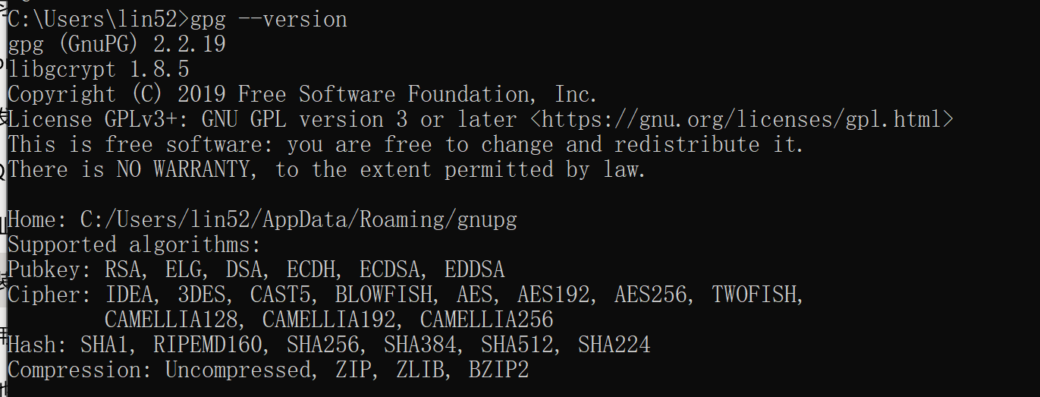

2. Use gpg to generate a key pair (gpg --gen-key) (required for the first release)

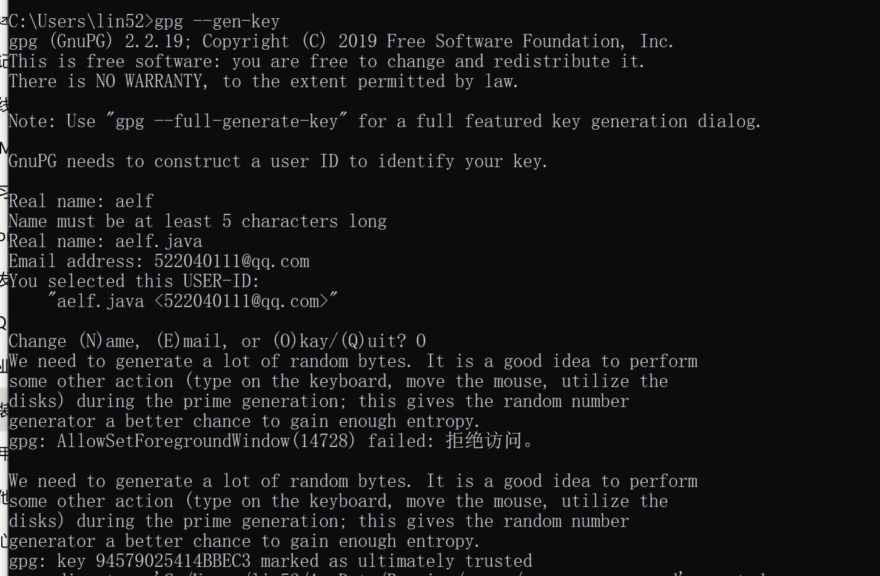

3. View the public key (gpg --list-keys) (required for the first release)

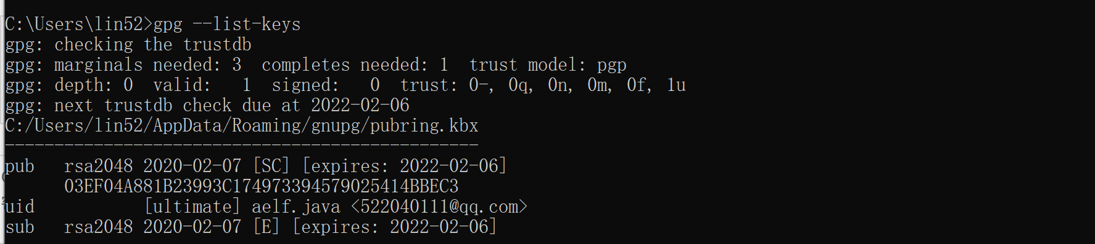

4. Publish the public key or key to the gpg key server (required for the first release)

gpg --keyserver hkp://pool.sks-keyservers.net --send-keys

03EF04A881B23993C174973394579025414BBEC3



gpg --keyserver hkp://keyserver.ubuntu.com:11371 --send-keys 03EF04A881B23993C174973394579025414BBEC3



5. Check whether the public key or key has been released successfully.gpg --keyserver hkp://keyserver.ubuntu.com:11371 --send-keys 03EF04A881B23993C174973394579025414BBEC3



gpg --keyserver hkp://keyserver.ubuntu.com:11371 --recv-keys 03EF04A881B23993C174973394579025414BBEC3



Pom upload sample



Settings sample file screenshot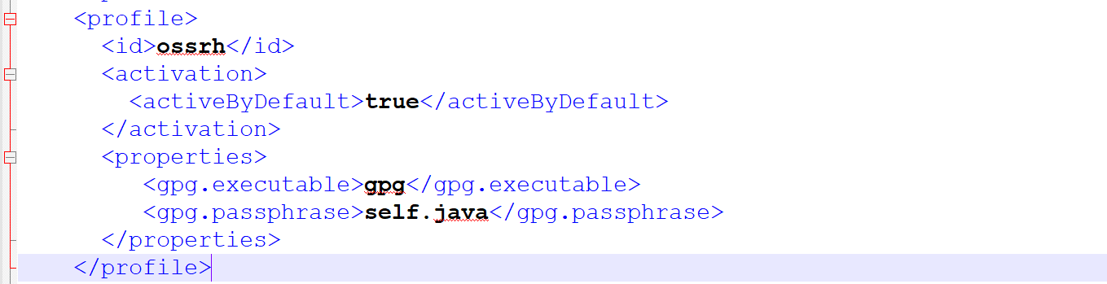

You need to delpoy with the command at the maven command line when you commit

Maven clean delopy

A password input box will pop up to enter the password

aelf.java