# CS 255 System Design Document Template

## UML Diagrams

### UML Use Case Diagram

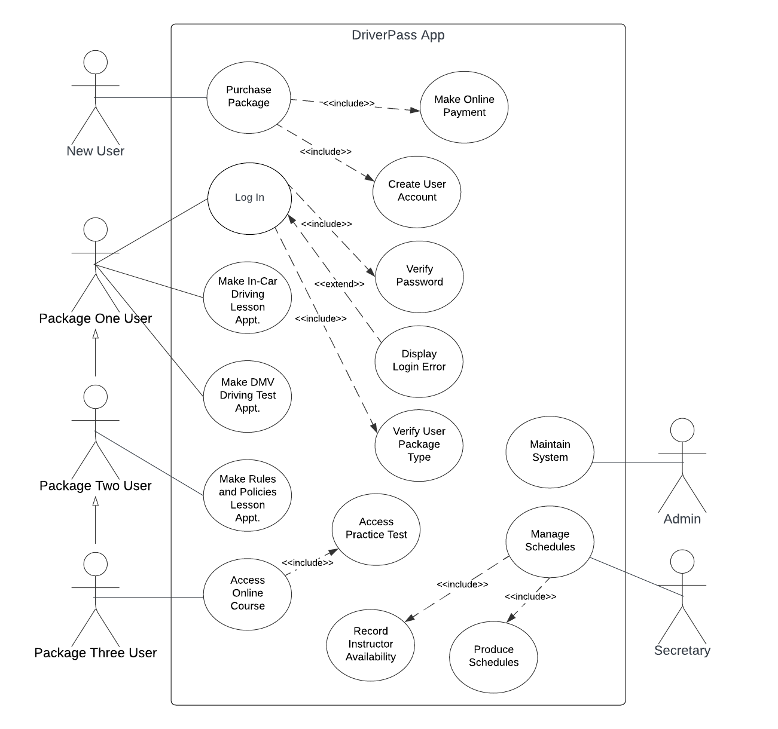

### UML Activity Diagrams

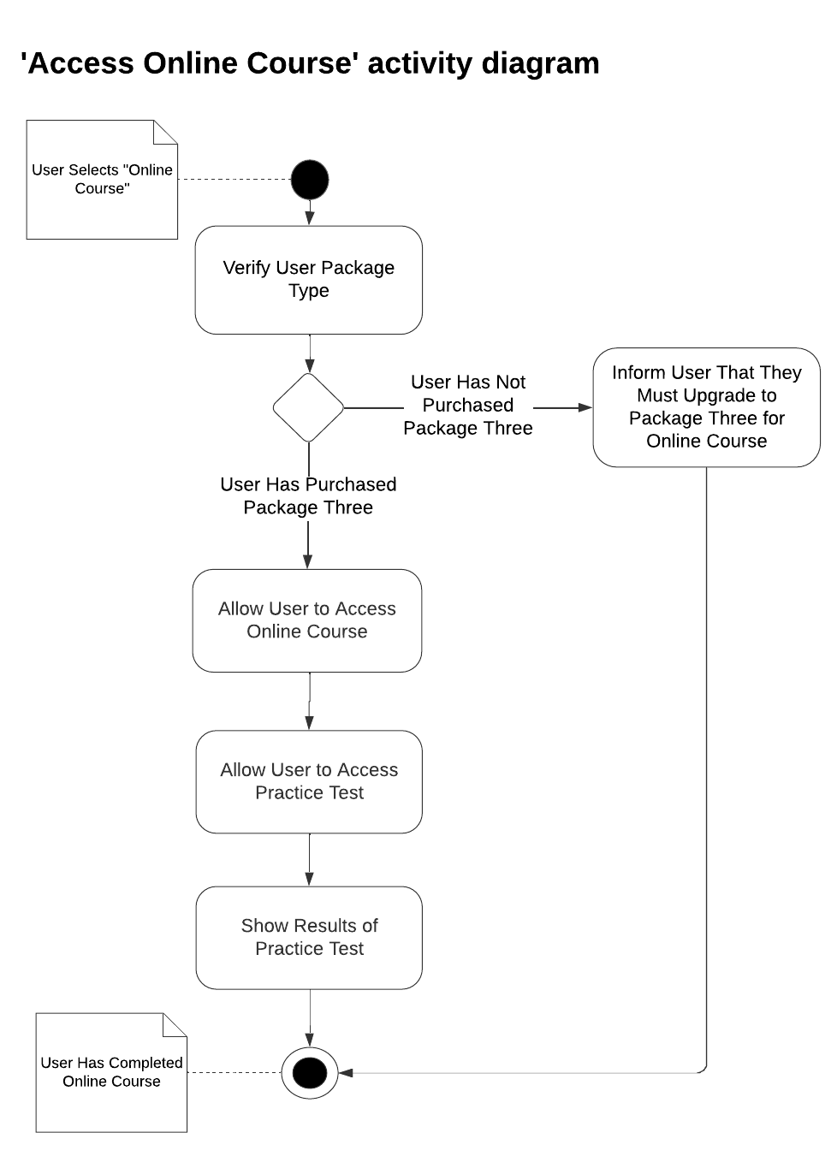

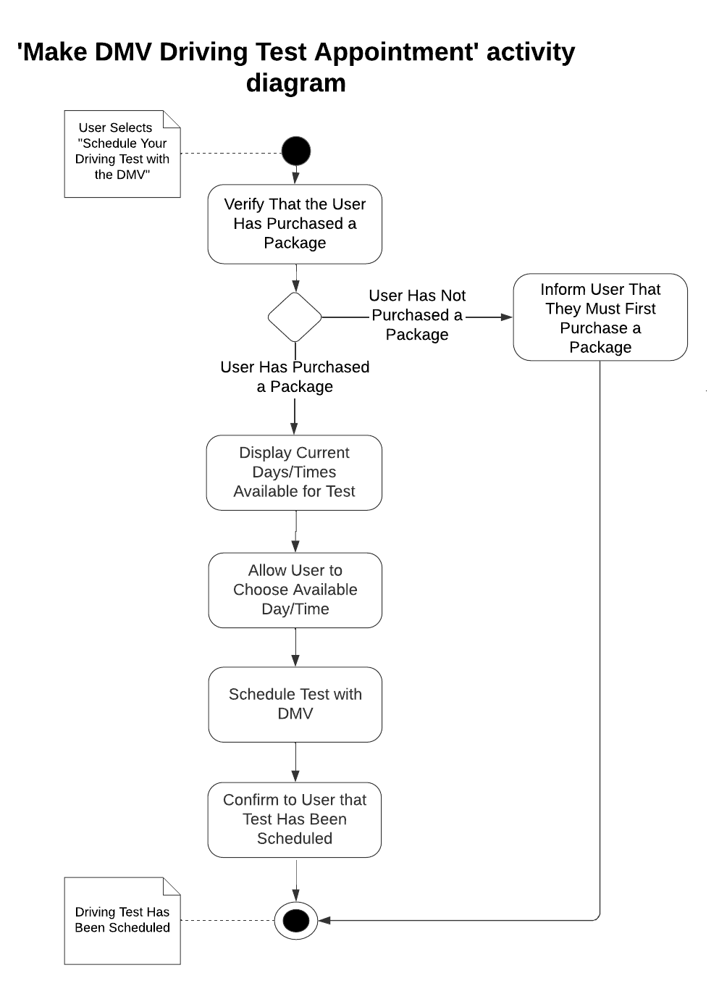

### UML Sequence Diagram

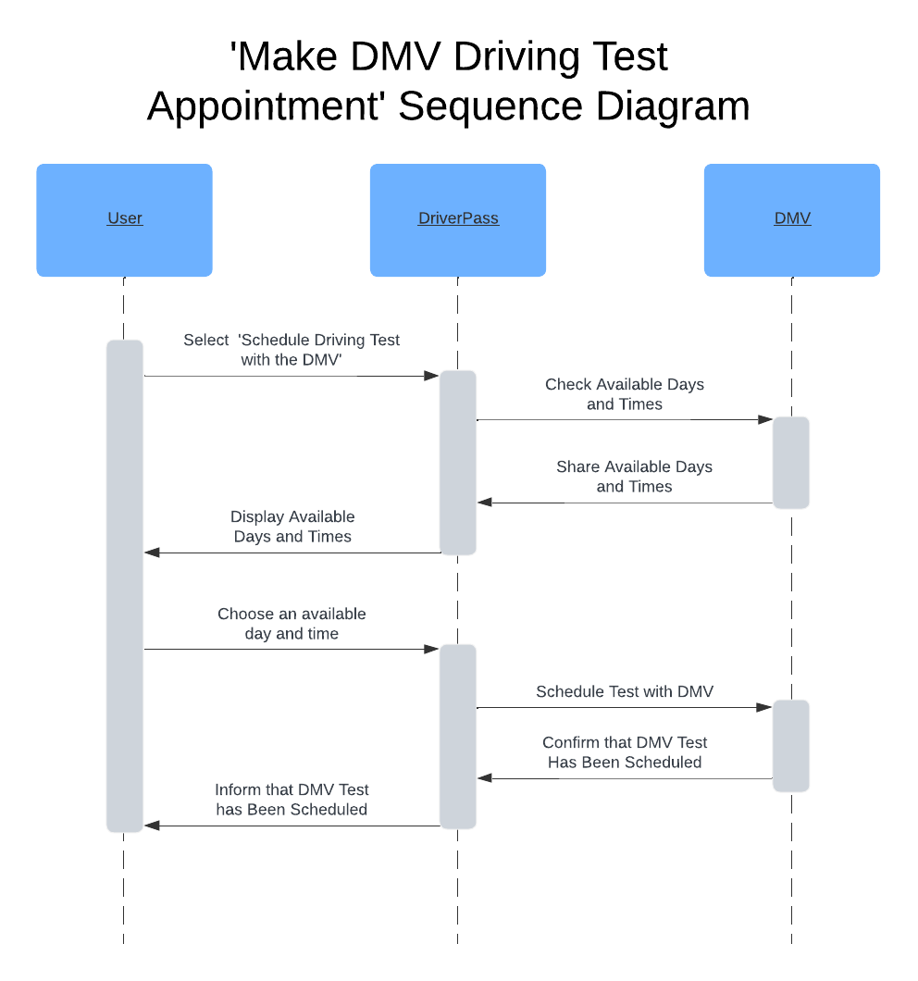

### UML Class Diagram

In order to specify the number of hours a user can spend in a car with a driving trainer as specified in the DriverPass interview transcript by Liam, each driving lesson will be one hour long. This is the reason for the zero-to-six multiplicity expressed in the association relationship between the ‘PackageOneUser’ object and the ‘InCarDrivingLesson’ object, the zero-to-eight multiplicity expressed in the association relationship between the ‘PackageTwoUser’ object and the ‘InCarDrivingLesson’ object, and the zero-to-twelve multiplicity expressed in the association relationship between the ‘PackageThreeUser’ object and the ‘InCarDrivingLesson’ object.

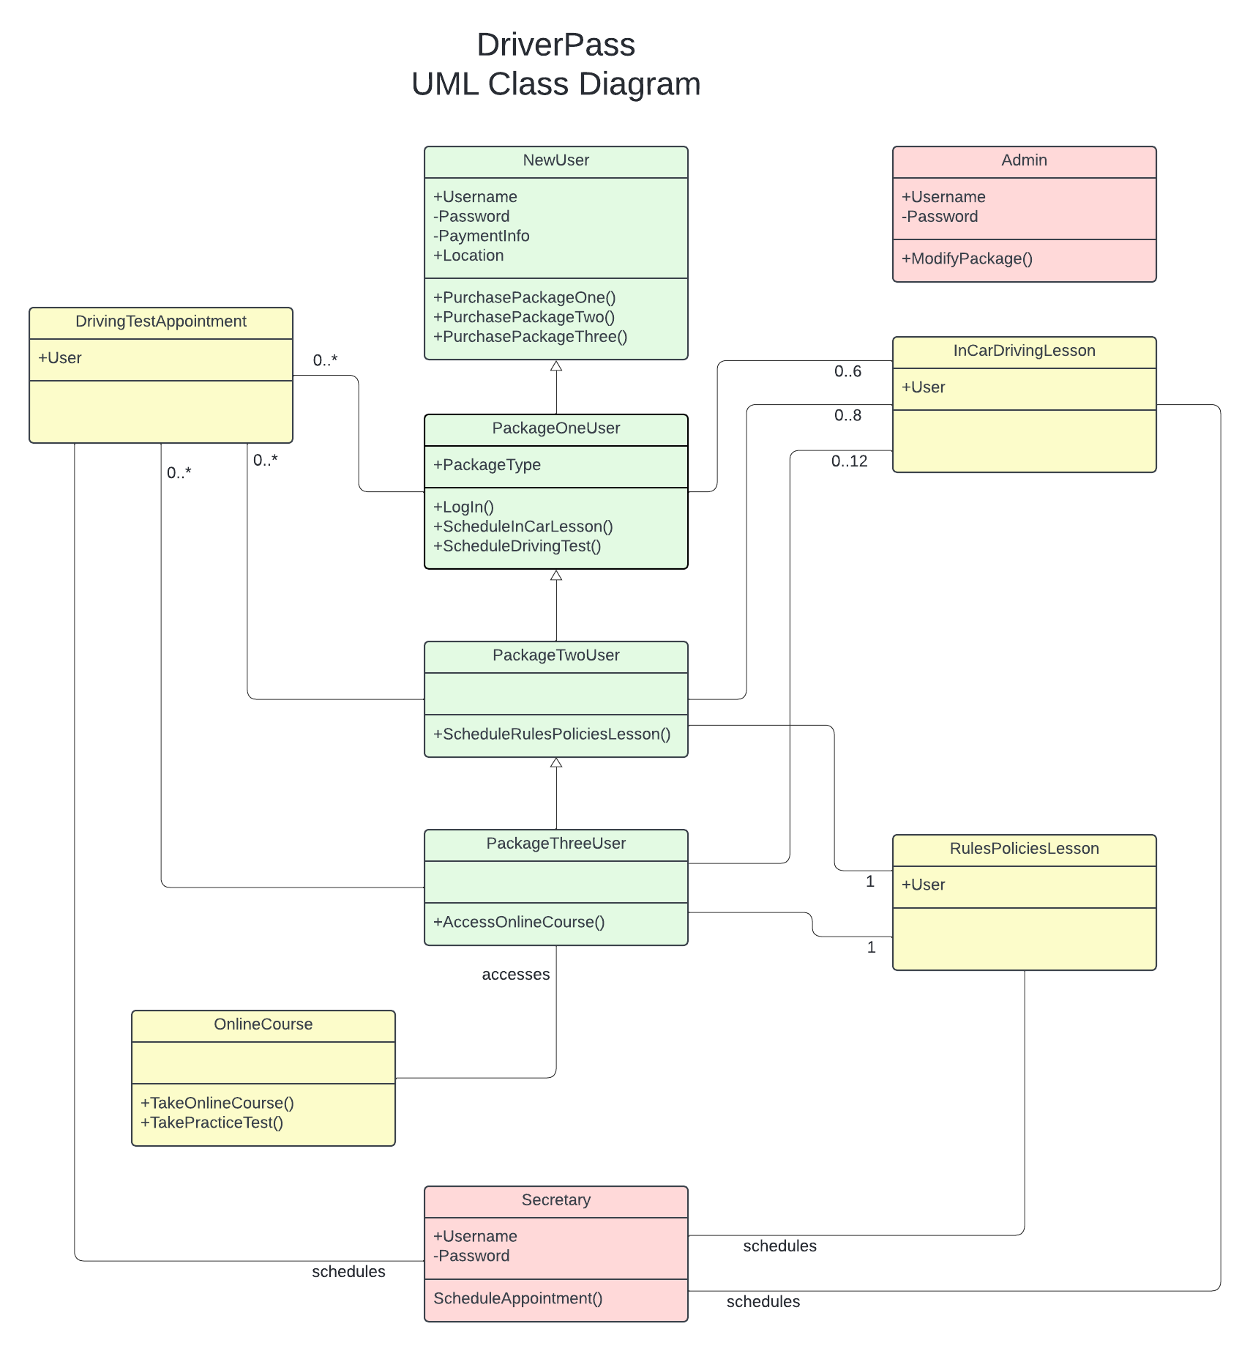

## Technical Requirements

* The web application must be hosted either on a physical server or on a virtual server on a cloud platform.
* The server hosting the web application must have a server-specific operating system installed.
* The server must have a reliable and constant connection to the internet.
* The application must use user authentication methods to verify user identity and protect sensitive user information.
* Data exchange must be encrypted in order to protect sensitive information.
* The user must have a device capable of accessing web applications via the internet such as a desktop computer or mobile device.
* The user’s device must have an operating system installed such as Windows, Linux, MacOS, Android or iOS.
* The user must have a credit or debit card in order to purchase packages.