# CS 499 Module One Assignment

Andrew Emilio DiStefano

SNHU

Professor Neil Kalinowski

May 8, 2025

1. **Self-Introduction:** 
   1. **How long have you been in the Computer Science program?**

I have been in the computer science program at SNHU since August, 2023. This means that I have been in the program for one year and eight months. Due to my prior programming experience I was able to fulfill many of the credit requirements for my Bachelor or Science in Computer Science degree through third-party exams and courses.

* 1. **What have you learned while in the program? List three of the most important concepts or skills you have learned.**

Considering my desired career path into the robotics industry, the most important skill which I have learned in this program is the development of embedded systems. I would like to pursue a career developing Autonomous Mobile Robots (AMRs) for defense applications. My experience turning a Raspberry Pi Single Board Computer into a series of embedded systems, including a smart thermometer which activates heating or cooling states depending on temperature readings, was a great introduction to the same type of electrical and software engineering which is expected of robotics software engineers.

One of the most important concepts that I learned while in this program is the concept of secure coding in C++ by manually addressing potential memory management exploits, which is a necessity in C++ development. C and C++ are used extensively in the robotics industry due to the significant level of efficiency which can be achieved through effective C++ memory management and multithreading. In order to take advantage of these benefits, developing the skills required to write secure C++ code is a necessity for robotics software engineers.

Another important concept that I learned during my time in this program is the concept of storing data in databases rather than in simple data files to facilitate the effective manipulation and interpretation of large amounts of data. Before this program I had some experience using *CSV* and *JSON* files as data stores, but the use of databases really takes my programs to the next level in terms of data usability.

* 1. **Discuss the specific skills you aim to demonstrate through your enhancements to reach each of the course outcomes.**

In reaching course outcomes through my enhancements to the original artifact(s), I would like to demonstrate my ability to write secure C++ code, my ability to program for embedded systems, and my ability to develop for popular Linux environments. These three skills are highly relevant to the robotics industry, and they have been a stated necessity for every robotics software engineering position which I have recruited for during my career as a technical recruiter. These skills also closely align with each of the stated course outcomes in the following ways:

Demonstrating my ability to develop for popular Linux environments aligns well with the outcome of building collaborative environments that enable diverse audiences to support organizational decision-making. Linux is the most widely-used operating system for robotics development (ESA Automation, 2024). While the development of robotics systems can be achieved through the use of custom operating systems (Wolf, 2023), or using microcontrollers where operating systems can not be installed, the use of popular Linux environments in robotics projects makes it much easier for a wider range of diverse professionals to collaborate on projects.

As is the case for any software engineering subdiscipline, comprehensive and easily interpreted documentation (such as in-line commenting as well as product use/troubleshooting guides) is an incredibly important aspect of robotics and embedded systems development. My ability to create comprehensive documentation while putting together an effective embedded system will demonstrate my commitment to designing, developing, and delivering professional-quality communications that are coherent, technically sound, and appropriately adapted to specific audiences and contexts.

In demonstrating my skill level in development for embedded systems and in popular Linux environments, there will be many opportunities for me to showcase my ability to solve problems using algorithmic principles and computer science practices while managing design decision trade-offs. Showing my embedded systems development skills will involve the use of sensors, the integration of which requires careful consideration of hardware and software specifications including what type of sensors will be used and which libraries and frameworks will be used to interact with them. While developing for popular Linux environments, important design considerations will include the specifications of the environment that will be set up on the Linux operating system, and which popular variant of Linux will be used for development (there are several popular choices).

Showcasing my embedded systems development skills will demonstrate my ability to use well-founded and innovative techniques and tools in computing practices for the purpose of implementing computer solutions to accomplish industry-specific goals. Embedded systems are typically designed for specific tasks (Lenovo, 2025) which are often industry-specific, such as a smart thermostat for residential temperature control or an intelligently controlled climate system for agricultural production in controlled environments.

Demonstrating my ability to write secure C++ code aligns well with the outcome of developing a security mindset that anticipates adversarial exploits to expose potential vulnerabilities, mitigate design flaws, and ensure privacy and enhanced security of data and resources. C++ programs can be made incredibly lightweight and efficient for their functionality compared to programs written in other popular coding languages (GeeksForGeeks, 2025). The freedom to optimize memory management, however, comes with the responsibility to address potential memory exploits while writing in C++. Showing my ability to write secure C++ code will align well with this outcome, particularly in terms of ensuring privacy and enhancing the security of data and resources.

* 1. **How do the specific skills you will demonstrate align with your career plans related to your degree?**

My career plans involve working in the robotics industry, particularly in the development of autonomous mobile robot systems for defense applications. Ideally I would like to pursue contract opportunities myself or with a small team, but I would also be happy to work for a defense contractor working on cutting-edge robotics projects. Autonomous Mobile Robot systems rely heavily on embedded systems to accomplish specific tasks (Baskar, 2025). In my experience as a robotics recruiter, I have seen that when robotics companies are open to hiring recent graduates or people from other industries, having experience programming for embedded systems really sets candidates apart. This is because many of the same techniques used in robotics development are also used in the development of embedded systems (Chowdhary, 2024). The demonstration of my ability to program for embedded systems will certainly make me a more competitive candidate for robotics software engineering contracts or positions.

The writing of secure C++ code aligns with my career plans due to the fact that C++ coding is a necessity for robotics software engineers (The Robotics Back-End, 2025), especially in industries where maximum performance and minimum hardware is critical. Due to the capacity for robot systems to expert physical force on real-world environments, secure C++ coding has become a major concern in robotics system development (Abada & Tanimu, 2025). This is especially the case in the defense industry, where successful enemy cyberattacks could have devastating consequences.

Developing in Linux environments is essential in robotics development since Linux is the most widely-used operating system for robotics systems (ESA Automation, 2024). In my professional experience, every robotics client that I have ever had required applicants to have experience programming in Linux environments and for Linux-based systems. The demonstration of my proficiency in developing Linux-based systems will show potential employers and contracting officers that this important skill is certainly a part of my software engineering arsenal.

* 1. **How does this contribute to the specialization you are targeting for your career?**

The demonstration of my skills in programming for Linux environments, programming for embedded systems, and developing secure C++ code will contribute to my success in the robotics industry as a software engineer. I was pleasantly surprised by how much of what is covered throughout SNHU’s Computer Science program applies to robotics development, especially the material covered in the courses *CS 350: Emerging Systems Architectures and Technologies*, *CS 260: Data Structures and Algorithms*, *CS 405: Secure Coding*, and *IT 365: Operating Environments*. My skills acquired in these and other SNHU computer science courses will facilitate my transition as a software engineer into the robotics industry.

1. **ePortfolio Set Up:**
   1. **Submit a screen capture of your ePortfolio GitHub Pages home page that clearly shows your URL.** 
      1. **You already have a repository in GitHub where you uploaded projects in previous courses. Your ePortfolio will reside in GitHub but can link to work at other sites, such as Bitbucket.**
   2. **Use the GitHub Pages link in the Resource section for directions on:**
      1. **How to create your GitHub website and publish code to GitHub Pages**
      2. **Issues, such as adding links to other sites**
   3. **Paste a screenshot of your GitHub Pages home page with your URL clearly showing in the space below.**

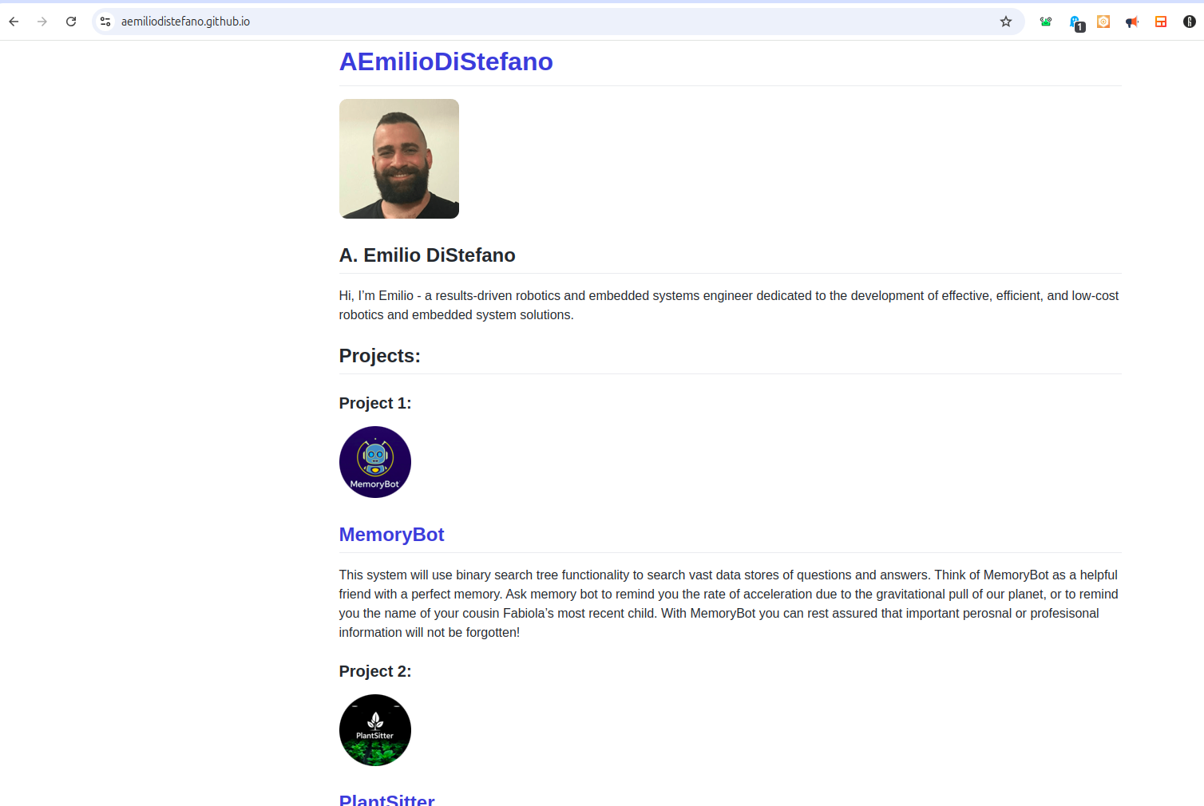

1. **Enhancement Plan:** 
   1. **Category One: Software Engineering and Design**
      1. **Select an artifact that is aligned with the software engineering and design category and explain its origin. Submit a file containing the code for the artifact you choose with your enhancement plan.**

The artifact which I choose to enhance for this category is my final project from the *CS 350: Emerging Systems Architectures and Technologies* course which I took last term. This project involved the design and development of a *Python* state machine which runs on a *Raspberry Pi* with the *Ubuntu* variation of *Linux* operating system. The project involved the design and engineering of a smart thermostat which interacts with the environment by activating a cooling process when the room temperature exceeds the target temperature, and activating a heating process when the room temperature is below the target temperature. The file for this project is called *Thermostat.py*, and I have included this file with my submission of this document.

* + 1. **Describe** a practical, well-illustrated **plan** for enhancement in alignment with the category, including a pseudocode or flowchart that illustrates the planned enhancement.

I would like to enhance this smart thermostat by adding functionality which would enable its use as a smart climate control system for a commercial greenhouse. The pseudocode for my added enhancements is as follows:  
  
 Import the appropriate library for the soil moisture sensors.

Add a state for moisturizing the soil.

Add a state for dehumidifying the air.

Add the moisturizing state to the state machine cycle.

Add the dehumidifying state to the state machine cycle.

Declare and assign a value to a variable for the maximum allowable

soil humidity level.

Declare and assign a value to a variable for the minimum allowable

soil humidity level.

Declare a function defining the behavior of the system upon entering

a moisturizing state.

Create a function defining the behavior of the system upon entering

a dehumidifying state.

Define the sensor readings which would result in the system entering

a humidifying state.

Define the sensor readings which would result in a system transition from one state to another.

As shown in the pseudocode for my enhancements to the Smart Thermostat Project, I would be adding code to process data collected from soil humidity sensors which I can easily order online. These sensors will each be inserted into pots of soil with real plants in them. The completion of this project will be an excellent opportunity to showcase my software engineering and design skills while also showcasing my skills in embedded system development. I will refer to this system as *PlantSitter* throughout the rest of this document.

* + 1. **Explain how the planned enhancement will demonstrate specific skills and align with course outcomes.** 
       1. **Identify and describe the specific skills you will demonstrate that align with the course outcome.**

The enhancement of this project in adding functionality which effectively turns this system from a residential smart thermostat system into an entire climate control system for a production greenhouse will demonstrate my skills in software engineering and design while also showcasing my skills in embedded systems development. The project will also give me the opportunity to showcase my skills in the engineering and development of software meant to run on Linux-based systems.

* + - 1. **Select one or more of the course outcomes below that your enhancement will align with.**

This enhancement particularly aligns with course outcomes *2*, *3*, and *4*. These enhancements will demonstrate my ability to use well-founded and innovative techniques, skills, and tools in computing practices for the purpose of implementing computer solutions that deliver value and accomplish industry-specific goals. The goals in question would pertain to the agricultural robotics industry since such a system would be set up with a robotics watering system in a real-world agricultural setting. The enhancement will also involve designing, developing, and delivering professional-quality communications that are coherent and technically sound in my documentation included in the ReadMe instructions of the program, and in the comments included in the code files. My use of the appropriate sensors and sensor libraries for desired system functionality will display my ability to design and evaluate solutions using algorithmic principles and computer science practices and standards appropriate to its solution, while managing the trade-offs involved in design choices.

* 1. **Category Two: Algorithms and Data Structures**

1. **Select an artifact that is aligned with the algorithms and data structures category and explain its origin. Submit a file containing the code for the artifact you choose with your enhancement plan. You may choose work from the courses listed under Category One.**

The artifact which I would like to enhance for this category is a project which I completed as part of a Sophia Python Programming course where I earned *3* of the *120* credits required for the completion of my BSCS degree at SNHU. The project is meant to extend human memory by providing a conversational in-terminal text interface where the user can ask the system questions such as “*What is the formula for maximum velocity due to gravity on earth?*” or “*What is the name of my cousin Natalia’s third child?*” The system responds with the appropriate answer if it is saved into the system, or asks the user if they would like to add an answer to that question to the system.

1. **Describe a practical, well-illustrated plan for enhancement in alignment with the category, including a pseudocode or flowchart that illustrates the planned enhancement.**

There are several enhancements which I would like to make to this project including the addition of methods for editing existing answers to questions, and the implementation of a better search algorithm and data structure which provide a more efficient time complexity for the process of searching for questions in the system’s data store. Specifically, I would like to implement a binary search tree algorithm to increase the efficiency of the program (the program currently uses the vector data structure with iteration over the entire data structure). Such a change would align closely with the specifications of this category since replacing the vector data structure with a binary search tree data structure and corresponding search algorithm would certainly expand the complexity of the use of data structures and algorithms. While the creation of search trees in Python is possible, transferring this program from Python into the C++ programming language would certainly show dedication to the goal of system efficiency. The file for this project is called *MemoryBot.cpp*, and this file will be included with my submission of this document. The pseudocode for my proposed enhancements is as follows:

Code for adding the binary search tree data structure and the inOrder binary search algorithm:

Declare and define a struct qAndA for questions and answers.

Declare a string called ”*question*” meant to store questions.

Declare a string called “*answer*” to hold each question’s

corresponding answer.

Declare and define a structure called *Node* for node pointers.

Create a qAndA object.

Create a node pointer called “*left*”

Create a node pointer called “*right*”

Create a default constructor which is initialized with “*left*”

and “*right*” node pointers both initially set to *nullptr*.

Initialize each *Node* object with an qAndA object called aQAndA.

Declare a binary search tree class.

Declare a series of private functions including:

addNode (used to add a node to the tree)

inOrder (used to search the binary search tree with an inOrder

search algorithm)

deleteTree (used to recursively delete the binary search tree)

removeNode (used to remove one node from the search tree)

Declare a series of public functions including:

A constructor

A destructor

A DeleteTree function (this will call the private deleteTree function)

An InOrder function (this will call the private inOrder function)

An Insert function (this will be used to add an element to the tree)

A Remove function (this will call the private removeNode function)

A search function

Define the addNode function:

Add a node to the tree

Define the inOrder function:

If the question input string is larger than the current node,

then descend the right side of the tree.

If the question input string is smaller than the current node,

then descend the left side of the tree.

If the question input string does not begin with a letter from *A* to *Z*,

then prompt the user for input starting with a letter

rather than a numerical character.

If the question is found in the tree,

Then output the answer.

If the question can not be found in the tree,

then ask the user if they would like to store an answer to this

question.

Define the addNode function:

If there is no node in the tree,

then add the node as the initial node.

If the node is greater than the current node,

then navigate down one level to the right.

If the node is smaller than the current node,

then navigate down one level to the right.

If there is no left node,

then add the node one level down to the left.

If there is no right node,

then add the node one level down to the right.

Define the deleteTree function:

Navigate to the bottom level of the tree,

then delete each node recursively.

Code for adding a method for the user to change the answer to an existing question with an existing answer:

If the string *“change answer*” can be found in the user’s input,

Then confirm that the user would like to change the

answer to this question.

If the user decided not to change the answer,

then return to the conversation loop.

Otherwise (if the user decides to change the change

the answer),

then delete the previous answer and save the

next user input as the new answer.

Code for input validation to avoid overflows:

If the user’s input string contains more than [x amount] of memory,

tell the user to enter less lengthy input.

If characters or character combinations are entered by the user which

could be interpreted as code by the system rather than string input,

then ask the user to form their question with only letters and

numerical digits as string characters.

The attributes and methods belonging to the binary search tree class and the inOrder search algorithm function will be used in the program the same way that the vector data structure and the simple vector traversal algorithm is used in the current program. The code which adds a method for the user to change the answer to an existing question will be added to the conversation loop in order to include that additional functionality. As I learned in the SNHU course *CS 260: Data Structures and Algorithms*, the use of the binary search tree data structure along with an inOrder search function will dramatically improve the time complexity for this project. I am very much looking forward to using what I have learned in the Computer Science program at SNHU to dramatically enhance and increase the efficiency of this system. I will refer to this system as *MemoryBot* throughout the rest of this document.

1. **Explain how the planned enhancement will demonstrate specific skills and align with course outcomes.** 
   1. **Identify and describe the specific skills you will demonstrate to align with the course outcome.**

These enhancements will show my ability to create complex data structures and search algorithms in C++ to achieve an impressive *O(log n)* runtime complexity for my search algorithm, with each of the other system functions achieving a respectable *O(n)* worst-case runtime complexity. The enhancements will also demonstrate my skill in developing secure C++ code, especially in the area of correct use of pointers for memory efficiency. These changes will involve the use of private functions called by public functions in order to obfuscate functionality, and the validation of user input to mitigate against the possibility of low-level cyberattacks.

* 1. **Select one or more of the course outcomes listed under Category One that your enhancement will align with.**

The aforementioned skills align well with the stated course outcomes. The outcome which is perhaps most relevant to these skills is the outcome of demonstrating an ability to use well-founded and innovative computing practices for the purpose of implementing computer solutions that deliver value and accomplish industry-specific goals. The use of complex data structures and search algorithms in a program which I developed from scratch demonstrates my ability to develop formidable C++ code.

It is also important to note that this program relies only on the most simple and straightforward C++ libraries, and that the user has the option to abstain from sharing their data to some cloud platform controlled by the developing entity. Ideally this system would be deployed on an embedded IoT device with an audio interface similar to that of home assistant software available on the market today (such as Alexa, Siri, etc). The data privacy movement has consistently fed into a growing demand for non-cloud IoT devices (Dunkels, 2019) since these systems first became widely available and accessible in the early- to mid-2010s. A no-cloud home assistant system could certainly satisfy a growing market demand for home assistant software which does not constantly siphon user data into the cloud for potentially nefarious use-cases by third parties, or for malicious use by non-ethical hackers upon their penetration of third-party systems.  
  
 Another course outcome which is highly relevant to this artifact enhancement is the outcome of developing a security mindset that anticipates exploits and designs to expose potential vulnerabilities, mitigate design flaws, and ensure privacy and enhanced security of data and resources. My correct use of C++ pointers for memory management, my addition of user input validation, and my obfuscation of system functionality in private functions called by public functions will showcase my dedication to the development of secure C++ code.

* 1. **Category Three: Databases**
     1. **Select an artifact that is aligned with the databases category and explain its origin. Submit a file containing the code for the artifact you choose with your enhancement plan. You may choose work from the courses listed under Category One.**

For this category, I would like to enhance the same embedded system which I chose for *Category One* with database functionality for the collection and use of data collected from system sensors. The implementation of database functionality is an incredibly important aspect of robotics development (Macneil, 2024), and my ability to configure this embedded system to feed data into the appropriate database for manipulation and processing will showcase this valuable robotics development skill. For this artifact enhancement, I would like to use a non-relational database option called ReductStore. ReductStore is a popular option for robotics data due to its ability to process unstructured data through the use of time ranges and other alternative filters to identify data (Nikolovska, 2024). This approach is quite ingenious for the type of data which is collected from robotics and embedded systems, which can often only really be referenced in any meaningful way through timestamps or through some obscure reference method specific to a given situation. As a non-relational NoSQL database option, ReductStore shares a lot of similarities with MongoDB (Nikolovska, 2024). Also like MongoDB, ReductStore is completely free for non-commercial use (ReductStore, 2025). I am very much looking forward to using this type of database in an embedded systems project.

* + 1. **Describe a practical, well-illustrated plan for enhancement in alignment with the category, including a pseudocode or flowchart that illustrates the planned enhancement.**

The smart thermostat system which I will be enhancing currently prints sensor readings to the terminal rather than saving them into a data store. This means that potentially valuable sensor data is currently being discarded rather than taken advantage of. After my enhancement to this system, timestamped sensor readings will be stored for future use in a ReductStore. The following flowchart depicts the flow of data from system sensors to our ReductStore database:

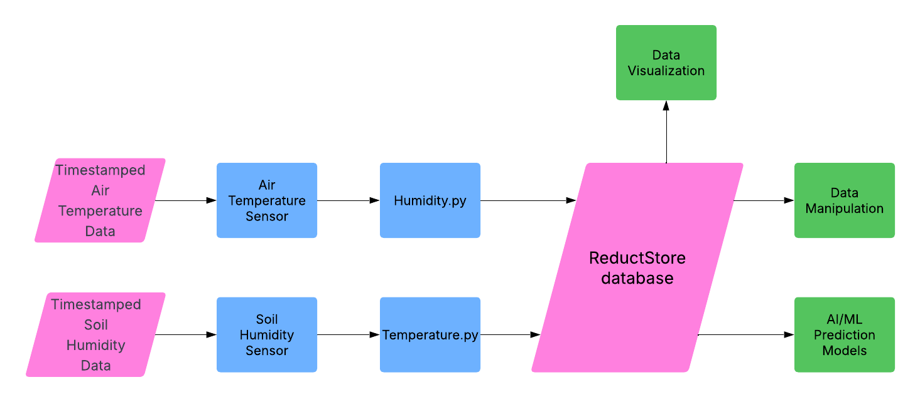

As seen in the diagram, pink parallelogram shapes represent data and data stores while blue rectangles represent hardware and software components which collect and transfer said data to our ReductStore database. Green rectangles represent potential use-cases (destinations) for this data. As a final touch for this system enhancement, I would like to implement data visualization via a simple web application. With all of these enhancements, the system will very much resemble real-world products available on the market now such as the GrowDirector indoor growing system (GrowDirector, 2025), the Moen Smart Wireless Soil Sensors (Moen, n. d.), and the NiuBoL Smart Irrigation System (NiuBoL, 2024). I am very much looking forward to adding ReductStore database functionality and data visualization to my smart greenhouse system.

* + 1. **Explain how the planned enhancement will demonstrate specific skills and align with course outcomes.** 
       1. **Identify and describe the specific skills you will demonstrate that align with the course outcome.**

Companies hire professionals who can offer value to their organizations, and the potential use-cases for sensor data collected from the air temperature and soil moisture in a production greenhouse are virtually limitless. Data could be collected from a series of greenhouses in order to compare their rates of production and crop mortality. Patterns could emerge in temperature and humidity fluctuation rates revealing deficiencies in greenhouse infrastructure, such as certain areas of a greenhouse being unintentionally watered more than others. Data could even be fed into AI/ML models and neural networks in order to predict the success of a specific crop based on air temperature and soil humidity readings. This demonstration of my ability to collect and process data from sensors using a database service which is commonly used at a professional level in the robotics industry will certainly increase my chances of landing lucrative contracts and/or employment opportunities in this industry. Since I have never used ReductStore before, my ability to quickly familiarize myself with this database software will showcase my ability to adapt and learn new technologies quickly, which is a skill that is certainly highly valued in the robotics industry.

* + - 1. **Select one or more of the course outcomes listed under Category One that your enhancement will align with.**

The ability for non-technical stakeholders to view a visual depiction of temperature and humidity data collected over time will enable the formation of collaborative environments that support organizational decision-making. Such software would facilitate the interpretation and explanation of sensor data, enabling diverse audiences to support organizational decision-making in computer science fields where it would be difficult for non-technical stakeholders to participate effectively otherwise. My use of software so closely associated with robotics and embedded systems aligns well with the outcome of demonstrating an ability to use innovative techniques for the purpose of implementing computer solutions to accomplish industry-specific goals.

1. **ePortfolio Overall Skill Set**

I will make sure to describe how each of the aforementioned skills and provided course outcomes will be illustrated across my three artifact enhancements for this course. In my code review, I will comprehensively break down how the code in the original artifacts work and how artifact components interact with each other to achieve program functionality. I will also make sure to highlight weaknesses in original artifact code, and how those weaknesses can be addressed through my proposed changes.  
I will use the reflection narratives and self-assessment for this project as opportunities to further describe my skills and my achievement of the outcomes described in this module. I will describe how my ability to set up an embedded system consisting of popular but powerful system components supports the building of collaborative environments that enable diverse audiences to support organizational decision-making in the field of computer science. I will describe how the binary search tree and inOrder algorithm implemented in my MemoryBot project dramatically increases the time complexity of the search function, and how the implementation of secure C++ code demonstrates a security mindset that anticipates adversarial exploits in software architecture and designs to expose potential vulnerabilities. I will reference my comments and user guide documents to show how my documentation consists of professional-quality written communications that are coherent, technically sound, and appropriately adapted to specific audiences and contexts. My enhancements to both the *MemoryBot* and *PlantSitter* projects will demonstrate my ability to implement computer solutions that deliver value and accomplish industry-specific goals. Since these reflections will be framed as self-analysis, I will focus these communications on how I have grown as a professional during my time in the SNHU computer science program. I will touch on all of the details described in the previous section, and I will also include some background regarding how other projects prepared me to make these enhancements to my chosen artifacts.

**Sources:**

Abada, W. & Tanimu, J. A. (2025). Addressing cybersecurity challenges in robotics:

A comprehensive overview Author links open overlay panel. *Cyber*

*Security and Applications, 3*.

<https://doi.org/10.1016/j.csa.2024.100074>

Baskar, N. (2025). *Embedded Systems and Robotics: A Match Made in Heaven*.

Skill-Lync.

[https://skill-lync.com/blogs/embedded-systems-and-robotics-a-match-  
made-in-heaven](https://skill-lync.com/blogs/embedded-systems-and-robotics-a-match-made-in-heaven)

Chowdhary, J. (2024, May 30). *Robotics & Autonomous Machines – Beyond the*

*Prototypes, What’s the Reality?* Einfochips.

[https://www.einfochips.com/blog/robotics-autonomous-machines-](https://www.einfochips.com/blog/robotics-autonomous-machines-beyond-the-prototypes-whats-the-reality/)

[beyond-the-prototypes-whats-the-reality/](https://www.einfochips.com/blog/robotics-autonomous-machines-beyond-the-prototypes-whats-the-reality/)

Dunkels, A. (2019, November 25). *Cloudless IoT: The Internet of Things, without*

*the Cloud*. ThingsSquare. [https://www.thingsquare.com/blog/articles/iot-](https://www.thingsquare.com/blog/articles/iot-without-the-cloud/)

[without-the-cloud/](https://www.thingsquare.com/blog/articles/iot-without-the-cloud/)

ESA Automation. (2024). *Linux Operating System in Automation and Robotics*.

[https://www.esa-automation.com/en/linux-operating-system-in-](https://www.esa-automation.com/en/linux-operating-system-in-automation-and-robotics/)

[automation-and-robotics/](https://www.esa-automation.com/en/linux-operating-system-in-automation-and-robotics/)

GeeksForGeeks. (2025, April 8). *Top 10 Fastest Programming Languages*.

<https://www.geeksforgeeks.org/top-10-fastest-programming-languages/>

GrowDirector. (2025). *Soil Moisture Sensors and Meters: A Practical Guide for*

*Commercial Greenhouses in the 2025 Growing Season*.

[https://growdirector.com/soil-moisture-sensors-and-meters-a-](https://growdirector.com/soil-moisture-sensors-and-meters-a-practical-guide-for-commercial-greenhouses-in-the-2025-growing-season/)

[practical-guide-for-commercial-greenhouses-in-the-2025-](https://growdirector.com/soil-moisture-sensors-and-meters-a-practical-guide-for-commercial-greenhouses-in-the-2025-growing-season/)

[growing-season/](https://growdirector.com/soil-moisture-sensors-and-meters-a-practical-guide-for-commercial-greenhouses-in-the-2025-growing-season/)

Lenovo. (2025). *What is embedded?*

<https://www.lenovo.com/us/en/glossary/embedded/>

Macleil, A. (2024, January 23). *Best Practices for Processing and Analyzing*

*Robotics Data*. FoxGlove.

[https://foxglove.dev/blog/best-practices-for-processing-and-](https://foxglove.dev/blog/best-practices-for-processing-and-analyzing-robotics-data)

[analyzing-robotics-data](https://foxglove.dev/blog/best-practices-for-processing-and-analyzing-robotics-data)

Moen. (n. d.). *Moen Smart Wireless Soil Sensors*.

<https://www.moen.com/smart-home/smart-irrigation/soil-sensor>

Nikolovska, G. (2024, November 26). *MongoDB vs ReductStore: Choosing the*

*Right Database for Robotics Applications*. ReductStore.

[https://www.reduct.store/blog/robotics-mongodb-vs-](https://www.reduct.store/blog/robotics-mongodb-vs-reductstore)

[reductstore](https://www.reduct.store/blog/robotics-mongodb-vs-reductstore)

NiuBol. (2024, October 1). *Smart irrigation system using soil moisture sensor*.

[https://www.niubol.com/Product-knowledge/Smart-irrigation-system-](https://www.niubol.com/Product-knowledge/Smart-irrigation-system-using-soil-moisture-sensor.html)

[using-soil-moisture-sensor.html](https://www.niubol.com/Product-knowledge/Smart-irrigation-system-using-soil-moisture-sensor.html)

ReductStore. (2025). *Tailored for Every Scale*. <https://www.reduct.store/pricing>

Wolf, I. (2023, July 26). *Robot Operating System Advances Left Up to Industry*.

EE Times.

[https://www.eetimes.com/robot-operating-system-advances-left-up-](https://www.eetimes.com/robot-operating-system-advances-left-up-to-industry)

[to-industry](https://www.eetimes.com/robot-operating-system-advances-left-up-to-industry)