**PUBLIC TRANSPORT EFIICIENCY ANALYSIS**

import numpy as np

import pandas as pd

import matplotlib.pyplot as plt

import datetime

import os

from math import sqrt

data = pd.read_csv('content/drive/MyDrive/phase4.CSV')

data.shape

(10857234, 6)

out_geo = pd.read_csv('../input/outgeo/output_geo.csv')

out_geo.shape

out_geo.head()

(4165, 10)

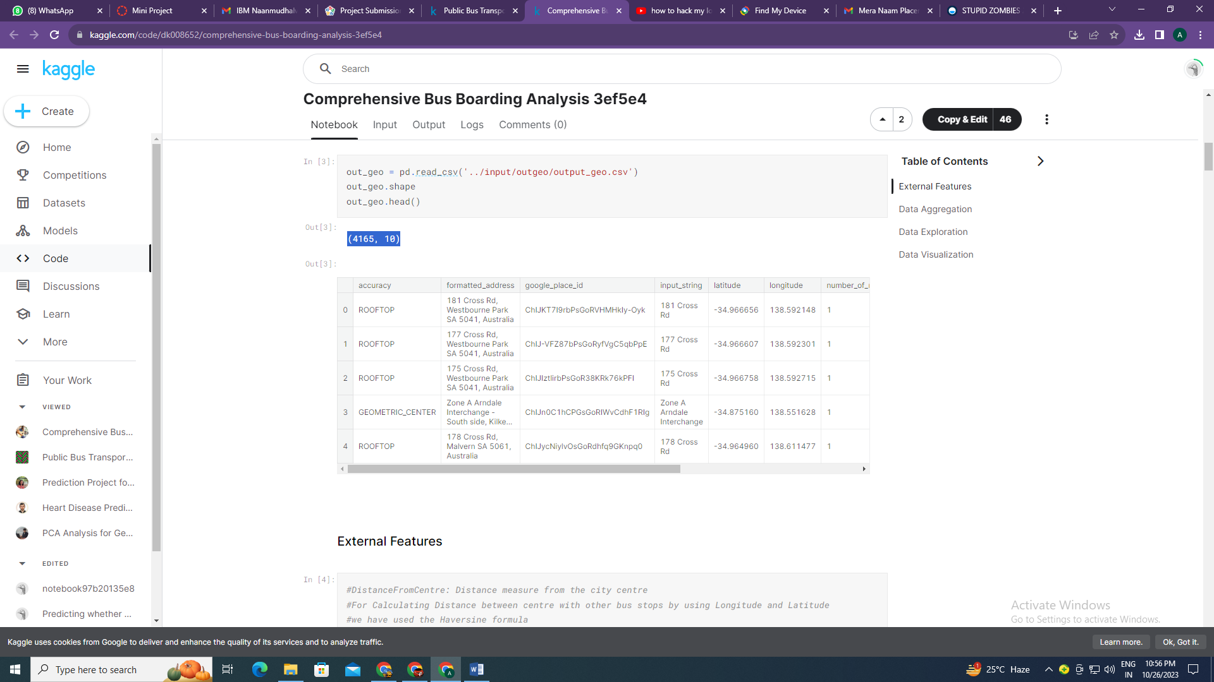

from math import sin, cos, sqrt, atan2, radians

def calc_dist(lat1,lon1):

## approximate radius of earth in km

R = 6373.0

dlon = radians(138.604801) - radians(lon1)

dlat = radians(-34.921247) - radians(lat1)

a = sin(dlat / 2)**2 + cos(radians(lat1)) * cos(radians(-34.921247)) * sin(dlon / 2)**2

c = 2 * atan2(sqrt(a), sqrt(1 - a))

return R * c

out_geo['dist_from_centre'] = out_geo[['latitude','longitude']].apply(lambda x: calc_dist(*x), axis=1)

out_geo['type'].fillna('street_address',inplace=True)

out_geo['type'] = out_geo['type'].apply(lambda x: str(x).split(',')[-1])

out_geo['type'].unique()

array(['street_address', 'transit_station', 'premise', 'political',

'school', 'route', 'intersection', 'point_of_interest',

'subpremise', 'real_estate_agency', 'university', 'travel_agency',

'restaurant', 'supermarket', 'store', 'post_office'], dtype=object)

data['WeekBeginning'] = pd.to_datetime(data['WeekBeginning']).dt.date

data['WeekBeginning'][1]

datetime.date(2013, 6, 30)

data= pd.merge(data,out_geo,how='left',left_on = 'StopName',right_on = 'input_string')

data.head(5)

data.shape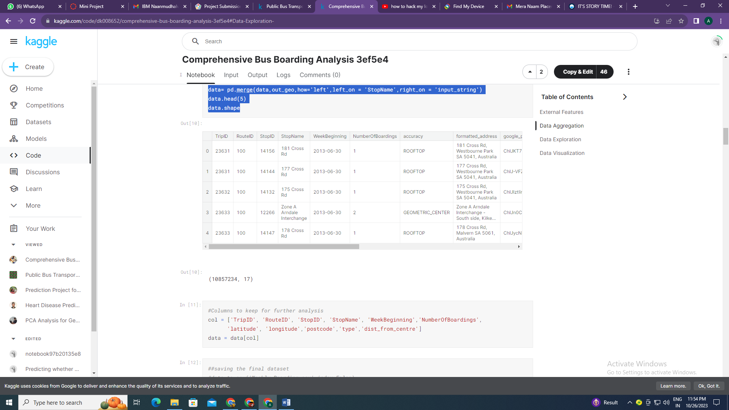

col = ['TripID', 'RouteID', 'StopID', 'StopName', 'WeekBeginning','NumberOfBoardings',

'latitude', 'longitude','postcode','type','dist_from_centre']

data = data[col]

st_week_grp = pd.DataFrame(grouped).reset_index()

st_week_grp.shape

st_week_grp.head()

(207864, 6)

aa = list(st_week_grp1[st_week_grp1['WeekBeginning'] == 54]['StopName'])

aa[1:10]

['1 Bartels Rd',

'1 Botanic Rd',

'1 Frome Rd',

'1 Fullarton Rd',

'1 George St',

'1 Glen Osmond Rd',

'1 Goodwood Rd',

'1 Henley Beach Rd',

'1 Kensington Rd']

bb = st_week_grp[st_week_grp['StopName'].isin(aa)]

bb.head()

bb.shape

type(bb)

(175446, 6)

data.nunique()

TripID 39211

RouteID 616

StopID 5838

StopName 3127

WeekBeginning 54

NumberOfBoardings 359

latitude 2393

longitude 2379

postcode 138

type 8

dist_from_centre 2397

dtype: int64

fig,axrr=plt.subplots(2,2,figsize=(15,15))

ax=axrr[0][0]

ax.set_title("No of Boardings")

data['NumberOfBoardings'].value_counts().sort_index().head(20).plot.bar(ax=axrr[0][0])

ax=axrr[0][1]

ax.set_title("WeekBeginning")

data['WeekBeginning'].value_counts().plot.area(ax=axrr[0][1])

ax=axrr[1][0]

ax.set_title("most Busiest Route")

data['RouteID'].value_counts().head(10).plot.bar(ax=axrr[1][0])

ax=axrr[1][1]

ax.set_title("least Busiest Route")

data['RouteID'].value_counts().tail(10).plot.bar(ax=axrr[1][1])

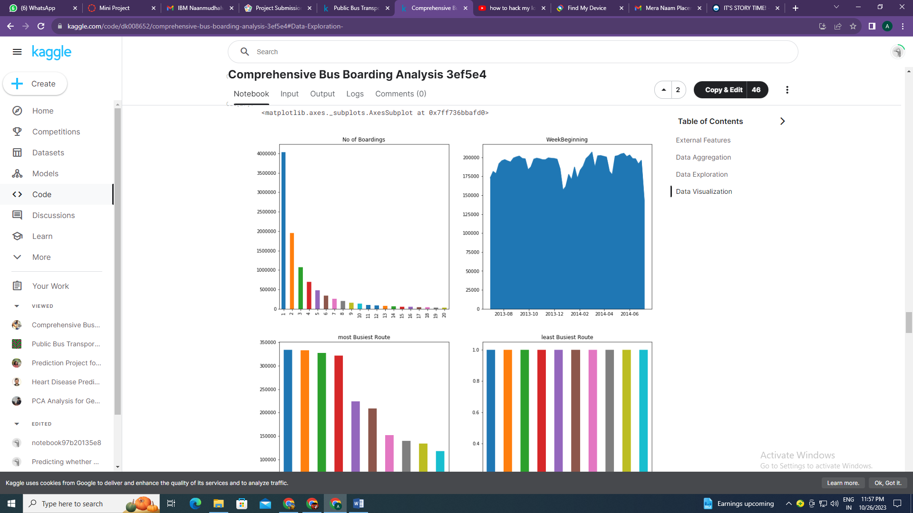

ax = stopageName_with_boarding.head(10).plot.bar(x='StopName', y='Total_boarding_on_the_stopage', rot=90)

ax.set_title("most busiest stopage")

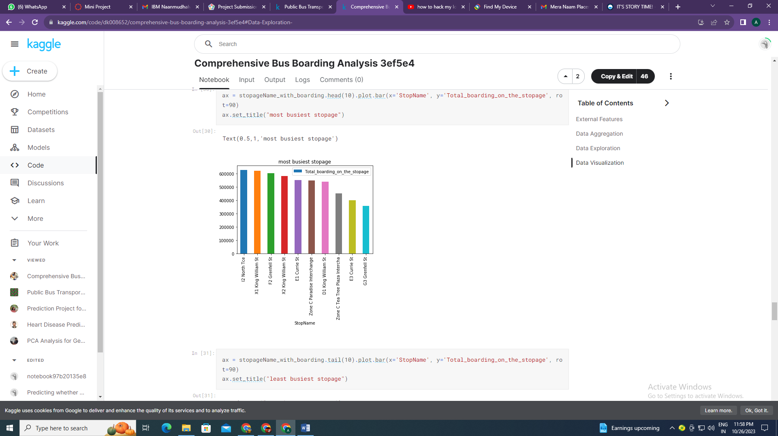

data['WeekBeginning'].value_counts().mean()

191508.66666666666

y = len(distance_10)+len(distance_10_50)+len(distance_50_100)

print(total)

print("passangers, boarding the buses in the radious of 10Km from the city center = ", (len(distance_10)/total)*100)

print("passanger, boarding the buses from the distance of 10Km to 50Km from the city center = ", (len(distance_10_50)/total)*100)

print("passanger, boarding the buses from the distance of 50Km to 100 from the city center = ", (len(distance_50_100)/total)*100)

10341468

passangers, boarding the buses in the radious of 10Km from the city center = 64.31275521038212

passanger, boarding the buses from the distance of 10Km to 50Km from the city center = 33.16731241638035

passanger, boarding the buses from the distance of 50Km to 100 from the city center = 2.5199323732375327