CS525 ASSIGNMENT-4 PHASE-I REPORT

ANUSHA VENKATESH

A20594323

added my github username in the file given (a.java)

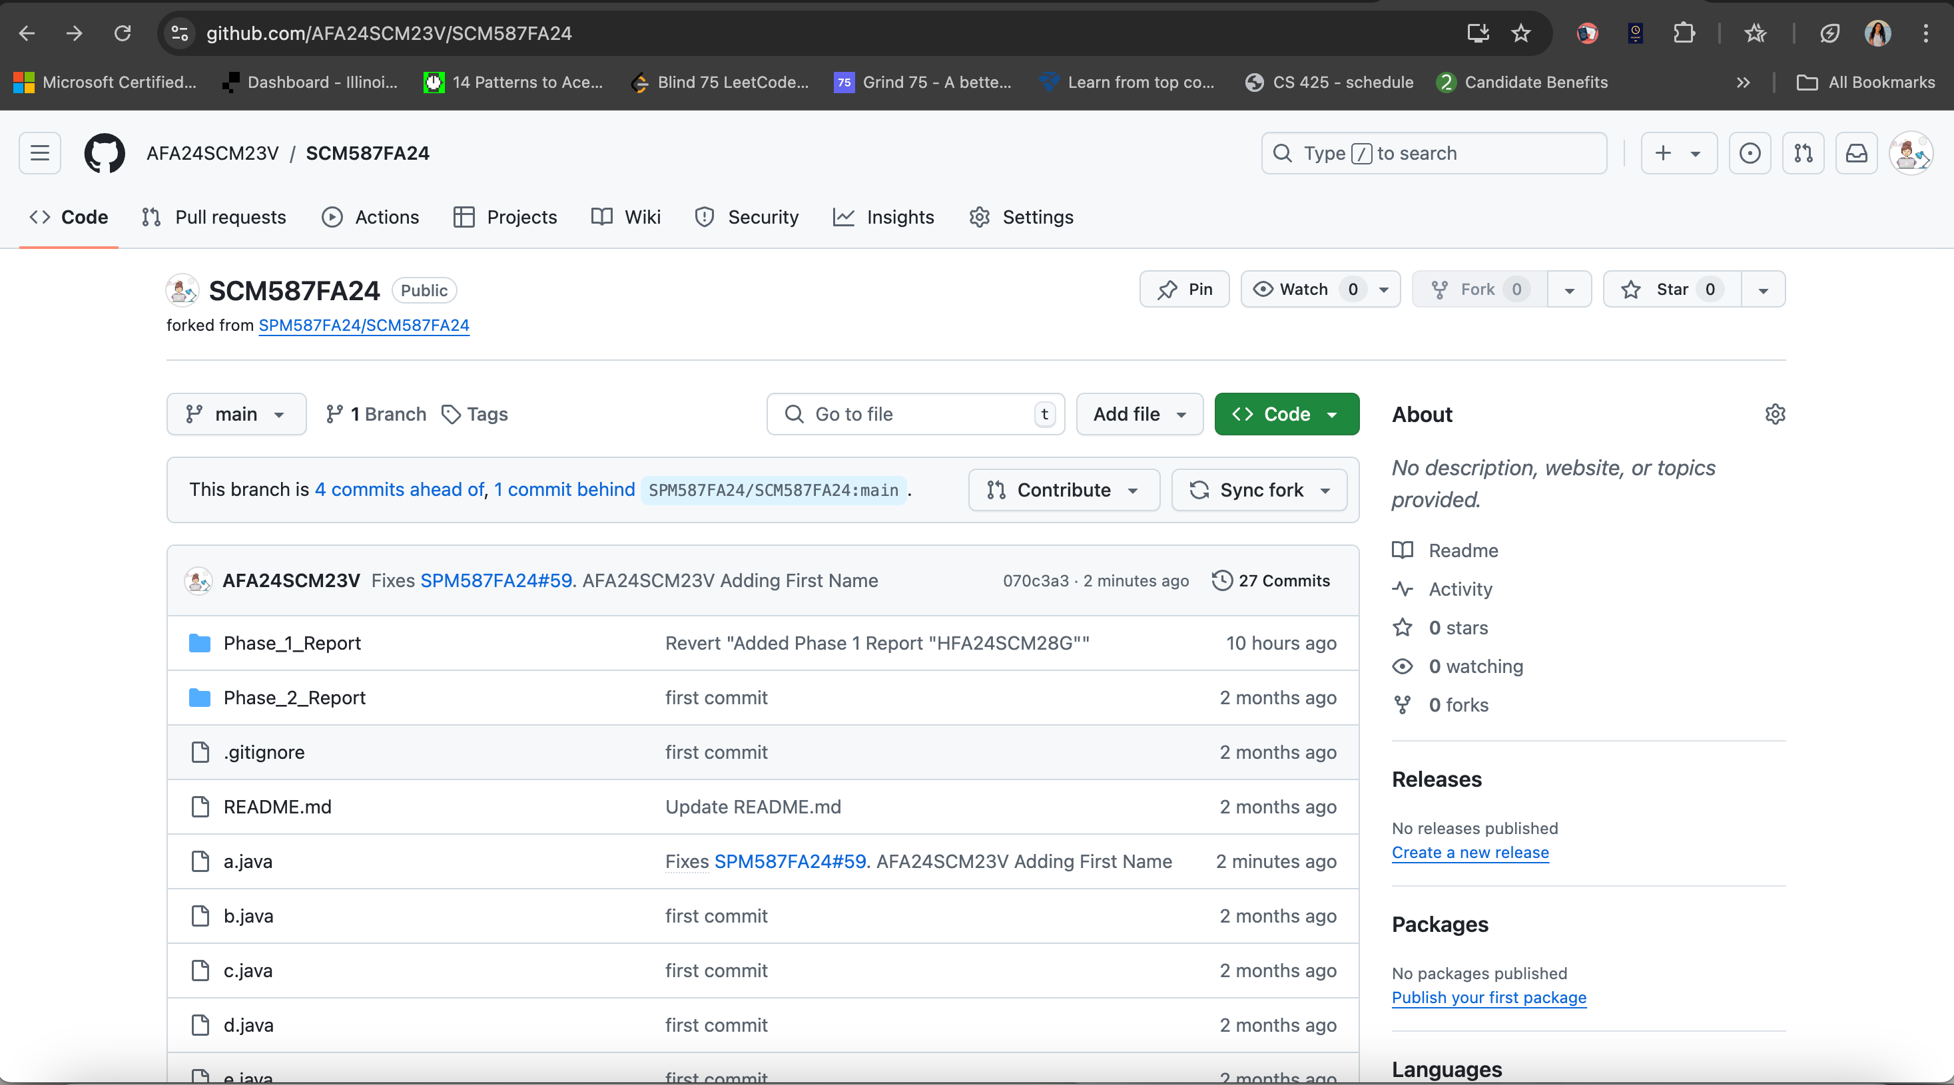

Added my issue #59

