SMART INDIA HACKATHON 2024



* **Problem Statement ID – 1620**
* **Problem Statement Title- Queuing models in OPDs/ availability of beds/ admission of patients. A hospital based solution is ideal**

**which can be integrated with city wide module.**

* **Theme- MedTech / BioTech / HealthTech**
* **PS Category- Software**
* **Team ID-**
* **Team Name- 2024T21**

# IDEA TITLE

* Centralized, user-friendly web-based portal for hospital management.
* Streamlined forms and document uploads for patient data and records.
* 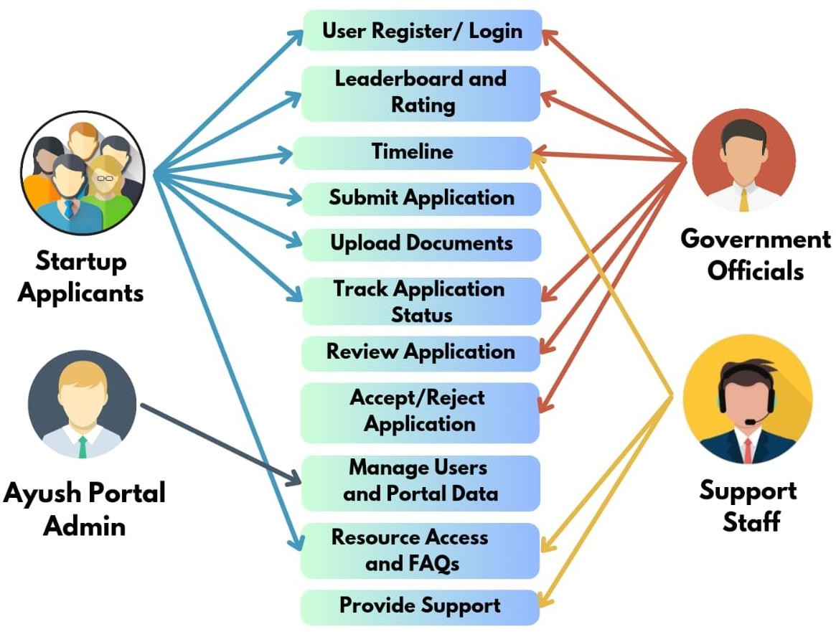Secure, role-based access for patients, staff, and admins.
* Real-time tracking and reporting of patient flow and bed occupancy.
* API-enabled for integration with existing systems and city-wide modules.

**UNIQUENESS:**

* **Dynamic Resource Optimization:** Real-time tracking of patient flow and bed availability.
* **Real-Time Data Analytics:** Provides actionable reports on patient flow and resource use.
* **Integrated Alerts and Notifications:** Automated updates for appointments and bed status.
* **Patient Interface for Transparency:** Online access to wait times, bed availability, and appointment booking.
* **City-Wide Integration:** Connects with city-wide modules for comprehensive resource management.

**USE CASE DIAGRAM:**

# TECHNICAL APPROACH

**TECHNOLOGY:**



@SIH Idea submission- Template

**3**

* **React.js:** For responsive and dynamic UI
* **JavaScript:** For client-side interactivity
* **Node.js:** Runtime Environment for Server Side
* **Express.js:** Framework for Node.js
* **MongoDB:** For Storing and Managing data
* **Power BI:** Generates insightful data visualizations

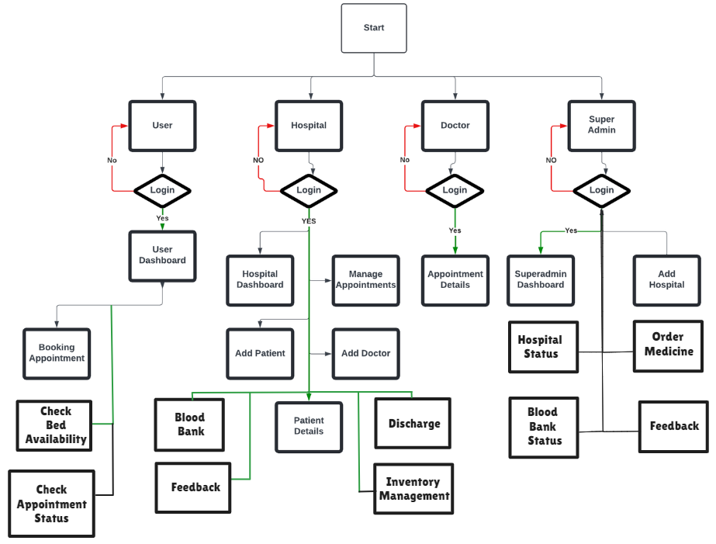

# FEASIBILITY AND VIABILITY

**Technical Feasibility:** Utilizes the MERN stack for

scalability, with seamless integration into existing hospital

systems and city-wide modules.



|  |  |
| --- | --- |
| **Challenge** | **Solution** |
| Data Security | Role-Based Access Control (RBAC), ensuring GDPR compliance for secure data handling. |
| Integration with Existing Systems | API-enabled for seamless integration with existing systems and city-wide modules. |
| Real-Time Tracking & Reporting | Implement robust real-time tracking and reporting mechanisms for patient flow and bed occupancy. |

@SIH Idea submission- Template Technical Feasibility: Utilizes the MERN stack for



scalability, with seamless integration into existing hospital

**Operational Feasibility:** User-friendly interface and

scalable design makes it easy for hospital staff and patients to adopt and expand.

systems and city-wide modules. Technical Feasibility: Utilizes the MERN stack for

scalability, with seamless integration into existing hospital Technical Feasibility: Utilizes the MERN stack for

**Economic Feasibility:** Cost-effective due to open-source

technologies and long-term savings through efficient

resource management.

scalability, with seamless integration into existing hospital

systems and city-wide modules.

**Time Feasibility:** Achievable within a reasonable timeline

using agile development with room for post-launch

improvements.

systems and city-wide modules. **4**

## Impact

**Adaptable Tool:** Can be modified to track and manage other healthcare projects effectively.

## Benefit

**Patient Satisfaction:** Simplifies appointment booking and provides real-time updates.

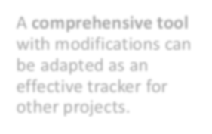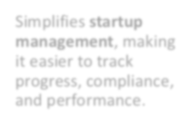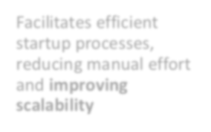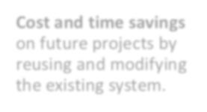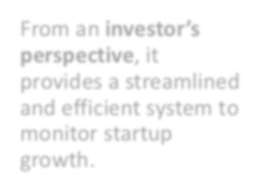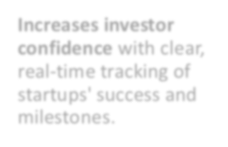

@SIH Idea submission- Template

**5**

**Simplified Management:** Streamlines tracking of patient flow, bed availability, and compliance.

**Resource Utilization:** Optimizes bed usage and resource allocation in real-time.

**Efficient Processes:** Reduces manual effort and improves scalability in hospital operations.

**Data Security:** Protects patient data with secure, authorized access.

# RESEARCH AND REFERENCES



@SIH Idea submission- Template

**6**

* ** World Health Organization (WHO) - Hospital Management**  
  <https://www.who.int/hospitals>
* **National Health Service (NHS) - Hospital Management Systems**  
  <https://www.nhs.uk/hospital-management>
* **Health IT - The Office of the National Coordinator for Health Information Technology (ONC)**  
  <https://www.healthit.gov/>
* **PubMed - Research on Hospital Management Systems**  
  <https://pubmed.ncbi.nlm.nih.gov/>
* **Healthcare Information and Management Systems Society (HIMSS)**  
  <https://www.himss.org/>