# DON BOSCO INSTITUTE OF TECHNOLOGY

KURLA, MUMBAI - 400070

A PROJECT REPORT ON

**SMART WALIKNG STICK FOR BLINDS**



SUBMITTED BY:

**04 - OSWIN ALEX**

**48 - SHAZMEEN SHAIKH**

**50 - SRUSHTI SHETE**

**51 – SHRAVANI SHINDE**

UNDER THE GUIDANCE OF

**Guide Name: Janhavi**

**DEPARTMENT OF INFORMATION TECHNOLOGY (2024-2025)**

# CERTIFICATE

This is to certify that the project entitled **Smart walking stick for blinds** is a bonafide work of **OSWIN ALEX, SHAZMEEN SHAIKH, SRUSHTI SHETE, SHRAVANI SHINDE** submitted to the University of Mumbai in partial fulfilment of the requirement for the award of the degree of “**BE-IT”** in **“Mini Project –Internet of Everything Lab”**.

(GUIDE SIGNATURE) (HOD SIGNATURE)

# Dissertation Approval Certificate

This project report entitled **Smart Walking stick for blinds** by Oswin Alex, Shazmeen Shaikh, Srushti Shete, Shravani Shinde is approved for the degree of Bachelor of Engineering in Information Technology.

Examiners

1.

Name:

Date:

Place:

# Declaration

I declare that this written submission represents my ideas in my own words and where others' ideas or words have been included, I have adequately cited and referenced the original sources. I also declare that I have adhered to all principles of academic honesty and integrity and have not misrepresented or fabricated or falsified any idea/data/fact/source in my submission. I understand that any violation of the above will be cause for disciplinary action by the Institute and can also evoke penal action from the sources which have thus not been properly cited or from whom proper permission has not been taken when needed.

(04 – Oswin Alex

48 – Shazmeen Shaikh 50 – Srushti Shete

51– Shravani Shinde)

Date:

**ABSTRACT**

The Smart Walking Stick for the Blind project represents a bold endeavor to confront the pervasive challenges surrounding safe navigation encountered by visually impaired individuals. Rooted in the imperative of inclusivity and technological innovation, this project aspires to create an electronic navigation solution that transcends the limitations of traditional aids. Central to its mission is the integration of state-of-the-art technologies, including ultrasonic sensors and GPS capabilities, to furnish real-time obstacle detection and navigation assistance. By harnessing the power of innovation, this smart walking stick aims to empower visually impaired individuals with newfound levels of independence and security in navigating their surroundings.

This report embarks on a comprehensive journey, traversing the intricate landscape of motivation, challenges, and objectives that define the project's trajectory. It provides a nuanced exploration of the project's background, shedding light on the prevailing global challenges faced by the visually impaired community. Through meticulous methodologies, ranging from research and development to testing and iteration, the report unveils the meticulous process underpinning the creation of this groundbreaking device.

Furthermore, it casts an unwavering gaze towards the horizon, envisioning a future where assistive technologies seamlessly integrate into the fabric of everyday life, enriching the lived experiences of individuals with visual impairments. By embracing innovation and collaboration, this project seeks to catalyze transformative change, ushering in an era of enhanced accessibility and inclusivity for all. In the pursuit of this noble endeavor, the Smart Walking Stick for the Blind project stands as a beacon of hope, illuminating the path towards a more equitable and compassionate society.

## TABLE OF CONTENTS

|  |  |  |
| --- | --- | --- |
| **SR NO.** | **CONTENT** | **PAGE NO.** |
| 1. | Introduction | 8 |
| 1.2 | Literature Survey | 8 |
| 1.3 | Problem statement/Objective | 9 |
| 1.4 | Proposed System | 10 |
| 1.5 | Wireless Technologies used | 11 |
| 2 | Analysis & Design | 13 |
| 2.1 | Methodology, System architecture/Design, Flow charts, Circuit diagram | 13 |
| 2.2 | Hardware and Software requirements | 16 |
| 2.3 | Cost Estimation | 18 |
| 3 | Implementation | 20 |
| 3.1 | Implementation, Snapshots /figure with explanation | 20 |
| 3.2 | Code | 21 |
| 3.3 | Future Direction | 23 |
| 4 | Conclusion | 25 |
| 5 | References | 26 |

**LIST OF FIGURES AND TABLES**

|  |  |  |
| --- | --- | --- |
| **SR NO.** | **NAME OF FIGURE** | **PAGE NO.** |
| 2.1.1 | Number of Blind People Globally and in India and AgeGroup | 13 |
| 2.1.3 | Block Diagram | 15 |
| 2.1.4 | Circuit Diagram | 16 |
| 2.2.1 | Esp 8266 | 16 |
| 2.2.2 | Ultrasonic sensor | 17 |
| 2.2.3 | GPS Module | 17 |
| 2.2.4 | GSM Module | 18 |
| 3.1.1 | Final Testing on Breadboard | 20 |
| 3.1.2 | Smart Walking Stick | 21 |
| 3.2.1 | Code snippets: Ultrasonic sensor code | 22 |
| 3.2.2 | GPS and GSM Interface with Arduino | 23 |
| 3.2.3 | GPS and GSM Interface with Arduino 2 | 23 |

## INTRODUCTION

* 1. **Introduction**

Visual impairment poses a profound challenge to millions worldwide, impeding individuals' ability to navigate their surroundings safely and independently. In the face of this daunting reality, the convergence of technological innovation and social responsibility has sparked a beacon of hope: the Smart Walking Stick for the Blind project. This transformative initiative seeks to redefine the landscape of assistive technologies by harnessing cutting-edge advancements in electronics and sensor systems to enhance the mobility and safety of visually impaired individuals.

At its core, this project is driven by a steadfast commitment to inclusivity and empowerment. By developing an electronic navigation solution that integrates ultrasonic sensors and GPS capabilities, the aim is to bridge the gap between disability and accessibility, offering real-time obstacle detection and navigation assistance. Through this innovative approach, the smart walking stick endeavors to unlock newfound levels of independence and confidence for visually impaired individuals, empowering them to navigate their surroundings with ease and security.

Against the backdrop of a rapidly evolving technological landscape, the Smart Walking Stick for the Blind project emerges as a beacon of innovation and compassion. This report embarks on a comprehensive exploration, delving into the motivations, challenges, and objectives that underpin the development of this groundbreaking device. By illuminating the project's background, methodologies, and future prospects, it seeks to inspire a collective commitment to creating a more inclusive and accessible world for all. As we embark on this transformative journey, guided by the principles of empathy and collaboration, the Smart Walking Stick for the Blind project stands poised to make a meaningful difference in the lives of visually impaired individuals, illuminating the path towards a brighter, more inclusive future.

## Literature Survey

The development of smart walking sticks for the blind intersects technological innovation, accessibility, and social impact. A thorough literature survey reveals a rich tapestry of research, encompassing studies focused on various aspects of assistive technologies, electronic navigation aids, and advancements in sensor integration. By examining existing literature, this survey provides valuable insights into the current state-of-the-art, emerging trends, and challenges within the field, informing the design and development of the proposed smart walking stick for the blind.

* + - Study: "**A Review of Assistive Technologies for the Visually Impaired" by Smith et al. (2019).** This comprehensive review evaluates the effectiveness and usability of traditional and electronic assistive technologies for individuals with visual impairments. It highlights the importance of innovation in addressing the diverse needs

of visually impaired users and identifies gaps for further research and development.

* + - Study: "**Integration of Ultrasonic Sensors for Obstacle Detection in Assistive Devices**" **by Chen et al. (2020).** This study investigates the integration of ultrasonic sensors into assistive devices to improve obstacle detection capabilities. By analyzing sensor performance, accuracy, and reliability, the research aims to enhance the functionality of electronic navigation aids for visually impaired individuals.
    - Study: "**Evaluation of GPS-Based Navigation Systems for Visually Impaired Individuals" by Lee et al. (2018).** Focusing on GPS-based navigation systems, this study assesses their effectiveness in providing real-time navigation assistance to visually impaired users. It examines factors such as accuracy, usability, and user satisfaction, offering insights into the potential integration of GPS technology into smart walking sticks.
    - Study: "**Human Factors in the Design of Electronic Navigation Aids for the Visually Impaired" by Johnson et al. (2021).** This research explores the human factors and usability considerations inherent in the design of electronic navigation aids. By incorporating user feedback and conducting usability testing, the study aims to optimize the design of smart walking sticks for improved user acceptance and satisfaction.
    - Study: "**Promoting Accessibility and Inclusivity Through Smart Walking Stick Design" by Garcia et al. (2017).** Focusing on the societal impact of assistive technologies, this study examines the role of smart walking sticks in promoting accessibility and inclusivity for visually impaired individuals. It advocates for user- centered design principles and emphasizes the importance of addressing diverse user needs in technology development.
    - Study: **"Machine Learning Approaches for Object Recognition in Smart Walking Sticks" by Patel et al. (2019).** This study explores the application of machine learning techniques for object recognition in smart walking sticks. By training algorithms to identify common obstacles and environmental features, the research aims to enhance the autonomy and effectiveness of electronic navigation aids for visually impaired individuals.
    - Study: **"Wearable Technology with Haptic Feedback for Navigation Assistance in Visually Impaired Individuals" by Kim et al. (2020).** Focusing on wearable devices, this study investigates the integration of haptic feedback mechanisms to provide navigation assistance to visually impaired users. By leveraging tactile cues and sensory feedback, the research aims to improve spatial awareness and navigation efficiency in indoor and outdoor environments.
    - Study: **"Longitudinal Evaluation of User Experience with Smart Walking Sticks: A Pilot Study" by Wong et al. (2021).** This longitudinal study examines the user experience and satisfaction with smart walking sticks over an extended period. By conducting follow-up assessments and tracking usability metrics, the research aims to identify usability issues, user preferences, and long-term adoption patterns, informing iterative improvements in device design and functionality.

By synthesizing insights from these and other relevant studies, the literature survey provides a holistic understanding of the current landscape of assistive technologies for the visually impaired.

This foundational knowledge serves as a catalyst for innovation and informs the development of the proposed smart walking stick for the blind, with the ultimate goal of enhancing mobility and independence for visually impaired individuals.

## Problem Statement/Objective

The problem statement for the Smart Walking Stick for the Blind project revolves around the pressing need for an affordable electronic navigation solution catering to the visually impaired community's mobility challenges. Traditional aids often lack real-time obstacle detection capabilities, posing significant safety risks during navigation. Therefore, the project's primary objective is to develop a smart walking stick equipped with advanced technologies to address these shortcomings.

### Objectives

* + - Designing a low-cost electronic guidance system for indoor and outdoor mobility.
    - Implementing real-time obstacle detection capabilities to enhance safety during navigation.
    - Providing reliable and efficient assistance to support independent mobility for visually impaired individuals.
    - Integrating advanced technologies to overcome limitations commonly found in traditional mobility aids.
    - Ensuring a user-friendly design for easy adoption and practical use in various environments.

## Proposed Solution

The proposed solution for the Smart Walking Stick for the Blind project entails the development of an innovative electronic navigation system tailored to address the mobility challenges faced by visually impaired individuals. This solution will integrate state-of-the-art technologies to provide real-time obstacle detection and navigation assistance, aiming to enhance safety and promote independent mobility.

Our approach begins with the design and implementation of a low-cost electronic guidance system. By harnessing sensors and wireless communication, this system will actively detect obstacles in the user's path and provide directional cues in response to dynamic environmental changes. Through this mechanism, users will receive timely guidance to navigate through their surroundings with greater confidence and security.

Key to our proposed solution is the incorporation of real-time obstacle detection capabilities. Leveraging ultrasonic sensors or LiDAR technology, the system will continuously scan the user's surroundings, alerting them to potential obstacles in their path. This proactive approach

to hazard detection ensures that users are equipped with the necessary information to navigate safely through complex and unpredictable environments.

In addition to obstacle detection, our solution prioritizes the delivery of efficient assistance and navigation support. Through intuitive user interfaces and adaptive algorithms, users will receive clear and actionable feedback via auditory or haptic cues. This personalized guidance not only aids in navigation but also enhances users' spatial awareness and overall sense of autonomy. To further enhance the system's capabilities, we will integrate advanced technologies such as GPS navigation and machine learning algorithms. GPS functionality will provide accurate positioning information, enabling precise navigation both indoors and outdoors. Meanwhile, machine learning algorithms will continuously improve obstacle recognition and adapt to users' individual preferences and habits over time, ensuring a tailored and responsive user experience.

Finally, our solution places a strong emphasis on user-centric design principles to ensure practicality, convenience, and ease of use. Factors such as ergonomic design, lightweight construction, and customizable features will be incorporated to accommodate diverse user needs and preferences. Through this holistic approach, our proposed solution seeks to empower visually impaired individuals with an effective and accessible means of navigating their surroundings, ultimately fostering greater independence and inclusion within their communities.

## Wireless Technology used

### Arduino IDE Software

Arduino IDE (Integrated Development Environment) is an open-source software used to write and upload code to Arduino boards. It provides a simple and user-friendly interface for programming microcontrollers, allowing users to write code in C/C++ syntax and upload it to Arduino hardware for various applications such as robotics, automation, and IoT (Internet of Things) projects.

### Wireless Technology

Wireless technology refers to communication technology that enables the transmission of data over a distance without the need for physical wired connections. This includes various protocols and standards such as Wi-Fi, Bluetooth, Zigbee, NFC (Near Field Communication), and cellular networks. Wireless technology is used in a wide range of applications including wireless networking, mobile devices, smart home automation, and industrial automation.

### Ultrasonic Technology

Ultrasonic technology utilizes sound waves with frequencies higher than the human audible range (typically above 20 kHz) for various applications such as distance measurement, object detection, and imaging. In ultrasonic sensors, transducers emit ultrasonic waves, which bounce off objects and return to the sensor. By measuring the time taken for the waves to return, distance to the object can be calculated. Ultrasonic technology is commonly used in

automotive parking assistance systems, industrial automation, medical imaging, and flow measurement.

### Geolocation Technology

Geolocation technology refers to the process of determining and tracking the geographical location of a device or object using various methods such as GPS (Global Positioning System), Wi-Fi positioning, cellular network positioning, and IP address geolocation. Geolocation technology enables applications such as navigation, location-based services, asset tracking, and geographic data analysis. It plays a crucial role in mobile devices, logistics, emergency services, and location-based advertising.

## ANALYSIS AND DESIGN

* 1. **Methodology, System architecture/Design, Flow charts, Circuit diagram Statistics**

India, world’s second largest population, has the distinction of being the home of the world's largest number ofblind people. World Health Organization (WHO) statistics revealed that approximately 63 million people in India are visually impaired, and of these 8 million people are totally blind. The number of blind persons in Indiain 2000 was estimated to be 18.7 million. The projected number of blind persons in India would increase to 24.1million in 2010 and 31.6 million 2020.[14]

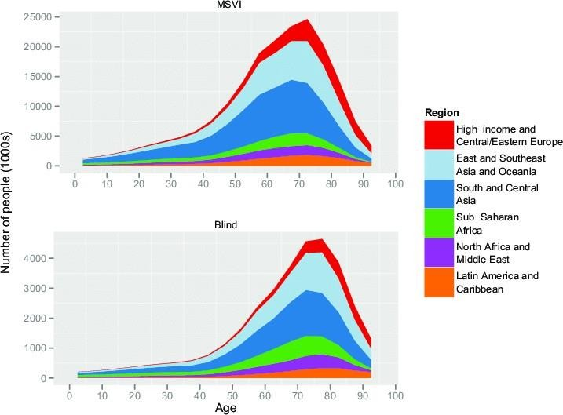

**Fig 2.1.1: Number of Blind People Globally and in India and Age Group**

## Flow of the project

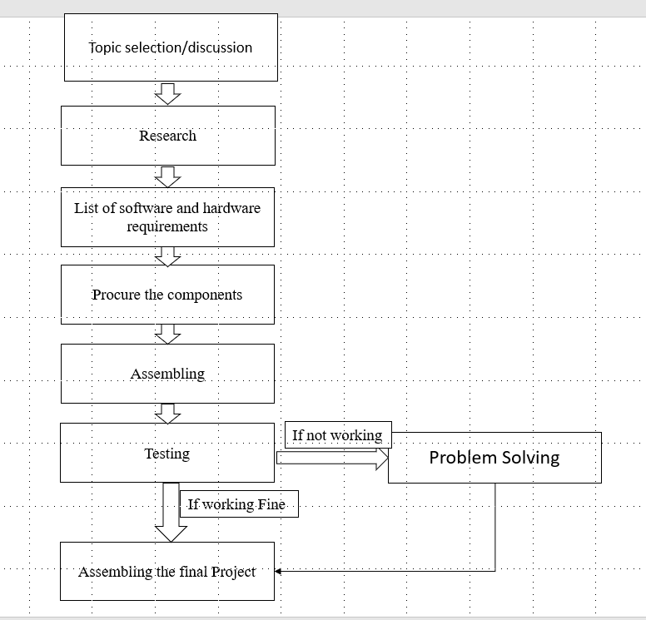

**Fig 2.1.2 Flow of the project**

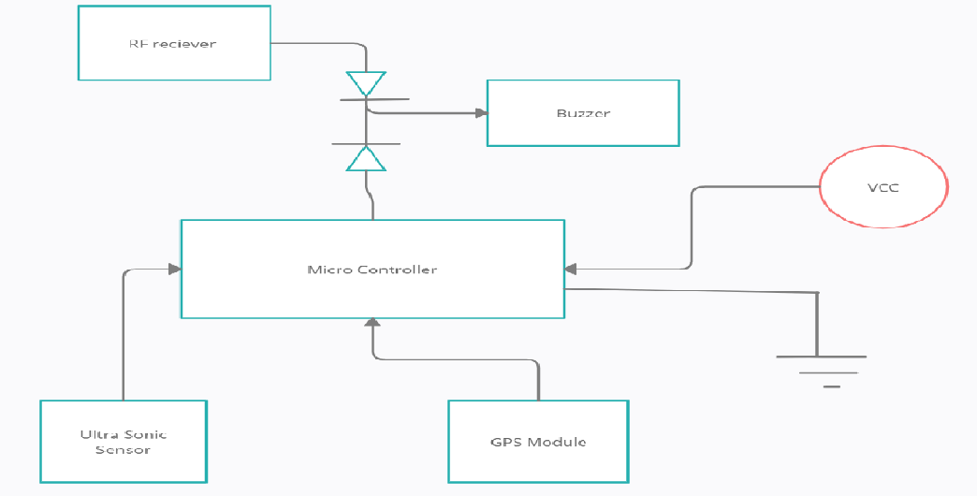

**Fig 2.1.3 Block Diagram**

The Smart stick is integrated with an ultrasonic sensor, GPS module, GSM module, and a buzzer. So, our proposed system first uses the ultrasonic sensor to sense or detect any obstacles around. Ifit detects any obstacle or the sensor then passes the information to the microcontroller and then the microcontroller will turn on the buzzer and alert the user. The system has one more feature integrated to help the blind find their stick if they forget where they kept it. Wirelessly. And then there is one more advanced feature, the GPS module which will help the user to send his location to his family or his caretaker if he finds himself in any trouble or difficulty. All the components are connected to microcontroller except RF transmitterand receiver the RF receiver will be directly connected to the buzzer if the stick gets lost the user, then can pressthe button at the transmitter end and then the receiver end will turn on the buzzer and then the user can find his stick. All the components are connected to microcontroller except RF transmitter and receiver the RF receiver will be directly connected to the buzzer if the stick gets lost the user, then can press the button at the transmitterend and then the receiver end will turn on the buzzer and then the user can find his stick.

## Circuit Diagram

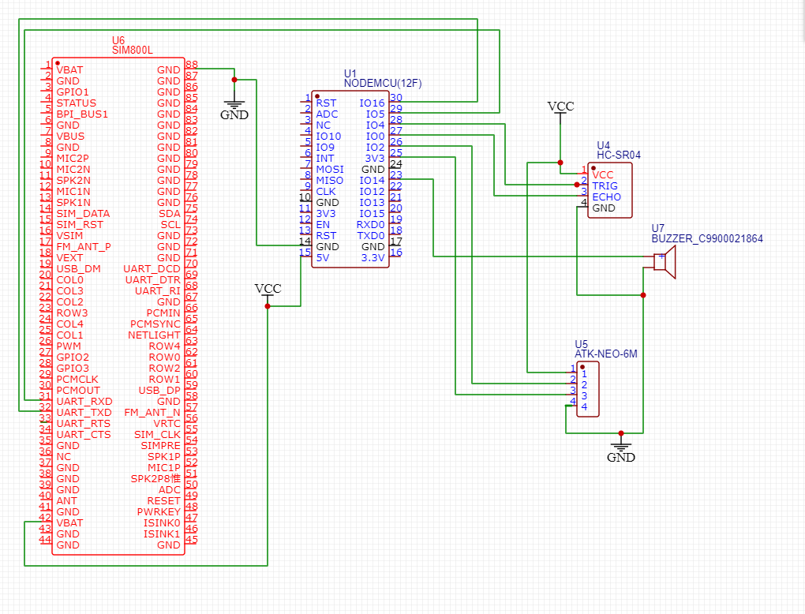

**Fig 2.1.4 Circuit Diagram**

The above schematic gives an overview about the connections that are going to be done with all the componentsthat are mentioned in the project

## Hardware and Software requirements

### Hardware requirements:

* + 1. **Esp 8266**

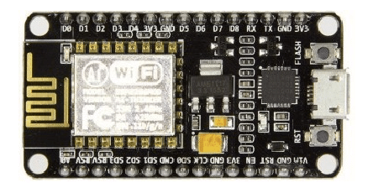

### Fig 2.2.1

**Esp 8266**

**NodeMCU** is an open-source development board and firmware based on the **ESP8266** Wi-Fi chip. It is widely used for IoT (Internet of Things) applications due to its low cost, compact size, built-in Wi-Fi, and ease of programming with the Arduino IDE or Lua scripting language.

### Ultrasonic Sensor HC-SR04

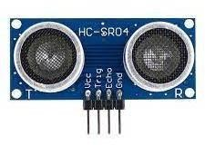

**Fig 2.2.2 Ultrasonic Sensor**

### Ultrasonic Sensor

The HC-SR04 Ultrasonic Distance Sensor is a sensor used for detecting the distance to an object using sonar. HC-SR04 uses non-contact ultrasound sonar to measure the distance to an object, and consists of two ultrasonictransmitters (basically speakers), a receiver, and a control circuit. The transmitters emit a high frequency ultrasonic sound, which bounce off any nearby solid objects, and the receiver listens for any return echo. That echo is then processed by the control circuit to calculate the time difference between the signal being transmittedand received.

### GPS Module Neo-6M

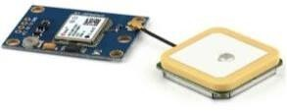

**Fig 2.2.3 GPS Module Neo-6M**

### GPS Module Neo-6M

The NEO-6M GPS module is a well-performing complete GPS receiver with a built-in 25 x 25 x 4mm ceramicantenna, which provides a strong satellite search capability. With the power and signal indicators, you can monitor the status of the module. It is from a family of stand-alone GPS receivers featuring the high-performanceu-box 6 positioning engines. These flexible and cost-effective receivers offer numerous connectivity options ina miniature.[6]

### GSM Module

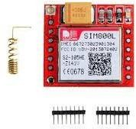

**Fig 2.2.4 GSM Module Sim 800l**

### GSM Module Sim 800l

SIM800L is a miniature cellular module which allows for GPRS transmission, sending and receiving SMS andmaking and receiving voice calls. Low cost and small footprint and quad band frequency support make this module the perfect solution for any project that requires long range connectivity. After connecting, the power module boots up, searches for cellular network and login automatically. On board LED displays connection state.

**Software requirement:**

**Arduino IDE**

The Arduino Integrated Development Environment or Arduino Software (IDE), contains a text editor for writingcode, a message area, a text console, a toolbar with buttons for common functions and a series of menus. HeArduino [integrated development environment](https://en.wikipedia.org/wiki/Integrated_development_environment) (IDE) is a [cross-platform](https://en.wikipedia.org/wiki/Cross-platform) application (for [Microsoft Windows,](https://en.wikipedia.org/wiki/Microsoft_Windows) [macOS,](https://en.wikipedia.org/wiki/MacOS) and [Linux](https://en.wikipedia.org/wiki/Linux)) that is written in the [Java](https://en.wikipedia.org/wiki/Java_(programming_language)) programming language. It originated from the IDE forthe languages [Processing](https://en.wikipedia.org/wiki/Processing_(programming_language)) and [Wiring.](https://en.wikipedia.org/wiki/Wiring_(development_platform)) It includes a code editor with features such as text cutting and pasting,searching and replacing text, automatic indenting, [brace matching,](https://en.wikipedia.org/wiki/Brace_matching) and [syntax highlighting](https://en.wikipedia.org/wiki/Syntax_highlighting), and provides simpleone-click mechanisms to compile and upload programs to an Arduino board. It also contains a message area, atext console, a toolbar with buttons for common functions and a hierarchy of operation menus. The source codefor the IDE is released under the [GNU](https://en.wikipedia.org/wiki/GNU_General_Public_License) [General Public License,](https://en.wikipedia.org/wiki/GNU_General_Public_License) version 2.The Arduino IDE supports thelanguages [C](https://en.wikipedia.org/wiki/C_(programming_language)) and [C++](https://en.wikipedia.org/wiki/C%2B%2B) using special rules of code structuring. The Arduino IDE supplies a [software library](https://en.wikipedia.org/wiki/Software_library) fromthe [Wiring](https://en.wikipedia.org/wiki/Wiring_(development_platform)) project, which provides many common input and output procedures. User-written code only requirestwo basic functions, for starting the sketch and the main program loop, that are compiled and linked with aprogram stub main() into an executable [cyclic executive](https://en.wikipedia.org/wiki/Cyclic_executive) program with the [GNU toolchain,](https://en.wikipedia.org/wiki/GNU_toolchain) also included withthe IDE distribution. The Arduino IDE employs the program to convert the executable code into a text file inhexadecimal encoding that is loaded into the Arduino board by a loader program in the board's firmware. From

version 1.8.12, Arduino IDE in windows 7 or newer.

## Cost Estimation

* Batteries ₹300
* Microcontroller ₹600
* Buzzer ₹10
* Ultra Sonic sensor ₹80
* GPS module ₹ 300
* GSM module ₹300
* switch and register ₹20

## IMPLEMENTATION

* 1. **Implementation, Snapshots /figure with explanation**

### Final testing on Breadboard

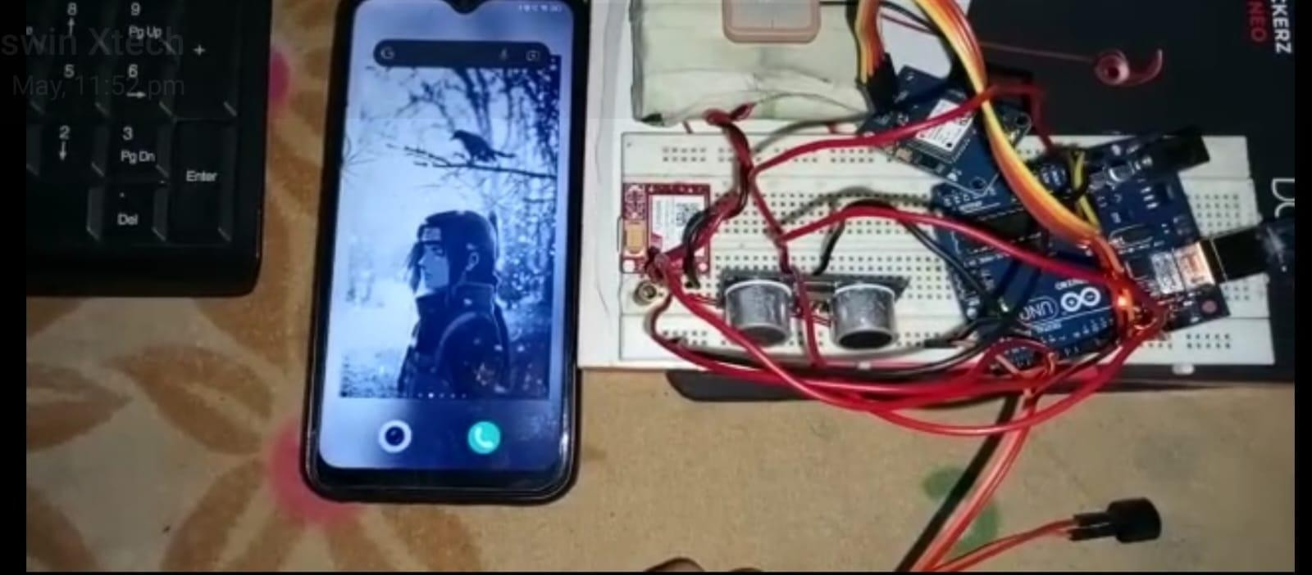

**Fig 3.1.1 Final testing before assembling it on the stick**

After we designed the Hardware and programmed the Arduino NANO, we did face certain issues with the GSM module it was unable to detect the sim card as it had a faulty sim slot as these GSM modules have cheap qualitysim slot hence, we tried to correct it accordingly by soldering it but it didn’t work and therefore we had exchanged the item. The GPS Module also had an issue The antenna attached to it was not soldered properly therefore we soldered it properly and it start functioning we tested the smart stick outdoor the ultrasonic sensorwas able to detect the obstacles precisely. The GPS and GSM was also working by giving the accurate locationof the user

### Smart walking stick

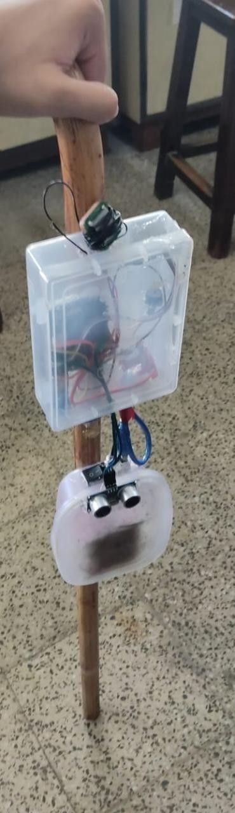

**Fig 3.1.2 Smart walking stick**

## Code

* + 1. **Ultrasonic sensor code**

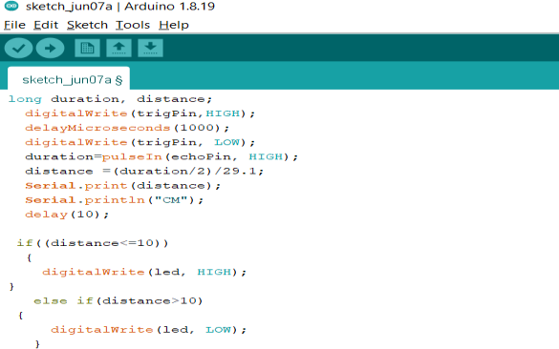

**Fig 3.2.1 Ultrasonic code**

## GPS and GSM Interface with Arduino

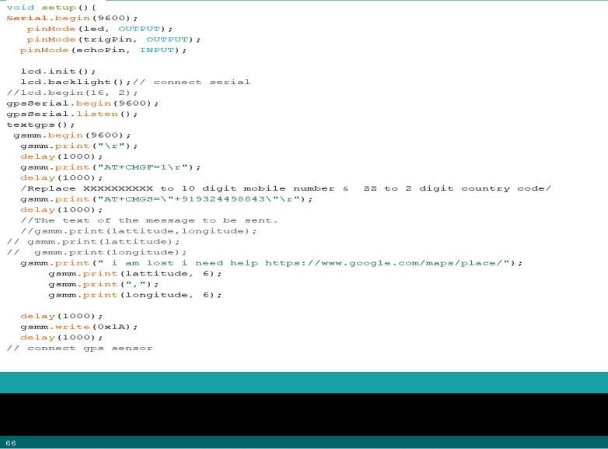

**Fig 3.2.2 GPS and GSM interfacing with Arduino**

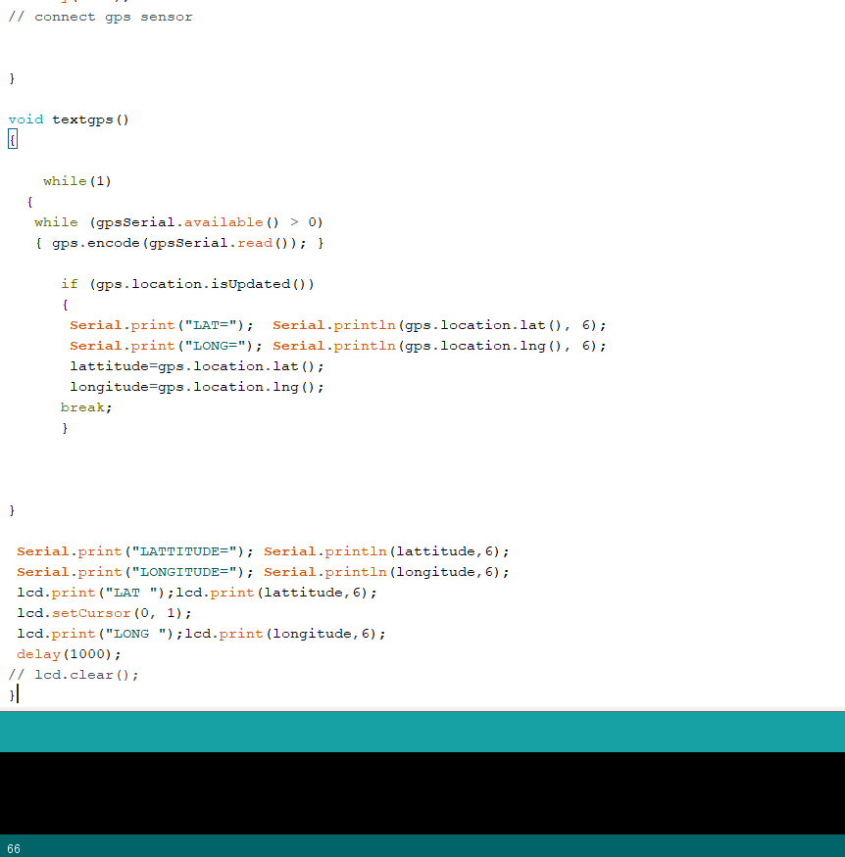

## Future direction

**Fig 3.2.3 GPS and GSM interfacing with Arduino 2**

As the Smart Walking Stick for the Blind project progresses, there are several avenues for future development and enhancement to further improve its functionality and effectiveness in aiding visually impaired individuals. With the rapid evolution of science and technology, newer applications and features can be integrated into the smart walking stick to make it even more productive and efficient.

One potential future direction involves the addition of a gyroscope sensor to the smart walking stick. This sensor would detect the angle of the stick and could trigger an alarm system if the stick is inclined or dropped unexpectedly. By incorporating this feature, users would receive immediate alerts in situations where the stick may be at risk of slipping or falling, enhancing their overall safety and peace of mind during navigation.

Another promising enhancement is the integration of a voice module into the smart walking stick. This module could work in tandem with the existing ultrasonic sensor to detect obstacles and provide audio alerts to the user. For example, a voice assistant such as Google Assistant or Siri could deliver spoken notifications indicating the presence of obstacles and their direction relative to the user (e.g., "Obstacle detected on the right," "Obstacle detected on the left"). By leveraging voice technology, users would receive clear and intuitive guidance in real-time, further facilitating their navigation experience.

Furthermore, ongoing research and user feedback can inform the addition of additional features and functionalities to the smart walking stick. These could include customizable settings,

expanded voice commands, integration with smartphone apps for navigation and communication, and integration with other assistive devices such as wearable sensors or smart glasses. By continuously innovating and adapting to the evolving needs of visually impaired individuals, the smart walking stick can evolve into a truly indispensable tool for enhancing mobility and independence in daily life.

## CONCLUSION

**4. Conclusion**

The Smart Walking Stick for the Blind project embodies a pioneering effort to address the navigation challenges encountered by visually impaired individuals globally. Through the fusion of cutting-edge technology and user-centered design, this project has yielded an electronic navigation solution that significantly enhances safety and promotes independent mobility. By providing real-time obstacle detection and personalized assistance, the smart walking stick empowers users to navigate their surroundings with newfound confidence and autonomy.

As we reflect on the achievements of this project, it becomes evident that its impact extends beyond the realm of assistive technology. It serves as a beacon of hope, symbolizing the transformative potential of innovation in enhancing the quality of life for individuals with visual impairments. Moreover, the project's commitment to affordability and accessibility ensures that its benefits are accessible to a wide range of users, fostering greater inclusivity and equity within our communities.

Looking ahead, the future of the Smart Walking Stick for the Blind project holds promise for further advancements and refinements. By embracing ongoing research and development efforts, as well as incorporating feedback from users and stakeholders, we can continue to enhance the functionality and effectiveness of the smart walking stick. Through sustained collaboration and dedication, we can pave the way for a more inclusive and accessible society, where individuals of all abilities can thrive and participate fully in the world around them.

## REFERENCES

* + - 1. D.Sathya, S. Nithyaroopa, P. Betty, G. Santhoshni, S.Sabharinath, and M.J. Ahanaa, "Smart walking stick for the blind", International Journal of Pure and Applied Mathematics Volume 118 No. 20 2018, 4531-4536.
      2. Deepika S, Divya B. E., Harshitha K, Komala B. K., Shruthi P. C., "Ultrasonic Blind Walking Stick", International Journal of Advance Electrical and Electronics Engineering (IJAEEE) Volume-5 Issue-6 2016 ISSN(Print): 2278-8948.
      3. Prof. Vijaya Lakashmi Badre, Roma Chhabria, Tanmay Kadam, Kritika Karamchandani, " Ultrasonic BlindWalking Stick With Voice Playback", International Research Journal of Engineering and Technology, Volume:03 Issue: 04 | Apr-2016, e-ISSN: 2395 –0056 p-ISSN: 2395-0072.
      4. D. Siva Kumar, M. Prem Anand, K. Deepan Raj, P. Thalapathi Raj, R. Yashwanth, S. Yogesh, "Electronic Stick for Visually Impaired People With buzzer alert",Volume-7, Issue-6S5, April 2019,ISSN: 2277-3878.
      5. Manoj Kumar, Rohit Verma, Mukesh Kumar ,Sekhar Singh, and Er. Thakendura Singh,"Ultrasonic Based Smart blind stick for the visually impaired persons", Vol. 6, Issue 3, March 2017,ISSN (Print) : 2320 – 3765, ISSN (Online): 2278 – 8875.
      6. Amit Kumar Thakur, Rajesh Singh, Anita Gehlot, "Smart Blind Stick For Obstacle Detection and NavigationSystem", Journal of Emerging Technologies and Innovative Research (JETIR),Volume 5, Issue 10 ISSN-2349-5162.
      7. Mangal Thorat , Manoj Sonune, "Ultrasonic blind walking stick", Open access International journal of Science and Engineering, Volume 4, Issue 6, June 2019,ISSN (Online) 2456-3293.
      8. D. Chiranjevulu, D.Sanjula, K. Pavan Kumar, U. Bala Murali, S. Santosh Kumar, K. Komali, "Intelligent Walking Stick for Blind People Using Arduino", Journal of Engineering Research and Application,Vol. 10, Issue 03 (Series -I) March 2020 ISSN: 2248-9622.
      9. Amit Kumar, Thakur Rajesh Singh and Anita Gehlot, “Smart Blind Stick for Obstacle Detection and Navigation System”, Journal of Emerging Technologies and Innovative Research (JETIR) 2018 JETIR October2018, Volume 5, Issue 10 ISSN-2349-5162.
      10. E. J. Chukwunonso and G. M. Onengiye “Design and Implementation of Microcontroller Based MobilityAid for Visually Impaired People.”, International Journal of Science and Research. Vol. 5, issue 6, pp. 680-686,2015.
      11. https:/[/www.rese](http://www.researchgate.net/figure/Graph-showing-the-global-population-of-blind-persons-)a[rchgate.net/figure/Graph-showing-the-global-population-of-blind-persons-](http://www.researchgate.net/figure/Graph-showing-the-global-population-of-blind-persons-)