**The Bombay Salesian Society’s**

# Don Bosco Institute of Technology

**Department of Information Technology**

COMPLETION CERTIFICATE

This is to certify that Mini Project Report titled **‘EmoSound’** submitted in the partial fulfillment for the **TE, SEM VI** in the subject of **ITL 604: MAD & PWA Lab** in ‘Information Technology’ department to the University of Mumbai is a record of the candidates own work carried out during **Jan to April 2024** by them under our supervision in AY 2023-24.

# Project Team Members:

|  |  |  |
| --- | --- | --- |
| **Roll No.** | **Student Name** | **Signature** |
| 47 | Sumit Sawant |  |
| 52 |  |  |
|  |  |  |

Prof. Nilesh Ghavate Project Guide

# ITL 604: MAD & PWA Lab (AY 2023-24)

|  |  |  |  |
| --- | --- | --- | --- |
| **Sr.**  **No.** | **Title of Experiment** | **Date of condution** | **Signature** |
| **1** | **Experiment no 1: First Flutter App** |  |  |
|  | To design a basic layout of Flutter App using Scaffold widget (Snack-Bar, Bottom-Navigation-Bar, Floating- Action-Button, App-Bar) |  |  |
| **2** | **Experiment 2: Common Widgets** |  |  |
|  | To include icons, images, Text, TextStyle, Font, Image, Assets, Icons, Padding, and Center in Flutter app |  |  |
| **3** | **Experiment No 3: Profile Page App** |  |  |
|  | To develop a profile page feature for our Flutter application (Stateful) including FloatingActionButton and onPress activity |  |  |
| **4** | **Experiment No 4: ListView and Card Layout** |  |  |
|  | To develop a card layout for our Flutter application. |  |  |
| **5** | **Experiment No 5: Authentication** |  |  |
|  | To develop a Authentication mechanism for our Flutter application (Stateful) with Gesture Detector, Firebase Authenticatoin Service and Toast messages |  |  |
| **6** | **Experiment No 6: Routes and Consume API** |  |  |
|  | To develop multiple activities and navigate through routes for our Flutter application, pass data through routing and consume third party API |  |  |
| **7** | **Experiment No 7: Navigation Drawer** |  |  |
|  | To develop navigation drawer in the Flutter application |  |  |
| **8** | **Experiment No 8: Route Map** |  |  |
|  | To develop navigation map to display route in the Flutter application using OpenStreetMap |  |  |

**Project Details**

## Name of the app: EmoSound

## Package name of the app: com.example.myapp

## GithHub Repo: https://github.com/SumitSawant1029/EBMR_Flutter.git

## About this app:EmoSound is the perfect app for music enthusiasts seeking emotion-driven playlists. With curated tracks ranging from upbeat melodies to tranquil tunes, it caters to every mood. For administrators, EmoSound offers seamless library management, intuitive graph visualization, and effortless music additions. Users can enjoy uninterrupted playback, track their recently played songs, and delve into personalized playlists that resonate with their emotions. EmoSound transforms the music listening experience, making it more immersive and tailored to individual preferences.

## Admin:-

## 

## User:

## 

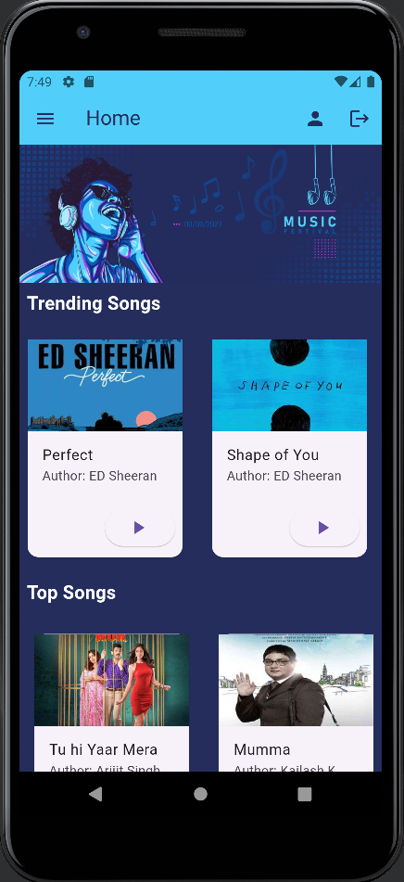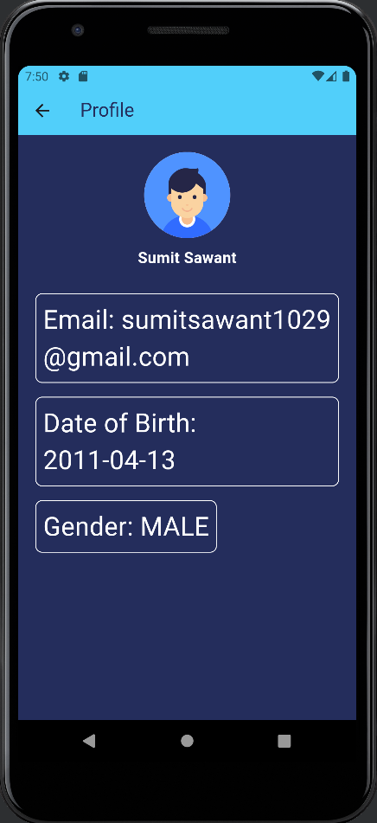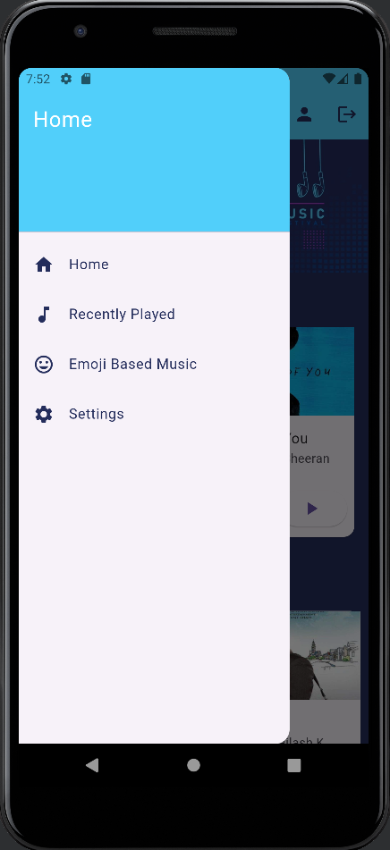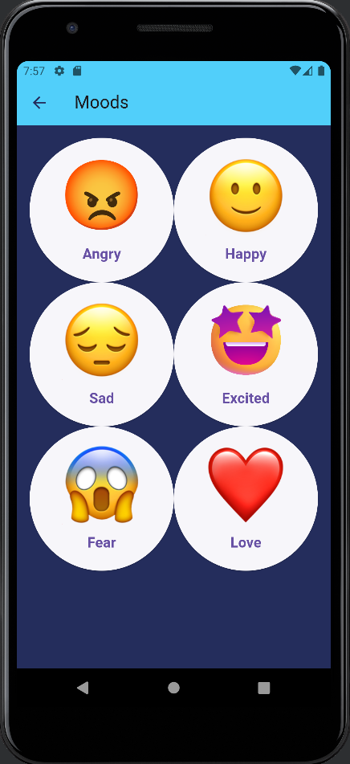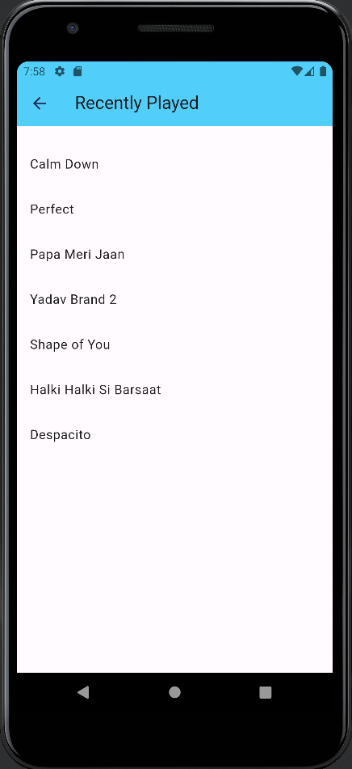

List of dependent Libraries/Packages:

* firebase_auth: Manages user authentication using Firebase Authentication service.
* fluttertoast: Displays native toast messages for both Android and iOS platforms.
* flutter_datetime_picker: Provides date and time picker dialogs for selecting dates and times.
* cloud_firestore: Allows you to interact with Cloud Firestore, a flexible, scalable database for mobile, web, and server development from Firebase and Google Cloud Platform.
* flutter_date_pickers: Offers customizable date picker widgets for selecting dates.
* pie_chart: Enables the creation of beautiful pie charts to visualize data.
* fl_chart: Provides a variety of customizable and animated charts to visualize data.
* flutter_lints: Offers a set of lint rules to enforce coding standards and best practices in Flutter projects.
* email_auth: Allows for email-based authentication, often used for verifying user identities.
* email_otp: Provides functionality for generating and verifying one-time passwords (OTPs) sent via email.
* firebase_storage: Allows for interaction with Firebase Cloud Storage, which provides secure file uploads and downloads.
* file_picker: Enables the selection of files from the device's file system.
* image_picker: Allows users to pick images from the device's image gallery or camera.
* just_audio: Provides audio playback functionality for playing audio files in Flutter apps.

Data safety

* Does your app share data with third party ? If yes, list the data & state the reason for sharing.

→ EmoSound prioritizes user privacy and does not share personal data with third parties without explicit consent. However, EmoSound may collaborate with research institutes under strict data anonymization and privacy protocols. In such cases, aggregated and anonymized data related to music preferences, emotions, and usage patterns may be shared. This data sharing aims to contribute to academic research in fields such as music psychology, emotion-driven technology, and user behavior analysis, fostering advancements in understanding the impact of music on emotions and well-being. Users' identities and personally identifiable information are always kept confidential and are not shared in any form without explicit consent.

* Which data is collected and why ? List and describe

→ we collect data about users' age, gender, and emotions to improve their experience. We use this info to understand what users like and how they feel. By doing this, we can give them content and features they enjoy. We take privacy seriously and follow the rules about how we use their data. Our goal is to make sure users have a great time on our platform.

* Do you encrypt the data collected ? If yes, mention encryption algorithm

→ Yes, I hash sensitive data such as passwords. One commonly used hashing algorithm is SHA-256 (Secure Hash Algorithm 256).

* Do you have provision for request to delete data? If yes, mention the process

→ Yes, there is a provision for data deletion upon request. Administrators can initiate the deletion process by accessing the user's profile or data record within the system and permanently removing the relevant data. This process typically involves verifying the legitimacy of the request and ensuring that all associated data is securely deleted from the system.

* Age group for your target audience

→ The target audience for the platform or service I represent typically falls within the age group of 18 to 30 years old. This demographic range is often associated with young adults and individuals in early adulthood who are active users of technology and online services.