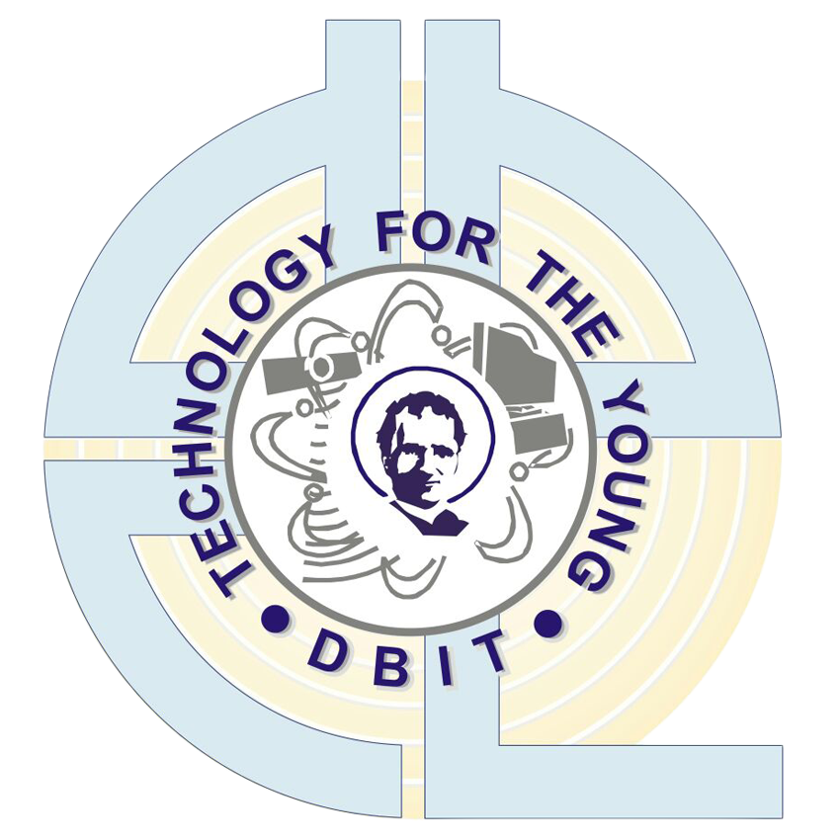Don Bosco Institute of Technology, (DBIT), Mumbai -

400070.

Lab Journal by

**Afzal Siddiquie**

**Roll no : 53 Seat No : 3651**

for the Subject

**ITL602: Web Lab**

**T.E. / Sem VI / Jan – May 2024.**

Department of Information Technology

Don Bosco Institute of Technology, (DBIT), Mumbai - 400070.

Index

|  |  |  |  |
| --- | --- | --- | --- |
| **Sr No.** | **Name of the experiment/assignment** | **Submitted Date** | **Page No.** |
| 1 | Experiment 1 - Web Analytics | 15/01/2024 | 1 |
| 2 | Experiment 2 - Semantic Web | 22/01/2024 | 4 |
| 3 | Experiment 3 - Design a Calculator using TypeScript | 08/02/2024 | 7 |
| 4 | Experiment 4 - Access Modifiers in TypeScript | 08/02/2024 | 9 |
| 5 | Experiment 5 - Hello world program using MVC model of AngularJS | 14/02/2024 | 11 |
| 6 | Experiment 6 - Form Validation using AngularJs | 22/02/2024 | 13 |
| 7 | Experiment 7 - Basic JavaScript program using Ajax | 01/03/2024 | 16 |
| 8 | Experiment 8 - A web application using Ajax , HTML and JavaScript | 08/03/2024 | 18 |
| 9 | Experiment 9 - Create RESTful API using mongoDB | 14/04/2024 | 20 |
| 10 | Experiment 10 - Create Typescript REST API using MongoDB | 14/04/2024 | 24 |
| 11 | Assignment 1 | 22/04/2024 | 27 |
| 12 | Assignment 2 | 22/04/2024 | 35 |