**Drive-time**: This sample perform drive time analysis by invoking an online GP service.

Service URL:

<http://sampleserver1.arcgisonline.com/ArcGIS/rest/services/Network/ESRI_DriveTime_US/GPServer/CreateDriveTimePolygons>

Pre-requisites:

A local service connection (.ags) file need to be created and referred to execute a remote service.

1. Open ArcCatalog and created an ArcGIS Server connection to services directory

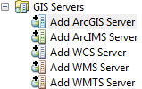

Server URL: <http://sampleserver1.arcgisonline.com/ArcGIS/rest/services>

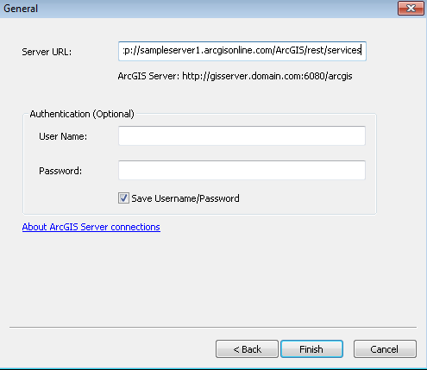

1. Right-click and rename the connection to ArcGIS. The connection is saved as ArcGIS.ags file.

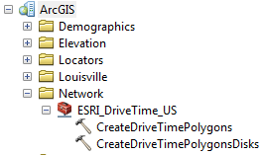

1. Optionally, the server connection file can be saved to different location by drag and drop.
2. Use the path to the connection file to invoke GP Service. Please refer to this sample code to see how this can be done.

**Steps to run drive time analysis:**

1. Click on the Drive-time analysis tool to enable drawing tool

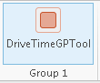

1. Click on the map to run the analysis
2. In a few second the drive time polygons are drawing on the map

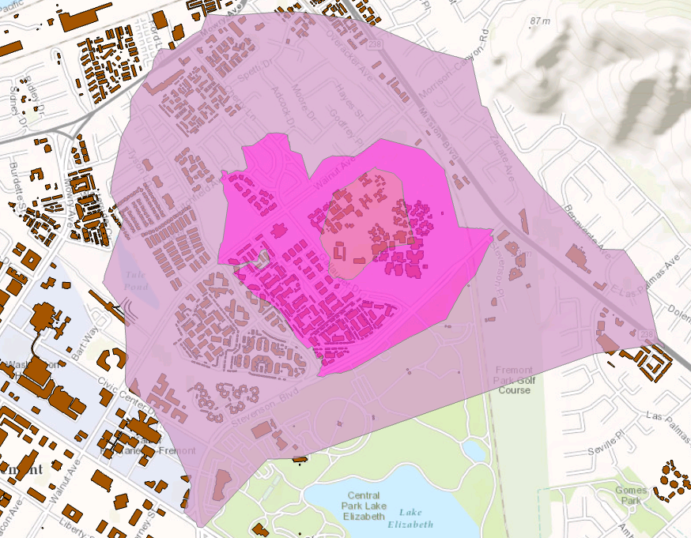

1. A message box showing the job status will be displayed

