Group Assignment 1 – Project Vision + Entity Design

# Goal

Develop a project charter to highlight the goals of the project that is about to undertaken. In addition, the group will develop a conceptual architecture. This high-level architecture will outline the various entities that are being managed in the system.

# Deliverables (20pts)

* Project charter
* Entity Design / Conceptual architecture

# Instructions

Knowing where you are going and being able to convey that direction to others is vital to a successful project. For this first group assignment, the group will develop a vision statement – a reminder and a standing stone which will guide decisions as the project moves along. Having a strong vision can be a compelling motivator for team members, stakeholders and possible investors. The scope portion of the document ensures that the important aspects of the project are considered and diversions are caught early.

Once the vision has been set and the team is clear on the project’s direction from a business perspective, it’s important to set the technical boundaries of the project. A conceptual (or logical) diagram of entities involved in the system can help to keep the technical team on the same page. Highlighting the key data that will be made available to the API and the type of data that will be stored in the database can make evident any design difficulties early in the process before getting too far into the implementation.

Turn in a single PDF document which has the project charter and the entity design (which will serve as your design document). You may add additional information that you feel will be valuable to convey the vision and to keep the project on track (i.e. use cases, requirements doc).

***The example that follows is based on the case study with regard to Geocaching outings (derived from Systems Analysis and Design, Kendall and Kendall). In short, Wayne (the customer) wants to have a geocaching application with the features described in this project charter.***

***You should cover all the aspects represented here. Remove the sample text and instructions before submitting. Remember to ensure your deliverables are professional and neat. (proper headers/footers, consistent font, use of built in styles, etc.)***

Project Charter

# Project Overview

**Briefly describe the project purpose**.

***Project Overview*** *should be very brief (2-3 sentences) that answer the question – “what is this project all about?”.*

|  |
| --- |
| *The primary purpose of this project will be to develop a geocaching site for Wayne and others to use to track their geocaching activities. The sites that Wayne has used all left something to be desired, so this project will address those other site shortcomings and provide a superior experience for Wayne and the geocaching community.*  *Wayne would like to create a community around this new geocaching site, so not only will the site need to provide for the basic geocaching activities (listing geocaches, tracking finds), but will also need to have functionality that will allow users to share their findings and thoughts on geocaching.* |

# Objectives

**Describe the outcomes of the project.**

***Objectives*** *define goals for the project. How are things different when the application is implemented? What benefit will be realized when this project is complete.*

|  |
| --- |
| *When the site is finished*   * *Users will be able to share geocaching location with others* * *Users will be able to find new geocaching locations* * *Users will be able to create community where they can meet up with friends or meet new people that share interest in Geocaching* |

# Key Stakeholders

**List the primary stakeholders and how they will be impacted by the project**

***Stakeholders*** *are people or organizations that benefit from the project or are impacted by the changes that are required to gain the benefit. Usually the project team is not a stakeholder unless they are beneficiaries or somehow have a stake in the outcome of the project. In this case, the customers of the project may be useful to identify as stakeholders.*

|  |  |
| --- | --- |
| **Stakeholder Name (or Role Name)** | **Impact / Role in the Project** |
| Wayne | Wayne will serve as the Product Owner and as the owner, will have the biggest impact on the direction of the development of the site |
| User community | We will need to form a ‘focus group’ of key individuals to provide feedback to Wayne and the team on the ongoing development to ensure the final product is well received |

# Project Risks

**Identify the risks that are known or suspected at the beginning of the project.**

***Risks*** *identify undesirable outcomes that might happen. They should be considerate of the things that are unique to the project.*

*More interesting and possibly more important are risks that are unique to this project.*

* *Risks should be stated in terms of “what might happen”, not in terms of constraints.*
* *Avoid identifying "lazy" risks. Such as - 'scope creep', 'limited time', 'low priority' or other topics that can be easily mitigated with a bit of effort.*
* *Build confidence in your investors (your CIO is an investor too!), identify risks that are truly out of control.*
* *Be prepared to have the risks mitigated for you.*

|  |
| --- |
| The project may run over the time budgeted (single class semester) because:   * Wayne’s brother (Duane) will be leading the development effort as part of a class project * Duane and team have been assigned other “high priority” projects and may not have the bandwidth to focus on this effort * Duane has limited experience with web development which will require a few weeks of learning early on.   The project may exceed the small financial budget if the team is not able to find a hosting vendor and domain registration that is reasonable. |

# Key Assumptions

**List any assumptions that were made during the development of the vision statement.**

***Key Assumptions*** *include conditions that need to be in place for the project to be a success. Also, include the constraints on the project, such as availability of budget, resources and time.*

|  |
| --- |
| 1. Duane, as well as Wayne, are very familiar with the geocaching community and its needs and will be able to provide excellent guidance to the team on what functionality is needed. 2. The other members of Duane’s team have adequate analytic and development skills to deliver the product 3. Wayne will be able to assemble a small team of other enthusiasts to serve as his focus group 4. The product will probably not be finished in a single semester, but sufficient functionality will be available so that a consumable solution can be available to the public |

# Project Scope

**Considering estimated time, cost, and other resources, define the high-level scope of the project. Describe what functionality will be delivered and what won’t be delivered.**

***Project Scope*** *defines which functions and features will be delivered and which features/functions will not be delivered (just as important as the things that are to be delivered).*

|  |
| --- |
| The site will provide the following functionality:   * Allow users to register so they can contribute to the community * Allow anonymous access to ‘public’ sections of the site * Allow users to post new geocaches for others to find * Allow users to post their finds and details of their adventure * Allow users to post details of sites visited that were not the correct destination * Allow users to determine which of their posts are public and which are private * Allow users to self-form groups by inviting others to join * The site will have discussion boards for various topics * The site will have a full website * The site will provide the ability to post ‘contests’ in which users could compete to see who can find the cache first (or other contests as determined) * The site will provide a user dashboard that will show data pertinent to the user (number of caches found, status of current searches, etc) * The site will provide a ‘leader’ dashboard to show various stats but primarily those users who have found the most caches   The following features are out of scope for the initial release   * The application will not have a mobile app * The application will not have integration with social media platforms |

# Release Plan

**(Optional) Describe how the functions will be prioritized.**

***Release plans*** *provide a sense of when the features / functions will be delivered in relative priority. Having a release plan provides vision beyond the initial stages of the project into future plans. Another way to represent this information is to show relative times (e.g. now, next, later).*

|  |
| --- |
| **Release 1** – domain registered and site created; site is accessible and will have a single introductory page  **Release 2** – basic user functionality; anonymous access; user registration; groups  **Release 3** – basic geocaching functions – creating caches, posting finds; private and public posting; discussion boards  **Release 4** – full geocache activity tracking (successful and unsuccessful treks)  **Release 5** – dashboards and leader boards  **Release 6** – mapping capability |

# Initial Timeline

**Provide an overview of the project.**

***Initial timeline*** *provides a high-level estimate of project milestones and dates. Having an initial timeline provides the stakeholders a better sense of what is to come and when to expect to see progress.*

|  |
| --- |
| **Week 1-3:** Project Initiation (requirements gathering, planning, estimations)  **Week 4/Day 1 :** Go/No Go decision point  **Week 4-6:** Development  **Week 7:** Release 1 reviewed with focus group  **Week 8-9:** Incorporate feedback  **Week 10:** Release 1 go-live in test environment |

Sample Entity Design

The following is an example of an entity design. Your first pass may be a little less detailed in the first pass. Just keep in mind that this is a first pass and that the design may need to change as the requirements become clearer. The earlier in the process that the design is complete, the easier it will be to complete the project. Changes to the fundamental design after the object model is complete or the API has been developed will have a more profound ripple affect on the rest of the system. This is a sample data model borrowed from (SQLite Sample Database and It's Diagram, 2023)

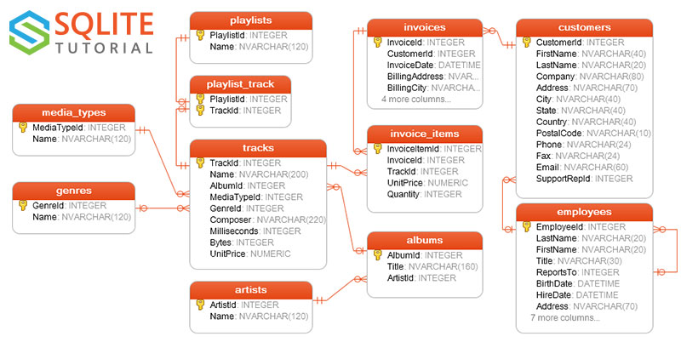

Figure 1. Entity design for the Chinook database. (SQLite Sample Database and It's Diagram, 2023)

* **employees**table stores employees data such as employee id, last name, first name, etc. It also has a field named ReportsTo to specify who reports to whom.
* **customers** table stores customers data.
* **invoices** & **invoice_items** tables: these two tables store invoice data. The invoices table stores invoice header data and the **invoice_items** table stores the invoice line items data.
* **artists** table stores artists data. It is a simple table that contains only the artist id and name.
* **albums** table stores data about a list of tracks. Each album belongs to one artist. However, one artist may have multiple albums.
* **media_types** table stores media formats such as MPEG audio and AAC audio files.
* **genres** table stores music types such as rock, jazz, metal, etc.
* **tracks** table stores the data of songs. Each track belongs to one album.
* **playlists** & **playlist_track** tables: playlists table store data about playlists. Each playlist contains a list of tracks. Each track may belong to multiple playlists. The relationship between the playlists table and tracks table is many-to-many. The **playlist_track** table is used to reflect this relationship.

# References

*SQLite Sample Database and It's Diagram*. (2023, 9 6). Retrieved from SQLite tutorial.com: https://www.sqlitetutorial.net/sqlite-sample-database/