Impact of 5G NR-V2X Mode 2 Message Losses on Cooperative Vehicle Behavior: A Reproducible Ray-Traced Co-Simulation Study
Andrey V. Fizulin
HSE University,
Moscow, Russia
avfizulin@edu.hse.ru

Abstract— Connected and automated vehicles depend on timely V2X message exchange to support cooperative safety functions. However, the end-to-end effect of 5G NR-V2X Mode 2 radio impairments on vehicle behavior is still insufficiently quantified. This paper presents a reproducible co-simulation framework that couples SUMO traffic simulation, ns-3 networking with NR-V2X Mode 2 sidelink, and NVIDIA Sionna RT ray-tracing. The framework introduces three methodological elements: per-vehicle link-quality profiles, identifier-preserving packet tracing across transmission, reception, loss, and control stages, and an automated causal audit that links packet drops to application-level no-action decisions and traffic outcomes. Two deterministic scenarios are used to evaluate the framework. In the first scenario, packet reception ratio (PRR) is degraded in a controlled manner through a transmit-power sweep; the 90th-percentile cooperative reaction delay increases from 3.98 s to 18.09 s as PRR falls from 0.94 to 0.077. In the second scenario, degradation of a single vehicle link changes a safe lane-change sequence into a collision, and the audit reconstructs a packet-loss-to-collision chain. The results show that aggregate communication metrics alone are insufficient for safety assessment and that end-to-end causal traceability is required for credible evaluation of cooperative driving functions.
Keywords—V2X, NR-V2X Mode 2, co-simulation, digital twin, packet reception ratio, cooperative driving, ray-tracing, SUMO, ns-3, Sionna RT.

Introduction
Connected and automated vehicles (CAVs) impose strict requirements on the supporting communication infrastructure. Cooperative perception, hazard warning, and maneuver coordination rely on timely and reliable vehicle-to-everything (V2X) exchange [1], [3]–[5]. In this setting, communication performance is meaningful only insofar as it affects the behavior of the traffic agents that consume the transmitted information.
Most V2X studies still assess system quality through aggregate network indicators such as mean packet reception ratio (PRR) and average latency [6], [7]. Although such metrics are useful, they do not establish which communication events actually alter vehicle decisions, delay reactions, or produce unsafe traffic states. As a result, a favorable network-level average can obscure unsafe tail behavior at the application level.
This gap is especially relevant for 5G NR-V2X sidelink Mode 2, where distributed resource allocation produces a complex loss structure. In addition to external interference, packet losses may arise from hidden nodes, resource collisions, and timing constraints in the sensing-based scheduling process [8], [9]. For cooperative safety applications, these losses matter primarily because they change what vehicles know and when they know it.
Existing integrated simulation platforms provide useful building blocks, but they rarely offer end-to-end causal tracing from physical-layer events to traffic outcomes. Frameworks such as Veins [10], Eclipse MOSAIC [11], ms-van3t [12], and VaN3Twin [13] support different degrees of traffic-network co-simulation, yet the analysis is typically split between communication performance and behavioral effects. A digital-twin methodology that keeps these layers coupled is therefore needed.
This paper makes four contributions. First, it presents a reproducible co-simulation framework that integrates SUMO, ns-3 with NR-V2X Mode 2, and Sionna RT ray-tracing, while preserving packet identifiers across the communication pipeline. Second, it introduces an automated causal audit that links packet losses to application-level decisions and crash outcomes. Third, it defines deterministic scenarios that isolate the effect of communication degradation on reaction delay, braking onset, and collision occurrence. Fourth, it demonstrates a strongly nonlinear increase in cooperative reaction delay as PRR degrades, showing that end-to-end behavior cannot be inferred reliably from aggregate communication metrics alone.

Related Work

Channel and Co-Simulation Models
Prior work has examined vehicular communication reliability from both propagation and simulation perspectives. Viriyasitavat et al. [6] review vehicular channel and propagation models and emphasize their sensitivity to environment and modeling assumptions. Boban et al. [14], [15] develop geometry-aware models that distinguish line-of-sight, vehicle-obstructed, and building-obstructed conditions, demonstrating that obstacle-aware modeling is critical for realistic V2V performance evaluation.
For NR-V2X sidelink, Harounabadi et al. [8] summarize the design of Release 16 Mode 2 and the challenges of distributed scheduling. Romanov and Stepanyants [2] survey integrated simulation environments for connected automated vehicles and identify reproducibility and cross-layer consistency as key requirements. The ms-van3t framework [12] provides a multi-stack V2X simulation environment on top of ns-3, while VaN3Twin [13] extends this line of work with Sionna RT ray-tracing-in-the-loop.

Safety Metrics and the Remaining Gap
Surrogate safety analysis based on indicators such as time-to-collision and post-encroachment time is well established [16]. Likewise, Age of Information has been formalized as a useful intermediate metric between communication and control [7], [17]. However, prior studies usually evaluate network metrics, information freshness, and traffic behavior as separate layers. To the best of the author’s knowledge, the literature still lacks a reproducible framework that traces individual NR-V2X Mode 2 packet drops through application-level decisions to collision outcomes while using geometry-sensitive ray-tracing.

Co-Simulation Framework

Architecture Overview
The proposed framework implements a bidirectional cyber-physical loop with four layers: the application layer, the ETSI Facilities layer, the transport/network layer, and the physical/channel layer. The application logic is represented by the emergencyVehicleAlert function. The Facilities layer includes CA Basic Service, DEN Basic Service, and CP Basic Service [4], [5], [18]. The transport/network layer includes BTP, GeoNetworking, and DCC, while the channel layer supports IEEE 802.11p, LTE-V2X Mode 4, and NR-V2X Mode 2 [19]. SUMO and ns-3 are synchronized through TraCI, which exchanges vehicle states and control actions at each simulation step [20].
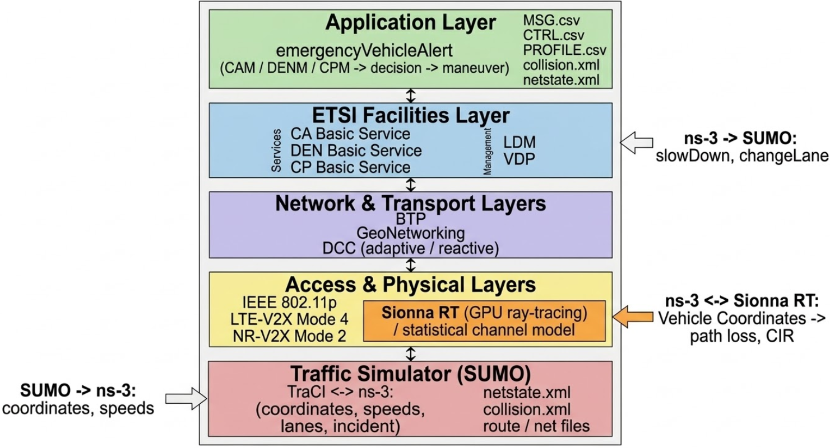
- Architecture of the co-simulation framework. Arrows indicate interactions among SUMO, ns-3, Sionna RT, and the causal-audit stage.
Sionna RT [21] is used as an external GPU-based ray-tracing service. At each ns-3 step, the simulator sends transmitter and receiver coordinates to the service, which computes geometry-aware channel parameters, including path loss and Doppler shift, and returns them to the network simulator. This design follows the ray-tracing-in-the-loop idea of VaN3Twin [13] and extends it with per-vehicle link profiles and end-to-end causal tracing. As a result, the same simulation instance that produces physical-layer behavior also drives the traffic agents whose safety outcomes are ultimately evaluated.

Per-Vehicle Link-Quality Profiles
A dedicated per-vehicle profile mechanism enables controlled degradation of selected communication links. Each vehicle can be assigned a PHY-layer CAM drop probability, an equivalent transmit power, and a target PRR through a compact command-line specification such as veh3:0.05:23:0.95 or veh4:0.923:-20:0.077. This feature makes it possible to vary only the communication quality of specific vehicles while keeping the traffic scenario, initial conditions, and random-number-generator states unchanged.

ID-Aware Packet Tracing
Each CAM is assigned a unique packet identifier, denoted pkt_uid, which is preserved across transmission, successful reception, physical-layer drop, and application-level control processing. The framework records per-vehicle MSG.csv, CTRL.csv, and PROFILE.csv files. During post-processing, pkt_uid is used to correlate communication events with subsequent decisions, thereby reconstructing the fate of each packet across layers. In the reported experiments, the strict match ratio between traced losses and application-level outcomes is 1.0, which indicates complete traceability within the logging pipeline.

Automated Causal Audit
The causal-audit module reconstructs event chains where packet loss contributes to a no-action decision, which in turn precedes a collision. It identifies collision participants from SUMO collision logs, extracts the corresponding pre-collision time window, quantifies packet drops and no-action decisions within that interval, and assigns a causal classification such as strong_no_action_only, mixed, or weak. This procedure replaces ad hoc manual log inspection with a reproducible evidence pipeline suitable for larger-scale simulation campaigns.

Experimental Design

Scenario 1: Emergency Vehicle Alert with Parametric Transmit-Power Sweep
The first scenario is based on the open-source ms-van3t example v2v-emergencyVehicleAlert-nrv2x [12]. Vehicles exchange CAMs [4] under NR-V2X Mode 2 autonomous resource allocation [8], [22]. A parametric sweep changes only the transmit power, whereas trajectories, simulation parameters, and random seeds remain fixed. Communication performance is measured by PRR [9]. Behavioral response is quantified through the time to first emergency CAM reception for each vehicle, together with the median and 90th-percentile statistics of that reaction time. SUMO logs are also used to compute the median time to first braking.

Scenario 2: Lane Change Under a Stopped Leader
The second scenario considers a vehicle string in the right lane, where the leader stops and becomes a stationary obstacle. The working hypothesis is straightforward: if following vehicles receive the warning in time, they perform lane changes and maintain safe flow; if a critical vehicle experiences severe communication degradation, its maneuver is delayed sufficiently to generate a conflict and, potentially, a crash.
Two operating regimes are defined. In the safe regime, veh3, veh4, and veh5 maintain relatively high link quality, with PRR values of 0.945, 0.944, and 0.722, respectively. In the crash regime, only veh4 is degraded to an equivalent transmit power of -20 dBm and a PRR of 0.071, while veh3 and veh5 keep their original parameters. The roadway geometry, fleet composition, incident timing at t = 6.00 s, and traffic dynamics remain identical across the two regimes; only the quality of one vehicle’s communication link changes.

Reproducibility Provisions
All experiments follow a strict reproducibility protocol [2]. The road network, route definitions, SUMO microscopic parameters, network settings, Sionna RT configuration, link-quality profiles, and random-number-generator states are fixed and versioned. In addition to final plots, the framework stores raw CSV logs that allow independent re-analysis of each run. The full experiment can be launched from a single shell command.

Results
The following results should be interpreted as a deterministic proof-of-concept rather than as a full statistical campaign. Each point corresponds to one controlled run with fixed seeds. This design favors exact causal attribution and repeatability, although it does not yet provide confidence intervals or distributional estimates across repeated trials.

PRR as a Function of Transmit Power
Fig. 2 shows that PRR increases monotonically with transmit power under NR-V2X Mode 2. At -20 dBm, PRR is approximately 0.077, whereas at 23 dBm it reaches 0.94. The transition is distinctly nonlinear, with the steepest change occurring roughly between -10 dBm and 0 dBm. This operating region is therefore particularly relevant when designing controlled degradation experiments.
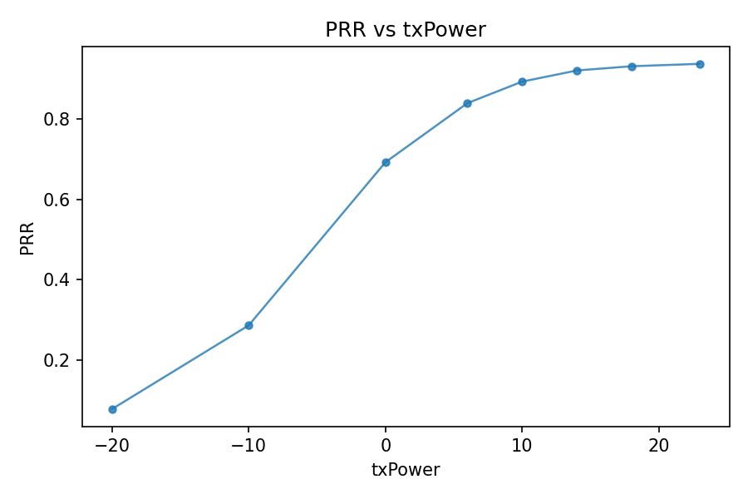
- PRR versus transmit power for NR-V2X Mode 2. The increase is monotonic, with the sharpest transition around -10 to 0 dBm.

Cooperative Reaction Delay
Fig. 3 reports the 90th-percentile cooperative reaction delay as a function of PRR. When PRR is about 0.94, the delay is 3.98 s; when PRR falls to about 0.077, the delay rises to 18.09 s, which corresponds to an increase by a factor of approximately 4.5. The curve is strongly nonlinear: moderate degradation from 0.94 to 0.6 produces only a limited delay increase, whereas degradation below 0.3 leads to a rapid escalation. Consequently, linear interpolation from PRR values to behavioral delay bounds would be misleading.
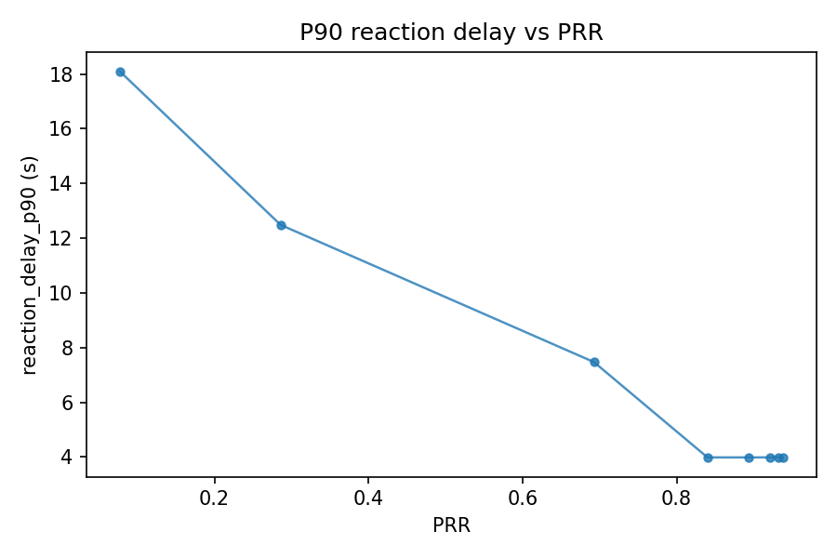
- 90 percentile cooperative reaction delay versus PRR. Delay growth becomes pronounced once PRR drops below 0.3.

Time to First Braking
The median time to first braking follows the same qualitative trend. As shown in Fig. 4, braking begins near t ≈ 6 s under high PRR, that is, shortly after the incident. Under severe degradation at PRR ≈ 0.077, the median braking onset shifts to approximately 11 s. At highway speeds, this additional 5 s delay translates into a substantial increase in travel distance before deceleration begins and thus materially worsens the safety margin.
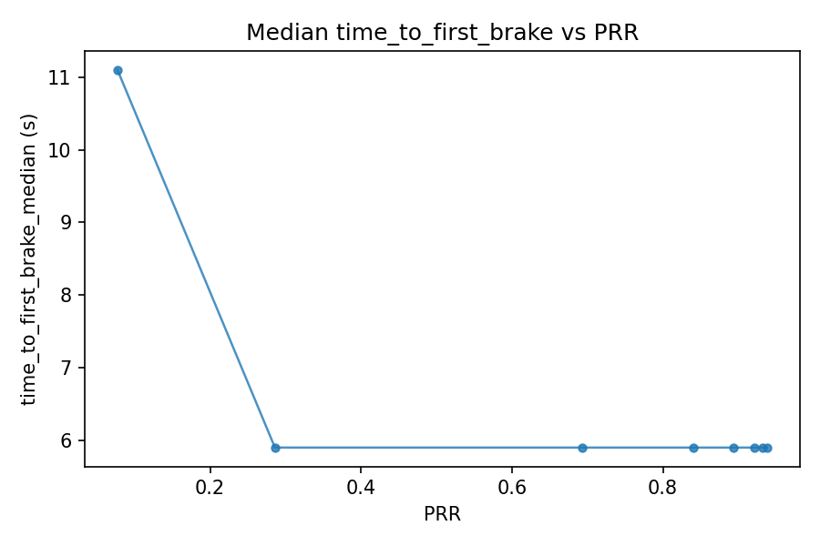
- Median time to first braking versus PRR. Low-PRR conditions substantially delay braking onset.

Safe and Crash Regimes in Scenario 2
In the safe regime, lane changes propagate in an orderly sequence: veh3 changes lane at 7.14 s, veh4 at 9.13 s, and veh5 at 12.13 s, and no collisions are reported. In the crash regime, veh3 still changes lane successfully, but veh4, whose PRR is reduced to 0.071, does not receive the warning in time and fails to execute the maneuver. The causal audit classifies the event as strong_no_action_only, meaning that the recorded packet drops map directly to repeated no-action decisions that accumulate before the crash.
Table I summarizes the timing comparison. Since the traffic scenario is identical in the two regimes and only veh4’s link quality is modified, the observed change in safety outcome can be causally attributed to communication degradation with a high degree of experimental control.
- TIMING COMPARISON BETWEEN THE SAFE AND CRASH REGIMES IN SCENARIO 2
Metric | Safe Regime | Crash Regime
veh3 first lane change | 7.14 s | 7.14 s
veh4 first lane change | 9.13 s | No lane change
veh5 first lane change | 12.13 s | 12.13 s
Collision | None | veh4 rear-ends veh2
Causal classification | N/A | strong_no_action_only

Cross-Technology Comparison
Table II provides a configuration-specific comparison between IEEE 802.11p and NR-V2X Mode 2 under identical co-existence conditions with ten nodes [23]. In this setup, NR-V2X yields a higher mean PRR, 0.962 versus 0.920, but also a substantially higher mean latency, 12.3 ms versus 0.49 ms. The comparison should not be interpreted as a universal ranking of the two technologies; rather, it shows that reliability and latency must be assessed jointly and in relation to the timing budget of the target cooperative application.
- CONFIGURATION-SPECIFIC COMPARISON OF RADIO TECHNOLOGIES UNDER CO-EXISTENCE
Metric | IEEE 802.11p | NR-V2X Mode 2
Mean PRR | 0.920 | 0.962
PRR range | 0.789 – 1.000 | 0.826 – 1.000
Mean latency | 0.49 ms | 12.3 ms
Latency range | 0.44 – 0.64 ms | 7.7 – 16.8 ms

Discussion
Three implications follow from the results. First, communication requirements for cooperative safety functions should not be specified solely in terms of average PRR. The experiments show that the 90th-percentile reaction delay grows much faster than the mean behavior would suggest, especially once PRR drops below approximately 0.3. Tail-oriented behavioral metrics are therefore more informative for safety assessment than aggregate network averages.
Second, identifier-preserving tracing and automated causal auditing make it possible to attribute traffic outcomes to specific communication events rather than to generic notions of poor channel quality. This capability is important when a framework is used not just for performance benchmarking, but also for failure analysis and design-space exploration.
Third, per-vehicle link-quality profiles provide a practical mechanism for isolating communication effects. Because the roadway geometry and traffic evolution remain fixed while selected links are degraded, the resulting experiments support stronger causal claims than studies in which both traffic and communication conditions change simultaneously. The integration of Sionna RT further increases realism by capturing geometry-dependent propagation effects that purely stochastic models may smooth out.

Limitations and Future Work
The study has several limitations. The reported results are obtained from single-seed deterministic runs; therefore, they establish causal plausibility and methodological validity, but not statistical generality. Multi-seed campaigns are required to estimate variability and confidence intervals across traffic demand, channel load, and scheduling conditions.
In addition, the present control analysis focuses on the first successfully received CAM and the resulting reaction timing. Closed-loop effects such as maneuver stability under degraded feedback are outside the current scope. The per-vehicle degradation mechanism is also simplified, because it primarily reflects independent losses rather than bursty patterns caused by persistent MAC-level conflicts in NR-V2X Mode 2 [8].
Future work will extend the audit pipeline with intermediate variables such as packet inter-reception time and Age of Information, evaluate additional cooperative applications such as platooning [24], conduct statistical campaigns with confidence intervals, and compare simulation outcomes against experimental V2X testbed measurements.

Conclusion
This paper presented a reproducible co-simulation framework for evaluating the impact of 5G NR-V2X Mode 2 message losses on cooperative vehicle behavior. The framework integrates SUMO, ns-3, and Sionna RT with per-vehicle link-quality profiles, identifier-preserving packet tracing, and an automated causal-audit module, thereby enabling end-to-end analysis from wireless degradation to vehicle-level behavioral outcomes.
Two deterministic case studies were used to demonstrate the proposed methodology. In the first scenario, a reduction in PRR from 0.94 to 0.077 increased the 90th-percentile cooperative reaction delay from 3.98 s to 18.09 s and delayed braking onset by up to 5 s. In the second scenario, degradation of a single critical communication link was sufficient to convert a previously safe lane-change sequence into a collision. The causal-audit module then reconstructed a consistent pre-collision chain linking packet loss, no-action decisions, and the resulting collision.
These results show that communication degradation must be assessed not only through network-level metrics but also through its effect on cooperative driving behavior. More broadly, the proposed framework provides a reproducible basis for V2X safety evaluation with explicit causal traceability, which is essential for credible assessment of communication-induced safety risks in connected and automated driving scenarios.

References
- SAE International, “Taxonomy and Definitions for Terms Related to Driving Automation Systems for On-Road Motor Vehicles,” SAE J3016, Rev. Apr. 2021, doi: 10.4271/J3016_202104.
- V. G. Stepanyants and A. Yu. Romanov, “A survey of integrated simulation environments for connected automated vehicles: Requirements, tools, and architecture,” IEEE Intell. Transp. Syst. Mag., vol. 16, no. 2, pp. 6–22, 2024, doi: 10.1109/MITS.2023.3335126.
- NHTSA, “Vehicle-to-Vehicle Communication: Readiness of V2V Technology for Application,” DOT HS 812 014, 2014.
- ETSI EN 302 637-2 V1.4.1, “Intelligent Transport Systems (ITS); Vehicular Communications; Basic Set of Applications; Part 2: Specification of Cooperative Awareness Basic Service,” 2019.
- ETSI EN 302 637-3 V1.3.1, “Intelligent Transport Systems (ITS); Vehicular Communications; Basic Set of Applications; Part 3: Specification of Decentralized Environmental Notification Basic Service,” 2019.
- W. Viriyasitavat, M. Boban, H.-M. Tsai, and A. Vasilakos, “Vehicular communications: Survey and challenges of channel and propagation models,” IEEE Veh. Technol. Mag., vol. 10, no. 2, pp. 55–66, Jun. 2015, doi: 10.1109/MVT.2015.2410341.
- M. A. Abd-Elmagid, N. Pappas, and H. S. Dhillon, “On the role of age of information in the Internet of Things,” IEEE Commun. Mag., vol. 57, no. 12, pp. 72–77, Dec. 2019, doi: 10.1109/MCOM.001.1900041.
- M. Harounabadi et al., “V2X in 3GPP standardization: NR sidelink in Rel-16 and beyond,” IEEE Commun. Standards Mag., vol. 5, no. 1, pp. 12–21, 2021, doi: 10.1109/MCOMSTD.001.2000070.
- 3GPP TR 37.885, “Study on evaluation methodology of new V2X use cases for LTE and NR,” v15.3.0, 2019.
- C. Sommer, R. German, and F. Dressler, “Bidirectionally Coupled Network and Road Traffic Simulation for Improved IVC Analysis,” IEEE Trans. Mobile Comput., vol. 10, no. 1, pp. 3–15, Jan. 2011, doi: 10.1109/TMC.2010.133.
- Eclipse MOSAIC, “Multi-Domain and Multi-Scale Simulation for Connected and Automated Mobility,” [Online]. Available: https://eclipse.dev/mosaic/
- DriveX-devs, “ms-van3t: Multi-stack vehicular network simulation framework,” [Online]. Available: https://github.com/DriveX-devs/ms-van3t
- DriveX-devs, “VaN3Twin: Vehicular digital twin framework with ray-tracing-in-the-loop,” [Online]. Available: https://github.com/DriveX-devs/VaN3Twin
- M. Boban, J. Barros, and O. K. Tonguz, “Geometry-based vehicle-to-vehicle channel modeling for large-scale simulation,” IEEE Trans. Veh. Technol., vol. 63, no. 9, pp. 4146–4164, Nov. 2014, doi: 10.1109/TVT.2014.2317803.
- M. Boban, T. T. V. Vinhoza, M. Ferreira, J. Barros, and O. K. Tonguz, “Impact of vehicles as obstacles in vehicular ad hoc networks,” IEEE J. Sel. Areas Commun., vol. 29, no. 1, pp. 15–28, Jan. 2011, doi: 10.1109/JSAC.2011.110103.
- FHWA, “Surrogate Safety Assessment Model and Validation: Final Report,” FHWA-HRT-08-051, 2008.
- Y. Sun, E. Uysal-Biyikoglu, R. D. Yates, C. E. Koksal, and N. B. Shroff, “Update or wait: How to keep your data fresh,” IEEE Trans. Inf. Theory, vol. 63, no. 11, pp. 7492–7508, Nov. 2017, doi: 10.1109/TIT.2017.2735804.
- ETSI TS 103 324 V2.1.1, “Intelligent Transport Systems (ITS); Vehicular Communications; Collective Perception Service; Release 2,” 2023.
- 3GPP TS 23.287 V17.5.0, “Architecture enhancements for 5G System (5GS) to support Vehicle-to-Everything (V2X) services,” Sep. 2022.
- D. Krajzewicz, J. Erdmann, M. Behrisch, and L. Bieker, “Recent development and applications of SUMO – Simulation of Urban Mobility,” Int. J. Adv. Syst. Meas., vol. 5, no. 3–4, pp. 128–138, 2012.
- NVIDIA, “Sionna: An Open-Source Library for Next-Generation Physical Layer Research,” [Online]. Available: https://developer.nvidia.com/sionna
- 3GPP TS 38.321, “NR; Medium Access Control (MAC) protocol specification,” Rel. 16, v16.7.0, 2021.
- A. Molina-Masegosa, J. Gozalvez, and M. Sepulcre, “Comparison of IEEE 802.11p and LTE-V2X: An evaluation with periodic and aperiodic messages of constant and variable size,” IEEE Access, vol. 8, pp. 121526–121548, 2020, doi: 10.1109/ACCESS.2020.3007115.
- J. Heinovski, D. S. Buse, and F. Dressler, “Scalable Simulation of Platoon formation maneuvers with PlaFoSim,” in Proc. IEEE Veh. Netw. Conf. (VNC), Poster Session, 2021, pp. 137–138, doi: 10.1109/VNC52810.2021.9644678.

