OOPJ Unit II: Class Declaration, Access Modifiers, Access Control and Encapsulation
Faculty reference study material | GPCET / JNTUA R23 | Concept 2
Technical baseline: Java Language Specification, Java SE 27 Edition, checked 9 October 2026.
Purpose: Build faculty-level understanding, not serve as a student handout copied verbatim.
Scope note. Concept 1, Introduction to Classes and Objects, is treated as complete. This chapter builds on that foundation and focuses on class declarations and modifiers, the distinction between class-level and member-level access, member access control, private members, and encapsulation. Fields, methods, constructors, and references are revisited only as much as needed to explain access rules.

Quick navigation
- Class declaration anatomy
- Top-level access and package-private
- Abstract and final classes
- extends and implements
- Class access versus member access
- The four member access levels
- Encapsulation and information hiding
- Worked BankAccount example
- Compile-and-observe experiments
- Misconceptions
- Source-by-source analysis
- Faculty rehearsal
- Self-check and answer key
- Scope boundaries and next topic

How to study this chapter
Use three passes:
- Understand: Read Sections 1 through 9 and redraw the figures without looking.
- Verify: Run the examples in Section 10. Before compiling, predict whether each declaration is legal and explain why.
- Prepare to teach: Use the misconceptions, rehearsal plan, and self-check questions in Sections 11 through 14.
At every point separate four kinds of statements:
- Java language rule: required by the language specification.
- Toolchain convention: normal practice in javac and IDE projects.
- Teaching model: an intentionally simplified way to picture the rule.
- Design recommendation: a practice that improves maintainability but is not always mandatory.
This separation is important because Java syntax, conventional file organization, diagrams of memory, and good object-oriented design are not the same kind of claim.

Learning outcomes
By the end of this study, you should be able to:
- Read a class declaration and identify its modifier, name, relationship clauses, and body.
- Distinguish a top-level class from a member or nested class when discussing legal modifiers.
- Explain public and package-private access for top-level classes.
- Explain the different purposes of abstract and final classes.
- Distinguish class access from member access.
- Compare private, package-private, protected, and public member access.
- Explain why cross-package protected access has a subtle rule beyond a simple yes/no table.
- Design a class that hides representation and protects valid state through an intentional public API.
- Explain why getters and setters do not automatically make a class well encapsulated.
- Separate Java language semantics from JVM implementation detail and teaching analogy.

1. Where this topic sits in Unit II
Concept 1 established the basic model:
Class -> instances (objects) -> state and behavior
This chapter adds two design questions:
CLASS DECLARATION
|-- Who can name and use this type?
|-- What restrictions apply to the type?
|-- What declarations belong to the class body?
MEMBER ACCESS AND ENCAPSULATION
|-- Who can directly use each field, method, or constructor?
|-- Which state should remain internal?
|-- Which operations should the class expose?
In the GPCET / JNTUA R23 Unit II sequence, class declaration and modifiers lead into class members, object declaration, object assignment, member access control, accessing private members, constructors, this, and related topics. The goal here is to make the access-control and encapsulation portion conceptually coherent without prematurely teaching every later topic. [1]

2. Read a class declaration accurately
Consider the simple form:
class Student {
// class body
}
The class keyword begins a normal class declaration. Student is the declared type name. The braces delimit the class body.
A class declaration can be expanded:
public final class ExamRule extends AcademicRule
implements Printable, Auditable {
// fields, constructors, methods, nested declarations, initializers
}
Read each part separately:
Part | Meaning | Type of rule
public | Access modifier for the top-level class | Access rule
final | Prevents subclassing | Class modifier
class | Declaration keyword | Syntax
ExamRule | Class identifier | Name
extends AcademicRule | Declares the superclass relationship | Relationship clause
implements Printable, Auditable | Lists interfaces implemented by the class | Relationship clause
{ ... } | Class body | Declaration container
The square-bracketed elements often used in teaching syntax are placeholders, not Java keywords. Also, extends and implements are not modifiers. The Java Language Specification treats class modifiers, superclass/superinterface clauses, and the class body as distinct parts of the declaration. [2]
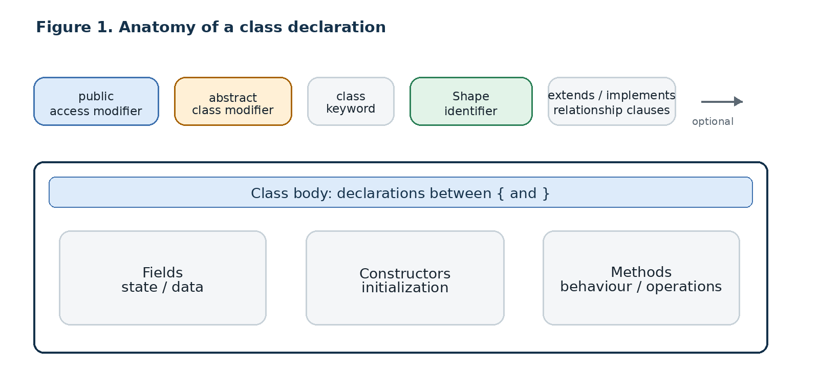

2.1 What belongs in the class body?
For this chapter, recognize these categories without attempting to cover their full rules:
- Fields: variables declared as part of a class. Instance fields represent per-object state; static fields represent class-level state.
- Constructors: declarations used when new class instances are created.
- Methods: operations that can be invoked.
- Nested types and initializers: additional declarations that may appear in a class body.
Example:
public class Student {
private int rollNo; // field
private String name; // field
public Student(int rollNo, String name) { // constructor
this.rollNo = rollNo;
this.name = name;
}
public void display() { // method
System.out.println(rollNo + " " + name);
}
}
The point of the example is structural: class access and member access can differ within the same declaration. Student is public, while rollNo and name are private. The public class can be used by clients that can access its type, but those clients cannot directly read or write the private fields. [3]

3. Top-level class access: public and package-private
A top-level class is declared directly in a compilation unit, not inside another class. For introductory Java programs, there are two normal access choices for a top-level class:
public class Student {
}
class InternalHelper {
}
Declaration | Meaning | Typical use
public class Student | The type can be accessed from other packages, provided the package and module visibility conditions are satisfied | A type intended to be part of a package's public API
class InternalHelper | The type has package access, often called package-private | An implementation helper intended for use within its package

3.1 Package-private is not a keyword
Java does not use a default keyword to declare a package-private class. Package access means the access modifier is omitted:
class CourseHelper {
}
Do not teach default class CourseHelper. That is not the syntax for an ordinary class declaration.
Also, subpackages are separate packages. A class in college.students is not automatically in the same package as a class in college, even though the package names look related.

3.2 Is public the same as “accessible everywhere”?
For a normal classpath-based introductory exercise, saying that a public class can be used from another package is usually adequate. At faculty level, qualify the statement: under the Java Platform Module System, the package must be exported and the consuming module must have the required readability relationship. Access to the type also depends on the type itself being observable and accessible. [2]

3.3 Which modifiers are legal on a top-level class?
For a normal top-level class, private, protected, and static are not permitted. They have uses in particular nested or local class contexts, but that does not make them legal on an ordinary top-level declaration. [2]
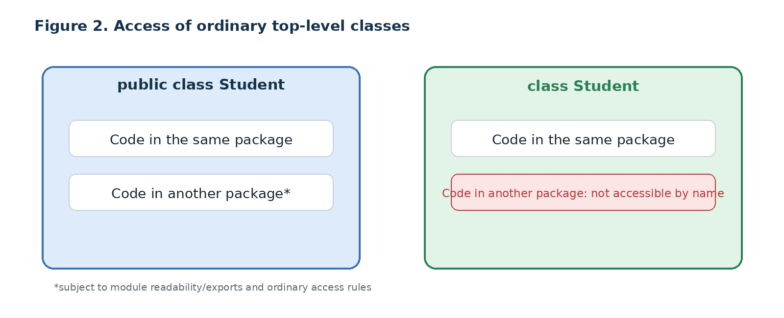

3.4 File-name conventions
In the usual file-based javac workflow, place a public top-level class in a source file with the same name, such as public class Student in Student.java. This is the practical rule to follow in labs and IDEs. The language specification also describes compilation-unit rules and implementation-dependent flexibility, so avoid turning the beginner workflow into an absolute statement that Java can never have multiple top-level declarations in one file. [2]
Class names commonly use UpperCamelCase, such as StudentRecord. This is a Java naming convention, not a rule that makes every differently capitalized identifier syntactically invalid. [3, 4]

4. Class modifiers: abstract and final
For the core lesson, concentrate on abstract and final. They answer different questions.
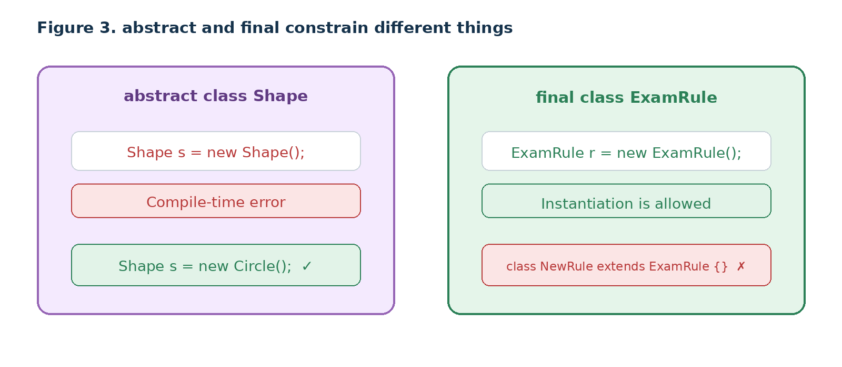

4.1 abstract: no direct instantiation
An abstract class is declared as incomplete, or intended to be treated as incomplete. Java does not allow direct instance creation of an abstract class using new. It can contain abstract methods, concrete methods, fields, and constructors. If a class declares or inherits an abstract method that has not been implemented, it must be abstract. [2]
abstract class Shape {
abstract double area();
void describe() {
System.out.println("A shape has an area.");
}
}
class Circle extends Shape {
private final double radius;
Circle(double radius) {
this.radius = radius;
}
@Override
double area() {
return Math.PI * radius * radius;
}
}
class ShapeDemo {
public static void main(String[] args) {
// Shape s1 = new Shape(); // compile-time error
Shape s2 = new Circle(2.0); // valid: reference type Shape, object type Circle
System.out.println(s2.area());
s2.describe();
}
}
Important observations:
- new Shape() is illegal because Shape is abstract.
- A variable whose declared type is Shape is still valid.
- That variable can refer to an instance of a concrete subclass such as Circle.
- The superclass can contain useful implemented behavior, not only abstract methods.
An abstract class need not always declare an abstract method. However, do not simplify its meaning to “a class with no method bodies.” If the sole intention is to prevent ordinary construction of a utility class, a private constructor is often the more accurate design. The JLS makes this distinction explicitly. [2]

4.2 final: no subclasses
A final class cannot be extended. The modifier does not, by itself, stop the class from being instantiated.
final class ExamRule {
private int passingMarks = 35;
public int getPassingMarks() {
return passingMarks;
}
public void setPassingMarks(int marks) {
passingMarks = marks;
}
}
class FinalDemo {
public static void main(String[] args) {
ExamRule rule = new ExamRule(); // valid
rule.setPassingMarks(40); // valid: object state can change
System.out.println(rule.getPassingMarks());
}
}
The following would be illegal:
// compile-time error:
// class SpecialExamRule extends ExamRule { }
Critical distinction: a final class is not automatically immutable. final prevents inheritance from that class. It does not automatically prevent its fields from changing, nor does it make referenced mutable objects immutable. Immutability requires a separate design analysis.
Avoid teaching java.lang.Math as the first example of a final class. Math is final, but its constructor is also private. Students may wrongly conclude that final prevents object creation. Use a minimal class such as ExamRule to isolate the modifier's effect. [2]

4.3 Compare them
Question | abstract class | final class
Can we directly write new Type()? | No | Yes, if constructor access permits it
Can a subclass extend it? | Yes, subject to normal rules | No
Can it contain implemented methods? | Yes | Yes
Does it automatically make object state immutable? | No | No
Can a class be both abstract and final? | No | No; the combination is illegal

4.4 Modern Java awareness, not first-lesson focus
The current Java specification also includes sealed and non-sealed class declarations for controlling permitted subclassing. strictfp remains in the grammar but is obsolete and has no compile-time or run-time effect in current Java. These are useful faculty-awareness topics, but they should not displace the basic contrast between abstract and final. [2]

5. extends, implements, and declaration boundaries
These words identify type relationships; they are not access modifiers.
class Person {
}
class Student extends Person {
}
For an ordinary class, extends specifies its direct superclass. A class has at most one direct superclass.
interface Printable {
void print();
}
interface Auditable {
void audit();
}
class Report implements Printable, Auditable {
public void print() {
System.out.println("Report");
}
public void audit() {
System.out.println("Audit recorded");
}
}
A class can implement multiple interfaces, listed with commas. The details of implementing interface contracts and overriding methods should be taught in their designated topics. Here, the objective is simply to read the declaration accurately. [2, 3]

6. Class access versus member access
This is one of the most important transitions in the chapter.
public class BankAccount {
private double balance;
public double getBalance() {
return balance;
}
}
Two independent decisions have been made:
- public applies to the top-level class. It determines whether code outside the package can access the type, subject to package/module rules.
- private applies to the field. It prevents external classes from directly accessing that field.
Class-level access asks: Who can use this type by name?
Member-level access asks: Who can use this field, method, constructor, or member type?
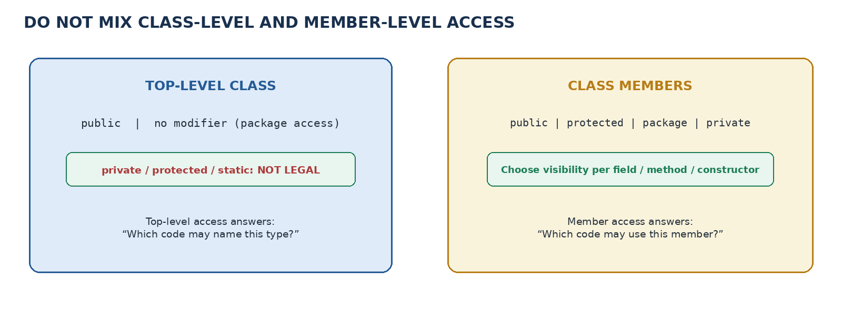

7. The four member access levels
For fields, methods, constructors, and member types where the relevant modifiers are allowed, the four common access levels are:
- private
- package-private, written with no access modifier
- protected
- public

7.1 Comparison matrix
Access level | Declaring class / nest | Same package | Subclass in another package | Unrelated class in another package
private | Yes | No | No | No
package-private | Yes | Yes | No | No
protected | Yes | Yes | Conditional* | No
public | Yes | Yes | Yes* | Yes*
Interpret the compact table carefully:
- private: applicable nested/nest access rules mean private access is not simply a rule about one object instance.
- package-private: “same package” means the exact same package; a subpackage is a different package.
- protected: cross-package access is permitted from subclass code only under the protected-access rules, including a constraint on the qualifying type for instance members.
- public: the declaring type and its package/module must also be accessible. A public member inside an inaccessible type is not magically accessible.
The specification distinguishes accessibility from scope and gives special conditions for protected access across packages. [2]
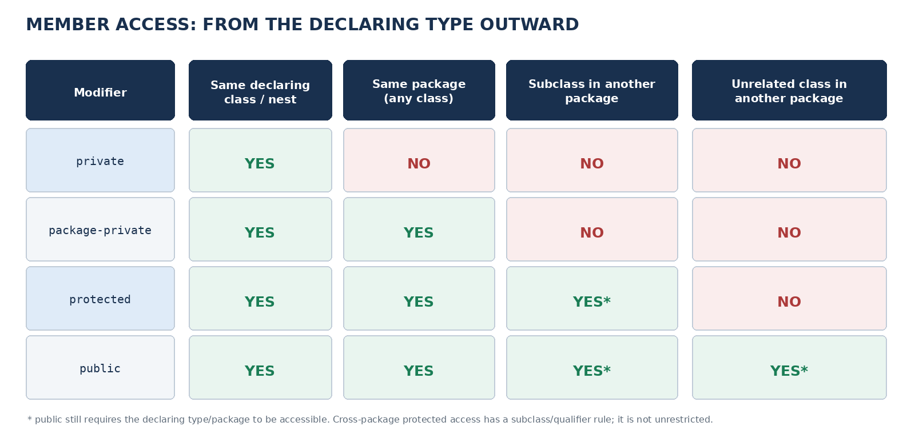

7.2 private
A private member is intended for use within the declaring class's implementation. Code in an unrelated external class cannot access it directly.
public class Student {
private double marks;
public void updateMarks(double newMarks) {
if (newMarks >= 0 && newMarks <= 100) {
marks = newMarks;
}
}
public double getMarks() {
return marks;
}
}
This is valid:
Student s = new Student();
s.updateMarks(88.5);
System.out.println(s.getMarks());
This is not valid from a different, unrelated class:
// s.marks = 120; // compile-time error: marks has private access
A subtle point for faculty: private access is not simply a rule about which object instance is being accessed. Code inside the class can access private fields on another instance of the same class. Java's nested-class rules also permit applicable private access within the enclosing top-level class/nest. The teaching simplification “private members are only accessible in the class” is broadly useful, but do not translate it into “an instance may access only its own private data.” [2]

7.3 Package-private
If no member access modifier is written, the member has package access:
class AttendanceRecord {
int presentDays; // package-private field
void increment() { // package-private method
presentDays++;
}
}
Code in the same package can use these members, whether it is a subclass or not. Code in a different package cannot use them merely because its package name begins with the same prefix. Java subpackages are distinct packages.
Do not write default int presentDays; to mean package-private. For an ordinary class member, the modifier is simply omitted.

7.4 protected
A protected member is accessible from code in the same package. It is also accessible from subclasses in other packages, but cross-package protected access is more restricted than “every subclass can access it in any way.” [2]
Consider Base in package school.base:
package school.base;
public class Base {
protected int score = 10;
}
And Child in package school.special:
package school.special;
import school.base.Base;
public class Child extends Base {
public void update() {
this.score = 20; // allowed
Child other = new Child();
other.score = 30; // allowed
// Base b = new Base();
// b.score = 40; // not allowed here
}
}
The protected-access rule outside the declaring package depends on the qualifying expression/type being the subclass type Child or a subtype of it for instance member access. This is why a simple matrix can say “subclass access: yes” while still being incomplete. Teach the detailed qualifier rule as a faculty note or follow-up exercise, after students understand the four basic levels. [2]

7.5 public
A public member is the broadest member access level, but the declaring type must itself be accessible. A public field inside an inaccessible package-private class does not become usable from every package simply because the field is public.
A useful way to teach this is to read access from outside inward:
- Can the client access the package and type?
- If yes, can it access the member within that type?
- If the member is protected and the use is across packages, do the subclass/qualifier conditions hold?
This order prevents students from assuming a member modifier overrides every other restriction.

8. Access control is not the same as encapsulation
Access control is a language mechanism. Encapsulation is a design principle.

8.1 Access control
Access modifiers declare where code may access a type or member. For example, private blocks direct external access to a field. This is a language-level rule checked by the compiler and relevant runtime mechanisms. [2]

8.2 Encapsulation
Encapsulation combines state and the operations that work with that state behind a defined interface. A class hides implementation details and offers clients intentional ways to interact with it.
Information hiding is the related design principle of keeping internal representation details from becoming dependencies of client code. private fields are a common tool for information hiding, but encapsulation requires the API and behavior to be designed deliberately. [5, 6, 7]
Why it matters:
- Protect invariants: prevent values that make no sense for the domain, such as a negative bank balance or marks outside the allowed range.
- Reduce coupling: client code depends on the public operations instead of a particular field layout.
- Allow internal change: a class can change how it stores state without forcing every client to be rewritten, as long as the public contract remains stable.
- Make behavior meaningful: prefer deposit(500) over allowing arbitrary writes to balance.
- Improve testing: a class's public operations provide a clear interface through which behavior can be checked.

8.3 Encapsulation is more than “private fields plus getters and setters”
The usual introductory pattern is:
- Make implementation fields private.
- Expose public methods appropriate to the task.
- Validate inputs and preserve class invariants.
- Do not provide a setter merely because a field exists.
A getter and setter are not automatic requirements for every field. For example, a bank account may offer a deposit operation and a read-only getBalance, but no arbitrary setBalance method. A setter that accepts any value without validation may simply move the path to invalid state from a field write to a method call.
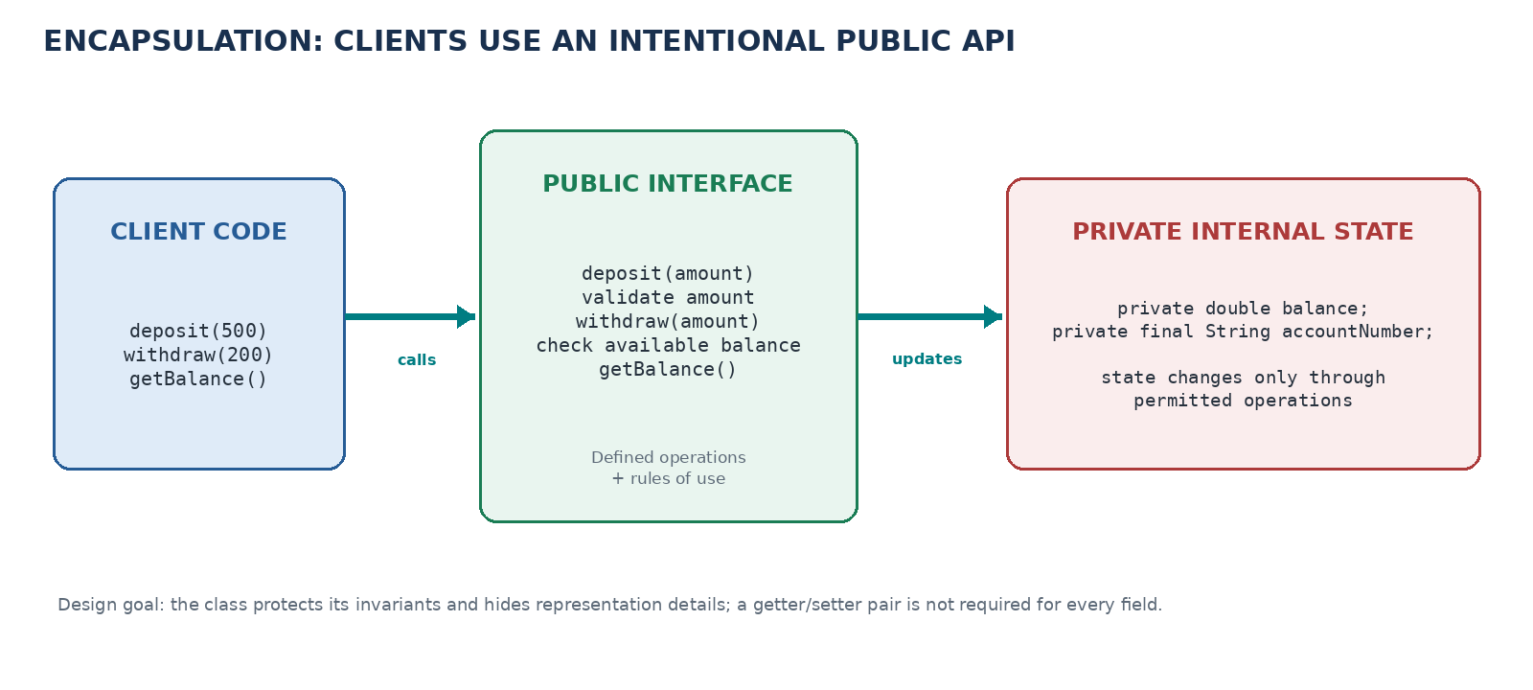

9. Worked example: encapsulated BankAccount
This example brings access modifiers, private state, and a public API together. It intentionally includes a validation rule so that encapsulation has a visible purpose.

9.1 BankAccount.java
public class BankAccount {
private final String accountNumber;
private double balance;
public BankAccount(String accountNumber, double openingBalance) {
if (accountNumber == null || accountNumber.trim().isEmpty()) {
throw new IllegalArgumentException("Account number is required");
}
if (openingBalance < 0) {
throw new IllegalArgumentException("Opening balance cannot be negative");
}
this.accountNumber = accountNumber;
this.balance = openingBalance;
}
public String getAccountNumber() {
return accountNumber;
}
public double getBalance() {
return balance;
}
public void deposit(double amount) {
if (amount <= 0) {
throw new IllegalArgumentException("Deposit must be positive");
}
balance += amount;
}
public boolean withdraw(double amount) {
if (amount <= 0 || amount > balance) {
return false;
}
balance -= amount;
return true;
}
}

9.2 BankAccountDemo.java
public class BankAccountDemo {
public static void main(String[] args) {
BankAccount account = new BankAccount("A1001", 1000.0);
account.deposit(250.0);
boolean success = account.withdraw(300.0);
System.out.println(account.getAccountNumber());
System.out.println("Withdrawal successful: " + success);
System.out.println("Balance: " + account.getBalance());
}
}
Expected output:
A1001
Withdrawal successful: true
Balance: 950.0

9.3 What to notice
Code element | Design role
public class BankAccount | The type is intended for use by accessible client code
private final String accountNumber | The representation is hidden; the account number is assigned during construction and cannot be reassigned afterward
private double balance | Clients cannot directly write the balance field
getBalance() | The class intentionally allows observation of its balance
deposit(amount) | The class controls the conditions for increasing the balance
withdraw(amount) | The class decides whether a withdrawal is valid and changes its own state
no setBalance() | Clients cannot arbitrarily replace the balance with any number
The code is illustrative, not a full production banking implementation. In real financial software, amounts normally require decimal-safe representation such as integer minor units or BigDecimal, and domain-specific transaction rules. For this lesson, the example isolates access control and state invariants.

9.4 Why the public field version is weaker
Compare the design above with:
public class BankAccountBad {
public double balance;
}
A client could write:
BankAccountBad account = new BankAccountBad();
account.balance = -9000;
The class has no opportunity to enforce a rule about the balance. The problem is not that public fields never compile; the problem is that they allow arbitrary client code to depend on and change the representation directly.

10. Compile-and-observe experiments
Run each experiment independently. For intentionally invalid code, keep the invalid line commented or create a separate file so the rest of the demonstration can compile.

Experiment A: public versus package-private class
- Create package college.core with public class Student.
- Create another package college.client and import college.core.Student.
- Repeat using a package-private class Student.
- Record which compilation succeeds and why.
Expected learning: public class access can cross package boundaries if the type and package/module are accessible; package-private access cannot.

Experiment B: top-level illegal modifiers
Try one at a time:
// private class Helper {}
// protected class Helper {}
// static class Helper {}
Expected learning: these are not legal access/modifier choices for an ordinary top-level class. Do not generalize this into a rule about all nested classes.

Experiment C: abstract and final
Try:
abstract class Shape {}
final class Rule {}
Then separately try new Shape(), new Rule(), and a class that extends Rule.
Expected learning: direct construction of the abstract class fails; the final class can be constructed, but cannot be subclassed.

Experiment D: access levels on a field
Declare fields with each of the four access levels. Attempt to access them from:
- a method of the declaring class,
- another class in the same package,
- a subclass in another package,
- an unrelated class in another package.
Expected learning: access depends on both modifier and access context. The protected row needs the additional qualifier rule in cross-package inheritance.

Experiment E: bypassing encapsulation
Try this in the demo class:
// account.balance = -500.0;
Then use account.deposit(500.0) and account.getBalance().
Expected learning: private state is accessed indirectly through the class's public interface, and the class decides which operations are allowed.

Experiment F: a setter is not a magic shield
Add this method temporarily:
public void setBalance(double balance) {
this.balance = balance;
}
Expected learning: the field remains private, but the public API now allows arbitrary replacement. Encapsulation quality depends on the operations and rules exposed, not simply the presence of private.

Experiment G: same-class private access across two instances
Inside a class, write a method such as:
boolean hasSameBalance(BankAccount other) {
return this.balance == other.balance;
}
In this method, direct access to other.balance is permitted because the code is inside BankAccount. This challenges the inaccurate claim that one object can never access another instance's private state.

11. Common misconceptions and corrections
Misconception | Correct explanation | Demonstration to use
“There is a default access modifier keyword.” | For package access, omit the modifier. | Compare class Helper {} with invalid default class Helper {}.
“public means accessible under every possible circumstance.” | The declaring type and package/module must also be accessible. | Use separate packages; keep module-system caveats as faculty enrichment.
“Java classes cannot be private or static.” | That claim is only correct for ordinary top-level classes, not all nested-class contexts. | Compare top-level with member-class locations.
“abstract means every method has no body.” | An abstract class can contain both implemented and abstract methods, and can even have no abstract method. | Use Shape with a concrete describe() method.
“final means objects cannot be changed.” | A final class prevents subclassing; its instances may still be mutable. | Instantiate ExamRule, then change its field through a method.
“A final class cannot be instantiated.” | Instantiation and subclassing are separate questions. | new ExamRule() succeeds; extends ExamRule fails.
“The protected row means every subclass may access every protected instance member through any reference.” | Cross-package access has a qualifier/subclass-type rule. | Compare this.score, Child other, and Base b in the subclass.
“Private means inaccessible even to another instance of the same class.” | Code inside the class can access the private members of another instance of that class. | Add hasSameBalance(BankAccount other).
“Encapsulation means make all fields private and add every getter/setter.” | Encapsulation is about an intentional interface and preserving invariants. A setter may be unnecessary or harmful. | Compare deposit() with unrestricted setBalance().
“A public method automatically guarantees valid state.” | Its implementation must enforce the rules. | Introduce and test input validation.
“Subpackages count as the same package.” | Package names are distinct package identities; a subpackage is not automatically a member of the parent package. | Use college and college.students.
“Class names must start with uppercase letters for compilation.” | UpperCamelCase is a convention, not the core syntax rule. | Separate style warnings from compiler errors.

12. Source-by-source research analysis
The final chapter should not treat sources as interchangeable. Use them for the purpose each is best suited to support.

Source 1: Java Language Specification, Java SE 27
Role: normative technical authority. Chapters 6, 7, and 8 define names/accessibility, packages/modules, class declarations, class modifiers, and class members. The protected access section is especially important because it states the cross-package qualifier rule that introductory tables often compress. [2]
Use it for: checking the legal modifier context, access rules, abstract/final restrictions, compile-time errors, and distinctions between access and scope.
Limitation: the prose is formal and dense. It is excellent for verifying a claim but not usually the best first explanation to a novice.

Source 2: Dev.java, “Creating Classes”
Role: primary teaching narrative for declaration anatomy. It presents the class header and body, class name conventions, fields, superclass clause, interface clause, and the relationship between fields and methods. [3]
Use it for: the initial explanation of how to read a declaration incrementally.
Limitation: it is an introductory overview. Use the JLS when a question concerns every legal context or a precise language edge case.

Source 3: Dev.java, “More on Classes”
Role: practical explanation of member access. It distinguishes top-level access from member-level access, gives the four member access levels, and recommends choosing the most restrictive access level that makes sense. [4]
Use it for: the teaching-level access matrix and the design recommendation to avoid unnecessarily public fields.
Limitation: its summary matrix necessarily compresses cross-package protected access. Supplement it with the JLS rule rather than treating the table as exhaustive.

Source 4: Think Java, 2nd edition, Chapter 11, “Designing Classes”
Role: conceptual design and information hiding. It explains how private instance variables isolate a class's internal representation and reduce the knowledge other programmers need to use the class. [5]
Use it for: explaining why encapsulation is useful, not merely which keyword to type.
Limitation: the chapter is focused on learner understanding and class design, not a complete modern Java specification survey.

Source 5: University of Helsinki Java Programming MOOC, Part 4
Role: gradual novice progression. The course builds a Person class around private fields, a constructor, and methods, illustrating how an object exposes behavior through methods rather than arbitrary direct field access. [6]
Use it for: a step-by-step teaching sequence, small examples, and connecting object state to methods.
Limitation: it is not intended to be a full legality reference for every modifier context.

Source 6: Runestone / CSAwesome, “Anatomy of a Java Class”
Role: active learning and visual checks. It separates the class header from the body, reinforces private fields and encapsulation, and uses short comprehension checks. [7]
Use it for: question design, predict-and-check exercises, and visual prompts.
Limitation: it targets introductory/AP Computer Science A learning and simplifies some edge cases that a faculty reference must preserve.

Source 7: MIT OpenCourseWare 6.092
Role: course sequencing. The older course moves from classes and objects into access control, class scope, packages, and then design/debugging/interfaces. [8]
Use it for: deciding the order of explanations and what belongs in a later topic.
Limitation: the course dates to 2010. Treat it as pedagogical background, not as the authority for modern Java language details.

Source 8: NPTEL Programming in Java, Prof. Debasis Samanta
Role: academic lecture supplement. The course frames Java and object-oriented design in the context of building large, modifiable, secure, robust software; its course plan includes a dedicated encapsulation segment. [9]
Use it for: alternate lecture explanations and academic context around encapsulation, information hiding, and access specifications.
Limitation: verify exact syntax and current modifier rules against the current JLS. Lecture examples may use simplified or older presentation conventions.

Source 9: Uploaded JAVA-Unit-2_CSE(1).docx
Role: local faculty synthesis and curriculum mapping. This 71-page file gathers class/object explanations, diagrams, access matrices, misconceptions, examples, and connections to later Unit II concepts. [1]
Use it for: identifying the local course scope, preserving GPCET/JNTUA terminology, and mapping a concept to later teaching and lab work.
Limitation: it is a synthesis, not the original text of every named source. Some memory-layout descriptions elsewhere in it are implementation-specific shortcuts; use them as teaching models only when labelled, not as Java language guarantees.

Source 10: GPCET OOPJ Lab manual, A40515
Role: practical alignment. The lab's class mechanism and later inheritance/polymorphism exercises show where declaration, fields, access, and subclass relationships become executable tasks. [10]
Use it for: selecting a class example and preparing exercises that lead toward the lab.
Limitation: lab exercise coverage does not substitute for the theory syllabus or for checking a Java rule against the JLS.

Recommended synthesis order
- JLS first for correctness: check top-level versus nested class modifiers and the protected rule.
- Dev.java second for explanation: use a concise header/body progression and an access-level summary.
- Think Java and Helsinki for mental models: emphasize information hiding, reduced coupling, and incremental object/class construction.
- CSAwesome for activities: use identify-the-header, predict-the-error, and private-field exercises.
- MIT OCW and NPTEL for course sequencing and alternate explanations.
- Local GPCET synthesis for curriculum mapping, not as the ultimate authority for Java semantics.

13. Faculty rehearsal sequence
A clean first delivery can be prepared in a 35 to 45 minute block, or separated into two shorter classes if the students need more guided practice.

Step 1: Reconnect to Concept 1 (3 minutes)
Write:
public class BankAccount {
private double balance;
}
Ask: “Can an object be created from this class?” Then: “Can external code write account.balance = 1000?” Separate the public type from the private field.

Step 2: Class declaration and top-level access (7 minutes)
Compare public class Student and class Helper. Emphasize that “package-private” means no access keyword is written. Explain that a top-level class cannot be private, protected, or static.

Step 3: abstract versus final (6 minutes)
Use two separate minimal examples. Ask two questions for each: “Can we instantiate it directly?” and “Can we extend it?” Never combine the answers into one vague statement about whether a class is “usable.”

Step 4: Member access levels (10 minutes)
Reveal the matrix one row at a time: private, package-private, protected, public. Use the protected qualifier rule as a faculty detail after the simple matrix.

Step 5: Encapsulation (10 minutes)
Use the BankAccount example. Demonstrate that a client can request deposit but cannot assign to balance. Show why a setter with no validation would weaken the design.

Step 6: Predict and verify (5 to 10 minutes)
Have learners predict compilation for 3 short snippets before compiling them. Ask them to name the rule rather than simply say “it gives an error.”

A short board explanation
CLASS ACCESS
Who can use the type?
public / package-private
MEMBER ACCESS
Who can use a field, method, or constructor?
private / package-private / protected / public
ENCAPSULATION
What should clients be allowed to do?
A deliberate public API protects the class's rules and internal representation.

14. Faculty self-check with answers
Try answering these without looking, then compare with the answer key.

Questions
- What is the difference between an access modifier and a class modifier?
- Is default a keyword for package-private classes?
- Can a top-level class be declared private or static?
- What does abstract prevent? What does it allow?
- What does final prevent? Can a final class be instantiated?
- Why is public class BankAccount compatible with private double balance?
- Compare private and package-private members.
- Why is a basic yes/no protected access matrix incomplete?
- Does encapsulation require a getter and setter for every field?
- Why is setBalance(double balance) potentially a poor API?
- Can code inside BankAccount compare the private balance of another BankAccount instance?
- What is the practical difference between access control and information hiding?

Answer key
- An access modifier determines where a declaration may be accessed; class modifiers such as abstract and final constrain the nature or allowed use of the class.
- No. Package access is represented by omitting the access modifier.
- No, not for an ordinary top-level class. Some of these modifiers apply in nested/local class contexts.
- It prevents direct instantiation of the abstract class. It allows the class to be used as a reference type and extended; it may contain concrete methods and fields.
- It prevents subclassing. A final class can be instantiated if it has an accessible constructor.
- The class and its members have separate access decisions. Clients can use the type but cannot directly access the private field.
- Private members are available within the declaring class's applicable private-access context; package-private members are available to classes in the same package.
- Cross-package protected access requires access from subclass code and, for instance members, the qualifying expression must have the subclass type or a subtype as specified by the JLS.
- No. The public interface should expose intentional operations. Some fields may be read-only externally or manipulated only through domain operations.
- If it accepts any value, clients can create an invalid state. A method such as deposit can encode domain-specific rules.
- Yes. Code in the class may access private members on another instance of the same class.
- Access control is a language mechanism that determines legal access. Information hiding is a design aim: client code should depend on an intentional interface, not internal representation details.

15. What to retain and what to defer

Must understand before teaching
- Class declaration anatomy.
- Top-level public versus package-private access.
- abstract versus final.
- Difference between class access and member access.
- Four member access levels.
- Why fields are commonly private.
- Public methods as an intentional interface.
- Encapsulation, information hiding, and state validation.

Understand at faculty level; introduce selectively
- Module exports and readability.
- Protected cross-package qualifier rule.
- Private access involving nested classes/nests.
- Sealed and non-sealed class modifiers.
- File-based source restrictions versus language/toolchain convention.
- Difference between invariants, access modifiers, immutability, and security.

Defer to designated Unit II topics
- Full class-member syntax and initialization details.
- Constructor overloading and constructor chaining.
- this keyword beyond reading the example.
- Nested classes as their own topic.
- Full inheritance and interface semantics.
- Method overloading and overriding.

16. Concept map and next step
Class declaration
|
+-- Class access: public / package-private
|
+-- Class restrictions: abstract / final
|
+-- Relationships: extends / implements
|
+-- Class body
|
+-- Fields and methods
|
+-- Member access: private / package / protected / public
|
+-- Intentional public API
|
+-- Encapsulation and information hiding
|
+-- Next: constructors, this, class members, nested classes
The teaching target is not memorizing a modifier list. It is being able to explain why a declaration has the access it does, what restriction a modifier imposes, and how a class uses its public interface to protect valid state.

References and source links
[1] Local curriculum synthesis. JAVA-Unit-2_CSE(1).docx, uploaded faculty synthesis for GPCET / JNTUA R23 OOPJ Unit II. Use for local scope and cross-topic mapping; audit technical claims against the sources below.
[2] Java Language Specification, Java SE 27 Edition. Chapter 6, Names and Access Control: https://docs.oracle.com/javase/specs/jls/se27/html/jls-6.html. Chapter 7, Packages and Modules: https://docs.oracle.com/javase/specs/jls/se27/html/jls-7.html. Chapter 8, Classes: https://docs.oracle.com/javase/specs/jls/se27/html/jls-8.html.
[3] Dev.java. “Creating Classes”: https://dev.java/learn/language/oop/classes-objects/creating-classes/.
[4] Dev.java. “More on Classes”: https://dev.java/learn/language/oop/classes-objects/more-on-classes/.
[5] Allen Downey and Chris Mayfield. Think Java, 2nd Edition, Chapter 11, “Designing Classes”: https://trinket.strivemath.org/books/thinkjava2/chapter11.html.
[6] University of Helsinki. Java Programming MOOC, Part 4, “Introduction to Object-Oriented Programming”: https://java-programming.mooc.fi/part-4/1-introduction-to-object-oriented-programming/.
[7] Runestone Academy / CSAwesome. “Anatomy of a Java Class”: https://runestone.academy/ns/books/published/csawesome/Unit5-Writing-Classes/topic-5-1-parts-of-class.html. Additional interactive text: https://author.runestone.academy/ns/books/published/csawesome2/topic-3-3-anatomy-of-class.html.
[8] MIT OpenCourseWare. 6.092 Introduction to Programming in Java, IAP 2010: https://ocw.mit.edu/courses/6-092-introduction-to-programming-in-java-january-iap-2010/. Use for instructional sequence, not as the current language-rule authority.
[9] NPTEL / SWAYAM. Prof. Debasis Samanta, IIT Kharagpur, Programming in Java, 2026 course page: https://onlinecourses.nptel.ac.in/e-learning/course/noc26_cs153. Archived course plan: https://onlinecourses-archive.nptel.ac.in/noc19_cs07/preview. For access-specification concepts, see the instructor's course material: https://cse.iitkgp.ac.in/~dsamanta/java/ch3.htm.
[10] GPCET OOPJ Lab manual. OOPJ(5).pdf, especially the class mechanism and inheritance/polymorphism exercises. Use the locally supplied manual for exact lab exercise wording.
Research-use note: This chapter paraphrases and synthesizes the linked material; it does not reproduce the source texts. The Java Language Specification is the final authority when a pedagogical simplification conflicts with a precise language rule.

