PAKISTAN YOUTH NATIONAL PARLIMENT
PYNP

SOFTWARE DESIGN DESCRIPTION
PYNP Mobile Management Application
IEEE Std 1016-2009 Aligned
Document Title | SDD — PYNP Mobile Management Application
Organization | Pakistan Youth National Parliment (PYNP)
Version | 1.1.0
Status | Final — Revision 1.1 (Cross-Document Consistency Update)
Date | August 2026
Standard | IEEE Std 1016-2009 (Software Design Descriptions)
Derived From | PYNP SRS v1.1, PYNP UI/UX Design & Wireframes v1.1, PYNP Firestore Database & Data Model Design v1.0
Platform | Flutter + Firebase (Android & iOS)
Confidentiality | Internal — PYNP Use Only

DOCUMENT CONTROL
Attribute | Value
Author | Ahsan Ahmad
Reviewed By | [TBD — requires PYNP stakeholder confirmation]
Approved By | [TBD — requires PYNP stakeholder confirmation]
Distribution | PYNP technical stakeholders, development team
Source Documents | PYNP_SRS_v1_1_Professional.docx (v1.1); PYNP_UIUX_Design_Wireframes_v1_1.docx (v1.1); PYNP_Firestore_DataModel_v1_0.docx (v1.0)

REVISION HISTORY
Version | Date | Author | Description
1.0 | August 2026 | Ahsan Ahmad | Initial Software Design Description, derived in full from SRS v1.1. Covers architecture, component design, database design, API/Cloud Function design, security, UI architecture, state management, navigation, workflows, diagrams, error handling, offline design, performance, scalability, backup/DR, logging/monitoring, deployment, testing, folder structure, and traceability.
1.1 | August 2026 | Ahsan Ahmad | Cross-document consistency update against the finalized SRS v1.1, UI/UX Design & Wireframes v1.1, and Firestore Database & Data Model Design v1.0. Added a Volunteer Management Component (Section 3.16), three Cloud Functions (submitVolunteerApplication, approveVolunteerApplication/rejectVolunteerApplication, sendBroadcastNotification), a Volunteer Application Lifecycle state model, two workflows, four Proposed Firestore collections (news_articles, volunteers, gallery_albums, gallery_media), and corresponding Screen Inventory and traceability updates. Closed a previously undocumented gap: SRS FR-043 (broadcast announcements) had no corresponding Cloud Function anywhere in v1.0. Clean Architecture, Riverpod state management, GoRouter navigation, the Firebase service set, and the overall security model are unchanged — this is a targeted gap closure, not a redesign.

TABLE OF CONTENTS
DOCUMENT CONTROL 1
REVISION HISTORY 1
TABLE OF CONTENTS 1
LIST OF FIGURES 1
LIST OF TABLES 1
1. INTRODUCTION 1
1.1 Purpose 1
1.2 Scope 1
1.3 Design Goals 1
1.4 Design Principles 1
1.5 References 1
2. SYSTEM ARCHITECTURE 1
2.1 Architecture Overview 1
2.2 Architectural Style 1
2.3 Clean Architecture 1
2.4 Presentation Layer 1
2.5 Domain Layer 1
2.6 Data Layer 1
2.7 Firebase Architecture 1
2.8 Cloud Functions Architecture 1
2.9 External Services 1
2.10 Deployment Architecture 1
3. COMPONENT DESIGN 1
3.1 Authentication Component 1
3.2 Registration Component 1
3.3 Membership Management Component 1
3.4 Event Management Component 1
3.5 Notification System Component 1
3.6 News/Content Management Component 1
3.7 Document Management Component 1
3.8 Media Gallery Component 1
3.9 Opportunities Component 1
3.10 Payments Component 1
3.11 Audit Logging Component 1
3.12 Analytics Component 1
3.13 Reporting Component 1
3.14 Administration Component 1
3.15 Role Management Component 1
3.16 Volunteer Management Component 1
4. DATABASE DESIGN 1
4.1 Firestore Architecture 1
4.2 Collections 1
4.3 Document Structure 1
4.4 Relationships 1
4.5 Indexes 1
4.6 Denormalization 1
4.7 Transactions 1
4.8 Batch Writes 1
4.9 Counters 1
4.10 Analytics Aggregates 1
4.11 Data Validation 1
4.12 Data Retention 1
5. API / CLOUD FUNCTION DESIGN 1
5.1 Callable / HTTPS Functions 1
submitRegistration 1
approveMembership / rejectMembership 1
submitRenewal / approveRenewal 1
registerForEvent / cancelEventRegistration 1
verifyPaymentProof 1
updateUserRole 1
submitVolunteerApplication 1
approveVolunteerApplication / rejectVolunteerApplication 1
sendBroadcastNotification 1
5.2 Background / Trigger Functions 1
onUserStatusChange 1
onEventRegistrationCreate / onEventRegistrationCancel 1
onDocumentUpload 1
onAnyAuditableWrite 1
5.3 Scheduled Functions 1
sendRenewalReminders 1
enforceExpiredStatus 1
sendEventReminders 1
recomputeAnalyticsAggregates 1
purgeUnverifiedRegistrations 1
6. AUTHENTICATION AND AUTHORIZATION DESIGN 1
7. SECURITY ARCHITECTURE 1
8. UI ARCHITECTURE 1
8.1 Navigation 1
8.2 Screen Hierarchy 1
8.3 Screen Inventory 1
8.4 Reusable Widgets 1
8.5 Forms 1
8.6 Validation 1
8.7 Loading States 1
8.8 Error States 1
8.9 Accessibility 1
8.10 Light/Dark Mode 1
9. STATE MANAGEMENT 1
10. NAVIGATION DESIGN 1
11. DETAILED WORKFLOWS 1
11.1 Registration Workflow 1
11.2 Email Verification Workflow 1
11.3 Membership Approval Workflow 1
11.4 Membership Rejection Workflow 1
11.5 Membership Renewal Workflow 1
11.6 Event Creation Workflow 1
11.7 Event Registration Workflow 1
11.8 Event Attendance Workflow 1
11.9 Payment Proof Upload Workflow 1
11.10 Payment Verification Workflow 1
11.11 Notification Delivery Workflow 1
11.12 Opportunity Click Tracking Workflow 1
11.13 Document Download Workflow 1
11.14 Report Generation Workflow 1
11.15 Role Assignment Workflow 1
11.16 Audit Logging Workflow 1
11.17 Volunteer Application Workflow (Added This Revision) 1
11.18 Volunteer Approval Workflow (Added This Revision) 1
12. SEQUENCE DIAGRAMS 1
13. STATE DIAGRAMS 1
13.1 Membership Lifecycle 1
13.2 Payment Lifecycle 1
13.3 Event Registration Lifecycle 1
13.4 Event Lifecycle 1
13.5 Notification Lifecycle 1
13.6 Volunteer Application Lifecycle (Added This Revision) 1
14. ERROR HANDLING ARCHITECTURE 1
15. OFFLINE AND CONNECTIVITY DESIGN 1
16. PERFORMANCE DESIGN 1
17. SCALABILITY DESIGN 1
18. BACKUP AND DISASTER RECOVERY 1
19. LOGGING AND MONITORING 1
20. DEPLOYMENT ARCHITECTURE 1
21. TESTING ARCHITECTURE 1
22. FILE AND FOLDER STRUCTURE 1
23. DESIGN-TO-REQUIREMENT TRACEABILITY 1
24. DESIGN DECISIONS AND RATIONALE 1
24.1 Clean Architecture over a simpler layered approach 1
24.2 HMAC-SHA256 lookup collection over alternative uniqueness mechanisms 1
24.3 Riverpod over Provider or BLoC 1
24.4 GoRouter over Navigator 1.0 / imperative navigation 1
24.5 Cloud Functions for all security-sensitive writes, not Firestore Security Rules alone 1
24.6 Denormalized counters over live aggregation queries 1
24.7 Three fully separate Firebase projects over a single project with environment prefixes 1
24.8 Closing the Volunteer/News/Gallery design gaps found by cross-document audit (This Revision) 1
25. LIMITATIONS AND FUTURE DESIGN CONSIDERATIONS 1
26. CONCLUSION 1

LIST OF FIGURES
Figure 1 — System Context Diagram 1
Figure 2 — Clean Architecture Layer Diagram 1
Figure 3 — High-Level System Architecture Diagram 1
Figure 4 — Deployment Architecture Diagram 1
Figure 5 — Firestore Data Model Diagram 1
Figure 6 — Authentication Flow Diagram 1
Figure 7 — Registration Sequence Diagram 1
Figure 8 — Membership Approval Sequence Diagram 1
Figure 9 — Event Registration Sequence Diagram 1
Figure 10 — Payment Verification Sequence Diagram 1
Figure 11 — Notification Dispatch Sequence Diagram 1
Figure 12 — Membership Lifecycle State Diagram 1
Figure 13 — Payment Lifecycle State Diagram 1
Figure 14 — Event Registration Lifecycle State Diagram 1

LIST OF TABLES
Table 1 — SYSTEM ARCHITECTURE — Firebase Architecture 1
Table 2 — COMPONENT DESIGN — Authentication Component 1
Table 3 — COMPONENT DESIGN — Registration Component 1
Table 4 — COMPONENT DESIGN — Membership Management Component 1
Table 5 — COMPONENT DESIGN — Event Management Component 1
Table 6 — COMPONENT DESIGN — Notification System Component 1
Table 7 — COMPONENT DESIGN — News/Content Management Component 1
Table 8 — COMPONENT DESIGN — Document Management Component 1
Table 9 — COMPONENT DESIGN — Media Gallery Component 1
Table 10 — COMPONENT DESIGN — Opportunities Component 1
Table 11 — COMPONENT DESIGN — Payments Component 1
Table 12 — COMPONENT DESIGN — Audit Logging Component 1
Table 13 — COMPONENT DESIGN — Analytics Component 1
Table 14 — COMPONENT DESIGN — Reporting Component 1
Table 15 — COMPONENT DESIGN — Administration Component 1
Table 16 — COMPONENT DESIGN — Role Management Component 1
Table 17 — COMPONENT DESIGN — Volunteer Management Component 1
Table 18 — DATABASE DESIGN — Collections 1
Table 19 — DATABASE DESIGN — Indexes 1
Table 20 — DATABASE DESIGN — Transactions 1
Table 21 — DATABASE DESIGN — Analytics Aggregates 1
Table 22 — Callable / HTTPS Functions — submitRegistration 1
Table 23 — Callable / HTTPS Functions — approveMembership / rejectMembership 1
Table 24 — Callable / HTTPS Functions — submitRenewal / approveRenewal 1
Table 25 — Callable / HTTPS Functions — registerForEvent / cancelEventRegistration 1
Table 26 — Callable / HTTPS Functions — verifyPaymentProof 1
Table 27 — Callable / HTTPS Functions — updateUserRole 1
Table 28 — Callable / HTTPS Functions — submitVolunteerApplication 1
Table 29 — Callable / HTTPS Functions — approveVolunteerApplication / rejectVolunteerApplication 1
Table 30 — Callable / HTTPS Functions — sendBroadcastNotification 1
Table 31 — Background / Trigger Functions — onUserStatusChange 1
Table 32 — Background / Trigger Functions — onEventRegistrationCreate / onEventRegistrationCancel 1
Table 33 — Background / Trigger Functions — onDocumentUpload 1
Table 34 — Background / Trigger Functions — onAnyAuditableWrite 1
Table 35 — Scheduled Functions — sendRenewalReminders 1
Table 36 — Scheduled Functions — enforceExpiredStatus 1
Table 37 — Scheduled Functions — sendEventReminders 1
Table 38 — Scheduled Functions — recomputeAnalyticsAggregates 1
Table 39 — Scheduled Functions — purgeUnverifiedRegistrations 1
Table 40 — AUTHENTICATION AND AUTHORIZATION DESIGN 1
Table 41 — SECURITY ARCHITECTURE 1
Table 42 — UI ARCHITECTURE — Screen Inventory 1
Table 43 — STATE MANAGEMENT 1
Table 44 — NAVIGATION DESIGN 1
Table 45 — DETAILED WORKFLOWS — Registration Workflow 1
Table 46 — DETAILED WORKFLOWS — Email Verification Workflow 1
Table 47 — DETAILED WORKFLOWS — Membership Approval Workflow 1
Table 48 — DETAILED WORKFLOWS — Membership Rejection Workflow 1
Table 49 — DETAILED WORKFLOWS — Membership Renewal Workflow 1
Table 50 — DETAILED WORKFLOWS — Event Creation Workflow 1
Table 51 — DETAILED WORKFLOWS — Event Registration Workflow 1
Table 52 — DETAILED WORKFLOWS — Event Attendance Workflow 1
Table 53 — DETAILED WORKFLOWS — Payment Proof Upload Workflow 1
Table 54 — DETAILED WORKFLOWS — Payment Verification Workflow 1
Table 55 — DETAILED WORKFLOWS — Notification Delivery Workflow 1
Table 56 — DETAILED WORKFLOWS — Opportunity Click Tracking Workflow 1
Table 57 — DETAILED WORKFLOWS — Document Download Workflow 1
Table 58 — DETAILED WORKFLOWS — Report Generation Workflow 1
Table 59 — DETAILED WORKFLOWS — Role Assignment Workflow 1
Table 60 — DETAILED WORKFLOWS — Audit Logging Workflow 1
Table 61 — DETAILED WORKFLOWS — Volunteer Application Workflow (Added This Revision) 1
Table 62 — DETAILED WORKFLOWS — Volunteer Approval Workflow (Added This Revision) 1
Table 63 — ERROR HANDLING ARCHITECTURE 1
Table 64 — OFFLINE AND CONNECTIVITY DESIGN 1
Table 65 — PERFORMANCE DESIGN 1
Table 66 — BACKUP AND DISASTER RECOVERY 1
Table 67 — LOGGING AND MONITORING 1
Table 68 — DEPLOYMENT ARCHITECTURE 1
Table 69 — DEPLOYMENT ARCHITECTURE 1
Table 70 — TESTING ARCHITECTURE 1
Table 71 — FILE AND FOLDER STRUCTURE 1
Table 72 — DESIGN-TO-REQUIREMENT TRACEABILITY 1
Table 73 — DESIGN DECISIONS AND RATIONALE — Clean Architecture over a simpler layered approach 1
Table 74 — DESIGN DECISIONS AND RATIONALE — HMAC-SHA256 lookup collection over alternative uniqueness mechanisms 1
Table 75 — DESIGN DECISIONS AND RATIONALE — Riverpod over Provider or BLoC 1
Table 76 — DESIGN DECISIONS AND RATIONALE — GoRouter over Navigator 1.0 / imperative navigation 1
Table 77 — DESIGN DECISIONS AND RATIONALE — Cloud Functions for all security-sensitive writes, not Firestore Security Rules alone 1
Table 78 — DESIGN DECISIONS AND RATIONALE — Denormalized counters over live aggregation queries 1
Table 79 — DESIGN DECISIONS AND RATIONALE — Three fully separate Firebase projects over a single project with environment prefixes 1
Table 80 — DESIGN DECISIONS AND RATIONALE — Closing the Volunteer/News/Gallery design gaps found by cross-document audit (This Revision) 1

1. INTRODUCTION

1.1 Purpose
This Software Design Description (SDD) specifies how the requirements defined in the PYNP Mobile Management Application Software Requirements Specification (SRS v1.1) will be implemented. It translates each functional module, non-functional requirement, security control, and data structure in the SRS into a concrete Flutter/Firebase architecture: components, classes, Firestore collections, Cloud Functions, state management, navigation, and workflows.
This document does not introduce new functionality, alter the scope defined in SRS Section 1.2, or change any requirement. Every design decision traces back to one or more SRS requirement IDs (see Section 29, Design-to-Requirement Traceability). Where the SRS marks a value as [TBD — requires PYNP stakeholder confirmation], this SDD preserves that marker rather than inventing a value.

1.2 Scope
This SDD covers the design of the PYNP Mobile Management Application: a Flutter mobile client (Android and iOS) built on Clean Architecture with Riverpod state management and GoRouter navigation, backed by Firebase (Authentication, Cloud Firestore, Storage, Cloud Messaging, App Check, Cloud Functions). It covers all seventeen functional modules, the corrected CNIC/HMAC security design, the Firestore data model, the Cloud Function interface catalog, UI architecture, offline behavior, performance, scalability, backup/disaster recovery, logging/monitoring, deployment, and testing — each as specified in the corresponding SRS section.
Out of scope, consistent with SRS Section 1.2: Digital Membership Card, AI Chatbot, LMS, Marketplace, Donor Management, and Mentorship Platform (SRS Section 30, Future Enhancements).

1.3 Design Goals
- Traceability: every component, collection, and function maps to one or more SRS requirement IDs.
- Separation of concerns: Clean Architecture layering keeps UI, business logic, and data access independently testable and replaceable.
- Security by construction: CNIC protection, RBAC, and audit logging are enforced at the data layer and Firestore security rules, not solely in UI logic that a compromised client could bypass.
- Predictable offline behavior: the design implements the offline capability matrix in SRS Section 15 exactly, with no operation silently changing category.
- Operability: the design supports the monitoring, logging, backup, and deployment requirements of SRS Sections 19–21 from day one, not as an afterthought.

1.4 Design Principles
- Clean Architecture with strict dependency direction: Presentation → Domain ← Data. The Domain layer depends on nothing Firebase-specific (Dependency Inversion Principle).
- Single Responsibility: each use case class performs one business operation; each repository is scoped to one aggregate/collection group.
- Fail closed: security-sensitive operations (CNIC handling, role changes, membership approval) execute only in Cloud Functions under the Admin SDK, never trusting client-supplied state.
- Immutability where it matters: audit log entries and HMAC lookup records are never updated or deleted by application code.
- Explicit state: every asynchronous operation in the UI is represented as an explicit loading / data / error state (Riverpod AsyncValue), never an implicit boolean flag.

1.5 References
- PYNP_SRS_v1_1_Professional.docx — Software Requirements Specification, Version 1.1 (August 2026) — the authoritative source for all requirements referenced in this document.
- IEEE Std 1016-2009 — IEEE Standard for Information Technology — Systems Design — Software Design Descriptions.
- Flutter documentation: https://docs.flutter.dev
- Riverpod documentation: https://riverpod.dev
- GoRouter documentation: https://pub.dev/packages/go_router
- Firebase documentation: https://firebase.google.com/docs
- Google Cloud Secret Manager documentation: https://cloud.google.com/secret-manager/docs

2. SYSTEM ARCHITECTURE

2.1 Architecture Overview
The system is a mobile-first, serverless-backend architecture. The Flutter client never accesses a custom application server; it communicates directly with Firebase managed services for reads/writes permitted by Firestore Security Rules, and invokes Cloud Functions for operations requiring server-side trust (validation, secrets, cross-document consistency, audit logging). This satisfies SRS Section 2.1 (Product Perspective) and Section 21.1 (Technical Constraints — Firebase-only backend).
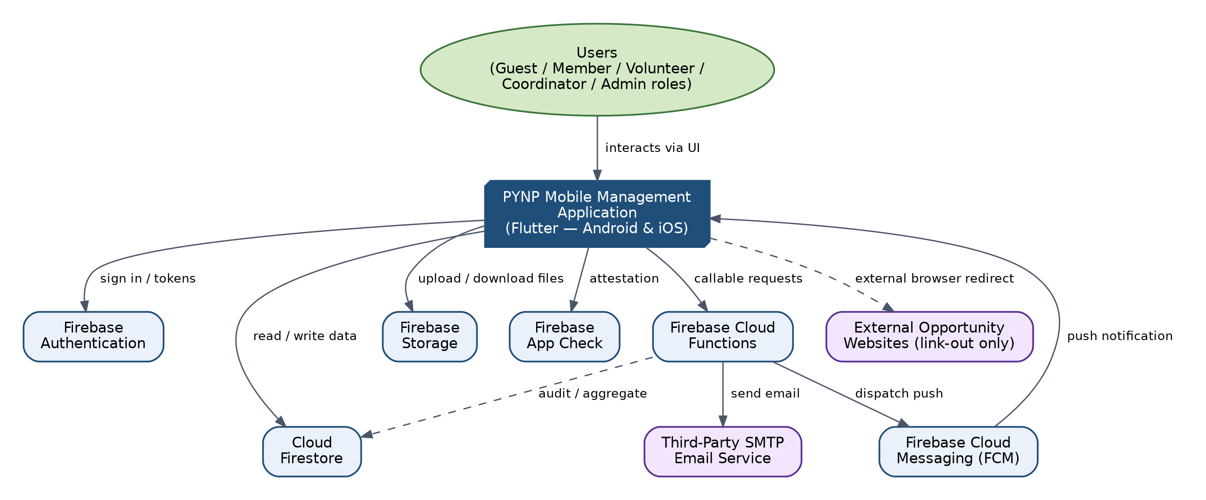
Figure 1 — System Context Diagram

2.2 Architectural Style
The client follows Clean Architecture (Presentation / Domain / Data) combined with the Repository Pattern; the backend follows a Backend-as-a-Service (BaaS) style augmented by Function-as-a-Service (Cloud Functions) for the subset of operations that must not be trusted to the client. This hybrid style was chosen over a traditional three-tier architecture because it eliminates a custom API server layer while still allowing security-critical logic (Section 13) to run server-side.

2.3 Clean Architecture
Figure 2 shows the three client-side layers and their allowed dependency directions. Dependencies point inward: the Data layer depends on the Domain layer's repository interfaces (Dependency Inversion), and the Presentation layer depends on the Domain layer's use cases. The Domain layer has zero imports of Firebase packages, so business rules (e.g., renewal grace period, event capacity checks mirrored client-side for UX) remain independently unit-testable.
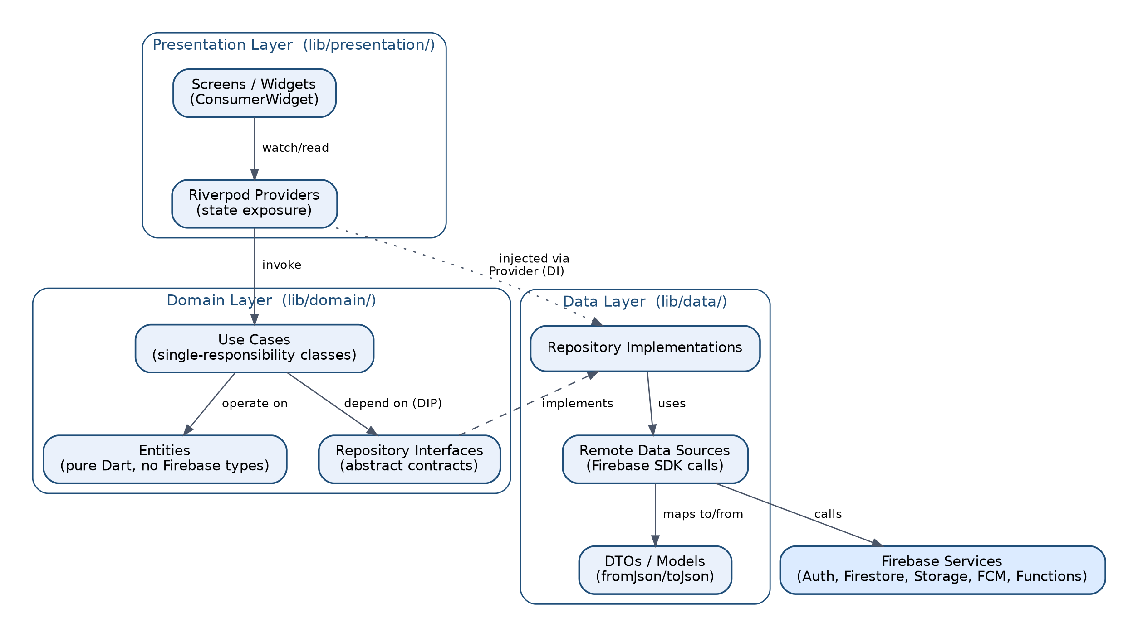
Figure 2 — Clean Architecture Layer Diagram

2.4 Presentation Layer
Located in lib/presentation/. Contains screens (ConsumerWidget / ConsumerStatefulWidget), reusable widgets, and Riverpod providers that expose UI-ready state. This layer contains no direct Firebase SDK calls and no business logic beyond simple view-state (e.g., form field visibility, tab selection). It reads AsyncValue<T> state from Domain-layer use-case providers and renders loading/data/error views (Section 14, Section 15).

2.5 Domain Layer
Located in lib/domain/. Contains: (1) Entities — plain Dart classes representing business objects (User, Event, Registration, Payment, etc.) with no serialization or Firebase-type dependencies; (2) Repository interfaces — abstract contracts (e.g., abstract class EventRepository) that the Data layer implements; (3) Use cases — single-method classes (e.g., RegisterForEventUseCase) that encapsulate one business operation and are the only classes the Presentation layer invokes for business logic. This layer implements the client-side mirror of business rules in SRS Section 8 for immediate UX feedback, while the authoritative enforcement always happens server-side (Cloud Functions / security rules).

2.6 Data Layer
Located in lib/data/. Contains repository implementations, remote data sources (one per Firebase service area — FirestoreDataSource, StorageDataSource, FunctionsDataSource, AuthDataSource), and DTOs with fromJson/toJson (or Firestore fromFirestore/toFirestore) mappers that convert between Firestore documents and Domain entities. All Firebase SDK calls are confined to this layer.

2.7 Firebase Architecture
Figure 3 shows the Firebase services used and how the Data layer integrates with each, consistent with SRS Sections 2.1, 14.1, and 21.1.
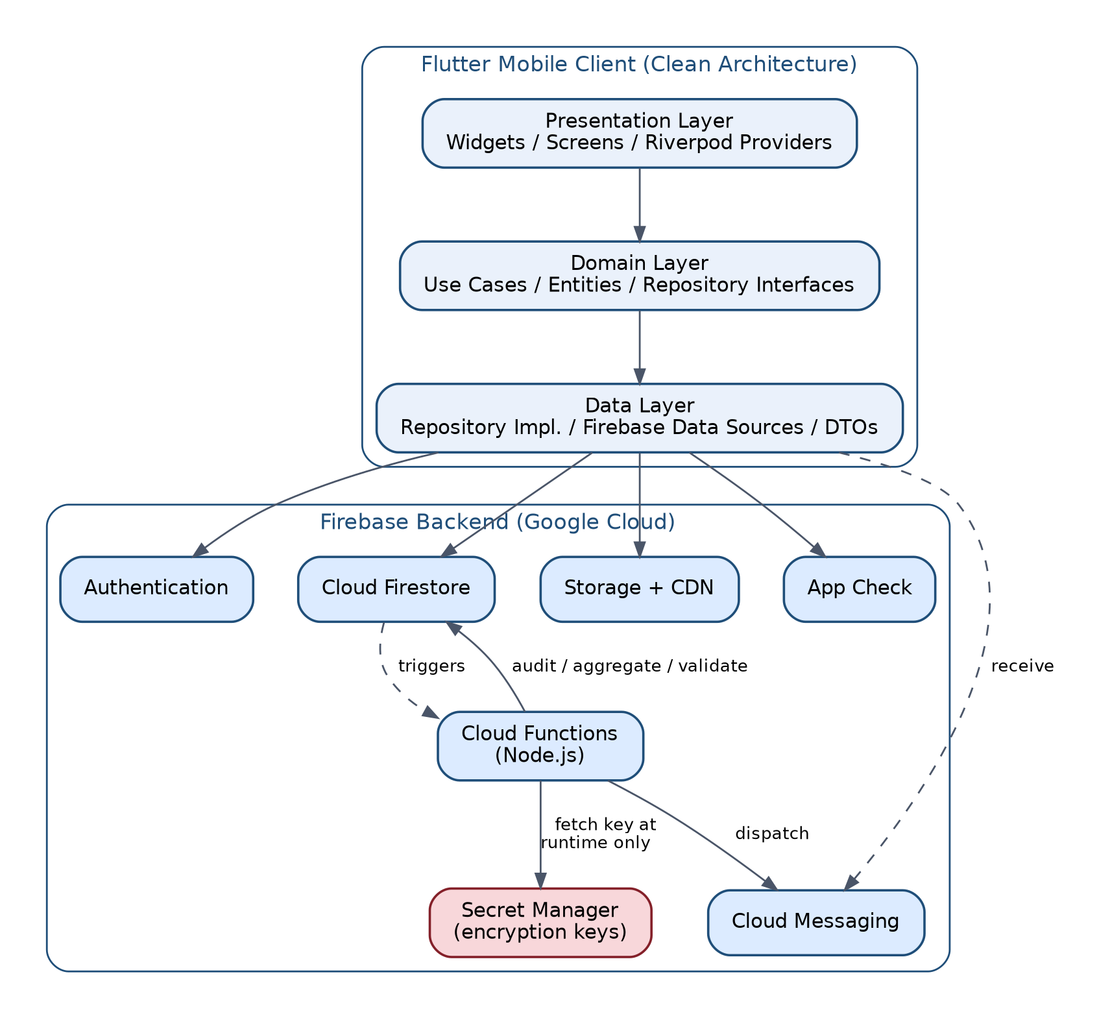
Figure 3 — High-Level System Architecture Diagram
Table 1 — SYSTEM ARCHITECTURE — Firebase Architecture
Firebase Service | Used For | Accessed From
Authentication | Email/password sign-in, session/token management (SRS Section 5.1, 12.1) | AuthDataSource (client) + Admin SDK (Cloud Functions)
Cloud Firestore | All structured application data (SRS Section 12) | FirestoreDataSource (client, rules-gated) + Admin SDK (Cloud Functions, bypasses rules)
Storage | CNIC images, CVs, payment proofs, documents, media gallery (SRS Section 12.6, 14.5) | StorageDataSource (client) + onFinalize trigger functions
Cloud Messaging (FCM) | Push notifications (SRS Section 5.8) | Cloud Functions dispatch; client registers device token
App Check | Attests requests originate from the genuine app build (SRS Section 13.1) | Initialized at app startup; enforced by Firestore/Storage rules and callable functions
Cloud Functions | Callable, trigger, and scheduled functions (Section 11 of this document) | FunctionsDataSource (client, for callable) / Firebase-managed triggers

2.8 Cloud Functions Architecture
Cloud Functions (Node.js, 2nd-generation) run in three categories mirroring SRS Section 17: callable (client-invoked, synchronous), background/trigger (Firestore/Storage event-driven), and scheduled (Cloud Scheduler-driven). All functions requiring a secret (CNIC encryption/HMAC keys) fetch them from Google Cloud Secret Manager at invocation time via the function's service-account identity — never from environment variables committed to source control or from Firebase Remote Config (SRS Section 14.6). Full per-function design is in Section 11 of this document.

2.9 External Services
Two external integrations, both already scoped as external interfaces in SRS Section 16: a third-party SMTP provider invoked from Cloud Functions for transactional email, and external opportunity websites which the app links out to (no data is scraped or ingested from them).

2.10 Deployment Architecture
Figure 4 shows the three-environment deployment topology mandated by SRS Section 19 (Deployment and Environments): fully separate Firebase projects for Development, Staging, and Production, each with its own credentials, Secret Manager secrets, and Firestore instance.
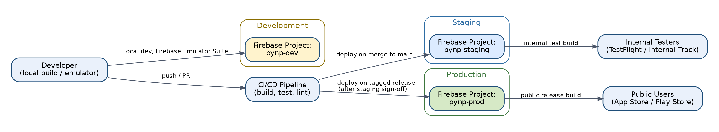
Figure 4 — Deployment Architecture Diagram

3. COMPONENT DESIGN

3.1 Authentication Component
Table 2 — COMPONENT DESIGN — Authentication Component
Aspect | Description
Responsibility | Manages sign-in, session persistence, and auth-state propagation to the rest of the app (SRS 5.1, AUTH module).
Inputs | Email, password (login); Firebase ID token (session restore).
Outputs | AsyncValue<User?> auth state consumed by GoRouter guards and role-aware UI (Section 15, 16).
Dependencies | AuthRepository (Domain interface), FirebaseAuthDataSource (Data layer), Firebase Authentication, App Check.
Business Logic | On successful sign-in, custom claims (role, status) are read from the ID token and cached in AuthNotifier state; failed sign-in increments a client-visible attempt counter used only for UX messaging (server-side lockout is authoritative per SR-015).
Error Handling | FirebaseAuthException codes (wrong-password, user-not-found, too-many-requests, network-request-failed) are mapped to plain-language messages per Section 20 of this document; network errors trigger a retry affordance, not a silent failure.
Security Controls | TLS 1.3 (SR-008); App Check attestation on every auth call; account lockout after 5 failed attempts for 15 minutes, enforced by Firebase Authentication (SR-015); ID token revocation on role downgrade (SR-014).

3.2 Registration Component
Table 3 — COMPONENT DESIGN — Registration Component
Aspect | Description
Responsibility | Collects and submits the new-member application, including CNIC and document uploads (SRS 5.2, REG module).
Inputs | Form fields (name, CNIC, DOB, contact, province/district, documents) validated client-side.
Outputs | Pending user record; confirmation screen; email-verification prompt.
Dependencies | RegisterUseCase, submitRegistration Cloud Function (Section 11.1), StorageDataSource for document upload.
Business Logic | Client-side validation mirrors SRS business rules (13-digit CNIC format, minimum age) for immediate feedback; the authoritative CNIC uniqueness check (HMAC lookup) and final validation occur server-side in the submitRegistration function inside a Firestore transaction (FR-011).
Error Handling | Duplicate-CNIC and validation errors returned by the Cloud Function are surfaced as inline field errors, not generic dialogs; upload failures allow retry without re-entering form data (state held in a Riverpod StateNotifier for the multi-step form).
Security Controls | CNIC is transmitted over TLS to the Cloud Function and never written to Firestore directly by the client (Section 13, SR-006); uploaded documents are validated server-side by onDocumentUpload (SR-011); App Check required on the unauthenticated submitRegistration call.

3.3 Membership Management Component
Table 4 — COMPONENT DESIGN — Membership Management Component
Aspect | Description
Responsibility | Presents pending applications to admins/coordinators and executes approve/reject/renew decisions (SRS 5.3, 5.5, APPR/RENEW modules).
Inputs | Admin decision (approve/reject + reason), renewal submission.
Outputs | Updated membership status, membershipId, membershipExpiryDate; audit log entry; notification dispatch.
Dependencies | ApproveMembershipUseCase, RejectMembershipUseCase, approveMembership/rejectMembership Cloud Functions, onUserStatusChange trigger.
Business Logic | Enforces the membership state machine (SRS Section 9.1): only Pending -> Approved/Rejected and Approved/Expired -> Archived are permitted transitions; the Cloud Function rejects any other transition attempt regardless of client request.
Error Handling | Rejection requires a non-empty reason (FR-014); the status update, audit log write, and notification dispatch are sequenced within the same trigger-driven execution so a partial write is never left visible to the client.
Security Controls | Only National Admin and President roles may call approveMembership/rejectMembership, enforced both by custom-claim checks inside the function and by Firestore Security Rules as defense in depth (SR-013, Section 12).

3.4 Event Management Component
Table 5 — COMPONENT DESIGN — Event Management Component
Aspect | Description
Responsibility | Event creation/editing (admin) and registration/cancellation (member), including capacity enforcement (SRS 5.6, EVENTS module).
Inputs | Event details (admin); registration/cancellation request (member).
Outputs | Event and event_registrations documents; updated currentRegistrations counter; confirmation UI.
Dependencies | EventRepository, registerForEvent/cancelEventRegistration Cloud Functions, onEventRegistrationCreate/Cancel triggers.
Business Logic | Capacity and deadline checks run inside a Firestore transaction in the Cloud Function so concurrent registrations cannot oversell an event (FR-036 - FR-037); cancellation is blocked client-side (and re-validated server-side) within 24 hours of the event start (FR-038).
Error Handling | A capacity-exceeded response from the transaction surfaces a specific "Event is now full" message rather than a generic error, since this is an expected concurrent-user race condition.
Security Controls | Only the registering member's own UID may be written as the registrant; admin attendance marking is an explicit, audit-logged action (SR-016).

3.5 Notification System Component
Table 6 — COMPONENT DESIGN — Notification System Component
Aspect | Description
Responsibility | Delivers push, email, and in-app notifications triggered by system events (SRS 5.8, NOTIF module).
Inputs | Triggering event (status change, event reminder, scheduled job).
Outputs | notifications Firestore documents (in-app inbox); FCM push payloads; outbound emails.
Dependencies | NotificationRepository, onUserStatusChange / onEventRegistrationCreate triggers, sendRenewalReminders / sendEventReminders scheduled functions, sendBroadcastNotification callable (Section 5.1, added this revision), FCM SDK, SMTP service (SRS Section 16.4).
Business Logic | Each notification type maps to a notificationPreferences flag on the user document; critical notification categories (approval/rejection, security alerts) cannot be disabled (SRS data dictionary note).
Error Handling | FCM delivery failures (invalid/expired token) are caught in the Cloud Function and do not block the underlying business operation from completing; the in-app notification document is still written so the user sees it on next login.
Security Controls | Notification payloads never include plaintext CNIC or other PII beyond first name; delivery is logged at the application-log level (Section 25), not the audit-log level, since it is not a security-sensitive action.

3.6 News/Content Management Component
Table 7 — COMPONENT DESIGN — News/Content Management Component
Aspect | Description
Responsibility | Publishing and moderation of news, announcements, and broadcast content (SRS 5.7, NEWS module).
Inputs | Article title/body/media (Content Manager+); publish/unpublish decision.
Outputs | Published article documents; push notification to subscribed members for broadcast-flagged content.
Dependencies | NewsRepository (backed by the news_articles collection, Section 4.2 — added this revision), Firebase Storage (media), sendBroadcastNotification callable (Section 5.1, added this revision) for FR-043 broadcast announcements.
Business Logic | Rich-text body content is sanitized server-side using a whitelist-based HTML sanitizer before storage (SR-012) to prevent stored XSS when rendered back into the app's rich-text viewer.
Error Handling | Publish failures preserve the draft in local state (not lost) so the Content Manager can retry without re-typing.
Security Controls | Only Content Manager role and above may publish (Section 7 permission matrix); sanitization is mandatory and cannot be bypassed by any client flag.

3.7 Document Management Component
Table 8 — COMPONENT DESIGN — Document Management Component
Aspect | Description
Responsibility | Upload, versioning, and access-controlled download of organizational documents (SRS 5.9, DOCS module).
Inputs | File upload (Content Manager+); download request (any authorized viewer).
Outputs | documents Firestore metadata records; Storage objects; download URL.
Dependencies | DocumentRepository, StorageDataSource, onDocumentUpload trigger (MIME validation).
Business Logic | accessLevel field on each document (public / member-only / admin-only) is checked both client-side (to hide unavailable items) and by Storage Security Rules (authoritative).
Error Handling | Invalid MIME type uploads are deleted server-side by onDocumentUpload and the client is notified via a Cloud Function error response rather than leaving an orphaned, unreferenced file.
Security Controls | Storage Security Rules deny any read not matching the document's accessLevel and the requester's role (SR-007 pattern extended to general documents).

3.8 Media Gallery Component
Table 9 — COMPONENT DESIGN — Media Gallery Component
Aspect | Description
Responsibility | Album-organized photo/video storage and browsing (SRS 5.10, GALLERY module).
Inputs | Image (max 8 MB) / video (max 100 MB) uploads (Content Manager+); album selection (viewer).
Outputs | Gallery album and media documents; thumbnail previews.
Dependencies | GalleryRepository, StorageDataSource, image-compression utility (client-side, pre-upload).
Business Logic | Client compresses images before upload to reduce bandwidth and storage cost (SRS Section 22 performance targets); thumbnails are generated server-side to avoid shipping full-resolution images in list views.
Error Handling | Oversized-file uploads are rejected client-side before network transfer begins, with the size limit shown inline.
Security Controls | Same accessLevel and MIME-validation pattern as the Document Management Component.

3.9 Opportunities Component
Table 10 — COMPONENT DESIGN — Opportunities Component
Aspect | Description
Responsibility | Publishing volunteer/opportunity listings with external link-out and click tracking (SRS 5.12, OPP module).
Inputs | Opportunity listing (Opportunity Manager+); click event (any viewer).
Outputs | opportunities documents; click-count analytics field; external browser launch.
Dependencies | OpportunityRepository, url_launcher package (external browser), analytics aggregation pathway.
Business Logic | Click tracking increments a denormalized clickCount field via a Cloud Function rather than a raw client write, preventing simple click-count manipulation (Section 13).
Error Handling | If the external URL fails to launch (malformed or app unavailable), the app shows a copy-to-clipboard fallback rather than a bare exception.
Security Controls | External URLs are validated against an https:// scheme allowlist before launch to reduce the risk of the field being used for a malicious redirect.

3.10 Payments Component
Table 11 — COMPONENT DESIGN — Payments Component
Aspect | Description
Responsibility | Payment-proof upload by members and verification by admins (SRS 5.15, PAY module).
Inputs | Proof-of-payment image/PDF upload (member); verify/reject decision (admin).
Outputs | payments documents (Pending/Verified/Rejected per SRS Section 9.2); notification to member.
Dependencies | PaymentRepository, verifyPaymentProof Cloud Function, StorageDataSource.
Business Logic | Implements the payment state machine (SRS Section 9.2) exactly: Pending -> Verified or Rejected, Rejected -> Pending on re-upload only.
Error Handling | Verification actions are idempotent at the function level -- re-invoking verify on an already-Verified record is a no-op, not a duplicate audit entry.
Security Controls | Only National Admin and District/Regional Coordinator roles may verify payments; proof files are stored with the same access-restricted pattern as CNIC images (SR-007).

3.11 Audit Logging Component
Table 12 — COMPONENT DESIGN — Audit Logging Component
Aspect | Description
Responsibility | Writes and exposes the immutable audit trail for all auditable actions (SRS 5.16, AUDIT module; SR-016 - SR-017).
Inputs | Any create/update/delete on an auditable collection; any CNIC read.
Outputs | Immutable audit_logs documents; filtered audit view for National Admin / Super Admin.
Dependencies | onAnyAuditableWrite trigger function, AuditLogRepository (read-only from the client's perspective).
Business Logic | Audit entries are written exclusively by Cloud Functions using the Admin SDK; there is no client code path that writes to audit_logs, which is enforced redundantly by Firestore Security Rules (SR-017).
Error Handling | If the audit-write step of a trigger function fails, the function logs the failure to Cloud Logging at ERROR severity and relies on Cloud Functions' built-in retry policy for background triggers, since a missing audit entry is treated as a compliance-relevant failure, not a silent drop.
Security Controls | Read access restricted to national_admin and super_admin custom claims (SR-017); entries are never updated or deleted by any code path.

3.12 Analytics Component
Table 13 — COMPONENT DESIGN — Analytics Component
Aspect | Description
Responsibility | Aggregates anonymized, org-wide metrics for the admin dashboard (SRS 5.13, ANALYTICS module).
Inputs | Nightly trigger (recomputeAnalyticsAggregates); underlying collections (users, events, payments).
Outputs | analytics_aggregates documents (pre-computed counts/sums, never raw PII).
Dependencies | AnalyticsRepository, recomputeAnalyticsAggregates scheduled function.
Business Logic | All aggregation happens server-side over the full dataset; the client never queries raw member records to build a chart, both for performance (SRS Section 22) and privacy (SR-009).
Error Handling | A failed nightly aggregation run leaves the prior day's aggregate document in place (last-known-good) rather than showing a broken or empty dashboard; the failure is logged and alertable (Section 25).
Security Controls | analytics_aggregates documents contain only counts and sums, never individual CNIC, name, or contact fields, satisfying SR-009.

3.13 Reporting Component
Table 14 — COMPONENT DESIGN — Reporting Component
Aspect | Description
Responsibility | Generates the eight standard organizational reports on demand (SRS 5.14, REPORTS module).
Inputs | Report type selection, date range, filters (Coordinator+).
Outputs | Formatted report (in-app table / exportable PDF or CSV per SRS UI requirements).
Dependencies | ReportingRepository, Firestore composite-indexed queries (Section 10.5 of this document), pagination utility.
Business Logic | Report queries use the composite indexes defined in Section 10.5 to stay within the SRS Section 24 performance targets even as the dataset grows; large result sets are paginated rather than loaded in full.
Error Handling | A report query that would exceed a reasonable document-read budget is capped with a user-visible "narrow your date range" prompt rather than allowed to run unbounded.
Security Controls | Report access is role-gated per the Section 7 permission matrix; generated reports containing PII are not cached to shared/public device storage.

3.14 Administration Component
Table 15 — COMPONENT DESIGN — Administration Component
Aspect | Description
Responsibility | Super Admin / National Admin console for user management, role assignment, and system configuration (SRS 5.17, ADMIN module).
Inputs | Role-change request; account activation/deactivation request.
Outputs | Updated user role/status; revoked ID tokens on downgrade; audit entry.
Dependencies | AdminRepository, updateUserRole Cloud Function.
Business Logic | Role changes take effect within one app session refresh, without requiring the affected user to log out, by combining a custom-claim update with a forced ID-token refresh signal (SRS AC-010).
Error Handling | Attempts to self-downgrade the last remaining Super Admin are rejected server-side to prevent an unrecoverable lockout.
Security Controls | Restricted to the super_admin custom claim only (SR-014); every role change is audit-logged with before/after values.

3.15 Role Management Component
Table 16 — COMPONENT DESIGN — Role Management Component
Aspect | Description
Responsibility | Implements the ten-role hierarchy and permission matrix consistently across UI, client-side guards, and server-side enforcement (SRS Section 7).
Inputs | Authenticated user's custom claims (role, status).
Outputs | Role-scoped navigation (Section 16), role-scoped UI element visibility, role-scoped Firestore/Storage access.
Dependencies | AuthNotifier (role state), GoRouter redirect guards, Firestore Security Rules, Storage Security Rules.
Business Logic | The permission matrix (SRS 7.3) is implemented once as a single source of truth -- a Dart const map used by UI guards -- kept structurally identical to the Firestore Security Rules role checks to avoid the two diverging.
Error Handling | Unauthorized navigation attempts are intercepted by the GoRouter guard before the destination screen builds, redirecting to an "Access Restricted" screen rather than allowing a partial render followed by a data-access error.
Security Controls | Client-side role checks are a UX convenience only; every sensitive read/write is independently authorized by Firestore/Storage Security Rules and, for privileged operations, by Cloud Function custom-claim checks (defense in depth, Section 13).

3.16 Volunteer Management Component
Table 17 — COMPONENT DESIGN — Volunteer Management Component
Aspect | Description
Responsibility | Collects volunteer position applications from approved members and lets National Admin+ review a directory of active volunteers (SRS FR-056 – FR-058, VOL module).
Inputs | Selected volunteer role and availability slots (applicant); approve/reject decision (National Admin+, per FR-057).
Outputs | A volunteers document per applicant (status: pending/approved/rejected); an in-app status banner replacing the application form for members who already applied; the National Admin+ volunteer directory list.
Dependencies | VolunteerRepository, submitVolunteerApplication / approveVolunteerApplication / rejectVolunteerApplication Cloud Functions (Section 5.1), Notification System Component (approval/rejection notice, per FR-057).
Business Logic | Mirrors the same single-pending-application pattern already used by Membership Management: a member may not submit a second application while one is pending or approved — the UI/UX Design & Wireframes document (Section 8, UI-040) specifies this as an "already-applied" status banner replacing the form, and the Cloud Function enforces it server-side as the authoritative check.
Error Handling | Duplicate-application attempts return a FAILED_PRECONDITION error surfaced as the status banner rather than a generic error; validation errors (no role/availability selected) are inline field errors, consistent with the Error Handling Architecture (Section 14).
Security Controls | submitVolunteerApplication restricted to callers with status=approved (any role at or above Member); approveVolunteerApplication/rejectVolunteerApplication restricted to national_admin+ custom claim, enforced both in the Cloud Function and by Firestore Security Rules on the volunteers collection, following the same defense-in-depth pattern as Membership Management (Section 7).

Design note (added in this revision): this component did not exist in SDD v1.0. It is added because the finalized PYNP UI/UX Design & Wireframes document (v1.1) specifies full screen behavior for UI-040 (Volunteer Application) and UI-041 (Volunteer Directory) — see that document's Section 8 — while SRS FR-056–FR-058 already required the underlying functionality. No new requirement is introduced; this closes a design-documentation gap identified by that document's own Appendix C (Cross-Document Propagation Requirements, item 1).

4. DATABASE DESIGN

4.1 Firestore Architecture
Cloud Firestore is used as the single system of record (SRS Section 12.1). The design follows a top-level-collection structure (no deeply nested subcollections beyond what is shown below) to keep security rules simple to reason about and to avoid Firestore's subcollection query limitations.
The application uses Google Cloud Firestore (NoSQL document database) organized into top-level collections containing documents. The design follows denormalization principles appropriate for NoSQL. Aggregation counters (e.g., currentRegistrations) are maintained by Cloud Function triggers for query performance. Pre-computed analytics aggregates are updated by scheduled Cloud Functions.

4.2 Collections
Table 1 summarizes the ten original top-level collections plus four collections proposed in this revision (design note below) and which layer is authorized to write each. Full field-level schemas for every collection are defined in SRS Section 12 and Section 13 (Data Dictionary) and are not repeated in full here to avoid the two documents drifting out of sync; this section restates only what is necessary to explain the design.
Table 18 — DATABASE DESIGN — Collections
Collection | Purpose | Written By
users | Member/staff profile, role, status, encrypted CNIC + HMAC lookup reference (SRS 12.3) | Client (own profile fields) + Cloud Functions (status/role/CNIC fields)
cnic_lookup | Deterministic HMAC-SHA256 CNIC uniqueness index (SRS 12.4) | Cloud Functions only — zero client access
events | Event catalog and capacity counters (SRS 12.5) | Admin/Coordinator client writes (metadata) + Cloud Functions (counters)
event_registrations | Member-to-event registration records (SRS 12.6) | Client (create/cancel) via callable function; Cloud Functions (status)
notifications | Per-user in-app notification inbox (SRS 12.7) | Cloud Functions only; client marks read
documents | Organizational document metadata (SRS 12.8) | Content Manager+ client writes; Cloud Functions validate
opportunities | Volunteer/opportunity listings (SRS 12.9) | Opportunity Manager+ client writes; Cloud Functions increment clickCount
payments | Payment proof and verification status (SRS 12.10) | Member (create) + Cloud Functions (verify/reject)
audit_logs | Immutable audit trail (SRS 12.11) | Cloud Functions only — zero client access
analytics_aggregates | Pre-computed dashboard metrics (SRS 12.12) | Cloud Functions only (scheduled)
news_articles (Proposed) | News/announcement articles (SRS 12.7... module FR-042–FR-044); no collection is currently defined in SRS Section 12 or the Firestore Data Model document despite the News/Content Management Component requiring persisted article storage | Content Manager+ client writes (mirrors the documents collection pattern); Cloud Functions (broadcast dispatch, audit)
volunteers (Proposed) | Volunteer position applications and directory (SRS FR-056–FR-058) | Client (create, self-service) via submitVolunteerApplication; Cloud Functions (status, via approve/rejectVolunteerApplication)
gallery_albums (Proposed) | Gallery album metadata — name, cover image, media count (SRS FR-054/FR-055; UI/UX Design & Wireframes UI-029) | Content Manager+ client writes; Cloud Functions maintain mediaCount counter
gallery_media (Proposed) | Individual gallery photo/video items, referencing a parent album (SRS FR-054/FR-055; UI/UX Design & Wireframes UI-030/031) | Content Manager+ client writes; onDocumentUpload trigger validates MIME type (extends the existing pattern already applied to documents)

Design note (added in this revision): the four rows above are Proposed collections, not yet formally specified in the Firestore Database & Data Model Design document. They are added here because the finalized UI/UX Design & Wireframes document (v1.1) fully specifies screen behavior that depends on them (Gallery: UI-029–031; Volunteer: UI-040/041) and because SRS FR-042–FR-044 (News), FR-054/FR-055 (Gallery), and FR-056–FR-058 (Volunteer) already require the underlying functionality — this SDD cannot describe a consistent design without naming where that data lives. Full field-level schemas for these four collections still need to be added to the Firestore Database & Data Model Design document, consistent with that document's own stated authority over field-level schema (see this document's Section 1.3-equivalent convention, and Appendix C of the UI/UX Design & Wireframes document). This is listed as a remaining cross-document action item, not a closed decision — see Section 25 (Limitations and Future Design Considerations).

4.3 Document Structure
Each collection's document shape is defined by a corresponding Data-layer DTO class (e.g., UserDto, EventDto) with an explicit fromFirestore(DocumentSnapshot) and toFirestore() pair, so field renames or type changes are caught at compile time rather than surfacing as a runtime cast exception. DTOs map to Domain entities via a mapper function, never exposing Firestore-specific types (Timestamp, DocumentReference) to the Domain or Presentation layers.
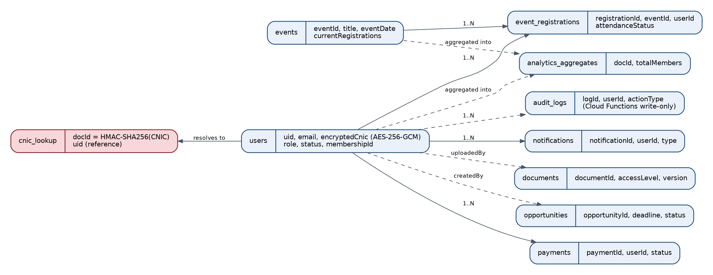
Figure 5 — Firestore Data Model Diagram

4.4 Relationships
Firestore is non-relational; relationships are represented as either (a) a UID/ID string field resolved by a second read (e.g., event_registrations.userId → users/{uid}), or (b) a denormalized copy of frequently-displayed fields (e.g., a registration record stores the member's display name at registration time so event attendee lists do not require N additional reads). Denormalized copies are treated as a display cache, not a source of truth — the users collection remains authoritative for profile fields.

4.5 Indexes
Composite indexes are defined for every multi-field query used by the Reporting Component (Section 3) and the Analytics Component, since Firestore requires an explicit composite index for any query combining an equality filter with a range/order-by on a different field.
Table 19 — DATABASE DESIGN — Indexes
Collection | Composite Index Fields | Supports
users | status ASC, membershipType ASC, createdAt DESC | Admin pending-approvals list; membership-type reports
event_registrations | eventId ASC, attendanceStatus ASC | Per-event attendance report
event_registrations | userId ASC, registeredAt DESC | Member's own registration history
payments | status ASC, submittedAt ASC | Pending payments verification queue
audit_logs | userId ASC, timestamp DESC | Per-user audit trail lookup
notifications | userId ASC, read ASC, createdAt DESC | Unread notification badge + inbox list

4.6 Denormalization
- events.currentRegistrations — a running counter avoiding a full event_registrations count query on every event list render (supports SRS Section 24 performance targets).
- event_registrations.eventTitle, .userDisplayName — avoids N+1 reads when rendering attendee/registration lists.
- opportunities.clickCount — a running counter avoiding a scan of click-event records.
- All denormalized fields are updated exclusively by Cloud Functions in the same transaction/trigger as the authoritative write, so they cannot silently drift from source data under normal operation.

4.7 Transactions
Firestore transactions (runTransaction) are used wherever a read-then-conditional-write must be atomic under concurrent access:
Table 20 — DATABASE DESIGN — Transactions
Operation | Transaction Guarantees
submitRegistration | Create cnic_lookup/{hash} and users/{uid} atomically — if the lookup doc already exists, the whole registration fails, guaranteeing no duplicate CNIC can ever be committed (FR-011).
registerForEvent | Read events/{id}.currentRegistrations, verify capacity, then create the registration and increment the counter — prevents overselling under concurrent registrations (FR-037).
cancelEventRegistration | Update registration status and decrement the counter atomically.

4.8 Batch Writes
Non-conditional multi-document writes that do not require a read-first check use WriteBatch instead of a transaction, since batches have lower contention overhead. Example: recomputeAnalyticsAggregates writes several analytics_aggregates documents (per-province, per-membership-type, org-wide) in one batch so the dashboard never reads a partially-updated set.

4.9 Counters
High-frequency counters (currentRegistrations, clickCount) are implemented as simple atomic FieldValue.increment() operations within the transaction/batch described above. Given PYNP's expected scale (SRS Section 22/23 targets, not high-frequency social-media-scale counters), a distributed sharded-counter pattern is not required; if event registration volume ever approaches Firestore's ~1 write/second per document contention limit for a single very popular event, sharded counters are a documented future optimization (Section 31, Limitations).

4.10 Analytics Aggregates
Pre-computed counters maintained by scheduled Cloud Function jobs for high-performance dashboard reads.
Table 21 — DATABASE DESIGN — Analytics Aggregates
Field | Type | Required | Description & Validation
docId | String | Yes | stats_YYYY_MM for monthly; stats_total for all-time cumulative.
totalMembers | Number | Yes | Total approved members at snapshot time.
newMembersThisMonth | Number | Yes | New approvals during the current calendar month.
membersByProvince | Map | Yes | Map of province_name: member_count.
membersByGender | Map | Yes | Map of gender_value: member_count.
membersByType | Map | Yes | Map of membership_type: member_count.
totalEvents | Number | Yes | Total published events count.
totalEventRegistrations | Number | Yes | Total event registrations all-time.
updatedAt | Timestamp | Yes | Timestamp of last successful aggregation job run.

4.11 Data Validation
Validation is layered, consistent with SR-010:
- Client-side (Presentation/Domain layer): immediate UX feedback using the same validation rules as the server, implemented as pure Dart validator functions unit-tested independently of any widget.
- Cloud Function (server-side, authoritative): every field is re-validated before any write; the client's validation is never trusted alone.
- Firestore Security Rules (structural, last line of defense): rules assert required fields exist, types match, and enum-like fields (status, role) are within the allowed value set, rejecting any write — even one bypassing the Cloud Function via a compromised client — that violates document shape.

4.12 Data Retention
Implements SRS Section 21.1 (Data Retention). Member records are retained indefinitely across Active/Expired/Archived status per BDR-001; audit_logs are retained a minimum of 3 years (BDR-002) and are never subject to a client-triggered delete path. Where the SRS marks retention duration as [TBD — requires PYNP stakeholder confirmation], no automatic deletion job is implemented until that value is confirmed, to avoid irreversibly deleting data under an assumed policy.

5. API / CLOUD FUNCTION DESIGN

5.1 Callable / HTTPS Functions
These functions are invoked directly by the authenticated (or, for submitRegistration, pre-account) mobile client via the FunctionsDataSource and return a synchronous response.
The three functions below are added in this revision. submitVolunteerApplication / approveVolunteerApplication / rejectVolunteerApplication close the gap identified when the Volunteer Management Component was added (Section 3.16). sendBroadcastNotification closes a gap found independently in this SDD-focused audit: SRS FR-043 ("National Admin and President shall send broadcast announcements as push notifications to all active members") had no corresponding entry anywhere in SDD v1.0's function catalog, even though the News/Content Management Component's Outputs field already described "push notification to subscribed members for broadcast-flagged content" — the component's narrative and the function catalog had drifted apart.

submitRegistration
Table 22 — Callable / HTTPS Functions — submitRegistration
Field | Specification
Purpose | Create a new member application (SRS FR-009 - FR-018).
Trigger | HTTPS callable, invoked from the Registration Component before an authenticated session exists.
Authentication | App Check token required; no Firebase Auth session required (pre-account).
Authorization | Public — any device passing App Check attestation.
Input | Registration form fields (name, CNIC, DOB, contact, province/district, password) + document upload references.
Validation | Server-side re-validation of all fields (13-digit numeric CNIC, minimum age, required fields); HMAC-SHA256(CNIC) computed using the Secret-Manager-held key.
Processing | Firestore transaction: (1) attempt to create cnic_lookup/{hmac} — fails closed if it exists; (2) create the Firebase Auth account; (3) create users/{uid} with status=Pending and encryptedCnic (AES-256-GCM); (4) send confirmation email.
Output | { success: true, uid } on success.
Error Responses | ALREADY_EXISTS (duplicate CNIC or email), INVALID_ARGUMENT (validation failure), INTERNAL (unexpected).
Audit Logging | onUserStatusChange-style entry is not applicable here (no prior status); a dedicated audit_logs entry of actionType=REGISTRATION_SUBMITTED is written directly by this function.
Dependencies | Secret Manager (CNIC keys), Firebase Auth Admin SDK, Firestore, SMTP service.

approveMembership / rejectMembership
Table 23 — Callable / HTTPS Functions — approveMembership / rejectMembership
Field | Specification
Purpose | Transition a Pending application to Approved or Rejected (SRS FR-019 - FR-023).
Trigger | HTTPS callable.
Authentication | Firebase Auth session required.
Authorization | Custom claim role in {national_admin, president} — checked in-function and denied otherwise (FUNCTION-level check, in addition to Firestore rules on the underlying write).
Input | { targetUid, decision: 'approve'|'reject', reason? }.
Validation | reason is required and non-empty when decision='reject' (FR-014); targetUid must currently be status=Pending, or the call is rejected as an invalid transition.
Processing | Updates users/{targetUid}.status, sets membershipId/membershipType on approval; the update triggers onUserStatusChange in the background for notification + audit.
Output | { success: true, newStatus }.
Error Responses | PERMISSION_DENIED (wrong role), FAILED_PRECONDITION (not Pending), INVALID_ARGUMENT (missing reason).
Audit Logging | Delegated to the onUserStatusChange trigger function (Section 5.2 below) for consistency across all status-changing paths.
Dependencies | Firestore, custom-claims read from the caller's ID token.

submitRenewal / approveRenewal
Table 24 — Callable / HTTPS Functions — submitRenewal / approveRenewal
Field | Specification
Purpose | Extend membership validity by 12 months within the renewal window (SRS FR-030 - FR-032).
Trigger | HTTPS callable.
Authentication | Firebase Auth session required.
Authorization | submitRenewal: the member themself. approveRenewal: national_admin, president.
Input | submitRenewal: { paymentProofRef }. approveRenewal: { renewalId, decision }.
Validation | Renewal only accepted for status in {Approved, Expired-within-grace-period} per SRS Section 9.1.
Processing | Creates/updates a renewal sub-record; on approval, extends membershipExpiryDate by 12 months and resets status to Approved if it had lapsed to Expired.
Output | { success: true, newExpiryDate }.
Error Responses | FAILED_PRECONDITION (outside renewal/grace window), PERMISSION_DENIED.
Audit Logging | audit_logs entry actionType=MEMBERSHIP_RENEWED with before/after expiry dates.
Dependencies | Firestore, PaymentRepository linkage.

registerForEvent / cancelEventRegistration
Table 25 — Callable / HTTPS Functions — registerForEvent / cancelEventRegistration
Field | Specification
Purpose | Register or cancel a member's event registration with capacity enforcement (SRS FR-036 - FR-038).
Trigger | HTTPS callable.
Authentication | Firebase Auth session required.
Authorization | Any authenticated member (self-service; targetUid always equals caller's UID).
Input | { eventId }.
Validation | Event must exist, registration deadline not passed, capacity not full (registerForEvent); cancellation only permitted >= 24h before eventDate (cancelEventRegistration).
Processing | Firestore transaction reading events/{eventId}.currentRegistrations, verifying capacity, then writing the event_registrations document and incrementing/decrementing the counter atomically.
Output | { success: true, registrationId, status }.
Error Responses | RESOURCE_EXHAUSTED (event full), FAILED_PRECONDITION (deadline passed / cancellation window closed), NOT_FOUND (event does not exist).
Audit Logging | Not separately audited (non-security-sensitive, high-volume action) — captured in application logs (Section 25) instead, consistent with the SRS's audit-log scope.
Dependencies | Firestore transactions, onEventRegistrationCreate/Cancel triggers for downstream notification.

verifyPaymentProof
Table 26 — Callable / HTTPS Functions — verifyPaymentProof
Field | Specification
Purpose | Mark a submitted payment as Verified or Rejected (SRS PAY module, Section 9.2).
Trigger | HTTPS callable.
Authentication | Firebase Auth session required.
Authorization | Custom claim role in {national_admin, district_coordinator, regional_coordinator}.
Input | { paymentId, decision: 'verify'|'reject' }.
Validation | Payment must currently be status=Pending; idempotent no-op if already in the target state.
Processing | Updates payments/{paymentId}.status and writes an audit entry; triggers a notification to the member.
Output | { success: true, newStatus }.
Error Responses | PERMISSION_DENIED, FAILED_PRECONDITION (not Pending).
Audit Logging | audit_logs entry actionType=PAYMENT_VERIFIED or PAYMENT_REJECTED.
Dependencies | Firestore, Notification System Component.

updateUserRole
Table 27 — Callable / HTTPS Functions — updateUserRole
Field | Specification
Purpose | Change a user's role and revoke stale tokens (SRS SR-014, AC-010).
Trigger | HTTPS callable.
Authentication | Firebase Auth session required.
Authorization | Custom claim role = super_admin only.
Input | { targetUid, newRole }.
Validation | Rejects the request if targetUid is the last remaining super_admin (prevents lockout); newRole must be one of the ten defined roles (SRS Section 7.2).
Processing | Sets custom claims via Admin SDK setCustomUserClaims, then calls revokeRefreshTokens(targetUid) so the client is forced to obtain a fresh ID token reflecting the new role within one refresh cycle.
Output | { success: true }.
Error Responses | PERMISSION_DENIED, FAILED_PRECONDITION (last-super-admin protection).
Audit Logging | audit_logs entry actionType=ROLE_CHANGED with before/after role.
Dependencies | Firebase Admin SDK (custom claims, token revocation).

submitVolunteerApplication
Table 28 — Callable / HTTPS Functions — submitVolunteerApplication
Field | Specification
Purpose | Create a volunteer position application for an approved member (SRS FR-056).
Trigger | HTTPS callable.
Authentication | Firebase Auth session required.
Authorization | Caller's own users document must have status=approved (Member and above).
Input | { role, availability: string[] }.
Validation | Rejects if the caller already has a volunteers document with status in {pending, approved} — enforces the single-active-application rule described in Section 3.16.
Processing | Creates a volunteers document keyed by an auto-generated ID, with applicantUid=caller's UID and status=pending.
Output | { success: true, applicationId }.
Error Responses | ALREADY_EXISTS (duplicate active application), PERMISSION_DENIED (caller not approved), INVALID_ARGUMENT (missing role/availability).
Audit Logging | audit_logs entry actionType=VOLUNTEER_APPLICATION_SUBMITTED, written directly by this function.
Dependencies | Firestore.

approveVolunteerApplication / rejectVolunteerApplication
Table 29 — Callable / HTTPS Functions — approveVolunteerApplication / rejectVolunteerApplication
Field | Specification
Purpose | Review a pending volunteer application (SRS FR-057).
Trigger | HTTPS callable.
Authentication | Firebase Auth session required.
Authorization | Custom claim role = national_admin or above.
Input | { applicationId, decision: 'approve'|'reject' }.
Validation | Application must currently be status=pending.
Processing | Updates volunteers/{applicationId}.status; on approval the applicant becomes visible in the Volunteer Directory (UI-041); on rejection the applicant may submit a new application (mirrors the membership Rejected → re-apply pattern, Section 3.16).
Output | { success: true, newStatus }.
Error Responses | PERMISSION_DENIED, FAILED_PRECONDITION (not pending).
Audit Logging | audit_logs entry actionType=VOLUNTEER_APPLICATION_APPROVED or _REJECTED.
Dependencies | Firestore, Notification System Component (approval/rejection notice, per FR-057).

sendBroadcastNotification
Table 30 — Callable / HTTPS Functions — sendBroadcastNotification
Field | Specification
Purpose | Send an admin-composed broadcast announcement as a push notification to all active members (SRS FR-043).
Trigger | HTTPS callable.
Authentication | Firebase Auth session required.
Authorization | Custom claim role in {national_admin, president} — matches FR-043's stated authorization exactly.
Input | { title, body, relatedDocumentId? }.
Validation | title and body are required and length-bounded (consistent with the sanitization approach already applied to news content, SR-012).
Processing | Writes a notifications document per active (status=approved) member and dispatches an FCM push to each; for large member counts this is batched to respect Cloud Functions' execution limits, consistent with the batching approach already used by recomputeAnalyticsAggregates.
Output | { success: true, recipientCount }.
Error Responses | PERMISSION_DENIED, INVALID_ARGUMENT (empty title/body).
Audit Logging | audit_logs entry actionType=BROADCAST_SENT, capturing the sender and recipient count (not per-recipient, to avoid an audit_logs write storm).
Dependencies | Firestore, FCM, Notification System Component.

5.2 Background / Trigger Functions
These functions execute automatically in response to a Firestore or Storage event and are never directly callable from the client.

onUserStatusChange
Table 31 — Background / Trigger Functions — onUserStatusChange
Field | Specification
Purpose | Central audit + notification hook for every users.status transition (SRS SR-016, FR-014, FR-017).
Trigger | Firestore onUpdate — users/{uid}, filtered to changes in the status field.
Authentication | N/A — background trigger executes under the Cloud Functions service account.
Authorization | N/A — not client-invocable.
Input | Firestore change snapshot (before/after document).
Validation | No-op if status field is unchanged (avoids duplicate audit entries on unrelated profile edits).
Processing | Writes an audit_logs entry with before/after status; determines the appropriate notification (approval, rejection with reason, expiry) and dispatches via the Notification System Component.
Output | None (void trigger); side effects only.
Error Responses | Caught and logged to Cloud Logging at ERROR severity; Cloud Functions' built-in retry applies for background triggers.
Audit Logging | This function IS the audit-writing mechanism for status changes.
Dependencies | Firestore, FCM, SMTP.

onEventRegistrationCreate / onEventRegistrationCancel
Table 32 — Background / Trigger Functions — onEventRegistrationCreate / onEventRegistrationCancel
Field | Specification
Purpose | Maintain the denormalized currentRegistrations counter and send confirmations (SRS FR-037, FR-038, FR-045).
Trigger | Firestore onCreate / onUpdate (status -> cancelled) — event_registrations/{id}.
Authentication | N/A — background trigger.
Authorization | N/A.
Input | Firestore change snapshot.
Validation | Guards against double-processing the same document (idempotency check via a processed flag).
Processing | Increments/decrements events/{eventId}.currentRegistrations; sends registration confirmation or cancellation notice.
Output | None (void trigger).
Error Responses | Logged; does not roll back the registration itself since the registration was already validated in the callable function's transaction.
Audit Logging | Not separately audited (see registerForEvent note above).
Dependencies | Firestore, Notification System Component.

onDocumentUpload
Table 33 — Background / Trigger Functions — onDocumentUpload
Field | Specification
Purpose | Server-side MIME-type validation for every uploaded file (SRS SR-011).
Trigger | Cloud Storage onFinalize — cnic images, CVs, payment proofs, documents, media gallery paths.
Authentication | N/A — background trigger.
Authorization | N/A.
Input | Storage object metadata.
Validation | Verifies actual file content matches an allowed MIME type (not just the file extension).
Processing | Deletes the object immediately if validation fails; otherwise leaves it in place and, for media gallery images, triggers thumbnail generation.
Output | None (void trigger).
Error Responses | Deletion failure is logged and alertable, since an invalid file left in place is a security concern.
Audit Logging | audit_logs entry actionType=INVALID_UPLOAD_REJECTED when a file is deleted.
Dependencies | Cloud Storage Admin SDK.

onAnyAuditableWrite
Table 34 — Background / Trigger Functions — onAnyAuditableWrite
Field | Specification
Purpose | Generic audit-log writer for collections not covered by a more specific trigger (SRS SR-016, SR-017).
Trigger | Firestore onCreate/onUpdate/onDelete on auditable collections (documents, opportunities, payments, news/content).
Authentication | N/A — background trigger.
Authorization | N/A.
Input | Firestore change snapshot + collection name.
Validation | N/A — records every matching event.
Processing | Writes a normalized audit_logs entry capturing actionType, collection, documentId, and the acting user's UID (from the write's context, where available).
Output | None (void trigger).
Error Responses | Logged to Cloud Logging; does not block the underlying write since it fires after commit.
Audit Logging | This function IS an audit-writing mechanism.
Dependencies | Firestore.

5.3 Scheduled Functions
These functions run on a Cloud Scheduler cron trigger, independent of any client action.

sendRenewalReminders
Table 35 — Scheduled Functions — sendRenewalReminders
Field | Specification
Purpose | Proactively remind members before membership expiry (SRS FR-030).
Trigger | Cloud Scheduler — daily.
Authentication | N/A — scheduled function runs under the service account.
Authorization | N/A.
Input | Current date; query of users where membershipExpiryDate falls at 60/30/15/7 days out.
Validation | Skips users who have already renewed or whose notificationPreferences disable renewal reminders (non-critical category).
Processing | Batches notification writes + FCM/email dispatch for all matching users.
Output | None (scheduled job); a summary is written to Cloud Logging.
Error Responses | Per-user failures are caught individually so one bad record does not abort the whole batch.
Audit Logging | Not audit-logged (routine notification, not a security-sensitive action).
Dependencies | Firestore, Notification System Component.

enforceExpiredStatus
Table 36 — Scheduled Functions — enforceExpiredStatus
Field | Specification
Purpose | Transition Approved members past their grace period to Expired (SRS FR-033).
Trigger | Cloud Scheduler — daily.
Authentication | N/A.
Authorization | N/A.
Input | Query of users where status=Approved and membershipExpiryDate + 15 days < now.
Validation | N/A.
Processing | Batch-updates matching users to status=Expired, which fires onUserStatusChange for audit + notification.
Output | None; summary logged.
Error Responses | Logged; retried on next scheduled run if the job fails outright.
Audit Logging | Delegated to onUserStatusChange.
Dependencies | Firestore.

sendEventReminders
Table 37 — Scheduled Functions — sendEventReminders
Field | Specification
Purpose | Remind registered members before an event (SRS FR-040).
Trigger | Cloud Scheduler — hourly.
Authentication | N/A.
Authorization | N/A.
Input | Query of events with eventDate 24h or 1h out; corresponding event_registrations.
Validation | Skips cancelled registrations.
Processing | Dispatches push reminders to all registered, non-cancelled members.
Output | None; summary logged.
Error Responses | Per-registration failures caught individually.
Audit Logging | Not audit-logged.
Dependencies | Firestore, FCM.

recomputeAnalyticsAggregates
Table 38 — Scheduled Functions — recomputeAnalyticsAggregates
Field | Specification
Purpose | Rebuild the analytics_aggregates documents used by the Analytics Component (SRS Section 5.13, 12.12).
Trigger | Cloud Scheduler — nightly.
Authentication | N/A.
Authorization | N/A.
Input | Full scan of users, events, payments collections (batched to respect Firestore read limits).
Validation | N/A.
Processing | Computes counts/sums (never raw PII) and writes them in a single WriteBatch so the dashboard never reads a half-updated set.
Output | None; summary logged. On failure, the prior day's aggregate remains in place (Section 4.10).
Error Responses | Logged and alertable (Section 25); does not affect any user-facing write path.
Audit Logging | Not audit-logged (derived, non-authoritative data).
Dependencies | Firestore.

purgeUnverifiedRegistrations
Table 39 — Scheduled Functions — purgeUnverifiedRegistrations
Field | Specification
Purpose | Remove abandoned registrations whose email was never verified within 48 hours (SRS UC-001 Alternate Flow C).
Trigger | Cloud Scheduler — daily.
Authentication | N/A.
Authorization | N/A.
Input | Query of users where status=Pending, emailVerified=false, createdAt older than 48h.
Validation | N/A.
Processing | Deletes the corresponding users and cnic_lookup documents together, freeing the CNIC for a future genuine application.
Output | None; summary logged.
Error Responses | Logged; a failed deletion in one record does not block others.
Audit Logging | audit_logs entry actionType=UNVERIFIED_REGISTRATION_PURGED.
Dependencies | Firestore.

6. AUTHENTICATION AND AUTHORIZATION DESIGN
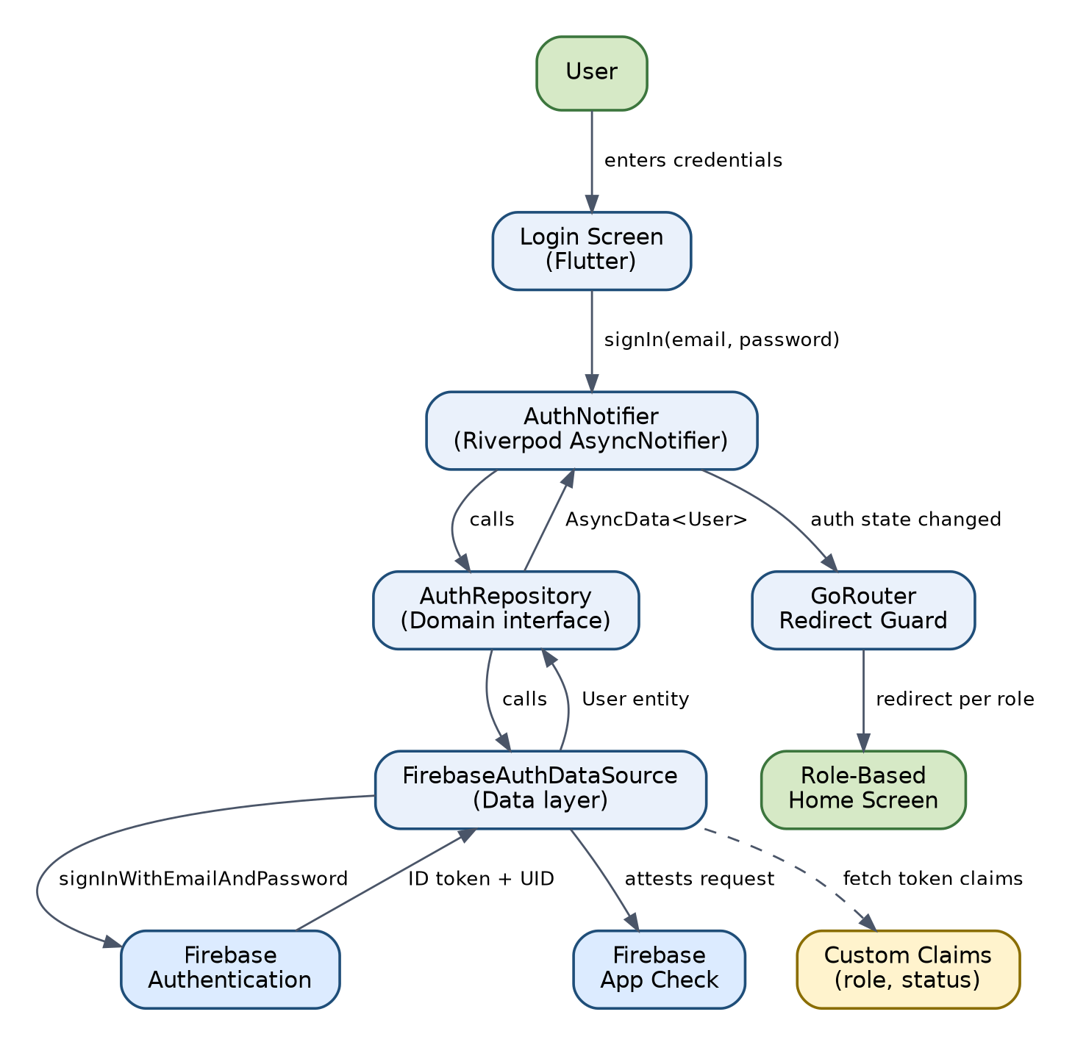
Figure 6 — Authentication Flow Diagram
Table 40 — AUTHENTICATION AND AUTHORIZATION DESIGN
Control | Design
Firebase Authentication | Email/password provider only, consistent with SRS Section 5.1 scope. AuthDataSource wraps FirebaseAuth.instance; no other identity provider is configured, matching the SRS's explicit scope.
Email Verification | New accounts require email verification before status can progress past Pending review readiness; unverified accounts older than 48 hours are purged by purgeUnverifiedRegistrations (Section 5.3).
Password Policy | Minimum 8 characters, at least one letter and one digit, enforced client-side for UX and re-validated by Firebase Authentication's own password policy configuration at the project level.
RBAC | Ten roles per SRS Section 7.2 (Guest through Super Admin), implemented as a single Dart enum UserRole shared by the Role Management Component (Section 3) across UI guards and mirrored in Firestore Security Rules.
Custom Claims | role and status are set as Firebase Auth custom claims (not merely Firestore fields) so Firestore/Storage Security Rules can evaluate them without an extra document read, and so they are cryptographically bound to the ID token.
Role Hierarchy | Modeled as an ordered enum with a numeric rank; higher-rank roles inherit all permissions of lower-rank roles within the same functional area, matching SRS Section 7.1's hierarchy diagram.
Route Guards | GoRouter's redirect callback inspects the current AuthNotifier state (authenticated?, role, status) before allowing navigation to any role-scoped route (Section 16).
Firestore Security Rules | Default-deny; each collection has an explicit allow rule keyed on request.auth.token.role and request.auth.token.status, structurally mirroring the Section 7.3 permission matrix and the Section 4.5 (of this document) validation rules.
Storage Security Rules | Path-based rules keyed on the same custom claims, e.g. /cnic_images/{uid}/* readable only by {uid} and national_admin+.
App Check | Initialized at app startup with Play Integrity (Android) / DeviceCheck (iOS) providers; enforced on all callable functions and on direct Firestore/Storage access, rejecting requests from unverified app instances (e.g., emulators, tampered builds, bots).

7. SECURITY ARCHITECTURE
This section explains how each SRS Section 14 (Security Requirements) control is realized in the design. It restates each control's design mechanism rather than re-deriving the requirement, which remains authoritative in the SRS.
Table 41 — SECURITY ARCHITECTURE
SRS Control | Design Mechanism
Authentication security (SR-001 - SR-005) | Firebase Authentication with App Check; session tokens auto-refresh every hour and are invalidated on role downgrade (SR-014).
Authorization (SR-013 - SR-015) | Custom-claim RBAC evaluated in three independent places: GoRouter guard (UX), Firestore/Storage Security Rules (data-layer enforcement), and Cloud Function role checks (privileged-operation enforcement) — defense in depth, so a bypass of any one layer alone is insufficient.
CNIC encryption (SR-006) | AES-256-GCM, performed exclusively inside Cloud Functions using a key fetched from Secret Manager at invocation time; the mobile client never holds or transmits the encryption key.
HMAC uniqueness lookup (FR-011, SR-006, BR-021) | Deterministic HMAC-SHA256(CNIC) computed server-side with a distinct key from the encryption key; used only as the cnic_lookup document ID, never persisted or logged in plaintext form.
Key management (SR-019 - SR-023) | Google Cloud Secret Manager, IAM-scoped per function service account; keys are versioned to support rotation without breaking previously encrypted records.
Data at rest | Google Cloud default encryption at rest for all Firestore/Storage data, plus application-level AES-256-GCM for CNIC specifically (defense in depth for the single most sensitive field).
Data in transit (SR-008) | TLS 1.3 minimum, enforced by the Firebase SDKs by default; no custom networking code bypasses this.
File upload security (SR-011) | Client-side extension/size checks for UX, authoritative server-side MIME-type validation in onDocumentUpload, with automatic deletion of files that fail validation.
XSS protection (SR-012) | Whitelist-based HTML sanitization of all rich-text content server-side before storage, and the Flutter rich-text renderer never evaluates raw HTML/JS.
Brute-force protection (SR-015) | Firebase Authentication's built-in rate limiting plus a 15-minute lockout after 5 consecutive failures.
Audit logging (SR-016 - SR-017) | Write-only-from-Cloud-Functions audit_logs collection (Section 3, Audit Logging Component); zero client write path, enforced by Firestore Security Rules.
Privacy (SR-009) | Analytics and reporting read only from analytics_aggregates (pre-aggregated, anonymized), never raw per-member fields.
OWASP Mobile Top 10 controls | Mapped one-to-one in SRS Section 14.7; this design satisfies each mapped item through the mechanisms listed above plus standard Flutter release-build hardening (--obfuscate, --split-debug-info, no debug flags in release builds per DEP-004).

8. UI ARCHITECTURE

8.1 Navigation
Navigation is centralized in a single GoRouter configuration (lib/routing/app_router.dart) rather than scattered Navigator.push calls, so route-level guards (Section 16) have one enforcement point.

8.2 Screen Hierarchy
Screens are organized by feature module (matching the 17 functional modules of SRS Section 5), each under lib/presentation/<module>/screens/. A shared AppShell widget provides the bottom navigation bar and role-aware drawer common to all authenticated screens.

8.3 Screen Inventory
Table 42 — UI ARCHITECTURE — Screen Inventory
Screen Group | Representative Screens | Primary Role(s)
Onboarding | Splash, Login, Register (multi-step), Email Verification Pending | Guest
Home / Dashboard | Member Home, Admin Dashboard (role-variant) | All authenticated roles
Profile | My Profile, Edit Profile, Renewal | Member and above
Events | Event List, Event Detail, My Registrations, Attendance Marking (admin) | Member and above; Coordinator+ for attendance
News | News Feed, Article Detail, Compose/Edit (admin) | All; Content Manager+ for compose
Documents & Gallery | Document List, Document Viewer, Gallery Albums | All, access-level filtered
Opportunities | Opportunity List, Opportunity Detail | All
Payments | Submit Payment Proof, Pending Verifications (admin) | Member; Coordinator+ for verification
Volunteer | Volunteer Application, Volunteer Directory (admin) | Approved Member and above (apply); National Admin and above (directory) — added this revision, see Component Design Section 3.16
Admin | Pending Approvals, User Management, Role Assignment, Analytics Dashboard, Audit Log Viewer | National Admin, President, Super Admin
Shared | Access Restricted, Offline Banner Overlay, Error/Empty States | All
Reports | Report Generator (report type, date range, preview, export) | Regional Coordinator and above — split out from the Admin row this revision for clarity, per the UI/UX Design & Wireframes document's dedicated UI-049 specification

8.4 Reusable Widgets
- PynpButton, PynpTextField, PynpCard — design-system primitives ensuring visual consistency (SRS Section 25 UI/UX design principles).
- AsyncValueWidget<T> — a generic wrapper that consumes an AsyncValue<T> and renders loading/data/error states consistently across every screen, so loading and error handling (Sections 14.7-14.8 below) are implemented once, not per screen.
- RoleGate — a widget that conditionally renders its child only if the current user's role satisfies a given permission, used to hide (not merely disable) UI the user cannot use.
- OfflineBanner — a persistent, unobtrusive connectivity indicator (NFR-OFF-05).

8.5 Forms
Multi-step forms (Registration) hold state in a dedicated Riverpod StateNotifier scoped to the form's lifetime, so navigating between steps does not lose entered data, and the whole form can be validated as a unit immediately before submission.

8.6 Validation
Field-level validators are pure Dart functions in lib/domain/validators/, shared between form field validators (immediate feedback) and, conceptually, the equivalent server-side checks in the corresponding Cloud Function — kept consistent by code review discipline since Dart and Node.js validators cannot literally share code across the client/server boundary.

8.7 Loading States
Every asynchronous provider exposes AsyncValue<T>; the AsyncValueWidget renders a skeleton/shimmer placeholder during .loading(), matching the shape of the eventual content to minimize layout shift.

8.8 Error States
Errors are categorized (network, validation, permission, not-found, unknown) by the exception-mapping layer described in Section 20, and each category has a distinct visual treatment and retry affordance where retrying is meaningful.

8.9 Accessibility
Implements SRS Section 25.3 (Accessibility Requirements): minimum touch target size 48x48dp, text scaling support via Flutter's MediaQuery.textScaleFactor, semantic labels on all interactive widgets for screen-reader support, and a minimum 4.5:1 contrast ratio enforced by the design system's color tokens.

8.10 Light/Dark Mode
Implemented via Flutter's ThemeMode.system by default with a manual override stored in local device preferences (not synced to Firestore, since it is a device-level UI preference, not application data).

9. STATE MANAGEMENT
The application uses Riverpod (flutter_riverpod / riverpod_generator) as its sole state-management and dependency-injection mechanism, replacing the need for a separate service-locator package.
Table 43 — STATE MANAGEMENT
Provider Type | Used For | Example
Provider<T> | Stateless dependencies — repository instances, use-case instances, constants. | final eventRepositoryProvider = Provider<EventRepository>((ref) => EventRepositoryImpl(ref.watch(firestoreProvider)));
StreamProvider<T> | Real-time Firestore listeners where the UI should update live (event lists, notification inbox unread count). | eventListStreamProvider watches the events collection query.
AsyncNotifierProvider<N, T> | Multi-step or user-triggered asynchronous operations with explicit loading/error/data state (sign-in, registration submission, event registration). | AuthNotifier extends AsyncNotifier<User?> with a signIn(email, password) method.
NotifierProvider<N, T> | Synchronous local UI state not requiring async (multi-step form field values, selected tab, filter selections). | RegistrationFormNotifier holding in-progress form field state.
FutureProvider<T> | One-shot asynchronous reads that do not need live updates (a single report generation call). | reportGenerationProvider(params).

Repository providers are the sole dependency-injection mechanism: a use case or notifier obtains its repository via ref.watch(xRepositoryProvider) rather than a constructor default, so tests can override the provider with a mock/fake implementation using ProviderScope's overrides parameter without touching production code (Section 27, Testing Architecture).
Every asynchronous provider surfaces AsyncValue<T>, which the AsyncValueWidget (Section 14.4) renders into the three UI states required across the app: loading (skeleton), error (categorized message + retry where applicable), and data (the actual content). This is the single mechanism used everywhere loading/error/success states appear in the UI, satisfying the consistency goal in Section 1.3 (Design Goals).
Provider scoping: most providers are declared at the root ProviderScope for app-lifetime singletons (repositories, AuthNotifier). Screen-scoped state (e.g., a form in progress) uses autoDispose so state is released when the user navigates away, preventing stale state from leaking into a later visit to the same screen.

10. NAVIGATION DESIGN
GoRouter provides declarative, URL-based routing with built-in deep-link support, configured in a single GoRouter instance built from a route tree matching the Screen Inventory (Section 14.3).
Table 44 — NAVIGATION DESIGN
Aspect | Design
Routes | Top-level routes per feature module (e.g., /events, /events/:eventId, /profile, /admin/approvals), declared with GoRoute and typed path parameters.
Nested Routes | The authenticated app shell (bottom navigation + drawer) is a ShellRoute wrapping all post-login routes, so the shell persists across navigation within it rather than rebuilding.
Authentication Guards | The router's top-level redirect callback checks AuthNotifier state on every navigation attempt: unauthenticated users attempting any route other than /login or /register are redirected to /login; authenticated users attempting /login are redirected to their role-appropriate home.
Role Guards | A second redirect check compares the target route's declared minimumRole (attached as route extra metadata) against the current user's role from custom claims; a failing check redirects to /access-restricted rather than allowing the destination screen to build and then fail on data access.
Deep Links | Configured via each platform's app-links mechanism (Android App Links / iOS Universal Links) so a notification tap (e.g., 'view this event') can deep-link directly into /events/:eventId, subject to the same auth/role guards as manual navigation.
Unauthorized Navigation Handling | Rather than throwing or silently no-op'ing, a blocked navigation attempt always resolves to a defined route (/login or /access-restricted) so the user is never left on a blank screen or stuck mid-transition.

11. DETAILED WORKFLOWS

11.1 Registration Workflow
Table 45 — DETAILED WORKFLOWS — Registration Workflow
Step | Action
1 | Guest opens the Registration screen and completes the multi-step form (personal details, CNIC, documents).
2 | Client-side validators check format/required fields as the user progresses through steps.
3 | On final submit, the client calls the submitRegistration Cloud Function with the complete payload and uploaded document references.
4 | The function computes the CNIC HMAC lookup and, in a single transaction, creates cnic_lookup, the Firebase Auth account, and the users document with status=Pending.
5 | A verification email is sent; the client navigates to an 'Email Verification Pending' screen.
6 | If the CNIC is a duplicate, the transaction fails and the client shows an inline duplicate-CNIC error without creating any account (FR-011).

11.2 Email Verification Workflow
Table 46 — DETAILED WORKFLOWS — Email Verification Workflow
Step | Action
1 | User taps the verification link sent to their email.
2 | Firebase Authentication marks the account's emailVerified flag true.
3 | On next app open, AuthNotifier detects the verified flag and updates local auth state.
4 | The user's application remains status=Pending and now appears in the admin Pending Approvals queue (unverified accounts are excluded from that queue).
5 | If verification is not completed within 48 hours, purgeUnverifiedRegistrations removes the account (Section 5.3).

11.3 Membership Approval Workflow
Table 47 — DETAILED WORKFLOWS — Membership Approval Workflow
Step | Action
1 | National Admin/President opens Pending Approvals and selects an application.
2 | Admin reviews submitted details and documents, then taps Approve.
3 | Client calls approveMembership; the Cloud Function validates the caller's role and the target's current status.
4 | On success, users/{uid}.status becomes Approved and membershipId/membershipType are assigned.
5 | onUserStatusChange fires: writes the audit entry and dispatches an approval notification to the applicant.
6 | The applicant's next app session reflects Approved status and unlocks member-only screens.

11.4 Membership Rejection Workflow
Table 48 — DETAILED WORKFLOWS — Membership Rejection Workflow
Step | Action
1 | Admin selects an application and taps Reject, entering a mandatory reason.
2 | Client calls rejectMembership with the reason; the function validates the reason is non-empty.
3 | users/{uid}.status becomes Rejected.
4 | onUserStatusChange fires: audit entry + rejection notification including the stated reason.
5 | The applicant may re-apply, creating a new Pending application (BR-012); the prior Rejected record is retained for audit history.

11.5 Membership Renewal Workflow
Table 49 — DETAILED WORKFLOWS — Membership Renewal Workflow
Step | Action
1 | Starting 60 days before membershipExpiryDate, sendRenewalReminders notifies the member on a fixed schedule (60/30/15/7 days).
2 | Member opens the Renewal screen, uploads payment proof, and calls submitRenewal.
3 | A renewal record is created linked to a new payments document.
4 | Admin verifies the payment via verifyPaymentProof (Payment Verification Workflow).
5 | Admin calls approveRenewal; membershipExpiryDate is extended by 12 months and status is reset to Approved if it had lapsed to Expired.
6 | If the grace period (15 days past expiry) lapses without renewal, enforceExpiredStatus sets status=Expired automatically.

11.6 Event Creation Workflow
Table 50 — DETAILED WORKFLOWS — Event Creation Workflow
Step | Action
1 | Coordinator or above opens Create Event and fills in title, description, date, location, and capacity.
2 | Client-side validation checks required fields and that eventDate is in the future.
3 | The event document is created directly by the client (permitted for this role tier by Firestore Security Rules), with currentRegistrations initialized to 0.
4 | The event becomes visible in the Event List to all authorized roles per its visibility setting.

11.7 Event Registration Workflow
Table 51 — DETAILED WORKFLOWS — Event Registration Workflow
Step | Action
1 | Member opens an event's detail screen and taps Register.
2 | Client calls registerForEvent(eventId).
3 | The Cloud Function transaction re-reads currentRegistrations, verifies capacity and deadline, then writes the event_registrations document and increments the counter.
4 | onEventRegistrationCreate fires: sends a registration confirmation notification.
5 | If capacity was filled by a concurrent registration between the member's screen load and their tap, the transaction fails and the client shows 'Event is now full'.

11.8 Event Attendance Workflow
Table 52 — DETAILED WORKFLOWS — Event Attendance Workflow
Step | Action
1 | During or after the event, Coordinator+ opens the event's attendee list.
2 | Admin marks each registrant as Attended or Absent.
3 | The corresponding event_registrations.attendanceStatus is updated directly (admin-tier write, permitted by Security Rules) — this update is captured by onAnyAuditableWrite.
4 | Attendance data feeds into the Reporting Component's event-attendance report.

11.9 Payment Proof Upload Workflow
Table 53 — DETAILED WORKFLOWS — Payment Proof Upload Workflow
Step | Action
1 | Member opens Submit Payment, selects the fee type, and uploads a proof image/PDF.
2 | The file is uploaded to Storage under a path scoped to the member's UID.
3 | onDocumentUpload validates the MIME type server-side; invalid files are deleted immediately.
4 | A payments document is created with status=Pending, referencing the validated Storage object.

11.10 Payment Verification Workflow
Table 54 — DETAILED WORKFLOWS — Payment Verification Workflow
Step | Action
1 | Admin/Coordinator opens the Pending Verifications queue (indexed query on payments.status).
2 | Admin reviews the proof and taps Verify or Reject.
3 | Client calls verifyPaymentProof(paymentId, decision).
4 | The function updates payments.status, writes an audit entry, and dispatches a notification to the member.
5 | If rejected, the member may re-upload a corrected proof, returning the record to Pending.

11.11 Notification Delivery Workflow
Table 55 — DETAILED WORKFLOWS — Notification Delivery Workflow
Step | Action
1 | A triggering event occurs (status change, scheduled reminder, admin broadcast).
2 | The relevant Cloud Function (trigger or scheduled) writes a notifications document for each affected user.
3 | The function sends an FCM push payload to the user's registered device token(s), and an email via the SMTP integration where the notification category requires it.
4 | The client's notification inbox StreamProvider updates live if the app is foregrounded; otherwise the OS displays the push notification and the inbox reflects it on next open.
5 | The user taps the notification/inbox item; the client marks it read and, where applicable, deep-links to the relevant screen (Section 16).

11.12 Opportunity Click Tracking Workflow
Table 56 — DETAILED WORKFLOWS — Opportunity Click Tracking Workflow
Step | Action
1 | Member opens the Opportunities list and taps an external listing.
2 | The client calls a lightweight Cloud Function (or direct increment via a narrowly-scoped Security Rule permitting only a FieldValue.increment on clickCount) to record the click.
3 | The client launches the external URL in an in-app or system browser via url_launcher after validating the https:// scheme.
4 | clickCount feeds the Opportunities section of the Analytics/Reporting components.

11.13 Document Download Workflow
Table 57 — DETAILED WORKFLOWS — Document Download Workflow
Step | Action
1 | User opens the Documents list, filtered client-side to items whose accessLevel matches their role.
2 | User taps a document; the client requests a download URL from Storage.
3 | Storage Security Rules independently verify the requester's role/accessLevel match before issuing the file — a client-side filtering bug cannot expose a restricted document.
4 | The file downloads and opens using the platform's default viewer via open_file.

11.14 Report Generation Workflow
Table 58 — DETAILED WORKFLOWS — Report Generation Workflow
Step | Action
1 | Coordinator+ opens Reports, selects a report type, date range, and filters.
2 | The client issues a composite-indexed Firestore query (Section 4.5) scoped to the selected range.
3 | Results are paginated; if the estimated read count would exceed the configured budget, the client prompts the user to narrow the range before executing.
4 | The formatted report renders in-app and can be exported (PDF/CSV) using a client-side generation library.

11.15 Role Assignment Workflow
Table 59 — DETAILED WORKFLOWS — Role Assignment Workflow
Step | Action
1 | Super Admin opens User Management and selects a user.
2 | Super Admin selects a new role and confirms.
3 | Client calls updateUserRole; the function rejects the change if it would remove the last super_admin.
4 | Custom claims are updated and the target user's refresh tokens are revoked, forcing a claims refresh within one session.
5 | An audit entry records the before/after role.

11.16 Audit Logging Workflow
Table 60 — DETAILED WORKFLOWS — Audit Logging Workflow
Step | Action
1 | Any create/update/delete on an auditable collection occurs (via a callable function or a direct admin-tier client write).
2 | The corresponding trigger (onUserStatusChange, onAnyAuditableWrite, or an explicit in-function write for callable functions that own their own audit semantics) captures actor UID, action type, target document, and before/after values where applicable.
3 | The entry is written to audit_logs, which permits no client update or delete under any role.
4 | National Admin/Super Admin can query and filter the audit trail from the Admin console, indexed by userId + timestamp (Section 4.5).

11.17 Volunteer Application Workflow (Added This Revision)
Table 61 — DETAILED WORKFLOWS — Volunteer Application Workflow (Added This Revision)
Step | Action
1 | Approved Member opens the Volunteer Application screen (UI-040) from the drawer.
2 | Member selects a volunteer role and one or more availability slots.
3 | Client calls submitVolunteerApplication(role, availability).
4 | The function rejects the call if the caller already has a pending or approved application (single-active-application rule, Section 3.16); otherwise it creates a volunteers document with status=pending.
5 | The screen replaces the form with a "Pending Review" status banner (UI/UX Design & Wireframes document, Section 8, UI-040).

11.18 Volunteer Approval Workflow (Added This Revision)
Table 62 — DETAILED WORKFLOWS — Volunteer Approval Workflow (Added This Revision)
Step | Action
1 | National Admin (or above) opens the Volunteer Directory screen (UI-041) or a pending-applications view.
2 | Admin reviews the application and taps Approve or Reject.
3 | Client calls approveVolunteerApplication or rejectVolunteerApplication(applicationId, decision).
4 | The function validates the application is currently pending, updates its status, and writes an audit_logs entry.
5 | The Notification System Component dispatches an approval/rejection notice to the applicant (SRS FR-057).
6 | On approval, the applicant appears in the Volunteer Directory (UI-041); on rejection, the applicant may submit a new application.

12. SEQUENCE DIAGRAMS
This section presents sequence diagrams for the workflows most critical to correctness and security. Each corresponds directly to the numbered steps in Section 11.
Registration Sequence (Section 11.1):
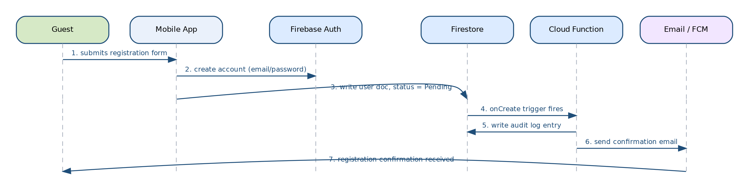
Figure 7 — Registration Sequence Diagram
Membership Approval Sequence (Section 11.3):
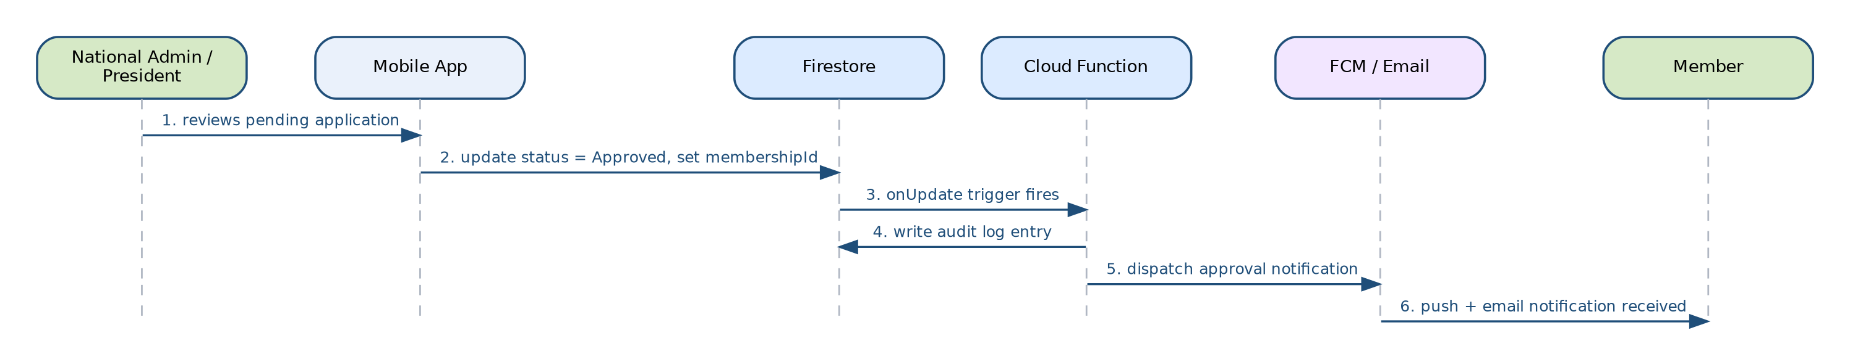
Figure 8 — Membership Approval Sequence Diagram
Event Registration Sequence (Section 11.7):
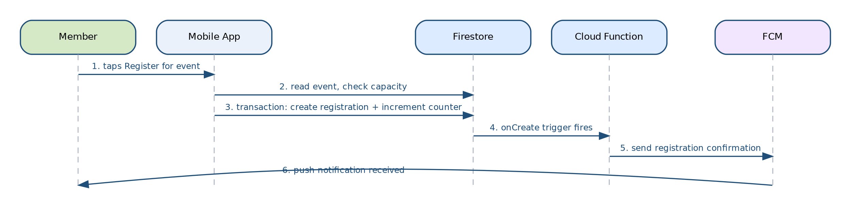
Figure 9 — Event Registration Sequence Diagram
Payment Verification Sequence (Section 11.10):
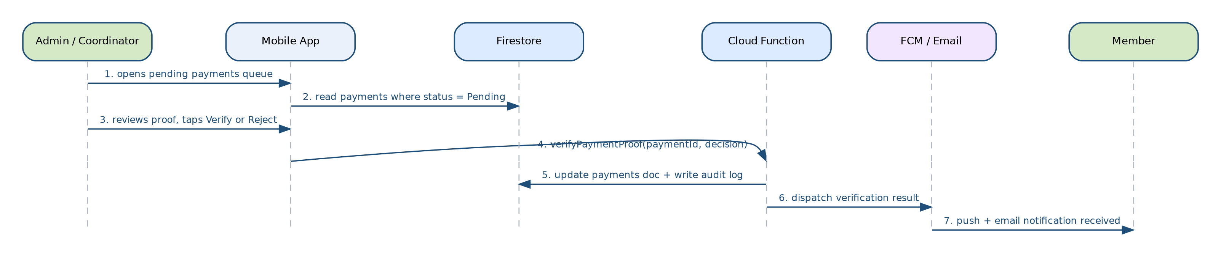
Figure 10 — Payment Verification Sequence Diagram
Notification Dispatch Sequence (Section 11.11):
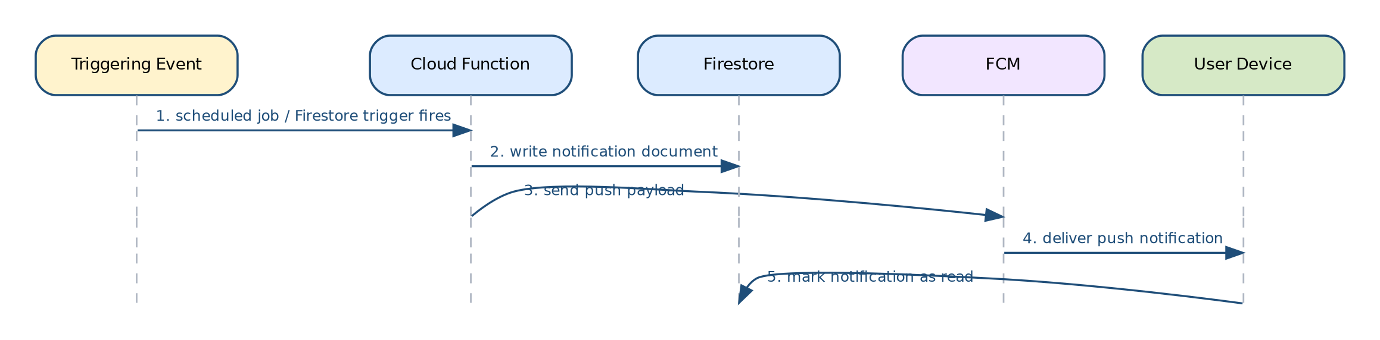
Figure 11 — Notification Dispatch Sequence Diagram

13. STATE DIAGRAMS

13.1 Membership Lifecycle
Implemented exactly as specified in SRS Section 9.1; enforced authoritatively by the approveMembership/rejectMembership/enforceExpiredStatus Cloud Functions (Section 5), never by direct client writes to the status field.
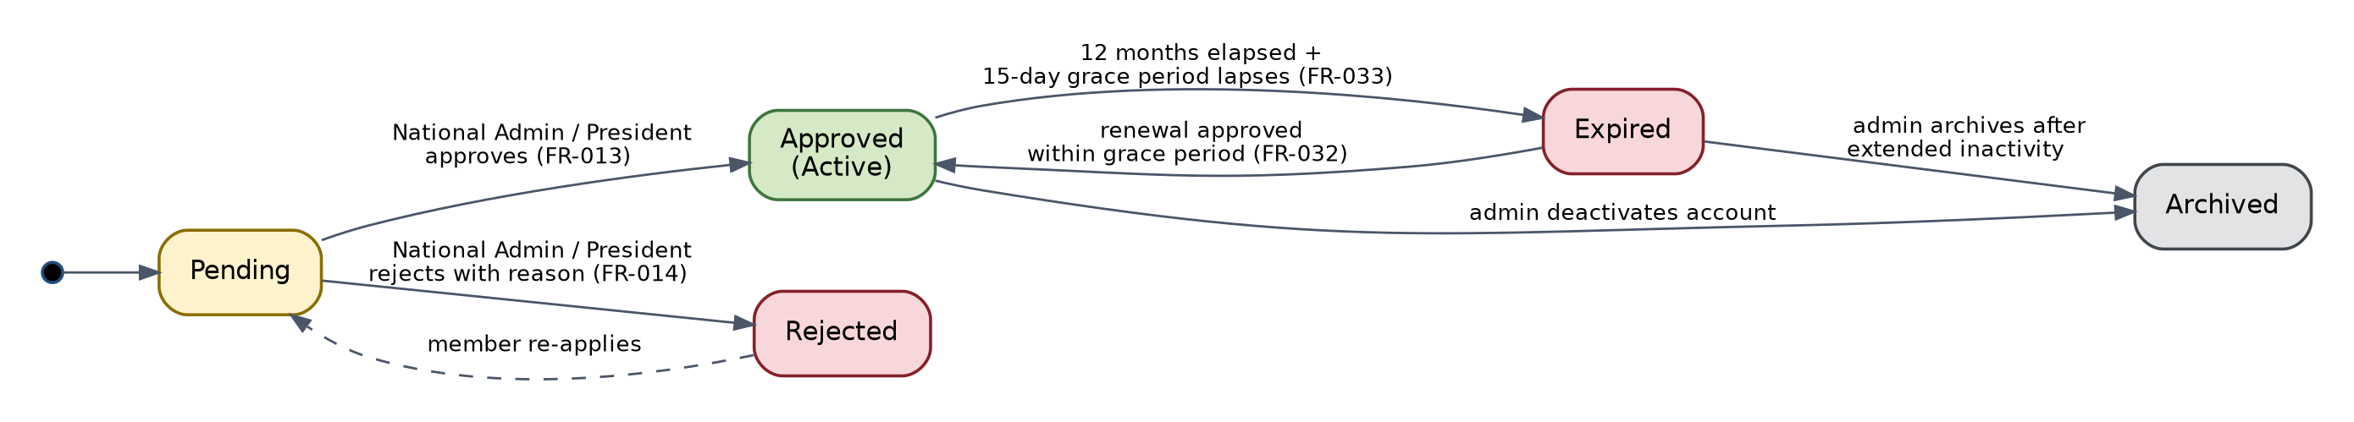
Figure 12 — Membership Lifecycle State Diagram

13.2 Payment Lifecycle
Implemented exactly as specified in SRS Section 9.2; enforced by verifyPaymentProof.
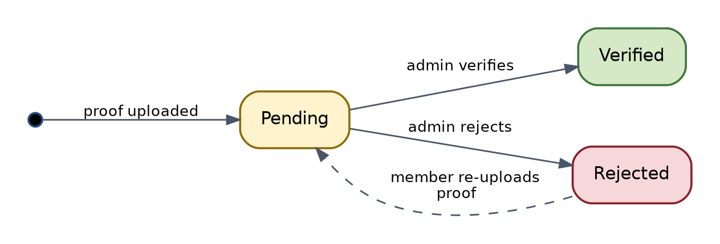
Figure 13 — Payment Lifecycle State Diagram

13.3 Event Registration Lifecycle
Implemented exactly as specified in SRS Section 9.3; enforced by registerForEvent / cancelEventRegistration and the attendance-marking admin action.
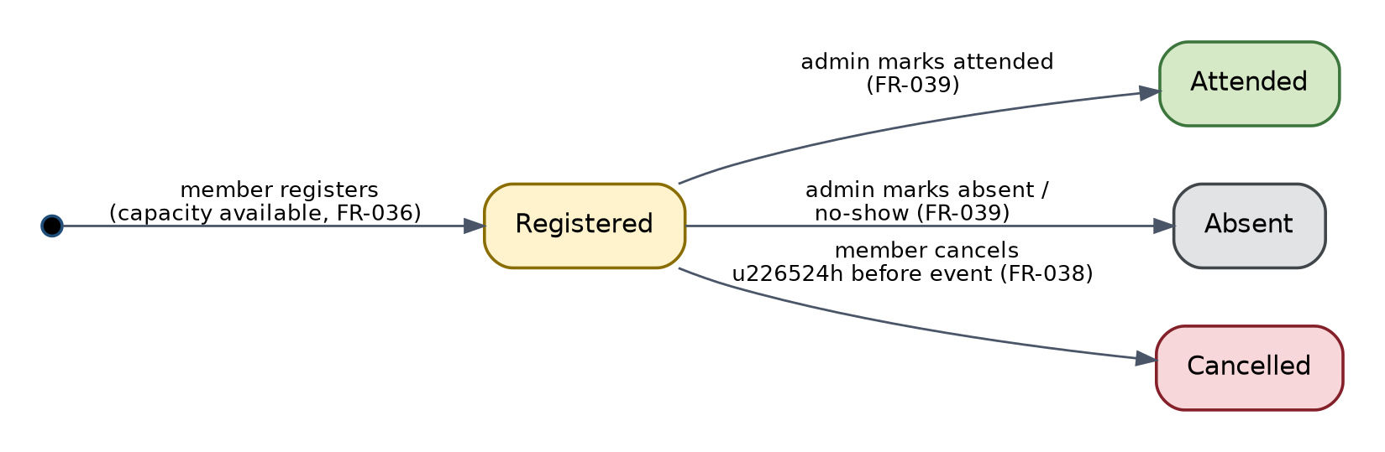
Figure 14 — Event Registration Lifecycle State Diagram

13.4 Event Lifecycle
An event itself moves through Draft (optional, admin-only visibility) -> Published (visible per audience settings) -> Registration Closed (deadline passed, no new registrations accepted, existing registrations unaffected) -> Completed (event date has passed; attendance marking enabled) -> Archived (retained for historical reporting). This lifecycle is presentation-level state derived from eventDate and registrationDeadline fields rather than a separately stored status enum, since it is fully computable from existing data (SRS Section 12.5).

13.5 Notification Lifecycle
A notification document moves through Created (written by a Cloud Function) -> Delivered (FCM/email dispatch attempted) -> Read (client marks read on user interaction). Delivery failure does not remove the Created state — the in-app inbox entry remains the durable record regardless of push/email delivery outcome, consistent with the Notification System Component's error-handling design (Section 3).

13.6 Volunteer Application Lifecycle (Added This Revision)
A volunteers document moves through Pending (created by submitVolunteerApplication) -> Approved or Rejected (via approveVolunteerApplication / rejectVolunteerApplication, National Admin+ only) -> for Rejected, the applicant may submit a new application, creating a new document rather than reopening the old one, mirroring the Membership Rejected -> re-apply pattern (Section 13, Membership Lifecycle). This lifecycle is enforced by the same single-active-application rule described in the Volunteer Management Component (Section 3.16): a new submitVolunteerApplication call is rejected while a Pending or Approved application already exists for that member.

14. ERROR HANDLING ARCHITECTURE
Every error surfaced to the UI is first classified into one of five categories by a shared ExceptionMapper (lib/core/error/exception_mapper.dart), which every repository implementation routes exceptions through before they reach a Riverpod provider's AsyncValue.error state. This guarantees the Presentation layer never handles a raw FirebaseException or PlatformException directly.
Table 63 — ERROR HANDLING ARCHITECTURE
Category | Example Source Errors | UI Behavior | Retry Behavior | Logging
Network | SocketException, FirebaseException(unavailable), TimeoutException | Banner: "You appear to be offline" + cached content if available (Section 15) | Automatic retry on connectivity restore (via connectivity_plus listener) or manual retry button | Application log at WARN — not alertable unless sustained
Validation | Cloud Function INVALID_ARGUMENT, client-side validator failure | Inline field-level error message | None — user must correct input | Not logged (expected, high-frequency, non-error condition)
Permission | Cloud Function PERMISSION_DENIED, Firestore permission-denied | "You don't have permission to do this" + navigate back; for navigation-time checks, redirect to /access-restricted (Section 16) | None | Application log at WARN; repeated occurrences from the same user are alertable (possible tampered client)
Not Found / Conflict | Cloud Function NOT_FOUND / FAILED_PRECONDITION / RESOURCE_EXHAUSTED (e.g., event full, duplicate CNIC) | Specific contextual message (e.g., "Event is now full", "This CNIC is already registered") | None automatic; user chooses a different action | Not logged as an error (expected business-rule outcome)
Unknown / Internal | Cloud Function INTERNAL, uncaught exceptions | Generic "Something went wrong, please try again" + Crashlytics non-fatal report | Manual retry button | Application log at ERROR; Crashlytics captures stack trace (Section 25)

SRS Section 22 (Error Handling Requirements) error codes/scenarios are each mapped to exactly one of the five categories above at the point the corresponding Cloud Function or client validator raises the error, so the mapping stays centralized rather than duplicated per screen.

15. OFFLINE AND CONNECTIVITY DESIGN
This design implements the SRS Section 15 offline capability matrix exactly. Firestore's built-in offline persistence (Settings(persistenceEnabled: true)) is enabled for all collections readable by the current role, providing the cached-read behavior automatically.
Table 64 — OFFLINE AND CONNECTIVITY DESIGN
Behavior | Design Mechanism
Cached Reads | Firestore local cache serves reads transparently when offline; StreamProviders continue to emit the last-known snapshot with a fromCache flag the UI can optionally surface.
Offline Drafts | Multi-step form state (e.g., an in-progress registration or profile edit) lives in a Riverpod NotifierProvider backed by nothing more than in-memory state for the current session — per SRS constraints, this is not persisted to on-device storage beyond the current app session, consistent with the mobile client not maintaining a secondary local database.
Queued Operations | Only the operations SRS Section 15.1 marks as queueable (e.g., profile field edits, event registration/cancellation) are allowed to use Firestore's default offline write queue; these use plain document writes, not callable Cloud Functions, since callable functions require a live connection by definition.
Operations Requiring Connectivity | Registration, payment proof upload, membership approval/rejection, and any operation implemented as a callable Cloud Function are gated behind a connectivity check (connectivity_plus) in the corresponding UI, with the control disabled and an explanatory tooltip/message when offline (NFR-OFF-04).
Conflict Handling | Queued writes that depend on a server-side invariant (event capacity) are, per the SRS's explicit design choice, not implemented as plain queued Firestore writes but as callable functions requiring connectivity — this sidesteps client-side conflict resolution entirely for capacity-sensitive operations, since the transaction can only run once connectivity is available (NFR-OFF-02).
Synchronization | Firestore's SDK synchronizes the local write queue automatically on reconnect; the app listens for pending-writes-cleared events to remove any "pending sync" indicator from the affected UI element.

16. PERFORMANCE DESIGN
Maps directly to the SRS Section 24 performance targets.
Table 65 — PERFORMANCE DESIGN
SRS Target Area | Design Technique
List screen load time | Pagination via Firestore query cursors (startAfter/limit), default page size tuned per screen (typically 20 items), rather than loading full collections.
Query latency at scale | Composite indexes (Section 4.5) for every filtered/sorted query used in production code paths; ad-hoc unindexed queries are disallowed by code review.
Repeated data access | Riverpod's provider caching means a given repository call is not re-issued on every widget rebuild; StreamProviders keep one live listener per query shared across all subscribing widgets.
Event/registration counters | Denormalized counters (Section 4.4) avoid a full collection count query on every list render.
Media load time | Client-side image compression before upload (Media Gallery Component, Section 3) and server-generated thumbnails so list views never transfer full-resolution originals.
Perceived responsiveness | Lazy loading of below-the-fold list content and of the media gallery grid using Flutter's built-in lazy ListView.builder/GridView.builder.
Server-side computation cost | Expensive aggregation (Analytics Component) is precomputed nightly by a Cloud Function rather than computed on-demand per dashboard view.

17. SCALABILITY DESIGN
Firestore and Cloud Functions scale horizontally by default, which covers the majority of the SRS Section 23 scalability requirement without custom design. The specific design choices that support scaling predictably as PYNP's membership grows are:
- Stateless Cloud Functions: every function reads all needed state from Firestore/Secret Manager per invocation rather than holding in-memory state between calls, so Cloud Functions can scale to any number of concurrent instances without coordination.
- Pagination everywhere (Section 22) bounds per-request cost independent of total collection size.
- Composite indexes (Section 4.5) keep query cost roughly logarithmic in collection size rather than linear.
- Counters and aggregates (Sections 4.4, 4.9-4.10) avoid full-collection scans on every dashboard/list render as the member base grows into the thousands.
- The documented future optimization path (sharded counters, Section 4.9) is noted explicitly rather than pre-built, since PYNP's SRS Section 23 targets do not currently require it — avoiding speculative complexity.

18. BACKUP AND DISASTER RECOVERY
Implements SRS Section 21 (Backup, Retention, and Disaster Recovery) directly; this design does not introduce any different RPO/RTO target than the SRS specifies.
Table 66 — BACKUP AND DISASTER RECOVERY
Aspect | Design
Backup Strategy | Automated daily Firestore managed export (gcloud firestore export) to a dedicated, access-restricted Cloud Storage bucket, scheduled via Cloud Scheduler + a lightweight Cloud Function wrapper (BDR-004).
Storage Versioning | Object versioning enabled on the Firebase Storage bucket for CNIC images, payment proofs, and documents (BDR-005), protecting against accidental overwrite/deletion.
Restore Process | gcloud firestore import against a target project (first tested in a non-production project), followed by a validation pass comparing document counts per collection against the pre-restore export manifest.
RPO | 24 hours, aligned with the daily export schedule (BDR-008) — matches SRS BDR-008 exactly.
RTO | 8 business hours (BDR-009), covering Firestore data restore and Cloud Functions redeployment from source control — matches SRS BDR-009 exactly.
Retention | Backup exports retained per BDR-001/BDR-002 policy; audit_logs specifically retained a minimum of 3 years regardless of the general backup retention window, since audit data has a longer, independent retention requirement.
Failure Scenarios | (1) Accidental data deletion — restore the affected collection(s) from the most recent export; (2) Firebase project-level outage — Google-managed multi-region redundancy applies automatically, no PYNP-side action; (3) Compromised Secret Manager key — rotate the key (SR-022) and re-encrypt affected CNIC fields in a controlled migration, run during a maintenance window.
Runbook Ownership | [TBD — requires PYNP stakeholder confirmation], per SRS BDR-010 — not assumed by this design.

19. LOGGING AND MONITORING
Implements SRS Sections 19-20 (Monitoring and Logging), keeping four log categories structurally separate so a single stream is never overloaded with unrelated data:
Table 67 — LOGGING AND MONITORING
Log Category | Store | Contents | Access
Audit Logs | Firestore audit_logs collection | Business-significant actions: status changes, role changes, CNIC access, payment verification — immutable, retained 3+ years (SR-016, BDR-002) | national_admin, super_admin (in-app Audit Log Viewer)
Application Logs | Google Cloud Logging | Cloud Function execution logs: invocation, duration, outcome, non-PII error detail (MON-005, MON-006) | Technical stakeholders via Cloud Console; 90-day default retention (BDR-003)
Security Logs | Google Cloud Audit Logs (IAM/Secret Manager access) + Firestore Security Rules denial logs | Secret Manager access events (SR-023), rule-denial patterns feeding MON-002 | Super Admin / designated technical stakeholder
Performance Monitoring | Firebase Performance Monitoring + Cloud Monitoring | API/query latency, cold-start time, screen render time | Technical stakeholders
Crash Monitoring | Firebase Crashlytics | Uncaught exceptions, non-fatal errors reported by the Unknown/Internal error category (Section 14) | Technical stakeholders
Alerting | Cloud Monitoring alert policies | Elevated Cloud Function error rate, sustained security-rule denials, failed nightly aggregation/backup jobs (MON-001-MON-004) | On-call channel — [TBD, per SRS MON-004]

20. DEPLOYMENT ARCHITECTURE
Implements SRS Section 19 (Deployment and Environments); Figure 4 (Section 2.10) shows the topology.
Table 68 — DEPLOYMENT ARCHITECTURE
Environment | Firebase Project | Purpose | Access
Development | pynp-dev | Local development against the Firebase Emulator Suite where possible; pynp-dev used for integration testing against real (non-production) Firebase services. | Individual developers
Testing | pynp-dev / Emulator Suite | Automated unit, widget, and integration test runs in CI (Section 27) — the Emulator Suite is preferred here to keep test runs fast and free of shared-state flakiness. | CI pipeline
Staging | pynp-staging | Pre-production verification mirroring production Security Rules and Cloud Function configuration. | Internal testers, QA
Production | pynp-prod | Live system. | Public end users

Table 69 — DEPLOYMENT ARCHITECTURE
Aspect | Design
Configuration Management | Environment-specific, non-secret configuration (API endpoints, feature flags) via Firebase Remote Config per environment (DEP-008); each environment has its own google-services.json / GoogleService-Info.plist, excluded from source control (DEP-009).
Secrets | CNIC encryption/HMAC keys and any other cryptographic secrets are stored per-environment in Google Cloud Secret Manager, never in Remote Config or source control (Section 7 of this document, SR-019).
CI/CD | A pipeline (tool choice [TBD — requires PYNP stakeholder confirmation] per SRS DEP-007) runs static analysis (dart analyze), unit/widget tests, and builds on every push; deploys Cloud Functions and Security Rules to Staging on merge to main, and to Production only on a tagged release after Staging sign-off (DEP-005).
Release Process | Semantic versioning; internal testing track (Staging) before public release track (Production), per DEP-006.
Android Deployment | Release builds signed with the production keystore, built with --obfuscate --split-debug-info (DEP-004), distributed via Google Play's internal testing track then production track.
iOS Deployment | Release builds signed with the production distribution certificate, distributed via TestFlight then the App Store, following Apple's standard review process.

21. TESTING ARCHITECTURE
Implements SRS Section 33 (Testing Considerations).
Table 70 — TESTING ARCHITECTURE
Test Level | Scope | Tooling
Unit Testing | Domain-layer use cases, validators, and mappers, tested in isolation with mocked repository interfaces (Riverpod's ProviderScope overrides). | package:test, mocktail
Widget Testing | Individual screens and reusable widgets (Section 14.4), verifying rendering for each AsyncValue state (loading/data/error) and role-gated visibility (RoleGate). | flutter_test
Integration Testing | End-to-end flows (registration, event registration, approval) run against the Firebase Emulator Suite so no real production/staging data is touched. | integration_test package + Firebase Emulator Suite
Firebase Emulator Suite | Local emulation of Auth, Firestore, Storage, and Functions used for both integration tests and Security Rules tests, avoiding any test run against live Firebase projects. | firebase-tools emulators
Security Rules Testing | Automated tests asserting, for each collection, that unauthorized roles are denied and authorized roles are permitted — including the explicit assertion that no client role can write to audit_logs or cnic_lookup. | @firebase/rules-unit-testing
Performance Testing | Load testing with simulated concurrent users against the Emulator Suite / a Staging project, per SRS Section 33.5 targets (500 concurrent users, 3-second API response). | Custom test harness + Firebase Emulator Suite
UAT | Manual scenario-based testing with real PYNP stakeholders covering all six critical use cases and fifteen user stories, per SRS Section 33.6. | Manual, PYNP-led

22. FILE AND FOLDER STRUCTURE
The project follows Clean Architecture with a feature-first organization inside the Presentation layer, so a developer working on one SRS functional module (e.g., Events) finds all of that module's screens, widgets, and providers together, while shared cross-feature code stays out of any single feature's folder.
lib/
core/ # Cross-cutting utilities shared by every feature
error/ # ExceptionMapper, Failure types (Section 20)
theme/ # Design tokens, light/dark ThemeData (Section 14.10)
utils/ # Formatters, extensions, connectivity helper
constants/ # Role enum, permission matrix map (Section 3, Role Management)
domain/ # Pure Dart — no Firebase imports
entities/ # User, Event, Registration, Payment, ...
repositories/ # Abstract repository interfaces
usecases/ # One class per business operation
validators/ # Shared field validators (Section 14.6)
data/ # Firebase-aware implementations
datasources/ # Firestore, Storage, Functions, Auth data sources
models/ # DTOs with fromFirestore/toFirestore (Section 4.3)
repositories/ # Repository implementations (fulfil Domain interfaces)
presentation/
<feature>/ # One folder per SRS functional module (auth, registration, events, ...)
screens/
widgets/
providers/ # Riverpod providers scoped to this feature
shared_widgets/ # PynpButton, PynpTextField, AsyncValueWidget, RoleGate, OfflineBanner (Section 14.4)
app_shell.dart # Bottom nav + drawer shell used by ShellRoute
routing/
app_router.dart # GoRouter configuration (Section 16)
route_guards.dart # Auth/role redirect logic
services/
firebase_options.dart # Per-environment Firebase config (generated by FlutterFire CLI)
notification_service.dart # FCM registration/handling glue
shared/
providers/ # App-lifetime providers (firestoreProvider, authProvider, etc.)
main.dart # App entrypoint — App Check init, ProviderScope, MaterialApp.router
functions/ # Cloud Functions (Node.js) — separate deployable unit
src/
callable/ # submitRegistration, approveMembership, ... (Section 5.1)
triggers/ # onUserStatusChange, onDocumentUpload, ... (Section 5.2)
scheduled/ # sendRenewalReminders, enforceExpiredStatus, ... (Section 5.3)
lib/ # Shared helpers: Secret Manager client, HMAC/AES utilities, audit-log writer
firestore.rules # Security Rules (Section 6, Section 13)
storage.rules # Storage Security Rules (Section 6, Section 13)
firestore.indexes.json # Composite indexes (Section 4.5)
test/ # Unit + widget tests, mirroring lib/ structure
integration_test/ # End-to-end tests against the Emulator Suite
Table 71 — FILE AND FOLDER STRUCTURE
Folder | Purpose
core/ | Cross-cutting concerns with no business meaning of their own: error mapping, theming, formatting utilities, and the shared role/permission constants used by every feature.
domain/ | The Clean Architecture Domain layer — entities, repository interfaces, use cases, validators. No Firebase or Flutter UI imports, so it is trivially unit-testable and would survive a hypothetical future backend change.
data/ | The Clean Architecture Data layer — every direct Firebase SDK call lives here, isolated behind the repository interfaces the Domain layer defines.
presentation/<feature>/ | One folder per SRS functional module, containing that module's screens, widgets, and Riverpod providers — mirrors the Screen Inventory (Section 14.3) and Component Design (Section 3) directly.
presentation/shared_widgets/ | Design-system primitives and cross-feature reusable widgets (Section 14.4).
routing/ | The single GoRouter configuration and its guard logic (Section 16).
services/ | Thin glue modules for platform/Firebase integration that isn't itself a repository (FCM registration, generated Firebase config).
shared/providers/ | App-lifetime Riverpod providers that many features depend on (the Firestore instance, the current-user provider).
functions/ | The entire Cloud Functions codebase, deployed independently of the Flutter app, organized by the same callable/trigger/scheduled categories as Section 5 of this document.
firestore.rules, storage.rules, firestore.indexes.json | Declarative security and indexing configuration, version-controlled alongside the code that depends on them.

23. DESIGN-TO-REQUIREMENT TRACEABILITY
Table 2 maps each major design component to the SRS requirement IDs it implements. This is a design-level traceability map; the authoritative requirement-to-test-case trace remains the SRS Section 31 Requirements Traceability Matrix, which this table does not duplicate.
Table 72 — DESIGN-TO-REQUIREMENT TRACEABILITY
Design Component | SRS Requirement IDs Implemented
Authentication Component (Section 3.1) | FR-001–FR-008, SR-001–SR-005, SR-008, SR-013–SR-015
Registration Component (Section 3.2) | FR-009–FR-018, FR-011, SR-006, SR-006a, SR-011, BR-021
Membership Management Component (Section 3.3) | FR-019–FR-023, FR-030–FR-033, SR-016
Event Management Component (Section 3.4) | FR-036–FR-040
Notification System Component (Section 3.5) | FR-045–FR-049
News/Content Management Component (Section 3.6) | News/Announcements module (SRS 5.7), SR-012
Document Management Component (Section 3.7) | Documents module (SRS 5.9), SR-007, SR-011
Media Gallery Component (Section 3.8) | Media Gallery module (SRS 5.10)
Opportunities Component (Section 3.9) | Opportunities module (SRS 5.12)
Payments Component (Section 3.10) | Payments module (SRS 5.15)
Audit Logging Component (Section 3.11) | SR-016, SR-017
Analytics Component (Section 3.12) | Analytics module (SRS 5.13), SR-009
Reporting Component (Section 3.13) | Reports module (SRS 5.14)
Administration Component (Section 3.14) | Administration module (SRS 5.17), SR-014
Role Management Component (Section 3.15) | SRS Section 7 (all role/permission requirements)
cnic_lookup / HMAC design (Section 4, Section 7) | FR-011, SR-006, SR-006a, BR-021
Secret and Key Management design (Section 7) | SR-019–SR-023
Offline and Connectivity Design (Section 15) | NFR-OFF-01–NFR-OFF-05
Backup and Disaster Recovery design (Section 18) | BDR-001–BDR-010
Logging and Monitoring design (Section 19) | MON-001–MON-007
Deployment Architecture design (Section 20) | DEP-001–DEP-009
API / Cloud Function Design (Section 5) | Section 17 of the SRS (Cloud Function Interface Catalog), in full
Volunteer Management Component (Section 3.16, added this revision) | FR-056–FR-058
sendBroadcastNotification (Section 5.1, added this revision) | FR-043
news_articles / volunteers / gallery_albums / gallery_media collections (Section 4.2, added this revision, Proposed) | FR-042–FR-044, FR-054–FR-058

24. DESIGN DECISIONS AND RATIONALE

24.1 Clean Architecture over a simpler layered approach
Table 73 — DESIGN DECISIONS AND RATIONALE — Clean Architecture over a simpler layered approach
Aspect | Description
Decision | Adopt full Clean Architecture (Presentation/Domain/Data) with the Repository Pattern, as mandated by the project's technology constraints.
Alternatives Considered | A simpler two-layer split (UI + Firebase calls directly in widgets); MVC.
Reason Selected | SRS Section 21.1 (Technical Constraints) explicitly requires Clean Architecture and the Repository Pattern; it also keeps the Domain layer independently testable and Firebase-call-free, satisfying the unit-testing goals of Section 27.
Trade-offs | More boilerplate (interfaces, DTOs, mappers) per feature than directly calling Firestore from a widget would require; accepted as a deliberate cost for testability and long-term maintainability on a project with a defined multi-year lifespan.

24.2 HMAC-SHA256 lookup collection over alternative uniqueness mechanisms
Table 74 — DESIGN DECISIONS AND RATIONALE — HMAC-SHA256 lookup collection over alternative uniqueness mechanisms
Aspect | Description
Decision | Use a dedicated cnic_lookup collection keyed by a deterministic HMAC-SHA256 of the CNIC to enforce uniqueness, rather than any comparison of the encrypted or plaintext CNIC.
Alternatives Considered | (a) Store CNIC in plaintext for direct uniqueness queries; (b) use a non-keyed hash (e.g., plain SHA-256) for the lookup; (c) enforce uniqueness only client-side.
Reason Selected | Plaintext storage was rejected outright by SRS SR-006/BR-021. A non-keyed hash would be brute-forceable offline against the small, guessable 13-digit CNIC space if the lookup collection were ever exposed; keying the HMAC with a Secret-Manager-held key prevents that. Client-side-only enforcement cannot prevent a modified client from bypassing the check.
Trade-offs | Requires an additional Firestore document and a Secret Manager dependency in the registration path; accepted because the security property (no plaintext CNIC exposure, no brute-forceable lookup) is a hard SRS requirement.

24.3 Riverpod over Provider or BLoC
Table 75 — DESIGN DECISIONS AND RATIONALE — Riverpod over Provider or BLoC
Aspect | Description
Decision | Use Riverpod (AsyncNotifier/Notifier/Stream/Future providers) as the sole state-management solution.
Alternatives Considered | provider package; flutter_bloc; GetX.
Reason Selected | SRS's technology list specifies Riverpod explicitly. Independently, Riverpod's compile-time-safe provider graph and built-in AsyncValue loading/error/data modeling directly satisfy the Section 1.4 design principle of explicit state and the Section 27 testability goal (providers are trivially overridable in tests without a widget tree).
Trade-offs | A steeper learning curve than plain Provider for contributors unfamiliar with it; mitigated by consistent, documented provider-type conventions (Section 15).

24.4 GoRouter over Navigator 1.0 / imperative navigation
Table 76 — DESIGN DECISIONS AND RATIONALE — GoRouter over Navigator 1.0 / imperative navigation
Aspect | Description
Decision | Use GoRouter with a centralized, declarative route tree and redirect-based guards.
Alternatives Considered | Imperative Navigator.push/pop calls scattered per screen; auto_route.
Reason Selected | SRS's technology list specifies GoRouter. It also centralizes auth/role guard logic in one place (Section 16) rather than requiring every screen to remember to check permissions itself, and it provides first-class deep-link support needed for notification tap-through (Section 11.11).
Trade-offs | Route configuration is more upfront work than ad-hoc navigation calls; accepted for the centralized-guard and deep-link benefits.

24.5 Cloud Functions for all security-sensitive writes, not Firestore Security Rules alone
Table 77 — DESIGN DECISIONS AND RATIONALE — Cloud Functions for all security-sensitive writes, not Firestore Security Rules alone
Aspect | Description
Decision | Route CNIC handling, membership status transitions, role changes, and payment verification through callable Cloud Functions rather than relying solely on Firestore Security Rules to gate direct client writes.
Alternatives Considered | Enforce all business rules purely declaratively in Security Rules, allowing direct client writes to collections like users.
Reason Selected | Security Rules can validate document shape and simple field-level conditions but cannot: compute an HMAC, access Secret Manager, perform multi-document transactional consistency with business-rule branching, or call an external SMTP service. Cloud Functions were necessary for these operations regardless of preference.
Trade-offs | Adds function cold-start latency (typically under 1 second for this function size, within SRS Section 24 targets) compared to a direct client write; accepted since these are inherently sensitive, lower-frequency operations, not high-frequency reads.

24.6 Denormalized counters over live aggregation queries
Table 78 — DESIGN DECISIONS AND RATIONALE — Denormalized counters over live aggregation queries
Aspect | Description
Decision | Maintain currentRegistrations and clickCount as denormalized fields updated transactionally, rather than computing them via a live COUNT-style query on every render.
Alternatives Considered | Firestore's count() aggregation query (available in modern Firestore) called live on every list render.
Reason Selected | Even though count() queries exist, they still cost a read operation and added latency on every list render at scale; a denormalized field is a single field read already included in the parent document fetch, better satisfying the Section 22/24 performance targets.
Trade-offs | Requires careful transactional discipline to avoid drift (Section 4.4); mitigated by updating counters only from Cloud Functions, never from ad-hoc client code.

24.7 Three fully separate Firebase projects over a single project with environment prefixes
Table 79 — DESIGN DECISIONS AND RATIONALE — Three fully separate Firebase projects over a single project with environment prefixes
Aspect | Description
Decision | Use pynp-dev / pynp-staging / pynp-prod as entirely separate Firebase projects.
Alternatives Considered | A single Firebase project with environment-prefixed collection names or a Firestore emulator-only non-production setup.
Reason Selected | SRS DEP-001 explicitly requires this separation so that no environment can share credentials or data with another — critical given production data includes CNIC and other PII that must never appear in a less-controlled development project.
Trade-offs | Slightly more deployment configuration to manage (three sets of credentials, three Secret Manager instances); accepted as the direct, non-negotiable consequence of the SRS requirement.

24.8 Closing the Volunteer/News/Gallery design gaps found by cross-document audit (This Revision)
Table 80 — DESIGN DECISIONS AND RATIONALE — Closing the Volunteer/News/Gallery design gaps found by cross-document audit (This Revision)
Aspect | Description
Decision | Add a Volunteer Management Component (Section 3.16), three Cloud Functions (submitVolunteerApplication, approveVolunteerApplication/rejectVolunteerApplication, sendBroadcastNotification), a Volunteer Application Lifecycle state model, two new workflows, and four Proposed Firestore collections (news_articles, volunteers, gallery_albums, gallery_media), rather than leaving these as silent gaps or inventing a broader redesign.
Alternatives Considered | (a) Leave the gaps undocumented on the assumption they would be resolved later; (b) redesign the affected modules more extensively (e.g., merge Volunteer into the existing Opportunities Component); (c) invent full authoritative Firestore schemas directly in this document without flagging them as proposed.
Reason Selected | Option (a) was rejected because SRS FR-043 and FR-056–FR-058 are Critical/High-priority requirements with no corresponding design anywhere, which a design document cannot leave unaddressed once found. Option (b) was rejected because Volunteer Management and Opportunities are functionally distinct in the SRS (VOL vs. OPP modules, FR-056–FR-058 vs. FR-059–FR-061) and merging them would be an unrequested architecture change, contrary to this task's instruction to avoid unnecessary changes. Option (c) was rejected because authoritative field-level Firestore schema is the Firestore Database & Data Model Design document's stated responsibility, not this document's — collections are named and referenced here only to the extent needed for internal SDD consistency, and are explicitly marked Proposed pending that document's own update.
Trade-offs | This revision adds one component (of 16 total), three functions (of 19 total callable+trigger+scheduled), and four collection references to an otherwise-unchanged architecture. Clean Architecture, Riverpod state management, GoRouter navigation, the Firebase service set, and the overall security model (Sections 6-7) are all unchanged — this was a targeted gap closure, not a redesign, consistent with this task's explicit instruction.

25. LIMITATIONS AND FUTURE DESIGN CONSIDERATIONS
- The news_articles, volunteers, gallery_albums, and gallery_media Firestore collections introduced in Section 4.2 of this revision are Proposed — their full field-level schemas still need to be formally added to the Firestore Database & Data Model Design document, which is this project's stated authority for field-level schema. Until that update is made, a genuine cross-document gap remains: this SDD now references four collections that document does not yet define.
- Sharded counters (Section 4.9 of this document) are not implemented in v1.0 of this design; if a single event's registration volume ever approaches Firestore's per-document write-contention limit, this is a documented, isolated future change confined to the Event Management Component.
- CI/CD tooling, data retention duration, key-rotation cadence, backup-test cadence, and DR runbook ownership remain [TBD — requires PYNP stakeholder confirmation] in the SRS and are therefore not fixed by this design; the design accommodates any reasonable choice for each without structural change.
- Report export (PDF/CSV) is designed client-side for the current report volume; if report sizes grow substantially, server-side export generation via a Cloud Function would reduce on-device memory pressure — noted as a future consideration, not a current requirement.
- The features explicitly out of scope in SRS Section 1.2 (Digital Membership Card, AI Chatbot, LMS, Marketplace, Donor Management, Mentorship Platform) are not designed here; SRS Section 30 (Future Enhancements) is the reference point for scoping any future SDD revision covering them.
- This design assumes Firebase remains the backend platform for the system's lifetime, per SRS Section 21.1; no migration path to a different backend is designed, since none is in scope.

26. CONCLUSION
This Software Design Description translates every functional module, non-functional requirement, security control, and data structure defined in PYNP SRS v1.1 into a concrete Flutter/Firebase implementation design: a Clean Architecture client using Riverpod and GoRouter, a Firestore data model corrected for secure and technically sound CNIC uniqueness enforcement, a Cloud Function catalog covering every server-side operation the SRS requires, and explicit designs for offline behavior, performance, scalability, security, backup/disaster recovery, monitoring, deployment, and testing.
No requirement, scope boundary, or architectural constraint from the SRS was altered, removed, or reinterpreted in the course of this design. Every design decision in Section 24 traces back to either an explicit SRS constraint or a stated design goal (Section 1.3), and every design component in Section 23 traces forward to the specific requirement IDs it exists to satisfy. Items the SRS left unresolved remain unresolved here, marked consistently as [TBD — requires PYNP stakeholder confirmation], pending the same stakeholder confirmation the SRS itself awaits.

