KarveCar Documentation.

This is how the data field works.

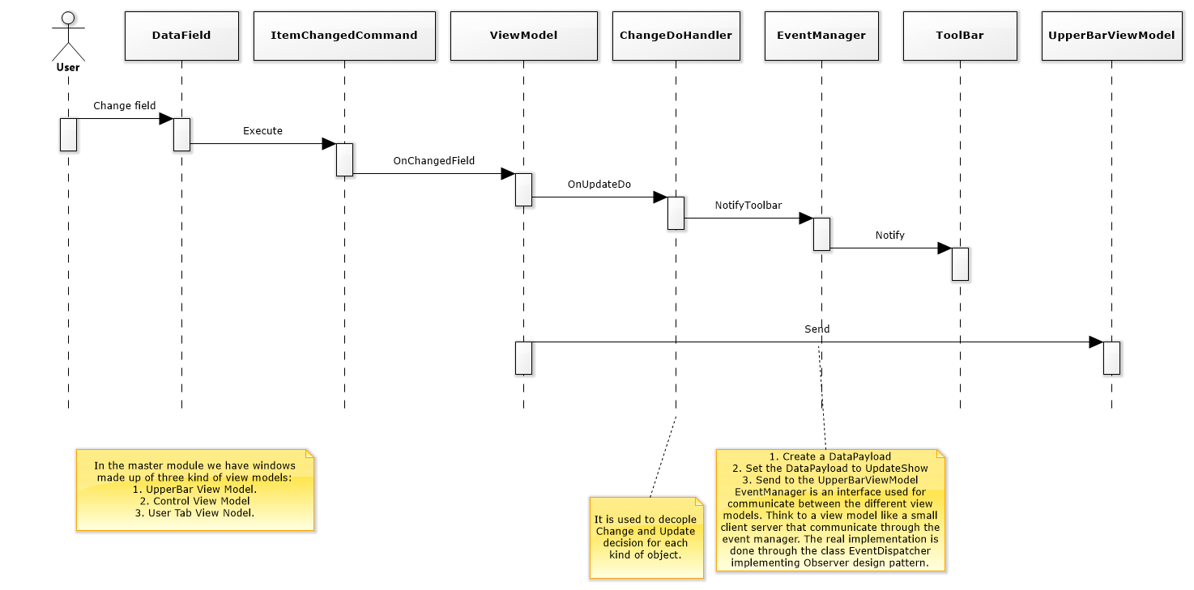1. DataField is the textbox

2. A window is made of two view and two viewmodel: ViewModel, UpperBarViewModel.

This is how the lupa works when an user clicks on the program.

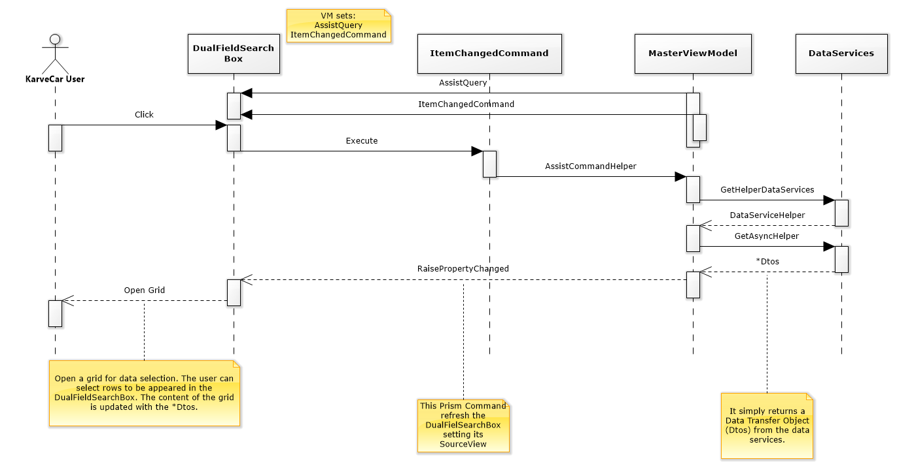

1. MasterViewModel is the class base for every view model

2. DataService is an interface to access to the database. Data Abstraction Layer.