Computer Vision Project

Group members: Boldrin Massimo
Da Re Leonardo

July 2022

Human hands detection and segmentation

1 Hand detection

The objective of this project is to produce a program that is able to detect and segment human hands in pictures. The pictures can obviously been taken from any angle with respect to the hand, so, as in the case of most object localization algorithms, we need a method that is rotation invariant. We also have to take into consideration the fact that hands, unlike most other objects, can change quite a bit depending on what the subject of the photo is doing. Taking all of this into account, it was immediate for us the choice of using deep learning.
1.1 Exploring the options
After some research the first models that we considered were R-CNN, Fast R-CNN and Faster R-CNN, which stand for Regions with CNN features, a “family” of methods for object localization, each one evolved from the previous one. When given an image in input, the network would try to figure out the so called “region proposals”, which are regions in the image where it would then look for objects, once extracted another network would classify them. In the case of R-CNN the number of region proposals is constant, always 2000, which is clearly not ideal, since generally is unlikely for 2000 objects to be present in a single image, but it would also fail in the unfortunate case of having more objects than those.
On its successors the approach it’s improved, since the number of region proposals it’s deducted from the image directly, but the main problem is that, while they are well functioning, these methods were still not fast as we would have liked.
1.2 YOLO
The YOLO algorithm (You Only Look Once) is the algorithm that we finally chose to use. Its fifth version, YOLOv5 (https://github.com/ultralytics/yolov5) is the state of the art object localization algorithm right now. The model predicts classes and bounding boxes in one single run: first the image is split into an SxS grid (commonly S = 19), each cell produced is then responsible for the bounding box prediction.
The probability of the cell to contain a certain class in computed, and the cell is then assing to the highest probability one.
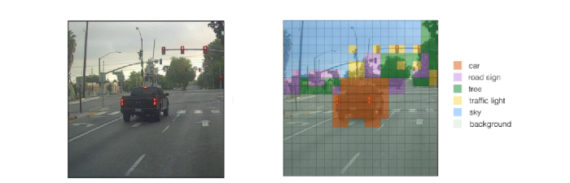Figure 1: division of the image in a grid, and assignation of the cells
Based on the probabilities the algorithm just computed, a certain number of bounding boxes is generated, but most of them aren’t correct. To get rid of the incorrect ones, YOLO performs Non-max suppression, a step where the value of Intersection over Union is calculated for each of the bounding boxes, and the ones that got a value over a certain threshold get eliminated.
Finally, for every object that found, algorithm outputs a vector containing: a number that indicates the class, the coordinates of the bounding box, and its width and height.
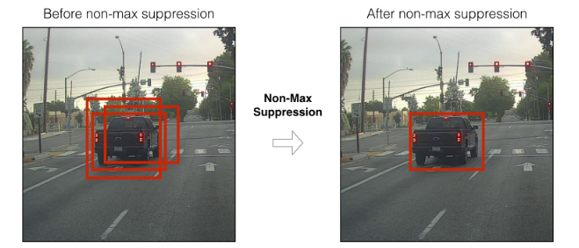Figure 2: non-max suppression
The algorithm is licenced under the GNU General Public Licence v3.0, so we can use it freely. So once found the model it was left to train it.
1.3 Dataset
Since we decided to work with deep learning, we had to create a good enough dataset that would allow us to train successfully the network. For this we considered creating a dataset ourselves, but ultimately decided to merge three different datasets, since the manual construction of a viable dataset would have taken a significant amount of time.
The datasets that we picked are “HandsOverFace” and “EgoHands”, both provided in the assignment of the project, to which we added the Hands dataset from the University of Oxford. Since the evaluation dataset for the project got provided to us alongside the two datasets mentioned above, we could effectively eliminate from the dataset all the images that will be used to evaluate this project. In the case of EgoHands we took it a step further and eliminated directly the whole subfolder containing an image that will be used in the evaluation, due to the big similarities among photos in the same folder.
HandsOverFace contains 300 images, while we used 288 of them. EgoHands contains 4800 images, while we used 3900 of them. Considering that the Hands dataset from Oxford contains 5628 photos, we used a total of 9816 images for the final dataset.

1.4 Python Notebook
References
- Figures 1, 2: https://towardsdatascience.com/yolo-you-only-look-once-3dbdbb608ec4#:~:text=YOLO%20algorithm%20is%20an%20algorithm,what%20is%20actually%20being%20predicted
- HandsOverFace dataset: https://drive.google.com/file/d/1hHUvINGICvOGcaDgA5zMbzAIUv7ewDd3
- EgoHands dataset: http://vision.soic.indiana.edu/projects/egohands/
- Oxford hand dataset: https://www.robots.ox.ac.uk/~vgg/data/hands/

