

Digital Image Processing: Analysis of Spatial Domain Filtering

Name: Ali Farrokhnejad
Student Number: 24502167
Instructor: Prof. Dr. Hasan Demirel
Course: EENG583 - Digital Image Processing

30 March 2026

1. Objective and problem statement
The objective of this assignment is to study digital image filtering in the spatial domain and to explain how smoothing and sharpening masks affect the visual appearance of an image. The report describes the theory behind neighborhood-based filtering, discusses implementations of representative filters, and compares their effects through examples and short observations.

2. Spatial filtering theory
Spatial filtering operates directly on image pixels by moving a small mask over the image and combining the neighborhood values with the mask coefficients. In lecture terminology, the small coefficient array may be called a filter, mask, kernel, template, or window. Linear spatial filtering is implemented through weighted sums, while nonlinear spatial filtering replaces the weighted sum rule with another local operation such as the median.

2.1 Smoothing filters
Smoothing filters reduce local intensity variation. They are commonly used to suppress noise, reduce small fluctuations, and produce a less detailed but more stable image. The tradeoff is that smoothing usually weakens fine texture and softens edges, leading to some “blurring” in most cases.
- Arithmetic mean filter: replaces each pixel with the average of its neighborhood values.
- Weighted average filter: gives greater importance to selected neighbors, often producing smoother behavior than a uniform mean filter.
- Gaussian smoothing: applies stronger weight near the center and weaker weight farther away, producing a natural blur.
- Median filter: nonlinear method that is especially effective for impulsive or salt-and-pepper-like noise.

2.2 Sharpening filters
Sharpening filters emphasize intensity transitions. Instead of suppressing detail, they strengthen local differences so that edges, boundaries, and fine structures become more visible. The cost is that aggressive sharpening can also amplify noise.
- Laplacian sharpening: uses a second-order derivative mask to highlight rapid intensity change.
- Unsharp masking: subtracts a blurred version from the original image to isolate detail, then adds that detail back.
- High-boost filtering: generalizes unsharp masking by scaling the detail mask before adding it back.
- Gradient-based edge emphasis: Sobel-type operators estimate local directional change and highlight strong edges.

3. Experimental methodology
The personal image used in this starter package is the same 512 x 512 grayscale lynx image used in the previous work on interpolation techniques. The experiment applies representative smoothing and sharpening filters in the spatial domain and compares the outputs visually. The goal is not only to show that the image changes, but to explain how each filter changes noise, texture, and edge visibility.
A simple workflow is recommended: first present the original image, then present a smoothing comparison panel, then present a sharpening comparison panel, and finally summarize the main observations in a compact table. If you want a stronger analysis, you can also compare variance, mean intensity, or a simple edge-strength proxy, but that is optional for this assignment.

4. Implementation summary
A Python script is included in the package to automate the filtering process. The script loads the image, converts it to grayscale when necessary, applies representative smoothing and sharpening filters, saves each result as an image, builds a contact sheet, and writes a CSV file with a few descriptive statistics (included in supplementary files).
The included filters are: arithmetic mean, weighted average, Gaussian smoothing, median filtering, Laplacian sharpening, unsharp masking, high-boost filtering, and Sobel gradient magnitude.
In the implementation used for this report, the Python code loads the 512 x 512 lynx image, applies the selected spatial-domain filters, saves each output, builds a comparison panel, and writes a CSV file with simple descriptive statistics. The main parameters used in the provided run were Gaussian smoothing with sigma = 1.0, unsharp masking with amount = 1.2, and high-boost filtering with coefficient k = 1.8. In addition to the visual outputs, the script computes a simple variance-of-Laplacian indicator so that the changes in edge strength can be compared in a rough quantitative way.

5. Results on the personal image
The figures below were regenerated from one consistent code run on the provided lynx image. Figure 1 shows the clean reference image. Figure 2 explicitly includes the noisy inputs and the corresponding denoised outputs so that the effect of the smoothing filters can be seen directly. Figure 3 then collects the sharpening and edge-emphasis outputs from the same run.
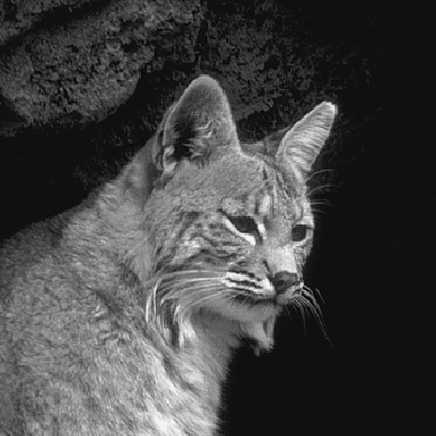
Figure 1. Original lynx image used as the reference for the spatial filtering examples.
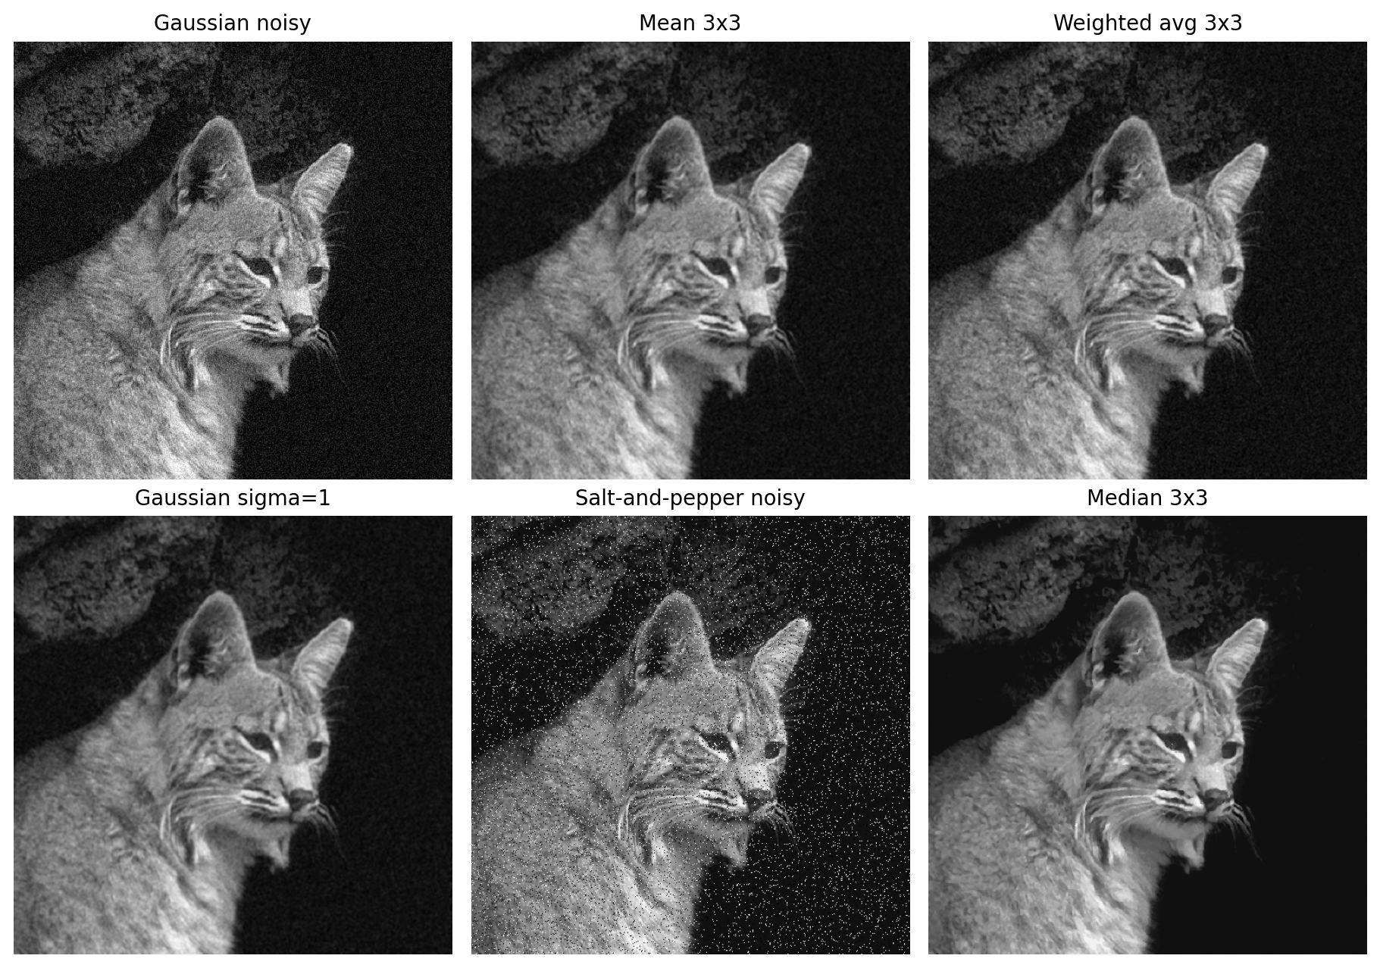
Figure 2. Denoising examples from the same run: Gaussian-noise suppression with mean, weighted-average, and Gaussian smoothing, and salt-and-pepper-noise suppression with median filtering.
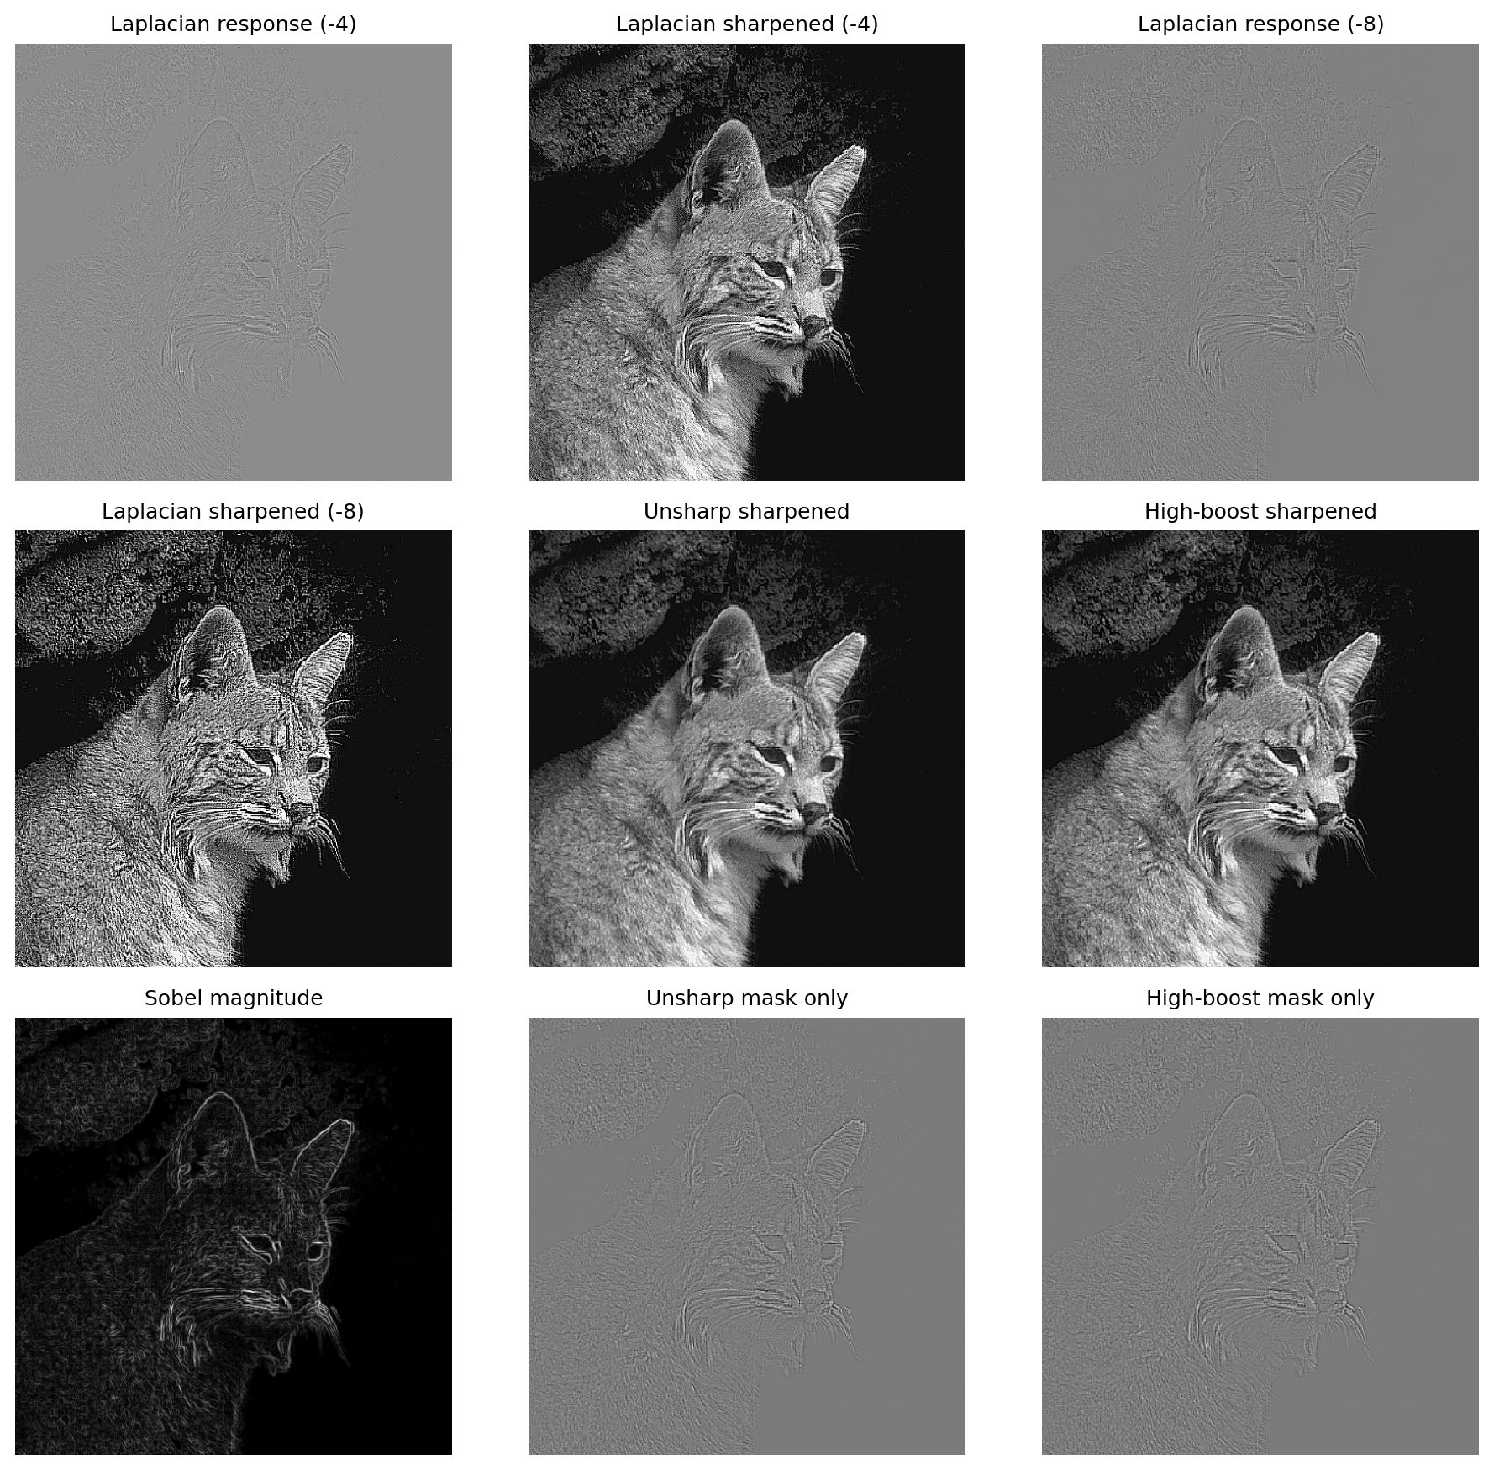
Figure 3. Sharpening and edge-emphasis outputs from the same run, including Laplacian responses, Laplacian sharpening, unsharp masking, high-boost filtering, and Sobel magnitude.

5.1 Observations
When Gaussian noise is added, all three linear smoothing filters reduce the visible grain, but they do so with different tradeoffs. The mean filter clearly suppresses noise, although it softens whiskers and fine fur detail. The weighted-average result preserves central structure a little better than the plain mean because the center pixel has more influence. Gaussian smoothing produces the smoothest and most natural-looking denoising result in this run, but it also removes the most texture. For salt-and-pepper corruption, the median filter is the appropriate choice because it removes isolated black and white spikes without averaging them into the surrounding region.
Among the sharpening outputs, Laplacian sharpening with the -4 mask strengthens edges strongly, while the -8 variant is visibly harsher and amplifies background grain much more. Unsharp masking gives a cleaner and more balanced enhancement of the face contour, whiskers, and eye region. High-boost filtering pushes the same idea further and produces stronger local contrast, but the image begins to look less natural. The Sobel magnitude image is useful for highlighting edge locations, but it should be interpreted as an edge map rather than as a final enhanced photograph.
Method | Category | Main visual effect | Effect on noise / texture | Observation
mean | Smoothing | Mild uniform blur | Reduces Gaussian-like grain | Simple baseline; suppresses noise, but fur and whiskers look softer.
Weighted average | Smoothing | Center-weighted blur | Reduces noise with slightly better structure retention | Keeps the face contour a little better than the plain mean filter.
Gaussian smoothing | Smoothing | Natural low-pass blur | Strongest suppression of fine fluctuation | Looks the smoothest, but also removes the most fine texture.
Median | Smoothing | Outlier removal | Best for impulse noise | Removes salt-and-pepper specks while keeping major edges recognizable.
Laplacian sharpened (-4) | Sharpening | Strong edge boost | Raises detail and noise together | Makes contours and whiskers clearer, but background roughness also increases.
Unsharp sharpened | Sharpening | Balanced detail enhancement | Moderate sharpening with better naturalness | Improves important facial detail without the harshness of Laplacian sharpening.
High-boost sharpened | Sharpening | Aggressive local contrast | Can over-emphasize grain | Produces stronger texture emphasis, but the result looks less natural.
Table 1 summarizes the main visual observations.

6. Discussion
In the smoothing family, the preferred method depends on the type of corruption. For additive Gaussian-like noise, Gaussian smoothing gives the strongest suppression of small fluctuations, but it also softens texture the most. The mean and weighted-average filters also reduce noise, but the weighted version preserves structure slightly better because of its center emphasis. Median filtering is different from the linear smoothers: it is most useful when the degradation is impulsive, because isolated black and white specks should be removed rather than averaged.
In the sharpening family, Laplacian methods produce the strongest immediate edge emphasis, but they are also the least forgiving when noise or background grain is present. The -8 Laplacian is clearly more aggressive than the -4 version and can over-enhance the image quickly. Unsharp masking gives the best compromise in this experiment, because it improves clarity without making the image look unnatural. High-boost filtering is useful when stronger local contrast is desired, but it crosses into over-enhancement sooner. Sobel magnitude remains valuable for detecting edge locations, not for producing a visually pleasing final photograph.

7. Conclusion
Overall, the experiment shows that spatial-domain filtering is goal-dependent rather than universally optimal. For the noisy examples in this run, Gaussian smoothing gave the cleanest Gaussian-noise suppression, while median filtering was the correct choice for salt-and-pepper corruption. In the sharpening group, unsharp masking gave the most balanced enhancement, Laplacian sharpening gave the strongest but harshest boost, and high-boost filtering pushed detail emphasis further at the cost of natural appearance. The main lesson is that smoothing trades detail for stability, whereas sharpening trades stability for stronger edge and texture visibility.

8. References
- Gonzalez, R. C., and Woods, R. E. Digital Image Processing. 4th ed. Pearson.
- Lecture 03 slides for EENG583: Image Enhancement in the Spatial Domain.
- Python script and generated output figures used in this report.

