EXP NO: 01
DATE: 08-07-2025
BASIC IMAGE PROCESSING OPERATIONS

Aim: To Implement various basic image processing operations like Reading image, writing image and conversion of images.
Algorithm:
- Import required libraries (OpenCV, NumPy).
- Read the input image using cv2.imread().
- Display the image using cv2.imshow().
- Convert colour spaces (RGB ↔ Grayscale ↔ HSV) using cv2.cvtColor().
- Write the output image using cv2.imwrite().
- Close windows using cv2.destroyAllWindows().

Code:
import cv2
image = cv2.imread("hello.jpg")
cv2_imshow(image)
cv2.waitKey(0)
cv2.destroyAllWindows()

cv2.imwrite('output.jpg', image)
print("Image saved as output.jpg")

gray_image = cv2.cvtColor(image, cv2.COLOR_BGR2GRAY)
cv2_imshow(gray_image)
cv2.waitKey(0)
cv2.destroyAllWindows()
hsv_image = cv2.cvtColor(image, cv2.COLOR_BGR2HSV)
cv2_imshow(hsv_image)
cv2.waitKey(0)
cv2.destroyAllWindows()

_, binary_image = cv2.threshold(gray_image, 127, 255, cv2.THRESH_BINARY)
cv2_imshow(binary_image)
cv2.waitKey(0)
cv2.destroyAllWindows()

Output:
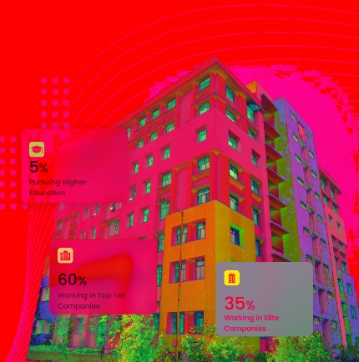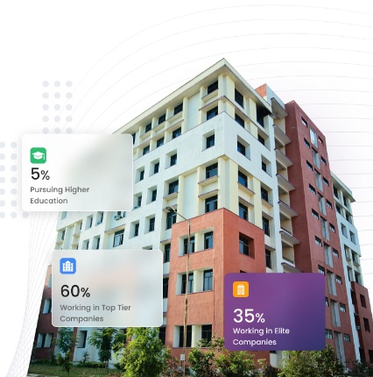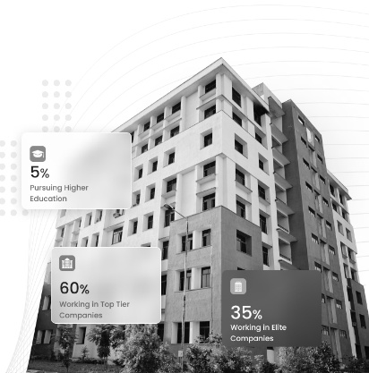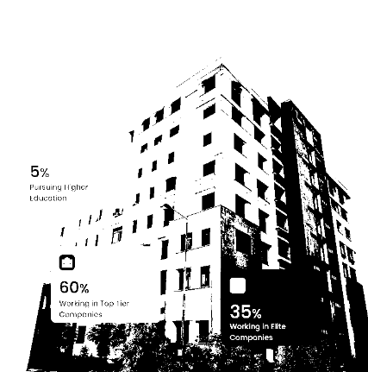

Result: various basic image processing operations like Reading image, writing image and conversion of images were implemented successfully.

