EXP NO: 10
DATE: 03-10-2025
Object Recognition
Aim: Object Recognition on available online image datasets
Algorithm:
- Load pretrained CNN model (e.g., ResNet, MobileNet).
- Read and preprocess input image (resize, normalize).
- Pass image through model for prediction.
- Obtain top predicted labels and confidence scores.
- Display recognized object with label.
- Compare performance on dataset images.

Code:
# Import libraries
import tensorflow as tf
from tensorflow.keras import datasets, layers, models
from sklearn.metrics import confusion_matrix, classification_report
import matplotlib.pyplot as plt
import numpy as np
import seaborn as sns

# Step 1: Load and preprocess dataset
(x_train, y_train), (x_test, y_test) = datasets.cifar10.load_data()
x_train, x_test = x_train / 255.0, x_test / 255.0 # Normalize
y_train, y_test = y_train.flatten(), y_test.flatten()

# Step 2: Define CNN model
model = models.Sequential([
layers.Conv2D(32, (3,3), activation='relu', input_shape=(32,32,3)),
layers.MaxPooling2D((2,2)),
layers.Conv2D(64, (3,3), activation='relu'),
layers.MaxPooling2D((2,2)),
layers.Conv2D(128, (3,3), activation='relu'),
layers.Flatten(),
layers.Dense(128, activation='relu'),
layers.Dense(10, activation='softmax')
])

# Step 3: Compile model
model.compile(optimizer='adam',
loss='sparse_categorical_crossentropy',
metrics=['accuracy'])

# Step 4: Train model
history = model.fit(x_train, y_train, epochs=20,
validation_data=(x_test, y_test),
batch_size=64)

# Step 5: Evaluate model
test_loss, test_acc = model.evaluate(x_test, y_test, verbose=2)
print(f"\nTest Accuracy: {test_acc*100:.2f}%")

# Step 6: Plot accuracy and loss curves
plt.figure(figsize=(12,4))
plt.subplot(1,2,1)
plt.plot(history.history['accuracy'], label='Train Accuracy')
plt.plot(history.history['val_accuracy'], label='Validation Accuracy')
plt.legend(); plt.title("Accuracy")

plt.subplot(1,2,2)
plt.plot(history.history['loss'], label='Train Loss')
plt.plot(history.history['val_loss'], label='Validation Loss')
plt.legend(); plt.title("Loss")
plt.show()

# Step 7: Confusion Matrix
y_pred = np.argmax(model.predict(x_test), axis=-1)
cm = confusion_matrix(y_test, y_pred)
plt.figure(figsize=(8,6))
sns.heatmap(cm, annot=False, cmap='Blues')
plt.title("Confusion Matrix")
plt.show()

# Step 8: Classification report
print("\nClassification Report:\n", classification_report(y_test, y_pred))

Output:
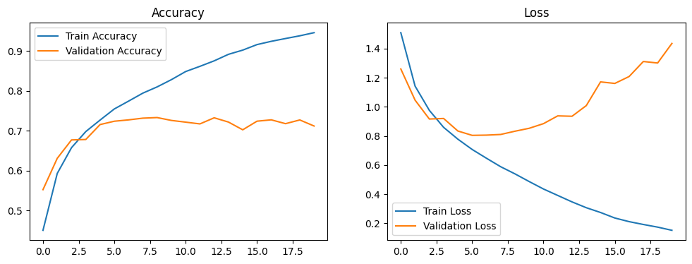

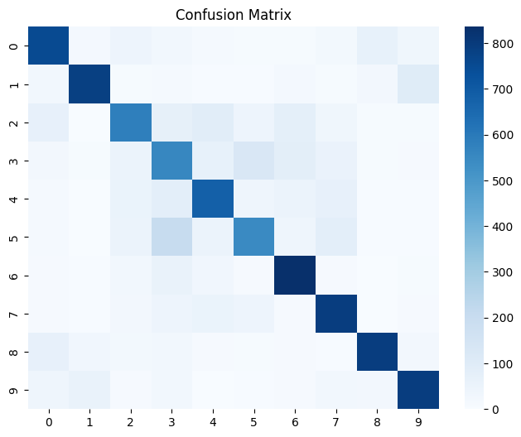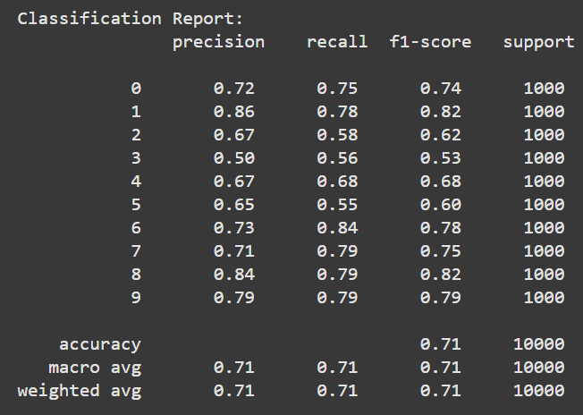

Result: Thus, Object Recognition on available online image datasets was implemented successfully.

