EXP NO: 02
DATE: 11-07-2025
Contrast Adjustment
Aim: To Implement contrast adjustment of an image.
Algorithm:
- Read the input image in grayscale.
- Normalize pixel values or use histogram stretching.
- Apply formula: output = alpha * input + beta (alpha = contrast, beta = brightness).
- Clip values to [0,255] range.
- Display original and adjusted images.
- Save the adjusted image.

Code:
from google.colab.patches import cv2_imshow
import cv2
img = cv2.imread('/content/drive/MyDrive/input.jpg')
alphas = [0.5, 2.0] # contrast factors
betas = [-50, 100] # brightness shifts
for a in alphas:
for b in betas:
adjusted = cv2.convertScaleAbs(img, alpha=a, beta=b)
cv2_imshow(adjusted) # Use cv2_imshow instead of cv2.imshow
cv2.imwrite(f"output_alpha{a}_beta{b}.jpg", adjusted)

cv2_imshow(img) # Use cv2_imshow instead of cv2.imshow
cv2.waitKey(0)
cv2.destroyAllWindows()
Output:
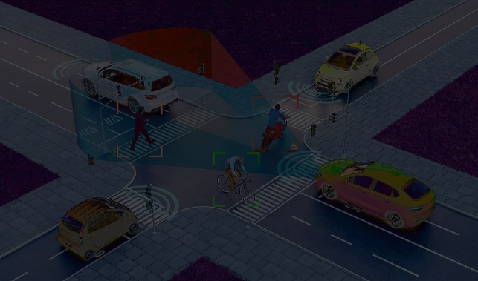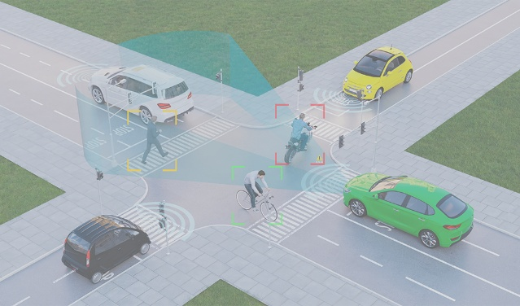
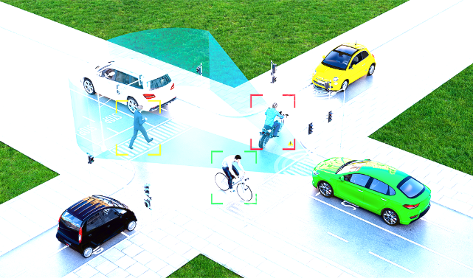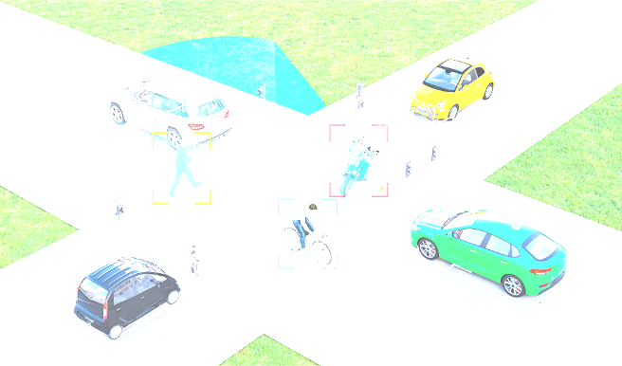

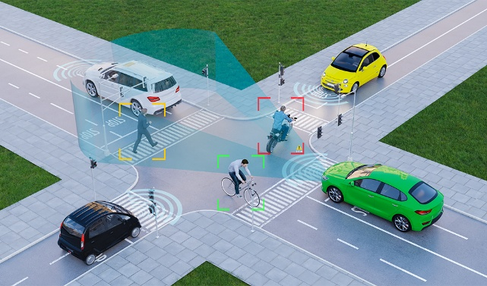

Result: Thus, contrast adjustment of an image implemented successfully.

