EXP NO: 03
DATE: 18-07-2025
Histogram processing and Equalization.
Aim: To Implement Histogram processing and Equalization.
Algorithm:
- Convert image to grayscale.
- Compute histogram using cv2.calcHist().
- Normalize and plot the histogram.
- Apply histogram equalization using cv2.equalizeHist().
- Compare before and after histograms.
- Display results.

Code:
import cv2
import numpy as np
import matplotlib.pyplot as plt
from google.colab.patches import cv2_imshow

# Read image
img = cv2.imread('/content/drive/MyDrive/input.jpg')

# Check if image is loaded
if img is None:
print("Error: Could not load image. Please check the file path.")
else:
gray = cv2.cvtColor(img, cv2.COLOR_BGR2GRAY)

# Histogram
hist = cv2.calcHist([gray], [0], None, [256], [0,256])

# Equalization
equalized = cv2.equalizeHist(gray)

# CLAHE
clahe = cv2.createCLAHE(clipLimit=2.0, tileGridSize=(8,8))
clahe_img = clahe.apply(gray)

# Show images
cv2_imshow(gray)
cv2_imshow(equalized)
cv2_imshow(clahe_img)

# Plot histogram
plt.figure()
plt.title("Histogram of Original Image")
plt.xlabel("Pixel Intensity")
plt.ylabel("Frequency")
plt.plot(hist)
plt.show()

# cv2.waitKey(0)
# cv2.destroyAllWindows()

# Save results
cv2.imwrite("equalized.jpg", equalized)
cv2.imwrite("clahe.jpg", clahe_img)

Output:
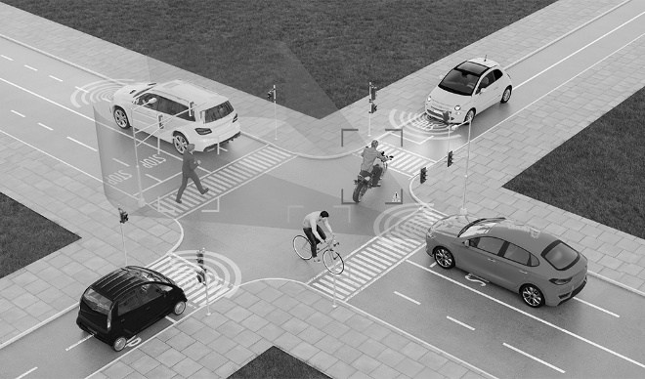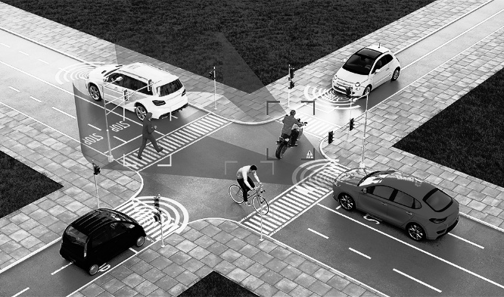
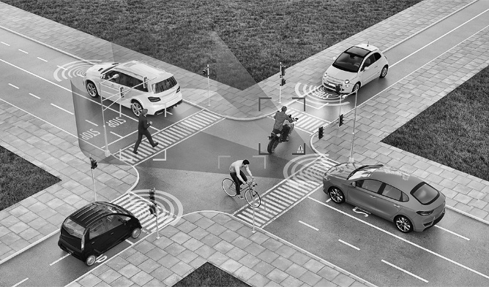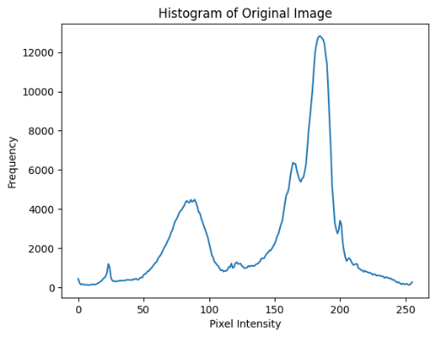

Result: Thus, Histogram processing and Equalization implemented successfully.

