EXP NO: 04
DATE: 25-07-2025
Low pass and High pass filtering mechanisms
Aim: To Implement the various low pass and high pass filtering mechanisms.
Algorithm:
- Read and convert image to grayscale.
- Apply low pass (Gaussian/average) filter using cv2.GaussianBlur() or cv2.blur().
- Apply high pass filter using Laplacian or Sobel operator.
- Combine results to observe smoothing vs sharpening effects.
- Display filtered images.
- Save outputs.

Code:
import cv2
import numpy as np
from PIL import Image
import matplotlib.pyplot as plt

# Read image using PIL and convert to OpenCV format
try:
img_pil = Image.open('/content/drive/MyDrive/input.jpg')
img = cv2.cvtColor(np.array(img_pil), cv2.COLOR_RGB2BGR)
gray = cv2.cvtColor(img, cv2.COLOR_BGR2GRAY)
except Exception as e:
print(f"Error reading image: {e}")
img = None
gray = None

if gray is not None:
# --- Low Pass Filters ---
avg_blur = cv2.blur(gray, (5,5)) # Average filter
gauss_blur = cv2.GaussianBlur(gray, (5,5), 0) # Gaussian filter
median_blur = cv2.medianBlur(gray, 5) # Median filter

# --- High Pass Filters ---
laplacian = cv2.Laplacian(gray, cv2.CV_64F)
laplacian = cv2.convertScaleAbs(laplacian)

sobelx = cv2.Sobel(gray, cv2.CV_64F, 1, 0, ksize=3)
sobely = cv2.Sobel(gray, cv2.CV_64F, 0, 1, ksize=3)
sobel = cv2.convertScaleAbs(cv2.magnitude(sobelx, sobely))

# High-pass kernel filter
kernel = np.array([[-1,-1,-1],
[-1, 8,-1],
[-1,-1,-1]])
highpass = cv2.filter2D(gray, -1, kernel)

# Display results using matplotlib
images = {
"Original": gray,
"Average Blur": avg_blur,
"Gaussian Blur": gauss_blur,
"Median Blur": median_blur,
"Laplacian": laplacian,
"Sobel": sobel,
"High-pass Kernel": highpass
}

plt.figure(figsize=(15, 10))
for i, (title, img) in enumerate(images.items()):
plt.subplot(2, 4, i + 1)
plt.imshow(img, cmap='gray')
plt.title(title)
plt.axis('off')
plt.tight_layout()
plt.show()

else:
print("Could not process the image.")

Output:
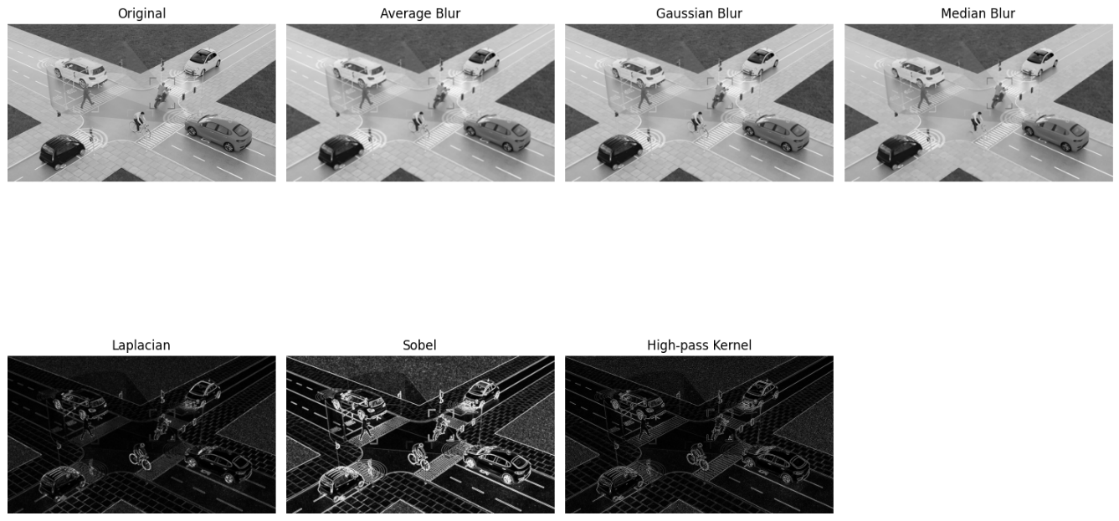

Code:
from google.colab.patches import cv2_imshow
import cv2
import numpy as np
from PIL import Image

# Read image using PIL and convert to OpenCV format
try:
img_pil = Image.open('/content/drive/MyDrive/input.jpg') # Replace with an existing image file
img = cv2.cvtColor(np.array(img_pil), cv2.COLOR_RGB2BGR)
gray = cv2.cvtColor(img, cv2.COLOR_BGR2GRAY)
except Exception as e:
print(f"Error reading image: {e}")
img = None
gray = None

if gray is not None:
# --- Low Pass Filters ---
avg_blur = cv2.blur(gray, (5,5)) # Average filter
gauss_blur = cv2.GaussianBlur(gray, (5,5), 0) # Gaussian filter
median_blur = cv2.medianBlur(gray, 5) # Median filter

# --- High Pass Filters ---
laplacian = cv2.Laplacian(gray, cv2.CV_64F)
laplacian = cv2.convertScaleAbs(laplacian)

sobelx = cv2.Sobel(gray, cv2.CV_64F, 1, 0, ksize=3)
sobely = cv2.Sobel(gray, cv2.CV_64F, 0, 1, ksize=3)
sobel = cv2.convertScaleAbs(cv2.magnitude(sobelx, sobely))

# High-pass kernel filter
kernel = np.array([[-1,-1,-1],
[-1, 8,-1],
[-1,-1,-1]])
highpass = cv2.filter2D(gray, -1, kernel)

# Display results using cv2_imshow
cv2_imshow(gray)
cv2_imshow(avg_blur)
cv2_imshow(gauss_blur)
cv2_imshow(median_blur)
cv2_imshow(laplacian)
cv2_imshow(sobel)
cv2_imshow(highpass)

# The waitKey and destroyAllWindows are not needed when using cv2_imshow
# cv2.waitKey(0)
# cv2.destroyAllWindows()

# Save results
cv2.imwrite("avg_blur.jpg", avg_blur)
cv2.imwrite("gauss_blur.jpg", gauss_blur)
cv2.imwrite("median_blur.jpg", median_blur)
cv2.imwrite("laplacian.jpg", laplacian)
cv2.imwrite("sobel.jpg", sobel)
cv2.imwrite("highpass.jpg", highpass)
else:
print("Could not process the image.")

Output:
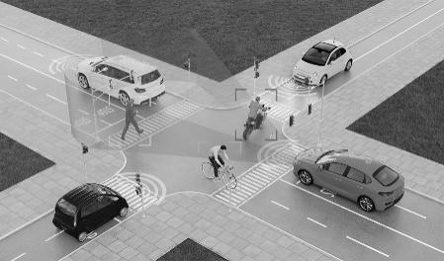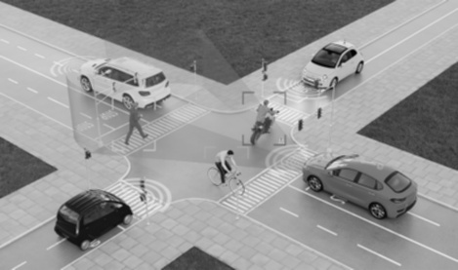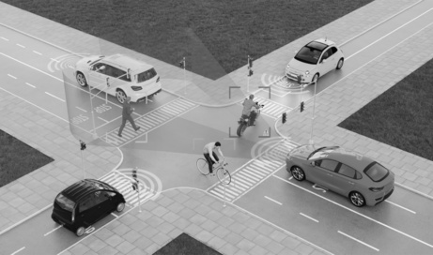

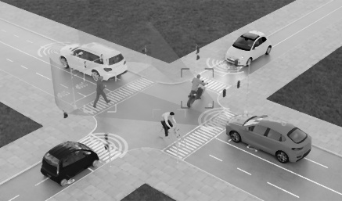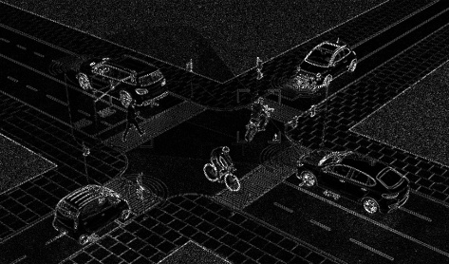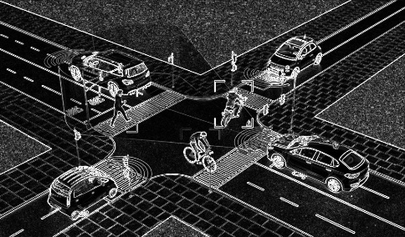

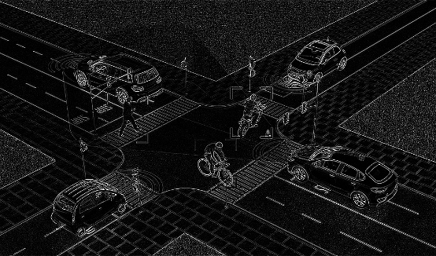

Result: Thus, the various low pass and high pass filtering mechanisms was successfully implemented.

