EXP NO: 05
DATE: 01-08-2025
Fourier transform for filtering the image

Aim: Use of Fourier transform for filtering the image.
Algorithm:
- Convert image to grayscale and float type.
- Apply DFT using np.fft.fft2() and shift using np.fft.fftshift().
- Create a mask for low/high pass filtering in frequency domain.
- Apply mask and perform inverse FFT using np.fft.ifft2().
- Take magnitude and display filtered image.
- Compare with original.

Code:
import cv2
import numpy as np
import matplotlib.pyplot as plt

# Read image
img = cv2.imread('/content/drive/MyDrive/input.jpg', 0)

# Check if the image was loaded successfully
if img is None:
print("Error: Could not load image. Please check the file path and ensure the image exists.")
else:
# Fourier Transform
f = np.fft.fft2(img)
fshift = np.fft.fftshift(f)
magnitude_spectrum = 20*np.log(np.abs(fshift))

# --- Low-pass filter ---
rows, cols = img.shape
crow, ccol = rows//2, cols//2
mask_lp = np.zeros((rows, cols), np.uint8)
r = 50 # radius for LPF
cv2.circle(mask_lp, (ccol, crow), r, 1, -1)

fshift_lp = fshift * mask_lp
img_lp = np.fft.ifft2(np.fft.ifftshift(fshift_lp))
img_lp = np.abs(img_lp)

# --- High-pass filter ---
mask_hp = 1 - mask_lp
fshift_hp = fshift * mask_hp
img_hp = np.fft.ifft2(np.fft.ifftshift(fshift_hp))
img_hp = np.abs(img_hp)

# Display results
plt.figure(figsize=(10,8))
plt.subplot(2,2,1), plt.imshow(img, cmap='gray')
plt.title("Original"), plt.axis('off')
plt.subplot(2,2,2), plt.imshow(magnitude_spectrum, cmap='gray')
plt.title("Magnitude Spectrum"), plt.axis('off')
plt.subplot(2,2,3), plt.imshow(img_lp, cmap='gray')
plt.title("Low-pass Filtered"), plt.axis('off')
plt.subplot(2,2,4), plt.imshow(img_hp, cmap='gray')
plt.title("High-pass Filtered"), plt.axis('off')
plt.show()

Output:
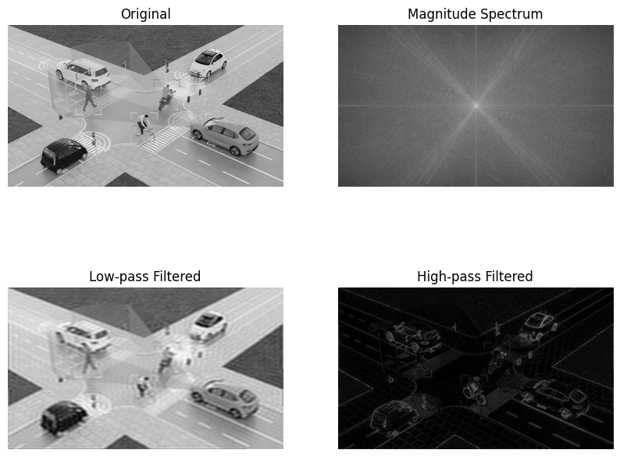

Result: Thus, Fourier transform for filtering the image was implemented successfully.

