EXP NO: 06
DATE: 22-08-2025
SIFT and HOG features for image analysis

Aim: Utilization of SIFT and HOG features for image analysis
Algorithm:
- Read image and convert to grayscale.
- Initialize SIFT/HOG detector (cv2.SIFT_create(), cv2.HOGDescriptor()).
- Detect keypoints and compute descriptors.
- Draw keypoints on the image.
- Display or store the extracted features.
- Use features for comparison or matching.

Code:
import cv2
import matplotlib.pyplot as plt
from skimage.feature import hog
from skimage import color

# ----------- SIFT -----------
img = cv2.imread('/content/drive/MyDrive/input.jpg')

# Check if image was loaded successfully
if img is None:
print("Error: Could not load image from the specified path. Please check the file path and ensure the image exists.")
else:
gray = cv2.cvtColor(img, cv2.COLOR_BGR2GRAY)

# SIFT detector
sift = cv2.SIFT_create()
keypoints, descriptors = sift.detectAndCompute(gray, None)

# Draw keypoints
sift_img = cv2.drawKeypoints(img, keypoints, None, flags=cv2.DRAW_MATCHES_FLAGS_DRAW_RICH_KEYPOINTS)

# ----------- HOG -----------
# Convert to grayscale for HOG
gray_hog = color.rgb2gray(cv2.cvtColor(img, cv2.COLOR_BGR2RGB))

# Compute HOG features and visualization
hog_features, hog_img = hog(gray_hog, orientations=9, pixels_per_cell=(8, 8),
cells_per_block=(2, 2), visualize=True, channel_axis=None)

# ----------- Display Results -----------
plt.figure(figsize=(10,5))

plt.subplot(1,2,1)
plt.imshow(cv2.cvtColor(sift_img, cv2.COLOR_BGR2RGB))
plt.title("SIFT Features")
plt.axis('off')

plt.subplot(1,2,2)
plt.imshow(hog_img, cmap='gray')
plt.title("HOG Features")
plt.axis('off')

plt.show()

Output:
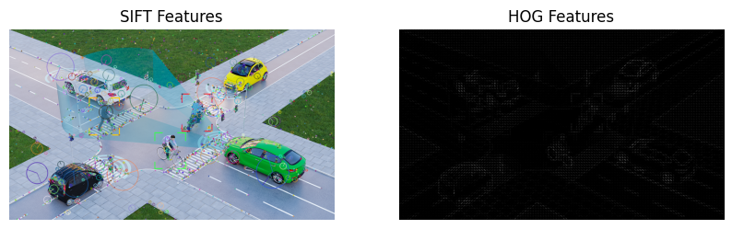

Result: Thus, Utilization of SIFT and HOG features for image analysis was implemented successfully.

